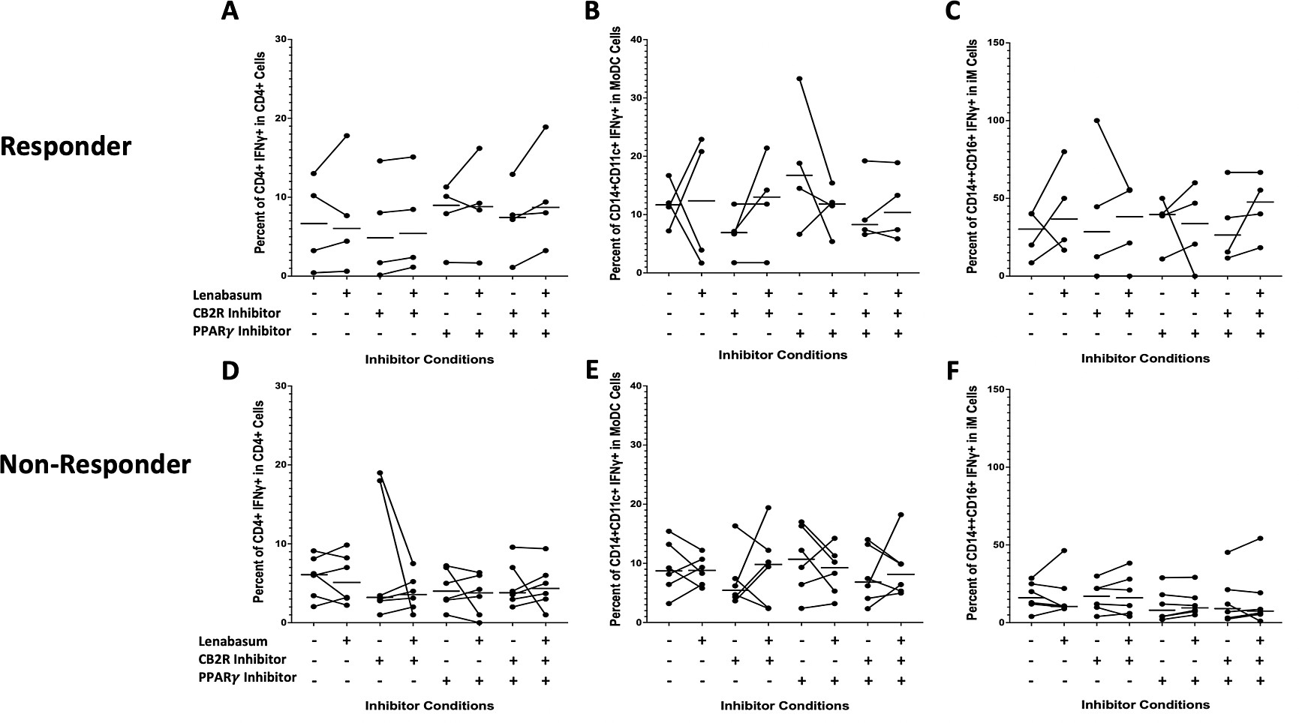
Figure S3: Flow cytometry of DM whole blood leukocytes displaying percent positivity of IFNγ across CD4⁺ T , moDCs, and iMs in non-responders and responders with various CB2R/PPARγ inhibition and lenabasum treatment. Black line reflects the median. A) IFNγ positivity in CD4T⁺ cells in responders with lenabasum treatment and CB2R/PPARγ inhibition. B) IFNγ positivity in moDCs in responders with lenabasum treatment and CB2R/PPARγ inhibition. C) IFNγ positivity in iMs in responders with lenabasum treatment and CB2R/PPARγ inhibition. D) IFNγ positivity in CD4T⁺ in non-responders with lenabasum treatment and CB2R/PPARγ inhibition. E) IFNγ positivity in moDCs in non-responders with lenabasum treatment and CB2R/PPARγ inhibition. F) IFNγ positivity in iMs in non-responders with lenabasum treatment and CB2R/PPARγ inhibition.

