Supplementary Figures

Supplementary Figure 1. Histograms with density overlays for cost phenotypes (blue = inpatient costs, orange = prescription costs, purple = inpatient + outpatient costs, green = primary care costs) of the following cohorts:

A - Australian Genetics of Depression Study (AGDS)
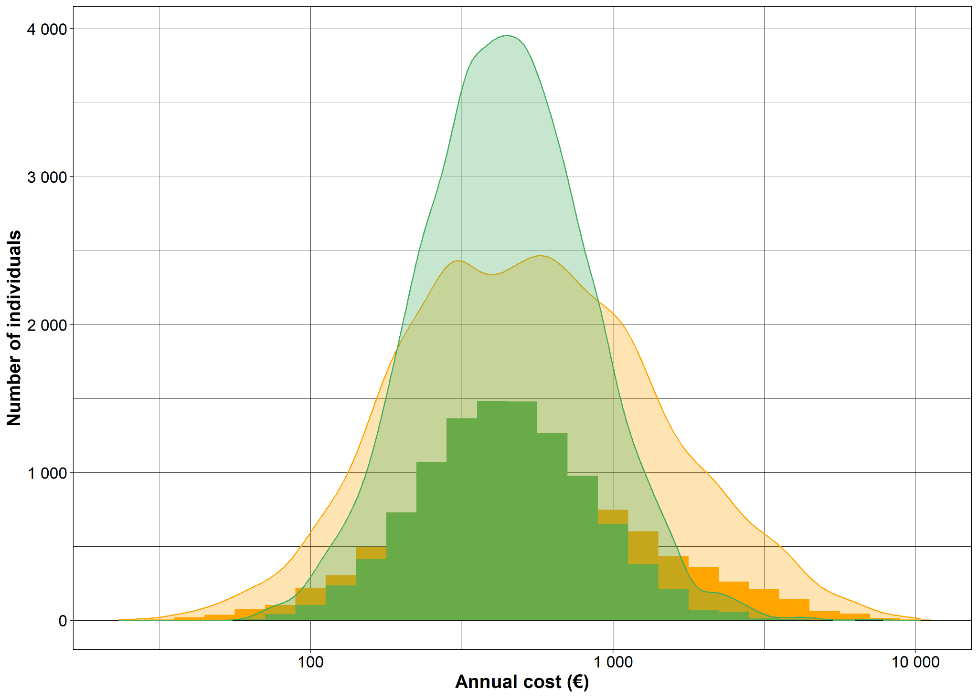

B - Australian Genetics of Bipolar Disorder (GBP)
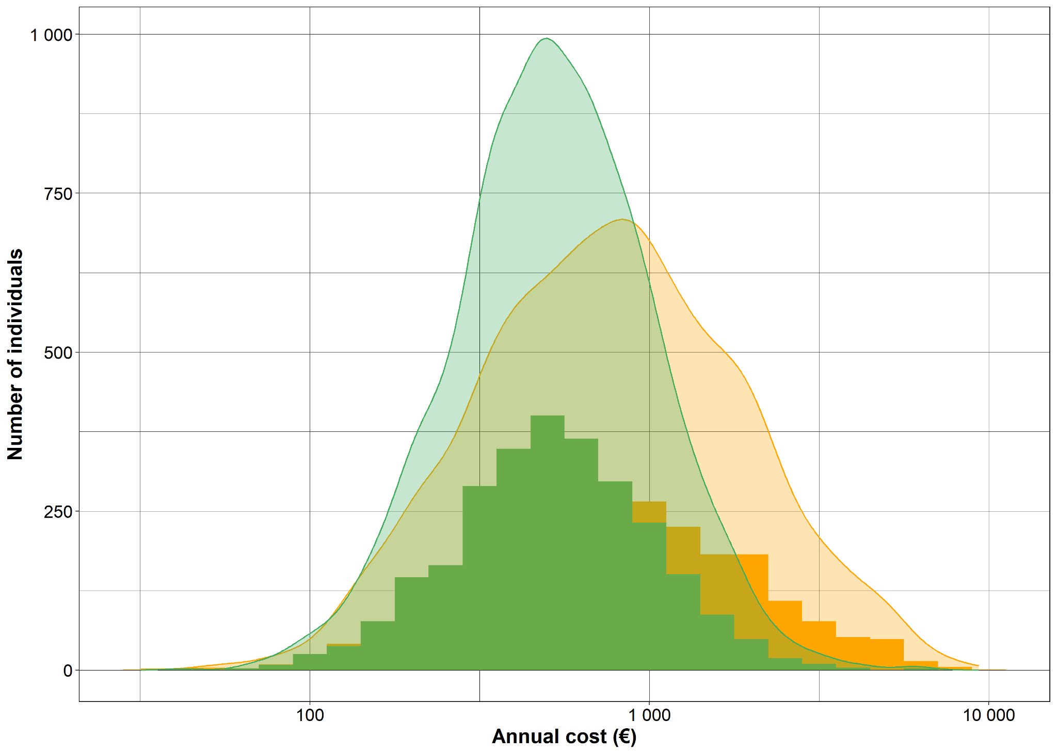
C - Copenhagen Hospital Biobank (CHB)
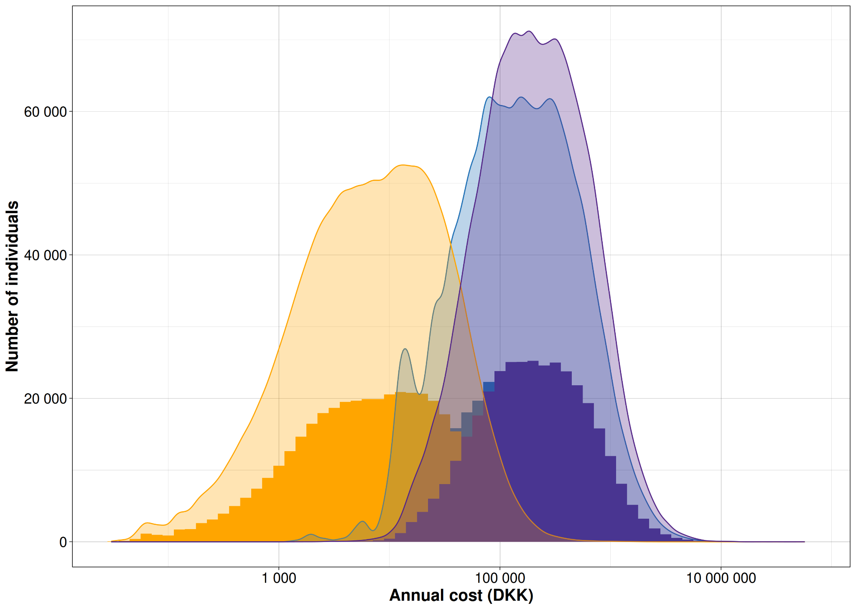

D - Estonian Biobank (EstBB)
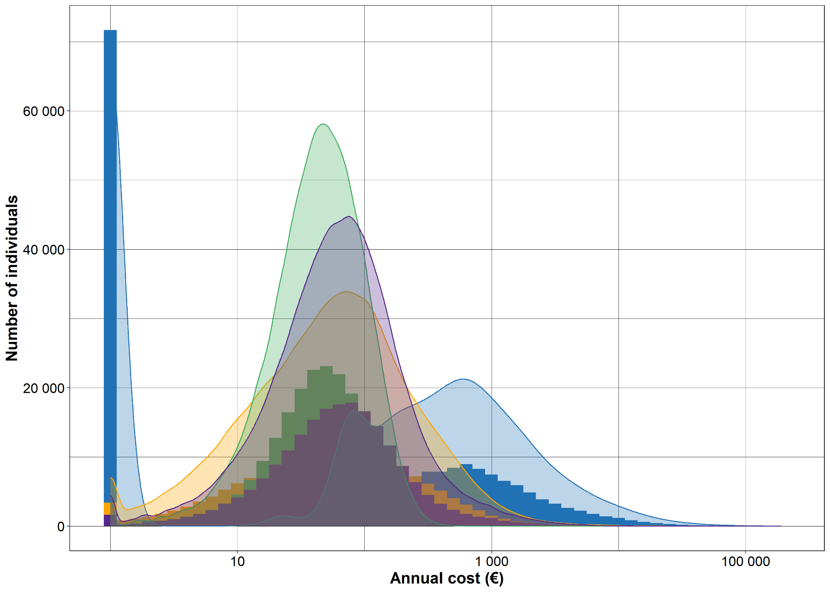

E - Generation Scotland (GS)
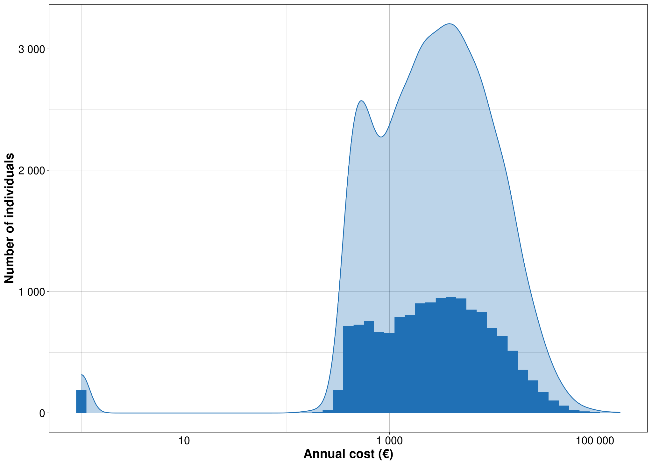

F - Genomics England (GE)
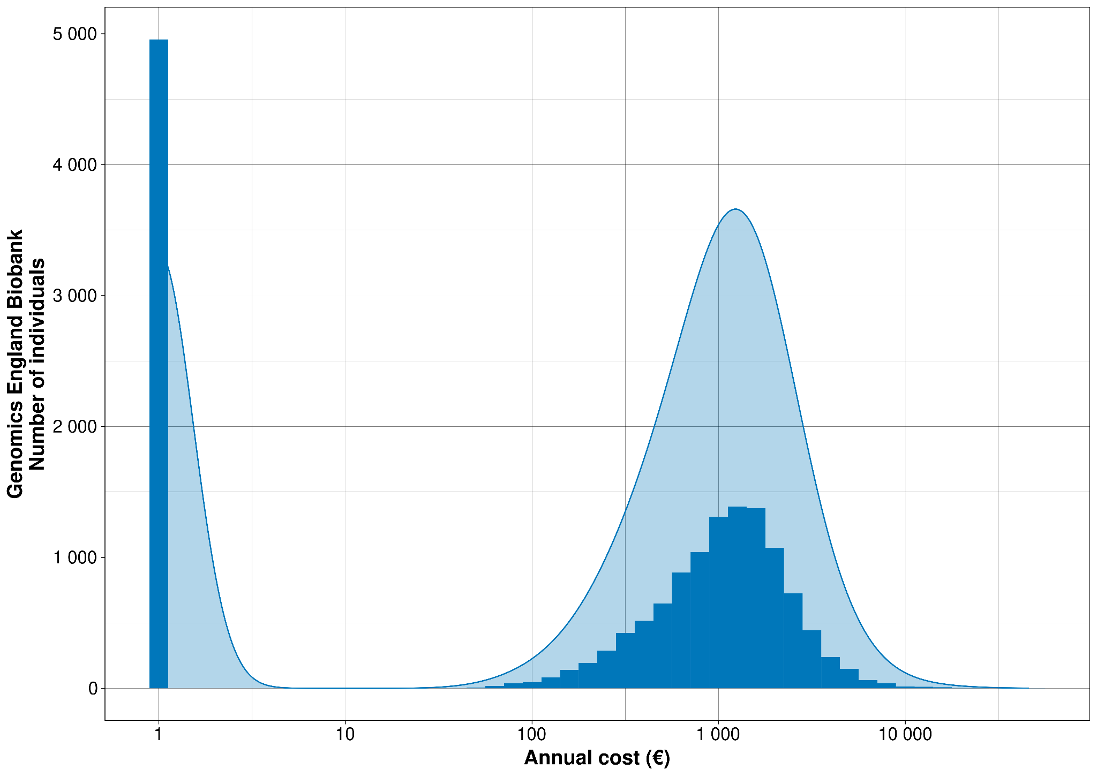

G - Genes and Health (G&H)

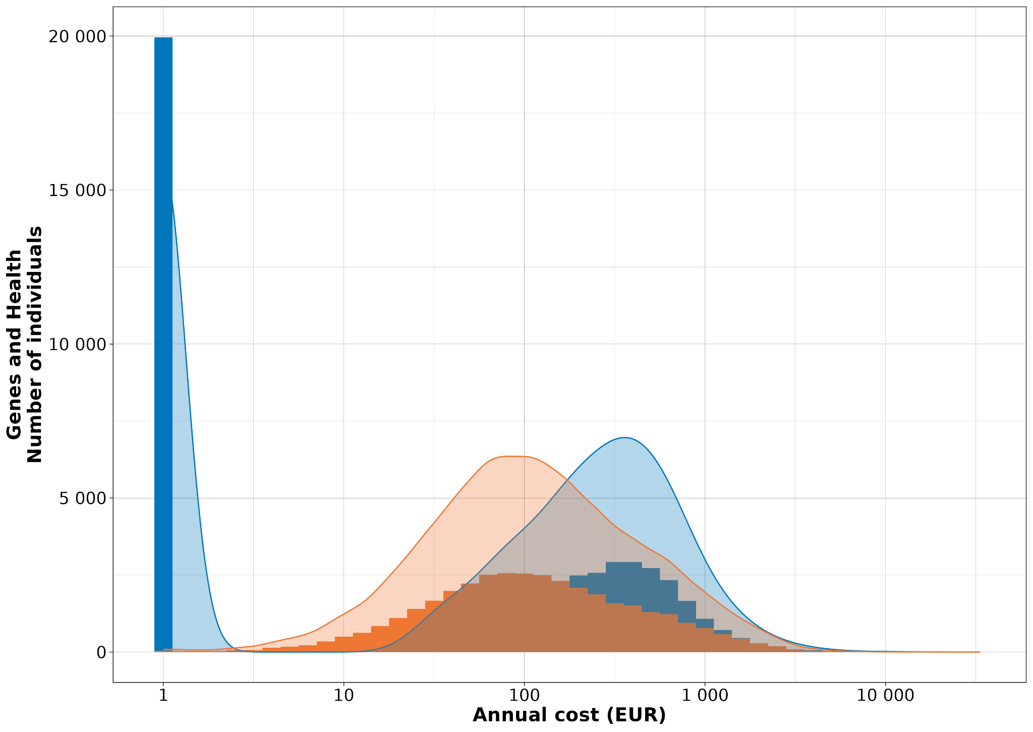

H - Mass General Brigham Biobank (MGBB)
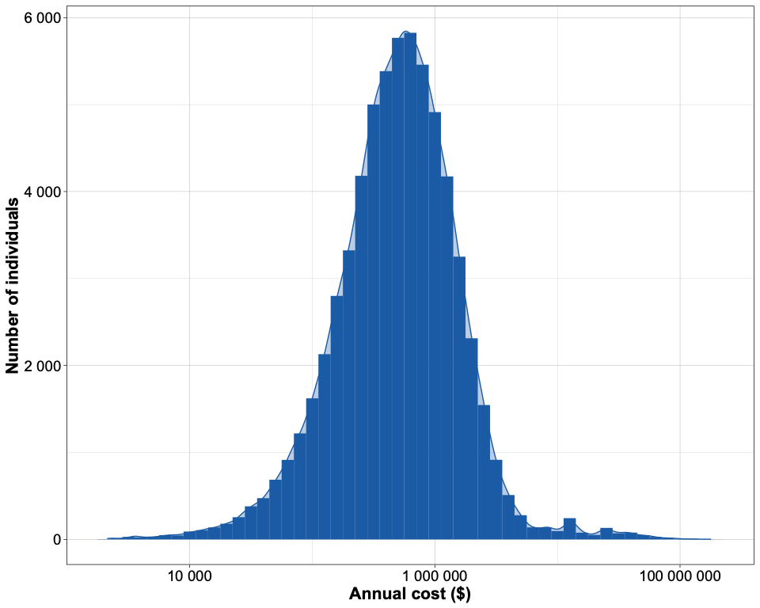

I - Qatar Genome Project (QGP)
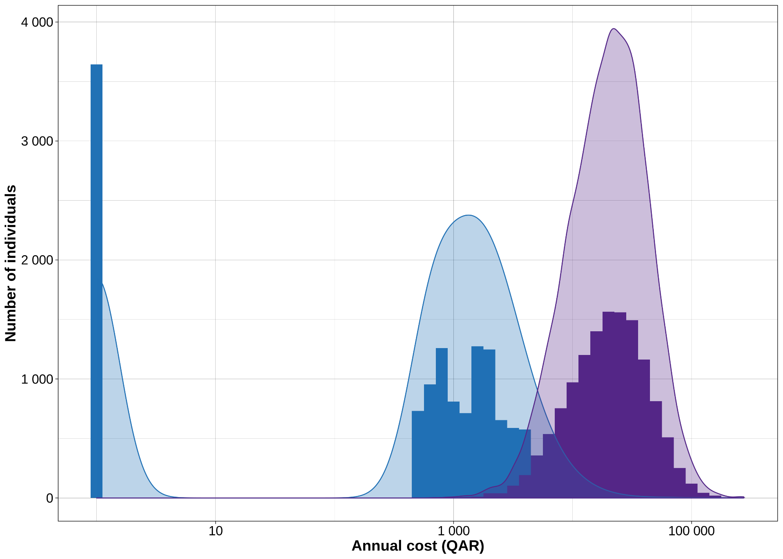

Supplementary Figure 2. Miami plot for inpatient + outpatient costs and primary care costs.

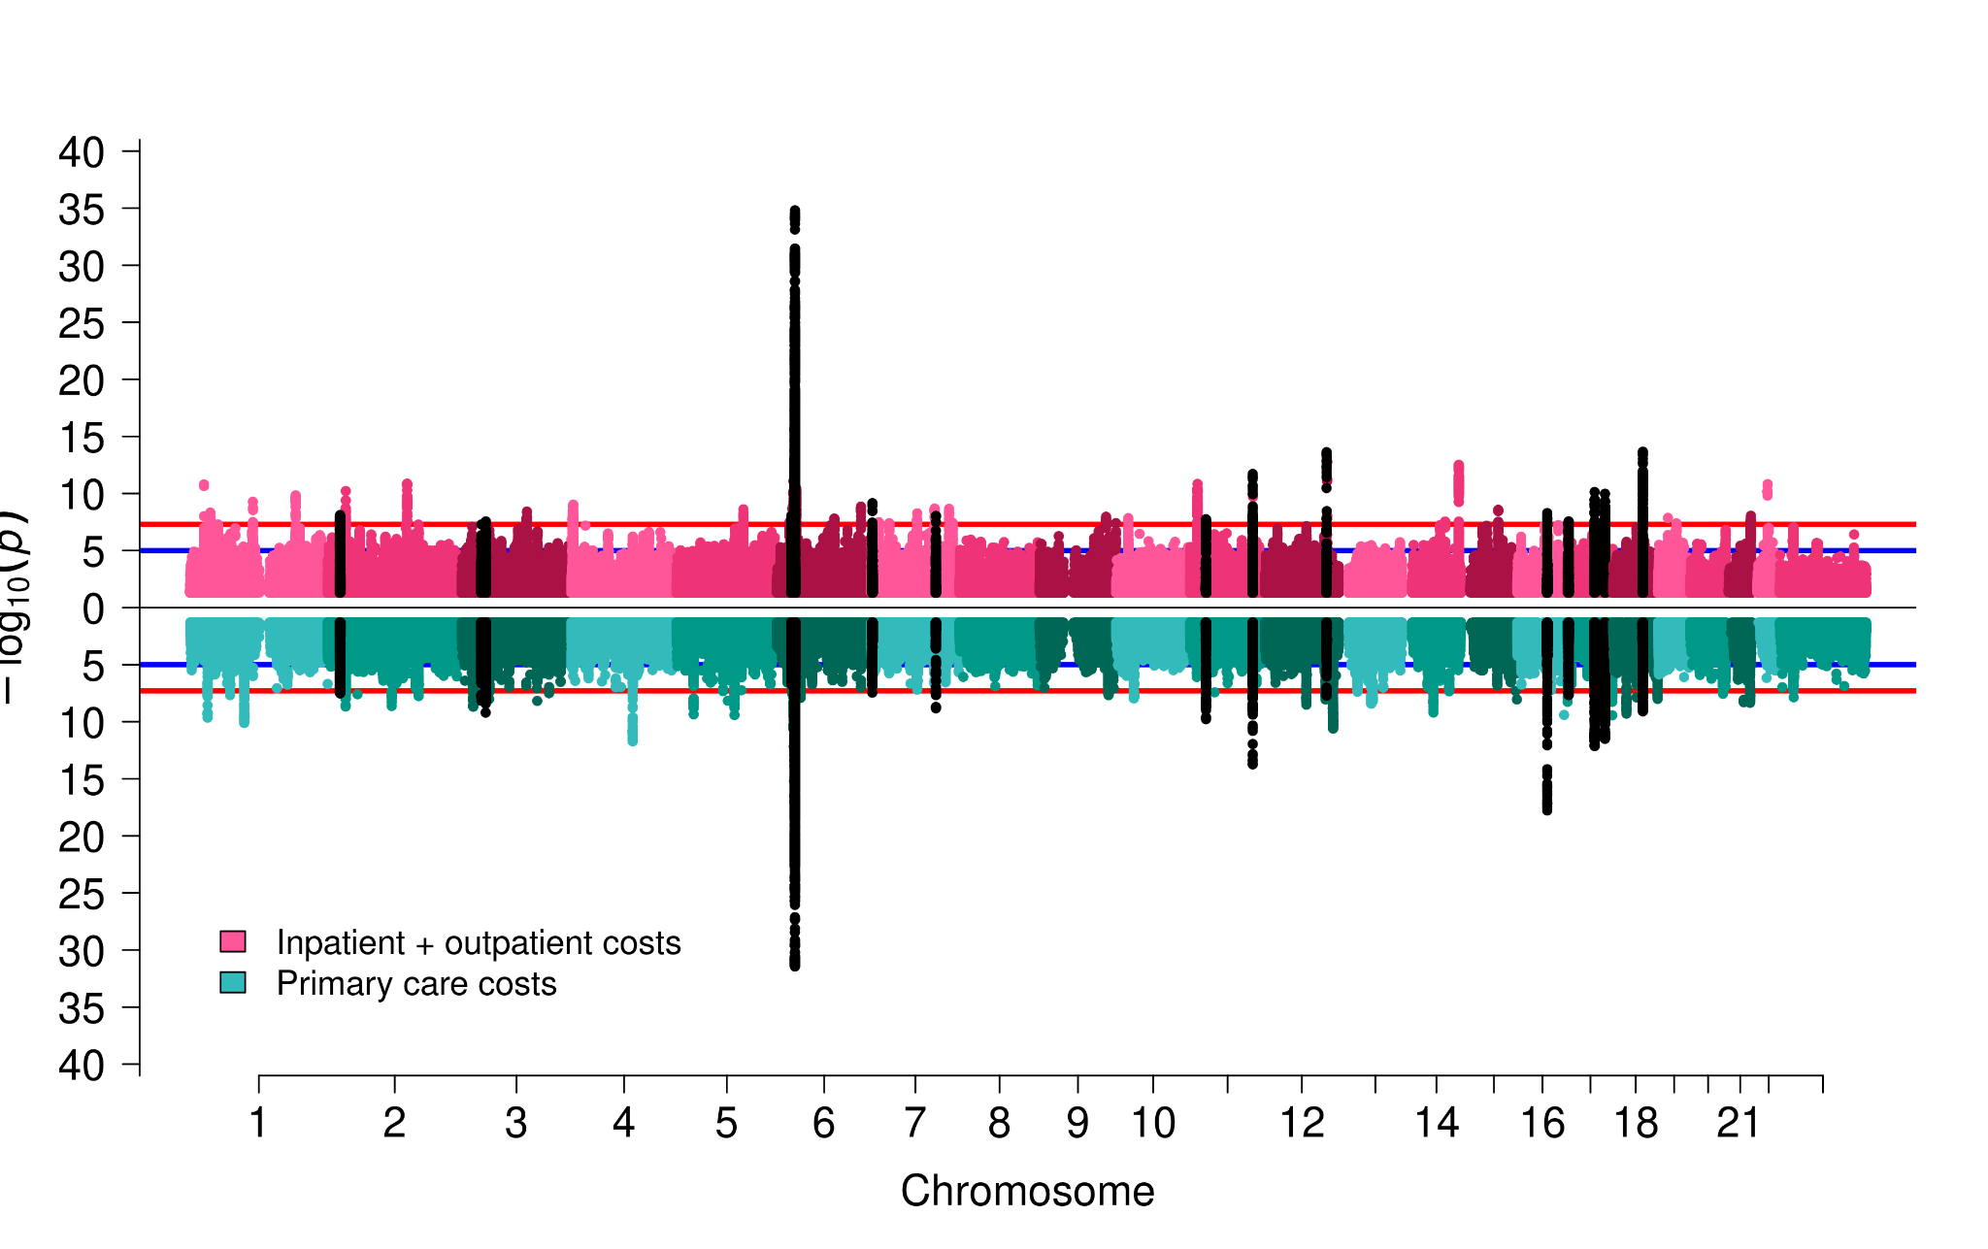

Supplementary Figure 3. Upset plot showing overlap of conditionally independent loci across different cost phenotypes.
