SUPPLEMENTARY MATERIALS
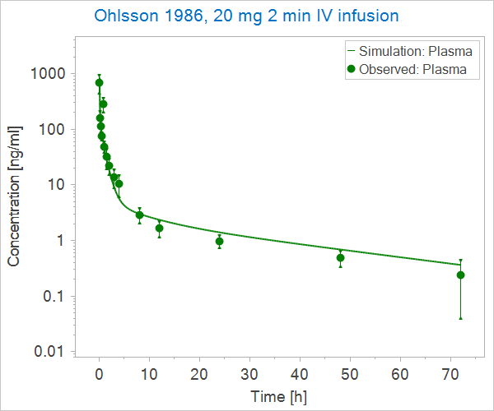
Figure S1. IV model optimization using Ohlsson, Lindgren¹, 20 mg IV infusion dataset.
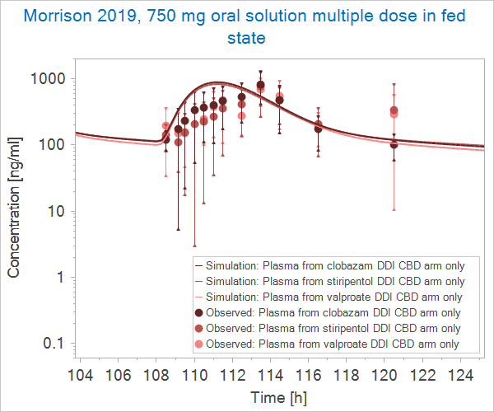
Figure S2. Oral fed state model evaluation using Morrison, Crockett², 750 mg multiple dose datasets.

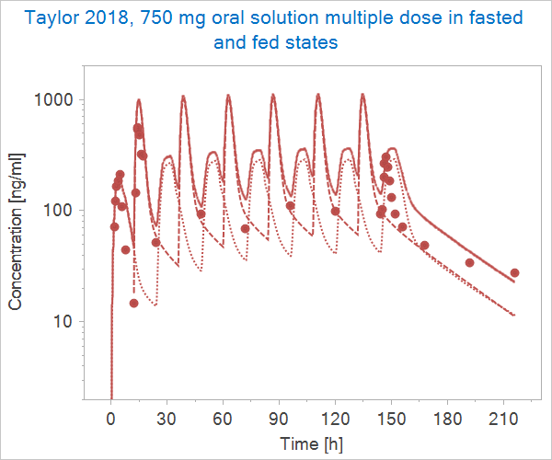
Figure S3. Oral fasted and fed state models evaluation using Taylor, Gidal³, 750 mg multiple dose dataset. The solid line represents simulated CBD plasma concentrations from administration in the fasted (morning) and fed (evening) states which reflect the dosing regimen in the study. The dotted and dashed lines represent administration in only the fasted and fed states, respectively.

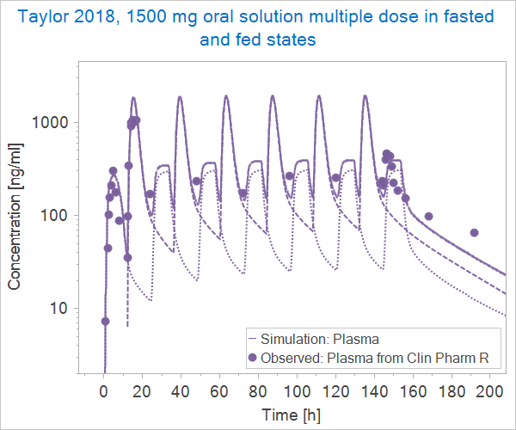
Figure S4. Oral fasted and fed state models evaluation using Taylor, Gidal³, 1500 mg multiple dose dataset. The solid line represents simulated CBD plasma concentrations from administration in the fasted (morning) and fed (evening) states which reflect the dosing regimen in the study. The dotted and dashed lines represent administration in only the fasted and fed states, respectively.

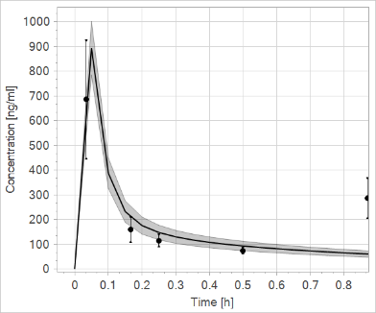
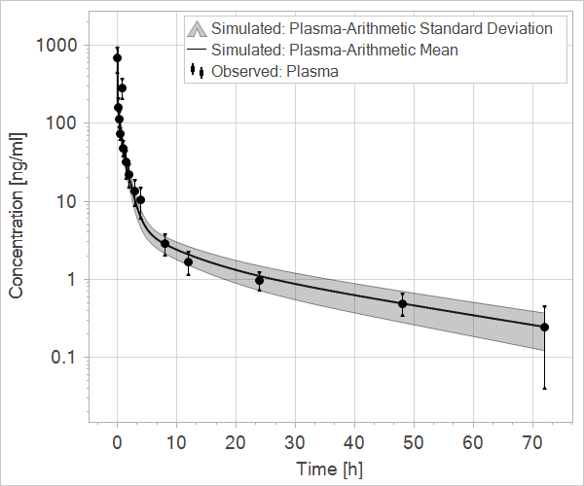
Figure S5. Population simulation compared to observed data from Ohlsson, Lindgren¹, 20 mg IV infusion. Box shows close up of profile between 0 and 0.9 hours.

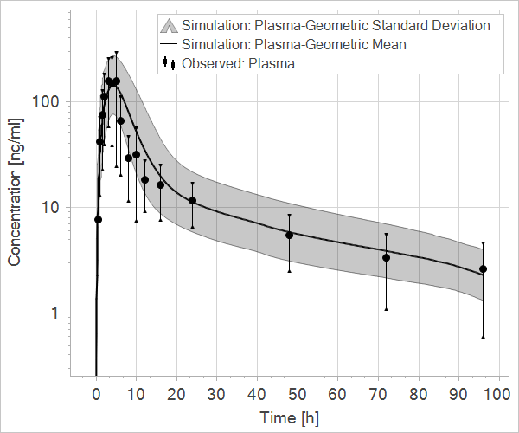
Figure S6. Population simulation compared to observed data from Crockett, Critchley⁴, 750 mg oral solution dataset.

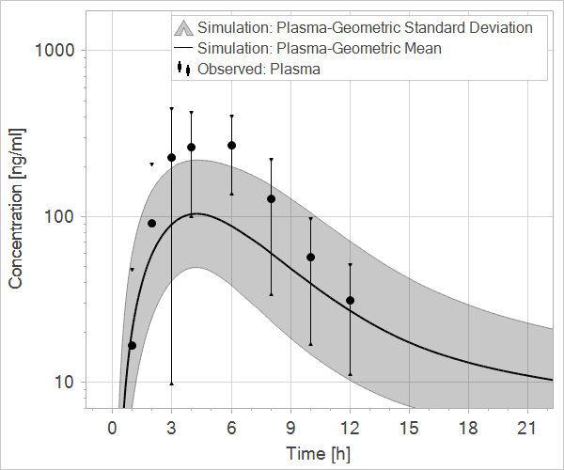
Figure S7. Population simulation compared to observed data from Schoedel, Szeto⁵, 750 mg oral solution dataset.

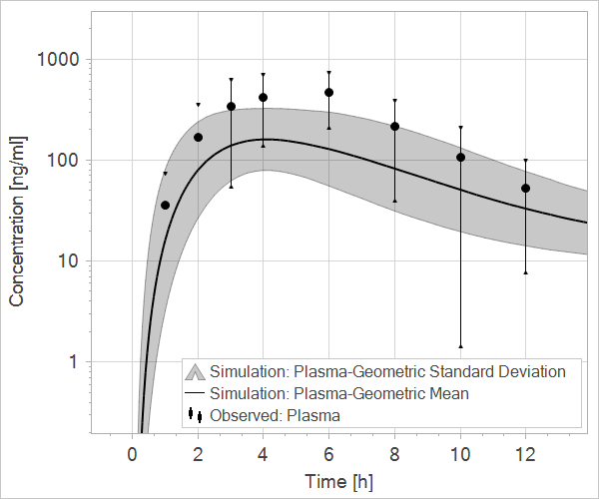
Figure S8. Population simulation compared to observed data from Schoedel, Szeto⁵, 1500 mg oral solution dataset.

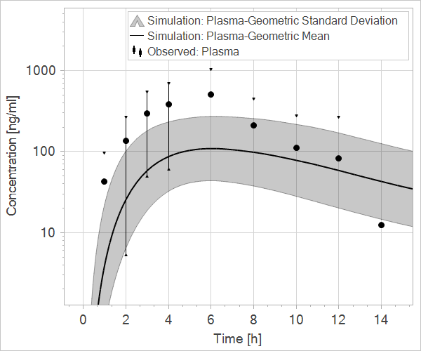
Figure S9. Population simulation compared to observed data from Schoedel, Szeto⁵, 4500 mg oral solution dataset.

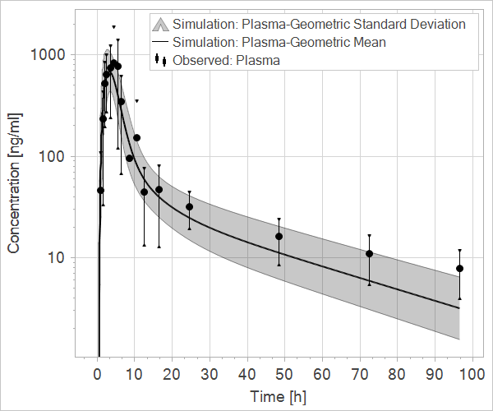
Figure S10. Population simulation compared to observed data from Crockett, Critchley⁴, 750 mg oral solution in the fed state.

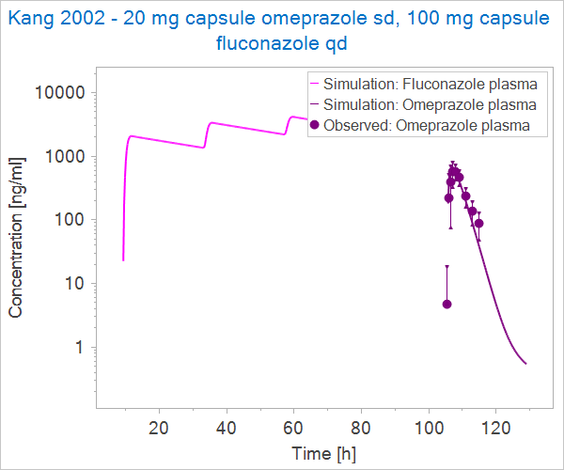
Figure S11. Qualification of CYP2C19 inhibition effect of fluconazole in human using Kang, Yang⁶. Simulated omeprazole plasma concentration-time profile resulting from the addition of CYP2C19 inhibition by co-administered fluconazole.

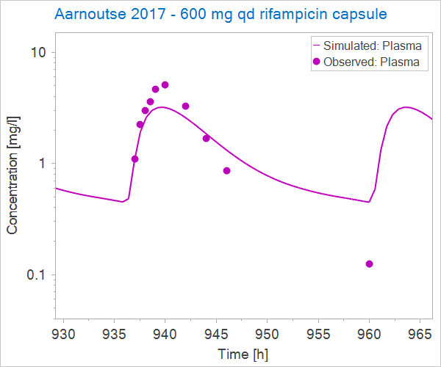
Figure S12. Rifampicin PBPK model⁷ capsule formulation evaluated using Aarnoutse, Kibiki⁸ dataset.

REFERENCES
1. Ohlsson A, Lindgren JE, Andersson S, Agurell S, Gillespie H, Hollister LE. Single-dose kinetics of deuterium-labelled cannabidiol in man after smoking and intravenous administration. Biomed Environ Mass Spectrom. 1986;13:77-83.
2. Morrison G, Crockett J, Blakey G, Sommerville K. A phase 1, open-label, pharmacokinetic trial to investigate possible drug-drug interactions between clobazam, stiripentol, or valproate and cannabidiol in healthy subjects. Clin Pharmacol Drug Dev. 2019;8:1009-1031.
3. Taylor L, Gidal B, Blakey G, Tayo B, Morrison G. A phase I, randomized, double-blind, placebo-controlled, single ascending dose, multiple dose, and food effect trial of the safety, tolerability and pharmacokinetics of highly purified cannabidiol in healthy subjects. CNS Drugs. 2018;32:1053-1067.
4. Crockett J, Critchley D, Tayo B, Berwaerts J, Morrison G. A phase 1, randomized, pharmacokinetic trial of the effect of different meal compositions, whole milk, and alcohol on cannabidiol exposure and safety in healthy subjects. Epilepsia. 2020;61:267-277.
5. Schoedel KA, Szeto I, Setnik B, et al. Abuse potential assessment of cannabidiol (CBD) in recreational polydrug users: A randomized, double-blind, controlled trial. Epilepsy Behav. 2018;88:162-171.
6. Kang BC, Yang CQ, Cho HK, Suh OK, Shin WG. Influence of fluconazole on the pharmacokinetics of omeprazole in healthy volunteers. Biopharm Drug Dispos. 2002;23:77-81.
7. Open Systems Pharmacology - PBPK Model Library - Rifampicin [Internet]. 2021 [cited February 16, 2022]. Available from: https://github.com/Open-Systems-Pharmacology/OSP-PBPK-Model-Library/tree/master/Rifampicin.
8. Aarnoutse RE, Kibiki GS, Reither K, et al. Pharmacokinetics, tolerability, and bacteriological response of rifampin administered at 600, 900, and 1,200 milligrams daily in patients with pulmonary tuberculosis. Antimicrob Agents Chemother. 2017;61:e01054-17

