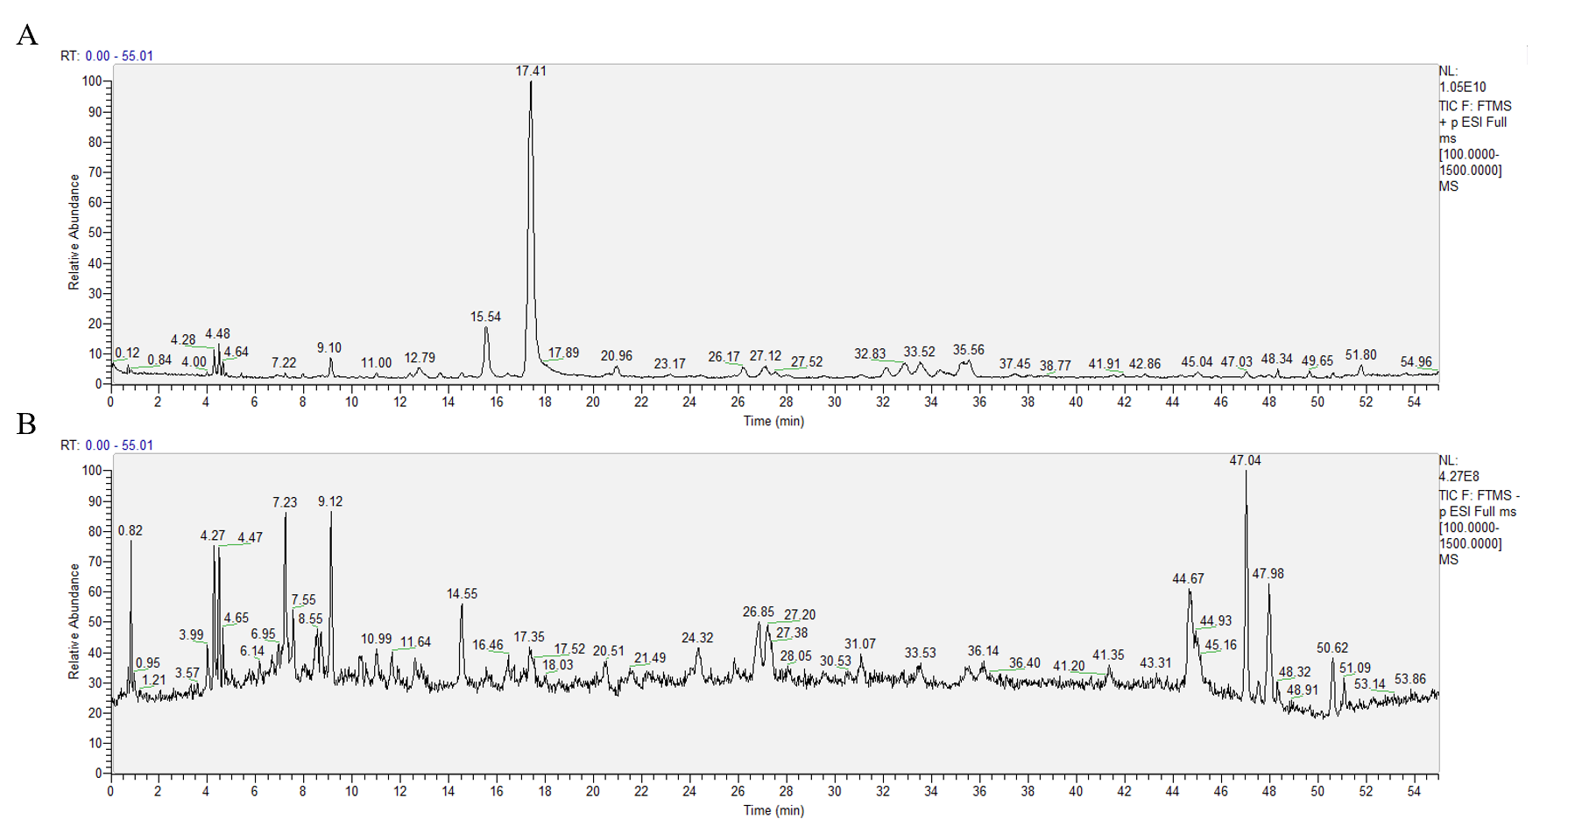
Figure S1. Total ion (Base peak) chromatograms of PEFC at positive mode (A) and negative mode (B).
We subsequently quantitatively analyzed Ligustilide (the most abundant component in PEFC) with high-performance liquid chromatography (HPLC) for quality control. We prepared PEFC stock solutions by dissolving 2.0 g of each analyte in 25 ml of diluted methanol and used the Hypersil GOLDTMC18 chromatographic column (250 mm × 4.6 mm, 5 μm, Thermo scientific, USA) with the following chromatographic separation parameters for quality control: mobile phase: 0.05% (V/V) phosphoric acid (A) + acetonitrile (B) (0~15 min, 20 % B; 15~25 min, 20%~30% B; 25~40 min, 30%~40% B, 40~55 min, 40%~45% B; 55~65 min, 45%~55% B; 65~80 min, 55%~60% B; 80~90 min, 60%~90% B); detection wavelength: 237 nm; column temperature: 35 °C; flow rate: 1.0 ml/min; injection volume: 10 μL.
The chromatogram of PEFC is shown in Figure S2 (A): peak 1 represents the characteristic peak of Ligustilide, whose content in 1.0 g of PEFC was 120.31 mg.
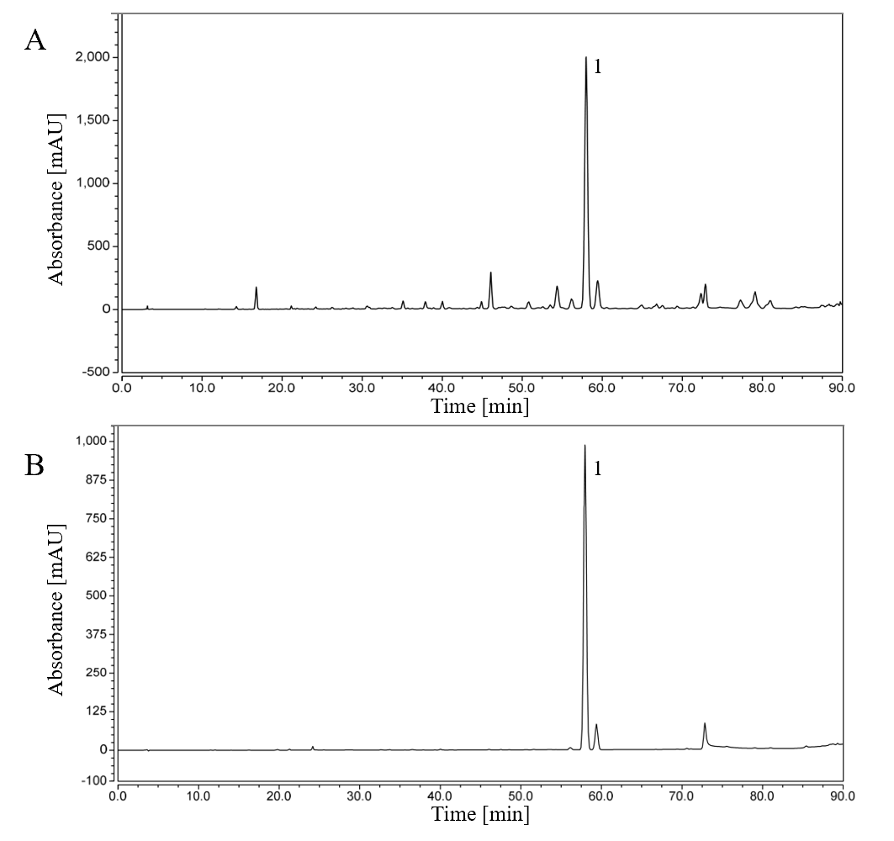
Figure S2. The quality control map of PEFC. (A) High performance liquid chromatography (HPLC) map of XYSEF sample. Peak 1 represents peak characteristic of Ligustilide. (B) HPLC map of reference substance, peak 1 represents peak characteristic of Ligustilide.

Behavioral despair depression models, including tail suspension test (TST) and forced swimming test (FST), are well-accepted and commonly used rodent models for antidepressant assessments. In our previous study, we used the behavioral despair depression model to initially screen for the effective dose range of the antidepressants in PEFC. Two batches of 5-week-old male ICR mice were used for the TST and FST, respectively (Figure S3.). Mice were housed for a 3-day period of adaptation and then randomly assigned by body weight: control group, fluoxetine group (FLX, 13.2 mg·kg⁻¹, i.g.), and PEFC (11.0 mg·kg⁻¹, 22.0 mg·kg⁻¹, 33.0 g·kg⁻¹ and 44.0 g·kg⁻¹, i.g., calculated as a dose of herbal medicine); eight mice per group.
In the behavioral despair mice model, PEFC at 11.0 mg·kg⁻¹, 22.0 mg·kg⁻¹, 33.0 g·kg⁻¹ and 44.0 g·kg⁻¹ shortened the duration of immobility in the TST and FST at different magnitudes compared to the control group, and shows a certain dose-dependence (Figure S4.). PEFC at 44.0 g·kg⁻¹ exhibited the most potent efficacy, pointing to the existence of a positive dose-effect relationship in the 11.0 mg·kg⁻¹ to 44.0 mg·kg⁻¹ dose range. Therefore, we selected 11.0 mg·kg⁻¹, 22.0 mg·kg⁻¹ and 44.0 g·kg⁻¹ of PEFC as the herbal drug doses for subsequent CUMS experiments.
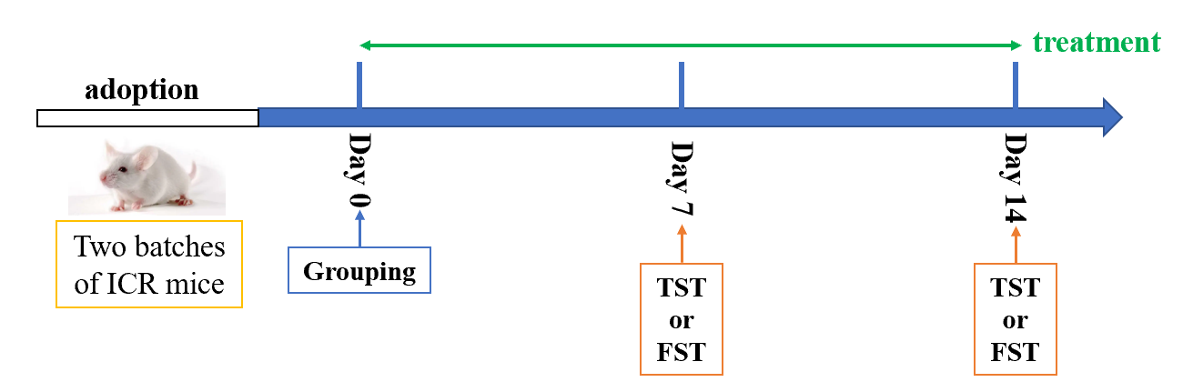
Figure S3. Experimental protocol for the behavioral despair depression model.
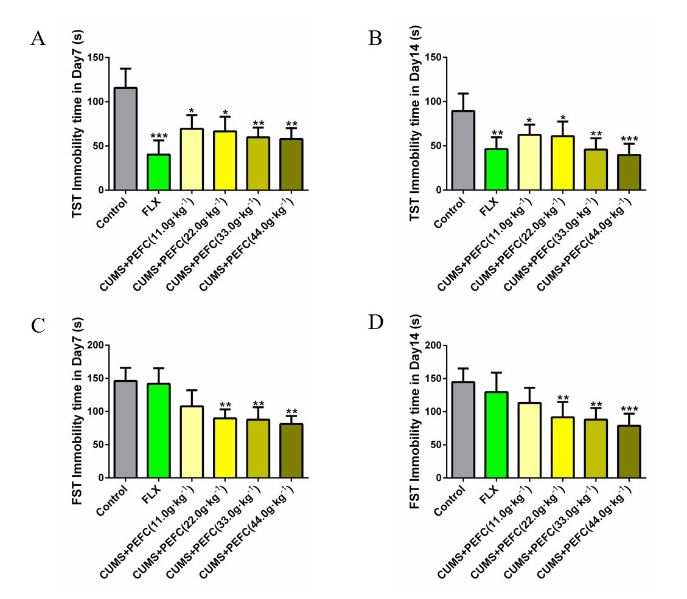
Figure S4. Immobility time in the tail suspension test (TST) and forced swimming test (FST) (n = 8). In the TST performed after day 7 or day 14 of administration, PEFC at doses of 11.0 mg·kg⁻¹, 22.0 mg·kg⁻¹, 33.0 g·kg⁻¹ and 44.0 g·kg⁻¹ were reduced the immobility time of mice to different degrees and showed a dose-dependent effect (A, B). Similar effects of PEFC were observed in FST (C, D). Data were normalized to the control and presented as means ± SEM. *p < 0.05, **p < 0.01, ***p < 0.001 vs. control.

