SUPPLEMENTARY TABLES
Supplementary table 1: Descriptive statistics of the behavioral and psychological variables of interest in the EMA sample (n= 99)
 | Healthy Control (N=35) |  |  | Any SUD (N=64) |  |  | Alcohol (N= 32) |  |  | Tobacco (N=20) |  |  | Cannabis (N=12)
 | M | SD | % | M | SD | % | M | SD | % | M | SD | % | M | SD | %
Age | 34 * | 8.22 |  | 41.66 | 11.81 |  | 44.20 ^{B} | 11.30 |  | 43.40 ^{C} | 11.10 |  | 32.00 | 10.20
Sex (% male) |  |  | 51.42 |  |  | 51.56 |  |  | 62.50 ^{B} |  |  | 20 ^{C} |  |  | 81.81
Education (years) | 14.40 | 2.91 |  | 13.40 | 2.52 |  | 13.10 | 2.24 |  | 14.40 | 2.70 |  | 12.60 | 2.57
Current Depressive Comorbidity |  |  | - |  |  | 17.18 |  |  | 21.87 |  |  | 5.00 |  |  | 27.27
Compliance |  |  | 94.29*** |  |  | 86 |  |  | 87.43 |  |  | 86 |  |  | 83.43
Addiction Severity for primary Substance (ASI) | - | - |  | 6.52 | 0.73 |  | 6.53 | 0.76 |  | 6.45 | 0.76 |  | 6.58 | 0.67
Mean Stroop Time (s) | 10.67*** | 2.248 |  | 14.43 | 4.91 |  | 16.07 ^{A} | 5.88 |  | 12.88 | 2.91 |  | 12.61 ^{B} | 3.12
Mean craving (Per day) | 1.02*** | 0.10 |  | 2.85 | 1.46 |  | 2.51 ^{B} | 0.971 |  | 2.87 | 1.40 |  | 3.73 | 1.47
Substance use of any substance (Per day) | 0.28*** | 0.61 |  | 3.20 | 1.58 |  | 3.48 | 1.52 |  | 2.89 | 1.61 |  | 2.98 | 1.54
Substance use of primary substance (Per day) | - | - |  | 1.98 | 1.66 |  | 1.52 ^{A} | 1.53 |  | 2.73 | 1.62 |  | 1.92 | 1.62

S.d. : standard deviation; Min : minimum; Max. : maximum ;* : <.05; **< .01 ; ***<.001 ; A : Alcohol ≠ Tobacco ; B : Alcohol ≠ Cannabis ; C Tobacco ≠ Cannabis.

Supplementary Table 2: Description of the MNI coordinates and AAL label for the center of the 84 Regions Of Interest derived from the Dictionary Learning networks.
ROI | MNI_x | MNI_y | MNI_z | AAL_label
1 | -8,58 | -30,44 | 62,89 | Paracentral_Lobule_L
2 | -43,17 | 4,41 | -16,23 | Temporal_Pole_Sup_L
3 | -0,43 | -28,59 | -47,63 | Vermis_10
4 | 9,08 | -22,01 | 13,82 | Thalamus_R
5 | 43,45 | 8,71 | -17,35 | Temporal_Pole_Sup_R
6 | -36,44 | 17,85 | -2,31 | Insula_L
7 | 44,79 | 19,73 | 1,49 | Frontal_Inf_Oper_R
8 | -29,45 | -75,62 | -24,19 | Cerebelum_Crus1_L
9 | -32,02 | 60,47 | 6,52 | Frontal_Mid_L
10 | 0,92 | -12,53 | 10,97 | Thalamus_R
11 | 5,85 | 9,25 | 70,80 | Supp_Motor_Area_R
12 | 26,61 | -79,18 | -23,43 | Cerebelum_Crus1_R
13 | 32,82 | 61,96 | 3,47 | Frontal_Mid_R
14 | -52,57 | -20,76 | 27,89 | Postcentral_L
15 | 31,44 | 18,96 | 18,53 | Insula_R
16 | 51,04 | -42,35 | 25,16 | SupraMarginal_R
17 | -57,27 | -26,29 | -17,47 | Temporal_Inf_L
18 | 2,62 | 38,56 | -16,38 | Rectus_R
19 | 56,78 | -10,91 | -21,22 | Temporal_Mid_R
20 | -13,75 | 21,08 | 26,76 | Cingulum_Ant_L
21 | 5,68 | -41,58 | -63,60 | Cerebelum_9_R
22 | 4,48 | -29,26 | -4,94 | Lingual_R
23 | 9,63 | 18,50 | 27,25 | Cingulum_Ant_R
24 | -42,60 | 0,11 | 37,82 | Precentral_L
25 | -39,44 | 39,55 | 36,76 | Frontal_Mid_L
26 | 28,55 | -64,93 | 48,68 | Angular_R
27 | 40,60 | 2,47 | 42,40 | Precentral_R
28 | -60,29 | -19,73 | 10,01 | Temporal_Sup_L
29 | -33,42 | -81,34 | -13,83 | Fusiform_L
30 | -30,74 | -43,17 | -54,09 | Cerebelum_8_L
31 | -31,94 | 4,24 | -18,12 | Amygdala_L
32 | -9,95 | -71,36 | 61,23 | Precuneus_L
33 | -6,68 | -40,36 | 77,08 | Paracentral_Lobule_L
34 | 0,96 | 3,21 | 42,68 | Cingulum_Mid_R
35 | 18,78 | -6,90 | -24,49 | ParaHippocampal_R
36 | 27,84 | -90,25 | -12,50 | Lingual_R
37 | 30,61 | -44,94 | -54,85 | Cerebelum_8_R
38 | 32,90 | 62,56 | -8,32 | Frontal_Mid_Orb_R
39 | 49,94 | -66,54 | -13,80 | Occipital_Inf_R
40 | -40,50 | 9,66 | -11,41 | Insula_L
41 | 0,99 | -45,98 | -20,43 | Vermis_3
42 | 39,16 | 15,44 | -13,43 | Insula_R
43 | -61,70 | -16,73 | -10,29 | Temporal_Mid_L
44 | -54,26 | 20,16 | 14,20 | Frontal_Inf_Tri_L
45 | -48,37 | -66,32 | 31,89 | Angular_L
46 | -23,23 | -19,73 | -14,12 | Hippocampus_L
47 | -21,23 | 32,13 | 45,84 | Frontal_Sup_L
48 | -0,39 | -55,14 | 31,66 | Precuneus_L
49 | -0,30 | 58,88 | -6,32 | Frontal_Med_Orb_L
50 | 5,08 | -54,03 | -48,48 | Cerebelum_9_R
51 | 25,09 | -20,26 | -13,68 | Hippocampus_R
52 | 22,55 | 32,33 | 49,35 | Frontal_Sup_R
53 | 51,89 | -63,29 | 30,74 | Angular_R
54 | 63,43 | -8,63 | -11,98 | Temporal_Mid_R
55 | -66,94 | -49,28 | -1,76 | Temporal_Mid_L
56 | -57,24 | -56,94 | 44,76 | Parietal_Inf_L
57 | -0,79 | 32,15 | 47,25 | Frontal_Sup_Medial_L
58 | 27,36 | -100,37 | 0,19 | Occipital_Mid_R
59 | 58,22 | -58,31 | 40,48 | Parietal_Inf_R
60 | -54,15 | -7,25 | 35,64 | Postcentral_L
61 | 20,72 | -74,53 | 41,99 | Occipital_Sup_R
62 | 45,25 | -19,95 | 42,58 | Postcentral_R
63 | 0,60 | -50,19 | -38,85 | Vermis_9
64 | -50,99 | -29,51 | 24,20 | SupraMarginal_L
65 | -31,58 | 36,25 | 28,57 | Frontal_Mid_L
66 | 9,53 | -99,13 | 21,03 | Occipital_Sup_R
67 | 31,25 | -74,61 | -52,93 | Cerebelum_7b_R
68 | 40,08 | 31,85 | 31,10 | Frontal_Mid_R
69 | 61,72 | -56,17 | -2,68 | Temporal_Inf_R
70 | 0,81 | 48,14 | 15,13 | Cingulum_Ant_L
71 | -61,14 | -23,80 | 24,88 | SupraMarginal_L
72 | -55,76 | 7,31 | 26,56 | Precentral_L
73 | -50,15 | 35,98 | 15,70 | Frontal_Inf_Tri_L
74 | -19,76 | -68,37 | -55,00 | Cerebelum_8_L
75 | 47,44 | 14,34 | 28,19 | Frontal_Inf_Oper_R
76 | 61,13 | -26,72 | 24,17 | SupraMarginal_R
77 | -44,84 | -8,73 | -39,32 | Temporal_Inf_L
78 | -24,32 | -76,43 | -49,69 | Cerebelum_7b_L
79 | 24,90 | -76,64 | -49,57 | Cerebelum_7b_R
80 | 41,90 | -9,07 | -39,62 | Temporal_Inf_R
81 | -56,46 | -45,17 | 10,36 | Temporal_Mid_L
82 | 13,46 | -86,62 | 13,90 | Calcarine_R
83 | 61,67 | -14,79 | 12,35 | Temporal_Sup_R
84 | 7,08 | -19,81 | 27,26 | Cingulum_Mid_R

SUPPLEMENTARY FIGURES
Supplementary figure 1: Description of the network’s components and their corresponding explained variance
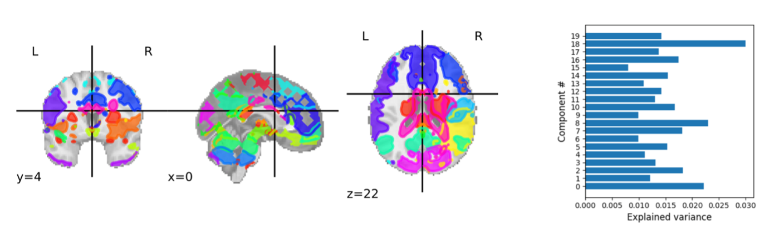
Legend: L: Left, R: Right
Legend: Dictionary Learning Model was fit into the rs dataset to decompose spatial maps based on sparsity. Each derived component represents a distinct functional network (see left figure) accounting for part of the explained variance in the fMRI BOLD time series (see right figure). Using Nilearn’s Regions Extractor, these networks were automatically segmented into Regions Of Interest (See supplementary Table 1) that were used to build the individual connectomes.

Supplementary figure 2: Illustration of the direct effect of Primary substance use at time t and Primary substance use at time t+1 and the moderating effect of Momentary Stroop Performance (group-centered).

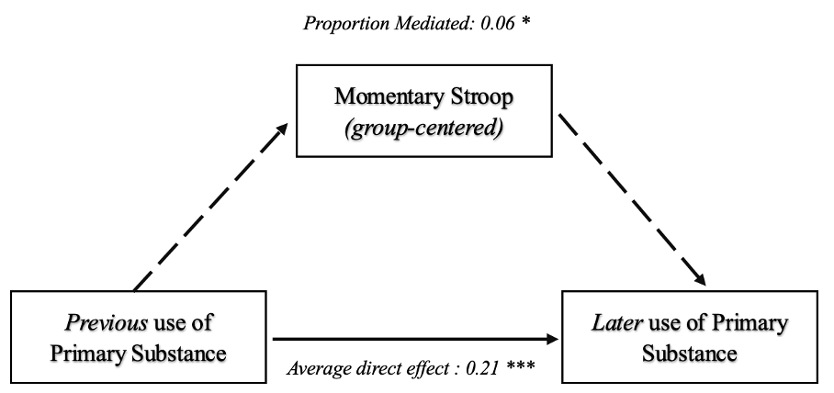

Legend: ***:p<.001, *:p<.05

