Supplemental Figure 1: Participant Consort
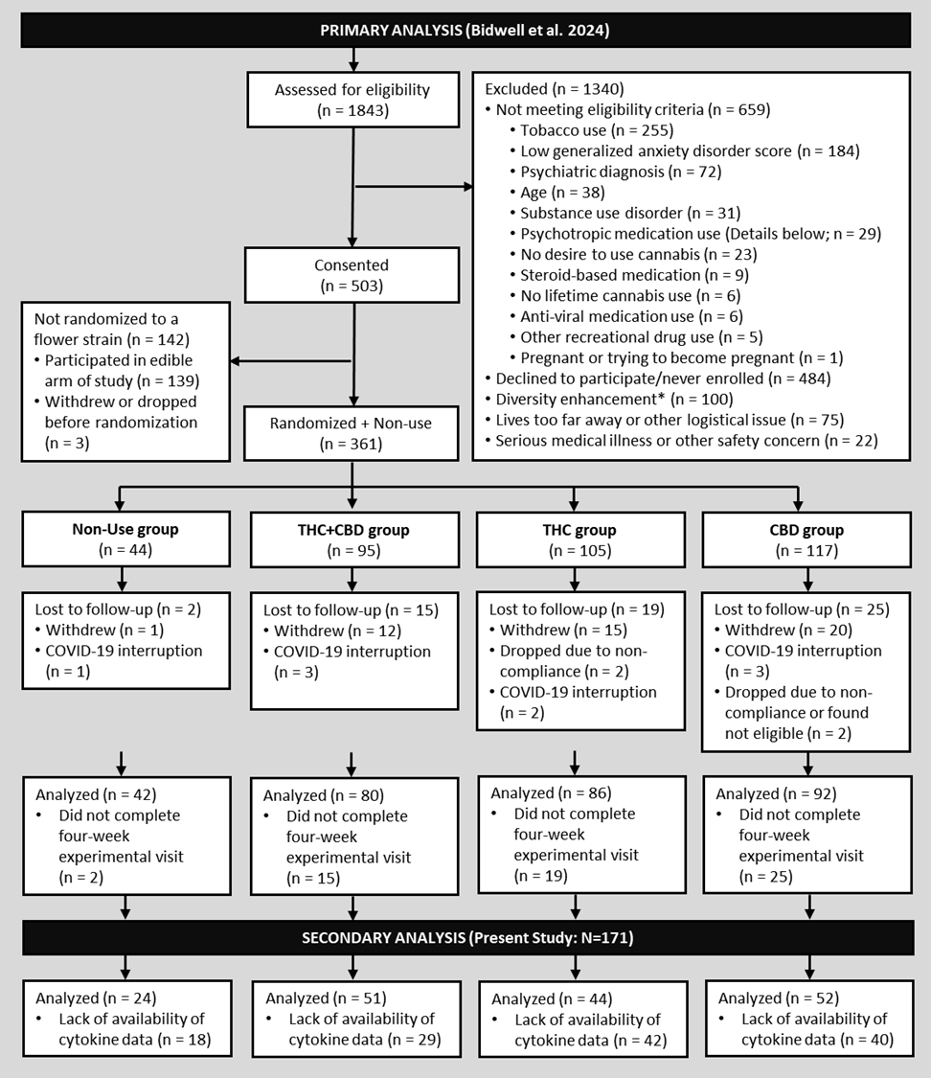
Note. Participants included in this secondary analysis (present study) were pulled from the primary analysis presented in Bidwell et al. 2024 based on the availability of cytokine data.

Supplemental Figure 2. Correlation Table
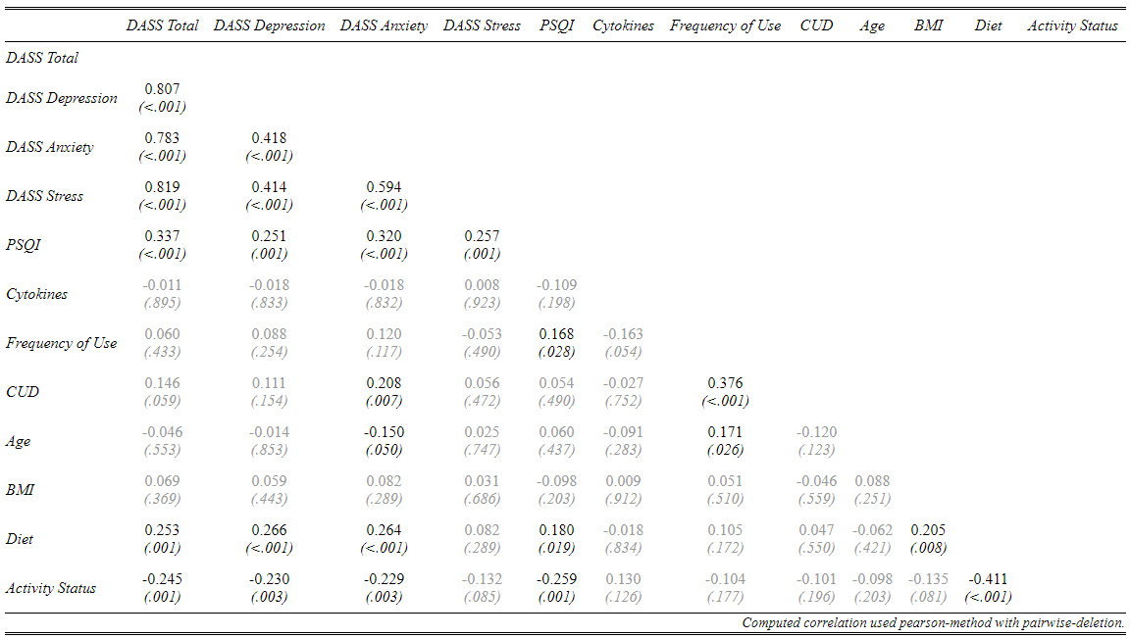
Note. Depression, Anxiety, and Stress Scale (DASS), Pittsburg Sleep Quality Index (PSQI), Cannabis Use Disorder (CUD), and Body Mass Index (BMI). *p<0.05, **p<0.01, ***p<0.001

Supplemental Figure 3. Blood Cannabinoid Concentration by Group at Week-4
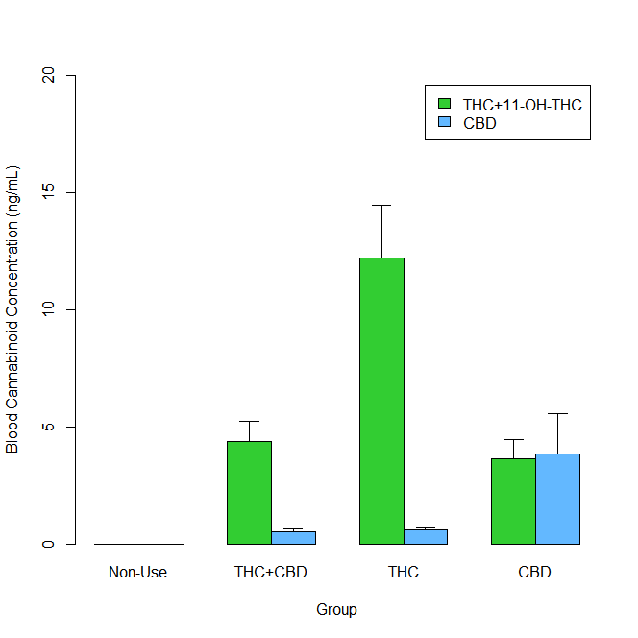
Note. Group means ± SE are depicted for Week-4 plasma concentrations of delta-9-tetrahydrocannabinol + 11-hydroxy-tetrahydrocannabinol (THC+11-OH-THC), and cannabidiol (CBD). Average THC+11-OH-THC was highest in the THC group, whereas average CBD was highest in the CBD group. No cannabinoids were detected in the Non-Use group.

Supplemental Figure 4. Moderation Model of DASS Depression and Anxiety Subscale Scores by Group Controlling for Baseline Cytokine Concentrations
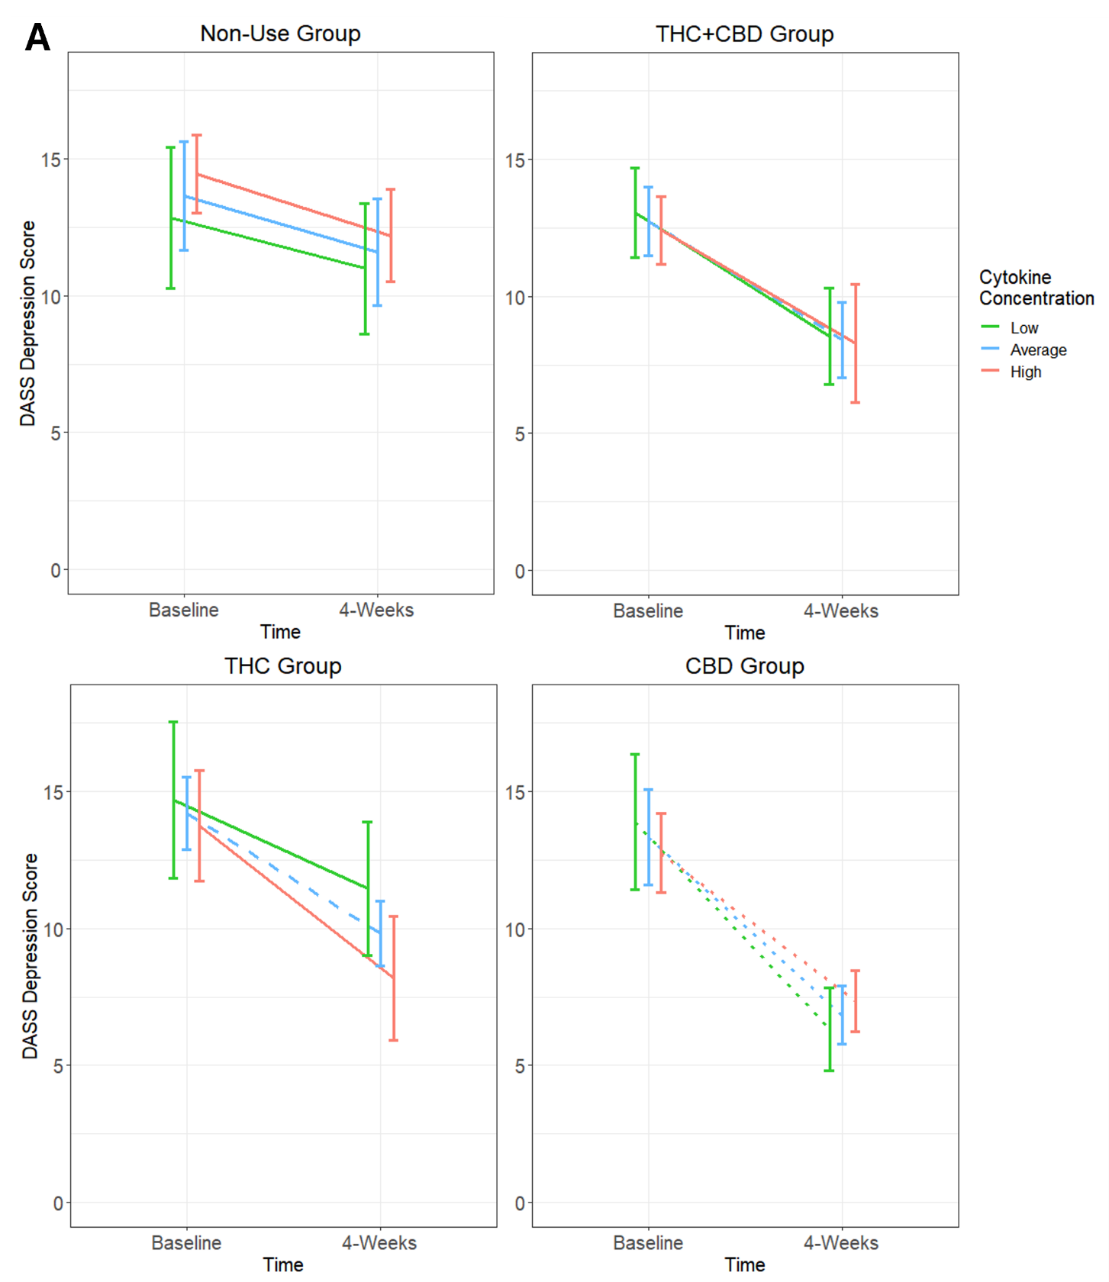

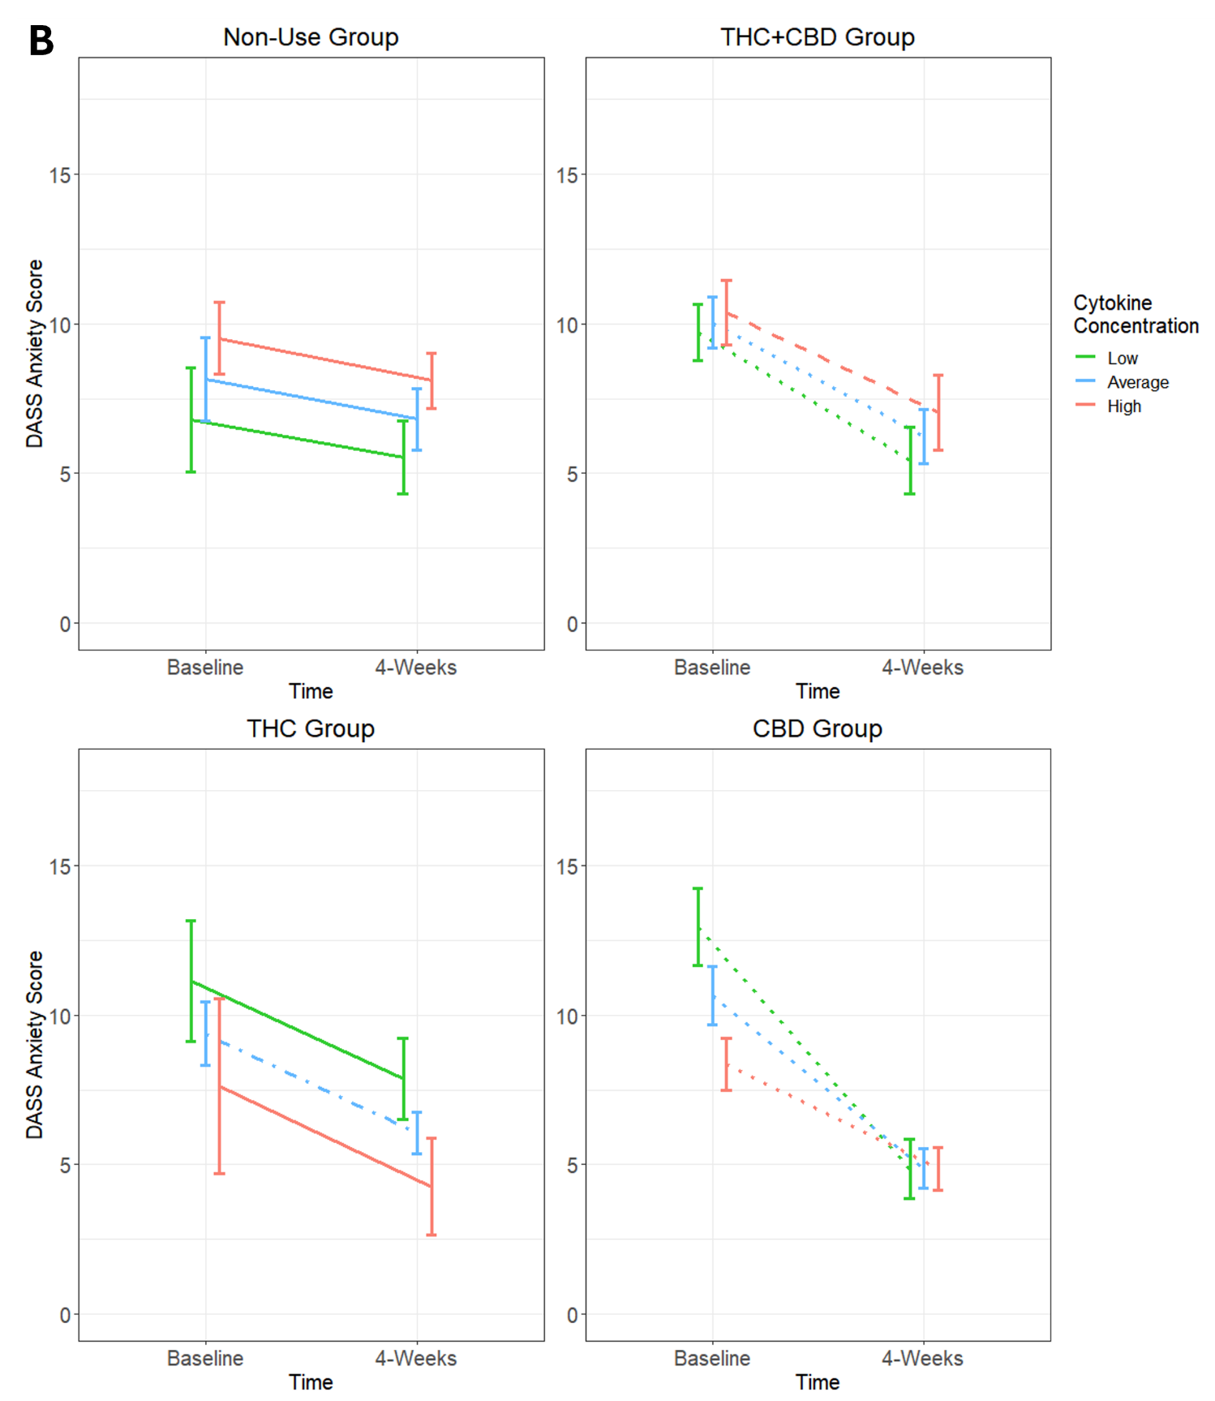
Note. A. DASS Depression. B. DASS Anxiety. Group estimated means ± SE are plotted for both sets of graphs. P-values of simple effects are represented by the following: solid p>0.05, dashed p<0.05, dot-dash p<0.01, dotted p<0.001. Age, body mass index (BMI), diet, activity status, and time of day when blood was collected were used as covariates in this moderation model.
Supplemental Figure 5. Group by Time Effects for Pittsburg Sleep Quality Index Scores
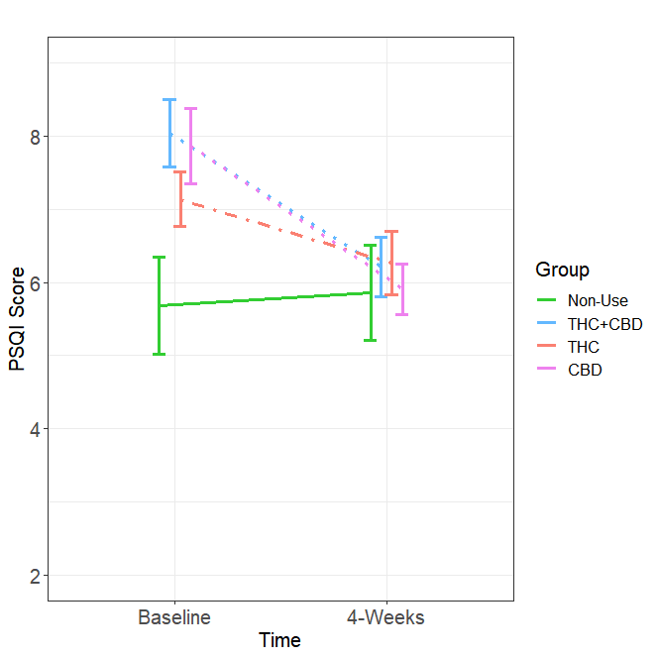
Note. Group estimated means ± SE are plotted. Simple effects by Group over Time: Non-Use (difference = 0.18, SE = 0.6, p=0.75), THC+CBD (difference = -1.83, SE = 0.5, p<0.001), THC (difference = -0.88, SE = 0.3, p=0.003), CBD (difference = -1.95, SE = 0.5, p<0.001). Age, body mass index (BMI), diet, activity status, and time of day when blood was collected were used as covariates in this moderation model.

