Supplementary Material
Association between regular antithrombotic drugs use and Nonbiliary Acute Pancreatitis risk: a prospective cohort study
Chenyang Wei^{1,2,†}, Ningning Mi^{1,2,3,†}, Jinyu Zhao^{1,2}, Pengfei Li^{1,2}, Zhengping An^{1,2}, Sheng Chen^{1,2}, Yanyan Lin^{1,2}, Ping Yue^{1,2}, Jinqiu Yuan^{3*}, Wenbo Meng^{1,2*}
¹The First School of Clinical Medicine, Lanzhou University, Lanzhou, Gansu, China
²Department of General Surgery, The First Hospital of Lanzhou University, Lanzhou, Gansu, China
³Clinical Research Center, Big Data Center, The Seventh Affiliated Hospital, Sun Yat-sen University, Shenzhen, Guangdong, China
*These authors are the corresponding authors
†Chenyang Wei and Ningning Mi have contributed equally to this work.
Correspondence
Wenbo Meng, Department of General Surgery, The First Hospital of Lanzhou University, Lanzhou, 730000, Gansu, China. Email: mengwb@lzu.edu.cn
Jinqiu Yuan, Clinical Research Center, Big Data Center, The Seventh Affiliated Hospital, Sun Yat-sen University, Shenzhen, 518107, Guangdong, China. Email: yuanjq5@mail.sysu.edu.cn

Supplementary Table 1. Assessment of main exposures.
Supplementary Table 2. Covariates about Physical activity and Dietary characteristics.
Supplementary Table 3. Effect modification by diabetes and hyperlipidemia on the Supplementary association between antithrombotic drug use and Nonbiliary Acute Pancreatitis risk.
Supplementary Table 4. Sensitivity analysis regarding risk of Nonbiliary Acute Pancreatitis according to Antithrombotic use.
Supplementary Table 5. Baseline characteristics according to Antithrombotic use after 1:4 propensity score matching.
Supplementary Figure 1. Flowchart of participant selection.

Supplementary Table 1. Assessment of main exposures.
Description | Questionnaire | Responses | Field ID
Prescription medications taking | Do you regularly take any other PRESCRIPTION medications? (Do not forget medications such as puffers or patches) | SELECT one of 4 from  1 : Yes - you will be asked about this later by an interviewer  0 : No  1 : Do not know -3 : Prefer not to answer | 2492

Field ID | Meaning | Data-Coding 4
20003 | Warfarin | 1140888266
20003 | Sodium Warfarin | 1140910832
20003 | Marevan 0.5mg tablet | 1141164760
20003 | Dipyridamole | 1140861778
20003 | Persantin 25mg tablet | 1140861780
20003 | Angettes 75mg tablet | 1140861804
20003 | Aspirin 75mg tablet | 1140861806
20003 | Disprin CV 100mg m/r tablet | 1140861808
20003 | Clopidogrel | 1141168318
20003 | Plavix 75mg tablet | 1141168322

Supplementary Table 2. Covariates about Physical activity and Dietary characteristics.
Healthy diet items | Questionnaire | Healthy diet | Unhealthy diet
Fruit | “About how many of …. would you eat per day?” Separate questions for pieces of fresh and dried fruit. | ≥ 4.5 pieces/day | < 4.5 pieces/day
Vegetable intake | “About how many of …. would you eat per day?” Separate questions for tablespoons of salad or cooked/raw vegetables. | ≥4.5 servings/day | < 4.5 servings/day
Total fish intake | “How often do you eat oily fish? (e.g., sardines, salmon, mackerel, herring)” | ≥2 times/week | < 2 times/week
Red meat intake | “How often do you eat…?” Separate questions for Beef/lamb or mutton/pork (excluding processed meats such as ham or bacon). | ≤5 times/week | >5 times/week
Processed meat intake | “How often do you eat processed meats (such as bacon, ham, sausages, meat pies, kebabs, burgers, chicken nuggets)?” | ≤2 times/week | >2 times/week
Note: Physical activity was measured using the validated short-form International Physical Activity Questionnaire[1].
Dietary characteristics (From touchscreen questionnaire at baseline. Healthy diet patterns were adapted from the American Heart Association Guidelines and were defined as meeting 2 or more healthy diet items).
Tablespoons of vegetables were considered one serving. The healthy diet score was dichotomized as 1 = at least two healthy food items, 0 = fewer than two healthy food items.

Supplementary Table 3. Effect modification by diabetes and hyperlipidemia on the association between antithrombotic drug use and Nonbiliary Acute Pancreatitis risk.
Drug Class | Subgroup | HR (95%CI) | P Value | P for Interaction
Antithrombotic
 | Diabetes: Yes | 1.08 (0.78-1.50) | 0.644 | 0.01
 | Diabetes:No | 1.52 (1.19-1.96) | 0.001
 | Hyperlipidemia: Yes | 1.23 (0.99-1.53) | 0.063 | 0.044
 | Hyperlipidemia: No | 1.96 (1.22-3.15) | 0.006
Anticoagulants
 | Diabetes: Yes | 0.97 (0.54-1.72) | 0.905 | 0.019
 | Diabetes:No | 1.68 (1.18-2.39) | 0.004
 | Hyperlipidemia: Yes | 1.26 (0.89-1.79) | 0.196 | 0.117
 | Hyperlipidemia: No | 1.98 (1.09-3.61) | 0.026
Warfarin
 | Diabetes: Yes | 0.89 (0.49-1.63) | 0.716 | 0.015
 | Diabetes: No | 1.64 (1.15-2.35) | 0.007
 | Hyperlipidemia: Yes | 1.23 (0.87-1.76) | 0.247 | 0.179
 | Hyperlipidemia: No | 1.82 (0.97-3.42) | 0.062
Antiplatelets
 | Diabetes: Yes | 1.13 (0.76-1.68) | 0.549 | 0.099
 | Diabetes: No | 1.40 (1.00-1.96) | 0.05
 | Hyperlipidemia: Yes | 1.21 (0.92-1.59) | 0.164 | 0.218
 | Hyperlipidemia: No | 1.89 (0.88-4.02) | 0.1
Clopidogrel
 | Diabetes: Yes | 1.38 (0.82-2.32) | 0.228 | 0.214
 | Diabetes: No | 1.69 (1.06-2.68) | 0.027
 | Hyperlipidemia: Yes | 1.49 (1.04-2.13) | 0.028 | 0.522
 | Hyperlipidemia: No | 2.10 (0.52-8.56) | 0.298
Note: The model was adjusted for age, gender, ethnicity, the Index of Multiple Deprivation (IMD), BMI, smoking status, alcohol intake, physical activity, dietary characteristics, type 2 diabetes, hypertension, hyperlipidemia, NSAID intake, hypolipidemic drug intake, multivitamin use, and mineral supplement intake. Formal interaction analysis for the subgroup of patients using DOACs or LMWH was not performed due to an insufficient sample size.

Supplementary Table 4. Sensitivity analysis regarding risk of Acute pancreatitis according to Antithrombotic use.
Sensitivity analysis | No. of Acute pancreatitis | No. of participants | Adjusted HR (95%CI) | p-value
1. Added overall History of cardiovascular and cerebrovascular disease to model 3 as model 4 for additional adjustment.
Non-Antithrombotic use | 2080 | 420614 | 1.00 (Reference)
Antithrombotic use | 109 | 11140 | 1.31(1.08-1.61) | 0.007
2. Excluding cholelithiasis participants diagnosed within 1 years after baseline (N=428,986).
Non-Antithrombotic use | 1997 | 418028 | 1.00 (Reference)
Antithrombotic use | 98 | 10958 | 1.21 (1.16-1.26) | <0.001
3. Propensity score matching cohort between Antithrombotic use and non-Antithrombotic use (1:4 matching, N=55249).
Non-Antithrombotic use | 336 | 44218 | 1.00 (Reference)
Antithrombotic use | 109 | 11031 | 1.36 (1.10-1.69) | 0.005
Note: Except for sensitivity analysis 1, which further adjusted for History of cardiovascular and cerebrovascular disease, all other adjusted HRs were adjusted for the following covariates: age, gender, ethnicity, IMD, BMI, smoking status, alcohol intake, physical activity, dietary characteristics, type 2 diabetes, hypertension, hyperlipidemia, NSAID intake, Hypolipidemic drug intake,multivitamin use and intake of mineral supplements. HR, Hazard ratio; CI, confidence interval; IMD, index of multiple deprivation; BMI, body mass index; NSAID, nonsteroidal anti-inflammatory drug.

Supplementary Table 5. Baseline characteristics according to Antithrombotic use after 1:4 propensity score matching.
 | Overall | Antithrombotic use
 | N = 55694 | N = 44554 | N = 11140
Age (mean (SD)) | 61.77 (6.11) | 61.80 (6.07) | 61.67 (6.26)
Male (%) | 38911 (69.9) | 31112 (69.8) | 7799 (70.0)
White race(%) | 52499 (94.3) | 41997 (94.3) | 10502 (94.3)
IMD (mean (SD)) | 19.31 (15.12) | 19.29 (15.07) | 19.40 (15.33)
BMI (mean (SD)) | 29.22 (5.04) | 29.22 (5.01) | 29.21 (5.18)
Smoking (%) | 32190 (57.8) | 25736 (57.8) | 6454 (57.9)
Drinking (%)
Never | 13934 (25.0) | 11124 (25.0) | 2810 (25.2)
Low | 5505 ( 9.9) | 4401 ( 9.9) | 1104 ( 9.9)
Moderate | 23770 (42.7) | 19019 (42.7) | 4751 (42.6)
High | 12423 (22.3) | 9962 (22.4) | 2461 (22.1)
MET_g (%)
high | 15259 (27.4) | 12212 (27.4) | 3047 (27.4)
low | 9491 (17.0) | 7562 (17.0) | 1929 (17.3)
moderate | 16997 (30.5) | 13618 (30.6) | 3379 (30.3)
HealthyDiet (%) | 28768 (51.7) | 23000 (51.6) | 5768 (51.8)
NASIDS (%) | 3615 ( 6.5) | 2916 ( 6.5) | 699 ( 6.3)
Hypolipidemic drug (%) | 40672 (73.0) | 32530 (73.0) | 8142 (73.1)
Vitamin (%) | 8130 (14.6) | 6494 (14.6) | 1636 (14.7)
Mineral (%) | 8005 (14.4) | 6409 (14.4) | 1596 (14.3)
Diabetes (%) | 14783 (26.5) | 11755 (26.4) | 3028 (27.2)
Hypertension (%) | 49330 (88.6) | 39511 (88.7) | 9819 (88.1)
Hyperlipidemia (%) | 47328 (85.0) | 37965 (85.2) | 9363 (84.0)
Myocardial Infarction (%) | 2239 ( 4.0) | 1800 ( 4.0) | 439 ( 3.9)
Coronary Heart Disease (%) | 3066 ( 5.5) | 2467 ( 5.5) | 599 ( 5.4)
PVD (%) | 656 ( 1.2) | 520 ( 1.2) | 136 ( 1.2)
AF (%) | 937 ( 1.7) | 749 ( 1.7) | 188 ( 1.7)
stroke (%) | 932 ( 1.7) | 745 ( 1.7) | 187 ( 1.7)
Note: Abbreviations: SD, standard deviation; NSAID, nonsteroidal anti-inflammatory drug; PVD: myocardial infarction, AF: peripheral vascular disease.
Values are numbers (percentages) unless stated otherwise.

Supplementary Figure 1. Flowchart of participant selection.
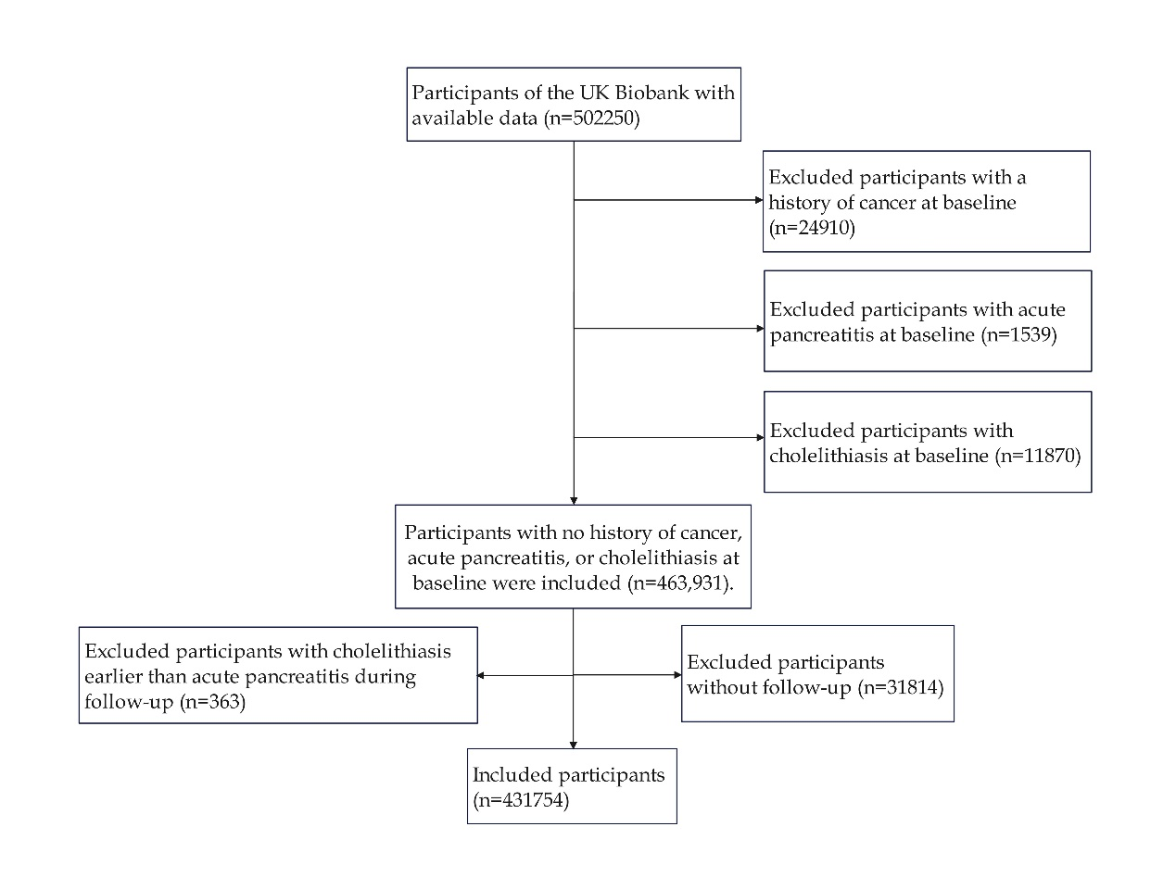
REFERENCE
1. Craig CL, Marshall AL, Sjöström M, Bauman AE, Booth ML, Ainsworth BE, et al. International physical activity questionnaire: 12-country reliability and validity. Med Sci Sports Exerc. 2003;35:1381–95. https://doi.org/10.1249/01.MSS.0000078924.61453.FB

