Supplementary file
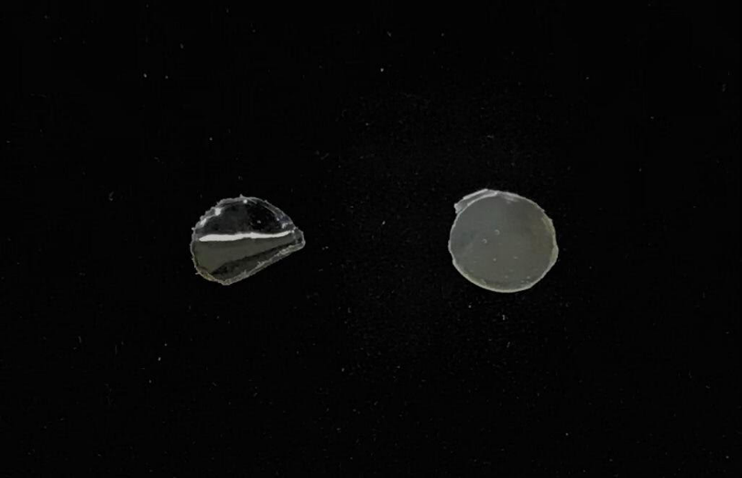

A
B

Photographs of:
- Placebo patch
- Zolmitriptan patch

