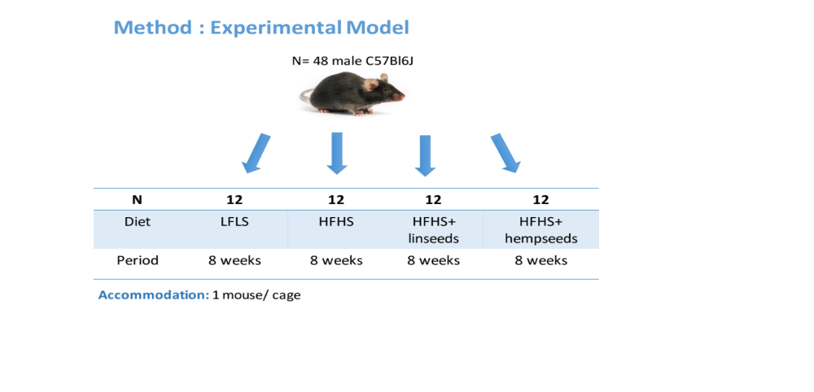
Suppl. Figure 1: Experimental model

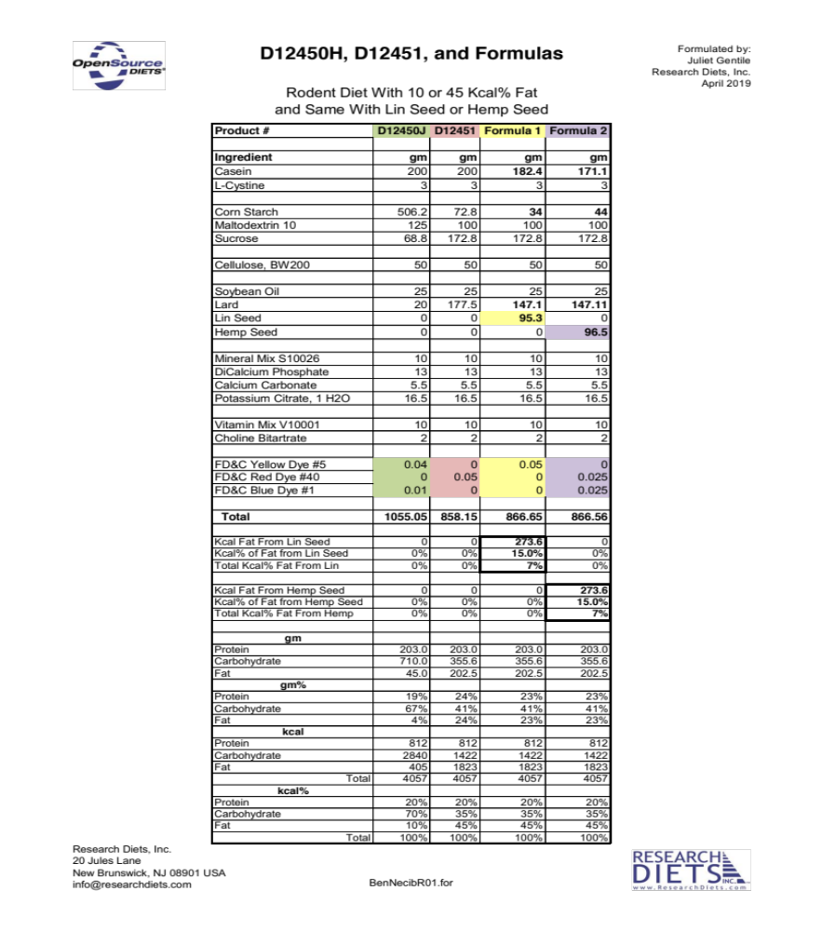
Suppl. Figure 2: diet composition.

Suppl. Figure 3: (A) Body composition at week 0; (B) body composition at week 8 corrected by total body weight. ** (p <0.01); *** (p <0.001)

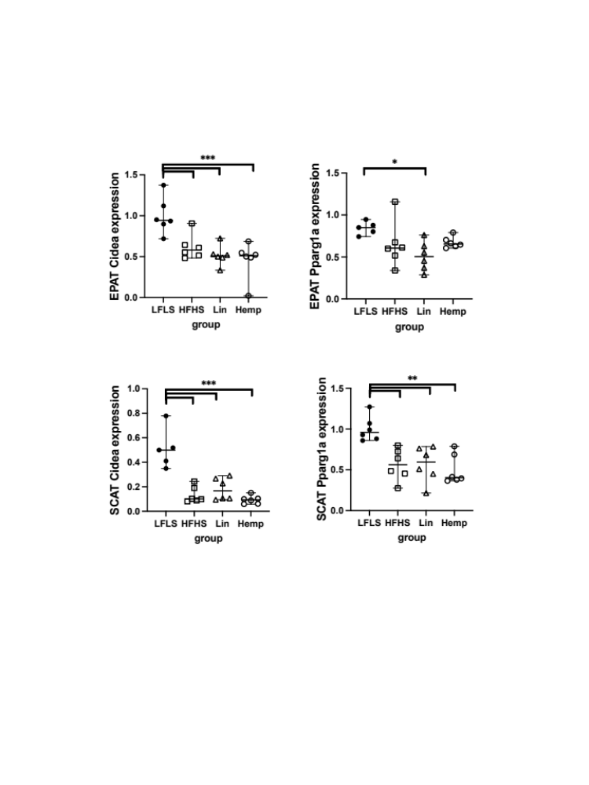

Suppl. Figure 4: Gene expression of Cidea and Pparg1a in adipose tissue. * (p <0.05) ** (p <0.01); *** (p <0.001)

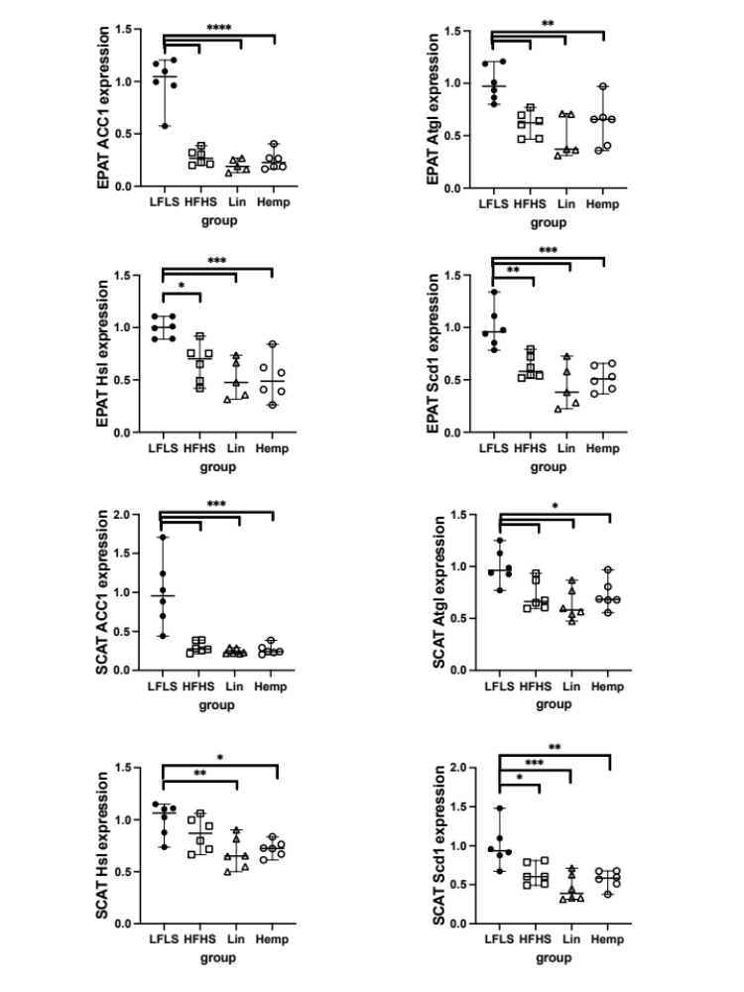
Suppl. Figure 5: Gene expression of Acc1, Atgl, Hsl and Scd1 in adipose tissue. ** (p <0.01); *** (p <0.001)
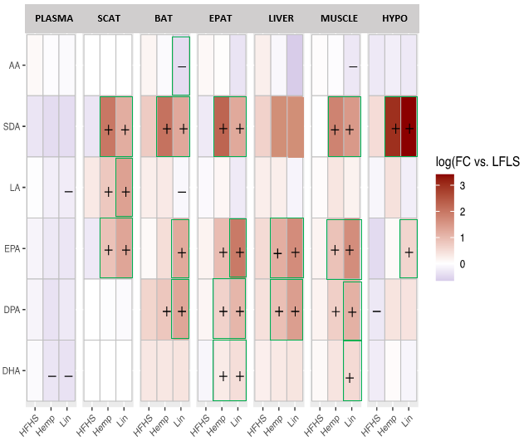

Suppl. Figure 6: Fatty acid levels in different tissues: Brown adipose tissue (BAT), Epididymal adipose tissue (EPAT), Subcutaneous adipose tissue (SCAT), Hypothalamus (HYPO), Liver and Muscle. Statistically significant differences between the high fat high sucrose groups (HFHS, Hemp or Lin) vs the LFLS group are indicated with a ‘’+’’ (increase in expression) or ‘’-‘’ (decrease in expression); p <0.05. Green boxes indicate significant differences between Hemp or Lin and HFHS; p <0.05.

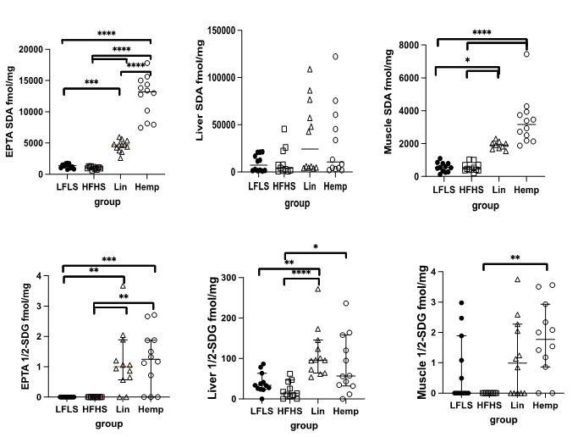

Suppl, Figure 7: SDA and 1/2 SDG profile in selected tissues. * (p <0.05); ** (p <0.01); *** (p <0.001); ****(p <0.00001).

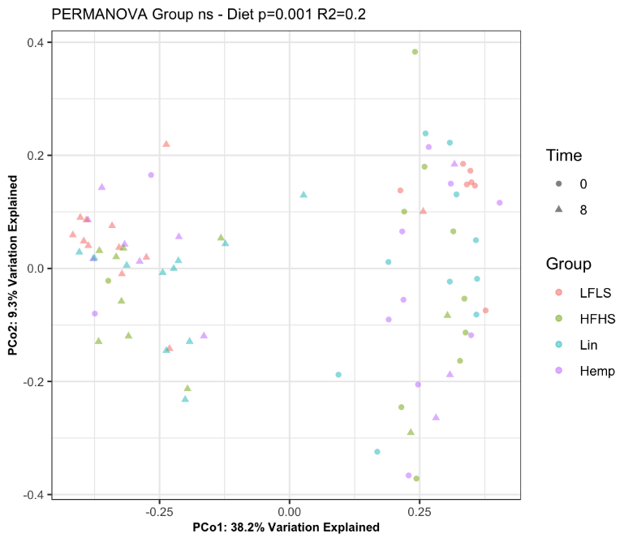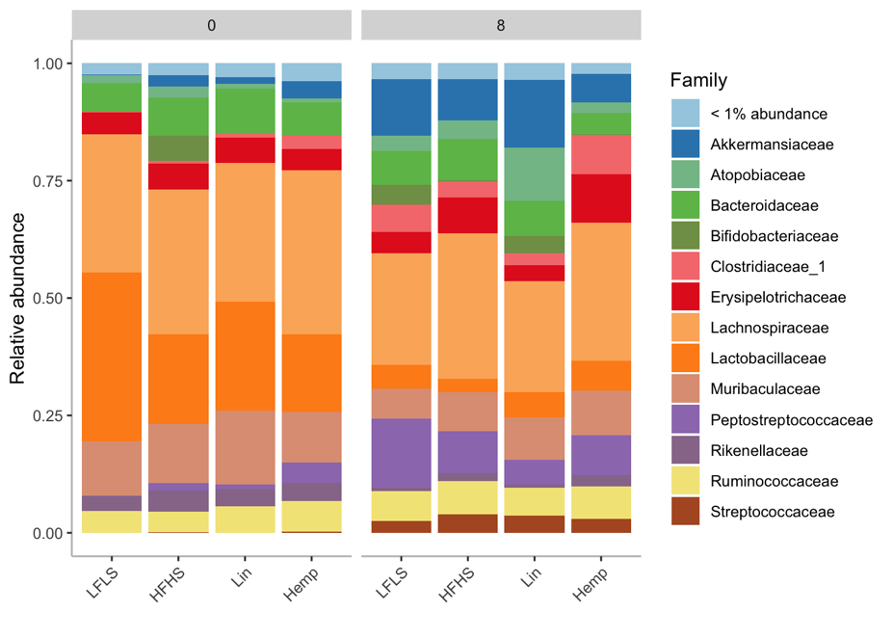
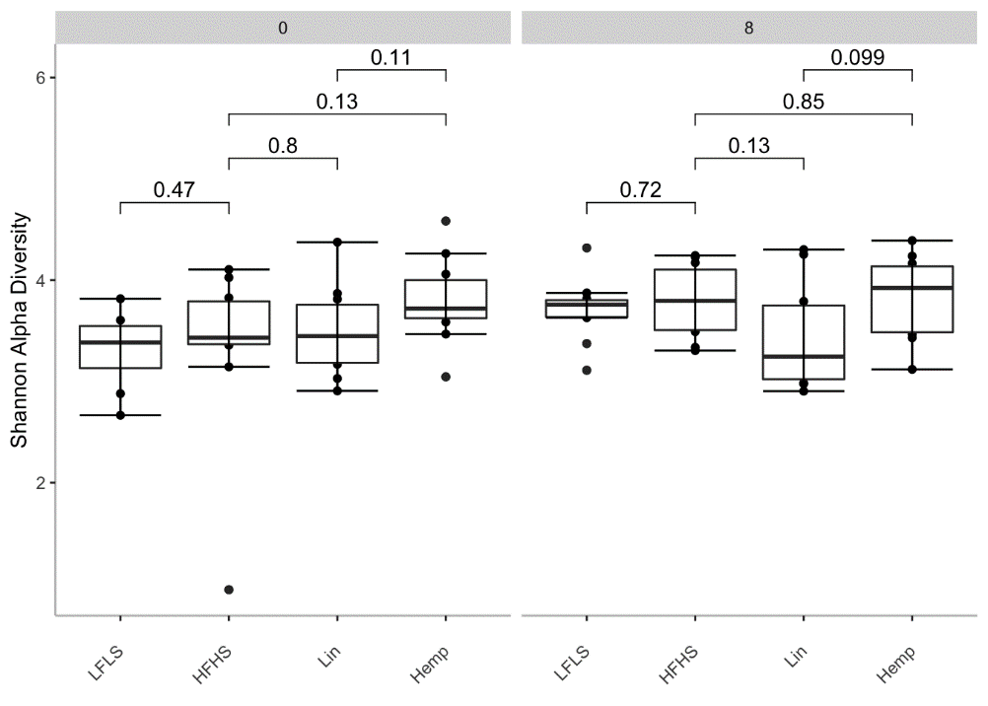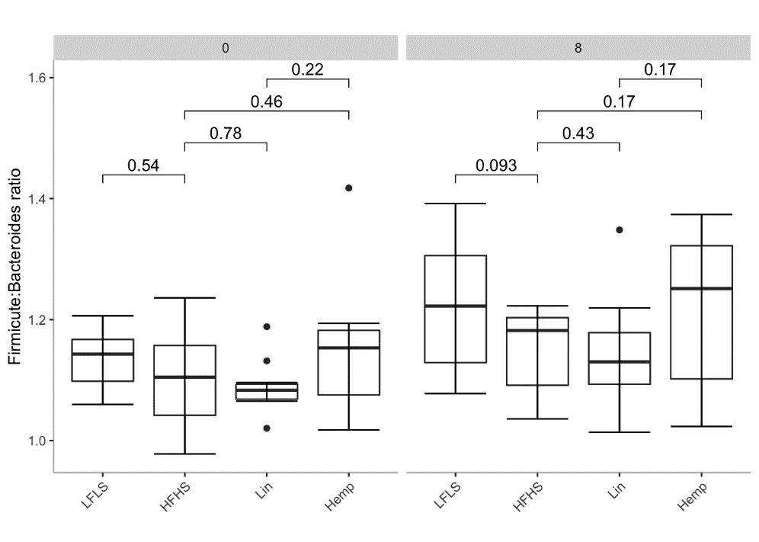

Suppl. Figure 8: Metagenomic analysis: PCoA of all groups showing the effect of switching from chow diet (week 0) to different HFHS diets (week 8) (top left), relative abundance plots of the most prevalent family taxa in each group at (top right), Shannon alpha diversity index to measure bacterial evenness and richness (bottom left) and Firmicutes:Bacteroides ratio (bottom right) at time 0 or after 8 weeks on the HFHS diets.

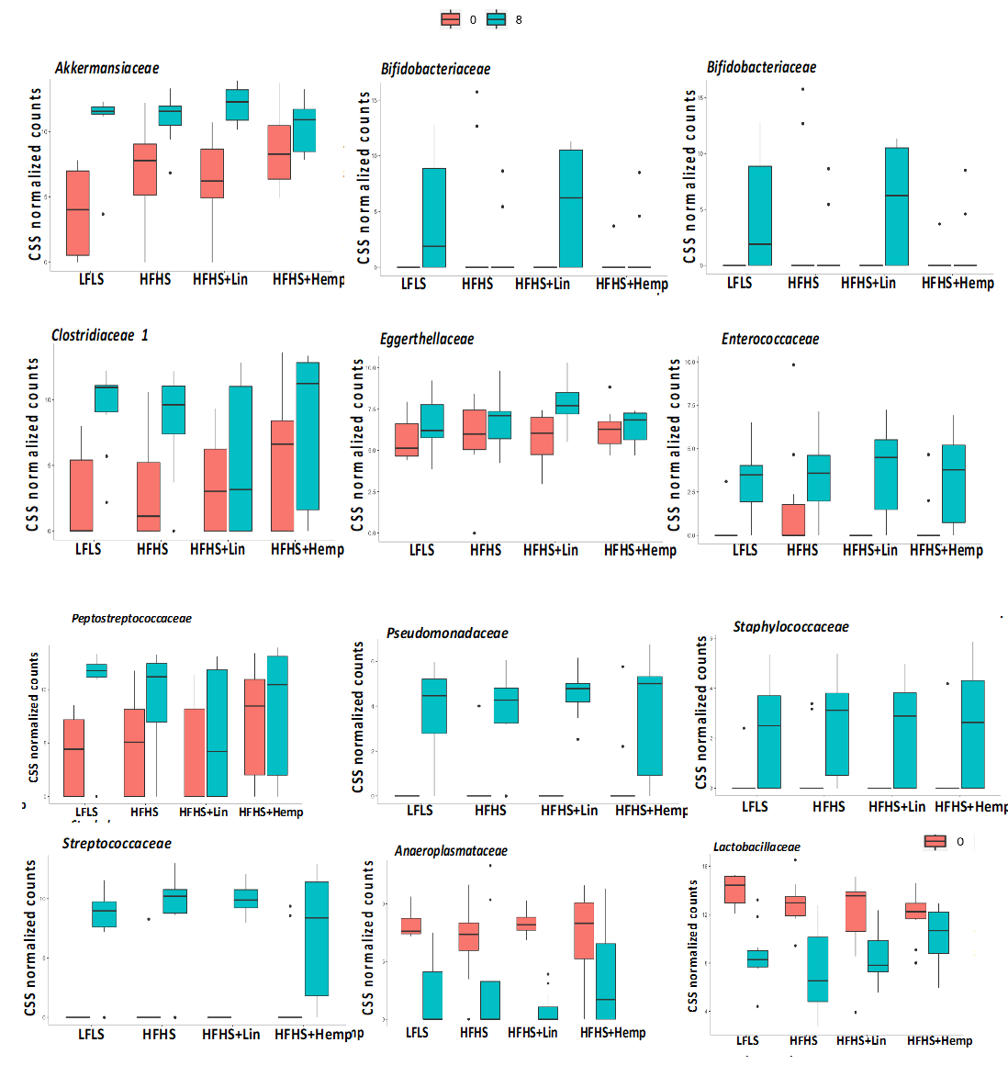
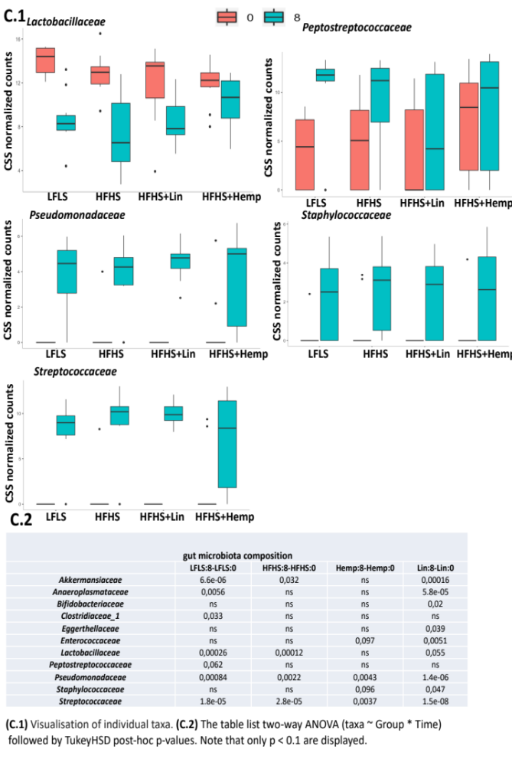
Suppl. Figure 9: Visualization of individual family taxa modified by HFHS diets (top), table detailed results of two-way ANOVA (taxa – Group*Time) followed by Tukey post-hoc analysis showing p-values for intra-diet comparisons between time 0 and week 8 (bottom)
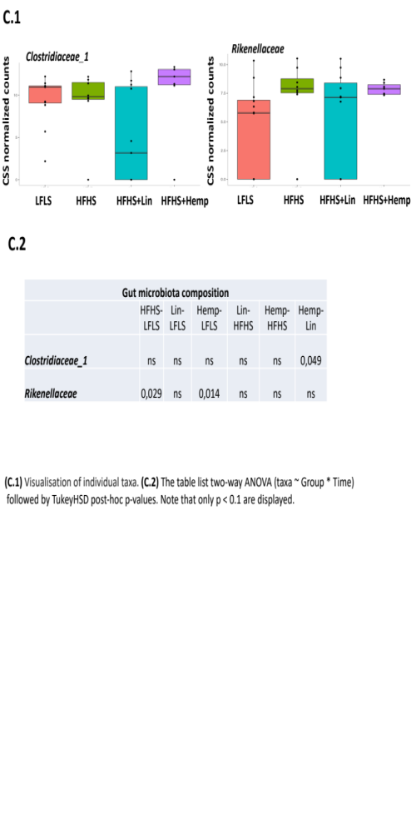
Suppl. Figure 10: Visualization of individual family taxa with different abundances between different diets at week 8 (top), table detailed results of one-way ANOVA followed by Tukey post-hoc analysis showing p-values for inter-diet comparisons at week 8 (bottom)
Suppl. Table 1: List of lipid mediators used as internal standards for LC/MS-MS analyses

Lipid mediators symbol | Lipid mediators name
AEA | d4-Anandamide
PEA | d4-N-palmitoyl-ethanolamine
SEA | stearoyl ethanolamide
OEA | d4-N-oleoyl-ethanolamine
LEA | d4-N-linoleoyl-ethanolamine
EPEA | d4-N-eicosapentaenoyl-ethanolamine
DPEA.n.3 | docosapentaenoyl ethanolamide
DHEA | d4-N-docosahexaenoyl-ethanolamine
DPEA.n.6
1.2-AG | d5-Mono-arachidonoyl-glycerol 1(3) and 2 isomens
1.2-PG | Mono-palmitoyl-glycerol 1(3) and 2 isomers
1.2-OG | 2-oleoyl-glycerol
1.2-LG | d5-Mono-linoleoyl-glycerol 1(3) and 2 isomers
1.2-SDG | stearidonoyl-glycerol
1.2-EPG | d5-Mono-eicosapentaenoyl-glycerol 1(3) and 2 isomers
1.2-DPG (n-3) | d5-Mono-docosapentaenoyl-glycerol 1(3) and 2 isomers
1.2-DHG | docosahexaenoyl-glycerol
AA | d8-Arachidonic acid
SDA | stearidonic acid
LA | linoleic acid
EPA | d5-Eicosapentaenoic acid
DPA | d5-Docosapentaenoic acid
DHA | d5-Docosahexaenoic acid
13.HODE.G | 13-hydroxyoctadecadienoic acid
PGD2 | d4-Prostaglandin D2
PGE2 | d4-Prostaglandin E2
PGF1 | d4-Prostaglandin F1
PGF2 | d4-Prostaglandin F2
Arachidonoyl Serotonin | N-Arachidonoyl Serotonin

Suppl. Table 2: List of eCBome genes analyzed by qPCR array

Gene symbol | Gene name | Function
Adgrf1 | adhesion G protein coupled receptor F1 | receptor
Cacna1b | calcium channel, voltage-dependent, T type, alpha 1B subunit | receptor
Cacna1h | calcium channel, voltage-dependent, T type, alpha 1H subunit | receptor
Cnr1 | cannabinoid receptor 1 | receptor
Cnr2 | cannabinoid receptor 2 | receptor
Gpr119 | G protein-coupled receptor 119 | receptor
Gpr18 | G protein-coupled receptor 18 | receptor
Gpr55 | G protein-coupled receptor 55 | receptor
Ppara | peroxisome proliferator activated receptor alpha | receptor
Pparg | peroxisome proliferator activated receptor gamma | receptor
Ptgfr | prostaglandin F receptor | receptor
Trpa1 | transient receptor potential cation channel, subfamily A, member 1 | ligand-activated channel
Trpm8 | transient receptor potential cation channel, subfamily M, member 8 | ligand-activated channel
Trpv1 | transient receptor potential cation channel, subfamily V, member 1 | ligand-activated channel
Trpv2 | transient receptor potential cation channel, subfamily V, member 2 | ligand-activated channel
Trpv4 | transient receptor potential cation channel, subfamily V, member 4 | ligand-activated channel
Abhd4 | abhydrolase domain containing 4 | anabolic enzyme for NAEs
Akr1b3 | aldo-keto reductase family 1, member B3 (aldose reductase) | anabolic enzyme for prostamides, catabolic enzyme for AEA and 2-AG
Fam213b | family with sequence similarity 213, member B | anabolic enzyme for prostamides,  catabolic enzyme for AEA and 2-AG
Gde1 | glycerophosphodiester phosphodiesterase 1 | anabolic enzyme for NAEs
Gdpd1 | glycerophosphodiester phosphodiesterase domain containing 1 | anabolic enzyme for NAEs
Glyatl3 | glycine-N-acyltransferase-like 3 | anabolic enzyme for N-acyl-glycines
Hrasls5 | HRAS-like suppressor family, member 5 | anabolic enzyme for NAEs
Inpp5d | inositol polyphosphate-5-phosphatase D | anabolic enzyme for NAEs
Napepld | N-acyl phosphatidylethanolamine-specific phospholipase D-like enzyme | anabolic enzyme for NAEs
Pla2g10 | phospholipase A2, group X | anabolic enzyme for NAEs
Pla2g4e | phospholipase A2, group IVE | calcium-dependent N-acyltransferase that generates NAE biosynthetic precursors
Pla2g5 | phospholipase A2, group V | AA-releasing enzyme possibly involved in phospholipid remodeling and hence biosynthesis of eCB precursors
Ptgs2 | prostaglandin-endoperoxide synthase 2 | anabolic enzyme for prostamides, catabolic enzyme for AEA and 2-AG
Ptpn22 | protein tyrosine phosphatase, non-receptor type 22 (lymphoid) | anabolic enzyme for AEA
Ptges | prostaglandin E synthase | anabolic enzyme for prostamides, catabolic enzyme for AEA and 2-AG
Comt | catechol-O-methyltransferase | catabolic enzyme for N-acyl-dopamines
Faah | fatty acid amide hydrolase | catabolic enzyme for NAEs, primary fatty acid amides, N-acyl-taurines and N-acyl-glycines
Naaa | N-acylethanolamine acid amidase | catabolic enzyme for saturated NAEs
Pam | peptidylglycine alpha-amidating monooxygenase | anabolic enzyme for primary fatty acid amides, catabolic enzyme for N-acyl-glycines
Dagla | diacylglycerol lipase, alpha | anabolic enzyme for 2-acylglycerols
Daglb | diacylglycerol lipase, beta | anabolic enzyme for 2-acylglycerols
Dgke | diacylglycerol kinase, epsilon | anabolic/catabolic enzyme for 2-acylglycerols
Enpp2 | ectonucleotide pyrophosphatase/phosphodiesterase 2 | autotaxin- a LysoPLD: produces LPA.
Pla1a | phospholipase A1 member A | anabolic enzyme for 2-acylglycerols
Plcb1 | phospholipase C, beta 1 | anabolic enzyme for 2-acylglycerols
Abhd12 | abhydrolase domain containing 12 | catabolic enzyme for monocylglycerols
Abhd16a | abhydrolase domain containing 16 | catabolic enzyme for monocylglycerols
Abhd6 | abhydrolase domain containing 6 | catabolic enzyme for monocylglycerols
Agk | acylglycerol kinase | catabolic enzyme for monocylglycerols
Alox12 | arachidonate 12-lipoxygenase | catabolic enzyme for AEA and 2-AG
Alox15 | arachidonate 15-lipoxygenase | catabolic enzyme for AEA and 2-AG
Ces1d | carboxylesterase 1D | catabolic enzyme for monoacylglycerols
Ces2h | carboxylesterase 2H | catabolic enzyme for monoacylglycerols
Mgll (Magl) | monoglyceride lipase | catabolic enzyme for monoacylglycerols
Mogat1 | monoacylglycerol O-acyltransferase 1 | catabolic enzyme for monoacylglycerols
Ppt1 | palmitoyl-protein thioesterase 1 | catabolic enzyme for 2-AG
Gapdh | glyceraldehyde-3-phosphate dehydrogenase | reference gene
Hprt | hypoxanthine guanine phosphoribosyl transferase | reference gene
Rps13 | ribosomal protein S13 | reference gene
Tbp | TATA box binding protein | reference gene

