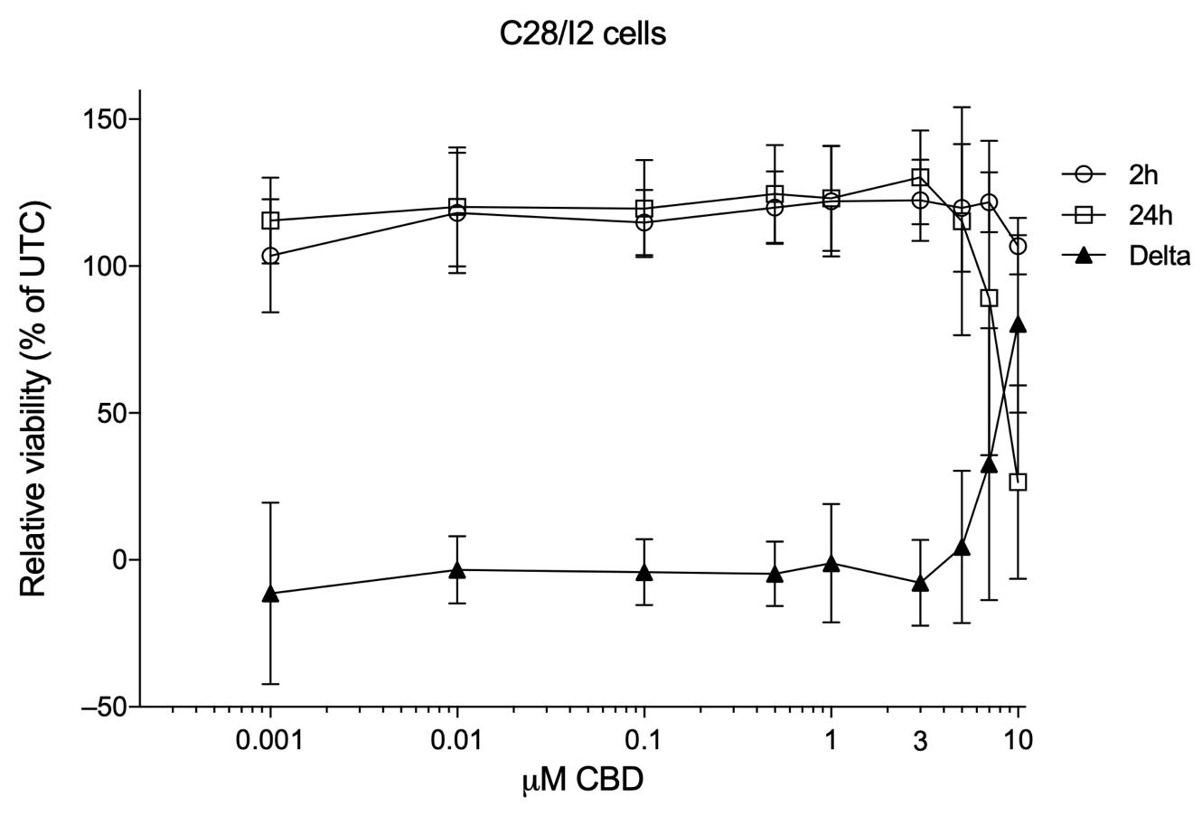
Fig.S1. Relative viability of C28/I2 cells treated with 0.001 µM to 10 µM CBD for 2 and 24 hours. Results are represented as % of untreated controls (UTC). Mean ± SD of 3 independent Resazurin assays.

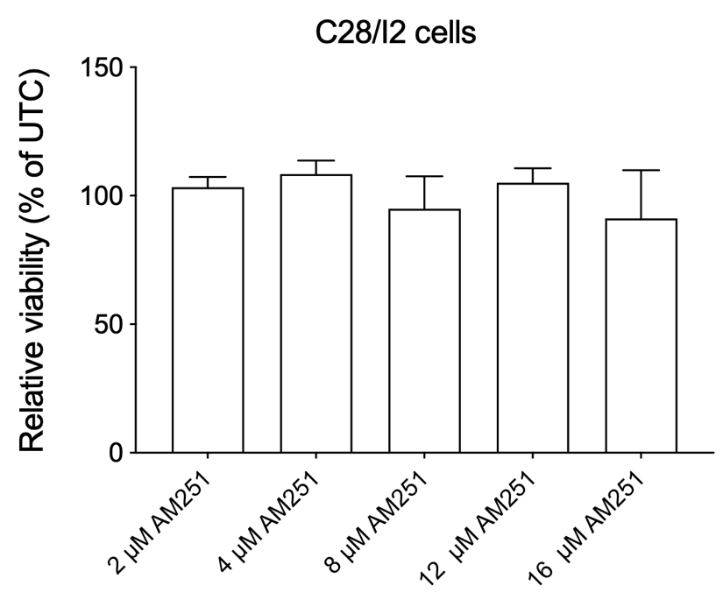
Fig.S2. Relative viability of C28/I2 cells treated with rising concentrations of AM251 (2, 4, 8, 12 and 16 µM AM251). Results are represented as % of untreated controls (UTC). Mean ± SD of 3 independent Resazurin assays.

