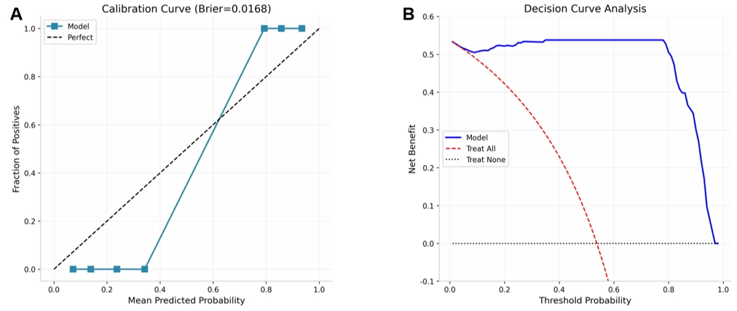
Figure S1. Secondary validation analyses of the dual-modal random forest model. (A) Calibration curve showing the agreement between predicted probabilities and observed outcomes (Brier score = 0.0168). (B) Decision curve analysis (DCA) comparing the net benefit of the dual-modal model against treat-all and treat-none strategies across clinically relevant threshold probabilities (0.05-0.85).

Table S1. Bootstrap stability analysis of candidate features across 100 resampling iterations.
Feature | Stability (n=100) | >70%
Oleamide | 0.79 | Yes
Alliin | 0.76 | Yes
Linoleoylglycerol | 0.38 | No
Glycylvaline | 0.15 | No
12-HETE | 0.97 | Yes
Linoleamide (18:2n6) | 0.71 | Yes
Oleoylglycerol | 0.04 | No
Hydroxyoctanoylcarnitine | 0.31 | No
palmitamide | 0.71 | Yes
Beta-cryptoxanthin | 0.94 | Yes
Fibrinopeptide A516 | 1.00 | Yes
Glucuronide of C10H18O2 | 0.75 | Yes
Sex | 0 | No
Age | 0.27 | No
Medical history | 0.75 | Yes
HDL | 0.91 | Yes
FBG | 0.76 | Yes

Table S2. LASSO-regularized multivariable logistic regression coefficients and retention status.
Variable | Coefficient | Retained
Glycylvaline | 0 | No
Alliin | -0.4192 | Yes
Linoleoylglycerol | 0 | No
Oleamide | -0.2558 | Yes
12-HETE | -0.0272 | Yes
Oleoylglycerol | 0 | No
Linoleamide (18:2n6) | -0.3434 | Yes
Hydroxyoctanoylcarnitine | 0.2858 | Yes
Palmitamide | -0.3187 | Yes
Beta-cryptoxanthin | -1.4089 | Yes
Fibrinopeptide A516 | -0.9529 | Yes
Glucuronide of C10H18O2 | 3.3492 | Yes
Sex | 0 | No
Age | 0 | No
Medical history | 1.0136 | Yes
HDL | -1.1413 | Yes
FBG | -1.9467 | Yes

Table S3. Nested 5×3-fold cross-validation results of the dual-modal random forest model.
Fold | Train N | Test N | Best mtry | Inner AUC | Outer AUC
1 | 74 | 19 | 2 | 0.9495 | 0.9556
2 | 74 | 19 | 2 | 0.9533 | 0.8556
3 | 74 | 19 | 2 | 0.9195 | 0.9611
4 | 75 | 18 | 2 | 0.9369 | 0.975
5 | 75 | 18 | 2 | 0.893 | 1
Mean |  |  |  |  | 0.9494
SD |  |  |  |  | 0.0494
95% CI Lower |  |  |  |  | 0.8656
95% CI Upper |  |  |  |  | 0.9975

