APPENDIX

Appendix A. Data Source and Extraction
The definitions and codes used to extract data are presented here.

Appendix Table 1: Relevant ICD-9 codes for Diagnosis of OUD.
ICD-9-CM Code | ICD-9-CM Description
304.00-304.02 | Opioid type dependence (unspecified; continuous; episodic)
304.70-304.72 | Combinations of opioid type drug with any other drug dependence (unspecified; continuous; episodic)
305.50-305.52 | Opioid abuse (unspecified; continuous; episodic)
ICD-9-CM=International Classification of Diseases, Ninth Revision, Clinical Modification

Appendix Table 2: Relevant ICD-10 codes for Diagnosis of OUD.
ICD-10-CM Code | ICD-10-CM Description
F11.10 | Opioid abuse, uncomplicated
F11.120 | Opioid abuse with intoxication, uncomplicated
F11.121 | Opioid abuse with intoxication delirium
F11.122 | Opioid abuse with intoxication with perceptual disturbance
F11.129 | Opioid abuse with intoxication, unspecified
F11.14 | Opioid abuse with opioid-induced mood disorder
F11.150 | Opioid abuse with opioid-induced psychotic disorder with delusions
F11.151 | Opioid abuse with opioid-induced psychotic disorder with hallucinations
F11.159 | Opioid abuse with opioid-induced psychotic disorder, unspecified
F11.181 | Opioid abuse with opioid-induced sexual dysfunction
F11.182 | Opioid abuse with opioid-induced sleep disorder
F11.188 | Opioid abuse with other opioid-induced disorder
F11.19 | Opioid abuse with unspecified opioid-induced disorder
F11.20 | Opioid dependence, uncomplicated
F11.220 | Opioid dependence with intoxication, uncomplicated
F11.221 | Opioid dependence with intoxication delirium
F11.222 | Opioid dependence with intoxication with perceptual disturbance
F11.229 | Opioid dependence with intoxication, unspecified
F11.23 | Opioid dependence with withdrawal
F11.24 | Opioid dependence with opioid-induced mood disorder
F11.250 | Opioid dependence with opioid-induced psychotic disorder with delusions
F11.251 | Opioid dependence with opioid-induced psychotic disorder with hallucinations
F11.259 | Opioid dependence with opioid-induced psychotic disorder, unspecified
F11.281 | Opioid dependence with opioid-induced sexual dysfunction
F11.282 | Opioid dependence with opioid-induced sleep disorder
F11.288 | Opioid dependence with other opioid-induced disorder
F11.29 | Opioid dependence with unspecified opioid-induced disorder
F11.90 | Opioid use, unspecified, uncomplicated
F11.920 | Opioid use, unspecified, with intoxication, uncomplicated
F11.921 | Opioid use, unspecified, with intoxication delirium
F11.922 | Opioid use, unspecified, with intoxication with perceptual disturbance
F11.929 | Opioid use, unspecified, with intoxication, unspecified
F11.93 | Opioid use, unspecified with withdrawal
F11.94 | Opioid use, unspecified with opioid-induced mood disorder
F11.950 | Opioid use, unspecified with opioid-induced psychotic disorder with delusions
F11.951 | Opioid use, unspecified with opioid-induced psychotic disorder with hallucinations
F11.959 | Opioid use, unspecified with opioid-induced psychotic disorder, unspecified
F11.981 | Opioid use, unspecified with opioid-induced sexual dysfunction
F11.982 | Opioid use, unspecified with opioid-induced sleep disorder
F11.988 | Opioid use, unspecified with other opioid-induced
F11.99 | Opioid use, unspecified with unspecified opioid-induced disorder

Appendix Table 3. Current Procedural Terminology (CPT) for OUD Medications.
MOUD | CPT code | In-office dispensing of
Methadone | H0020 | Methadone service
Buprenorphine | J0570-J0575 | Buprenorphine services
 | J2315 | ER injection
Naltrexone | Q9991-Q9992 | Injectable

Appendix Table 4. National Drug Codes Used to Identify Pharmacy Claims for OUD Medications. Adapted from (1, 2).

Buprenorphine:
149075701, 12496075701, 12496075705, 54569141600, 54569141601, 54017613, 93537856, 228315603, 378092393, 12496127802, 35356055530, 49999063830, 50383092493, 68308020230, 54017713, 93537956, 228315303, 378092493, 12496131002, 35356055630, 49999063930, 50383093093, 63874117303, 68308020830, 74201201, 74201232, 409201232, 21695051510, 38779088800, 38779088801, 38779088803, 38779088806, 38779088809, 49452129201, 49452129202, 49452129203, 49452825301, 49452825302, 49452825303, 51552076501, 51552076502, 51552076505, 51552076506, 51552076509, 51552076510, 51552076550, 51927101200, 62991158301, 62991158302, 62991158303, 62991158304, 62991158306, 62991158307, 62991158308, 63275992201, 63275992202, 63275992203, 63275992204, 63275992205, 63275992207, 63370090506, 63370090509, 63370090510, 63370090515, 54018813, 93572056, 228315403, 228315473, 406192303, 12496128302, 16590066630, 42291017430, 49999039507, 49999039515, 49999039530, 50383029493, 52959074930, 54569549600, 54868575000, 55700018430, 63629402801, 63874108503, 65162041603, 68071151003, 68258299903, 54018913, 93572156, 228315503, 228315573, 406192403, 12496130602, 35356000407, 35356000430, 42291017530, 43063018407, 43063018430, 50383028793, 52959030430, 54569573900, 54569573901, 54569573902, 54569640800, 54868570700, 54868570701, 54868570702, 54868570703, 54868570704, 55045378403, 63629403401, 63629403402, 63629403403, 63874108403, 65162041503, 66336001630, 68071138003, 40042001001, 42023017901, 42023017905, 55390010010, 35356060704, 59011075004, 35356060504, 54569632500, 59011075104, 35356060604, 54569632600, 59011075204, 12496120201, 12496120203, 12496120801, 12496120803, 54569639900, 55700014730, 12496120401, 12496120403, 12496121201, 12496121203, 54123091430, 54123095730, 59011075804, 59385001201, 59385001230, 59385001401, 59385001430, 59385001601, 59385001630, 59011075704, 54123098630, 54123011430, 54123092930, 63481016101, 63481016160, 63481020701, 63481020760, 63481034801, 63481034860, 63481051901, 63481051960, 63481068501, 63481068560, 63481082001, 63481082060, 63481095201, 63481095260, , 143924605, 378876593, 378876693, 378876793, 378876893, 406800503, 406802003, 517072505, 781721664, 781722764, 781723864, 781724964, 12496010001, 12496030001, 42858050103, 42858050203, 42858060103, 42858060203, 43598057930, 43598058030, 43598058130, 43598058230, 47781035503, 47781035603, 47781035703, 47781035803, 50268014415, 50268014515, 52427069203, 52427069403, 52427069803, 52427071203, 52440010014, 54123090730, 55700030230, 58118017608, 58118017708, 58118315608, 60429058630, 60429058730, 60687048121, 60687049221, 62175045232, 62175045832, 62756045964, 62756045983, 62756046064, 62756046083, 62756096964, 62756096983, 62756097064, 62756097083, 63629712601, 63629712602, 63629712603, 63629712604, 63629712605, 63629712606, 63629712607, 63629712608, 63629712609, 65162041509, 65162041609, 67046099430, 67046099530, 67046099630, 67046099730, 70518071100, 70518071101, 70518071102, 70518100700, 70518155700, 70518162500, 70518168400, 70518201400, 70518221600, 70518221700, 70518221800, 70518222600, 70518231100, 70518232700, 71335035301, 71335035302, 71335035303, 71335035304, 71335035305, 71335035306, 71335035307, 71335095001, 71335095002, 71335095003, 71335095004, 71335095005, 71335095006, 71335095007, 71335115401, 71335115402, 71335115403, 71335115404, 71335115405, 71335115406, 71335115407, 71335115408, 71335115409, 71335116301, 71335116302, 71335116303, 71335116304, 71335116305, 71335116306, 71335116307, 71335116308, 71335116309, 71335129601, 71335129602, 71335137801, 71335151401, 71335151402, 71335165301
Naltrexone:
56001122, 56001130, 56001170, 56007950, 56008050, 185003901, 185003930, 406009201, 406009203, 406117001, 406117003, 555090201, 555090202, 16729008101, 16729008110, 42291063230, 43063059115, 47335032683, 47335032688, 50436010501, 51224020630, 51224020650, 51285027501, 51285027502, 52152010502, 52152010504, 52152010530, 54868557400, 65694010003, 65694010010, 68084029111, 68084029121, 68094085362, 68115068030, 49452483501, 51927275300, 51927360200, 51927354800, 63459030042, 65757030001, 65757030202, 38779088703, 38779088704, 38779088705, 38779088706, 38779088708, 49452480801, 49452480802, 49452483502, 51552073701, 51552073702, 51552073704, 51927437700, 52372075101, 52372075102, 52372075103, 55812033301, 55812033302, 55812033303, 63370015810, 63370015815, 63370015825, 63370015835, 63370015845, 60966014404, 60966024403, 60966034402, 62991124301, 62991124302, 62991124303, 62991124304

Appendix Table 5. Current Procedural Terminology (CPT) and Healthcare Common Procedure Coding System (HCPCS) Codes Used to Identify Utilization of Behavioral health services (i.e., mental health or substance use disorder treatment). Adapted from (3).
Behavioral health services in any setting:
90791-90792, 90832-90834, 90836-90840, 90853, 90863, 90875-90876, G0396, G0397, H0001, H0002, H0004, H0005, H0007-H0011, H0012, H0013, H0014, H0015, H0016, H0019, H0022, H0031, H0034-H0037, H0039, H0040, H0047, H2000, H2001, H2010-H2020, H2035, H2036, M0064, S0201, S9480, S9484, S9485, T1006, T1012
Among above codes, those indicating detoxification services: H0008-H0014
Among above codes, those indicating intensive outpatient care: H0015
Among above codes, those indicating partial hospitalization: H0035
Among above codes, those indicating residential care: H0012, H0013, H0017-H0019
Among above codes, those indicating inpatient care: H0008-H0011

Appendix Table 6: Relevant ICD-9-CM and ICD-10-CM Codes for Clinical and Behavioral Variables. Adapted from (4).
Variables | ICD-9-CM/ICD-10-CM Code
Substance Use
Marijuana | 30430, 30431, 30432, F1210, F1212, F1215, F1218, F1219, F1220, F1222, F1225, F1228, F1229, F1290, F1292, F1295, F1298, F1299
Cocaine | 30420, 30421, 30422, 30560, 30561, 30562, F1410, F1412, F1414, F1415, F1418, F1419, F1420, F1422, F1424, F1425, F1428, F1429, F1490, F1492, F1494, F1495, F1498, F1499
Tobacco | 3051, 30510, F1720, F1721, F1722, F1729, T6522, T6529, Z720
Alcohol | 2911, 2912, 2913, 2914, 2915, 2918, 29180, 29181, 29182, 29189, 30300, 30301, 30302, 30390, 30391, 30392, 30500, 30501, 30502, 53530, 53531, F1010, F1012, F1015, F1018, F1019, F1020, F1022, F1023, F1024, F1025, F1028, F1029, F1092, F1094, F1095, K2920, K2921
Overdose
 | 96500, 96501, 96502, 96509, E8500, E8501, E8502, T400, T401, T402, T403
Pain
Lower back pain | 7245, 7248, 72458, 7249, M545, M546, M5489, M549, M6283
Neck pain | 52461, 52462, 52463, 52464, 52469, M2660, M2661, M2662, M2663
Headache | 30781, 34600, 34601, 34602, 34603, 34610, 34611, 34612, 34613, 34620, 34621, 34622, 34623, 34630, 34631, 34632, 34633, 34650, 34651, 34652, 34653, 34661, 34670, 34671, 34672, 34673, 34680, 34681, 34682. 34683, 34690, 34691, 34692, 34693, 7840, G4300, G4301, G4310, G4311, G4340, G4341, G4350, G4351, G4370, G4371, G4380, G4381, G4382, G4383, G4390, G4391, G43A0, G43A1, G43B0, G43B1, G43C0, G43C1, G43D0, G43D1, G4400, G4401, G4402, G4403, G4404, G4405, G4409, G441, G4420, G4421, G4422, G4430, G4431, G4432, G4440, G4441, G4451, G4452, G4453, G4459, G4481, G4482, G4483, G4484, G4485, G4489, R51
Fibromyalgia | 725, M353, M7910, M7911, M7912, M7918, M797, R5382
Osteoarthritis | 71516, 71517, 71518, 71520, 71521, 71522, 71523, 71524, 71525, 71526, 71527, 71528, 71530, 71531, 71532, 71533, 71534, 71535, 71536, 71537, 71580, 71589, M150, M151, M152, M153, M154, M158, M159, M160, M1610, M1611, M1612, M162, M1630, M1631, M1632, M164, M1650, M1651, M1652, M166, M167, M169, M170, M1710, M1711, M1712, M1730, M1731, M1732, M174, M175, M179, M180, M1810, M1811, M182, M1830, M1831, M179, M180, M1810, M1811, M1812, M182, M1830, M1831, M1832, M184, M1850, M1851, M1852, M189, M1901, M1902, M1903, M1904, M1907, M1911, M1912, M1913, M1914, M1917, M1921, M1922, M1923, M1924, M1927, M1990, M1991, M1992, M1993
Rheumatoid arthritis | 7140, 7141, 7142, 71430, 71431, 71432, M0510, M0514, M0516, M0519, M0520, M0523, M0524, M0529, M0530, M0531, M0540, M0543, M0544, M0545, M0546, M0547, M0549, M0550, M0553, M0554, M0555, M0556, M0559, M0560, M0561, M0562, M0564, M0566, M0567, M0569, M0570, M0571, M0572, M0573, M0574, M0575, M0576, M0577, M0579, M0580, M0581, M0582, M0583, M0584, M0585, M0586, M0587, M0589, M059, M0600, M0601, M0602, M0603, M0604, M0605, M0606, M0607, M0609, M061, M0621, M0622, M0623, M0625, M0627, M0628, M0630, M0632, M0634, M0637, M0639, M064, M0680, M0681, M0682, M0683, M0684, M0685, M0686, M0687, M0688, M0689, M069, M0800, M0801, M0803, M0804, M0807, M0808, M0809, M081, M0820, M0823, M0824, M0829, M083, M0840, M0843, M0844, M0848, M0880, M0883, M0890, M0899
Sprain | 8400, 8401, 8402, 8403, 8404, 8405, 8406, 8407, 8408, 8409, 8410, 8411, 8412, 8413, 8418, 8419, 84200, 84201, 84202, 84209, 84210, 84211, 84212, 84213, 84219, 8430, 8431, 8438, 8439, 8440, 8441, 8442, 8443, 8448, 8449, 84500, 84501, 84502, 84503, 84509, 84510, 84511, 84512, 84513, 84519, 8460, 8461, 8462, 8468, 8469, 8470, 8472, 8473, 8479, 8480, 8481, 8482, 8483, 84840, 84841, 84842, 84849, 8485, 8488, 8489, S031X, S0340, S0341, S0342, S034X, S039X, S0911, S134X, S135X, S138X, S139X, S161X, S233X, S2341, S2342, S238X, S239X, S2901, S335X, S336X, S338X, S339X, S3901, S4340, S4341, S4342, S4343, S4349, S4350, S4351, S4352, S4361, S4362, S4380, S4381, S4382, S4390, S4391, S4392, S4601, S4611, S4621, S4631, S4681, S4691, S5320, S5321, S5322, S5330, S5331, S5332, S5340, S5341, S5342, S5343, S5344, S5349, S5601, S5611, S5621, S5631, S5641, S5651, S5681, S5691, S6330, S6331, S6332, S6339, S6340, S6341, S6343, S6349, S6350, S6351, S6352, S6359, S6360, S6361, S6362, S6363, S6364, S6365, S6368, S6369, S638X, S6390, S6391, S6392, S6601, S6611, S6621, S6631, S6641, S6651, S6681, S6691, S7310, S7311, S7312, S7319, S7601, S7611, S7621, S7631, S7681, S7691, S8340, S8341, S8342, S8350, S8351, S8352, S8360, S8361, S8362, S838X, S8390, S8391, S8392, S8601, S8611, S8621, S8631, S8681, S8691, S9340, S9341, S9342, S9343, S9343, S9349, S9350, S9351, S9352, S9360, S9361, S9362, S9369, S9601, S9611, S9621, S9681, S9691
Clinical Disorders
Adjustment Disorder | 3090, 3091, 30922, 30923, 30924, 30928, 30929, 3093, 3094, 30982, 30983, 30989, 3099, F4320, F4321, F4322, F4323, F4324, F4325, F4329, F438, F439
Mood Disorder | 29383, 29600, 29601, 29602, 29603, 29604, 29605, 29606, 29610, 29611, 29612, 29613, 29614, 29615, 29616, 29620, 29621, 29622, 29623, 29624, 29625m 29626, 29630, 29631, 29632, 29633, 29634, 29635, 29636, 29640, 29641, 29642, 29643, 29644, 29645, 29646, 29650, 29651, 29652, 29653m 29654, 29655, 20656, 29660, 29661, 29662, 29963, 29664, 29665, 29666, 2967, 29670, 29680, 29681, 29682, 29689, 29690, 29699, 3004, 311, 3110, 31119, F0630, F0631, F0632, F0633, F0634, F3010, F3011, F3012, F3013, F302, F303, F304, F308, F309, F310, F3110, F3111, F3112, F3113, F312, F3130, F3131, F3132, F314, F315, F3160, F3161, F3162, F3163, F3164, F3170, F3171, F3172, F3173, F3174, F3175, F3176, F3177, F3178, F3181, F319, F320, F321, F322, F323, F324, F325, F328, F3281, F3289, F329, F330, F331, F332, F333, F3340, F3341, F3342, F338, F339, F340, F341, F348, F3481, F3489, F349, F39, R4586
Personality Disorder | 3010, 30110, 30112, 30113, 30120, 30121, 30122, 3013, 3014, 30150, 30151, 3016, 3017, 30181, 30182, 30183, 30184, 30189, 3019, F600, F601, F602, F603, F604, F605, F606, F607, F6081, F6089, F609, F69
Anxiety Disorder | 29384, 30000, 30001, 30002, 30009, 30010, 30020, 30021, 30022, 30023, 30029, 3003, 3005, 30089, 3009, 3080, 3081, 3082, 3083, 3084, 3089, 30981, 3130, 3131, 31321, 3133, F064, F4000, F4001, F4002, F4010, 4011, F4021, F4023, F4024, F4029, F408, F409, F410, F411, F413, F418, F419, F42, F422, F423, F424, F428, F429, F430, F4310, F4311, F4312, F488, F489, R452, R453, R454, R455, R456, R457, R4581, R4582, R4583, R4584
Other Clinical Factors
HCV | Pegasys, pegintron, ribavirin, sofosbuvir, viekira, zepatier
HIV | 042, 043, 044, B20, B21, B22, B24
CCI_b | Includes myocardial infarction, congestive heart failure, peripheral vascular disease, cerebrovascular disease, dementia, chronic pulmonary disease, connective tissue disease-rheumatic disease, peptic ulcer disease, mild liver disease, diabetes without complications, diabetes with complications, paraplegia and hemiplegia, renal disease, cancer, moderate or severe liver disease, metastatic carcinoma

Appendix Figure 1: Flow diagram describing the study sample selection process.

OUD during January 2012 to March 2019 defined as:
- admissions/primary/secondary dx from inpatient
- or primary dx from outpatient
- or secondary dx from outpatient ED setting

n=12,249
Patients that had been continuously enrolled during
baseline (one-year before index OUD dx) and more
than 30 days of follow-up

n=6,939
Adult patients had OUD dx before February 2018

n=10,840
Adult patients had OUD dx

n=12,173

Excluded since OUD dx criteria not met

n=76

Excluded since OUD dx criteria was not before February 2018

n=1,333

Excluded since were not enrolled continuously during baseline

n=3,901

Appendix B. Multistate Model Definition and Assumptions Assessment

We briefly describe the model described in detail in (5, 6) here. Let $X_{ij}$ denote the covariate matrix for person $i$at time $j$, $S_{ij}$ denotes state membership for person $i$at time $j,$ $L$ is the total number of states, $p_{jkl }=P(S_{j }=l|S_{j-1}=k)$ is the state transition probability, $t_{j}$is a calendar date corresponding to time interval, and $h_{kl}\left(d_{ij};γ_{kl}\right)$is the transition-specific period effect. Let $p_{jkl}=pr(S_{j}=l |S_{j-1}=k)$ represent the state transition probability, P_{j} for a given state S at time j given the previous state j-1. The estimated transition matrix is denoted P_{j}. A multistate model can take the form $log\left(\frac{p_{jkl }\left(x_{ij},d_{ij}\right)}{p_{jk1 }\left(x_{ij},d_{ij}\right)}\right)=α_{jkl}+x_{j}β_{kl }+ h_{kl}(d_{ij};γ_{kl})$, with $k=1,...,8$ and $l=2,...,8$.

We assessed lack of fit for the multistate model by creating plots of observed versus fitted state membership probabilities for each time interval. In Appendix Figure 2, the predicted proportions were calculated using the multistate model with covariates to estimate predicted state membership probabilities at each time point. The standard error of the predicted proportion in each state were estimated using bootstrap resampling with 200 bootstrap replicates (7). The points overlap for all states over time except the initial time intervals in RE1 and RE2. We evaluated the second order dependence by also including second order state membership at $t_{j-2}$ as a categorical covariate. In Appendix Figure 3, we plot the observed and predicted state probabilities with the second order state membership, $S_{j-2}$ , as a covariate in the model. These combined results demonstrated that for most states, the first order Markov assumption is not violated and there was no indication of a lack of model fit (5, 6).

In Appendix Figure 4 – 6, we examined the relative risk ratios when the multistate model also included the second order state membership. Comparing these results in Appendix Figure 4 – 6 with the main document Figures 2-4, we observed that inclusion of second order state membership did not meaningfully change our findings. Thus, the association of covariates with transition rates estimated in the two multistate models appears to be fairly robust to this assumption of first or second order Markov dependence.

Appendix Figure 2: Model assumption assessment by evaluating observed and predicted marginal state probabilities.

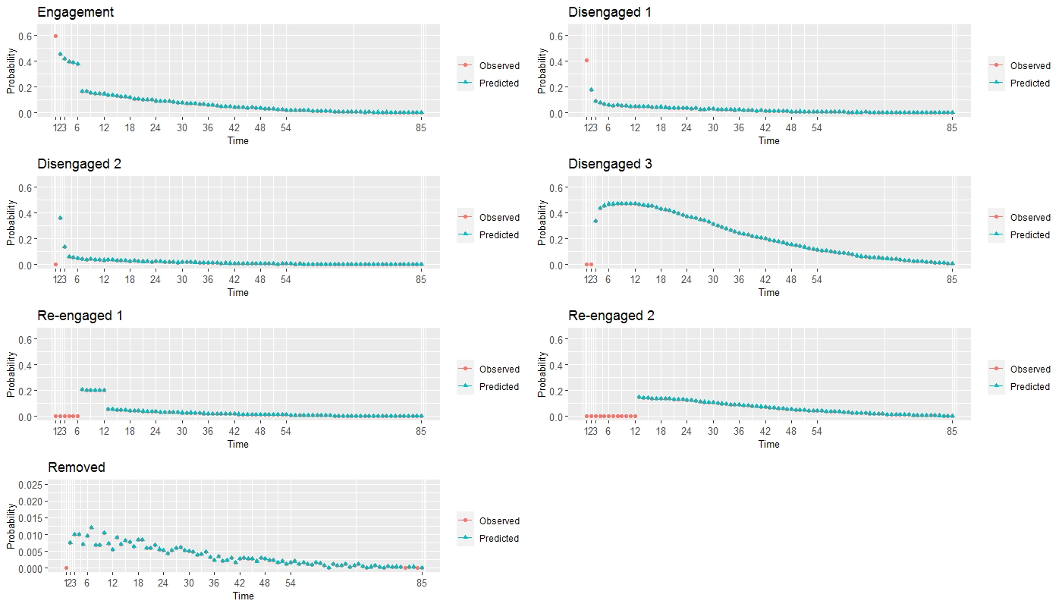

Appendix Figure 3: Model assumption assessment by evaluating observed and predicted marginal state probabilities.

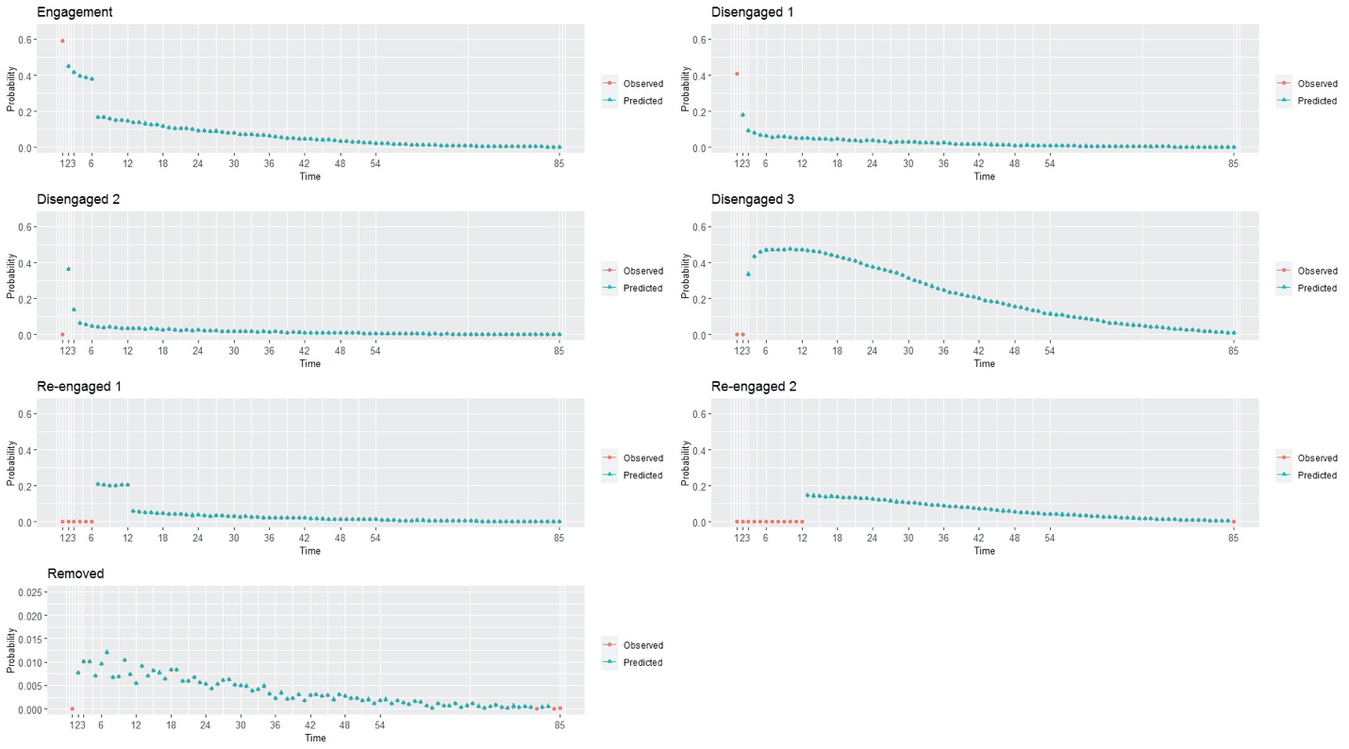

Appendix Figure 4: Model assumptions evaluated by assessing the relative risk ratiosª capturing transitions from engagement to early retention (EN to RE1, panel A) and from engagement to early discontinuation (EN to DS1, panel B) among patients with behavior and/or medication therapy.

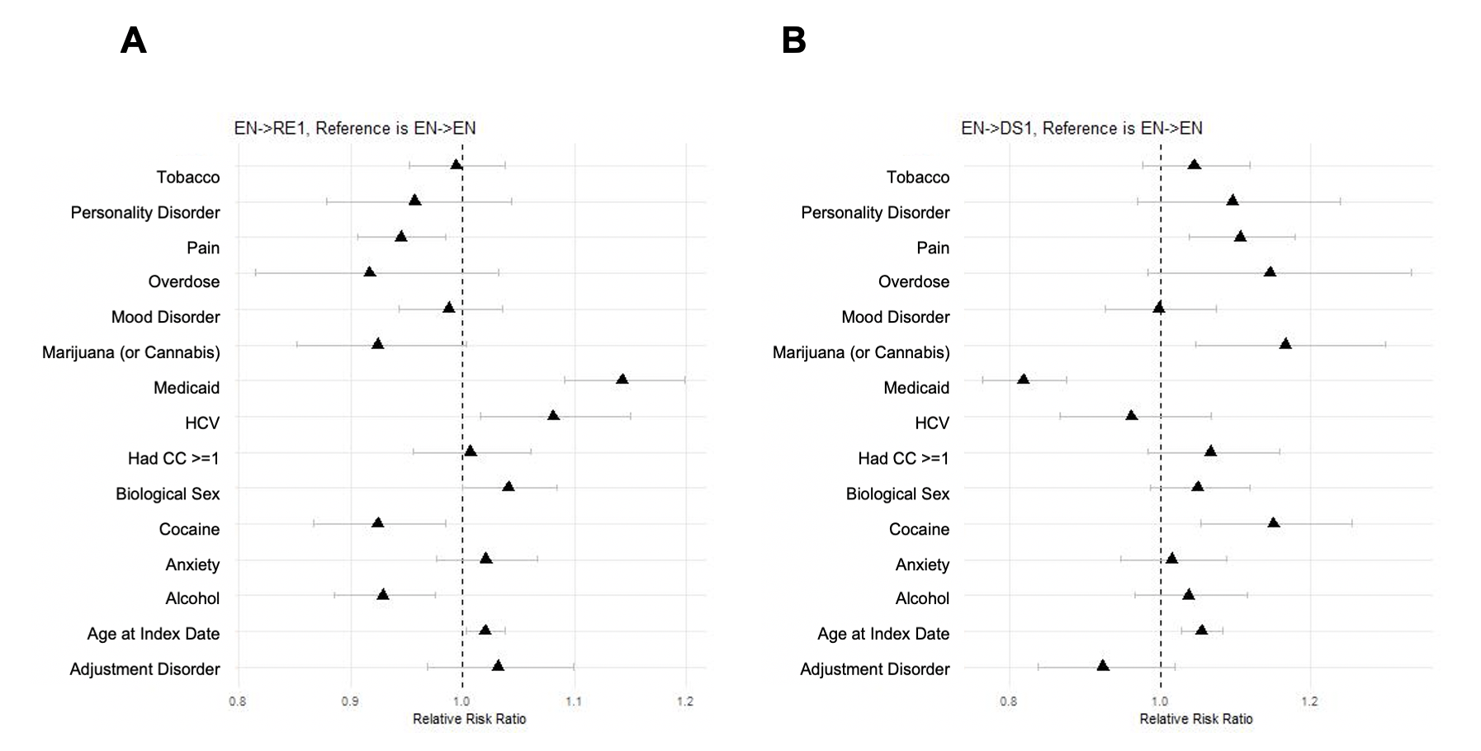
ª Reference group for variables defined as follows: “other (commercial or Medicare)” for Medicaid, “male” for biological sex, and “no” for tobacco use disorder, personality disorder, pain, overdose, mood disorder, marijuana (or cannabis), HCV, had CC >= 1, cocaine use disorder, anxiety disorder, alcohol use disorder, and adjustment disorder. Age at index date measured in years.

Appendix Figure 5: Model assumptions evaluated by assessing the relative risk ratiosª capturing transitions from short- and long-term retention. RE1 to RE2 in (panel A), RE1 to DS1 in (panel B), and RE2 to DS1 in (panel C) among patients with behavior and/or medication therapy.
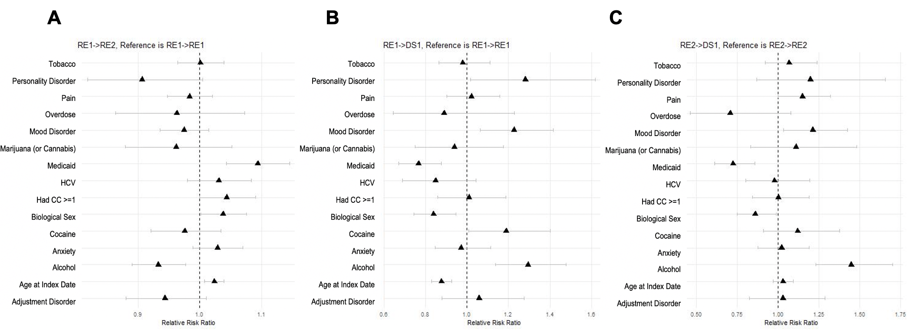

ª Reference group for variables defined as follows: “other (commercial or Medicare)” for Medicaid, “male” for biological sex, and “no” for tobacco use disorder, personality disorder, pain, overdose, mood disorder, marijuana (or cannabis), HCV, had CC >= 1, cocaine use disorder, anxiety disorder, alcohol use disorder, and adjustment disorder. Age at index date measured in years.

Appendix Figure 6: Model assumptions evaluated by assessing the relative risk ratiosª capturing transitions from short- and long-term disengagement. DS1 to EN in (panel A), DS2 to EN in (panel B), and DS3 to EN in (panel C) among patients with behavior and/or medication therapy.
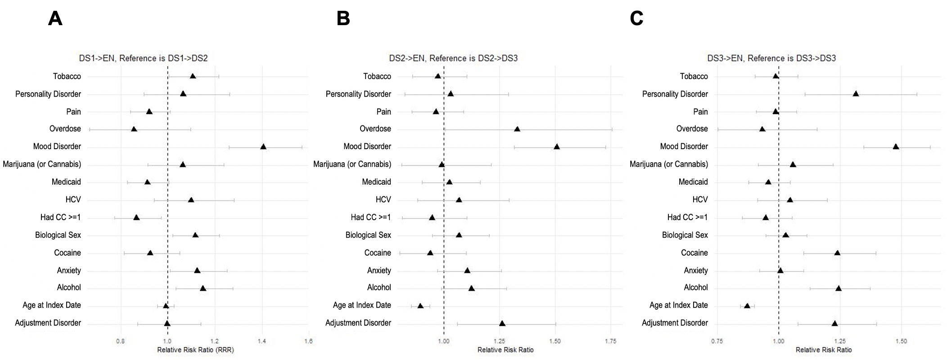

ª Reference group for variables defined as follows: “other (commercial or Medicare)” for Medicaid, “male” for biological sex, and “no” for tobacco use disorder, personality disorder, pain, overdose, mood disorder, marijuana (or cannabis), HCV, had CC >= 1, cocaine use disorder, anxiety disorder, alcohol use disorder, and adjustment disorder. Age at index date measured in years.

C. Sensitivity Analysis

This section contains results of the sensitivity analysis. The primary analysis defined OUD treatment as either behavioral and/or medication therapy. We conducted a sensitivity analysis classifying OUD treatment as medication only. The relative risk ratios (RRR) with 95% confidence intervals are shown below for the medication (M) only for each sub-stage below.

Appendix Figure 7: Relative risk ratiosª capturing engagement, EN to RE1, in (A) and early disengagement, EN to DS1, in (B). The M model refers to the results in which medication treatment only and BM model refers to the results in which medication and/or behavioral therapy are included.

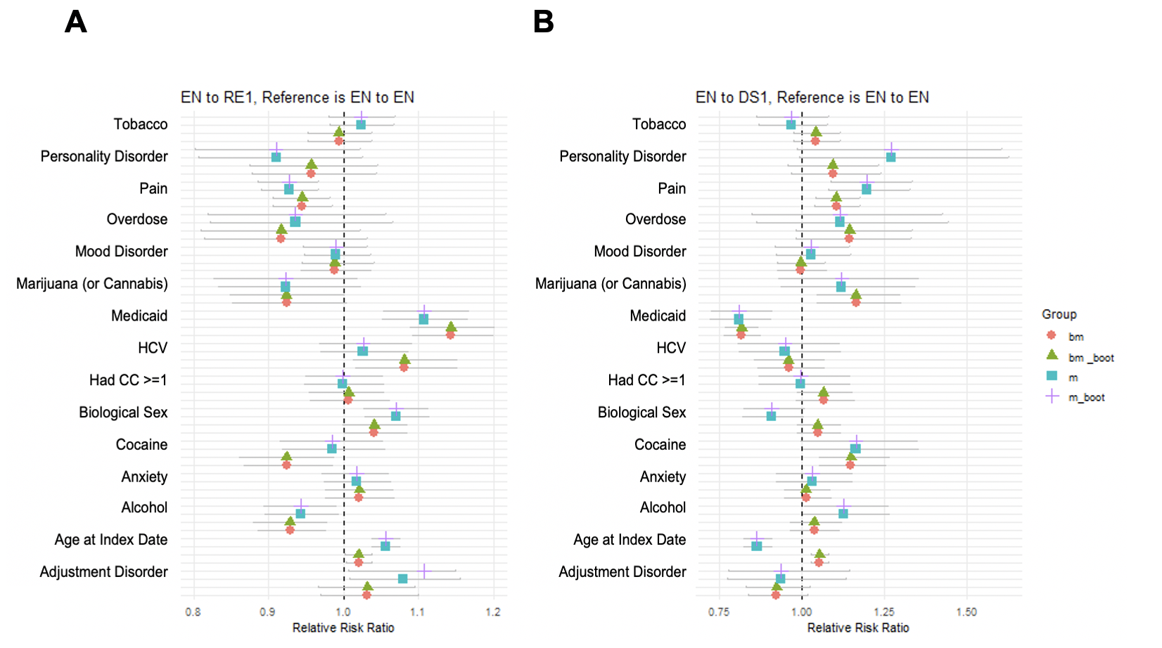

ª Reference group for variables defined as follows: “other (commercial or Medicare)” for Medicaid, “male” for biological sex, and “no” for tobacco use disorder, personality disorder, pain, overdose, mood disorder, marijuana (or cannabis), HCV, had CC >= 1, cocaine use disorder, anxiety disorder, alcohol use disorder, and adjustment disorder. Age at index date measured in years.

Appendix Figure 8: Relative risk ratiosª capturing Short- and Long-Term Disengagement. DS1 to EN in (A), DS2 to EN in (B), and DS3 to EN in (C). The M model refers to the results in which medication treatment only and BM model refers to the results in which medication and/or behavioral therapy are included.

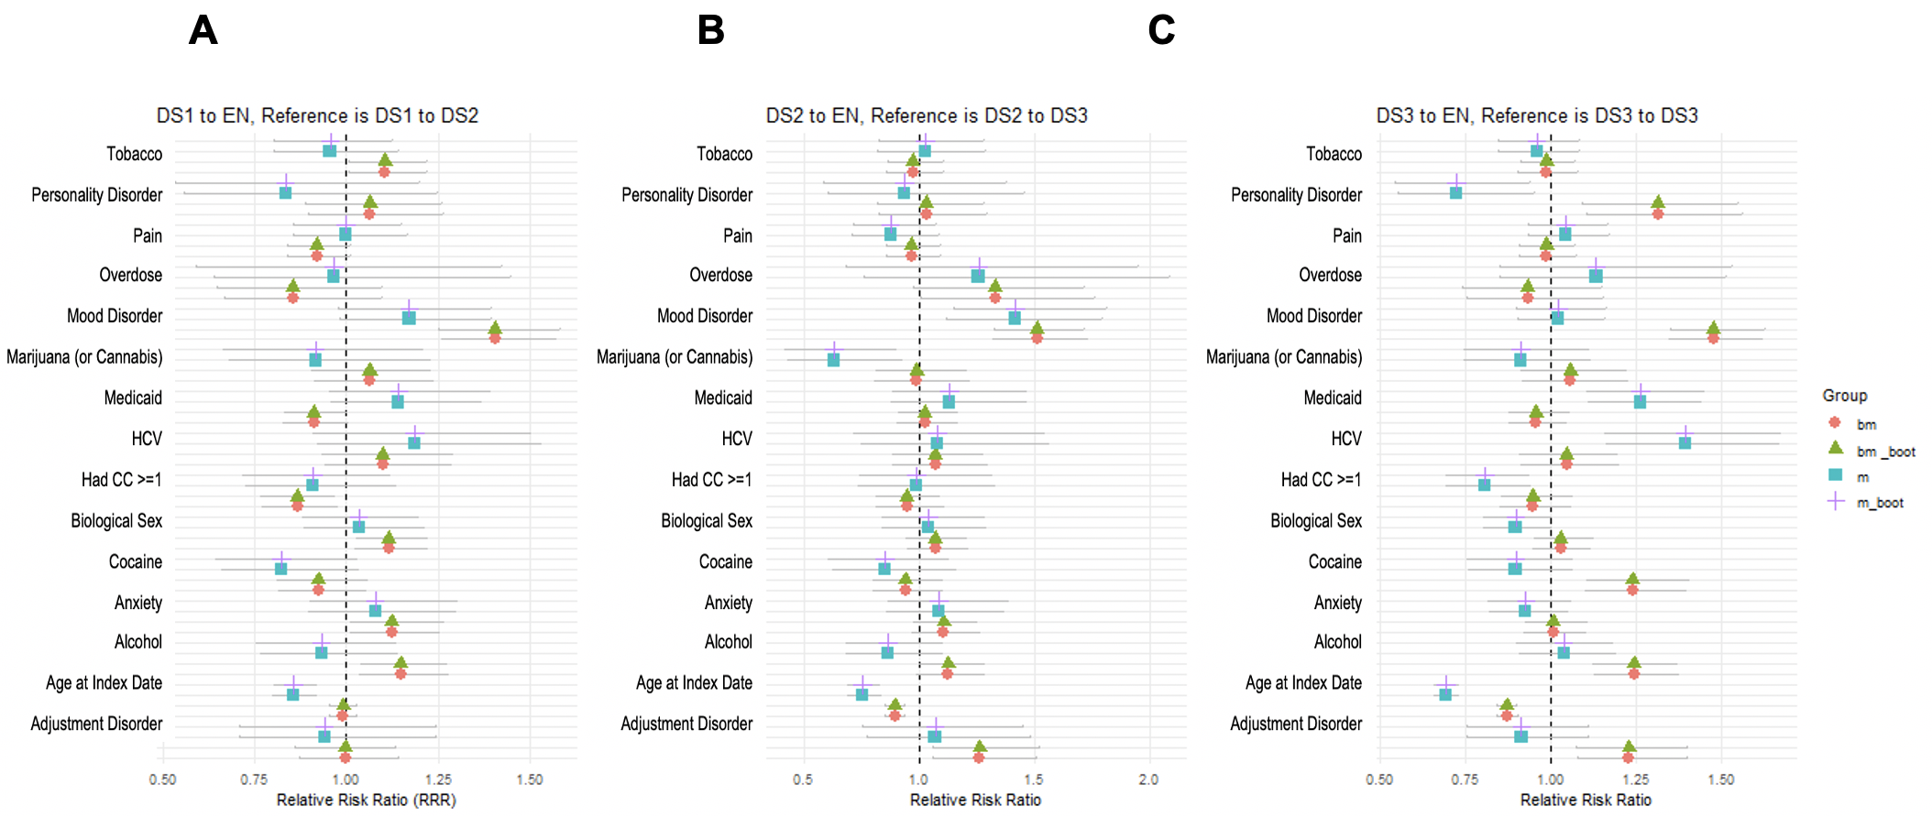

ª Reference group for variables defined as follows: “other (commercial or Medicare)” for Medicaid, “male” for biological sex, and “no” for tobacco use disorder, personality disorder, pain, overdose, mood disorder, marijuana (or cannabis), HCV, had CC >= 1, cocaine use disorder, anxiety disorder, alcohol use disorder, and adjustment disorder. Age at index date measured in years.

Appendix Figure 9: Relative risk ratiosª capturing Short- and Long-Term Retention. RE1 to RE2 in (A), RE1 to DS1 in (B), and RE2 to DS1 in (C). The M model refers to the results in which medication treatment only and BM model refers to the results in which medication and/or behavioral therapy are included.

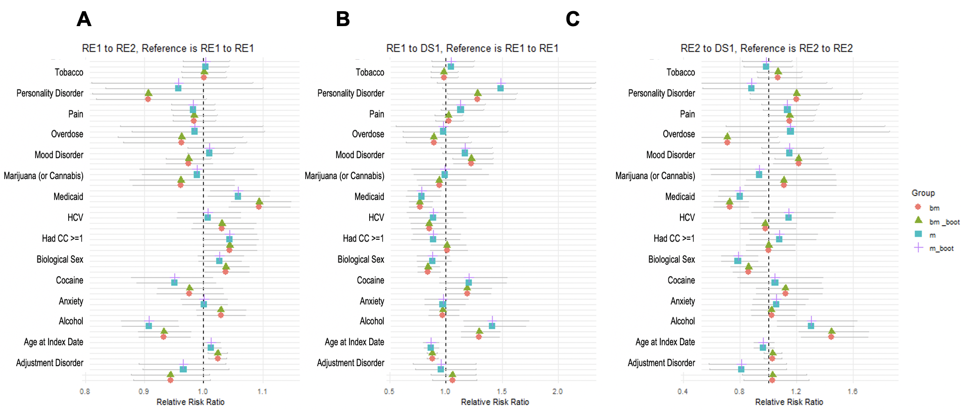

ª Reference group for variables defined as follows: “other (commercial or Medicare)” for Medicaid, “male” for biological sex, and “no” for tobacco use disorder, personality disorder, pain, overdose, mood disorder, marijuana (or cannabis), HCV, had CC >= 1, cocaine use disorder, anxiety disorder, alcohol use disorder, and adjustment disorder. Age at index date measured in years.
D. Additional Results

This section contains additional results not included in the main document. A detailed description of definitions used to classify patients into each state using claims data is summarized in Appendix D Table 7. Estimated transition probabilities between states are shown in Appendix D Table 8 and estimates over time shown in Appendix D Figure 7.

Appendix Table 7. Definition of States in the Multistate Modeling Framework.
state | Description | APCD Definition
Diagnosed with OUD | Persons identified with OUD diagnosis (ICD-9/10-CM code) | Inpatient admission had OUD as primary or secondary diagnosis.  Emergency department visit with OUD as primary or secondary diagnosis.  Outpatient visit with OUD as primary diagnosis to have high specificity.
Engaged | If MOUD or behavioral therapy services <= 180 days | At least one medical encounter for behavioral therapy, at least one CPT code for methadone, or a seven-day supply of OUD medication within one month of the initial OUD
Retained state I | If MOUD or behavioral therapy services 180 to 360 days | Consecutive intervals on treatment between 180 to 360 days after engaging in treatment.
Retained state 2 | If MOUD or behavioral therapy services > 360 days | Consecutive intervals on treatment for more than 360 days after engaging in treatment.
Disengaged state 1 | Did not start or no treatment for 30 days | Treatment was missed at least once within 30 days after initial OUD diagnosis.
Disengaged state 2 | No treatment for 60 days | Treatment was missed at least once within 60 days after initial OUD diagnosis.
Disengaged state 3 | No treatment for more than 90 days | Treatment was missed once within 90 days after initial OUD diagnosis.
Removal | Disenrolled or deceased | Records were not present in next time intervals due to disenrollment, deceased, or other unknown reason.

Appendix Table 8. Probability Transition States Estimated from the Multistate Model.
 | State at t_{j}
State at t_{j-1} | Engaged | Retained 1 | Retained 2 | Disengaged 1 | Disengaged 2 | Disengaged 3 | Removal
Engaged | 0.1290 | 0.0150 | 0 | 0.0465 | 0 | 0 | 0.0012
Retained 1 | 0 | 0.0560 | 0.0087 | 0.0053 | 0 | 0 | 0.0003
Retained 2 | 0 | 0 | 0.1214 | 0.0045 | 0 | 0 | 0.0006
Disengaged 1 | 0.0178 | 0 | 0 | 0 | 0.0477 | 0 | 0.0006
Disengaged 2 | 0.0076 | 0 | 0 | 0 | 0 | 0.0387 | 0.0004
Disengaged 3 | 0.0226 | 0 | 0 | 0 | 0 | 0.4700 | 0.0049
Removal | 0 | 0 | 0 | 0 | 0 | 0 | 1.0000

Appendix Figure 10: Estimating Transition States Over Time for Early Engagement and Retention (in A) and Short and Long-term Disengagement (in B).

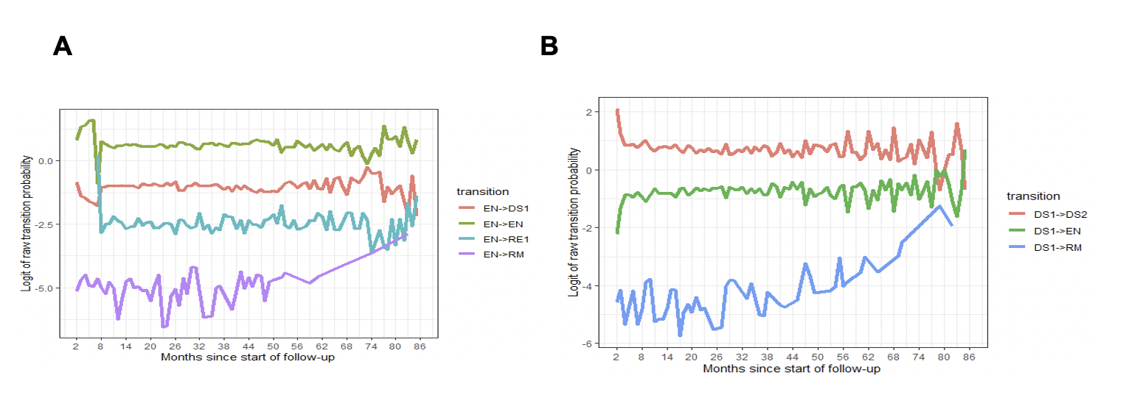

References

1. Hadland SE, Bagley SM, Rodean J, Silverstein M, Levy S, Larochelle MR, Samet JH, Zima BT. Receipt of timely addiction treatment and association of early medication treatment with retention in care among youths with opioid use disorder. JAMA pediatrics 2018; 172 (11), 1029-1037.
2. U.S. Food & Drug Administration. National Drug Code Directory, 2020;
3. Harris AH, Ellerbe L, Phelps TE, Finney JW, Bowe T, Gupta S, Asch SM, Humphreys K, Trafton J. Examining the specification validity of the HEDIS quality measures for substance use disorders. Journal of substance abuse treatment 2015; 53, 16-21.
4. Fingar KR (IBM Watson Health) and Owens PL (AHRQ). Opioid-Related and Stimulant-Related Adult Inpatient Stays, 2012–2018. HCUP Statistical Brief #271. ; Rockville, MD;
5. Lee H, Hogan JW, Genberg BL, Wu XK, Musick BS, Mwangi A, Braitstein P. A state transition framework for patient‐level modeling of engagement and retention in HIV care using longitudinal cohort data. Statistics in medicine 2018; 37 (2), 302-319.
6. Lee H, Wu XK, Genberg BL, Mugavero MJ, Cole SR, Lau B, Hogan JW. Beyond binary retention in HIV care: predictors of the dynamic processes of patient engagement, disengagement, and re-entry into care in a US clinical cohort. AIDS (London, England) 2018; 32 (15), 2217.
7. Efron B, LePage R. Introduction to bootstrap: Wiley & Sons, New York, 1992.

