Prevalence and determinants of modern contraception use among persons with disabilities in low- and middle-income countries: a systematic review and meta-analysis

Supplementary Table 01: Search strategy of Medline database (date: January 2015 to June 28, 2024)
# | Searches | Results
1 | (Women or men or reproductive age).mp. [mp=title, book title, abstract, original title, name of substance word, subject heading word, floating sub-heading word, keyword heading word, organism supplementary concept word, protocol supplementary concept word, rare disease supplementary concept word, unique identifier, synonyms, population supplementary concept word, anatomy supplementary concept word] | 1225197
2 | (Disability* or disability* or impairment* or physical disability* or visual impairment* or visual loss or blind or blind or hearing loss or hearing loss or hearing impairment* or deaf or intellectual disability* or intellectual disability* or sensory disability).mp. [mp=title, book title, abstract, original title, name of substance word, subject heading word, floating sub-heading word, keyword heading word, organism supplementary concept word, protocol supplementary concept word, rare disease supplementary concept word, unique identifier, synonyms, population supplementary concept word, anatomy supplementary concept word] | 1143702
3 | (Birth control or family planning service* or family planning services or contraception behavior or modern contraception* or traditional contraception* or barrier* or facilitator*).mp. [mp=title, book title, abstract, original title, name of substance word, subject heading word, floating sub-heading word, keyword heading word, organism supplementary concept word, protocol supplementary concept word, rare disease supplementary concept word, unique identifier, synonyms, population supplementary concept word, anatomy supplementary concept word] | 500541
4 | (Afghani* or Guinea* or Rwanda* or Benin* or Guinea-Bissau* or Senegal* or Burkina Faso* or Haiti* or Sierra Leone* or Burundi* or Korea* or Somalia* or Central African Republic or Liberia* or South Sudan* or Chad* or Madagascar* or Tanzania* or Comoros* or Malawi* or Togo* or Congo* or Mali* or Uganda* or Eritrea* or Mozambique* or Zimbabwe* or Ethiopia* or Nepa* or Gambia* or Niger* or Angol* or Indonesia* or Philippine* or Armenia* or Jordan* or Sao Tome* or Bangladesh* or Kenya* or Solomon Island* or Bhutan* or Kiribati* or Sri Lanka* or Bolivia* or Kosovo* or Sudan* or Cabo Verde* or Kyrgyz Republic* or Swazi* or Cambodia* or Lao* or Syria* or Cameroon* or Lesotho* or Tajikistan* or Congo* or Mauritania* or Timor-Leste* or Cote d'Ivoire* or Micronesia* or Tunisia* or Djibouti* or Moldov* or Ukraine* or Egypt* or Mongolia* or Uzbekistan* or El Salvador* or Morocco* or Vanuat* or Georgia* or Myanmar* or Vietnam* or Ghana* or Nicaragua* or West Bank* or Gaza* or Guatemala* or Nigeria* or Yemen* or Honduras* or Pakistan* or Zambia* or India* or Papua New Guinea*).mp. [mp=title, book title, abstract, original title, name of substance word, subject heading word, floating sub-heading word, keyword heading word, organism supplementary concept word, protocol supplementary concept word, rare disease supplementary concept word, unique identifier, synonyms, population supplementary concept word, anatomy supplementary concept word] | 1920085
5 | (((low* or middle) adj income adj (country* or nation*)) or LMICs).mp. [mp=title, book title, abstract, original title, name of substance word, subject heading word, floating sub-heading word, keyword heading word, organism supplementary concept word, protocol supplementary concept word, rare disease supplementary concept word, unique identifier, synonyms, population supplementary concept word, anatomy supplementary concept word] | 49006
6 | 1 and 2 | 65822
7 | 4 or 5 | 1949323
8 | 3 and 6 and 7 | 238
9 | limit 8 to yr="2015 -Current" | 157

Supplementary Table 02: Search strategy of PsycInfo database (date: January 2015 to June 28, 2024)
# | Searches | Results
1 | (Women or women or reproductive age).mp. [mp=title, abstract, heading word, table of contents, key concepts, original title, tests & measures, mesh word] | 328141
2 | (Disability* or disability* or impairment* or physical disability* or visual impairment* or visual loss or blind or blind or hearing loss or hearing loss or hearing impairment* or deaf or intellectual disability* or intellectual disability* or sensory disability).mp. [mp=title, abstract, heading word, table of contents, key concepts, original title, tests & measures, mesh word] | 422670
3 | (Birth control or family planning service* or family planning services or contraception behavior or modern contraception* or traditional contraception* or barrier* or facilitator*).mp. [mp=title, abstract, heading word, table of contents, key concepts, original title, tests & measures, mesh word] | 122631
4 | (Afghani* or Guinea* or Rwanda* or Benin* or Guinea-Bissau* or Senegal* or Burkina Faso* or Haiti* or Sierra Leone* or Burundi* or Korea* or Somalia* or Central African Republic or Liberia* or South Sudan* or Chad* or Madagascar* or Tanzania* or Comoros* or Malawi* or Togo* or Congo* or Mali* or Uganda* or Eritrea* or Mozambique* or Zimbabwe* or Ethiopia* or Nepa* or Gambia* or Niger* or Angol* or Indonesia* or Philippine* or Armenia* or Jordan* or Sao Tome* or Bangladesh* or Kenya* or Solomon Island* or Bhutan* or Kiribati* or Sri Lanka* or Bolivia* or Kosovo* or Sudan* or Cabo Verde* or Kyrgyz Republic* or Swazi* or Cambodia* or Lao* or Syria* or Cameroon* or Lesotho* or Tajikistan* or Congo* or Mauritania* or Timor-Leste* or Cote d'Ivoire* or Micronesia* or Tunisia* or Djibouti* or Moldov* or Ukraine* or Egypt* or Mongolia* or Uzbekistan* or El Salvador* or Morocco* or Vanuat* or Georgia* or Myanmar* or Vietnam* or Ghana* or Nicaragua* or West Bank* or Gaza* or Guatemala* or Nigeria* or Yemen* or Honduras* or Pakistan* or Zambia* or India* or Papua New Guinea*).mp. [mp=title, abstract, heading word, table of contents, key concepts, original title, tests & measures, mesh word] | 188863
5 | (((low* or middle) adj income adj (countr* or nation*)) or LMICs).mp. [mp=title, abstract, heading word, table of contents, key concepts, original title, tests & measures, mesh word] | 7884
6 | 1 and 2 | 18503
7 | 4 or 5 | 193588
8 | 3 and 6 and 7 | 85
9 | limit 8 to yr="2015 -Current" | 55

Supplementary Table 03: Search strategy of Embase database (date: January 2015 to June 28, 2024)
# | Searches | Results
1 | (Women or women or reproductive age).mp. [mp=title, abstract, heading word, drug trade name, original title, device manufacturer, drug manufacturer, device trade name, keyword heading word, floating subheading word, candidate term word] | 1741004
2 | (Disabili* or disabili* or impairmen* or physical disabilit* or visual impairmen* or visual loss or blind or blind or hearing loss or hearing loss or hearing impairmen* or deaf or intellectual disabili* or intellectual disabili* or sensory disabili).mp. [mp=title, abstract, heading word, drug trade name, original title, device manufacturer, drug manufacturer, device trade name, keyword heading word, floating subheading word, candidate term word] | 1666623
3 | (Birth control or family planning service* or family planning services or contraception behavior or modern contracepti* or traditional contracepti* or barrier* or facilitator*).mp. [mp=title, abstract, heading word, drug trade name, original title, device manufacturer, drug manufacturer, device trade name, keyword heading word, floating subheading word, candidate term word] | 627096
4 | (Afghani* or Guinea* or Rwand* or Benin* or Guinea-Bissau* or Senegal* or Burkina Faso* or Haiti* or Sierra Leone* or Burundi* or Korea* or Somalia* or Central African Republic or Liberia* or South Sudan* or Chad* or Madagasca* or Tanzania* or Comoros* or Malawi* or Togo* or Congo* or Mali* or Uganda* or Eritrea* or Mozambique* or Zimbabwe* or Ethiopia* or Nepa* or Gambia* or Niger* or Angol* or Indonesia* or Philippin* or Armenia* or Jordan* or Sao Tome* or Bangladesh* or Kenya* or Solomon Island* or Bhutan* or Kiribati* or Sri Lanka* or Bolivia* or Kosov* or Sudan* or Cabo Verde* or Kyrgyz Republic* or Swazi* or Cambodia* or Lao* or Syria* or Cameroon* or Lesotho* or Tajikistan* or Congo* or Mauritania* or Timor-Leste* or Cote d'Ivoire* or Micronesia* or Tunisia* or Djibouti* or Moldov* or Ukraine* or Egypt* or Mongolia* or Uzbekistan* or El Salvador* or Morocco* or Vanuat* or Georgia* or Myanmar* or Vietnam* or Ghana* or Nicaragua* or West Bank* or Gaza* or Guatemala* or Nigeria* or Yemen* or Hondur* or Pakistan* or Zambia* or India* or Papua New Guinea*).mp. [mp=title, abstract, heading word, drug trade name, original title, device manufacturer, drug manufacturer, device trade name, keyword heading word, floating subheading word, candidate term word] | 2857750
5 | (((low* or middle) adj income adj (countr* or nation*)) or LMICs).mp. [mp=title, abstract, heading word, drug trade name, original title, device manufacturer, drug manufacturer, device trade name, keyword heading word, floating subheading word, candidate term word] | 66180
6 | 1 and 2 | 101392
7 | 4 or 5 | 2897330
8 | 3 and 6 and 7 | 296
9 | limit 8 to yr="2015 -Current" | 212

Supplementary Table 04: Search strategy of Emcare database (date: January 2015 to June 28, 2024)
# | Searches | Results
1 | (Women or women or reproductive age).mp. [mp=title, abstract, heading word, drug trade name, original title, device manufacturer, drug manufacturer, device trade name, keyword heading word] | 554356
2 | (Disabili* or disabili* or impairmen* or physical disabilit* or visual impairmen* or visual loss or blind or blind or hearing loss or hearing loss or hearing impairmen* or deaf or intellectual disabili* or intellectual disabili* or sensory disabili).mp. [mp=title, abstract, heading word, drug trade name, original title, device manufacturer, drug manufacturer, device trade name, keyword heading word] | 454959
3 | (Birth control or family planning service* or family planning services or contraception behavior or modern contracepti* or traditional contracepti* or barrier* or facilitator*).mp. [mp=title, abstract, heading word, drug trade name, original title, device manufacturer, drug manufacturer, device trade name, keyword heading word] | 177453
4 | (Afghani* or Guinea* or Rwand* or Benin* or Guinea-Bissau* or Senegal* or Burkina Faso* or Haiti* or Sierra Leone* or Burundi* or Korea* or Somalia* or Central African Republic or Liberia* or South Sudan* or Chad* or Madagasca* or Tanzania* or Comoros* or Malawi* or Togo* or Congo* or Mali* or Uganda* or Eritrea* or Mozambique* or Zimbabwe* or Ethiopia* or Nepa* or Gambia* or Niger* or Angol* or Indonesia* or Philippin* or Armenia* or Jordan* or Sao Tome* or Bangladesh* or Kenya* or Solomon Island* or Bhutan* or Kiribati* or Sri Lanka* or Bolivia* or Kosov* or Sudan* or Cabo Verde* or Kyrgyz Republic* or Swazi* or Cambodia* or Lao* or Syria* or Cameroon* or Lesotho* or Tajikistan* or Congo* or Mauritania* or Timor-Leste* or Cote d'Ivoire* or Micronesia* or Tunisia* or Djibouti* or Moldov* or Ukrain* or Egypt* or Mongolia* or Uzbekistan* or El Salvador* or Morocc* or Vanuat* or Georgia* or Myanmar* or Vietnam* or Ghana* or Nicaragua* or West Bank* or Gaza* or Guatemala* or Nigeria* or Yemen* or Hondur* or Pakistan* or Zambia* or India* or Papua New Guinea*).mp. [mp=title, abstract, heading word, drug trade name, original title, device manufacturer, drug manufacturer, device trade name, keyword heading word] | 506638
5 | (((low* or middle) adj income adj (countr* or nation*)) or LMICs).mp. [mp=title, abstract, heading word, drug trade name, original title, device manufacturer, drug manufacturer, device trade name, keyword heading word] | 27826
6 | 1 and 2 | 34015
7 | 4 or 5 | 522882
8 | 3 and 6 and 7 | 142
9 | limit 8 to yr="2015 -Current" | 104

Supplementary Table 05: Search strategy of Maternity and Infant Care database (date: January 2015 to June 28, 2024)
# | Searches | Results
1 | (Women or women or reproductive age).mp. [mp=abstract, heading word, title] | 123795
2 | (Disabili* or disabili* or impairmen* or physical disabilit* or visual impairmen* or visual loss or blind or blind or hearing loss or hearing loss or hearing impairmen* or deaf or intellectual disabili* or intellectual disabili* or sensory disabili).mp. [mp=abstract, heading word, title] | 10330
3 | (Birth control or family planning service* or family planning services or contraception behavior or modern contracepti* or traditional contracepti* or barrier* or facilitator*).mp. [mp=abstract, heading word, title] | 8351
4 | (Afghani* or Guinea* or Rwand* or Benin* or Guinea-Bissau* or Senegal* or Burkina Faso* or Haiti* or Sierra Leone* or Burundi* or Korea* or Somalia* or Central African Republic or Liberia* or South Sudan* or Chad* or Madagasca* or Tanzania* or Comoros* or Malawi* or Togo* or Congo* or Mali* or Uganda* or Eritrea* or Mozambique* or Zimbabwe* or Ethiopia* or Nepa* or Gambia* or Niger* or Angol* or Indonesia* or Philippin* or Armenia* or Jordan* or Sao Tome* or Bangladesh* or Kenya* or Solomon Island* or Bhutan* or Kiribati* or Sri Lanka* or Bolivia* or Kosov* or Sudan* or Cabo Verde* or Kyrgyz Republic* or Swazi* or Cambodia* or Lao* or Syria* or Cameroon* or Lesotho* or Tajikistan* or Congo* or Mauritania* or Timor-Leste* or Cote d'Ivoire* or Micronesia* or Tunisia* or Djibouti* or Moldov* or Ukrain* or Egypt* or Mongolia* or Uzbekistan* or El Salvador* or Morocc* or Vanuat* or Georgia* or Myanmar* or Vietnam* or Ghana* or Nicaragua* or West Bank* or Gaza* or Guatemala* or Nigeria* or Yemen* or Hondur* or Pakistan* or Zambia* or India* or Papua New Guinea*).mp. [mp=abstract, heading word, title] | 23392
5 | (((low* or middle) adj income adj (countr* or nation*)) or LMICs).mp. [mp=abstract, heading word, title] | 2698
6 | 1 and 2 | 3293
7 | 4 or 5 | 24901
8 | 3 and 6 and 7 | 14
9 | limit 8 to yr="2015 -Current" | 11

Supplementary Table 06: Search strategy of Scopus database (date: January 2015 to June 28, 2024)
Searches | Results
( ( TITLE-ABS- ( women OR men OR reproductive AND age ) AND ( disabili* OR disabili* OR impairmen* OR physical AND disabilit* OR visual AND impairmen* OR visual AND loss OR blind OR blind OR hearing AND loss OR hearing AND loss OR hearing AND impairmen* OR deaf OR intellectual AND disabili* OR intellectual AND disabili* OR sensory AND disabili ) AND ( ( TITLE-ABS-KEY ( birth AND control OR family AND planning AND service* OR family AND planning AND services OR contraception AND behavior OR modern AND contracepti* OR traditional AND contracepti* OR barrier* OR facilitator* ) AND TITLE-ABS-KEY ( eritrea* OR mozambique* OR zimbabwe* OR ethiopia* OR nepa* OR gambia* OR niger* OR angol* OR indonesia* OR philippin* OR armenia* OR jordan* OR sao AND tome* OR bangladesh* OR kenya* OR solomon AND island* OR bhutan* OR kiribati* OR sri AND lanka* OR bolivia* ) OR TITLE-ABS-KEY ( kosov* OR sudan* OR cabo AND verde* OR kyrgyz AND republic* OR swazi* OR cambodia* OR lao* OR syria* OR cameroon* OR lesotho* OR tajikistan* OR congo* OR mauritania* OR timor-leste* OR cote AND d'ivoire* OR micronesia* OR tunisia* OR djibouti* ) OR TITLE-ABS-KEY ( moldov* OR ukrain* OR egypt* OR mongolia* OR uzbekistan* OR el AND salvador* OR morocc* OR vanuat* OR georgia* OR myanmar* OR vietnam* OR ghana* OR nicaragua* OR west AND bank* OR gaza* OR guatemala* OR nigeria* OR yemen* ) OR TITLE-ABS-KEY ( hondur* OR pakistan* OR zambia* OR india* OR papua AND new AND guinea* ) ) AND PUBYEAR > 2015 ) | 25

Supplemental Table 07. Summary of the selected studies to study modern contraception use among persons with disability in low- and middle-income countries, January 2015- June 2024.
Author, Year | Country | Study design and settings | Sample | Outcomes | Confounders adjustment
Tenaw et al 2023 [1] | Ethiopia | Community based,  Cross-sectional | 620 | Contraceptive Utilization | Age, education, occupation, marital union, knowledge, transport facility, distance to health facility, wealth index, residence.
Yesgat YM et al 2020 [2] | Ethiopia | Community based,  Cross-sectional | 418 | Utilization of Family Planning Methods | Age, education, occupation, marital union, knowledge, wealth, attitude, parity, friendly SRH services.
Mekonnen et al 2020 [3] | Ethiopia | Community based,  Cross-sectional | 397 | Utilization of Family Planning Methods | Married, age, knowledge.
Yimer AS et al 2019 [4] | Ethiopia | Facility based,  Cross-sectional | 326 | Use of contraceptive methods | Married, age, knowledge, attitude.
Oumer et al 2020 [5] | Ethiopia | Community based,  Cross-sectional | 708 | Modern Contraceptive Method Utilization | Age, education, occupation, marital union, wealth, husband’s education, husband’s occupation.
Ayiga N et al 2016 [6] | Uganda | National,  Cross-sectional | 1128 | Uptake of Contraception | Age, education, marital union, wealth, children alive, access to health facility, number of ANC visit.
Beyene et al 2019 [7] | Ethiopia | Community based,  Cross-sectional | 267 | Modern contraceptive use and associated factors | Age, education, marital union, wealth
Makau PM et al 2021 [8] | Kenya | Community based,  Cross-sectional | 291 | Utilization of family planning | Attitude towards contraception
Mahmood S et al 2022 [9] | Pakistan | National,  Cross-sectional | 6711 | Utilization of essential reproductive health services | Disability status
Alam MB et al 2024 [10] | Bangladesh | National,  Cross-sectional | 47465 | Distribution of contraceptive methods use | Disability status, disability level, six-dimension of disability
Tsegay K et al 2017 [11] | Ethiopia | Community based,  Cross-sectional | 539 | Modern Contraceptive Methods Utilization | Age, marriage, distance of health facility, attitude, health facility privacy, discussion with family
Shiwakoti et al, 2021 [12] | Nepal | Community based, cross sectional | 384 women with disabilities | Utilization of sexual and reproductive healthcare services, including modern contraception access | Age, family type, education of caregiver, marital status, household size, occupation, disability type, disability severity, empowerment, listens to radio, perceived need for SRH, perceived susceptibility to SRH-related services, perceived severity of SRH-related services, self-efficacy
Seing MM et al, 2022 [13] | Uganda | National, cross sectional | 15,733 persons aged 18-49 | Modern contraception uptake | Disability type, year, sex, marital status, education, religion, wealth, region, violence
Adigun OT et al, 2020 [14] | Nigeria | Community based qualitative approach, one to one interview with sign language | 9 reproductive age disable women | Experiences and satisfaction of pregnant deaf women with antenatal care, contraception use | Not applicable
Burke E et al, 2017 [15] | Senegal | qualitative peer-to-peer approach, community based | 23 interview informants aged (18-24) | Access to sexual and reproductive health services, including modern contraception use | Not applicable
Kumi-Kyereme, A. 2021 [16] | Ghana | Community based, cross sectional | 489 disable women | Sexual and reproductive health services use, including modern contraception use. | Not applicable
Ademokoya et al, 2016 [17] | Nigeria | Community based, descriptive study | 210 participants | Sexual behaviours and modern contraceptive use | Not applicable
Casebolt MT et al, 2022 [18] | Rajasthan, India | National, cross sectional | 238,240 women | Modern contraceptive use | Not applicable

.

Quality assessment of the included studies
Supplemental Table 08. Newcastle-Ottawa scale assessment of study quality for cross-sectional study
Author, Year | Selection |  |  |  |  | Comparability |  | Outcome |  | Study quality
Author, Year | 1 | 2 | 3 | 4 |  | 5 |  | 6 | 7 | Study quality
 | Representativeness of the sample | Sample size | Ascertainment of exposure | Non-respondents |  | The subjects in different outcome groups are comparable, based on the study design or analysis. Confounding factors are controlled. |  | Assessment of outcome | Statistical test is appropriate | Study quality
Tenaw et al 2023 [1] | * | * | * | * |  | * |  | * | * | 7
Yesgat YM et al 2020 [2] | * | * | * | * |  | * |  | * |  | 6
Mekonnen et al 2020 [3] | * | * | * | * |  | * |  | * | * | 7
Yimer AS et al 2019 [4] | * | * | * | * |  | * |  | * | * | 7
Oumer et al 2020 [5] | * |  | * | * |  | * |  | * | * | 6
Ayiga N et al 2016 [6] | * | * | * | * |  | * |  | * | * | 7
Beyene et al 2019 [7] | * | * | * | * |  | * |  | * | * | 7
Makau PM et al 2021 [8] | * | * | * | * |  | * |  | * | * | 7
Mahmood S et al 2022 [9] | * | * | * | * |  | * |  | * | * | 7
Alam MB et al 2024 [10] | * | * | * | * |  | * |  | * | * | 7
Tsegay K et al 2017 [11] | * | * | * | * |  | * |  | * | * | 7
Shiwakoti et al, 2021 [12] | * | * | * | * |  | * |  | * | * | 7
Seing MM et al, 2022 [13] | * | * | * | * |  | * |  | * | * | 7
Kumi-Kyereme, A. 2021 [16] | * | * | * | * |  | * |  | * | * | 7
Ademokoya et al, 2016 [17] | * | * | * | * |  | * |  | * | * | 7
Casebolt MT et al, 2022 [18] | * | * | * | * |  | * |  | * | * | 7

Supplemental Table 09. Newcastle-Ottawa scale assessment of study quality for qualitative study
 | Research aim(s) was/were clearly stated | Qualitative methods are an appropriate approach to this issue | Study design was suitable for answering the research question | Recruitment strategy was appropriate for the aims of the research | Data collection was adequate for answering the research question | Relationship between researcher and participants was adequately considered | Other potential ethical issues were adequately considered | Data analysis was of sufficient rigor | Findings were clearly stated | Research adds value to science, practice, and/or policy | Study quality
Adigun OT et al, 2020 [14] | * | * | * | * | * | * | * | * | * | * | 10
Burke E et al, 2017 [15] | * | * | * | * | * | * | * | * | * | * | 10

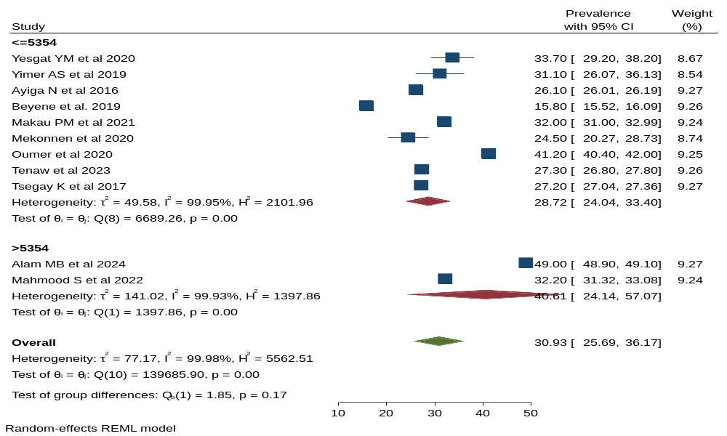
Supplementary figure 1: Heterogeneity of modern contraception use among persons with disability in low- and middle-income countries by sample size of the included studies

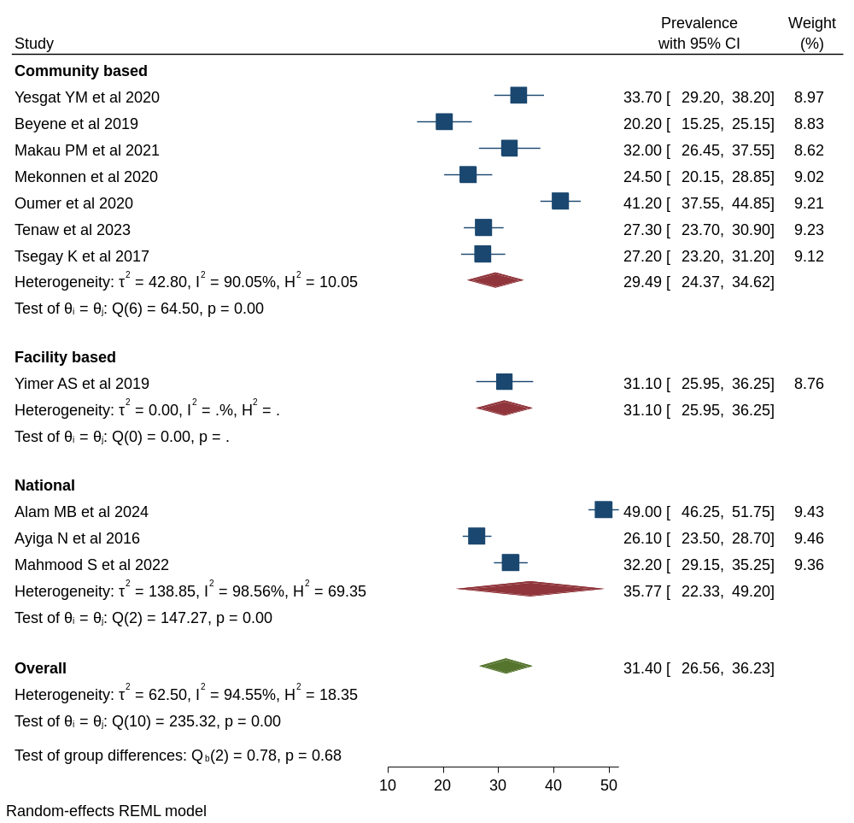

Supplementary figure 2: Heterogeneity of modern contraception use among persons with disability in low- and middle-income countries by study settings of the included studies
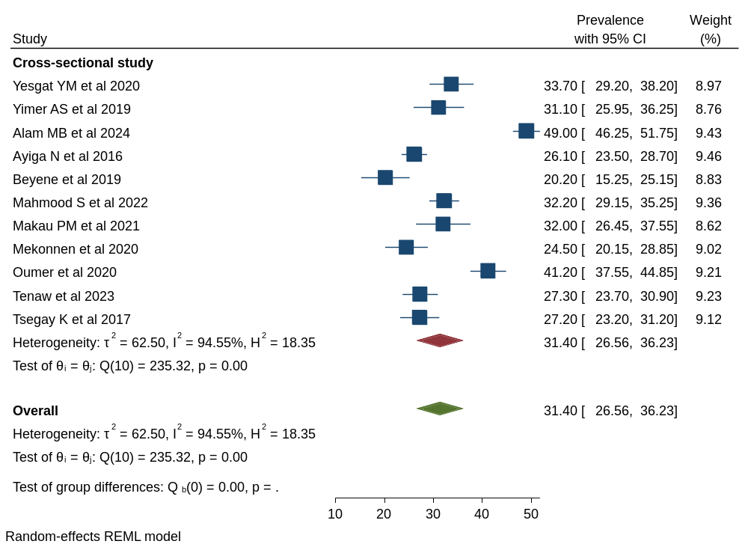

Supplementary figure 3: Heterogeneity of modern contraception use among persons with disability in low- and middle-income countries by study design of the included studies.

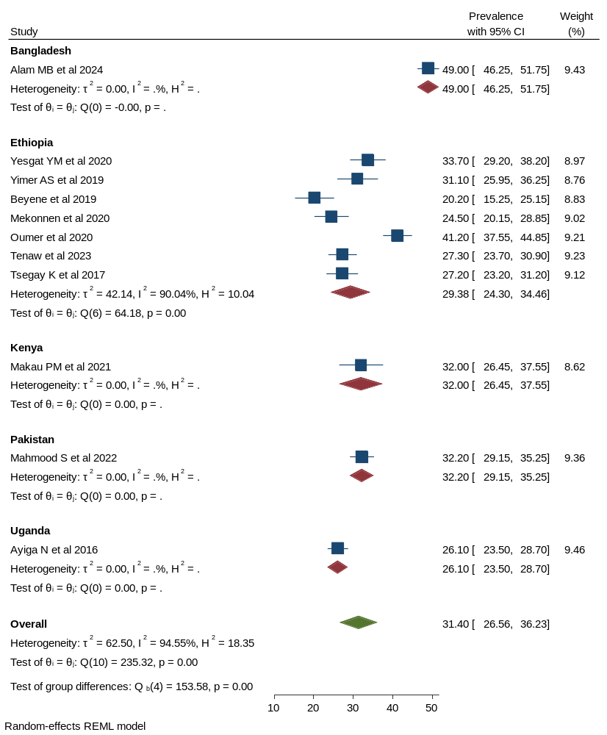
Supplementary figure 4: Heterogeneity of modern contraception use among persons with disability in low- and middle-income countries by country of the included studies.

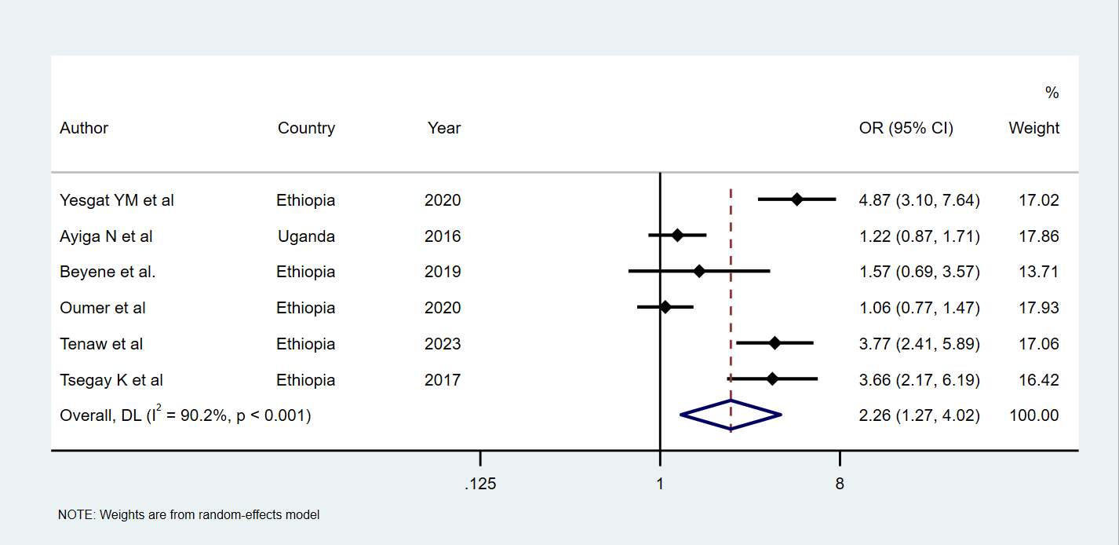

Supplementary figure 5: Summary estimations of age on modern contraception uptake among women with disabilities in low- and middle-income countries.
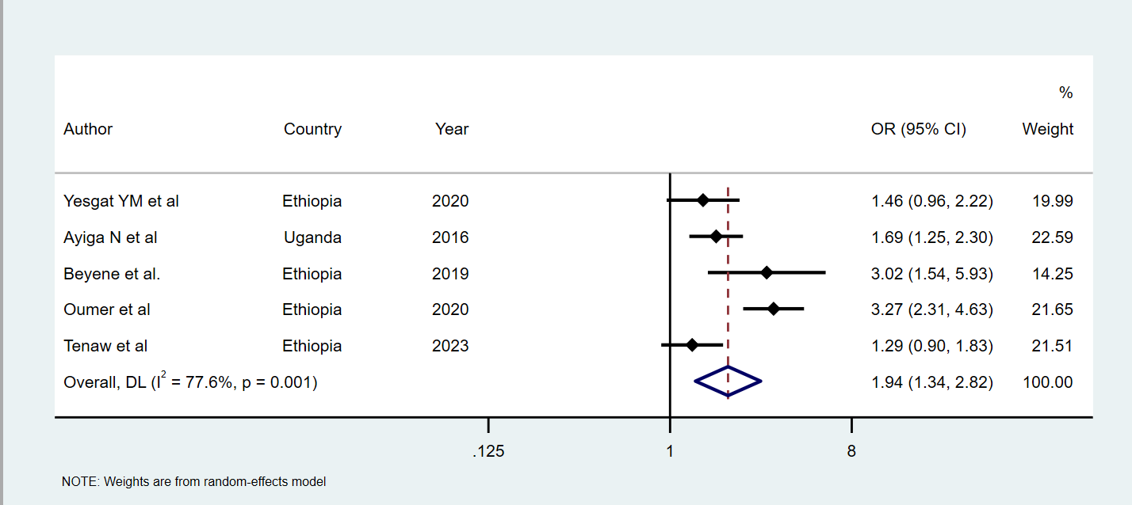
Supplementary figure 6: Summary estimations of education on modern contraception uptake among women with disabilities in low- and middle-income countries

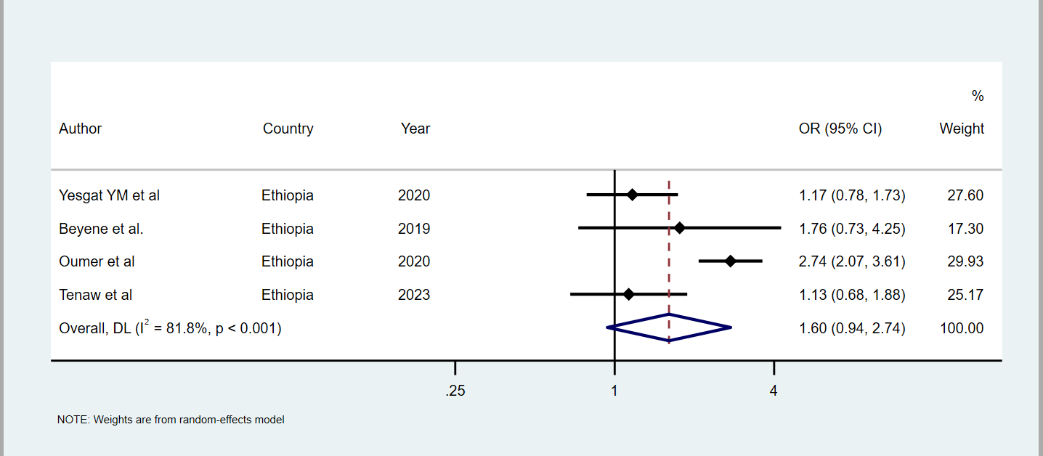
Supplementary figure 7: Summary estimations of occupation on modern contraception uptake among women with disabilities in low- and middle-income countries.

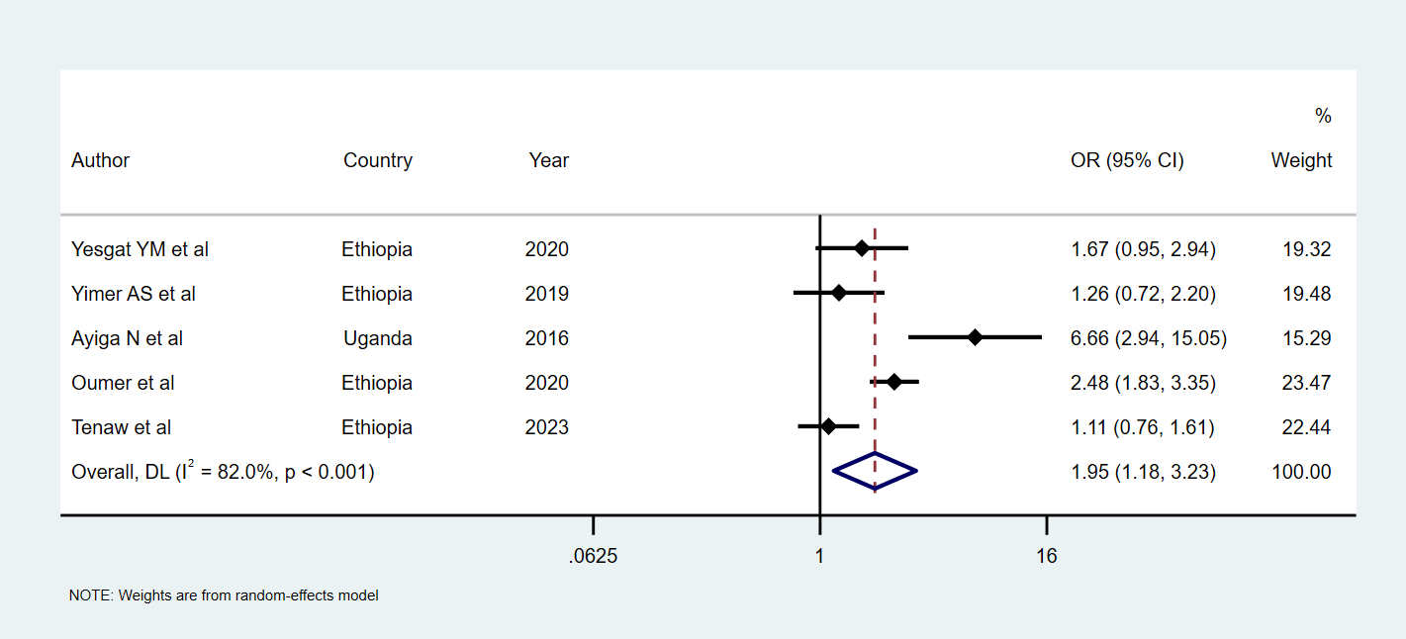
Supplementary figure 8: Summary estimations of wealth index on modern contraception uptake among women with disabilities in low- and middle-income countries.

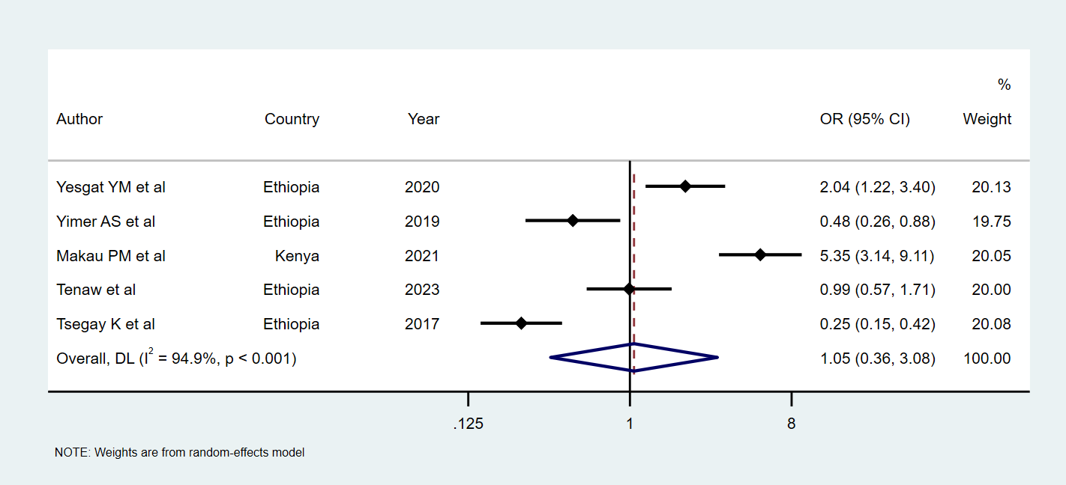
Supplementary figure 9: Summary estimations of attitude on modern contraception uptake among women with disabilities in low- and middle-income countries.

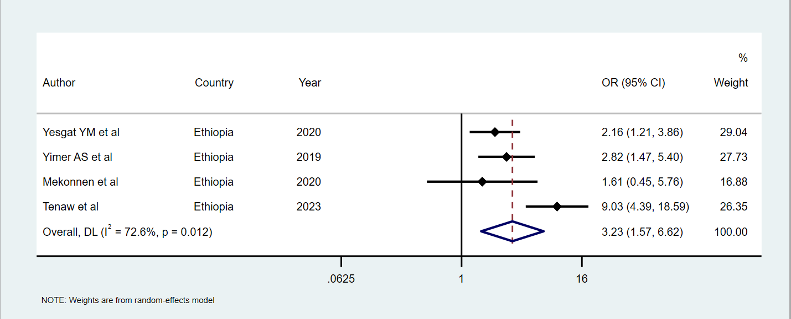
Supplementary figure 10: Summary estimations of knowledge on modern contraception uptake among women with disabilities in low- and middle-income countries.

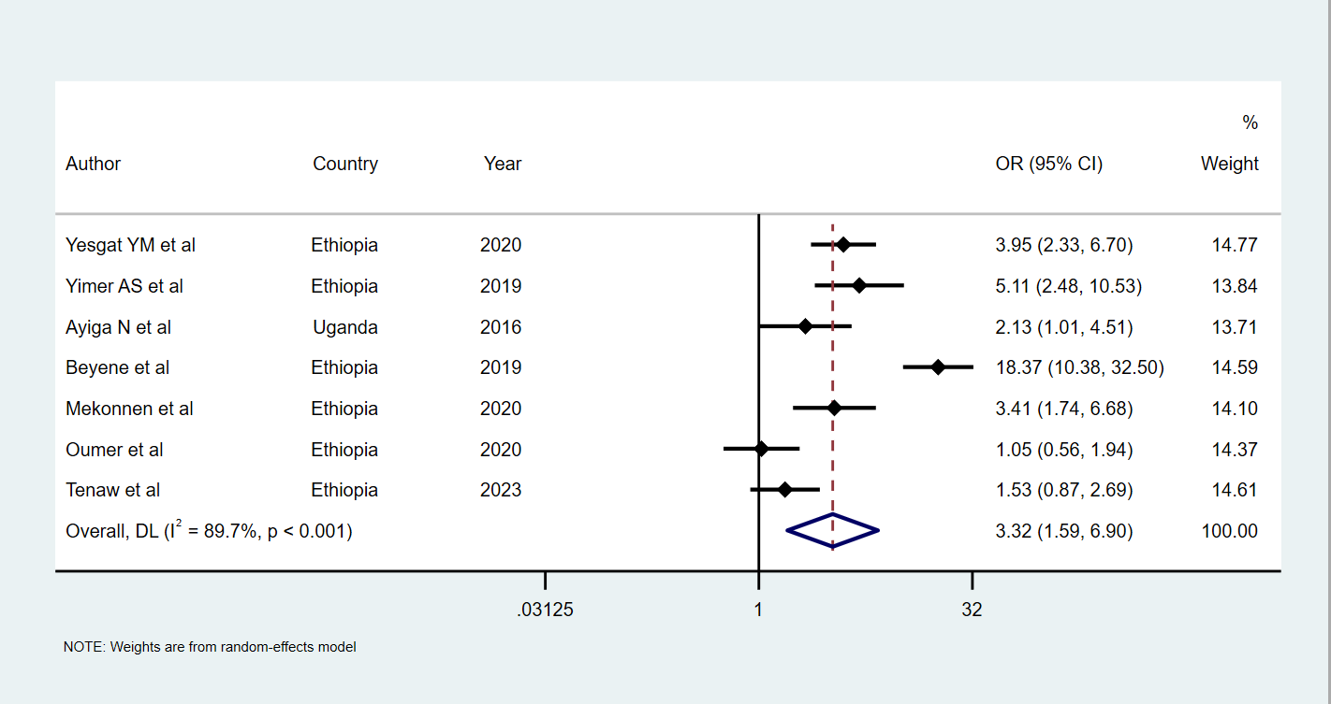
Supplementary figure 11: Summary estimations of marital union on modern contraception uptake among women with disabilities in low- and middle-income countries.
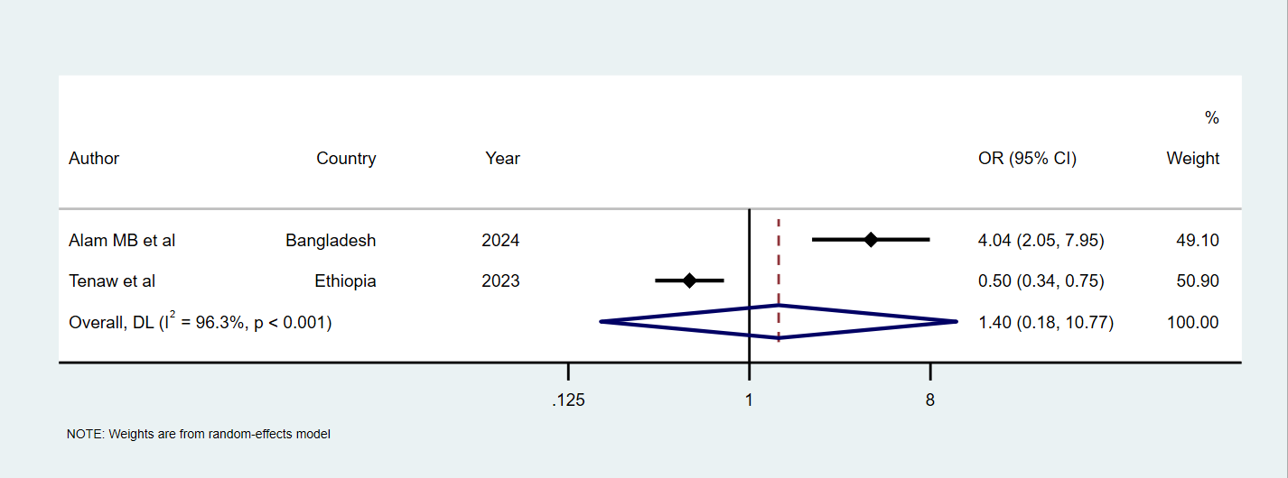
Supplementary figure 12: Summary estimations of proximity to healthcare facilities on modern contraception uptake among women with disabilities in low- and middle-income countries.

References
1. Tenaw, Z., T. Gari, and A. Gebretsadik, Contraceptive use among reproductive-age females with disabilities in central Sidama National Regional State, Ethiopia: a multilevel analysis. PeerJ, 2023. 11: p. e15354.
2. Mesfin Yesgat, Y., et al., Utilization of Family Planning Methods and Associated Factors Among Reproductive-Age Women with Disability in Arba Minch Town, Southern Ethiopia. Open Access J Contracept, 2020. 11: p. 25-32.
3. Mekonnen, A.G., et al., Level of knowledge, attitude, and practice of family planning and associated factors among disabled persons, north-shewa zone, Amhara regional state, Ethiopia. Contraception and Reproductive Medicine, 2020. 5(1).
4. Yimer, A.S. and L.M. Modiba, Modern contraceptive methods knowledge and practice among blind and deaf women in Ethiopia. A cross-sectional survey. BMC Womens Health, 2019. 19(1): p. 151.
5. Oumer, M., A. Manaye, and Z. Mengistu, Modern Contraceptive Method Utilization and Associated Factors Among Women of Reproductive Age in Gondar City, Northwest Ethiopia. Open Access J Contracept, 2020. 11: p. 53-67.
6. Natal Ayiga, S.K., Access to and Uptake of Contraception by Women with Disabilities. journal of social science, 2016.
7. Beyene, G.A., A.M. Munea, and G.A. Fekadu, Modern Contraceptive Use and Associated Factors among Women with Disabilities in Gondar City, Amhara Region, North West Ethiopia: A Cross Sectional Study. Afr J Reprod Health, 2019. 23(2): p. 101-109.
8. Makau, P.M., et al., Attitude towards utilization of family planning services among women of reproductive age living with disability in Kajiado County, Kenya. Int J Community Med Public Heal, 2021. 8(8): p. 3793.
9. Mahmood, S., W. Hameed, and S. Siddiqi, Are women with disabilities less likely to utilize essential maternal and reproductive health services?—A secondary analysis of Pakistan Demographic Health Survey. PLOS ONE, 2022. 17(8): p. e0273869.
10. Alam, M.B., et al., Pattern of contraceptive use among reproductive-aged women with disabilities in Bangladesh: Evidence from multiple indicator cluster survey 2019. Disabil Health J, 2024: p. 101651.
11. Tsegay, K., H. Gebremariam, and F. Haile. Modern Contraceptive Methods Utilization and Associated Factors among Women with Disabilities in Mekelle Town, Tigray, Ethiopia. 2017.
12. Shiwakoti, R., et al., Factors affecting utilization of sexual and reproductive health services among women with disabilities- a mixed-method cross-sectional study from Ilam district, Nepal. BMC Health Serv Res, 2021. 21(1): p. 1361.
13. Mac-Seing, M., et al., Disability and sexual and reproductive health service utilisation in Uganda: an intersectional analysis of demographic and health surveys between 2006 and 2016. BMC Public Health, 2022. 22(1): p. 438.
14. Adigun, O.T. and T.P. Mngomezulu, 'They Forget I'm Deaf': Exploring the Experience and Perception of Deaf Pregnant Women Attending Antenatal Clinics/Care. Ann Glob Health, 2020. 86(1): p. 96.
15. Burke, E., et al., A qualitative study to explore the barriers and enablers for young people with disabilities to access sexual and reproductive health services in Senegal. Reprod Health Matters, 2017. 25(50): p. 43-54.
16. Kumi-Kyereme, A., Sexual and reproductive health services utilisation amongst in-school young people with disabilities in Ghana. Afr J Disabil, 2021. 10: p. 671.
17. Ademokoya, J.A. and P.E. Igbeneghu. Sexual behaviours and contraceptive use among adolescents with learning disabilities in ibadan north local government area, oyo state, nigeria. 2016.
18. Casebolt, M.T., et al., Use of modern contraceptives by women with disabilities in Rajasthan, India: An analysis of the annual health survey. Sexual & Reproductive Healthcare, 2022. 31: p. 100699.

