SUPPLEMENTARY MATERIALS

Supplementary Table 1. Peripheral THC and THC Analyte Concentrations Following Overnight (T1; 17.80±6.2 hours) and Short-Term Cannabis Abstinence (T2; 3.96±1.8 days) in Chronic Cannabis Users (n= 14)
Compound | Overnight Abstinence (T1) | Short-Term Abstinence  (T2) | % Change | p
THC | 3.4±3.3 | 2.0±2.4 | -42.1% | 0.039
11-OH-THC | 1.3±2.0 | 0.2±0.8 | -83.8% | 0.015
THCCOOH | 50.1±53.1 | 13.7±19.9 | -72.6% | 0.005
Cannabidol | 0.05±0.1 | 0.01±0.03 | -80.0% | 0.293
Cannabinol | 0.04±0.09 | 0.02±0.06 | -44.7% | 0.035
Cannabigerol | 0.1±0.1 | 0.03±0.07 | -74.5% | 0.316
Note. Values presented as Mean ± Standard Deviation. Paired-sample t-tests (two-tailed) were conducted; statistically significant values are indicated in bold; p < .05. Δ9‑Tetrahydrocannabinol (THC), 11‑Hydroxy‑THC (11‑OH‑THC), 11‑Nor‑9‑Carboxy‑THC (THCCOOH), Cannabidiol (CBD), Cannabinol (CBN), Cannabigerol (CBG)

Supplementary Table 2. PET Parameters and Clinical Changes Following Overnight (T1; 17.8±6.2 hours) and Short-Term Cannabis Abstinence (T2; 3.96±1.8 days) in Chronic Cannabis Users (n= 14)
 | Overnight  Abstinence  (T1) | Short-Term  Abstinence  (T2) | %  Change | p
Duration of Cannabis Abstinence | 17.80±6.23  (13.6-36.2) hours | 3.96±1.77  (2.5-9.6) days |  | <.001
Scan Parameters
Amount Injected(mCi) | 9.65±0.63 | 9.89±0.65 |  | 0.140
Ratio of Activity Injected (mCi/kg) | 0.12±0.02 | 0.12±0.02 |  | 0.153
Specific Activity (mCi/umol) | 1703.93±937.98 | 1574.71±1028.29 |  | 0.505
Mass Injected (ug) | 2.47±1.62 | 3.66±3.54 |  | 0.167
Mood, Anxiety, and Affect Questionnaires ^{A}
Patient Health Questionnaire-9 | 4.86±1.07 | 4.64±0.87 | -4.4% | 0.779
General Anxiety Disorder-7 | 3.93±1.17 | 2.83±0.78 | -27.3% | 0.168
State-Trait Anxiety Inventory - State | 32.07±3.11 | 33.86±2.58 | 5.6% | 0.535
Profile of Mood States
Factor 1: Composed – Anxious | 27.86±1.49 | 27.14±1.60 | -2.6% | 0.621
Factor 2: Elated – Depressed | 25.79±1.64 | 22.71±1.29 | -11.9% | 0.056
Factor 3: Energetic – Tired | 18.50±2.01 | 19.79±1.74 | 7.0% | 0.511
Factor 4: Agreeable – Hostile | 27.64±1.51 | 25.86±1.83 | -6.5% | 0.137
Factor 5: Confident – Unsure | 24.43±1.87 | 23.21±1.45 | -5.0% | 0.333
Factor 6: Clearheaded – Confused | 26.21±2.18 | 27.79±1.48 | 6.0% |  | 0.300
Cannabis-Related Questionnaires ^{A}
Marijuana Craving Questionnaire
Factor 1: Compulsivity Sum | 8.07±1.41 | 8.57±1.49 | 6.2% | 0.699
Factor 2: Emotionality Sum | 9.21±1.63 | 10.71±1.45 | 16.3% | 0.311
Factor 3: Expectancy Sum | 13.57±1.32 | 12.07±1.39 | -11.1% | 0.111
Factor 4: Purposefulness Sum | 12.93±1.61 | 13.64±1.49 | 5.5% | 0.574
Marijuana Withdrawal Questionnaire
Checklist Total | 9.86±1.72 | 10.93±2.51 | 10.9% | 0.627
Discomfort Score | 7.64±1.33 | 8.43±1.89 | 10.3% | 0.660
Note. Continuous variable values presented as Mean ± Standard deviation and p values based on paired t-test, unless stated otherwise.
^{A}Values presented as Mean ± Standard error; Pairwise comparisons were performed on least-squares means adjusted for Days of Abstinence, derived from ANCOVA models (significance p < .05).

Supplementary Table 3. Neurocognitive Assessment Following Overnight (T1; 17.8±6.2 hours) and Short-Term Cannabis Abstinence (T2; 3.96±1.8 days) in Chronic Cannabis Users (n= 14)

 | Overnight  Abstinence  (T1) | Short-Term  Abstinence  (T2) | % Change | p
Trails Making Task
Trails A¹ | 21.62±1.91 | 21.23±1.50 | -6.0% | 0.400
Trails B² | 55.48±5.45 | 57.30±3.92 | 3.3% | 0.636
Hopkins Verbal Learning Task
Total¹ | 24.86±1.44 | 24.93±1.06 | 0.3% | 0.947
Learning Measure | 4.07±0.43 | 3.43.074 | -15.8% | 0.123
Retained² | 119.20±13.50 | 115.68±7.45 | -3.0% | 0.805
Retained 2² | 9.64±6.74 | 90.36±4.96 | -0.3% | 0.969
Discrimination Index³ | 10.00±1.11 | 10.50±0.45 | 5.0% | 0.987
Base Rate³ | 0.43±0.05 | 0.53±0.05 | 23.0% | 0.073
Higher of 2 or 3 | 10.00±0.53 | 9.86±0.41 | -1.4% | 0.762
Delay Correct² | 9.00±0.86 | 8.73±0.67 | -3.0% | 0.746
Cued³ | 10.60±0.91 | 11.40±0.23 | 7.5% | 0.379
Missed³ | 1.40±0.91 | 0.60±0.23 | -57.1% | 0.379
False Positive³ | 0.60±0.28 | 0.90±0.28 | 50.0% | 0.472
Digit Span Task
Digit Forward | 11.79±0.58 | 11.50±0.58 | -2.4% | 0.372
Digit Backward | 7.07±0.41 | 7.50±0.63 | 6.1% | 0.401
Delay Discounting Task - Geomean K | 0.027±0.008 | 0.025±0.008 | -7.4% | 0.554
Stop Signal Task²
Mean CRT | 666.12±42.34 | 641.46±47.39 | -3.7% | 0.397
Mean PCR | 98.10±0.69 | 96.41±1.13 | -1.7% | 0.111
Mean Delay | 417.84±33.79 | 391.86±61.71 | -6.2% | 0.634
Mean PSI | 55.68±2.05 | 57.82±2.84 | 3.8% | 0.523
Mean SSRT | 248.27±19.55 | 249.59±29.39 | 0.5% | 0.972
Purdue Pegboard Task - Both Hands | 12.50±0.74 | 12.29±0.27 | -1.7% | 0.780
Iowa Gambling Task - Total Earnings² | -1120.91±400.71 | -307.27±350.07 | -72.6% | 0.091
Values presented as Mean ± Standard error; Pairwise comparisons were performed on least-squares means adjusted for Days of Abstinence, derived from ANCOVA models (significance p < .05). Some tests were reported in a subset of participants ¹(n= 13); ²(n= 11); ³(n= 10).

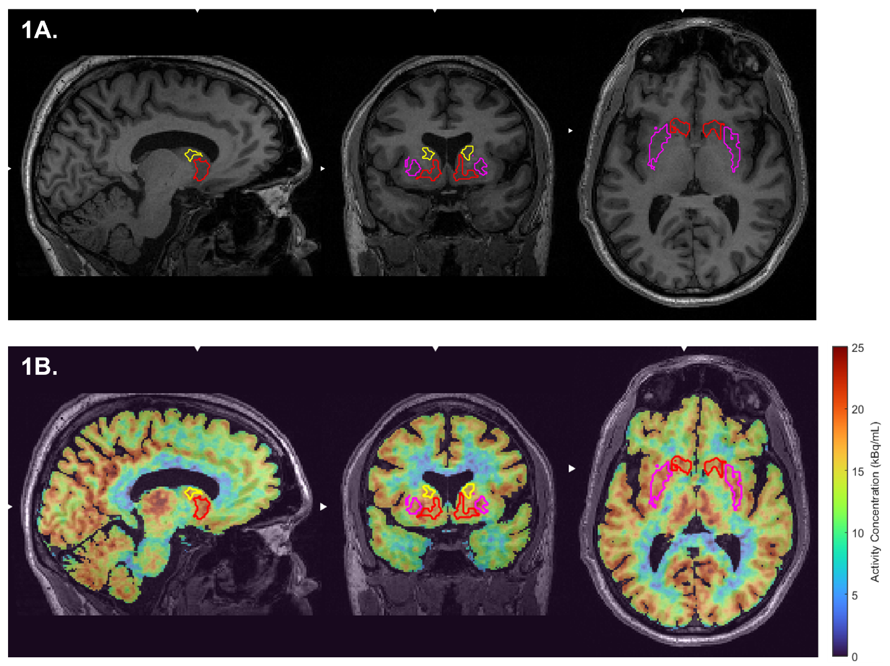
Supplementary Figure 1. Region of Interest (ROI) Delineation and PET Signal in the Ventral Striatum. MRI (A) and PET (B) images demonstrating ROI delineation of the ventral striatum. Shown in a sample participant (38M, rs324420 FAAH C385A AC, mild CUD severity). Segmented using the ROMI [¹¹C]CURB ROI template/brain atlas [1].

REFERENCES:
1 Rusjan P, Mamo D, Ginovart N, Hussey D, Vitcu I, Yasuno F, et al. An automated method for the extraction of regional data from PET images. Psychiatry Res. 2006;147(1):79-89.

