Supplemental Materials

Supplemental methods

Quality assessment of plasma NAE species analysis

Commercially available standards were used for peak referencing of the NAE species. Three pooled plasma samples (quality control; QC) were spiked with commercially available synthetic NAE standards added at a known concentration, and analysed in triplicate with blank ethanol injections run in between samples. Injection variation was analysed by calculation of the mean response and standard deviation of the triplicate injections for each of the three QC samples. The coefficient of variation was calculated, and the mean values are shown in Tables S1. A pooled sample was analysed alongside each batch of clinical samples and a species-specific response value was added to the adjustment model to account for inter-batch variability. An estimation of sample carry-over was calculated by assessing the presence of lipid species in blank injections; there was detectable carryover of NAE species.

Table S1: Mean injection coefficient of variation (CV) (n=3 samples) of plasma N-acyl ethanolamine (NAE) species.

NAE | Mean  Injection  CV (%)
AEA | 4
PEA | 4
OEA | 6
VEA | 6
LEA | 3
DPEA | 2
DHEA | 6
HEA | 4
STEA | 15

Quality assessment of plasma CER species analysis

Due to lack of commercially available synthetic standards for every CER species detected in human plasma, CER were analysed via multiple reaction monitoring (MRM) using three transitions per target compound (Table S2). A pooled lipid extract sample was used for the identification of CER species, and the coefficient of variation was calculated (Table S3).

Table S2: Multiple reaction monitoring transitions used for plasma ceramide analysis. R = fatty acyl chain

Ceramide | m/z | m/z | m/z | m/z | m/z
Ceramide | Precursor | Fragment 1 | Fragment 2 | Fragment 3 | Fragment 4
Ceramide | [M+H]⁺ | [M+H-R-HCHO]⁺ | [M+H-R-2H₂O]⁺ | [M+H-R-H₂O]⁺ | [M+H-R]+
CER[N(22)S(18)] | 662.6 | 252.4 | 264.4 | 282.4
CER[N(22)S(19)] | 636.6 | 266.4 | 278.4 | 296.4
CER[N(23)S(18)] | 636.6 | 252.4 | 264.4 | 282.4
CER[N(23)S(20)] | 664.7 | 280.4 | 292.4 | 310.4
CER[N(24)DS(18)] | 652.7 |  | 266.4 | 284.4 | 302.4
CER[N(24)DS(19)] | 666.7 |  | 280.4 | 289.4 | 316.4
CER[N(24)DS(20)] | 680.7 |  | 294.4 | 312.4 | 330.4
CER[N(24)S(16)] | 622.6 | 224.4 | 236.4 | 254.4
CER[N(24)S(17)] | 636.6 | 238.4 | 250.4 | 268.4
CER[N(24)S(18)] | 650.7 | 252.4 | 264.4 | 282.4
CER[N(24)S(19)] | 664.7 | 266.4 | 278.4 | 296.4
CER[N(24)S(20)] | 678.7 | 280.4 | 292.4 | 310.4
CER[N(24)S(22)] | 706.7 | 308.4 | 320.4 | 338.4
CER[N(25)S(20)] | 692.7 | 280.4 | 292.4 | 310.4
CER[N(26)S(18)] | 678.7 | 252.4 | 264.4 | 282.4
CER[N(26)S(19)] | 692.7 | 266.4 | 278.4 | 296.4

Table S3: Mean injection coefficient of variation (CV) (n=3 samples) of plasma ceramide species.

Ceramide | Mean injection  CV (%)
CER[N(22)S(18)] | 3
CER[N(22)S(19)] | 11
CER[N(23)S(18)] | 5
CER[N(23)S(20)] | 3
CER[N(24)DS(18)] | 2
CER[N(24)DS(19)] | 6
CER[N(24)DS(20)] | 7
CER[N(24)S(16)] | 5
CER[N(24)S(17)] | 5
CER[N(24)S(18)] | 6
CER[N(24)S(19)] | 7
CER[N(24)S(20)] | 6
CER[N(24)S(22)] | 9
CER[N(25)S(20)] | 7
CER[N(26)S(18)] | 3
CER[N(26)S(19)] | 4

Supplemental Tables

Table S4. Predictors identified from stepwise-multiple linear regression.
A) qc, quality control sample; Batch, mass spectrometry batch; Age, age at enrolment; Abnormality, presence of white blood cells, red blood cells or other sample abnormality. B) Correlation coefficient (R) of association between CER levels and hypertension status and blood pressure traits. We found no substantial correlation with blood pressure traits and lipid levels (-0.15<R<0.15). C) As anticipated, the significance of genetic effects on the lipids for which cholesterol and BMI were significant covariates, were somewhat diminished in analyses unadjusted for the two covariates. The table depicts the association of the lipids with the lead SNPs in FAAH and SPTLC3 without the inclusion of cholesterol or BMI.
A)
Class | Lipid | Predictors
CER | N(22)S(18) | N22_S18_qc + Batch + Abnormality + Age + Sex + Hypertension + Age2
CER | N(22)S(19) | N22_S19_qc + Batch + Abnormality + Cholesterol
CER | N(23)S(18) | N23_S18_qc + Batch + Age2 + Age
CER | N(23)S(20) | N23_S20_qc + Batch + Sex + Age2
CER | N(24)DS(18) | N24_DS18_qc + Batch + Sex + Age + BMI + Cholesterol
CER | N(24)DS(19) | N24_DS19_qc + Batch + Sex + BMI + Cholesterol
CER | N(24)DS(20) | N24_DS20_qc + Batch + Abnormality + Sex + Hypertension + Age + Age2 + BMI + Cholesterol
CER | N(24)S(16) | N24_S16_qc + Batch + Abnormality + Sex + Age + Age2
CER | N(24)S(17) | N24_S17_qc + Batch + Sex + Age + Age2
CER | N(24)S(18) | N24_S18_qc + Batch + Age + Age2 + Cholesterol
CER | N(24)S(19) | N24_S19_qc + Batch + Abnormality
CER | N(24)S(20) | N24_S20_qc + Batch + Abnormality + Sex + Hypertension + Age + Age2 + BMI + Cholesterol
CER | N(24)S(22) | N24_S22_qc + Sex + Age2 + BMI
CER | N(25)S(20) | N25_S20_qc + Age + BMI + Cholesterol
CER | N(26)S(18) | N26_S18_qc + Batch + Sex + Age + Age2 + Cholesterol
CER | N(26)S(19) | N26_S19_qc + Sex + Age2 + BMI + Cholesterol
NAE | AEA | AEA_qc + Cholesterol + BMI + Batch
NAE | DHEA | DHEA_qc + Cholesterol + Age2 + Batch
NAE | DPEA | DPEA_qc + Cholesterol + BMI + Batch + Sex + Hypertension + Age2 + Age + Abnormality
NAE | OEA | OEA_qc + Cholesterol + Batch + BMI
NAE | LEA | LEA_qc + Cholesterol + Batch + Age2
NAE | PEA | PEA_qc + Cholesterol
NAE | VEA | VEA_qc + Cholesterol + Batch + Sex + Hypertension
NAE | STEA | STEA_qc + Cholesterol + Batch + Sex + BMI
NAE | HEA | HEA_qc + Cholesterol + Batch
B)
Lipid | Hypertension  Status | Clinical Systolic  Blood Pressure | Clinical Diastolic  Blood Pressure
N(22)S(18) | -0.03 | -0.03 | -0.02
N(22)S(19) | -0.03 | -0.02 | -0.03
N(23)S(18) | -0.07 | -0.06 | -0.06
N(23)S(20) | 0.01 | 0.01 | 0.01
N(24)DS(18) | 0 | 0.03 | 0.07
N(24)DS(19) | 0.04 | 0.05 | 0.12
N(24)DS(20) | 0.03 | 0.03 | 0.11
N(24)S(16) | 0.01 | 0.01 | 0.03
N(24)S(17) | -0.1 | -0.08 | -0.06
N(24)S(18) | -0.09 | -0.09 | -0.07
N(24)S(19) | -0.08 | -0.05 | -0.04
N(24)S(20) | 0.01 | 0.02 | 0.08
N(24)S(22) | -0.07 | -0.1 | -0.05
N(25)S(20) | 0.08 | 0.05 | 0.08
N(26)S(18) | 0.06 | 0.05 | 0.08
N(26)S(19) | 0.01 | 0.01 | 0.02
AEA | -0.06 | 0.03 | 0.01
DHEA | -0.01 | 0.06 | 0.02
DPEA | -0.07 | 0.03 | 0
HEA | -0.02 | 0.03 | 0.01
LEA | -0.11 | -0.06 | -0.05
OEA | -0.11 | -0.04 | -0.05
PEA | -0.09 | 0 | -0.01
STEA | -0.05 | 0 | -0.02
VEA | -0.09 | -0.02 | -0.01
C)
Lipid | Beta | SE | P-value | SNP
DHEA | 0.28 | 0.05 | 1.74E-07 | rs324420
LEA | 0.31 | 0.05 | 1.99E-08 | rs324420
PEA | 0.28 | 0.05 | 2.97E-08 | rs324420
VEA | 0.31 | 0.05 | 2.71E-10 | rs324420
N(22)S(19) | 0.36 | 0.04 | 6.81E-17 | rs680379
N(24)DS(19) | 0.42 | 0.05 | 8.08E-20 | rs680379
N(24)DS(20) | 0.3 | 0.05 | 2.31E-10 | rs680379
N(24)S(20) | 0.37 | 0.05 | 3.16E-14 | rs680379
N(25)S(20) | 0.3 | 0.05 | 5.96E-10 | rs680379
N(26)S(19) | 0.32 | 0.04 | 4.67E-13 | rs680379

Table S5. Genomic inflation factors (GIF) from GWAS results per trait.

Class | Lipid | GIF
CER | N(22)S(18) | 1.0042
CER | N(22)S(19) | 0.9893
CER | N(23)S(18) | 1.0000
CER | N(23)S(20) | 1.0046
CER | N(24)DS(18) | 1.0044
CER | N(24)DS(19) | 0.9952
CER | N(24)DS(20) | 1.0045
CER | N(24)S(16) | 1.0012
CER | N(24)S(17) | 1.0037
CER | N(24)S(18) | 1.0036
CER | N(24)S(19) | 0.9944
CER | N(24)S(20) | 0.9907
CER | N(24)S(22) | 1.0036
CER | N(25)S(20) | 1.0061
CER | N(26)S(18) | 1.0017
CER | N(26)S(19) | 0.9939
CER | n24s19ratio | 0.9937
CER | s19_sum | 0.9954
CER | s20_sum | 0.9945
NAE | AEA | 0.9984
NAE | DHEA | 0.9916
NAE | DPEA | 1.0062
NAE | LEA | 0.9910
NAE | OEA | 0.9916
NAE | PEA | 0.9904
NAE | VEA | 0.9921
NAE | STEA | 0.9984
NAE | HEA | 0.9953
NAE | sumEA | 0.9961

Table S6. List of GWAS assessed by 2SMR analysis for relationship with the SNPs identified at GWAS to associate with the lipid species.
id, 2SMR software ID; pmid, PubMed ID; pop, population type; EU, European.

author | consortium | id | ncase | ncontrol | nsnp | pmid | pop | sample  size | sex | trait | unit | year
Nikpay | CARDIoGRAM  plusC4D | 7 | 60801 | 123504 | 9455779 | 26343387 | Mix | 184305 | both | Coronary heart  Disease and MI | log  odds | 2015
Mahajan | DIAGRAM | 23 | 26488 | 83964 | 2915012 | 24509480 | Mix | 110452 | both | Type 2  diabetes | Log  odds | 2014
Astle | UK Biobank  INTERVAL  UK BiLEVE | ebi-a-GCST004612 | NA | NA | 29163693 | 27863252 | EU | 170763 | both | Blood cell traits | NA | 2016
Neale lab | UK Biobank | ukb-d-30100_irnt  ukb-d-30080_irnt  ukb-d-30290_irnt  ukb-d-30300_irnt  ukb-d-30280_irnt  ukb-d-30240_irnt | NA | NA | 13586285 | NA | EU | 350470 | both | Blood cell traits | NA | 2018
Elsworth | UK Biobank | ukb-b-20044 | NA | NA | 9851867 | NA | EU | 454588 | both | Trunk fat  mass | SD | 2018
Elsworth | UK Biobank | ukb-b-8909 | NA | NA | 9851867 | NA | EU | 454588 | both | Body fat  percentage | SD | 2018
Bradfield | - | ieu-a-1096 | 5530 | 8318 | 2442739 | 22484627 | EU | 13848 | both | Childhood  obesity | NA | 2012
Elsworth | UK Biobank | ukb-b-19953 | NA | NA | 9851867 | NA | EU | 454588 | both | Body mass  index (BMI) | SD | 2018
Pilling | UK Biobank | ebi-a-GCST006804 | NA | NA | 16671830 | 28957414 | EU | 116666 | NA | Blood cell traits | NA | 2017

Table S7: Lipid species, corresponding class, summary statistics, and description of the species.
The concentrations are provided before adjustment or outlier removal for a total of 999 samples analysed from 196 families.

Lipid | Class | unit | N | Mean | SD | Description of lipid species
N(22)S(18) | CER | pmol/ml | 999 | 128 | 74 | Non-hydroxy fatty acid and sphingosine bas
N(22)S(19) | CER | pmol/ml | 999 | 32 | 22 | Non-hydroxy fatty acid and sphingosine base
N(23)S(18) | CER | pmol/ml | 999 | 866 | 365 | Non-hydroxy fatty acid and sphingosine base
N(23)S(20) | CER | pmol/ml | 999 | 51 | 16 | Non-hydroxy fatty acid and sphingosine base
N(24)DS(18) | CER | pmol/ml | 999 | 175 | 112 | Non-hydroxy fatty acid and dihydrosphingosine base
N(24)DS(19) | CER | pmol/ml | 999 | 66 | 42 | Non-hydroxy fatty acid and dihydrosphingosine base
N(24)DS(20) | CER | pmol/ml | 998 | 40 | 22 | Non-hydroxy fatty acid and dihydrosphingosine base
N(24)S(16) | CER | pmol/ml | 999 | 49 | 30 | Non-hydroxy fatty acid and sphingosine base
N(24)S(17) | CER | pmol/ml | 999 | 236 | 106 | Non-hydroxy fatty acid and sphingosine base
N(24)S(18) | CER | pmol/ml | 999 | 2724 | 1290 | Non-hydroxy fatty acid and sphingosine base
N(24)S(19) | CER | pmol/ml | 999 | 1068 | 486 | Non-hydroxy fatty acid and sphingosine base
N(24)S(20) | CER | pmol/ml | 999 | 249 | 93 | Non-hydroxy fatty acid and sphingosine base
N(24)S(22) | CER | pmol/ml | 999 | 45 | 31 | Non-hydroxy fatty acid and sphingosine base
N(25)S(20) | CER | pmol/ml | 999 | 38 | 19 | Non-hydroxy fatty acid and sphingosine base
N(26)S(18) | CER | pmol/ml | 999 | 706 | 219 | Non-hydroxy fatty acid and sphingosine base
N(26)S(19) | CER | pmol/ml | 999 | 108 | 74 | Non-hydroxy fatty acid and sphingosine base
AEA | NAE | pg/ml | 998 | 352 | 334 | Anandamide (N-arachidonoyl ethanolamide)
DHEA | NAE | pg/ml | 996 | 349 | 290 | N-docosahexaenoyl ethanolamide
DPEA | NAE | pg/ml | 990 | 22 | 17 | N-docosapentaenoyl ethanolamine
LEA | NAE | pg/ml | 999 | 619 | 511 | N-linoleoyl ethanolamide
OEA | NAE | pg/ml | 999 | 568 | 531 | N-oleoyl ethanolamide
PEA | NAE | pg/ml | 999 | 1884 | 1356 | N-palmitoyl ethanolamide
VEA | NAE | pg/ml | 999 | 252 | 259 | N-vaccinoyl ethanolamide
HEA | NAE | pg/ml | 968 | 24 | 19 | N-heptadecanoyl ethanolamide
STEA | NAE | pg/ml | 999 | 495 | 447 | N-stearoyl ethanolamide

Table S8. Heritability of plasma lipid species measured.

Heritability was estimated using GCTA SNP-based software using the genotyping data and QTDT pedigree-based software. h², estimated heritability; SE, standard error; n, number of individuals included in analysis after outlier removal; P-adj, P-value after Bonferroni adjustment of the P-value for multiple testing (16 for CER measured, 9 for NAE measures). A GCTA P-value of 0 is represented as a P-value result of <6.11x10⁻¹⁶.

 |  | QTDT |  |  |  |  | GCTA
Class | Lipid | h² | SE | n | P-value | P-adj | h² | SE | n | P-value | P-adj
CER | N(22)S(18) | 0.49 | 0.049 | 993 | 5.00E-23 | 1.50E-21 | 0.48 | 0.059 | 993 | 6.11E-16 | 1.83E-14
CER | N(22)S(19) | 0.38 | 0.048 | 992 | 1.00E-15 | 1.10E-14 | 0.36 | 0.057 | 992 | 6.11E-15 | 6.72E-14
CER | N(23)S(18) | 0.40 | 0.049 | 992 | 2.00E-16 | 6.00E-15 | 0.39 | 0.057 | 992 | 1.11E-16 | 3.33E-15
CER | N(23)S(20) | 0.53 | 0.056 | 994 | 1.00E-21 | 1.10E-20 | 0.54 | 0.061 | 994 | 6.11E-16 | 6.72E-15
CER | N(24)DS(18) | 0.40 | 0.048 | 992 | 8.00E-17 | 2.40E-15 | 0.39 | 0.06 | 992 | 5.55E-17 | 1.67E-15
CER | N(24)DS(19) | 0.45 | 0.053 | 994 | 1.00E-17 | 1.10E-16 | 0.46 | 0.062 | 994 | 6.11E-16 | 6.72E-15
CER | N(24)DS(20) | 0.52 | 0.050 | 993 | 6.00E-25 | 6.60E-24 | 0.52 | 0.059 | 993 | 6.11E-16 | 6.72E-15
CER | N(24)S(16) | 0.57 | 0.047 | 992 | 2.00E-34 | 2.20E-33 | 0.57 | 0.055 | 992 | 6.11E-16 | 6.72E-15
CER | N(24)S(17) | 0.42 | 0.047 | 994 | 3.00E-19 | 3.30E-18 | 0.44 | 0.057 | 994 | 6.11E-16 | 6.72E-15
CER | N(24)S(18) | 0.47 | 0.047 | 991 | 1.00E-23 | 1.10E-22 | 0.46 | 0.056 | 991 | 6.11E-16 | 6.72E-15
CER | N(24)S(19) | 0.46 | 0.054 | 991 | 2.00E-17 | 2.20E-16 | 0.38 | 0.061 | 993 | 9.94E-15 | 1.09E-13
CER | N(24)S(20) | 0.54 | 0.053 | 996 | 5.00E-24 | 5.50E-23 | 0.55 | 0.059 | 996 | 6.11E-16 | 6.72E-15
CER | N(24)S(22) | 0.55 | 0.057 | 992 | 6.00E-22 | 6.60E-21 | 0.55 | 0.061 | 992 | 6.11E-16 | 6.72E-15
CER | N(25)S(20) | 0.62 | 0.055 | 994 | 3.00E-29 | 3.30E-28 | 0.60 | 0.059 | 994 | 6.11E-16 | 6.72E-15
CER | N(26)S(18) | 0.54 | 0.050 | 995 | 7.00E-27 | 2.10E-25 | 0.54 | 0.059 | 995 | 6.11E-16 | 1.83E-14
CER | N(26)S(19) | 0.43 | 0.057 | 991 | 4.00E-14 | 4.40E-13 | 0.42 | 0.063 | 991 | 3.24E-14 | 3.56E-13
NAE | AEA | 0.48 | 0.051 | 994 | 1.00E-20 | 7.00E-20 | 0.46 | 0.06 | 994 | 6.11E-16 | 4.28E-15
NAE | DHEA | 0.56 | 0.049 | 990 | 2.00E-30 | 1.40E-29 | 0.54 | 0.057 | 990 | 6.11E-16 | 4.28E-15
NAE | DPEA | 0.54 | 0.054 | 986 | 2.00E-23 | 1.40E-22 | 0.52 | 0.06 | 986 | 6.11E-16 | 4.28E-15
NAE | LEA | 0.46 | 0.043 | 994 | 3.00E-27 | 2.10E-26 | 0.45 | 0.053 | 994 | 6.11E-16 | 4.28E-15
NAE | OEA | 0.45 | 0.049 | 994 | 4.00E-20 | 2.80E-19 | 0.45 | 0.058 | 994 | 6.11E-16 | 4.28E-15
NAE | PEA | 0.54 | 0.046 | 993 | 2.00E-32 | 1.40E-31 | 0.53 | 0.054 | 993 | 6.11E-16 | 4.28E-15
NAE | VEA | 0.49 | 0.048 | 994 | 1.00E-24 | 7.00E-24 | 0.50 | 0.058 | 994 | 6.11E-16 | 4.28E-15
NAE | STEA | 0.62 | 0.043 | 994 | 2.00E-47 | 2.20E-46 | 0.60 | 0.049 | 994 | 6.11E-16 | 6.72E-15
NAE | HEA | 0.69 | 0.045 | 964 | 2.00E-52 | 2.20E-51 | 0.68 | 0.05 | 964 | 6.11E-16 | 6.72E-15

Table S9. Significant GWAS associations for N-acyl ethanolamine species.
A) Description of the GWAS significant associations identified. B) Description of the SNPs using the Ensembl API Client. C) Summary of the information on eQTL status as identified using the GTEX browser, including a section specifying whole blood only, GWAS Catalog and PhenoScanner previous associations, and Gene Atlas PheWAS.

A
Lipid | Chr | SNP | Position | A1 | A2 | MAF | Beta | SE | P-value
DHEA | 1 | rs324420 | 46870761 | A | C | 0.20 | 0.30 | 0.053 | 2.15E-08
DHEA | 1 | rs324422 | 46886782 | T | C | 0.23 | 0.28 | 0.050 | 2.76E-08
DHEA | 1 | rs324418 | 46872698 | G | A | 0.22 | 0.28 | 0.052 | 4.36E-08
LEA | 1 | rs324420 | 46870761 | A | C | 0.20 | 0.31 | 0.055 | 1.01E-08
LEA | 1 | rs1571138 | 46895641 | A | G | 0.20 | 0.31 | 0.055 | 2.24E-08
LEA | 1 | rs324422 | 46886782 | T | C | 0.23 | 0.29 | 0.052 | 2.32E-08
PEA | 1 | rs324420 | 46870761 | A | C | 0.21 | 0.30 | 0.051 | 5.30E-09
PEA | 1 | rs1571138 | 46895641 | A | G | 0.20 | 0.29 | 0.051 | 1.13E-08
PEA | 1 | rs324418 | 46872698 | G | A | 0.22 | 0.27 | 0.050 | 2.96E-08
PEA | 1 | rs324422 | 46886782 | T | C | 0.23 | 0.27 | 0.048 | 3.44E-08
VEA | 1 | rs324420 | 46870761 | A | C | 0.20 | 0.31 | 0.049 | 1.24E-10
VEA | 1 | rs1571138 | 46895641 | A | G | 0.20 | 0.32 | 0.049 | 1.25E-10
VEA | 1 | rs324418 | 46872698 | G | A | 0.22 | 0.29 | 0.048 | 1.15E-09
VEA | 1 | rs11584511 | 46892811 | T | C | 0.14 | 0.34 | 0.058 | 3.35E-09
VEA | 1 | rs324422 | 46886782 | T | C | 0.23 | 0.27 | 0.047 | 4.66E-09
VEA | 1 | rs10489770 | 46807597 | A | G | 0.14 | 0.32 | 0.058 | 4.22E-08
VEA | 1 | rs72677586 | 46813848 | A | G | 0.14 | 0.32 | 0.058 | 4.22E-08
VEA | 1 | rs10890392 | 46852061 | G | A | 0.14 | 0.32 | 0.058 | 4.22E-08
sumEA | 1 | rs324420 | 46870761 | A | C | 0.21 | 0.32 | 0.053 | 1.36E-09
sumEA | 1 | rs1571138 | 46895641 | A | G | 0.20 | 0.31 | 0.053 | 2.62E-09
sumEA | 1 | rs324418 | 46872698 | G | A | 0.22 | 0.29 | 0.051 | 1.84E-08
sumEA | 1 | rs324422 | 46886782 | T | C | 0.23 | 0.28 | 0.050 | 2.10E-08

B
SNPID | Associated  Gene ID | Associated  Transcript ID | Associated  Gene Name | Associated  Gene Type | Impact  Rating | Variant  Allele | Consequence  Terms
rs324420 | ENSG00000117480 | ENST00000243167 | FAAH | Protein coding | MODERATE | A | Missense variant
rs324422 | (Intergenic) | (Intergenic) | (Intergenic) | (Intergenic) | MODIFIER | T | Intergenic variant
rs324418 | ENSG00000117480 | ENST00000243167 | FAAH | Protein coding | MODIFIER | G | Intron variant
rs1571138 | ENSG00000232022 | ENST00000446499 | FAAHP1 | pseudogene | MODIFIER | G | upstream
rs11584511 | ENSG00000232022 | ENST00000446499 | FAAHP1 | pseudogene | MODIFIER | T | upstream
rs10489770 | ENSG00000117481 | ENST00000307089 | NSUN4 | NMD | MODIFIER | A | intron_variant
rs72677586 | ENSG00000117481 | ENST00000307089 | NSUN4 | NMD | MODIFIER | A | intron_variant
rs10890392 | (Intergenic) | (Intergenic) | (Intergenic) | (Intergenic) | MODIFIER | G | intergenic_variant

C
SNPID | eQTL | Tissue | Other | GTEx whole blood | GWAS Catalog,  PhenoScanner | Gene Atlas
rs324420 | FAAH | Multiple | FAAHP1, LURAP1, NSUN4, RAD54L, MKNK1 | FAAH, NSUN4 | X | X
rs324422 | FAAH | Multiple | FAAHP1, LURAP1, NSUN4, RAD54L, MKNK1, MOB3C | FAAH, NSUN4, MOB3C | X | X
rs324418 | FAAH | Multiple | FAAHP1, LURAP1, NSUN4, RAD54L, MKNK1 | FAAH, NSUN4 | X | X
rs1571138 | FAAH | Multiple | FAAHP1, LURAP1, NSUN4, RAD54L, MKNK1 | FAAH, NSUN4 | X | X
rs11584511 | FAAH | Multiple | FAAHP1, LURAP1, NSUN4, RAD54L, MKNK1, UQCRH | FAAH, NSUN4 | X | X
rs10489770 | FAAH | Multiple | FAAHP1, LURAP1, NSUN4, RAD54L, MKNK1, UQCRH | FAAH | X | X
rs72677586 | FAAH | Multiple | FAAHP1, LURAP1, NSUN4, RAD54L, MKNK1, UQCRH | FAAH | X | X
rs10890392 | FAAH | Multiple | FAAHP1, LURAP1, NSUN4, RAD54L, MKNK1, UQCRH | FAAH | X | X

Table S10. Significant GWAS associations for CER species. Description of the GWAS significant associations identified.

Lipid | Chr | SNP | Position | A1 | A2 | MAF | Beta | SE | P-value
N22S19 | 20 | rs438568 | 12958687 | A | G | 0.36 | 0.37 | 0.044 | 7.59E-18
N22S19 | 20 | rs1321940 | 12959885 | A | G | 0.37 | 0.37 | 0.044 | 1.43E-17
N22S19 | 20 | rs364585 | 12962718 | A | G | 0.37 | 0.37 | 0.044 | 1.43E-17
N22S19 | 20 | rs168622 | 12966089 | T | G | 0.37 | 0.37 | 0.044 | 1.43E-17
N22S19 | 20 | rs680379 | 12969400 | A | G | 0.37 | 0.37 | 0.043 | 2.91E-17
N22S19 | 20 | rs686548 | 12973521 | A | T | 0.37 | 0.37 | 0.043 | 2.91E-17
N22S19 | 20 | rs4814175 | 12959094 | A | T | 0.37 | 0.36 | 0.044 | 1.40E-16
N22S19 | 20 | rs4814176 | 12959398 | T | C | 0.37 | 0.36 | 0.044 | 1.40E-16
N22S19 | 20 | rs2327452 | 12952964 | A | C | 0.32 | 0.34 | 0.046 | 1.30E-13
N22S19 | 20 | rs3848746 | 12950606 | A | G | 0.32 | 0.34 | 0.046 | 1.48E-13
N22S19 | 20 | rs2327451 | 12953934 | C | A | 0.32 | 0.34 | 0.046 | 1.61E-13
N22S19 | 20 | rs4508668 | 12955601 | T | C | 0.32 | 0.34 | 0.046 | 1.61E-13
N22S19 | 20 | rs3903703 | 12945963 | A | G | 0.32 | 0.33 | 0.046 | 2.31E-13
N22S19 | 20 | rs4814173 | 12947532 | G | C | 0.32 | 0.33 | 0.046 | 2.31E-13
N22S19 | 20 | rs3848744 | 12942649 | A | G | 0.32 | 0.33 | 0.046 | 2.84E-13
N22S19 | 20 | rs3843765 | 12943737 | G | A | 0.32 | 0.33 | 0.046 | 3.52E-13
N22S19 | 20 | rs3848745 | 12944067 | G | A | 0.32 | 0.33 | 0.046 | 3.52E-13
N22S19 | 20 | rs6041735 | 12940649 | T | C | 0.32 | 0.33 | 0.046 | 3.97E-13
N22S19 | 20 | rs4813102 | 12947883 | A | T | 0.37 | 0.30 | 0.045 | 9.50E-12
N23S20 | 20 | rs1321940 | 12959885 | A | G | 0.37 | 0.32 | 0.048 | 4.62E-11
N23S20 | 20 | rs364585 | 12962718 | A | G | 0.37 | 0.32 | 0.048 | 4.62E-11
N23S20 | 20 | rs168622 | 12966089 | T | G | 0.37 | 0.32 | 0.048 | 4.62E-11
N23S20 | 20 | rs680379 | 12969400 | A | G | 0.37 | 0.32 | 0.048 | 5.14E-11
N23S20 | 20 | rs686548 | 12973521 | A | T | 0.37 | 0.32 | 0.048 | 5.14E-11
N23S20 | 20 | rs438568 | 12958687 | A | G | 0.37 | 0.31 | 0.048 | 7.07E-11
N23S20 | 20 | rs4814175 | 12959094 | A | T | 0.37 | 0.31 | 0.048 | 2.07E-10
N23S20 | 20 | rs4814176 | 12959398 | T | C | 0.37 | 0.31 | 0.048 | 2.07E-10
N23S20 | 20 | rs2327451 | 12953934 | C | A | 0.32 | 0.28 | 0.050 | 1.50E-08
N23S20 | 20 | rs4508668 | 12955601 | T | C | 0.32 | 0.28 | 0.050 | 1.50E-08
N23S20 | 20 | rs2327452 | 12952964 | A | C | 0.32 | 0.28 | 0.050 | 1.70E-08
N23S20 | 20 | rs3903703 | 12945963 | A | G | 0.32 | 0.28 | 0.050 | 1.72E-08
N23S20 | 20 | rs4814173 | 12947532 | G | C | 0.32 | 0.28 | 0.050 | 1.72E-08
N23S20 | 20 | rs3848746 | 12950606 | A | G | 0.32 | 0.28 | 0.050 | 2.28E-08
N23S20 | 20 | rs4813102 | 12947883 | A | T | 0.37 | 0.27 | 0.049 | 2.90E-08
N24DS19 | 20 | rs1321940 | 12959885 | A | G | 0.37 | 0.44 | 0.047 | 3.14E-21
N24DS19 | 20 | rs364585 | 12962718 | A | G | 0.37 | 0.44 | 0.047 | 3.14E-21
N24DS19 | 20 | rs168622 | 12966089 | T | G | 0.37 | 0.44 | 0.047 | 3.14E-21
N24DS19 | 20 | rs438568 | 12958687 | A | G | 0.36 | 0.44 | 0.047 | 4.18E-21
N24DS19 | 20 | rs680379 | 12969400 | A | G | 0.37 | 0.43 | 0.046 | 1.13E-20
N24DS19 | 20 | rs686548 | 12973521 | A | T | 0.37 | 0.43 | 0.046 | 1.13E-20
N24DS19 | 20 | rs4814175 | 12959094 | A | T | 0.37 | 0.43 | 0.047 | 1.85E-20
N24DS19 | 20 | rs4814176 | 12959398 | T | C | 0.37 | 0.43 | 0.047 | 1.85E-20
N24DS19 | 20 | rs3848746 | 12950606 | A | G | 0.32 | 0.41 | 0.049 | 2.37E-17
N24DS19 | 20 | rs2327451 | 12953934 | C | A | 0.32 | 0.40 | 0.049 | 1.11E-16
N24DS19 | 20 | rs4508668 | 12955601 | T | C | 0.32 | 0.40 | 0.049 | 1.11E-16
N24DS19 | 20 | rs3903703 | 12945963 | A | G | 0.32 | 0.40 | 0.049 | 1.29E-16
N24DS19 | 20 | rs4814173 | 12947532 | G | C | 0.32 | 0.40 | 0.049 | 1.29E-16
N24DS19 | 20 | rs2327452 | 12952964 | A | C | 0.32 | 0.40 | 0.049 | 1.40E-16
N24DS19 | 20 | rs3843765 | 12943737 | G | A | 0.32 | 0.40 | 0.049 | 2.55E-16
N24DS19 | 20 | rs3848745 | 12944067 | G | A | 0.32 | 0.40 | 0.049 | 2.55E-16
N24DS19 | 20 | rs6041735 | 12940649 | T | C | 0.32 | 0.40 | 0.049 | 2.86E-16
N24DS19 | 20 | rs3848744 | 12942649 | A | G | 0.32 | 0.40 | 0.049 | 3.21E-16
N24DS19 | 20 | rs4813102 | 12947883 | A | T | 0.37 | 0.34 | 0.047 | 4.74E-13
N24DS19 | 20 | rs6078854 | 12960153 | A | T | 0.40 | -0.30 | 0.046 | 4.65E-11
N24DS19 | 20 | rs4544513 | 12954215 | T | C | 0.35 | -0.31 | 0.047 | 5.46E-11
N24DS19 | 20 | rs6109637 | 12954804 | T | C | 0.35 | -0.31 | 0.047 | 5.46E-11
N24DS19 | 20 | rs382003 | 12963171 | A | G | 0.30 | -0.29 | 0.049 | 1.59E-09
N24DS19 | 20 | rs360539 | 12966440 | G | T | 0.30 | -0.29 | 0.048 | 2.57E-09
N24DS19 | 20 | rs73079703 | 12941782 | T | C | 0.30 | -0.29 | 0.049 | 3.06E-09
N24DS19 | 20 | rs8183164 | 12942600 | A | C | 0.30 | -0.29 | 0.049 | 3.06E-09
N24DS19 | 20 | rs6131414 | 12945669 | A | G | 0.30 | -0.29 | 0.049 | 3.06E-09
N24DS19 | 20 | rs7272107 | 12946328 | A | G | 0.30 | -0.29 | 0.049 | 3.06E-09
N24DS19 | 20 | rs73079713 | 12947141 | T | C | 0.30 | -0.29 | 0.049 | 3.06E-09
N24DS19 | 20 | rs6134734 | 12952640 | T | A | 0.30 | -0.29 | 0.049 | 4.20E-09
N24DS19 | 20 | rs6109634 | 12953314 | G | A | 0.30 | -0.29 | 0.049 | 4.20E-09
N24DS19 | 20 | rs3848748 | 12957587 | C | G | 0.29 | -0.29 | 0.049 | 4.56E-09
N24DS19 | 20 | rs3848749 | 12962089 | C | T | 0.29 | -0.29 | 0.049 | 4.56E-09
N24DS19 | 20 | rs6131417 | 12967751 | A | G | 0.29 | -0.28 | 0.049 | 7.26E-09
N24DS19 | 20 | rs6134740 | 12968649 | C | G | 0.29 | -0.28 | 0.049 | 7.26E-09
N24DS19 | 20 | rs6134741 | 12970842 | A | G | 0.29 | -0.28 | 0.049 | 7.26E-09
N24DS19 | 20 | rs59131252 | 12975257 | A | C | 0.29 | -0.27 | 0.049 | 2.02E-08
N24DS20 | 20 | rs680379 | 12969400 | A | G | 0.37 | 0.30 | 0.047 | 1.48E-10
N24DS20 | 20 | rs686548 | 12973521 | A | T | 0.37 | 0.30 | 0.047 | 1.48E-10
N24DS20 | 20 | rs1321940 | 12959885 | A | G | 0.37 | 0.30 | 0.047 | 1.79E-10
N24DS20 | 20 | rs364585 | 12962718 | A | G | 0.37 | 0.30 | 0.047 | 1.79E-10
N24DS20 | 20 | rs168622 | 12966089 | T | G | 0.37 | 0.30 | 0.047 | 1.79E-10
N24DS20 | 20 | rs438568 | 12958687 | A | G | 0.37 | 0.30 | 0.047 | 2.62E-10
N24DS20 | 20 | rs4814175 | 12959094 | A | T | 0.37 | 0.30 | 0.047 | 2.89E-10
N24DS20 | 20 | rs4814176 | 12959398 | T | C | 0.37 | 0.30 | 0.047 | 2.89E-10
N24DS20 | 20 | rs3848746 | 12950606 | A | G | 0.32 | 0.28 | 0.050 | 1.88E-08
N24DS20 | 20 | rs2327451 | 12953934 | C | A | 0.32 | 0.28 | 0.050 | 2.34E-08
N24DS20 | 20 | rs4508668 | 12955601 | T | C | 0.32 | 0.28 | 0.050 | 2.34E-08
N24DS20 | 20 | rs2327452 | 12952964 | A | C | 0.32 | 0.27 | 0.050 | 2.81E-08
N24DS20 | 20 | rs3903703 | 12945963 | A | G | 0.32 | 0.27 | 0.050 | 3.01E-08
N24DS20 | 20 | rs4814173 | 12947532 | G | C | 0.32 | 0.27 | 0.050 | 3.01E-08
N24S16 | 14 | rs7160525 | 64232220 | A | G | 0.14 | 0.36 | 0.058 | 5.67E-10
N24S16 | 14 | rs17101394 | 64232386 | A | G | 0.14 | 0.36 | 0.058 | 5.67E-10
N24S16 | 14 | rs8008068 | 64233717 | G | A | 0.14 | 0.36 | 0.058 | 5.67E-10
N24S16 | 14 | rs8008070 | 64233720 | T | A | 0.14 | 0.36 | 0.058 | 5.67E-10
N24S16 | 14 | rs8012828 | 64233980 | T | C | 0.14 | 0.36 | 0.058 | 5.67E-10
N24S16 | 14 | rs34609767 | 64234034 | G | T | 0.14 | 0.36 | 0.058 | 5.67E-10
N24S16 | 14 | rs4902243 | 64234243 | G | A | 0.14 | 0.36 | 0.058 | 5.67E-10
N24S16 | 14 | rs7157785 | 64235556 | T | G | 0.14 | 0.36 | 0.058 | 5.67E-10
N24S16 | 14 | rs34817779 | 64236003 | T | C | 0.14 | 0.36 | 0.058 | 5.67E-10
N24S16 | 14 | rs35372182 | 64236157 | G | A | 0.14 | 0.36 | 0.058 | 5.67E-10
N24S16 | 14 | rs12897637 | 64239351 | C | T | 0.14 | 0.36 | 0.058 | 5.67E-10
N24S16 | 14 | rs12878001 | 64239629 | G | T | 0.14 | 0.36 | 0.058 | 5.67E-10
N24S16 | 20 | rs3848746 | 12950606 | A | G | 0.32 | 0.27 | 0.045 | 1.63E-09
N24S16 | 20 | rs2327452 | 12952964 | A | C | 0.32 | 0.27 | 0.045 | 2.33E-09
N24S16 | 20 | rs2327451 | 12953934 | C | A | 0.32 | 0.26 | 0.045 | 3.63E-09
N24S16 | 20 | rs4508668 | 12955601 | T | C | 0.32 | 0.26 | 0.045 | 3.63E-09
N24S16 | 20 | rs3903703 | 12945963 | A | G | 0.32 | 0.26 | 0.045 | 3.92E-09
N24S16 | 20 | rs4814173 | 12947532 | G | C | 0.32 | 0.26 | 0.045 | 3.92E-09
N24S16 | 20 | rs6041735 | 12940649 | T | C | 0.32 | 0.26 | 0.045 | 4.35E-09
N24S16 | 20 | rs438568 | 12958687 | A | G | 0.36 | 0.25 | 0.043 | 5.41E-09
N24S16 | 20 | rs680379 | 12969400 | A | G | 0.37 | 0.25 | 0.043 | 5.76E-09
N24S16 | 20 | rs686548 | 12973521 | A | T | 0.37 | 0.25 | 0.043 | 5.76E-09
N24S16 | 20 | rs3848744 | 12942649 | A | G | 0.32 | 0.26 | 0.045 | 5.83E-09
N24S16 | 20 | rs1321940 | 12959885 | A | G | 0.37 | 0.25 | 0.043 | 8.37E-09
N24S16 | 20 | rs364585 | 12962718 | A | G | 0.37 | 0.25 | 0.043 | 8.37E-09
N24S16 | 20 | rs168622 | 12966089 | T | G | 0.37 | 0.25 | 0.043 | 8.37E-09
N24S16 | 20 | rs3843765 | 12943737 | G | A | 0.32 | 0.26 | 0.045 | 8.98E-09
N24S16 | 20 | rs3848745 | 12944067 | G | A | 0.32 | 0.26 | 0.045 | 8.98E-09
N24S16 | 20 | rs4814175 | 12959094 | A | T | 0.37 | 0.24 | 0.043 | 2.58E-08
N24S16 | 20 | rs4814176 | 12959398 | T | C | 0.37 | 0.24 | 0.043 | 2.58E-08
N24S19 | 20 | rs438568 | 12958687 | A | G | 0.37 | 0.47 | 0.043 | 1.00E-27
N24S19 | 20 | rs1321940 | 12959885 | A | G | 0.37 | 0.47 | 0.043 | 1.92E-27
N24S19 | 20 | rs364585 | 12962718 | A | G | 0.37 | 0.47 | 0.043 | 1.92E-27
N24S19 | 20 | rs168622 | 12966089 | T | G | 0.37 | 0.47 | 0.043 | 1.92E-27
N24S19 | 20 | rs680379 | 12969400 | A | G | 0.37 | 0.46 | 0.043 | 4.82E-27
N24S19 | 20 | rs686548 | 12973521 | A | T | 0.37 | 0.46 | 0.043 | 4.82E-27
N24S19 | 20 | rs4814175 | 12959094 | A | T | 0.37 | 0.45 | 0.043 | 5.64E-26
N24S19 | 20 | rs4814176 | 12959398 | T | C | 0.37 | 0.45 | 0.043 | 5.64E-26
N24S19 | 20 | rs3848746 | 12950606 | A | G | 0.33 | 0.43 | 0.045 | 5.81E-22
N24S19 | 20 | rs2327452 | 12952964 | A | C | 0.32 | 0.43 | 0.045 | 7.61E-22
N24S19 | 20 | rs2327451 | 12953934 | C | A | 0.32 | 0.43 | 0.045 | 1.05E-21
N24S19 | 20 | rs4508668 | 12955601 | T | C | 0.32 | 0.43 | 0.045 | 1.05E-21
N24S19 | 20 | rs3903703 | 12945963 | A | G | 0.32 | 0.43 | 0.045 | 1.32E-21
N24S19 | 20 | rs4814173 | 12947532 | G | C | 0.32 | 0.43 | 0.045 | 1.32E-21
N24S19 | 20 | rs6041735 | 12940649 | T | C | 0.32 | 0.42 | 0.045 | 9.75E-21
N24S19 | 20 | rs3848744 | 12942649 | A | G | 0.32 | 0.42 | 0.045 | 1.04E-20
N24S19 | 20 | rs3843765 | 12943737 | G | A | 0.32 | 0.42 | 0.045 | 1.42E-20
N24S19 | 20 | rs3848745 | 12944067 | G | A | 0.32 | 0.42 | 0.045 | 1.42E-20
N24S19 | 20 | rs4813102 | 12947883 | A | T | 0.37 | 0.38 | 0.044 | 5.60E-18
N24S19 | 20 | rs608994 | 12980885 | G | A | 0.31 | 0.30 | 0.044 | 2.92E-11
N24S19 | 20 | rs6078854 | 12960153 | A | T | 0.40 | -0.28 | 0.042 | 4.29E-11
N24S19 | 20 | rs3910136 | 12962261 | A | T | 0.34 | -0.26 | 0.044 | 4.61E-09
N24S19 | 20 | rs6041755 | 12973617 | T | C | 0.33 | -0.25 | 0.044 | 1.07E-08
N24S19 | 20 | rs4544513 | 12954215 | T | C | 0.35 | -0.25 | 0.043 | 1.61E-08
N24S19 | 20 | rs6109637 | 12954804 | T | C | 0.35 | -0.25 | 0.043 | 1.61E-08
N24S19 | 20 | rs3848754 | 12971345 | C | T | 0.28 | -0.26 | 0.047 | 3.51E-08
N24S19 | 20 | rs3848755 | 12971437 | C | T | 0.28 | -0.26 | 0.047 | 3.51E-08
N24S19 | 20 | rs13037956 | 12974302 | A | C | 0.28 | -0.26 | 0.047 | 3.51E-08
N24S19 | 20 | rs6074538 | 12974493 | T | C | 0.28 | -0.26 | 0.047 | 3.51E-08
N24S19 | 20 | rs6078866 | 12974567 | G | A | 0.28 | -0.26 | 0.047 | 3.51E-08
N24S19 | 20 | rs6074539 | 12974665 | A | G | 0.28 | -0.26 | 0.047 | 3.51E-08
N24S20 | 20 | rs680379 | 12969400 | A | G | 0.37 | 0.38 | 0.049 | 9.86E-15
N24S20 | 20 | rs686548 | 12973521 | A | T | 0.37 | 0.38 | 0.049 | 9.86E-15
N24S20 | 20 | rs1321940 | 12959885 | A | G | 0.37 | 0.38 | 0.049 | 1.20E-14
N24S20 | 20 | rs364585 | 12962718 | A | G | 0.37 | 0.38 | 0.049 | 1.20E-14
N24S20 | 20 | rs168622 | 12966089 | T | G | 0.37 | 0.38 | 0.049 | 1.20E-14
N24S20 | 20 | rs438568 | 12958687 | A | G | 0.37 | 0.38 | 0.049 | 2.59E-14
N24S20 | 20 | rs4814175 | 12959094 | A | T | 0.37 | 0.37 | 0.050 | 5.79E-14
N24S20 | 20 | rs4814176 | 12959398 | T | C | 0.37 | 0.37 | 0.050 | 5.79E-14
N24S20 | 20 | rs2327451 | 12953934 | C | A | 0.33 | 0.34 | 0.052 | 4.27E-11
N24S20 | 20 | rs4508668 | 12955601 | T | C | 0.33 | 0.34 | 0.052 | 4.27E-11
N24S20 | 20 | rs3903703 | 12945963 | A | G | 0.33 | 0.34 | 0.052 | 5.46E-11
N24S20 | 20 | rs4814173 | 12947532 | G | C | 0.33 | 0.34 | 0.052 | 5.46E-11
N24S20 | 20 | rs2327452 | 12952964 | A | C | 0.33 | 0.34 | 0.052 | 5.60E-11
N24S20 | 20 | rs3848746 | 12950606 | A | G | 0.33 | 0.34 | 0.052 | 6.22E-11
N24S20 | 20 | rs3843765 | 12943737 | G | A | 0.32 | 0.33 | 0.052 | 1.22E-10
N24S20 | 20 | rs3848745 | 12944067 | G | A | 0.32 | 0.33 | 0.052 | 1.22E-10
N24S20 | 20 | rs3848744 | 12942649 | A | G | 0.32 | 0.33 | 0.052 | 1.59E-10
N24S20 | 20 | rs6041735 | 12940649 | T | C | 0.32 | 0.33 | 0.052 | 3.08E-10
N24S20 | 20 | rs4813102 | 12947883 | A | T | 0.38 | 0.30 | 0.050 | 1.44E-09
N25S20 | 20 | rs680379 | 12969400 | A | G | 0.37 | 0.29 | 0.048 | 9.18E-10
N25S20 | 20 | rs686548 | 12973521 | A | T | 0.37 | 0.29 | 0.048 | 9.18E-10
N25S20 | 20 | rs1321940 | 12959885 | A | G | 0.37 | 0.29 | 0.048 | 1.10E-09
N25S20 | 20 | rs364585 | 12962718 | A | G | 0.37 | 0.29 | 0.048 | 1.10E-09
N25S20 | 20 | rs168622 | 12966089 | T | G | 0.37 | 0.29 | 0.048 | 1.10E-09
N25S20 | 20 | rs438568 | 12958687 | A | G | 0.36 | 0.29 | 0.048 | 1.19E-09
N25S20 | 20 | rs4814175 | 12959094 | A | T | 0.37 | 0.29 | 0.048 | 2.08E-09
N25S20 | 20 | rs4814176 | 12959398 | T | C | 0.37 | 0.29 | 0.048 | 2.08E-09
N26S19 | 20 | rs438568 | 12958687 | A | G | 0.36 | 0.33 | 0.045 | 3.40E-13
N26S19 | 20 | rs1321940 | 12959885 | A | G | 0.36 | 0.32 | 0.045 | 3.98E-13
N26S19 | 20 | rs364585 | 12962718 | A | G | 0.36 | 0.32 | 0.045 | 3.98E-13
N26S19 | 20 | rs168622 | 12966089 | T | G | 0.36 | 0.32 | 0.045 | 3.98E-13
N26S19 | 20 | rs680379 | 12969400 | A | G | 0.37 | 0.32 | 0.045 | 7.18E-13
N26S19 | 20 | rs686548 | 12973521 | A | T | 0.37 | 0.32 | 0.045 | 7.18E-13
N26S19 | 20 | rs4814175 | 12959094 | A | T | 0.37 | 0.32 | 0.045 | 1.14E-12
N26S19 | 20 | rs4814176 | 12959398 | T | C | 0.37 | 0.32 | 0.045 | 1.14E-12
N26S19 | 6 | rs6940658 | 14238511 | C | G | 0.09 | 0.48 | 0.075 | 1.10E-10
N26S19 | 6 | rs4333409 | 14240330 | A | C | 0.09 | 0.48 | 0.075 | 1.10E-10
N26S19 | 6 | rs2039310 | 14250304 | A | G | 0.09 | 0.48 | 0.075 | 1.10E-10
N26S19 | 6 | rs9382948 | 14251751 | A | G | 0.09 | 0.48 | 0.075 | 1.10E-10
N26S19 | 6 | rs6910045 | 14255808 | G | A | 0.09 | 0.48 | 0.075 | 1.10E-10
N26S19 | 6 | rs9367828 | 14236554 | G | A | 0.09 | 0.48 | 0.075 | 2.00E-10
N26S19 | 6 | rs9370735 | 14244517 | T | G | 0.09 | 0.48 | 0.075 | 2.00E-10
N26S19 | 6 | rs6940973 | 14238655 | C | T | 0.09 | 0.47 | 0.076 | 8.61E-10
N26S19 | 6 | rs1537152 | 14240435 | C | A | 0.09 | 0.47 | 0.076 | 8.61E-10
N26S19 | 6 | rs1537151 | 14240594 | C | A | 0.09 | 0.47 | 0.076 | 8.61E-10
N26S19 | 6 | rs9396477 | 14234971 | C | G | 0.08 | 0.44 | 0.078 | 1.54E-08
N26S19 | 20 | rs3848746 | 12950606 | A | G | 0.32 | 0.26 | 0.047 | 1.97E-08
N26S19 | 20 | rs6041735 | 12940649 | T | C | 0.32 | 0.26 | 0.047 | 2.00E-08
N26S19 | 6 | rs12208698 | 14237070 | G | T | 0.07 | 0.46 | 0.082 | 2.07E-08
N26S19 | 6 | rs12190393 | 14239216 | A | G | 0.07 | 0.46 | 0.082 | 2.07E-08
N26S19 | 6 | rs12212956 | 14240006 | G | A | 0.07 | 0.46 | 0.082 | 2.07E-08
N26S19 | 6 | rs12207359 | 14244274 | T | G | 0.07 | 0.46 | 0.082 | 2.07E-08
N26S19 | 6 | rs75762794 | 14245458 | C | G | 0.07 | 0.46 | 0.082 | 2.07E-08
N26S19 | 6 | rs2876349 | 14246531 | T | C | 0.07 | 0.46 | 0.082 | 2.07E-08
N26S19 | 6 | rs12213267 | 14247608 | C | G | 0.07 | 0.46 | 0.082 | 2.07E-08
N26S19 | 6 | rs115366574 | 14250710 | C | T | 0.07 | 0.46 | 0.082 | 2.07E-08
N26S19 | 6 | rs79263173 | 14253258 | T | A | 0.07 | 0.46 | 0.082 | 2.07E-08
N26S19 | 20 | rs2327452 | 12952964 | A | C | 0.32 | 0.26 | 0.047 | 2.29E-08
N26S19 | 20 | rs3848744 | 12942649 | A | G | 0.32 | 0.26 | 0.047 | 2.55E-08
N26S19 | 20 | rs2327451 | 12953934 | C | A | 0.32 | 0.26 | 0.047 | 2.92E-08
N26S19 | 20 | rs4508668 | 12955601 | T | C | 0.32 | 0.26 | 0.047 | 2.92E-08
N26S19 | 20 | rs3843765 | 12943737 | G | A | 0.32 | 0.26 | 0.047 | 3.25E-08
N26S19 | 20 | rs3848745 | 12944067 | G | A | 0.32 | 0.26 | 0.047 | 3.25E-08
N26S19 | 20 | rs3903703 | 12945963 | A | G | 0.32 | 0.26 | 0.047 | 3.31E-08
N26S19 | 20 | rs4814173 | 12947532 | G | C | 0.32 | 0.26 | 0.047 | 3.31E-08
N24S19ratio | 1 | rs4653568 | 224396329 | A | G | 0.35 | 0.29 | 0.046 | 2.36E-10
N24S19ratio | 1 | rs4654000 | 224396487 | C | T | 0.35 | 0.29 | 0.046 | 2.36E-10
N24S19ratio | 1 | rs9793489 | 224397459 | T | A | 0.35 | 0.29 | 0.046 | 2.36E-10
N24S19ratio | 1 | rs2011117 | 224398639 | C | T | 0.35 | 0.29 | 0.046 | 2.36E-10
N24S19ratio | 1 | rs908801 | 224398817 | T | C | 0.35 | 0.29 | 0.046 | 2.36E-10
N24S19ratio | 1 | rs6681673 | 224398910 | T | C | 0.35 | 0.29 | 0.046 | 2.36E-10
N24S19ratio | 1 | rs4654003 | 224399383 | T | C | 0.35 | 0.29 | 0.046 | 2.36E-10
N24S19ratio | 1 | rs6682292 | 224400175 | A | G | 0.35 | 0.29 | 0.046 | 2.36E-10
N24S19ratio | 1 | rs12038372 | 224363881 | T | C | 0.41 | 0.26 | 0.045 | 1.30E-08
N24S19ratio | 1 | rs6426143 | 224318875 | G | A | 0.40 | 0.25 | 0.045 | 2.15E-08
N24S19ratio | 1 | rs6682551 | 224352258 | C | T | 0.39 | 0.25 | 0.045 | 2.42E-08
N24S19ratio | 1 | rs10799505 | 224351023 | T | C | 0.40 | 0.25 | 0.045 | 3.24E-08
N24S19ratio | 1 | rs10916403 | 224352551 | C | A | 0.40 | 0.25 | 0.045 | 3.24E-08
N24S19ratio | 1 | rs55664906 | 224355682 | A | C | 0.40 | 0.25 | 0.045 | 3.24E-08
N24S19ratio | 1 | rs12076788 | 224355701 | C | A | 0.40 | 0.25 | 0.045 | 3.24E-08
N24S19ratio | 1 | rs4653563 | 224314776 | A | C | 0.40 | 0.25 | 0.045 | 3.68E-08
N24S19ratio | 1 | rs4653564 | 224314814 | C | T | 0.40 | 0.25 | 0.045 | 3.68E-08
N24S19ratio | 1 | rs6426139 | 224315128 | A | G | 0.40 | 0.25 | 0.045 | 3.68E-08
N24S19ratio | 1 | rs10753454 | 224316813 | C | T | 0.40 | 0.25 | 0.045 | 3.68E-08
N24S19ratio | 1 | rs7542293 | 224316881 | A | G | 0.40 | 0.25 | 0.045 | 3.68E-08
N24S19ratio | 1 | rs7542474 | 224317043 | A | C | 0.40 | 0.25 | 0.045 | 3.68E-08
N24S19ratio | 1 | rs6698041 | 224317551 | G | A | 0.40 | 0.25 | 0.045 | 3.68E-08
N24S19ratio | 1 | rs7519433 | 224319003 | T | C | 0.40 | 0.25 | 0.045 | 3.68E-08
N24S19ratio | 1 | rs12730611 | 224319825 | G | C | 0.40 | 0.25 | 0.045 | 3.68E-08
N24S19ratio | 1 | rs2014782 | 224321492 | T | C | 0.40 | 0.25 | 0.045 | 3.68E-08
N24S19ratio | 1 | rs869945 | 224321637 | G | A | 0.40 | 0.25 | 0.045 | 3.68E-08
N24S19ratio | 1 | rs6691405 | 224322879 | A | G | 0.40 | 0.25 | 0.045 | 3.68E-08
N24S19ratio | 1 | rs6685783 | 224322942 | T | C | 0.40 | 0.25 | 0.045 | 3.68E-08
N24S19ratio | 1 | rs10916355 | 224323548 | T | C | 0.40 | 0.25 | 0.045 | 3.68E-08
N24S19ratio | 1 | rs66506223 | 224325436 | C | G | 0.40 | 0.25 | 0.045 | 3.68E-08
N24S19ratio | 1 | rs61827699 | 224325460 | G | A | 0.40 | 0.25 | 0.045 | 3.68E-08
N24S19ratio | 1 | rs10916367 | 224329969 | G | A | 0.40 | 0.25 | 0.045 | 4.33E-08
N24S19ratio | 1 | rs4653986 | 224330818 | A | G | 0.40 | 0.25 | 0.045 | 4.33E-08
N24S19ratio | 1 | rs7518839 | 224331779 | G | A | 0.40 | 0.25 | 0.045 | 4.33E-08
N24S19ratio | 1 | rs13374070 | 224332078 | A | G | 0.40 | 0.25 | 0.045 | 4.33E-08
N24S19ratio | 1 | rs55736782 | 224334072 | G | A | 0.40 | 0.25 | 0.045 | 4.33E-08
N24S19ratio | 1 | rs997297 | 224335492 | A | T | 0.40 | 0.25 | 0.045 | 4.33E-08
N24S19ratio | 1 | rs997296 | 224335497 | C | G | 0.40 | 0.25 | 0.045 | 4.33E-08
N24S19ratio | 1 | rs7531891 | 224335956 | A | G | 0.40 | 0.25 | 0.045 | 4.33E-08
N24S19ratio | 1 | rs1492694 | 224337153 | G | A | 0.40 | 0.25 | 0.045 | 4.33E-08
N24S19ratio | 1 | rs4653991 | 224337208 | G | A | 0.40 | 0.25 | 0.045 | 4.33E-08
N24S19ratio | 1 | rs7546235 | 224338017 | T | C | 0.40 | 0.25 | 0.045 | 4.33E-08
N24S19ratio | 1 | rs10916371 | 224338162 | A | G | 0.40 | 0.25 | 0.045 | 4.33E-08
N24S19ratio | 1 | rs7524705 | 224339000 | A | G | 0.40 | 0.25 | 0.045 | 4.33E-08
N24S19ratio | 1 | rs1826421 | 224339447 | A | G | 0.40 | 0.25 | 0.045 | 4.33E-08
N24S19ratio | 1 | rs12563153 | 224339647 | A | G | 0.40 | 0.25 | 0.045 | 4.33E-08
N24S19ratio | 1 | rs8328 | 224346959 | G | A | 0.40 | 0.25 | 0.045 | 4.33E-08
N24S19ratio | 1 | rs7526252 | 224348818 | T | C | 0.40 | 0.25 | 0.045 | 4.33E-08
S19Sum | 20 | rs438568 | 12958687 | A | G | 0.37 | 0.48 | 0.043 | 4.46E-29
S19Sum | 20 | rs1321940 | 12959885 | A | G | 0.37 | 0.48 | 0.043 | 6.33E-29
S19Sum | 20 | rs364585 | 12962718 | A | G | 0.37 | 0.48 | 0.043 | 6.33E-29
S19Sum | 20 | rs168622 | 12966089 | T | G | 0.37 | 0.48 | 0.043 | 6.33E-29
S19Sum | 20 | rs680379 | 12969400 | A | G | 0.37 | 0.48 | 0.043 | 2.19E-28
S19Sum | 20 | rs686548 | 12973521 | A | T | 0.37 | 0.48 | 0.043 | 2.19E-28
S19Sum | 20 | rs4814175 | 12959094 | A | T | 0.37 | 0.47 | 0.043 | 2.37E-27
S19Sum | 20 | rs4814176 | 12959398 | T | C | 0.37 | 0.47 | 0.043 | 2.37E-27
S19Sum | 20 | rs3848746 | 12950606 | A | G | 0.33 | 0.44 | 0.045 | 1.11E-22
S19Sum | 20 | rs2327452 | 12952964 | A | C | 0.32 | 0.44 | 0.045 | 1.56E-22
S19Sum | 20 | rs2327451 | 12953934 | C | A | 0.32 | 0.44 | 0.045 | 1.95E-22
S19Sum | 20 | rs4508668 | 12955601 | T | C | 0.32 | 0.44 | 0.045 | 1.95E-22
S19Sum | 20 | rs3903703 | 12945963 | A | G | 0.32 | 0.44 | 0.045 | 2.68E-22
S19Sum | 20 | rs4814173 | 12947532 | G | C | 0.32 | 0.44 | 0.045 | 2.68E-22
S19Sum | 20 | rs3848744 | 12942649 | A | G | 0.32 | 0.43 | 0.045 | 2.12E-21
S19Sum | 20 | rs3843765 | 12943737 | G | A | 0.32 | 0.43 | 0.045 | 2.64E-21
S19Sum | 20 | rs3848745 | 12944067 | G | A | 0.32 | 0.43 | 0.045 | 2.64E-21
S19Sum | 20 | rs6041735 | 12940649 | T | C | 0.32 | 0.43 | 0.045 | 3.28E-21
S19Sum | 20 | rs4813102 | 12947883 | A | T | 0.37 | 0.39 | 0.044 | 7.47E-19
S19Sum | 20 | rs6078854 | 12960153 | A | T | 0.40 | -0.30 | 0.042 | 3.38E-12
S19Sum | 20 | rs608994 | 12980885 | G | A | 0.31 | 0.30 | 0.045 | 1.70E-11
S19Sum | 20 | rs4544513 | 12954215 | T | C | 0.35 | -0.26 | 0.044 | 1.79E-09
S19Sum | 20 | rs6109637 | 12954804 | T | C | 0.35 | -0.26 | 0.044 | 1.79E-09
S19Sum | 20 | rs382003 | 12963171 | A | G | 0.30 | -0.26 | 0.045 | 6.06E-09
S19Sum | 20 | rs360539 | 12966440 | G | T | 0.30 | -0.26 | 0.045 | 7.23E-09
S19Sum | 20 | rs3910136 | 12962261 | A | T | 0.34 | -0.25 | 0.044 | 8.71E-09
S19Sum | 20 | rs73079703 | 12941782 | T | C | 0.30 | -0.25 | 0.045 | 2.40E-08
S19Sum | 20 | rs8183164 | 12942600 | A | C | 0.30 | -0.25 | 0.045 | 2.40E-08
S19Sum | 20 | rs6131414 | 12945669 | A | G | 0.30 | -0.25 | 0.045 | 2.40E-08
S19Sum | 20 | rs7272107 | 12946328 | A | G | 0.30 | -0.25 | 0.045 | 2.40E-08
S19Sum | 20 | rs73079713 | 12947141 | T | C | 0.30 | -0.25 | 0.045 | 2.40E-08
S19Sum | 20 | rs6041755 | 12973617 | T | C | 0.33 | -0.25 | 0.044 | 2.42E-08
S19Sum | 20 | rs6134734 | 12952640 | T | A | 0.30 | -0.25 | 0.045 | 3.94E-08
S19Sum | 20 | rs6109634 | 12953314 | G | A | 0.30 | -0.25 | 0.045 | 3.94E-08
S19Sum | 20 | rs3848748 | 12957587 | C | G | 0.29 | -0.25 | 0.045 | 4.26E-08
S19Sum | 20 | rs3848749 | 12962089 | C | T | 0.29 | -0.25 | 0.045 | 4.26E-08
S19Sum | 20 | rs3848754 | 12971345 | C | T | 0.28 | -0.26 | 0.047 | 4.90E-08
S19Sum | 20 | rs3848755 | 12971437 | C | T | 0.28 | -0.26 | 0.047 | 4.90E-08
S19Sum | 20 | rs13037956 | 12974302 | A | C | 0.28 | -0.26 | 0.047 | 4.90E-08
S19Sum | 20 | rs6074538 | 12974493 | T | C | 0.28 | -0.26 | 0.047 | 4.90E-08
S19Sum | 20 | rs6078866 | 12974567 | G | A | 0.28 | -0.26 | 0.047 | 4.90E-08
S19Sum | 20 | rs6074539 | 12974665 | A | G | 0.28 | -0.26 | 0.047 | 4.90E-08
S20Sum | 20 | rs680379 | 12969400 | A | G | 0.37 | 0.40 | 0.050 | 5.17E-16
S20Sum | 20 | rs686548 | 12973521 | A | T | 0.37 | 0.40 | 0.050 | 5.17E-16
S20Sum | 20 | rs1321940 | 12959885 | A | G | 0.37 | 0.40 | 0.050 | 5.94E-16
S20Sum | 20 | rs364585 | 12962718 | A | G | 0.37 | 0.40 | 0.050 | 5.94E-16
S20Sum | 20 | rs168622 | 12966089 | T | G | 0.37 | 0.40 | 0.050 | 5.94E-16
S20Sum | 20 | rs438568 | 12958687 | A | G | 0.37 | 0.40 | 0.050 | 1.12E-15
S20Sum | 20 | rs4814175 | 12959094 | A | T | 0.37 | 0.39 | 0.050 | 3.56E-15
S20Sum | 20 | rs4814176 | 12959398 | T | C | 0.37 | 0.39 | 0.050 | 3.56E-15
S20Sum | 20 | rs2327451 | 12953934 | C | A | 0.33 | 0.35 | 0.052 | 1.31E-11
S20Sum | 20 | rs4508668 | 12955601 | T | C | 0.33 | 0.35 | 0.052 | 1.31E-11
S20Sum | 20 | rs2327452 | 12952964 | A | C | 0.32 | 0.35 | 0.052 | 1.47E-11
S20Sum | 20 | rs3903703 | 12945963 | A | G | 0.32 | 0.35 | 0.052 | 1.74E-11
S20Sum | 20 | rs4814173 | 12947532 | G | C | 0.32 | 0.35 | 0.052 | 1.74E-11
S20Sum | 20 | rs3848746 | 12950606 | A | G | 0.33 | 0.35 | 0.052 | 1.77E-11
S20Sum | 20 | rs3843765 | 12943737 | G | A | 0.32 | 0.34 | 0.052 | 4.04E-11
S20Sum | 20 | rs3848745 | 12944067 | G | A | 0.32 | 0.34 | 0.052 | 4.04E-11
S20Sum | 20 | rs3848744 | 12942649 | A | G | 0.32 | 0.34 | 0.052 | 4.52E-11
S20Sum | 20 | rs6041735 | 12940649 | T | C | 0.32 | 0.34 | 0.052 | 8.35E-11
S20Sum | 20 | rs4813102 | 12947883 | A | T | 0.38 | 0.32 | 0.051 | 3.91E-10

Table S11(A): Ensembl and GTEx summary of the significant SNPs identified by GWAS association for ceramides and related sphingolipid species. Description of the SNPs using the Ensembl API Client and summary of the information on eQTL status as identified using the GTEX browser.
SNP ID | Gene Name | Gene Type | Variant Allele | Consequence Terms | GTEx | Liver or whole blood? | Other
rs438568 | LINC01723 | lncRNA | G | intron | SPTLC3 | Liver | X
rs1321940 | LINC01723 | lncRNA | G | intron | SPTLC3 | Liver | ISM1 (pancreas)
rs364585 | LINC01723 | lncRNA | G | downstream | SPTLC3 | Liver | X
rs168622 | LINC01723 | lncRNA | G | intron | SPTLC3 | Liver | X
rs680379 | LINC01723 | lncRNA | G | intron | SPTLC3 | Liver | X
rs686548 | LINC01723 | lncRNA | T | intron | SPTLC3 | Liver | ISM1 (pancreas)
rs4814175 | LINC01723 | lncRNA | T | intron | SPTLC3 | Liver | X
rs4814176 | LINC01723 | lncRNA | C | intron | SPTLC3 | Liver | X
rs2327452 | LINC01723 | lncRNA | C | intron | SPTLC3 | Liver | X
rs3848746 | LINC01723 | lncRNA | G | intron | SPTLC3 | Liver | X
rs2327451 | LINC01723 | lncRNA | A | intron | SPTLC3 | Liver | X
rs4508668 | LINC01723 | lncRNA | C | intron | SPTLC3 | Liver | X
rs3903703 | LINC01723 | lncRNA | G | intron | SPTLC3 | Liver | X
rs4814173 | LINC01723 | lncRNA | A | intron | SPTLC3 | Liver | X
rs3848744 | LINC01723 | lncRNA | G | intron | SPTLC3 | Liver | X
rs3843765 | LINC01723 | lncRNA | A | intron | SPTLC3 | Liver | X
rs3848745 | LINC01723 | lncRNA | A | intron | SPTLC3 | Liver | X
rs6041735 | LINC01723 | lncRNA | C | intron | SPTLC3 | Liver | X
rs4813102 | LINC01723 | lncRNA | T | intron | SPTLC3 | Liver | X
rs6078854 | LINC01723 | lncRNA | A | downstream | SPTLC3 | X | X
rs4544513 | LINC01723 | lncRNA | T | intron | SPTLC3 | Liver | X
rs6109637 | LINC01723 | lncRNA | T | intron | SPTLC3 | Liver | X
rs382003 | LINC01723 | lncRNA | A | downstream | SPTLC3 | Liver | X
rs360539 | LINC01723 | lncRNA | C | intron | SPTLC3 | Liver | X
rs73079703 | LINC01723 | lncRNA | T | intron | X | X | X
rs8183164 | LINC01723 | lncRNA | A | intron | X | X | X
rs6131414 | LINC01723 | lncRNA | A | intron | X | X | X
rs7272107 | LINC01723 | lncRNA | A | intron | X | X | X
rs73079713 | LINC01723 | lncRNA | T | intron | X | X | X
rs6134734 | LINC01723 | lncRNA | T | intron | X | X | X
rs6109634 | LINC01723 | lncRNA | G | intron | X | X | X
rs3848748 | LINC01723 | lncRNA | C | intron | X | X | X
rs3848749 | LINC01723 | lncRNA | C | downstream | X | X | X
rs6131417 | LINC01723 | lncRNA | A | intron | X | X | X
rs6134740 | LINC01723 | lncRNA | C | intron | X | X | X
rs6134741 | LINC01723 | lncRNA | A | intron | X | X | X
rs59131252 | LINC01723 | lncRNA | A | intron | X | X | X
rs7160525 | AL161670.1 | pseudogene | A | downstream | X | X | X
rs17101394 | AL161670.1 | pseudogene | A | downstream | X | X | X
rs8008068 | AL161670.1 | pseudogene | G | downstream | X | X | X
rs8008070 | AL161670.1 | pseudogene | T | downstream | X | X | X
rs8012828 | Intergenic | Intergenic | T | intergenic | X | X | X
rs34609767 | Intergenic | Intergenic | G | intergenic | X | X | X
rs4902243 | Intergenic | Intergenic | G | intergenic | X | X | X
rs7157785 | Intergenic | Intergenic | T | intergenic | X | X | X
rs34817779 | Intergenic | Intergenic | T | intergenic | X | X | X
rs35372182 | Intergenic | Intergenic | G | intergenic | X | X | X
rs12897637 | Intergenic | Intergenic | C | intergenic | X | X | X
rs12878001 | Intergenic | Intergenic | G | intergenic | X | X | X
rs608994 | LINC01723 | lncRNA | A | intron | SPTLC3 | Liver | X
rs3910136 | LINC01723 | lncRNA | A | downstream | NA | NA | NA
rs6041755 | LINC01723 | lncRNA | T | intron | SPTLC3 | X | X
rs3848754 | LINC01723 | lncRNA | C | intron | SPTLC3 | X | X
rs3848755 | LINC01723 | lncRNA | C | intron | X | X | X
rs13037956 | LINC01723 | lncRNA | A | intron | SPTLC3 | X | X
rs6074538 | LINC01723 | lncRNA | T | intron | SPTLC3 | X | X
rs6078866 | LINC01723 | lncRNA | G | intron | SPTLC3 | X | X
rs6074539 | LINC01723 | lncRNA | A | intron | X | X | X
rs6940658 | Intergenic | Intergenic | G | intergenic | X | X | X
rs4333409 | Intergenic | Intergenic | C | intergenic | X | X | X
rs2039310 | Intergenic | Intergenic | C | intergenic | X | X | X
rs9382948 | Intergenic | Intergenic | G | intergenic | X | X | X
rs6910045 | Intergenic | Intergenic | A | intergenic | RP3-500L14.2 | X | X
rs9367828 | AL353152.1 | lncRNA | A | upstream | X | X | X
rs9370735 | Intergenic | Intergenic | G | intergenic | X | X | X
rs6940973 | Intergenic | Intergenic | T | intergenic | X | X | X
rs1537152 | Intergenic | Intergenic | A | intergenic | X | X | X
rs1537151 | Intergenic | Intergenic | A | intergenic | X | X | X
rs9396477 | AL353152.1 | lncRNA | G | upstream | X | X | X
rs12208698 | Intergenic | Intergenic | A | intergenic | X | X | X
rs12190393 | Intergenic | Intergenic | A | intergenic | X | X | X
rs12212956 | Intergenic | Intergenic | G | intergenic | X | X | X
rs12207359 | Intergenic | Intergenic | T | intergenic | X | X | X
rs75762794 | Intergenic | Intergenic | C | intergenic | X | X | X
rs2876349 | Intergenic | Intergenic | A | intergenic | X | X | X
rs12213267 | Intergenic | Intergenic | C | intergenic | X | X | X
rs115366574 | Intergenic | Intergenic | C | intergenic | X | X | X
rs79263173 | Intergenic | Intergenic | T | intergenic | X | X | X
rs4653568 | AC092809.2 | lncRNA | G | downstream | FBXO28 | blood | DEGS1, RP11-365O16.3, CAPN8
rs4654000 | AC092809.2 | lncRNA | G | exon | FBXO28 | blood | DEGS1, RP11-365O16.3, CAPN8, GTP2IP20
rs9793489 | AC092809.2 | lncRNA | A | intron | FBXO28 | blood | DEGS1, RP11-365O16.3, CAPN8, GTP2IP20
rs2011117 | AC092809.2 | lncRNA | T | intron | FBXO28 | blood | DEGS1, RP11-365O16.3, CAPN8, GTP2IP20
rs908801 | AC092809.2 | lncRNA | A | intron | FBXO28 | blood | DEGS1, RP11-365O16.3, CAPN8, GTP2IP20
rs6681673 | AC092809.2 | lncRNA | C | intron | FBXO28 | blood | DEGS1, RP11-365O16.3, CAPN8, GTP2IP20
rs4654003 | AC092809.2 | lncRNA | C | intron | FBXO28 | blood | DEGS1, RP11-365O16.3, CAPN8, GTP2IP20
rs6682292 | AC092809.2 | lncRNA | G | intron | FBXO28 | blood | DEGS1, RP11-365O16.3, CAPN8, GTP2IP20
rs12038372 | DEGS1 | protein_coding | G | intron | FBXO28 | blood | DEGS1, RP11-365O16.3, CAPN8
rs6426143 | FBXO28 | protein_coding | A | intron | FBXO28 | blood | DEGS1, RP11-365O16.3, CAPN8
rs6682551 | FBXO28 | protein_coding | C | downstream | FBXO28 | blood | RP11-365O16.3
rs10799505 | FBXO28 | protein_coding | T | downstream | FBXO28 | blood | DEGS1, RP11-365O16.3, CAPN8, CNIH3
rs10916403 | FBXO28 | protein_coding | C | downstream | FBXO28 | blood | DEGS1, RP11-365O16.3, CAPN8, CNIH3
rs55664906 | Intergenic | Intergenic | A | intergenic | FBXO28 | blood | DEGS1, RP11-365O16.3, CAPN8
rs12076788 | Intergenic | Intergenic | A | intergenic | FBXO28 | blood | DEGS1, RP11-365O16.3, CAPN8
rs4653563 | FBXO28 | protein_coding | C | intron | FBXO28 | blood | DEGS1, RP11-365O16.3, CAPN8
rs4653564 | FBXO28 | protein_coding | T | intron | FBXO28 | blood | DEGS1, RP11-365O16.3, CAPN8
rs6426139 | FBXO28 | protein_coding | G | intron | FBXO28 | blood | DEGS1, RP11-365O16.3, CAPN8
rs10753454 | FBXO28 | protein_coding | G | intron | FBXO28 | blood | DEGS1, RP11-365O16.3, CAPN8
rs7542293 | FBXO28 | protein_coding | G | intron | FBXO28 | blood | DEGS1, RP11-365O16.3, CAPN8
rs7542474 | FBXO28 | protein_coding | C | intron | FBXO28 | blood | DEGS1, RP11-365O16.3, CAPN8
rs6698041 | FBXO28 | protein_coding | A | intron | FBXO28 | blood | DEGS1, RP11-365O16.3, CAPN8
rs7519433 | FBXO28 | protein_coding | T | intron | FBXO28 | blood | RP11-365O16.3
rs12730611 | FBXO28 | protein_coding | C | intron | FBXO28 | blood | DEGS1, RP11-365O16.3, CAPN8
rs2014782 | FBXO28 | protein_coding | T | intron | FBXO28 | blood | DEGS1, RP11-365O16.3, CAPN8
rs869945 | FBXO28 | protein_coding | G | intron | FBXO28 | blood | DEGS1, RP11-365O16.3, CAPN8
rs6691405 | FBXO28 | protein_coding | G | intron | FBXO28 | blood | DEGS1, RP11-365O16.3, CAPN8
rs6685783 | FBXO28 | protein_coding | C | intron | FBXO28 | blood | DEGS1, RP11-365O16.3, CAPN8
rs10916355 | FBXO28 | protein_coding | T | intron | FBXO28 | blood | DEGS1, RP11-365O16.3, CAPN8
rs66506223 | FBXO28 | protein_coding | G | intron | FBXO28 | blood | DEGS1, RP11-365O16.3, CAPN8
rs61827699 | FBXO28 | protein_coding | A | intron | FBXO28 | blood | DEGS1, RP11-365O16.3, CAPN8
rs10916367 | FBXO28 | protein_coding | A | intron | FBXO28 | blood | DEGS1, RP11-365O16.3, CAPN8
rs4653986 | FBXO28 | protein_coding | G | intron | FBXO28 | blood | DEGS1, RP11-365O16.3, CAPN8
rs7518839 | FBXO28 | protein_coding | A | intron | FBXO28 | blood | DEGS1, RP11-365O16.3, CAPN8
rs13374070 | FBXO28 | protein_coding | A | intron | FBXO28 | blood | DEGS1, RP11-365O16.3, CAPN8
rs55736782 | FBXO28 | protein_coding | G | intron | FBXO28 | blood | DEGS1, RP11-365O16.3, CAPN8
rs997297 | FBXO28 | protein_coding | T | intron | FBXO28 | blood | DEGS1, RP11-365O16.3, CAPN8
rs997296 | FBXO28 | protein_coding | A | intron | FBXO28 | blood | DEGS1, RP11-365O16.3, CAPN8
rs7531891 | FBXO28 | protein_coding | A | intron | FBXO28 | blood | DEGS1, RP11-365O16.3, CAPN8
rs1492694 | FBXO28 | protein_coding | G | intron | FBXO28 | blood | DEGS1, RP11-365O16.3, CAPN8
rs4653991 | FBXO28 | protein_coding | A | intron | FBXO28 | blood | DEGS1, RP11-365O16.3, CAPN8
rs7546235 | FBXO28 | protein_coding | T | intron | FBXO28 | blood | DEGS1, RP11-365O16.3, CAPN8
rs10916371 | FBXO28 | protein_coding | G | intron | FBXO28 | blood | DEGS1, RP11-365O16.3, CAPN8
rs7524705 | FBXO28 | protein_coding | A | intron | FBXO28 | blood | DEGS1, RP11-365O16.3, CAPN8
rs1826421 | FBXO28 | protein_coding | G | intron | FBXO28 | blood | DEGS1, RP11-365O16.3, CAPN8
rs12563153 | FBXO28 | protein_coding | A | intron | FBXO28 | blood | DEGS1, RP11-365O16.3, CAPN8
rs8328 | FBXO28 | protein_coding | A | 3_prime_UTR | FBXO28 | blood | DEGS1, RP11-365O16.3, CAPN8
rs7526252 | FBXO28 | protein_coding | C | 3_prime_UTR | FBXO28 | blood | DEGS1, RP11-365O16.3, CAPN8

Table S11(B): GWAS Catalog and PhenoScanner searches, Gene Atlas PheWAS, and UCSC Genome Browser summaries of the significant SNPs identified by GWAS association for ceramides and related sphingolipid species. The table depicts the results of GWAS Catalog and PhenoScanner searches, Gene Atlas PheWAS, and known CER metabolic enzymes genes identified at that locus using UCSC Genome Browser.
SNP ID | GWAS Catalog, PhenoScanner | Gene Atlas | UCSC
rs438568 | X | X | SPTLC3
rs1321940 | X | X | SPTLC3
rs364585 | LDL cholesterol, Arachidic acid 20:0, Lignoceric acid 24:0 | X | SPTLC3
rs168622 | LDL cholesterol, Arachidic acid 20:0 | X | SPTLC3
rs680379 | Sphingolipid levels, fatty acid levels, LDL cholesterol, Glycerophospholipid levels, Arachidic acid 20:0, ceramides | X | SPTLC3
rs686548 | Serum metabolite ratios in chronic kidney disease | X | SPTLC3
rs4814175 | X | X | SPTLC3
rs4814176 | Sphingolipid levels, blood metabolites, Lignoceric acid 24:0, Arachidic acid 20:0, LDL cholesterol | X | SPTLC3
rs2327452 | X | X | SPTLC3
rs3848746 | X | X | SPTLC3
rs2327451 | Lignoceric acid 24:0, Arachidic acid 20:0 | X | SPTLC3
rs4508668 | Lignoceric acid 24:0, Arachidic acid 20:0 | X | SPTLC3
rs3903703 | Fatty acids, Lignoceric acid 24:0, Arachidic acid 20:0 | X | SPTLC3
rs4814173 | X | X | SPTLC3
rs3848744 | X | X | SPTLC3
rs3843765 | X | X | SPTLC3
rs3848745 | X | X | SPTLC3
rs6041735 | X | X | SPTLC3
rs4813102 | X | X | SPTLC3
rs6078854 | Arachidic acid 20:0 | X | SPTLC3
rs4544513 | X | X | SPTLC3
rs6109637 | X | X | SPTLC3
rs382003 | X | X | SPTLC3
rs360539 | X | X | SPTLC3
rs73079703 | X | X | SPTLC3
rs8183164 | X | X | SPTLC3
rs6131414 | X | X | SPTLC3
rs7272107 | X | X | SPTLC3
rs73079713 | X | X | SPTLC3
rs6134734 | X | X | SPTLC3
rs6109634 | X | X | SPTLC3
rs3848748 | X | X | SPTLC3
rs3848749 | X | X | SPTLC3
rs6131417 | X | X | SPTLC3
rs6134740 | X | X | SPTLC3
rs6134741 | X | X | SPTLC3
rs59131252 | X | X | SPTLC3
rs7160525 | Serum metabolite concentrations in chronic kidney disease, red cell distribution width, mean platelet volume, high light scatter reticulocyte percentage of red cells, reticulocyte fraction of red cells | Mean platelet (thrombocyte) volume (P=3.2825e-29); Red blood cell (erythrocyte) distribution width (P=5.963e-14); Platelet count (P=5.5601e-13); High light scatter reticulocyte percentage (P=1.2661e-12); High light scatter reticulocyte count (P=6.6865e-11); Immature reticulocyte fraction (P=1.0614e-10); Reticulocyte percentage (P=1.9119e-08) | SGPP1
rs17101394 | Sphingolipid levels, red cell distribution width, mean platelet volume, high light scatter reticulocyte percentage of red cells, reticulocyte fraction of red cells, high light scatter reticulocyte count | Mean platelet (thrombocyte) volume (P=5.1305e-29); Red blood cell (erythrocyte) distribution width (P=4.9311e-14); Platelet count (P=6.397e-13); High light scatter reticulocyte percentage (P=3.2699e-12); High light scatter reticulocyte count (P=1.1051e-10); Immature reticulocyte fraction (P=2.0931e-10); Reticulocyte percentage (P=1.8191e-08) | SGPP1
rs8008068 | Red cell distribution width, mean platelet volume, high light scatter reticulocyte percentage of red cells, reticulocyte fraction of red cells, high light scatter reticulocyte count | Mean platelet (thrombocyte) volume (P=4.7089e-29); Red blood cell (erythrocyte) distribution width (P=4.8152e-14); Platelet count (P=6.2582e-13); High light scatter reticulocyte percentage (P=1.866e-12); Immature reticulocyte fraction (P=5.3687e-11); High light scatter reticulocyte count (P=6.6258e-11); Reticulocyte percentage (P=2.0003e-08) | SGPP1
rs8008070 | Serum metabolite ratios in chronic kidney disease, red cell distribution width, mean platelet volume, high light scatter reticulocyte percentage of red cells, reticulocyte fraction of red cells, high light scatter reticulocyte count | Mean platelet (thrombocyte) volume (P=2.8823e-29); Red blood cell (erythrocyte) distribution width (P=4.8987e-14); Platelet count (P=5.7716e-13); High light scatter reticulocyte percentage (P=1.7608e-12); Immature reticulocyte fraction (P=4.8545e-11); High light scatter reticulocyte count (P=6.1781e-11); Reticulocyte percentage (P=1.9361e-08) | SGPP1
rs8012828 | Red cell distribution width, mean platelet volume, high light scatter reticulocyte percentage of red cells, reticulocyte fraction of red cells, high light scatter reticulocyte count | Mean platelet (thrombocyte) volume (P=4.6195e-29); Red blood cell (erythrocyte) distribution width (P=5.5573e-14); Platelet count (P=7.3757e-13); High light scatter reticulocyte percentage (P=3.4938e-12); High light scatter reticulocyte count (P=1.2452e-10); Immature reticulocyte fraction (P=2.1356e-10); Reticulocyte percentage (P=1.6812e-08) | SGPP1
rs34609767 | Red cell distribution width, mean platelet volume, high light scatter reticulocyte percentage of red cells, reticulocyte fraction of red cells, high light scatter reticulocyte count | Mean platelet (thrombocyte) volume (P=3.1253e-29); Red blood cell (erythrocyte) distribution width (P=4.292e-14); Platelet count (P=5.6134e-13); High light scatter reticulocyte percentage (P=1.75e-12); High light scatter reticulocyte count (P=6.6063e-11); Immature reticulocyte fraction (P=6.8857e-11); Reticulocyte percentage (P=1.6786e-08) | SGPP1
rs4902243 | Blood metabolite levels, Red cell distribution width, mean platelet volume, high light scatter reticulocyte percentage of red cells, reticulocyte fraction of red cells, high light scatter reticulocyte count | Mean platelet (thrombocyte) volume (P=4.2606e-29); Red blood cell (erythrocyte) distribution width (P=2.0997e-14); Platelet count (P=6.7994e-13); High light scatter reticulocyte percentage (P=2.5783e-12); High light scatter reticulocyte count (P=9.5096e-11); Immature reticulocyte fraction (P=1.0739e-10); Reticulocyte percentage (P=2.0268e-08) | SGPP1
rs7157785 | Sphingolipid levels, blood metabolites, glycerophospholipids, total cholesterol, red cell distribution width, mean platelet volume, high light scatter reticulocyte percentage of red cells, reticulocyte fraction of red cells, high light scatter reticulocyte count | Mean platelet (thrombocyte) volume (P=1.2992e-28); Red blood cell (erythrocyte) distribution width (P=3.5732e-13); Platelet count (P=9.5427e-13); High light scatter reticulocyte percentage (P=1.0509e-12); Immature reticulocyte fraction (P=5.289e-11); High light scatter reticulocyte count (P=5.6669e-11); Reticulocyte percentage (P=1.6633e-08) | SGPP1
rs34817779 | Red cell distribution width, mean platelet volume, high light scatter reticulocyte percentage of red cells, reticulocyte fraction of red cells, high light scatter reticulocyte count | Mean platelet (thrombocyte) volume (P=3.6761e-29); Red blood cell (erythrocyte) distribution width (P=3.6016e-14); Platelet count (P=4.2642e-13); High light scatter reticulocyte percentage (P=1.5459e-12); High light scatter reticulocyte count (P=6.0295e-11); Immature reticulocyte fraction (P=8.1684e-11); Reticulocyte percentage (P=1.5888e-08) | SGPP1
rs35372182 | Red cell distribution width, mean platelet volume, high light scatter reticulocyte percentage of red cells, reticulocyte fraction of red cells, high light scatter reticulocyte count | Mean platelet (thrombocyte) volume (P=4.1731e-29); Red blood cell (erythrocyte) distribution width (P=4.1885e-14); Platelet count (P=4.8832e-13); High light scatter reticulocyte percentage (P=2.0206e-12); High light scatter reticulocyte count (P=7.8142e-11); Immature reticulocyte fraction (P=8.981e-11); Reticulocyte percentage (P=1.7224e-08) | SGPP1
rs12897637 | Red cell distribution width, mean platelet volume, high light scatter reticulocyte percentage of red cells, reticulocyte fraction of red cells, high light scatter reticulocyte count | Mean platelet (thrombocyte) volume (P=9.1577e-29); Red blood cell (erythrocyte) distribution width (P=1.2123e-14); Platelet count (P=3.9706e-13); High light scatter reticulocyte percentage (P=1.2183e-12); High light scatter reticulocyte count (P=4.5639e-11); Immature reticulocyte fraction (P=9.9928e-11); Reticulocyte percentage (P=1.2307e-08) | SGPP1
rs12878001 | Red cell distribution width, mean platelet volume, high light scatter reticulocyte percentage of red cells, reticulocyte fraction of red cells, high light scatter reticulocyte count | Mean platelet (thrombocyte) volume (P=4.1485e-29); Red blood cell (erythrocyte) distribution width (P=1.9038e-14); Platelet count (P=2.7341e-13); High light scatter reticulocyte percentage (P=7.549e-13); High light scatter reticulocyte count (P=2.948e-11); Immature reticulocyte fraction (P=5.8129e-11); Reticulocyte percentage (P=1.1537e-08) | SGPP1
rs608994 | Arachidic acid 20:0 | X | SPTLC3
rs3910136 | X | X | SPTLC3
rs6041755 | X | X | SPTLC3
rs3848754 | X | X | SPTLC3
rs3848755 | X | X | SPTLC3
rs13037956 | X | X | SPTLC3
rs6074538 | X | X | SPTLC3
rs6078866 | X | X | SPTLC3
rs6074539 | X | X | SPTLC3
rs6940658 | X | X | CD83
rs4333409 | X | X | CD83
rs2039310 | X | X | CD83
rs9382948 | X | X | CD83
rs6910045 | X | X | CD83
rs9367828 | X | X | CD83
rs9370735 | X | X | CD83
rs6940973 | X | X | CD83
rs1537152 | X | X | CD83
rs1537151 | X | X | CD83
rs9396477 | X | X | CD83
rs12208698 | X | X | CD83
rs12190393 | X | X | CD83
rs12212956 | X | X | CD83
rs12207359 | X | X | CD83
rs75762794 | X | X | CD83
rs2876349 | X | X | CD83
rs12213267 | X | X | CD83
rs115366574 | X | X | CD83
rs79263173 | X | X | CD83
rs4653568 | X | Mean platelet (thrombocyte) volume (P=4.7652e-12) | DEGS1
rs4654000 | X | Mean platelet (thrombocyte) volume (P=4.8955e-12) | DEGS1
rs9793489 | X | Mean platelet (thrombocyte) volume (P=6.0912e-12) | DEGS1
rs2011117 | X | Mean platelet (thrombocyte) volume (P=6.3718e-12) | DEGS1
rs908801 | X | Mean platelet (thrombocyte) volume (P=6.3548e-12) | DEGS1
rs6681673 | X | Mean platelet (thrombocyte) volume (P=7.1624e-12) | DEGS1
rs4654003 | X | Mean platelet (thrombocyte) volume (P=6.6526e-12) | DEGS1
rs6682292 | X | Mean platelet (thrombocyte) volume (P=7.1866e-12) | DEGS1
rs12038372 | X | Mean platelet (thrombocyte) volume (P=3.3948e-18); Neutrophil count (P=1.1357e-09); White blood cell (leukocyte) count (P=3.1852e-09)). | DEGS1
rs6426143 | X | Mean platelet (thrombocyte) volume (P=1.9455e-16); White blood cell (leukocyte) count (P=4.4764e-10); Neutrophil count (P=1.7302e-09); Red blood cell (erythrocyte) count (P=2.3883e-09)). | DEGS1
rs6682551 | X | Mean platelet (thrombocyte) volume (P=1.409e-16); White blood cell (leukocyte) count (P=2.7024e-10); Neutrophil count (P=4.8023e-09); Red blood cell (erythrocyte) count (P=1.2395e-09)). | DEGS1
rs10799505 | X | Mean platelet (thrombocyte) volume (P=1.513e-16); White blood cell (leukocyte) count (P=4.7039e-10); Red blood cell (erythrocyte) count (P=5.487e-10); Neutrophil count (P=6.0446e-10)). | DEGS1
rs10916403 | X | Mean platelet (thrombocyte) volume (P=1.6163e-16); White blood cell (leukocyte) count (P=4.6079e-10); Red blood cell (erythrocyte) count (P=5.9676e-10); Neutrophil count (P=6.0795e-10); Mean sphered cell volume (P=9.3161e-08). | DEGS1
rs55664906 | X | Mean platelet (thrombocyte) volume (P=5.3355e-16); Red blood cell (erythrocyte) count (P=5.5676e-10); White blood cell (leukocyte) count (P=1.6824e-09); Neutrophil count (P=2.3745e-09); Mean sphered cell volume (P=6.4397e-08). | DEGS1
rs12076788 | X | Mean platelet (thrombocyte) volume (P=2.1908e-16); White blood cell (leukocyte) count (P=7.174e-10); Red blood cell (erythrocyte) count (P=1.3034e-09); Neutrophil count (P=1.6361e-09). | DEGS1
rs4653563 | X | Mean platelet (thrombocyte) volume (P=9.2972e-17); White blood cell (leukocyte) count (P=4.6256e-10); Neutrophil count (P=1.5481e-09); Red blood cell (erythrocyte) count (P=2.0336e-09). | DEGS1
rs4653564 | X | Mean platelet (thrombocyte) volume (P=8.4965e-17); White blood cell (leukocyte) count (P=4.9323e-10); Neutrophil count (P=1.5762e-09); Red blood cell (erythrocyte) count (P=1.8868e-09). | DEGS1
rs6426139 | X | Mean platelet (thrombocyte) volume (P=8.978e-17); White blood cell (leukocyte) count (P=4.5862e-10); Neutrophil count (P=1.5587e-09); Red blood cell (erythrocyte) count (P=2.0271e-09). | DEGS1
rs10753454 | X | Mean platelet (thrombocyte) volume (P=1.0592e-16); White blood cell (leukocyte) count (P=4.7645e-10); Neutrophil count (P=1.5892e-09); Red blood cell (erythrocyte) count (P=1.8429e-09). | DEGS1
rs7542293 | X | Mean platelet (thrombocyte) volume (P=1.0092e-16); White blood cell (leukocyte) count (P=4.5228e-10); Neutrophil count (P=1.5183e-09); Red blood cell (erythrocyte) count (P=1.8065e-09). | DEGS1
rs7542474 | X | Mean platelet (thrombocyte) volume (P=9.8213e-17); White blood cell (leukocyte) count (P=4.5324e-10); Neutrophil count (P=1.5489e-09); Red blood cell (erythrocyte) count (P=1.8863e-09). | DEGS1
rs6698041 | X | Mean platelet (thrombocyte) volume (P=1.0606e-16); White blood cell (leukocyte) count (P=4.7114e-10); Neutrophil count (P=1.5776e-09); Red blood cell (erythrocyte) count (P=1.8254e-09). | DEGS1
rs7519433 | X | Mean platelet (thrombocyte) volume (P=9.8438e-17); White blood cell (leukocyte) count (P=3.8904e-10); Neutrophil count (P=1.2884e-09); Red blood cell (erythrocyte) count (P=2.125e-09). | DEGS1
rs12730611 | X | Mean platelet (thrombocyte) volume (P=1.0549e-16); White blood cell (leukocyte) count (P=4.5558e-10); Neutrophil count (P=1.5474e-09); Red blood cell (erythrocyte) count (P=1.7702e-09). | DEGS1
rs2014782 | X | Mean platelet (thrombocyte) volume (P=1.037e-16); White blood cell (leukocyte) count (P=3.6376e-10); Neutrophil count (P=7.8676e-10); Red blood cell (erythrocyte) count (P=1.4462e-09). | DEGS1
rs869945 | X | Mean platelet (thrombocyte) volume (P=1.0322e-16); White blood cell (leukocyte) count (P=3.5835e-10); Neutrophil count (P=7.7447e-10); Red blood cell (erythrocyte) count (P=1.4451e-09). | DEGS1
rs6691405 | X | Mean platelet (thrombocyte) volume (P=8.4246e-17); White blood cell (leukocyte) count (P=4.2562e-10); Neutrophil count (P=1.469e-09); Red blood cell (erythrocyte) count (P=2.0154e-09). | DEGS1
rs6685783 | X | Mean platelet (thrombocyte) volume (P=9.2798e-17); White blood cell (leukocyte) count (P=4.0593e-10); Neutrophil count (P=1.4225e-09); Red blood cell (erythrocyte) count (P=2.0518e-09). | DEGS1
rs10916355 | X | Mean platelet (thrombocyte) volume (P=8.8465e-17); White blood cell (leukocyte) count (P=3.6897e-10); Neutrophil count (P=7.8979e-10); Red blood cell (erythrocyte) count (P=1.3939e-09). | DEGS1
rs66506223 | X | Mean platelet (thrombocyte) volume (P=8.4007e-17); White blood cell (leukocyte) count (P=4.1628e-10); Neutrophil count (P=1.4926e-09); Red blood cell (erythrocyte) count (P=2.1213e-09). | DEGS1
rs61827699 | X | Mean platelet (thrombocyte) volume (P=8.882e-17); White blood cell (leukocyte) count (P=3.9042e-10); Neutrophil count (P=1.3987e-09); Red blood cell (erythrocyte) count (P=2.1437e-09). | DEGS1
rs10916367 | X | Mean platelet (thrombocyte) volume (P=5.0835e-17); White blood cell (leukocyte) count (P=3.555e-10); Neutrophil count (P=1.21e-09); Red blood cell (erythrocyte) count (P=1.8198e-09). | DEGS1
rs4653986 | X | Mean platelet (thrombocyte) volume (P=4.6912e-17); White blood cell (leukocyte) count (P=3.513e-10); Neutrophil count (P=1.1833e-09); Red blood cell (erythrocyte) count (P=1.8124e-09). | DEGS1
rs7518839 | X | Mean platelet (thrombocyte) volume (P=4.9221e-17); White blood cell (leukocyte) count (P=3.4999e-10); Neutrophil count (P=1.1542e-09); Red blood cell (erythrocyte) count (P=1.8229e-09). | DEGS1
rs13374070 | X | Mean platelet (thrombocyte) volume (P=4.8718e-17); White blood cell (leukocyte) count (P=2.794e-10); Neutrophil count (P=6.354e-10); Red blood cell (erythrocyte) count (P=1.0861e-09). | DEGS1
rs55736782 | X | Mean platelet (thrombocyte) volume (P=4.8498e-17); White blood cell (leukocyte) count (P=2.7262e-10); Neutrophil count (P=6.1833e-10); Red blood cell (erythrocyte) count (P=1.0713e-09). | DEGS1
rs997297 | X | Mean platelet (thrombocyte) volume (P=3.7928e-17); White blood cell (leukocyte) count (P=3.6642e-10); Neutrophil count (P=1.3338e-09); Red blood cell (erythrocyte) count (P=1.8344e-09). | DEGS1
rs997296 | X | Mean platelet (thrombocyte) volume (P=3.1302e-17); White blood cell (leukocyte) count (P=3.2187e-10); Neutrophil count (P=1.1007e-09); Red blood cell (erythrocyte) count (P=1.5943e-09). | DEGS1
rs7531891 | X | Mean platelet (thrombocyte) volume (P=6.0753e-17); White blood cell (leukocyte) count (P=2.5459e-10); Neutrophil count (P=5.6997e-10); Red blood cell (erythrocyte) count (P=9.9016e-10). | DEGS1
rs1492694 | X | Mean platelet (thrombocyte) volume (P=5.3205e-17); White blood cell (leukocyte) count (P=2.5298e-10); Neutrophil count (P=5.7417e-10); Red blood cell (erythrocyte) count (P=1.0494e-09). | DEGS1
rs4653991 | X | Mean platelet (thrombocyte) volume (P=5.0426e-17); White blood cell (leukocyte) count (P=3.204e-10); Neutrophil count (P=1.0394e-09); Red blood cell (erythrocyte) count (P=1.7487e-09). | DEGS1
rs7546235 | X | Mean platelet (thrombocyte) volume (P=5.2812e-17); White blood cell (leukocyte) count (P=2.4989e-10); Neutrophil count (P=5.7025e-10); Red blood cell (erythrocyte) count (P=1.0533e-09). | DEGS1
rs10916371 | X | Mean platelet (thrombocyte) volume (P=4.6957e-17); White blood cell (leukocyte) count (P=3.03e-10); Neutrophil count (P=9.7973e-10); Red blood cell (erythrocyte) count (P=1.7318e-09). | DEGS1
rs7524705 | X | Mean platelet (thrombocyte) volume (P=4.7556e-17); White blood cell (leukocyte) count (P=2.4762e-10); Neutrophil count (P=5.7017e-10); Red blood cell (erythrocyte) count (P=1.0728e-09). | DEGS1
rs1826421 | X | Mean platelet (thrombocyte) volume (P=4.5592e-17); White blood cell (leukocyte) count (P=3.3766e-10); Neutrophil count (P=1.1157e-09); Red blood cell (erythrocyte) count (P=1.733e-09). | DEGS1
rs12563153 | X | Mean platelet (thrombocyte) volume (P=4.8579e-17); White blood cell (leukocyte) count (P=2.6386e-10); Neutrophil count (P=6.0969e-10); Red blood cell (erythrocyte) count (P=1.0513e-09). | DEGS1
rs8328 | X | Mean platelet (thrombocyte) volume (P=5.1273e-17); White blood cell (leukocyte) count (P=3.3169e-10); Neutrophil count (P=1.1078e-09); Red blood cell (erythrocyte) count (P=1.7271e-09). | DEGS1
rs7526252 | X | Mean platelet (thrombocyte) volume (P=4.3542e-17); White blood cell (leukocyte) count (P=3.5044e-10); Neutrophil count (P=1.2329e-09); Red blood cell (erythrocyte) count (P=1.7174e-09). | DEGS1
Table S12. Significant results from the single SNP two-sample Mendelian randomisation analysis.
The table depicts the significant association of CER[N(24)S(16)] as exposures to multiple blood cell count outcomes via 2SMR analysis, and that of the CER product-precursor ratio ([CER(N(24)S(19)]/CER[N(24)DS(19)]) after adjustment for 20 tests. The beta and standard error (SE) values describe the relationship between the CER traits and blood cell phenotypes.

Exposure | SNP | Trait | Outcome ID | beta | SE | Padj
CER[N(24)S(19)]/  CER[N(24)DS(19)] ratio | rs4653568 | Mean platelet volume | ukb-d-30100_irnt | 0.04 | 0.01 | 6.20E-05
CER[N(24)S(16)] | rs7160525 | Mean platelet volume | ukb-d-30100_irnt | -0.08 | 0.01 | 7.48E-16
CER[N(24)S(16)] | rs7160525 | Red cell distribution width | ebi-a-GCST006804 | 0.09 | 0.02 | 1.38E-08
CER[N(24)S(16)] | rs7160525 | High light scatter reticulocyte  percentage of red cells | ebi-a-GCST004612 | -0.07 | 0.01 | 2.03E-05
CER[N(24)S(16)] | rs7160525 | Reticulocyte fraction of red cells | ebi-a-GCST006804 | 0.09 | 0.02 | 1.38E-08
CER[N(24)S(16)] | rs7160525 | Platelet count | ukb-d-30080_irnt | 0.04 | 0.01 | 8.45E-06
CER[N(24)S(16)] | rs7160525 | High light scatter reticulocyte percentage | ukb-d-30290_irnt | -0.06 | 0.01 | 4.40E-10
CER[N(24)S(16)] | rs7160525 | High light scatter reticulocyte count | ukb-d-30300_irnt | -0.06 | 0.01 | 4.36E-09
CER[N(24)S(16)] | rs7160525 | Immature reticulocyte fraction | ukb-d-30280_irnt | -0.06 | 0.01 | 2.71E-08
CER[N(24)S(16)] | rs7160525 | Reticulocyte percentage | ukb-d-30240_irnt | -0.05 | 0.01 | 1.85E-06

Table S13. Plasma ceramide concentrations by carrier status in SPTLC3.
The table depicts the plasma ceramide concentration (pmol/ml) by genotype carrier status of the variant rs680379 in SPTLC3 (AA, AG, GG) in the CER species that significantly associated at GWAS with the SPTLC3 locus.

AA | N(22)S(19) | N(23)S(20) | N(24)DS(19) | N(24)DS(20) | N(24)S(16) | N(24)S(19) | N(24)S(20) | N(25)S(20) | N(26)S(19)
SE | 1.92 | 1.59 | 4.56 | 1.92 | 3.18 | 48.51 | 9.92 | 1.81 | 9.26
Mean | 33.57 | 53.61 | 88.33 | 41.72 | 57.38 | 1512.65 | 319.23 | 40.13 | 158.61
n | 148 | 148 | 148 | 148 | 148 | 148 | 148 | 148 | 148
AG | N(22)S(19) | N(23)S(20) | N(24)DS(19) | N(24)DS(20) | N(24)S(16) | N(24)S(19) | N(24)S(20) | N(25)S(20) | N(26)S(19)
SE | 0.94 | 0.85 | 2.05 | 0.98 | 1.32 | 27.49 | 5.64 | 0.80 | 3.77
Mean | 28.10 | 49.46 | 69.57 | 36.30 | 46.79 | 1294.50 | 291.75 | 33.07 | 116.50
n | 442 | 442 | 442 | 442 | 442 | 442 | 442 | 442 | 442
GG | N(22)S(19) | N(23)S(20) | N(24)DS(19) | N(24)DS(20) | N(24)S(16) | N(24)S(19) | N(24)S(20) | N(25)S(20) | N(26)S(19)
SE | 0.64 | 0.68 | 1.40 | 0.72 | 1.18 | 24.38 | 4.60 | 0.67 | 2.79
Mean | 20.41 | 43.58 | 51.46 | 29.76 | 38.92 | 1028.83 | 244.97 | 29.13 | 92.50
n | 409 | 409 | 409 | 409 | 409 | 409 | 409 | 409 | 409

Table S14. Plasma N-acyl ethanolamine concentrations by carrier status in FAAH.
The table depicts the plasma N-acyl ethanolamine concentration (pg/ml) by genotype carrier status of the variant rs324420 in FAAH (AA, AC, CC) in the NAE species that significantly associated at GWAS with the FAAH locus.

AA | PEA | VEA | DHEA | LEA
SE | 219.39 | 50.57 | 72.07 | 88.13
mean | 2193.62 | 358.10 | 519.08 | 792.31
n | 51 | 51 | 51 | 51
AC | PEA | VEA | DHEA | LEA
SE | 81.77 | 17.16 | 17.04 | 30.99
mean | 2015.33 | 286.22 | 379.23 | 661.01
n | 310 | 310 | 310 | 310
CC | PEA | VEA | DHEA | LEA
SE | 50.96 | 8.70 | 9.99 | 18.92
mean | 1792.92 | 227.21 | 321.07 | 583.94
n | 638 | 638 | 638 | 638

Supplemental Figures
A
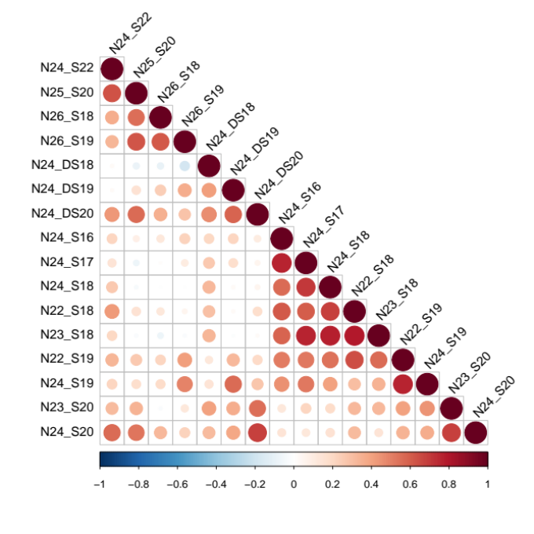
B
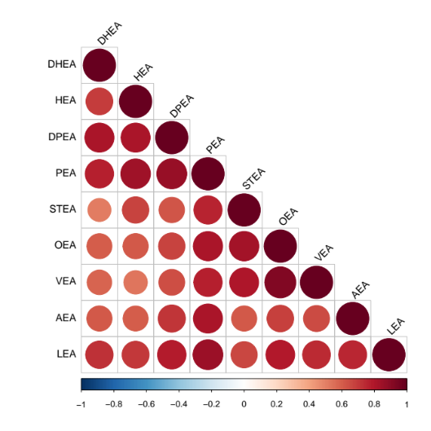
Figure S1. Intra-correlation analysis of ceramides, sphingoid bases, and related sphingolipids, and N-acyl ethanolamines.
The figure depicts the assessment of the relatedness within the two classes of lipids (A: CER, B: NAE) for the 999 plasma samples studied. The tool rquery.cormat was used in R, which takes into account strength of relationship (correlation coefficient; depicted as a scale of colours) and P-value (size of circle produced). The correlation was completed on the covariate-adjusted, standardised residuals used for genetic analyses.
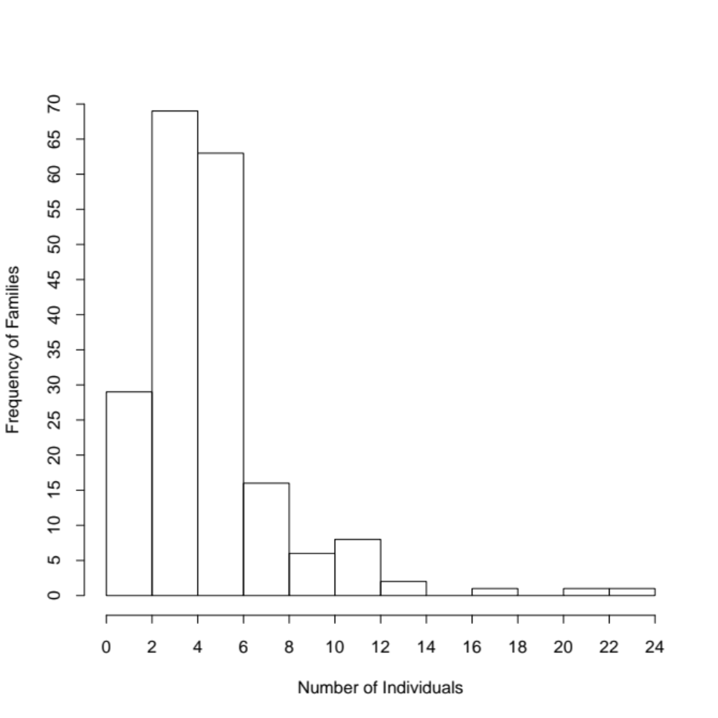
Figure S2. The frequency of individuals in each collected family that were analysed in this lipidomics study.

The graph depicts the range of individuals (1-24) with plasma available for lipidomics analyses. 999 individuals were assessed from 196 families. The mean number of individuals from each family assessed for mediator lipidomics was 5.

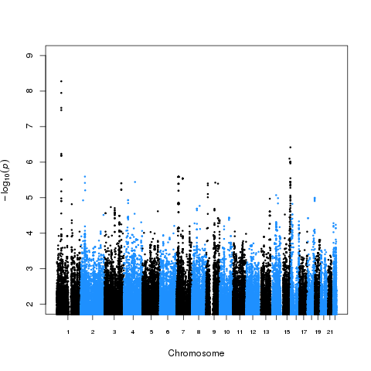

Figure S3. Manhattan plot of an example NAE species (PEA) associated at GWAS with SNPs in FAAH on chromosome 1.

The figure shows a Manhattan plot of GWAS results for PEA lipid species highlighting significant SNPs at chromosome 1 at the fatty acid amide hydrolase gene (FAAH) in 993 plasma samples.
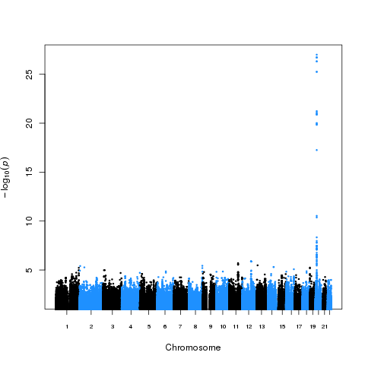

Figure S4. Manhattan plot of an example CER species N(24)S(19) associated at GWAS with SNPs in SPTLC3 on chromosome 20.

The figure shows a Manhattan plot of GWAS results for CER[N(24)S(19)], highlighting significant SNPs at chromosome 20 at the serine palmitoyltransferase gene (SPTLC3) in 991 plasma samples.
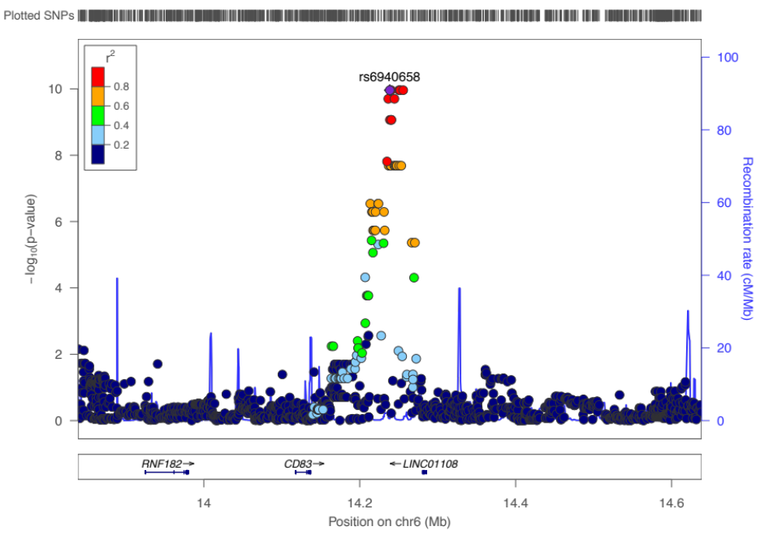
Figure S5. LocusZoom plot depicting the GWAS association of CER[N(26)S(19)] to the locus at CD83 on chromosome 6.

The figure depicts the GWAS association of this CER species with the locus of the leukocyte surface marker, CD83 in 991 plasma samples. The r² for each SNP is depicted in colour. This finding was supported by three significant genotyped SNPs. The plot was created using the LocusZoom plot tools at http://locuszoom.sph.umich.edu/.
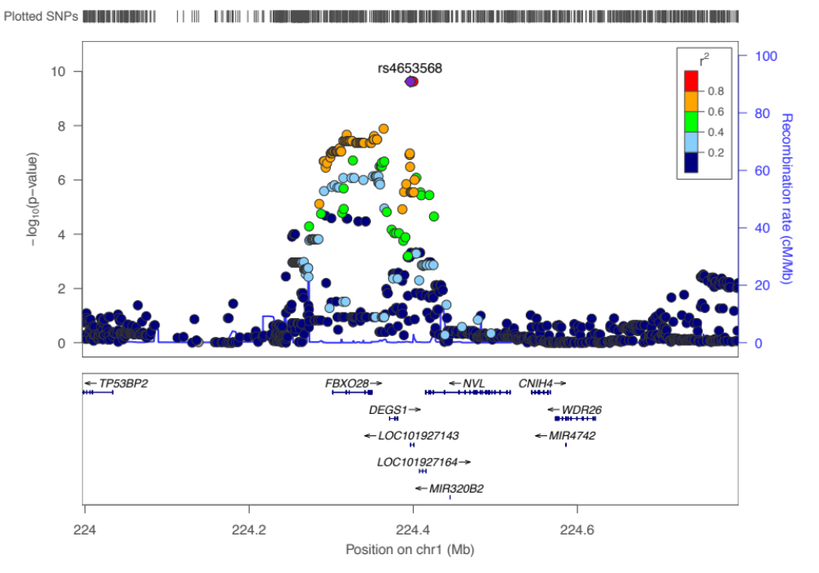
Figure S6. LocusZoom plot depicting the GWAS association of the ratio of CER[N(24)S(19)] to its precursor CER[N(24)DS(19)], at the locus of DEGS1 on chromosome 1.

The figure depicts the GWAS association of this CER species with the locus of the desaturase enzyme, DEGS1 in 991 plasma samples. The r² for each SNP is depicted in colour. This finding was supported by two significant genotyped SNPs. The plot was created using the LocusZoom plot tools at http://locuszoom.sph.umich.edu/.
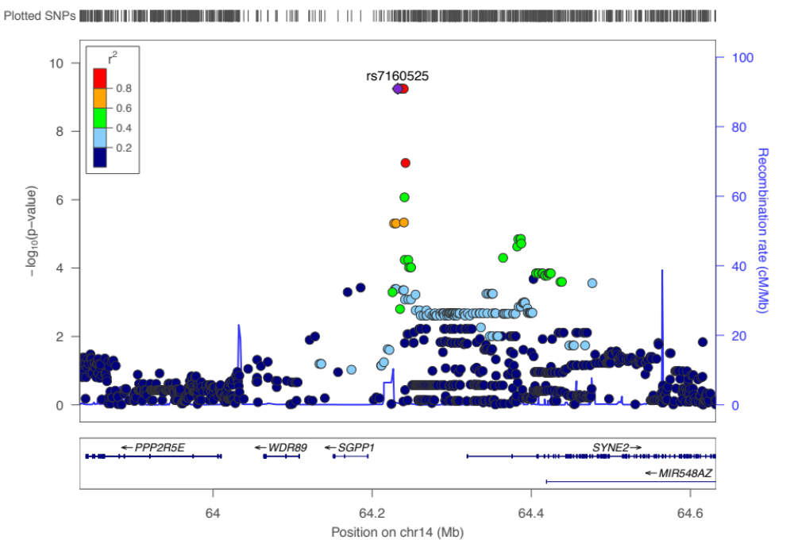
Figure S7. LocusZoom plot depicting the GWAS association of CER[N(24)S(16)] to the locus at SGPP1 on chromosome 14.

The figure depicts the GWAS association of this CER species with the locus of the sphingosine 1-phosphate phosphatase enzyme, SGPP1 in 992 plasma samples. The r² for each SNP is depicted in colour. This finding was supported by rs7157785, a GWAS significant genotyped SNP. The plot was created using the LocusZoom plot tools at http://locuszoom.sph.umich.edu/.

