Supplemental Information for Associations between Emotional Reactivity to Stress and Adolescent Substance Use: Differences by Sex and Valence
Table S1 presents inter-item reliability values for daily emotion for the full sample and disaggregated by sex and ethnicity. Table S2 presents the results of sensitivity power analyses for detecting two-way interactions between substance use and daily stress as predictors of emotion in male participants, female participants, and the full sample. Tables S3 presents descriptive statistics and correlations for study variables at each of the three data collection assessments. Tables S4-S6 present tabulated results for primary analyses, for which three-level multilevel models tested associations between frequency of alcohol use over the past year, cannabis use over the past year, and lifetime substance use and daily emotional reactivity. Table S7 summarizes study results by sex. Figures S1 provides a study schematic. Figure S2 visually depicts the conceptual model guiding the research questions for this study. Figure S3 presents associations for anxious emotion as a function of daily stressors and frequency of alcohol use over the past year, frequency of cannabis use over the past year, and lifetime substance use among male adolescents (figure for female adolescents presented in the main-text). Figure S4 presents associations for depressive emotion as a function of daily stressors and frequency of alcohol use over the past year, frequency of cannabis use over the past year, and lifetime substance use among female adolescents (figure for male adolescents presented in the main-text). Daily measures of stressors and emotion and wave measures of substance use are provided. Syntax for all models in Stata 16.1 are also provided.

Table S1. Alpha reliabilities for daily emotion items by sex and ethnic background.
Sample | Assessment | Positive Emotion | Anxious Emotion | Depressive Emotion
Full Sample | 1 | .89 | .80 | .74
Full Sample | 2 | .89 | .80 | .77
Full Sample | 3 | .90 | .82 | .78
Female | 1 | .87 | .80 | .73
Female | 2 | .89 | .81 | .77
Female | 3 | .88 | .84 | .77
Male | 1 | .91 | .81 | .76
Male | 2 | .89 | .78 | .77
Male | 3 | .90 | .75 | .79
Latine | 1 | .88 | .80 | .74
Latine | 2 | .87 | .78 | .76
Latine | 3 | .89 | .81 | .80
Asian American | 1 | .89 | .76 | .69
Asian American | 2 | .90 | .82 | .83
Asian American | 3 | .90 | .77 | .82
European American | 1 | .90 | .81 | .75
European American | 2 | .92 | .82 | .76
European American | 3 | .90 | .81 | .73
Different Ethnic Background | 1 | .89 | .89 | .82
Different Ethnic Background | 2 | .89 | .78 | .75
Different Ethnic Background | 3 | .89 | .90 | .77

Table S2. Detectable magnitude of two-way interactions (f²) for male participants (n=144), female participants (n=186), and the full sample (N=330) based on sensitivity power analyses using Monte Carlo simulations with 2000 replications that accounted for nesting of days within individuals.
 | 80% | 100%
Male Participants | .0035 | .0074
Female Participants | .0025 | .0053
All Participants | .0017 | .0033
Note: Values were calculated as R²_{product} values and converted to f² metrics of effect size using the following formula: f²=$\frac{R^{2}}{1-R^{2}}$. Values were calculated using the mlmpower package in R (Enders et al., 2023).

Table S3. Descriptive statistics and correlations for study variables at the first wave of data collection.
Wave | Variable | M | SD | Min | Max | 1. | 2. | 3. | 4. | 5. | 6. | 7.
Wave 1  (10th &11th Grade) | 1. Positive Emotion | 2.88 | 0.71 | 1.12 | 4.91 | —
Wave 1  (10th &11th Grade) | 2. Depressive Emotion | 1.41 | 0.46 | 1.00 | 4.00 | -.09 | —
Wave 1  (10th &11th Grade) | 3. Anxious Emotion | 1.44 | 0.52 | 1.00 | 4.15 | -.02 | .76*** | —
Wave 1  (10th &11th Grade) | 4. Daily Stressors | 0.30 | 0.36 | 0.00 | 2.00 | -.03 | .35*** | .38*** | —
Wave 1  (10th &11th Grade) | 5. Alcohol Frequency | 2.11 | 1.64 | 1.00 | 10.00 | -.10 | .11 | .10 | .20*** | —
Wave 1  (10th &11th Grade) | 6. Cannabis Frequency | 1.64 | 1.68 | 1.00 | 9.00 | .04 | .03 | .05 | .10 | .54*** | —
Wave 1  (10th &11th Grade) | 7. Lifetime Substance Use | 0.96 | 1.19 | 0.00 | 5.00 | -.09 | .11 | .15** | .18** | .68*** | .63*** | —
Wave 2  (12th Grade & 1-Year  Post-High School) | 1. Positive Emotion | 2.94 | 0.67 | 1.34 | 4.76 | —
Wave 2  (12th Grade & 1-Year  Post-High School) | 2. Depressive Emotion | 1.43 | 0.47 | 1.00 | 3.82 | -.19** | —
Wave 2  (12th Grade & 1-Year  Post-High School) | 3. Anxious Emotion | 1.44 | 0.47 | 1.00 | 3.27 | -.06 | .71*** | —
Wave 2  (12th Grade & 1-Year  Post-High School) | 4. Daily Stressors | 0.26 | 0.28 | 0.00 | 1.67 | -.14 | .21** | .27*** | —
Wave 2  (12th Grade & 1-Year  Post-High School) | 5. Alcohol Frequency | 2.98 | 2.05 | 1.00 | 10.00 | -.16* | -.01 | -.01 | .19** | —
Wave 2  (12th Grade & 1-Year  Post-High School) | 6. Cannabis Frequency | 2.02 | 2.07 | 1.00 | 10.00 | -.14 | -.05 | -.03 | .10 | .49*** | —
Wave 2  (12th Grade & 1-Year  Post-High School) | 7. Lifetime Substance Use | 1.42 | 1.38 | 0.00 | 6.00 | -.13 | .09 | .06 | .17* | .71*** | .58*** | —
Wave 3  (2-3 Years  Post-High School) | 1. Positive Emotion | 2.96 | 0.67 | 1.61 | 4.78 | —
Wave 3  (2-3 Years  Post-High School) | 2. Depressive Emotion | 1.44 | 0.52 | 1.00 | 3.40 | -.16* | —
Wave 3  (2-3 Years  Post-High School) | 3. Anxious Emotion | 1.46 | 0.50 | 1.00 | 3.25 | -.20* | .82*** | —
Wave 3  (2-3 Years  Post-High School) | 4. Daily Stressors | 0.18 | 0.23 | 0.00 | 1.33 | -.13 | .18* | .20* | —
Wave 3  (2-3 Years  Post-High School) | 5. Alcohol Frequency | 4.03 | 2.30 | 1.00 | 10.00 | .10 | .08 | .04 | .17* | —
Wave 3  (2-3 Years  Post-High School) | 6. Cannabis Frequency | 2.54 | 2.49 | 1.00 | 10.00 | .02 | -.01 | -.05 | -.04 | .49*** | —
Wave 3  (2-3 Years  Post-High School) | 7. Lifetime Substance Use | 2.07 | 1.64 | 0.00 | 7.00 | -.06 | .13 | .12 | .10 | .66*** | .56*** | —

Note: *p<.05, **p<.01, ***p<.001. Values for emotion and stressors were averaged across the 15 days.

Table S4. Positive emotion as a function of daily stressors and frequency of alcohol use (column 1), frequency of cannabis use (column 2), and lifetime substance use (column 3).
 |  | Frequency of Alcohol Use |  |  | Frequency of Cannabis Use |  |  | Lifetime Substance Use
Fixed Effects |  | B | SE | β | B | SE | β | B | SE | β
Intercept |  | 2.97*** | 0.06 | .01 | 2.97*** | 0.06 | .01 | 2.98*** | 0.06 | .01
Daily Stressors | $$β_{1jk}$$ | -0.12*** | 0.02 | -.06 | -0.12*** | 0.02 | -.06 | -0.12*** | 0.02 | -.06
Substance Use | $$γ_{01k}$$ | -0.02 | 0.01 | -.04 | -0.01 | 0.01 | -.01 | -0.03 | 0.02 | -.05
Daily Stressors × Substance Use | $$γ_{11k}$$ | 0.02* | 0.01 | .02 | 0.02* | 0.01 | .02 | 0.02 | 0.01 | .01
Female | $$π_{003}$$ | -0.17* | 0.07 | -.09 | -0.17* | 0.07 | -.09 | -0.17** | 0.07 | -.10
Asian American | $$π_{004}$$ | -0.09 | 0.09 | -.04 | -0.08 | 0.09 | -.03 | -0.09 | 0.09 | -.04
European American | $$π_{005}$$ | 0.12 | 0.08 | .06 | 0.10 | 0.08 | .06 | 0.12 | 0.08 | .06
Different Ethnic Backgrounds | $$π_{006}$$ | -0.09 | 0.15 | -.02 | -0.09 | 0.15 | -.02 | -0.10 | 0.15 | -.03
Parental Education | $$π_{007}$$ | 0.05* | 0.02 | .10 | 0.05* | 0.02 | .09 | 0.05* | 0.02 | .10
Age | $$γ_{02k}$$ | 0.04** | 0.01 | .07 | 0.03* | 0.01 | .06 | 0.04** | 0.01 | .07
Previous Day’s Emotion | $$β_{2jk}$$ | 0.22*** | 0.01 | .14 | 0.22*** | 0.01 | .14 | 0.22*** | 0.01 | .14
Random Effects |  | Variance | SE |  | Variance | SE |  | Variance | SE
Participant
Substance Use |  | 0.00 | 0.00 |  | 0.00 | 0.00 |  | 0.00 | 0.00
Age |  | 0.00 | 0.00 |  | 0.01 | 0.00 |  | 0.00 | 0.00
Participant Intercept |  | 0.25*** | 0.03 |  | 0.25*** | 0.03 |  | 0.25*** | 0.03
Wave
Arguments |  | 0.04*** | 0.01 |  | 0.03*** | 0.01 |  | 0.03*** | 0.01
Previous Day's Emotion |  | 0.02*** | 0.00 |  | 0.02*** | 0.00 |  | 0.02*** | 0.00
Wave Intercept |  | 0.16*** | 0.02 |  | 0.16*** | 0.02 |  | 0.16*** | 0.02
Arguments* Previous Day's Emotion |  | 0.01* | 0.00 |  | 0.01* | 0.00 |  | 0.01* | 0.00
Arguments*Wave Intercept |  | -0.01 | 0.01 |  | -0.01 | 0.01 |  | -0.01 | 0.01
Previous Day's Emotion*Wave Intercept |  | -0.02** | 0.01 |  | -0.02** | 0.01 |  | -0.02** | 0.01
Residual |  | 0.27*** | 0.00 |  | 0.27*** | 0.00 |  | 0.27*** | 0.00
Note: Daily stressors were centered at the wave mean, substance use was centered at the grand mean, female was dummy-coded (male as reference group), ethnicity was dummy-coded (Latine as reference group), parents’ education was centered at the grand mean, age was centered at the grand mean, and previous day’s emotion was centered at the wave mean. *p<.05, **p<.01, ***p<.001.
Table S5. Anxious emotion as a function of daily stressors and frequency of alcohol use (column 1), frequency of cannabis use (column 2), and lifetime substance use (column 3).
 |  |  |  | Frequency of Alcohol Use |  |  | Frequency of Cannabis Use |  |  | Lifetime Substance Use
Fixed Effects |  |  | B |  | SE | β | B | SE | β | B | SE | β
Intercept |  |  | 1.40*** |  | 0.04 | .01 | 1.39*** | 0.04 | .01 | 1.39*** | 0.04 | .01
Daily Stressors | $$β_{1jk}$$ |  | 0.16*** |  | 0.03 | .09 | 0.16*** | 0.03 | .09 | 0.16*** | 0.03 | .09
Substance Use | $$γ_{01k}$$ |  | 0.01 |  | 0.01 | .04 | 0.00 | 0.01 | .00 | 0.04 | 0.02 | .09
Daily Stressors × Substance Use | $$γ_{11k}$$ |  | -0.01 |  | 0.01 | .01 | -0.01 | 0.01 | .01 | -0.01 | 0.02 | .02
Female | $$π_{003}$$ |  | 0.09 |  | 0.05 | .06 | 0.10* | 0.05 | .07 | 0.10* | 0.05 | .07
Daily Stressors × Female | $$π_{102}$$ |  | -0.03 |  | 0.04 | -.01 | -0.03 | 0.04 | -.01 | -0.03 | 0.04 | -.01
Substance Use × Female | $$π_{011}$$ |  | 0.01 |  | 0.02 | .01 | 0.00 | 0.02 | .00 | 0.01 | 0.03 | .01
Daily Stressors × Substance Use × Female | $$π_{111}$$ |  | 0.04* |  | 0.02 | .02 | 0.02 | 0.02 | .01 | 0.05* | 0.02 | .02
Asian American | $$π_{004}$$ |  | -0.06 |  | 0.06 | -.04 | -0.07 | 0.06 | -.04 | -0.05 | 0.06 | -.03
European American | $$π_{005}$$ |  | -0.06 |  | 0.06 | -.04 | -0.05 | 0.06 | -.04 | -0.05 | 0.06 | -.03
Different Ethnic Backgrounds | $$π_{006}$$ |  | 0.24* |  | 0.10 | .08 | 0.24* | 0.10 | .08 | 0.24* | 0.10 | .08
Parental Education | $$π_{007}$$ |  | 0.02 |  | 0.01 | .05 | 0.02 | 0.01 | .05 | 0.02 | 0.01 | .05
Age | $$γ_{02k}$$ |  | 0.00 |  | 0.01 | .00 | 0.00 | 0.01 | .01 | -0.01 | 0.01 | -.01
Previous Day’s Emotion | $$β_{2jk}$$ |  | 0.11*** |  | 0.02 | .08 | 0.11*** | 0.02 | .08 | 0.11*** | 0.02 | .08
Random Effects |  |  | Variance |  | SE |  | Variance | SE |  | Variance | SE
Participant
Substance Use |  |  | 0.00 |  | 0.00 |  | 0.00 | 0.00 |  | 0.00 | 0.00
Age |  |  | 0.00 |  | 0.00 |  | 0.00 | 0.00 |  | 0.00 | 0.00
Participant Intercept |  |  | 0.09*** |  | 0.02 |  | 0.09*** | 0.01 |  | 0.09*** | 0.01
Wave
Arguments |  |  | 0.08*** |  | 0.01 |  | 0.08*** | 0.01 |  | 0.08*** | 0.01
Previous Day's Emotion |  |  | 0.04*** |  | 0.01 |  | 0.04*** | 0.01 |  | 0.04*** | 0.01
Wave Intercept |  |  | 0.13*** |  | 0.02 |  | 0.13*** | 0.02 |  | 0.12*** | 0.02
Arguments* Previous Day's Emotion |  |  | 0.00 |  | 0.01 |  | 0.00 | 0.01 |  | 0.00 | 0.01
Arguments*Wave Intercept |  |  | 0.03** |  | 0.01 |  | 0.03** | 0.01 |  | 0.02** | 0.01
Previous Day's Emotion*Wave Intercept |  |  | 0.02*** |  | 0.01 |  | 0.02*** | 0.01 |  | 0.02*** | 0.01
Residual |  |  | 0.21*** |  | 0.00 |  | 0.21*** | 0.00 |  | 0.21*** | 0.00
Note: Daily stressors were centered at the wave mean, substance use was centered at the grand mean, female was dummy-coded (male as reference group), ethnicity was dummy-coded (Latine as reference group), parents’ education was centered at the grand mean, age was centered at the grand mean, and previous day’s emotion was centered at the wave mean. *p<.05, **p<.01, ***p<.001.
Table S6. Depressive emotion as a function of daily stressors and frequency of alcohol use (column 1), frequency of cannabis use (column 2), and lifetime substance use (column 3).
 |  |  |  | Frequency of Alcohol Use |  |  | Frequency of Cannabis Use |  |  | Lifetime Substance Use
Fixed Effects |  |  | B |  | SE | β | B | SE | β | B | SE | β
Intercept |  |  | 1.35*** |  | 0.04 | .00 | 1.34*** | 0.04 | .01 | 1.34*** | 0.04 | .00
Daily Stressors | $$β_{1jk}$$ |  | 0.15*** |  | 0.03 | .12 | 0.15*** | 0.03 | .12 | 0.16*** | 0.03 | .12
Substance Use | $$γ_{01k}$$ |  | 0.01 |  | 0.01 | .06 | -0.01 | 0.01 | .02 | 0.04 | 0.02 | .07
Daily Stressors × Substance Use | $$γ_{11k}$$ |  | -0.03* |  | 0.01 | .00 | -0.03* | 0.01 | .00 | -0.05* | 0.02 | .00
Female | $$π_{003}$$ |  | 0.09* |  | 0.04 | .06 | 0.10* | 0.04 | .08 | 0.10* | 0.04 | .07
Daily Stressors × Female | $$π_{102}$$ |  | 0.06 |  | 0.04 | .02 | 0.06 | 0.04 | .02 | 0.05 | 0.04 | .02
Substance Use × Female | $$π_{011}$$ |  | 0.01 |  | 0.02 | .02 | 0.03 | 0.02 | .04 | -0.01 | 0.03 | -.01
Daily Stressors × Substance Use × Female | $$π_{111}$$ |  | 0.05** |  | 0.02 | .03 | 0.04* | 0.02 | .03 | 0.08** | 0.03 | .04
Asian American | $$π_{004}$$ |  | -0.01 |  | 0.06 | .00 | -0.01 | 0.06 | -.01 | -0.01 | 0.06 | -.01
European American | $$π_{005}$$ |  | -0.01 |  | 0.05 | .00 | 0.00 | 0.05 | .00 | 0.01 | 0.05 | .00
Different Ethnic Backgrounds | $$π_{006}$$ |  | 0.15 |  | 0.10 | .05 | 0.13 | 0.09 | .05 | 0.14 | 0.09 | .05
Parental Education | $$π_{007}$$ |  | 0.03* |  | 0.01 | .08 | 0.03* | 0.01 | .08 | 0.03* | 0.01 | .08
Age | $$γ_{02k}$$ |  | -0.01 |  | 0.01 | -.02 | 0.00 | 0.01 | .00 | -0.01 | 0.01 | -.02
Previous Day’s Emotion | $$β_{2jk}$$ |  | 0.10*** |  | 0.02 | .08 | 0.10*** | 0.02 | .08 | 0.11*** | 0.01 | .08
Random Effects |  |  | Variance |  | SE |  | Variance | SE |  | Variance | SE
Participant
Substance Use |  |  | 0.00 |  | 0.00 |  | 0.00 | 0.00 |  | 0.01 | 0.01
Age |  |  | 0.00 |  | 0.00 |  | 0.00 | 0.00 |  | 0.00*** | 0.00
Participant Intercept |  |  | 0.09*** |  | 0.01 |  | 0.09*** | 0.01 |  | 0.08*** | 0.01
Wave
Arguments |  |  | 0.08*** |  | 0.01 |  | 0.08*** | 0.01 |  | 0.08*** | 0.01
Previous Day's Emotion |  |  | 0.04*** |  | 0.01 |  | 0.04*** | 0.01 |  | 0.04*** | 0.01
Wave Intercept |  |  | 0.08*** |  | 0.01 |  | 0.08*** | 0.01 |  | 0.08*** | 0.01
Arguments* Previous Day's Emotion |  |  | 0.00 |  | 0.01 |  | 0.00 | 0.01 |  | 0.00 | 0.01
Arguments*Wave Intercept |  |  | 0.02** |  | 0.01 |  | 0.02** | 0.01 |  | 0.02*** | 0.01
Previous Day's Emotion*Wave Intercept |  |  | 0.02*** |  | 0.01 |  | 0.02*** | 0.01 |  | 0.02*** | 0.01
Residual |  |  | 0.23*** |  | 0.00 |  | 0.23*** | 0.00 |  | 0.23*** | 0.00
Note: Daily stressors were centered at the wave mean, substance use was centered at the grand mean, female was dummy-coded (male as reference group), ethnicity was dummy-coded (Latine as reference group), parents’ education was centered at the grand mean, age was centered at the grand mean, and previous day’s emotion was centered at the wave mean. *p<.05, **p<.01, ***p<.001.

Table S7. Summary of research questions and results.
Overarching Question | Operationalizing Emotion | Operationalizing Substance Use | Results | Arrow Representation of Results
How does substance use relate to emotional reactivity to stress? Do associations differ by sex? | How does substance use relate to positive emotional reactivity to stress? Do associations differ by sex? | Frequency of Alcohol Use | Main Effect: More frequent use is related to attenuated reactivity | _{ꜜ} male, _{ꜜ} female
 |  | Frequency of Cannabis Use | Main Effect: More frequent use is related to attenuated reactivity | _{ꜜ} male, _{ꜜ} female
 |  | Lifetime Substance Use | NS | —
 | How does substance use relate to anxious emotional reactivity to stress? Do associations differ by sex? | Frequency of Alcohol Use | In female adolescents, greater lifetime substance use is related to exaggerated reactivity | _{ꜛ} female
 |  | Frequency of Cannabis Use | NS | —
 |  | Lifetime Substance Use | In female adolescents, greater lifetime substance use is related to exaggerated reactivity | _{ꜛ} female
 | How does substance use relate to depressive emotional reactivity to stress? Do associations differ by sex? | Frequency of Alcohol Use | In male adolescents, more frequent alcohol use is related to attenuated reactivity | _{ꜜ} male
 |  | Frequency of Cannabis Use | In male adolescents, more frequent cannabis use is related to attenuated reactivity | _{ꜜ} male
 |  | Lifetime Substance Use | In male adolescents, greater lifetime substance use is related to attenuated reactivity | _{ꜜ} male
_{ꜛ}Indicates a significant negative association. _{ꜜ}Indicates a significant negative association.

n = 4360
M = 14.2, SD = 2.4
n = 2979
M = 14.1, SD = 2.5
n = 2178
M = 14.1, SD = 2.7

Survey followed by 15 Daily Checklists (14 days plus practice day)

Survey followed by 15 Daily Checklists (14 days plus practice day)

Survey followed by 15 Daily Checklists (14 days plus practice day)

8
9
1
2
8
9
1
2
8
9
1
2

10
11
3
4
10
11
3
4
10
11
3
4
12
13
5
6
12
13
5
6
12
13
5
6
7
14
7
14
7
14

Wave 1
n = 307
Wave 2
n = 211
Wave 3
n = 154
2 Years
2 Years

2011-2012
10th &11th Grade
2013-2014
12th Grade & 1Year
Post-High School
2015-2016
2 & 3 Years
Post-High School

Figure S1. Study schematic. Note: High levels of attrition were expected given that the study period includes the transition to college. Results of attrition analyses are provided in-text. The daily protocol period typically began one day after administration of the psychosocial survey. There were two weeks of checklists plus one practice day, which the majority of participants fully completed.

Poorer Emotion
(3 daily emotion outcomes)

3. Higher Depressive Emotion
Equation 2
Sex
2. Higher Anxious Emotion

1. Lower Positive Emotion
Degree of Daily Emotional Reactivity (Randomly Varying Daily Association)
Daily Arguments

Equation 1

Substance Use
(3 wave-level moderators)
1. Frequency of Alcohol Use
2. Frequency of Cannabis Use
3. Lifetime Substance Use

Figure S2. Statistical model of study research questions. Note: Positive emotion would be expected to decrease on days when adolescents experience more arguments (i.e., a negative coefficient), whereas anxious and depressive emotion would be expected to increase on days when adolescents experience more arguments (i.e., a positive coefficient). Therefore, a positive cross-level interaction would suggest that higher levels of substance use would be associated with lower positive emotional reactivity (i.e., a less negative daily association) and greater depressive and anxious emotional reactivity (i.e., a more positive daily association). In contrast, a negative cross-level interaction would suggest that higher levels of substance use would be associated with greater positive emotional reactivity (i.e., a more negative daily association) and lower depressive and anxious emotional reactivity (i.e., a less positive daily association).

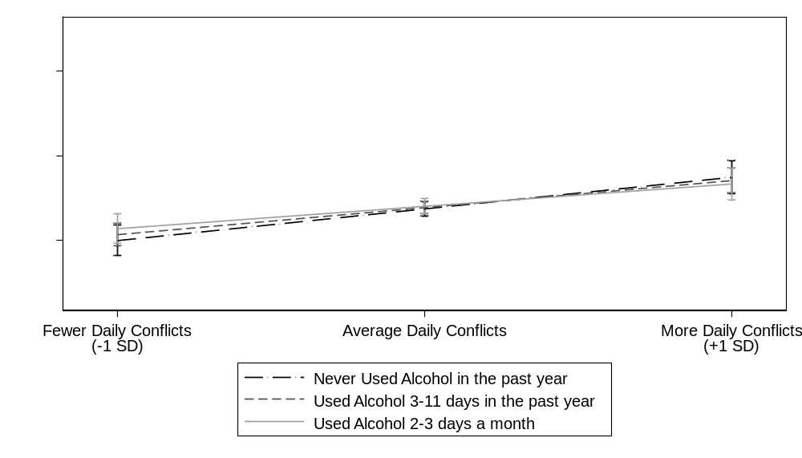
Simple Slopes
$β_{1jk}$ = 0.19, SE = 0.04, t=4.38, 95% CI [0.10, 0.27], β=.12
$β_{1jk}$= 0.16, SE = 0.03, t=5.14, 95% CI [0.10, 0.22], β=.10
$β_{1jk}$= 0.13, SE = 0.04, t=3.33, 95% CI [0.05, 0.21], β=.09
Stressors
Stressors
Stressors
a)
b)
c)
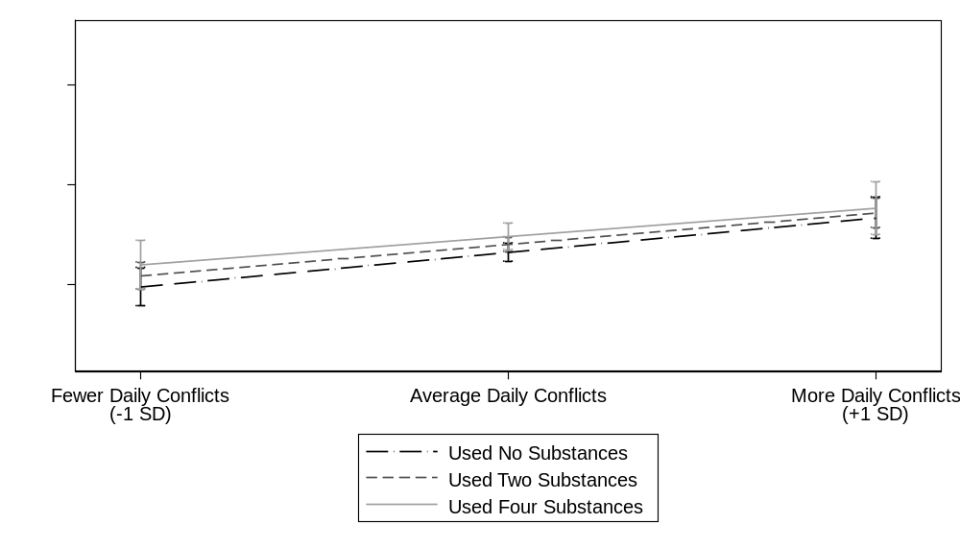
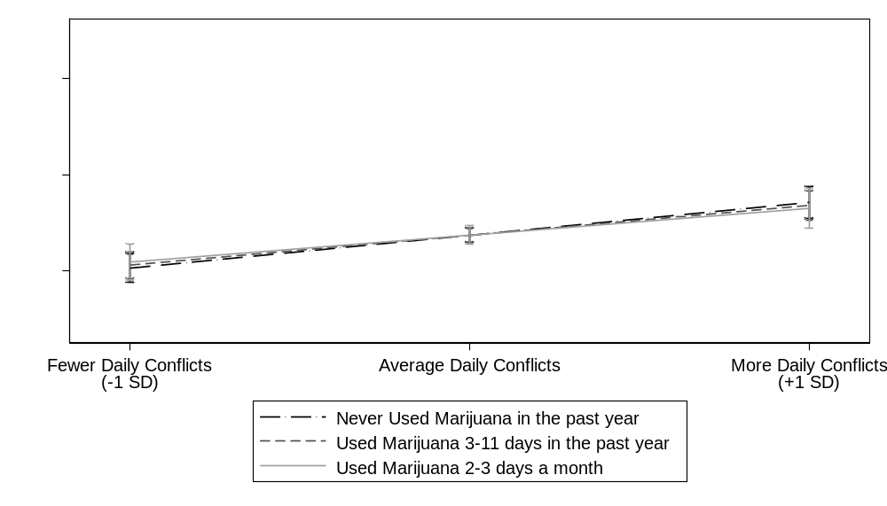
Simple Slopes
$β_{1jk}$ = 0.17, SE = 0.05, t=3.82, 95% CI [0.08, 0.26], β=.11
$β_{1jk}$ = 0.16, SE = 0.03, t=5.11, 95% CI [0.10, 0.22], β=.10
$β_{1jk}$ = 0.14, SE = 0.06, t=2.57, 95% CI [0.04, 0.25], β=.09
Simple Slopes
$β_{1jk}$ = 0.18, SE = 0.04, 95% CI [0.09, 0.26], β=.11
$β_{1jk}$ = 0.16, SE = 0.03, 95% CI [0.10, 0.22], β=.10
$β_{1jk}$ = 0.15, SE = 0.04, 95% CI [0.08, 0.22], β=.09
Never Used Cannabis in the past year
Used Cannabis 3-11 days in the past year
Used Cannabis 2-3 days per month
Stressors
Stressors
Stressors
Stressors
Stressors
Stressors
Figure S3. Anxious Emotion as a Function of Daily Stressors and Frequency of Alcohol Use (a), Frequency of Cannabis Use (b), and Lifetime Substance Use (c) among male adolescents. Note: *p<.05, **p<.01, ***p<.001. SD = Standard Deviation. CI = Confidence Interval. Associations controlled for age, ethnicity, parents’ education, and previous day’s emotion. Frequency of alcohol use, frequency of cannabis use, and lifetime substance use are continuous variables, and associations were probed at approximately one standard deviation below the mean, the mean, and one standard deviation above the mean. All simple slopes are significant, p<.001, and do not significantly differ from one another.
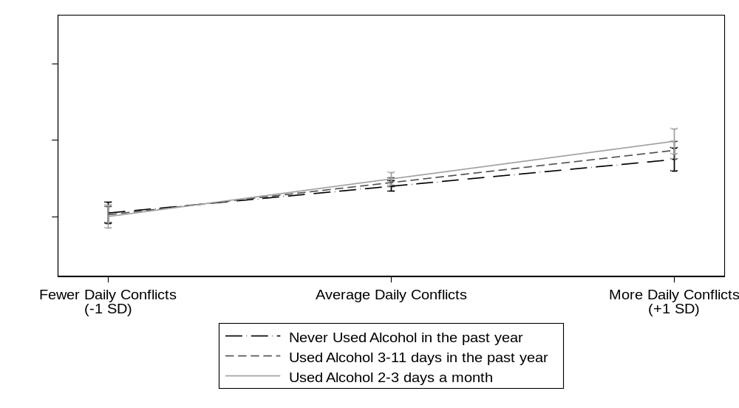
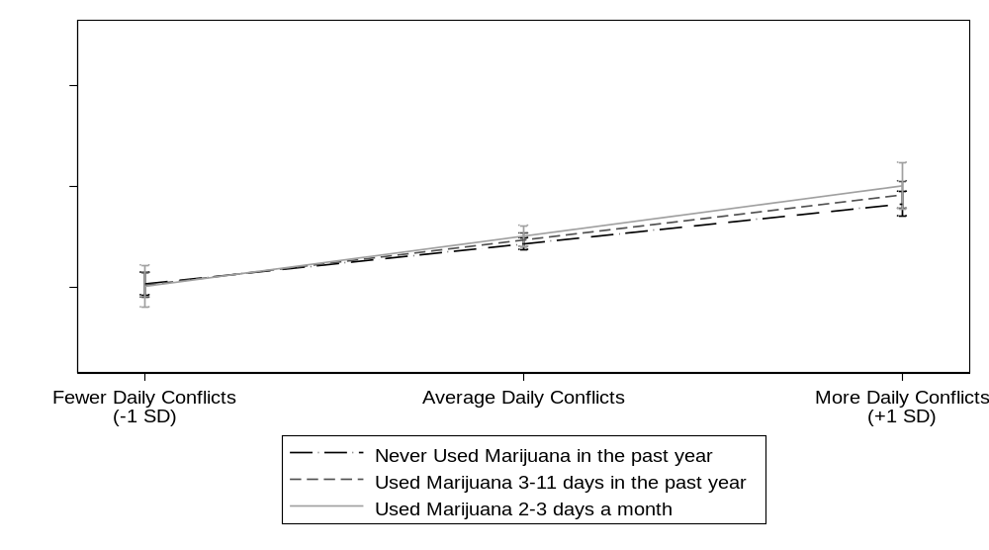
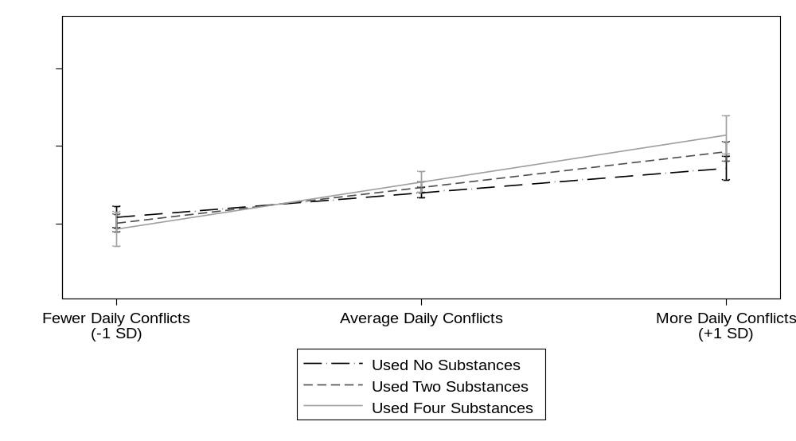
Stressors
Stressors
Stressors
Simple Slopes
$β_{1jk}$ = 0.17, SE = 0.03, t=5.36, 95% CI [0.11, 0.24], β=.12
$β_{1jk}$ = 0.21, SE = 0.02, t=8.97, 95% CI [0.16, 0.26], β=.14
$β_{1jk}$ = 0.25, SE = 0.03, t=7.38, 95% CI [0.18, 0.32], β=.16
Stressors
Stressors
Stressors
Simple Slopes
$β_{1jk}$ = 0.20, SE = 0.03, t=7.67, 95% CI [0.15, 0.25], β=.13
$β_{1jk}$ = 0.22, SE = 0.03, t=7.88, 95% CI [0.17, 28], β=.15
$β_{1jk}$ = 0.25, SE = 0.05, t=5.06, 95% CI [0.15, 35], β=.17
Never Used Cannabis in the past year
Used Cannabis 3-11 days in the past year
Used Cannabis 2-3 days per month
Stressors
Stressors
Stressors
Simple Slopes
$β_{1jk}$ = 0.16, SE = 0.03, t=4.83, 95% CI [0.09, 0.22], β=.10
$β_{1jk}$ = 0.23, SE = 0.03, t=9.16, 95% CI [0.16, 0.25], β=.15
$β_{1jk}$ = 0.30, SE = 0.05, t=6.17, 95% CI [0.09, 0.22], β=.20

c)
b)
a)
c)
b)

Figure S4. Depressive Emotion as a Function of Daily Stressors and Frequency of Alcohol Use (a), Frequency of Cannabis Use (b), and Lifetime Substance Use (c) among female adolescents. Note: *p<.05, **p<.01, ***p<.001. SD = Standard Deviation. CI = Confidence Interval. Associations controlled for age, ethnicity, parents’ education, and previous day’s emotion. Frequency of alcohol use, frequency of cannabis use, and lifetime substance use are continuous variables. Associations were probed at approximately one standard deviation below the mean, the mean, and one standard deviation above the mean. All simple slopes are significant, p<.001, and do not significantly differ from one another.
Study Materials. Below are the measures for daily emotion, daily stressors, and substance use.

The following is a list of feelings or experiences. How much did you experience them today?

 | Not at all | A little | Moderately | Quite a bit | Extremely
Attentive | 1 | 2 | 3 | 4 | 5
Back, joint, or muscle pain | 1 | 2 | 3 | 4 | 5
Calm | 1 | 2 | 3 | 4 | 5
Cheerful | 1 | 2 | 3 | 4 | 5
Discouraged | 1 | 2 | 3 | 4 | 5
Enthusiastic | 1 | 2 | 3 | 4 | 5
Excited | 1 | 2 | 3 | 4 | 5
Exhausted | 1 | 2 | 3 | 4 | 5
Fatigued | 1 | 2 | 3 | 4 | 5
Frightened | 1 | 2 | 3 | 4 | 5
Happy | 1 | 2 | 3 | 4 | 5
Headache | 1 | 2 | 3 | 4 | 5
Hopeless | 1 | 2 | 3 | 4 | 5
Interested | 1 | 2 | 3 | 4 | 5
Joyful | 1 | 2 | 3 | 4 | 5
Nervous | 1 | 2 | 3 | 4 | 5
On edge | 1 | 2 | 3 | 4 | 5
Sad | 1 | 2 | 3 | 4 | 5
Scared | 1 | 2 | 3 | 4 | 5
Sleepy | 1 | 2 | 3 | 4 | 5
Threatened | 1 | 2 | 3 | 4 | 5
Tired | 1 | 2 | 3 | 4 | 5
Trouble sleeping | 1 | 2 | 3 | 4 | 5
Unable to concentrate | 1 | 2 | 3 | 4 | 5
Uneasy | 1 | 2 | 3 | 4 | 5
Unsafe | 1 | 2 | 3 | 4 | 5
Worn-out | 1 | 2 | 3 | 4 | 5
Worried | 1 | 2 | 3 | 4 | 5

Stressors
Did any of the following activities or events occur to you today? (check if YES)
Oargued with your mother or father about something
Oargued with another family member about something
Ohad an argument or were punished by an adult at school
Ohad an argument with a close friend or partner

Substance Use
1. If you have ever smoked more than one or two puffs of a cigarette, how old were you when you smoked that much for the first time?

I have never smoked more than one or two puffs of a cigarette
Less than 9 years old
9 or 10 years old
11 or 12 years old
13 or 14 years old
15 or 16 years old
17 years old or older

2. If you have ever had more than a few sips of alcohol, how old were you when you first drank that much alcohol?

I have never had a drink of alcohol other than a few sips
Less than 9 years old
9 or 10 years old
11 or 12 years old
13 or 14 years old
15 or 16 years old
17 years old or older

3. If you have ever tried marijuana (pot, weed, grass, hash, etc.), how old were you when you tried it for the first time?

I have never tried marijuana
Less than 9 years old
9 or 10 years old
11 or 12 years old
13 or 14 years old
15 or 16 years old
17 years old or older

4. If you have ever tried any form of cocaine, including powder, crack, or freebase, how old were you when you tried it for the first time?

I have never tried cocaine
Less than 9 years old
9 or 10 years old
11 or 12 years old
13 or 14 years old
15 or 16 years old
17 years old or older

5. If you have ever used crystal meth (also called "ice" or “glass”), how old were you when you used crystal meth for the first time?

I have never tried crystal meth
Less than 9 years old
9 or 10 years old
11 or 12 years old
13 or 14 years old
15 or 16 years old
17 years old or older

6. If you have ever used any other type of illegal drug, such as LSD, PCP, ecstasy, mushrooms, speed, or heroin, how old were you when you used them for the first time?

I have never tried any other illegal drugs
Less than 9 years old
9 or 10 years old
11 or 12 years old
13 or 14 years old
15 or 16 years old
17 years old or older

7. If you have ever used any prescription drug such Ritalin, oxycotin, adderall, a valium, any narcotic, or any tranquilizer without a prescription, how old were you when you used a prescription drug without a prescription for the first time?

I have never used prescription drugs
Less than 9 years old
9 or 10 years old
11 or 12 years old
13 or 14 years old
15 or 16 years old
17 years old or older

Syntax for Analyses
*All analyses were tested in Stata 16.1
*Descriptives
sum Mean_PositiveMean Mean_DepressiveMean Mean_AnxiousMean Mean_ArgueMean Mean_SubCount Mean_AlcYear Mean_PotYear gender aEthnicity_W123 ParentEdu Age gender if Wave==1 & Day==2 & Participation_Subject==1
sum Mean_PositiveMean Mean_DepressiveMean Mean_AnxiousMean Mean_ArgueMean Mean_SubCount Mean_AlcYear Mean_PotYear gender aEthnicity_W123 ParentEdu aAge_W gender if Wave==1 & Day==2 & Participation_Subject==1
sum TotalDays if Participation_Subject==1 & Wave==1 & Day==1
tab TotalWaves if Day==1 & Wave==1
gen PercentagePossibleWaves=WaveTotal/3 if SubjectID<6000
replace PercentagePossibleWaves=WaveTotal/2 if SubjectID>5999

*Participation Analyses
ttest PercentagePossibleWaves if Wave==1 & Day==1 & Participation_Subject==1, by(gender)
anova PercentagePossibleWaves aEthnicity_W123 if Wave==1 & Day==1 & Participation_Subject==1
tabstat PercentagePossibleWaves if Wave==1 & Day==1 & Participation_Subject==1, by(aEthnicity_W123)
pwmean PercentagePossibleWaves if Wave==1 & Day==1 & Participation_Subject==1, over(aEthnicity_W123)
**Differences at study entry
gen Age_forentry=aAge_W if Participation_Wave==1
by SubjectID: egen age_at_entry=min(Age_forentry) if Participation_Wave==1
gen SubCount_forentry=SubCount if Participation_Wave==1
by SubjectID: egen SubCount_at_entry=min(SubCount_forentry) if Participation_Wave==1
gen AlcYear_forentry=AlcYear if Participation_Wave==1
by SubjectID: egen AlcYear_at_entry=min(AlcYear_forentry) if Participation_Wave==1
gen PotYear_forentry=PotYear if Participation_Wave==1
by SubjectID: egen PotYear_at_entry=min(PotYear_forentry) if Participation_Wave==1
pwcorr PercentagePossibleWaves Mean_PositiveMean Mean_DepressiveMean Mean_AnxiousMean Mean_ArgueMean SubCount_at_entry PotYear_forentry AlcYear_forentry age_at_entry ParentEdu if Wave==1 & Day==1 & Participation_Subject==1, o sig
*Multilevel Participation Models
mixed SubCount PercentagePossibleWaves Age_c || SubjectID: if Participation_Subject==1 & day==1, var cov()
mixed PotYear PercentagePossibleWaves Age_c || SubjectID: if Participation_Subject==1 & day==1, var cov()
mixed AlcYear PercentagePossibleWaves Age_c || SubjectID: if Participation_Subject==1 & day==1, var cov()
mixed positivemean PercentagePossibleWaves Age_c || SubjectID: || Wave: if Participation_Subject==1, var cov()
mixed depressivemean PercentagePossibleWaves Age_c || SubjectID: ||Wave: if Participation_Subject==1, var cov()
mixed anxiousmean PercentagePossibleWaves Age_c || SubjectID: ||Wave: if Participation_Subject==1, var cov()
mixed arguesum PercentagePossibleWaves Age_c || SubjectID: ||Wave: if Participation_Subject==1 , var cov()
*Compare Participants in Analytic vs Full Sample
gen Participation_Subject_di= Participation_Subject
replace Participation_Subject_di=0 if Participation_Subject==.
tab gender Participation_Subject_di if Wave==1 & Day==1, ch
tab aEthnicity_W123 Participation_Subject_di if Wave==1 & Day==1, ch
ttest ParentEdu if Wave==1 & Day==1, by(Participation_Subject_di)
mixed SubCount Participation_Subject_di Age_c || SubjectID: if day==1, var cov()
mixed PotYear Participation_Subject_di Age_c || SubjectID: if day==1, var cov()
mixed AlcYear Participation_Subject_di Age_c || SubjectID: if day==1, var cov()
mixed positivemean Participation_Subject_di Age_c || SubjectID: || Wave: , var cov()
mixed depressivemean Participation_Subject_di Age_c || SubjectID: ||Wave: , var cov()
mixed anxiousmean Participation_Subject_di Age_c || SubjectID: ||Wave: , var cov()
mixed arguesum Participation_Subject_di Age_c || SubjectID: ||Wave: , var cov()

*Descriptive Emotion Reactivity Models
mixed anxiousmean c.Argue_mc i.gender ib3.aEthnicity_W123 ParentEdu_c Age_c anxious_lag_c || SubjectID: Age_c || Wave: Argue_mc anxious_lag_c, var cov(unstr)
estimates store DescriptiveAnx
mixed depressivemean c.Argue_mc i.gender ib3.aEthnicity_W123 ParentEdu_c Age_c depressive_lag_c || SubjectID: Age_c || Wave: Argue_mc depressive_lag_c, var cov(unstr)
estimates store DescriptiveDep
mixed positivemean c.Argue_mc i.gender ib3.aEthnicity_W123 ParentEdu_c Age_c positive_lag_c || SubjectID: Age_c || Wave: Argue_mc positive_lag_c, var cov(unstr)
estimates store DescriptivePos

*Primary models: Associations between Substance Use and Emotional Reactivity (Tables 1-3)

mixed positivemean c.Argue_mc##c.SubCount_mc gender ib3.aEthnicity_W123 ParentEdu_c Age_c positive_lag_c || SubjectID: Age_c SubCount_mc || Wave:Argue_mc positive_lag_c, var cov(unstr)
estimates store pos1
mixed positivemean c.Argue_mc##c.AlcYear_mc gender ib3.aEthnicity_W123 ParentEdu_c Age_c positive_lag_c || SubjectID: Age_c AlcYear_mc || Wave: Argue_mc positive_lag_c, var cov(unstr)
estimates store pos2
mixed positivemean c.Argue_mc##c.PotYear_mc gender ib3.aEthnicity_W123 ParentEdu_c Age_c positive_lag_c || SubjectID: Age_c PotYear_mc || Wave: Argue_mc positive_lag_c, var cov(unstr)
estimates store pos3
mixed anxiousmean c.Argue_mc##c.SubCount_mc##gender ib3.aEthnicity_W123 ParentEdu_c Age_c anxious_lag_c || SubjectID: Age_c SubCount_mc || Wave: Argue_mc anxious_lag_c, var cov(unstr)
estimates store anx1
mixed anxiousmean c.Argue_mc##c.AlcYear_mc##gender ib3.aEthnicity_W123 ParentEdu_c Age_c anxious_lag_c || SubjectID: Age_c AlcYear_mc || Wave: Argue_mc anxious_lag_c, var cov(unstr)
estimates store anx2
mixed anxiousmean c.Argue_mc##c.PotYear_mc##gender ib3.aEthnicity_W123 ParentEdu_c Age_c anxious_lag_c || SubjectID: Age_c PotYear_mc || Wave: Argue_mc anxious_lag_c, var cov(unstr)
estimates store anx3
mixed depressivemean c.Argue_mc##c.SubCount_mc##gender ib3.aEthnicity_W123 ParentEdu_c Age_c depressive_lag_c || SubjectID: Age_c SubCount_mc || Wave: Argue_mc depressive_lag_c, var cov(unstr)
estimates store dep1
mixed depressivemean c.Argue_mc##c.AlcYear_mc##gender ib3.aEthnicity_W123 ParentEdu_c Age_c depressive_lag_c || SubjectID: Age_c AlcYear_mc || Wave: Argue_mc depressive_lag_c, var cov(unstr)
estimates store dep2
mixed depressivemean c.Argue_mc##c.PotYear_mc##gender ib3.aEthnicity_W123 ParentEdu_c Age_c depressive_lag_c || SubjectID: Age_c PotYear_mc || Wave: Argue_mc depressive_lag_c, var cov(unstr)
estimates store dep3

estout DescriptivePos DescriptiveAnx DescriptiveDep , cells((b(star fmt(2)) se(par fmt(2))))
estout pos1 pos2 pos3 , cells((b(star fmt(2)) se(par fmt(2))))
estout anx1 anx2 anx3 , cells((b(star fmt(2)) se(par fmt(2))))
estout dep1 dep2 dep3 , cells((b(star fmt(2)) se(par fmt(2))))

*Follow-up analyses covarying emotion variability and mean number of arguments at that wave
**Calculating emotion variability
sort IDWave Day
by IDWave: egen PositiveSD=sd(positivemean)
by IDWave: egen AnxiousSD=sd(anxiousmean)
by IDWave: egen DepressiveSD=sd(depressivemean)

*Analyses (primary models with additional covariates)

mixed positivemean c.Argue_mc##c.SubCount_mc gender ib3.aEthnicity_W123 ParentEdu_c Age_c positive_lag_c PositiveSD Mean_ArgueMean || SubjectID: Age_c SubCount_mc || Wave:Argue_mc positive_lag_c, var cov(unstr)
mixed positivemean c.Argue_mc##c.AlcYear_mc gender ib3.aEthnicity_W123 ParentEdu_c Age_c positive_lag_c PositiveSD Mean_ArgueMean || SubjectID: Age_c AlcYear_mc || Wave: Argue_mc positive_lag_c, var cov(unstr)
mixed positivemean c.Argue_mc##c.PotYear_mc gender ib3.aEthnicity_W123 ParentEdu_c Age_c positive_lag_c PositiveSD Mean_ArgueMean || SubjectID: Age_c PotYear_mc || Wave: Argue_mc positive_lag_c, var cov(unstr)
mixed anxiousmean c.Argue_mc##c.SubCount_mc##gender ib3.aEthnicity_W123 ParentEdu_c Age_c anxious_lag_c AnxiousSD Mean_ArgueMean || SubjectID: Age_c SubCount_mc || Wave: Argue_mc anxious_lag_c, var cov(unstr)
mixed anxiousmean c.Argue_mc##c.AlcYear_mc##gender ib3.aEthnicity_W123 ParentEdu_c Age_c anxious_lag_c AnxiousSD Mean_ArgueMean || SubjectID: Age_c AlcYear_mc || Wave: Argue_mc anxious_lag_c, var cov(unstr)
mixed anxiousmean c.Argue_mc##c.PotYear_mc##gender ib3.aEthnicity_W123 ParentEdu_c Age_c anxious_lag_c AnxiousSD Mean_ArgueMean || SubjectID: Age_c PotYear_mc || Wave: Argue_mc anxious_lag_c, var cov(unstr)
mixed depressivemean c.Argue_mc##c.SubCount_mc##gender ib3.aEthnicity_W123 ParentEdu_c Age_c depressive_lag_c DepressiveSD Mean_ArgueMean || SubjectID: Age_c SubCount_mc PositiveSD Mean_ArgueMean || Wave: Argue_mc depressive_lag_c, var cov(unstr)
mixed depressivemean c.Argue_mc##c.AlcYear_mc##gender ib3.aEthnicity_W123 ParentEdu_c Age_c depressive_lag_c DepressiveSD Mean_ArgueMean || SubjectID: Age_c AlcYear_mc || Wave: Argue_mc depressive_lag_c, var cov(unstr)
mixed depressivemean c.Argue_mc##c.PotYear_mc##gender ib3.aEthnicity_W123 ParentEdu_c Age_c depressive_lag_c DepressiveSD Mean_ArgueMean || SubjectID: Age_c PotYear_mc || Wave: Argue_mc depressive_lag_c, var cov(unstr)

*Likelihood ratio tests to determine whether age and substance use should be treated as random effects in primary models
mixed anxiousmean c.Argue_mc##c.SubCount_mc##gender i.aEthnicity_W123 ParentEdu_c Age_c anxious_lag_c || SubjectID: || Wave: Argue_mc anxious_lag_c, var cov(unstr)
estimates store anx1
mixed anxiousmean c.Argue_mc##c.SubCount_mc##gender i.aEthnicity_W123 ParentEdu_c Age_c anxious_lag_c || SubjectID: SubCount_mc || Wave: Argue_mc anxious_lag_c, var cov(unstr)
estimates store anx1sub
mixed anxiousmean c.Argue_mc##c.SubCount_mc##gender i.aEthnicity_W123 ParentEdu_c Age_c anxious_lag_c || SubjectID: Age_c || Wave: Argue_mc anxious_lag_c, var cov(unstr)
estimates store anx1age
lrtest anx1 anx1sub, stats
lrtest anx1 anx1age, stats
mixed anxiousmean c.Argue_mc##c.AlcYear_mc##gender i.aEthnicity_W123 ParentEdu_c Age_c anxious_lag_c || SubjectID: || Wave: Argue_mc anxious_lag_c, var cov(unstr)
estimates store anx2
mixed anxiousmean c.Argue_mc##c.AlcYear_mc##gender i.aEthnicity_W123 ParentEdu_c Age_c anxious_lag_c || SubjectID: AlcYear_mc || Wave: Argue_mc anxious_lag_c, var cov(unstr)
estimates store anx2sub
mixed anxiousmean c.Argue_mc##c.AlcYear_mc##gender i.aEthnicity_W123 ParentEdu_c Age_c anxious_lag_c || SubjectID: Age_c || Wave: Argue_mc anxious_lag_c, var cov(unstr)
estimates store anx2age
lrtest anx2 anx2sub, stats
lrtest anx2 anx2age, stats
mixed anxiousmean c.Argue_mc##c.PotYear_mc##gender i.aEthnicity_W123 ParentEdu_c Age_c anxious_lag_c || SubjectID: || Wave: Argue_mc anxious_lag_c, var cov(unstr)
estimates store anx3
mixed anxiousmean c.Argue_mc##c.PotYear_mc##gender i.aEthnicity_W123 ParentEdu_c Age_c anxious_lag_c || SubjectID: PotYear_mc || Wave: Argue_mc anxious_lag_c, var cov(unstr)
estimates store anx3sub
mixed anxiousmean c.Argue_mc##c.PotYear_mc##gender i.aEthnicity_W123 ParentEdu_c Age_c anxious_lag_c || SubjectID: Age_c || Wave: Argue_mc anxious_lag_c, var cov(unstr)
estimates store anx3age
lrtest anx3 anx3sub, stats
lrtest anx3 anx3age, stats

mixed depressivemean c.Argue_mc##c.SubCount_mc##gender i.aEthnicity_W123 ParentEdu_c Age_c depressive_lag_c || SubjectID: || Wave: Argue_mc depressive_lag_c, var cov(unstr)
estimates store dep1
mixed depressivemean c.Argue_mc##c.SubCount_mc##gender i.aEthnicity_W123 ParentEdu_c Age_c depressive_lag_c || SubjectID: SubCount_mc || Wave: Argue_mc depressive_lag_c, var cov(unstr)
estimates store dep1sub
mixed depressivemean c.Argue_mc##c.SubCount_mc##gender i.aEthnicity_W123 ParentEdu_c Age_c depressive_lag_c || SubjectID: Age_c || Wave: Argue_mc depressive_lag_c, var cov(unstr)
estimates store dep1age
lrtest dep1 dep1sub, stats
lrtest dep1 dep1age, stats
mixed depressivemean c.Argue_mc##c.AlcYear_mc##gender i.aEthnicity_W123 ParentEdu_c Age_c depressive_lag_c || SubjectID: || Wave: Argue_mc depressive_lag_c, var cov(unstr)
estimates store dep2
mixed depressivemean c.Argue_mc##c.AlcYear_mc##gender i.aEthnicity_W123 ParentEdu_c Age_c depressive_lag_c || SubjectID: AlcYear_mc || Wave: Argue_mc depressive_lag_c, var cov(unstr)
estimates store dep2sub
mixed depressivemean c.Argue_mc##c.AlcYear_mc##gender i.aEthnicity_W123 ParentEdu_c Age_c depressive_lag_c || SubjectID: Age_c || Wave: Argue_mc depressive_lag_c, var cov(unstr)
estimates store dep2age
lrtest dep2 dep2sub, stats
lrtest dep2 dep2age, stats
mixed depressivemean c.Argue_mc##c.PotYear_mc##gender i.aEthnicity_W123 ParentEdu_c Age_c depressive_lag_c || SubjectID: || Wave: Argue_mc depressive_lag_c, var cov(unstr)
estimates store dep3
mixed depressivemean c.Argue_mc##c.PotYear_mc##gender i.aEthnicity_W123 ParentEdu_c Age_c depressive_lag_c || SubjectID: PotYear_mc || Wave: Argue_mc depressive_lag_c, var cov(unstr)
estimates store dep3sub
mixed depressivemean c.Argue_mc##c.PotYear_mc##gender i.aEthnicity_W123 ParentEdu_c Age_c depressive_lag_c || SubjectID: Age_c || Wave: Argue_mc depressive_lag_c, var cov(unstr)
estimates store dep3age
lrtest dep3 dep3sub, stats
lrtest dep3 dep3age, stats

mixed positivemean c.Argue_mc##c.SubCount_mc gender i.aEthnicity_W123 ParentEdu_c Age_c positive_lag_c || SubjectID: || Wave:Argue_mc positive_lag_c, var cov(unstr)
estimates store pos1
mixed positivemean c.Argue_mc##c.SubCount_mc gender i.aEthnicity_W123 ParentEdu_c Age_c positive_lag_c || SubjectID: SubCount_mc || Wave:Argue_mc positive_lag_c, var cov(unstr)
estimates store pos1sub
mixed positivemean c.Argue_mc##c.SubCount_mc gender i.aEthnicity_W123 ParentEdu_c Age_c positive_lag_c || SubjectID: Age_c || Wave:Argue_mc positive_lag_c, var cov(unstr)
estimates store pos1age
lrtest pos1 pos1sub, stats
lrtest pos1 pos1age, stats

mixed positivemean c.Argue_mc##c.AlcYear_mc gender i.aEthnicity_W123 ParentEdu_c Age_c positive_lag_c || SubjectID: || Wave:Argue_mc positive_lag_c, var cov(unstr)
estimates store pos2
mixed positivemean c.Argue_mc##c.AlcYear_mc gender i.aEthnicity_W123 ParentEdu_c Age_c positive_lag_c || SubjectID: AlcYear_mc || Wave:Argue_mc positive_lag_c, var cov(unstr)
estimates store pos2sub
mixed positivemean c.Argue_mc##c.AlcYear_mc gender i.aEthnicity_W123 ParentEdu_c Age_c positive_lag_c || SubjectID: Age_c || Wave:Argue_mc positive_lag_c, var cov(unstr)
estimates store pos2age
lrtest pos2 pos2sub, stats
lrtest pos2 pos2age, stats

mixed positivemean c.Argue_mc##c.PotYear_mc gender i.aEthnicity_W123 ParentEdu_c Age_c positive_lag_c || SubjectID: || Wave:Argue_mc positive_lag_c, var cov(unstr)
estimates store pos3
mixed positivemean c.Argue_mc##c.PotYear_mc gender i.aEthnicity_W123 ParentEdu_c Age_c positive_lag_c || SubjectID: PotYear_mc || Wave:Argue_mc positive_lag_c, var cov(unstr)
estimates store pos3sub
mixed positivemean c.Argue_mc##c.PotYear_mc gender i.aEthnicity_W123 ParentEdu_c Age_c positive_lag_c || SubjectID: Age_c || Wave:Argue_mc positive_lag_c, var cov(unstr)
estimates store pos3age
lrtest pos3 pos3sub, stats
lrtest pos3 pos3age, stats

