Supplemental material
Endocannabinoid system gene expression in mesocorticolimbic brain regions of individuals with alcohol use disorder: a descriptive study
María S. García-Gutiérrez^{1,2,3}, Abraham B. Torregrosa^{1,2,3}, Francisco Navarrete^{1,2,3},
Aracil-Fernández, A.^{1,2}, Gabriel Rubio^{2,4,5,6}, Jorge Manzanares^{1,2,3*}

¹Instituto de Neurociencias, Campus de San Juan, Universidad Miguel Hernández-CSIC, San Juan de Alicante, Alicante, Spain. ²Red de Investigación en Atención Primaria de Adicciones, Instituto de Salud Carlos III, MICINN and FEDER, Madrid, Spain. ³Instituto de Investigación Sanitaria y Biomédica de Alicante (ISABIAL), Alicante, Spain. ⁴Instituto de Investigación Sanitaria Hospital 12 de Octubre (imas12), Madrid, Spain
⁵Departamento de Psiquiatría. Facultad de Medicina. Universidad Complutense de Madrid
⁶Servicio de Psiquiatría. Hospital Universitario 12 de Octubre. Madrid

Author to whom correspondence should be addressed:
Dr. Jorge Manzanares, Phone: 34-96-591-9252, E-mail: jmanzanares@umh.es

Supplementary table S1. STROBE Statement—Checklist of items that should be included in reports of case-control studies
 |  | Item No | Recommendation | Reported (Yes/No/NA) | Page/Section
Title and abstract |  | 1 | (a) Indicate the study’s design with a commonly used term in the title or the abstract | YES | Title and abstract
 |  | 1 | (b) Provide in the abstract an informative and balanced summary of what was done and what was found | YES | Abstract
Introduction
Background/rationale |  | 2 | Explain the scientific background and rationale for the investigation being reported | YES | Introduction, pp. 4-6
Objectives |  | 3 | State-specific objectives, including any prespecified hypotheses | YES | Introduction, pp. 4-6
Methods
Study design |  | 4 | Present key elements of the study design early in the paper | YES | Methods,  pp.7-9
Setting |  | 5 | Describe the setting, locations, and relevant dates, including periods of recruitment, exposure, follow-up, and data collection | YES | Methods,  pp.7-9
Participants |  | 6 | (a) Give the eligibility criteria, and the sources and methods of case ascertainment and control selection. Give the rationale for the choice of cases and controls | YES | Methods,  pp.7-9
 |  | 6 | (b) For matched studies, give the matching criteria and the number of controls per case | YES | Methods,  pp.7-9 and Table 1
Variables |  | 7 | Clearly define all outcomes, exposures, predictors, potential confounders, and effect modifiers. Give diagnostic criteria, if applicable | YES | Methods,  pp.7-9 and Table 1
Data sources/ measurement |  | 8* | For each variable of interest, give sources of data and details of methods of assessment (measurement). Describe comparability of assessment methods if there is more than one group | YES | Methods,  pp.7-9
Bias |  | 9 | Describe any efforts to address potential sources of bias | YES | Discussion, limitations p.15
Study size |  | 10 | Explain how the study size was arrived at | YES | Methods, p.7 (n=18 per group)
Quantitative variables |  | 11 | Explain how quantitative variables were handled in the analyses. If applicable, describe which groupings were chosen and why | YES | Methods,  pp.7-9
Statistical methods |  | 12 | (a) Describe all statistical methods, including those used to control for confounding | YES | Methods,  pp.7-9 and Table S1
 |  | 12 | (b) Describe any methods used to examine subgroups and interactions | NA | -
 |  | 12 | (c) Explain how missing data were addressed | NA | -
 |  | 12 | (d) If applicable, explain how the matching of cases and controls was addressed | YES | Methods,  pp. 7-9 and Table 1
 |  | 12 | (e) Describe any sensitivity analyses | NA | -
Results
Participants |  | 13* | (a) Report numbers of individuals at each stage of study—eg, numbers potentially eligible, examined for eligibility, confirmed eligible, included in the study, completing follow-up, and analysed | YES | Results, p.10
 |  | 13* | (b) Give reasons for non-participation at each stage | NA | -
 |  | 13* | (c) Consider use of a flow diagram | NA | -
Descriptive data |  | 14* | (a) Give characteristics of study participants (eg demographic, clinical, social) and information on exposures and potential confounders | YES | Table 1
 |  | 14* | (b) Indicate number of participants with missing data for each variable of interest | NA | -
Outcome data |  | 15 | Report numbers in each exposure category, or summary measures of exposure | YES | Results, p. 10
Main results |  | 16 | (a) Give unadjusted estimates and, if applicable, confounder-adjusted estimates and their precision (eg, 95% confidence interval). Make clear which confounders were adjusted for and why they were included | YES | Results, p. 10
 |  | 16 | (b) Report category boundaries when continuous variables were categorized | NA | -
 |  | 16 | (c) If relevant, consider translating estimates of relative risk into absolute risk for a meaningful time period | NA | -
Other analyses | 17 | Report other analyses done—eg, analyses of subgroups and interactions, and sensitivity analyses |  | NA | -
Discussion
Key results | 18 | Summarize key results with reference to study objectives |  | YES | Discussion  (first paragraph)
Limitations | 19 | Discuss limitations of the study, taking into account sources of potential bias or imprecision. Discuss both the direction and magnitude of any possible bias |  | YES | Discussion, limitations,  p. 15
Interpretation | 20 | Give a cautious overall interpretation of results, considering objectives, limitations, multiplicity of analyses, results from similar studies, and other relevant evidence |  | YES | Discussion, p.15
Generalisability | 21 | Discuss the generalisability (external validity) of the study results |  | YES | Discussion, p.15
Other information
Funding | 22 | Give the source of funding and the role of the funders for the present study and, if applicable, for the original research on which the present article is based |  | YES | Title page

Supplementary Table S1. Assumption testing for t-tests
Brain region | Gene | Normality test (Shapiro-Wilk) p | Equal variance test (Levene’s test, median-based) p | Assumption met | Test used
PFC | CNR1 | P<0.050 | - | No | Mann-Whitney U test
PFC | CNR2 | P=0.179 | P=0.213 | Yes | Student’s t-test
PFC | GPR55 | P=0.963 | P=0.305 | Yes | Student’s t-test
PFC | FAAH | P<0.050 | - | No | Mann-Whitney U test
PFC | MGLL | P=0.986 | P=0.418 | Yes | Student’s t-test
NAc | CNR1 | P<0.050 | - | No | Mann-Whitney U test
NAc | CNR2 | P=0.143 | P=0.148 | Yes | Student’s t-test
NAc | GPR55 | P=0.067 | P=0.808 | Yes | Student’s t-test
NAc | FAAH | P=0.551 | P=0.429 | Yes | Student’s t-test
NAc | MGLL | P=0.743 | P=0.249 | Yes | Student’s t-test

Supplementary Table S2. Results of assumption testing for all comparisons between alcohol use disorder (AUD) and control groups in the prefrontal cortex (PFC) and nucleus accumbens (NAc). Normality was assessed using the Shapiro–Wilk test, and equality of variances was verified using Levene’s test based on the median. For variables that met both assumptions (p > 0.05), parametric Student’s t-tests were applied. For variables that did not meet normality assumptions, the non-parametric Mann-Whitney U test was used instead.

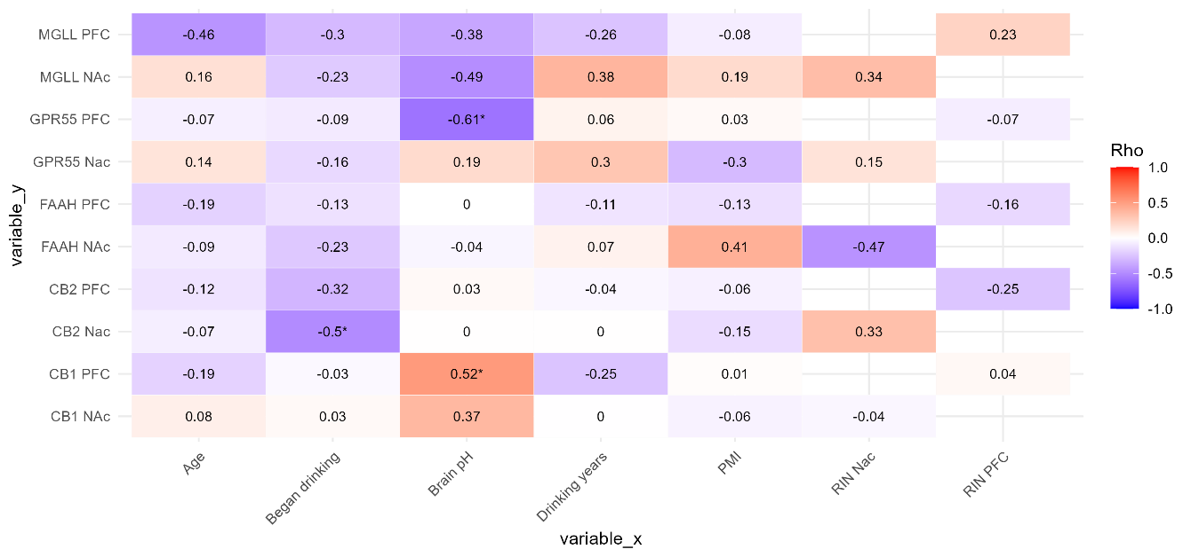
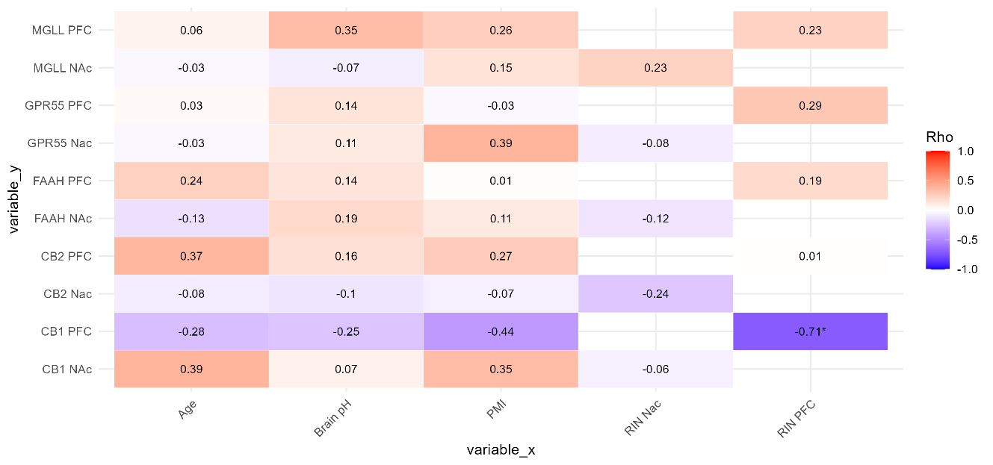
Supplementary figure S1. Spearman’s correlation analyses were performed to assess the relationships between CNR1, CNR2, GPR55, FAAH and MGLL gene expressions in each brain region and clinical and demographic data by group. Heatmaps display pairwise correlation coefficients between CNR1, CNR2, GPR55, FAAH and MGLL expression across brain regions and demographic and clinical variables in AUD (panel A) and C (panel B). In the case of AUD, significant positive and negative correlations were found between CNR1 (r = 0.52, p = 0.03) and GPR55 (r = –0.61, p =0.02) in the PFC and brain pH, respectively. Additionally, CNR2 expression in the NAc correlated with the age of onset of drinking (r = –0.5, p = 0.04). Other correlations were weaker and not statistically significant.
A)

B)

PMI: postmortem interval; RIN: RNA integrity number; NAc: nucleus accumbens; PFC: prefrontal cortex.

