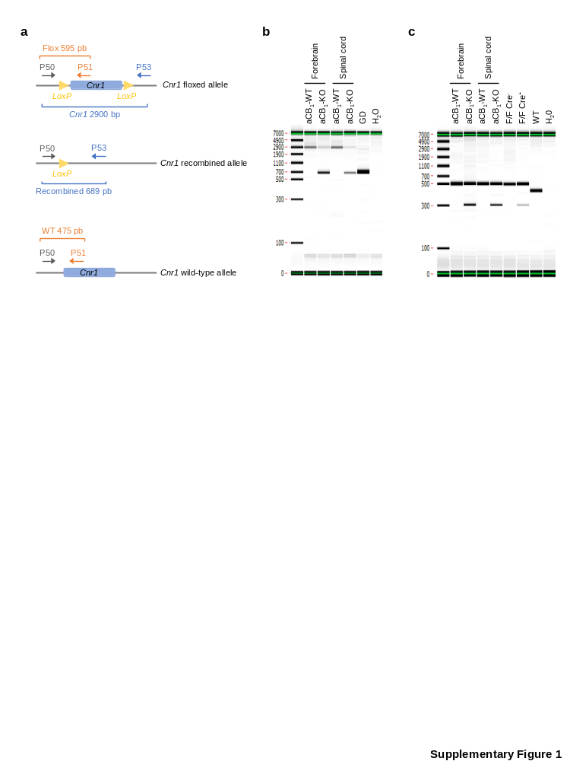

Supplementary Figure 1. (a) PCR-based strategy for the analysis of recombination in aCB₁-WT and aCB₁-KO mice. The diagram represents the wild-type, floxed, and Cre-recombined Cnr1 alleles, indicating the position of the primers used for genotyping and PCR amplicon sizes for each reaction. (b) Detection of the excised fragment as a result of Cre-mediated recombination in forebrain and spinal cord lysates. Probe hybridization, amplification and electrophoresis resulted in a 689 bp product corresponding to the excision in forebrain and spinal cord tissues from tamoxifen-treated aCB₁-KO (CB₁^{f/f;GFAP-CreERT2}) mice that was absent in samples from aCB₁-WT (CB₁^{f/f}) mice. The ~2900 bp amplicon for the unrecombined allele was enriched in lysates from aCB₁-WT mice. DNA samples with germinal deletion (GD) of the Cnr1 gene were used as control for recombination. (c) Genotyping of the floxed allele rendered a ~595 bp product in aCB₁-WT and aCB₁-KO samples and a ~475 bp product in samples from wild-type (WT) mice. The presence of Cre recombinase generated a specific band with 300 bp in aCB₁-KO samples. DNA samples from Cre⁺ and Cre⁻ mice were run as positive and negative controls.

Supplementary Figure 2. Restricted inflammatory neuropathology in aCB₁-KO mice at acute EAE disease. (a) Representative images of spinal cord lesions (*) stained with H&E. Scale bar = 200 µm. The bar graph depicts the quantitative analysis of inflammatory and demyelinating lesions identified in lumbar spinal cord sections from aCB₁-KO and aCB₁-WT mice at acute EAE using H&E staining and MBP/Hoechst immunofluorescence, respectively (n = 6 mice). (b, c) Confocal micrographs and quantification of (b) GFAP and C3, and (c) Iba1 immunostaining in spinal cord demyelinating lesions from aCB₁-KO and aCB₁-WT mice normalized to white matter tissue area (n = 6 mice). Scale bar = 100 µm. (d) Representative images and analysis of GFAP and C3 expression in somatosensory cortex layers V-VI from in aCB₁-KO and aCB₁-WT mice (n = 8-9 mice). Scale bar = 25 µm. *p < 0.05 and **p < 0.01, unpaired t-test or Mann-Whitney test. Error bars express SEM.
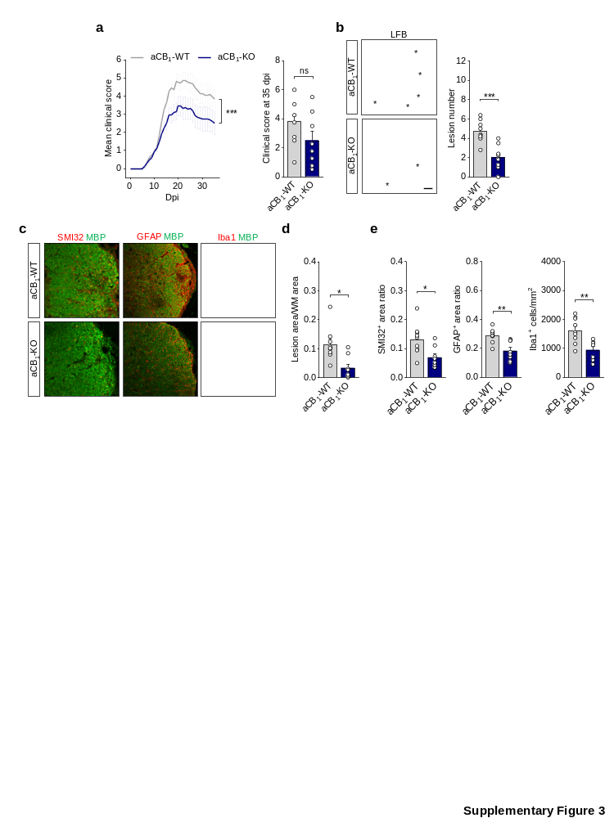

Supplementary Figure 3. Reduced clinical severity and spinal cord pathology of chronic EAE in astrocyte-specific CB₁R null mice. (a) Clinical scores of aCB₁-KO and aCB₁-WT mice during chronic EAE. Comparison of motor scores from symptom onset to 35 dpi revealed significantly attenuated neurological disability in aCB₁-KO mice. Data are representative of 2 independent EAE experiments pooled together (n = 8-12 mice; ***p < 0.0001; Wilcoxon matched-pairs signed rank test for the comparison of score curves from the onset of EAE symptoms at 6 dpi to 35 dpi). (b) Representative images of luxol fast blue (LFB) myelin staining and quantification of demyelinating lesions (*) in spinal cord sections from aCB₁-KO and aCB₁-WT mice at 35 dpi (n = 8-9 mice). Scale bar = 50 µm. (c) Confocal micrographs depict spinal cord sections from aCB₁-KO and aCB₁-WT mice double immunostained for MBP and SMI32, GFAP or Iba1. (d) Quantification of
MBP immunostaining shows a reduced proportion of demyelinated tissue normalized to white matter area in aCB₁-KO mice. (e) Attenuated neuroaxonal damage (left panel) and astrocyte reactivity (middle panel), and lower numbers of microglia/macrophages (right panel) within inflammatory lesions from aCB₁-KO mice as quantified by measuring SMI32 or GFAP immunopositive areas and Iba1⁺ cells (n = 7-9 mice). Scale bar = 100 µm. *p < 0.05, **p < 0.01 and ***p < 0.001, unpaired t-test or Mann-Whitney test. Error bars express SEM.

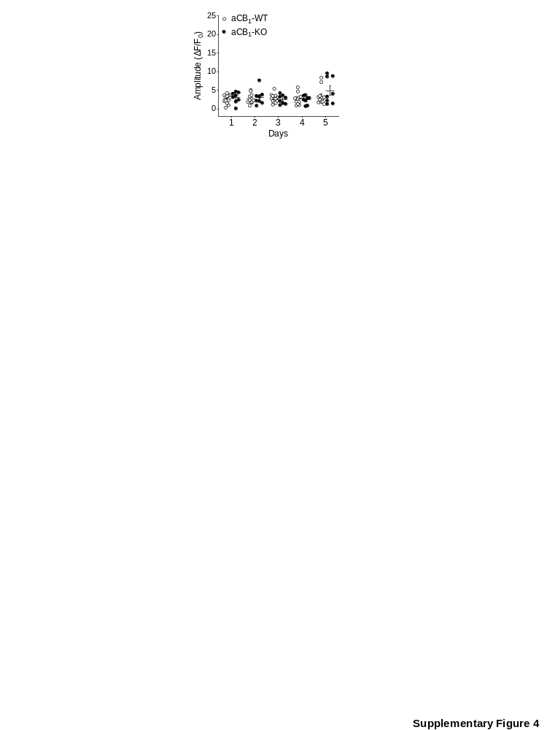
Supplementary figure 4. Comparative analysis of cortical astrocyte calcium responses in control aCB₁-WT and aCB₁-KO mice. The graph depicts the amplitude of sensory-evoked astrocyte calcium signals recorded from non-immunized animals (n = 8-12 mice) during 5 non-consecutive days that correspond to 12, 14, 17, 19 and 21 dpi in EAE mice tested in parallel. Analysis using two-way ANOVA followed by Šídák's test for multiple comparisons did not render significant differences between aCB₁-WT and aCB₁-KO mice.

Supplementary figure 5. Astrocyte-encoded CB₁R do not modulate oligodendrocyte populations in toxin induced remyelinating lesions. (a) Analysis of aCB₁-KO and aCB₁-WT mice in the LPC model of toxic demyelination. LPC lesions were analyzed at 14 dpl corresponding to the peak of oligodendrocyte differentiation and the onset of remyelination. Data are representative of 2 independent LPC experiments pooled together. (b) Immunohistochemistry for MBP depicts demyelinated lesions (dashed lines) in the dorsal funiculus of LPC-injected mice. Scale bar = 50 µm. Quantitative analysis of lesion area shows no differences between genotypes (n = 4-7 mice). (c, d) Quantification of CC1⁺/OLIG2⁺ oligodendrocytes and CC1⁻/OLIG2⁺ immature oligodendroglia in LPC lesions indicates equal cell populations in aCB₁-KO and aCB₁-WT animals (n = 4-7 mice). Figure e shows representative micrographs of LPC lesions triple labelled for MBP, OLIG2 and CC1. Scale bar = 40 µm. (f, g) Confocal images of LPC lesions double stained for MBP and (f) PDGFRα or (g) BCAS1. Analysis of PDGFRα⁺ OPCs and BCAS1⁺ myelinating oligodendrocytes in lesions from aCB₁-KO and aCB₁-WT mice shows no variations between genotypes (n = 3-7 mice). Scale bars = 40 µm. (h, j) Representative microphotographs and quantitative analysis of (h) astrocyte reactivity, (i) microglia/macrophage numbers and (j) infiltrating inflammatory cells in LPC lesions from aCB₁-KO and aCB₁-WT mice double labelled for MBP and GFAP, Iba1 or CD45, respectively. Scale bars = 40 µm. Error bars express SEM.

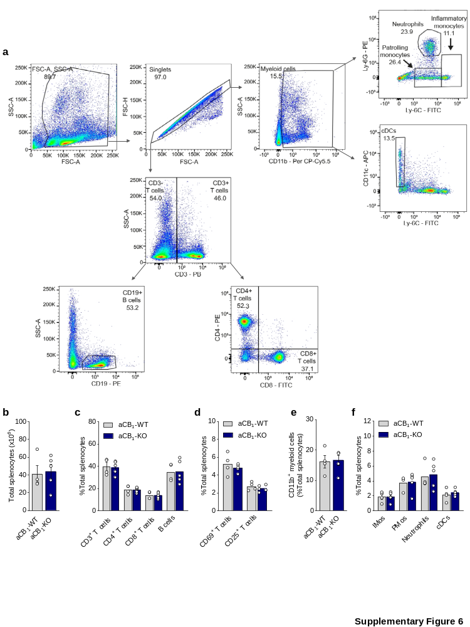

Supplementary figure 6. Comparative analysis of splenic lymphoid and myeloid populations in naive aCB₁-WT and aCB₁-KO mice. (a) Flow cytometry gating strategy for immune cell analysis presents representative dot-plots from an aCB₁-WT mouse. (b) The total number of splenocytes was similar between genotypes, as were the proportions of (c) global T cells (CD3⁺), T helper cells (CD3⁺ CD4⁺), cytotoxic T cells (CD3⁺ CD8⁺), B cells (CD3⁻ CD19⁺) and (d) activated T cells (early stage, CD3⁺ CD4⁺/CD8⁺ CD69⁺; late stage CD3⁺ CD4⁺/CD8⁺ CD25⁺). Likewise, the percentages of (e) global myeloid cells (CD11b⁺), (f) inflammatory monocytes (iMos; CD11b⁺ Ly6C^{hi} Ly6G^{-/low}), patrolling monocytes (pMos; CD11b⁺ Ly6C^{int} Ly6G⁻), neutrophils (CD11b⁺ Ly6C^{int} Ly6G^{hi}), and classical dendritic cells (cDCs; CD11b⁺ CD11c⁺ Ly6C⁻) showed no differences between aCB₁-WT and aCB₁-KO mice (n = 4-5 mice). Error bars express SEM.

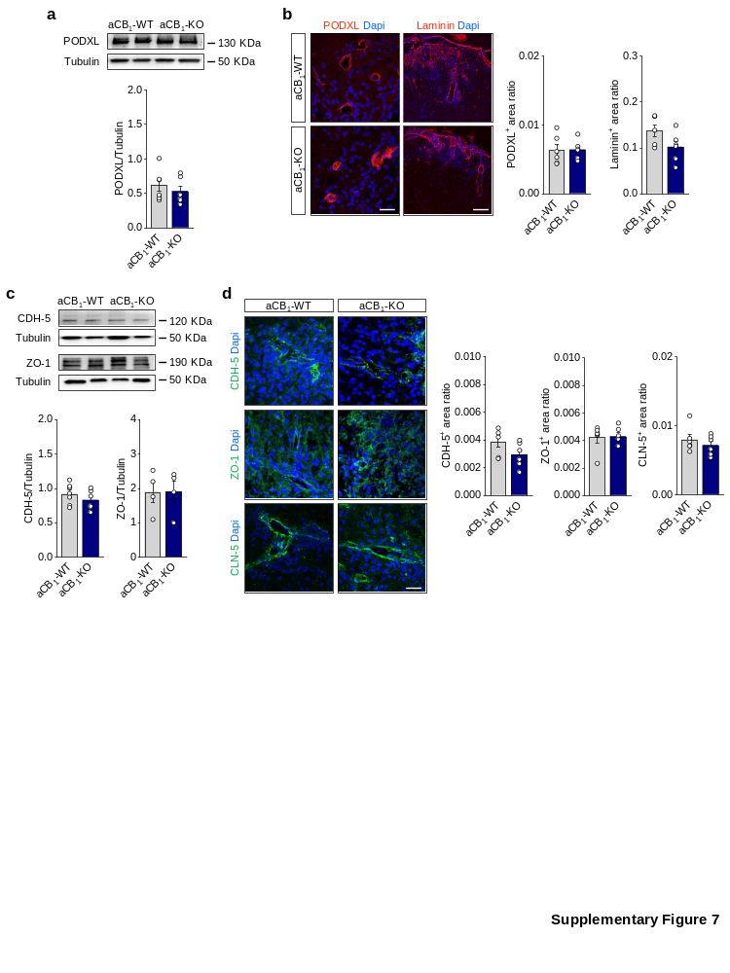

Supplementary figure 7. Analysis of the vascular endothelium in EAE lesions from mice lacking astrocyte-encoded CB₁R. (a, b) Immunoblotting and/or morphometry analysis of the endothelial cell markers PODXL and laminin in spinal cord tissue from aCB₁-KO mice and control aCB₁-WT mice at acute EAE disease (n = 6 mice). Scale bars = 50 µm (PODXL) and 100 µm (laminin). (c, d) Expression of endothelial TJ proteins CDH-5, ZO-1 and CLN-5 in spinal cord tissue from aCB₁-KO and aCB₁-WT mice was determined by (c) immunoblotting and/or (d) immunofluorescence (n = 6 mice). Scale bar = 25 µm.

Supplementary figure 8. Reduced expression of vascular effector molecules in EAE lesions from astrocyte-specific CB₁R null mice. (a, b) Representative confocal micrographs and morphometry show lower expression levels of the adhesion molecules ICAM-1, VCAM-1 and VEGF-A within lesion (L) and perilesion (PL) areas from aCB₁-KO mice (n = 6 mice). Scale bar = 100 µm. *p < 0.05 and **p < 0.01, unpaired t-test or Mann-Whitney test. Error bars express SEM.

Supplementary Table 1. Antibodies for flow cytometry
Antibody | Clone | Concentration | Reference
CD3e-PB | 500A2 | 0.2 µg/10⁶ cells | BD Biosciences (#558214)
CD4-PE | RM4-5 | 0.1 µg/10⁶ cells | BD Biosciences (#553049)
CD8a-FITC | 53-6.7 | 0.25 µg/10⁶ cells | BD Biosciences (#553031)
CD11b-PerCP-Cy5.5 | M1/70 | 0.2 µg/10⁶ cells | BD Biosciences (#550993)
CD11c-APC | N418 | 0.2 µg/10⁶ cells | Thermo Fisher (#17-0114-82)
CD19-PE | 6D5 | 0.025 µg/10⁶ cells | BioLegend (#115508)
CD25-Pe-Cy5.5 | PC61.5 | 0.2 µg/10⁶ cells | Thermo Fisher (#35-0251-82)
CD69-APC | H1.2F3 | 0.2 µg/10⁶ cells | Thermo Fisher (#17-0691-82)
Ly6C-FITC | AL-21 | 0.2 µg/10⁶ cells | BD Biosciences (#553104)
Ly-6G-PE | 1A8  A81 | 0.2 µg/10⁶ cells | BD Biosciences (#551461)

Supplementary Table 2. Primers for RT-qPCR analysis
Gene | Forward primer | Reverse primer
B2m | ACTGACCGGCCTGTATGCTA | ATGTTCGGCTTCCCATTCTCC
Bdnf | TCCAAAGGCCAACTGAAGCA | CTGCAGCCTTCCTTGGTGTA
C1ra | CCTTCCACCCCATAGAACAG | CCTTCAACTTACAGTGCCTGA
C3 | AGGGAGTGTTTGTGCTGAAC | GCCAATGTCTGCCTTCTCTAC
Ccl2 | GTAGTTTTTGTCACCAAGCTC | CAGAAGTGCTTGAGGTGGTT
Ccl5 | GCTCCAATCTTGCAGTCGT | CCTCTATCCTAGCTCATCTCCA
Cldn1 | ACAGCATGGTATGGAAACAGA | AGGAGCAGGAAAGTAGGACA
Cldn4 | CACTCAGCCTACACGTTACTC | CACTCAGCACACCATGACTT
Cntf | GTGAAGACAGAAGCAAACCAG | AGATAGAGCGGCTACAGA GG
Cxcl10 | ATTTTCTGCCTCATCCTGCT | TGATTTCAAGCTTCCCTATGGC
Fkbp5 | GACACCAAAGAAAAGCTGACG | ACTATCTTCCTGTACTGA ATC ACG
Gapdh | AGACGGCCGCATCTTCTT | TTCACACCGACCTTCACCAT
Gbp2 | GCAGAATTCACCTCATACATCTTG | GATGGCACCAACATAGGTCTG
Ggta1 | TCCTGTTGATGCTGATTGTCTC | GTCCTTCTGCCATCTGTT CTC
H2-T23 | ACAGTCCCGACCCAGAGTAG | CCACGTAGCCGACAATGATGA
Hprt | CAGTACAGCCCCAAAATGGTTA | AGTCTGGCCTGTATCCAACA
Icam1 | CTGTGCTTTGAGAACTGTGG | GGTCCTTGCCTACTTGCTG
Igf1 | ATGCTCTTCAGTTCGTGTGT | AGTACATCTCCAGTCTCC TCA G
Iigp1 | CTCATGTGAAGAGCCTGTAGC | CTGACCCATGACTTCAAGCA
Mbp | CCCTCACAGCGATCCAAGTA | CTCTGTGCCTTGGGAGGAA
Mog | CACTTGTGCCTACGATCCTC | AGTCCGATGGAGATTCTCTACT
Ntf3 | AGTCCACCTTTCTCTTCATGTC | ACATCACCTTGTTCACCTGTA
Olig2 | AGGGATGATCTAAGCTCTCGAA | ATTACAGACCGAGCCAAC AC
Pdgfa | ATTAACCATGTGCCCGAGA | GTATCTCGTAAATGACCGTCC TG
Pdgfra | TCACAGCCACCTTCATTACAG | GTTGCCTTACGACTCCAGATG
Ppia | AGGGTTCCTCCTTTCACAGAA | TGCCGCCAGTGCCATTA
Psmb8 | GCTGCTTTCCAACATGATGC | CCGAGTCCCATTGTCATC TAC
Serping1 | CTACCAAGATGGCTAAGACCAA | GATGCTCTCCAAGTTGCT CT
Tgfb1 | GCTGCGCTTGCAGAGATTAA | GTAACGCCAGGAATTGTTGCTA
Vcam1 | GCAAAGGACACTGGAAAAGAG | TGTGCAGTTGACAGTGACA
Vegfa | AGAAAGACAGAACAAAGCCAGA | TCGTTTAACTCAAGCTGCCT

Supplementary Table 3. Primary antibodies for immunohistochemistry
Antibody | Host | Dilution | Reference
Aquaporin-4 | Guinea pig | 1:1000 | Synaptic Systems (#429004)
APP | Mouse | 1:200 | Merck (#MAB348)
B220 | Rat | 1:200 | BD Biosciences (#557390)
BCAS1 | Rabbit | 1:500 | Synaptic Systems (#445003)
C3 | Rabbit | 1:1000 | Dako (#A0063)
CDH-5 | Goat | 1:100 | R&D Systems (#AF1002)
CC1 | Mouse | 1:200 | Calbiochem (#OP80)
CCL2 | Mouse | 1:300 | Santa Cruz (#sc-32771)
CD3 | Rat | 1:50 | Bio-Rad (#MCA1477)
CD45 | Rat | 1:100 | BD Pharmigen, (#550539)
CD68 | Rat | 1:100 | Bio-Rad (#MCA1957GA)
CLN-1 | Mouse | 1:100 | ThermoFisher (#37-4900)
CLN-4 | Mouse | 1:100 | ThermoFisher (#32-9400)
CLN-5 | Mouse | 1:100 | Invitrogen (#35-2500)
Fibrinogen | Sheep | 1:200 | US Biological (#F4199)
GFAP | Rabbit | 1:2000 | Dako (#(#Z0334)
GFAP | Chicken | 1:1000 | Abcam Ab4674)
Iba1 | Rabbit | 1:500 | Wako (#019-19741)
ICAM-1 | Goat | 1:500 | R&D Systems (#AF796)
Laminin | Rabbit | 1:500 | Merck (#L9393)
Ly6G | Rat | 1:100 | BioLegend (#127601)
MBP | Chicken | 1:200 | Merck (#ab9348)
MBP | Mouse | 1:1000 | Biolegend (#808402)
NG2 | Rabbit | 1:200 | Merck (#AB5320)
Olig2 | Mouse | 1:500 | Merck (#MABN50)
PDGFRα | Goat | 1:250 | R&D Systems (#AF1062)
PODXL | Goat | 1:500 | R&D Systems (#AF1556)
SMI32 | Mouse | 1:200 | BioLegend (#801702)
VCAM-1 | Rabbit | 1:500 | Abcam (#ab134047)
VEGF-A | Rabbit | 1:500 | Santa Cruz (#sc-507)
 | Mouse | 1:500 | Santa Cruz (#sc-7269)
ZO-1 | Rabbit | 1:100 | Invitrogen (#402200)

