Supplemental Table 1. Demographic characteristics by Study – Recent substance use
 |  |  | Studies
 |  | Total | BCAP | BRIGHT | STAR | STTS
N | N | 6,781 | 2,133 | 1,537 | 768 | 2,343
Male | 6,781 | 5,573 (82.2) | 1,243 (58.3) | 1,285 (83.6) | 768 (100) | 2,277 (97.2)
Age | 6,781 | 33 (26-45) | 36 (26-48) | 37 (27-46) | 44 (32-50) | 29 (24-35)
Race/Ethnicity | 6,781
Black or African American |  | 4,073 (60.1) | 1,503 (70.5) | 877 (57.1) | 191 (24.9) | 1,502 (64.1)
White |  | 748 (11.0) | 0 | 345 (22.5) | 0 | 403 (17.2)
Hispanic or Latino |  | 1,588 (23.4) | 588 (27.6) | 200 (13.0) | 574 (74.7) | 226 (9.7)
Other race |  | 111 (1.6) | 0 | 55 (3.6) | 0 | 56 (2.4)
Two or more races |  | 261 (3.9) | 42 (2.0) | 60 (3.9) | 3 (0.4) | 156 (6.7)
Sexual Orientation² | 5,244
Heterosexual/Straight |  | 4,289 (81.8) | 1,893 (88.8) | -- | 116 (15.1) | 2,280 (97.3)
Homosexual/Gay/Lesbian/  Queer/”Down-Lo” |  | 62 (1.2) | 15 (0.7) | -- | 39 (5.1) | 8 (0.3)
Bisexual/Other |  | 868 (16.6) | 223 (10.5) | -- | 601 (78.3) | 44 (1.9)
Refused/Missing |  | 25 (0.5) | 2 (0.1) | -- | 12 (1.6) | 11 (0.5)
Education | 6,781
High school or less |  | 5,270 (77.7) | 1,647 (77.2) | 1,274 (82.9) | 595 (77.4) | 1,754 (74.9)
Some college |  | 1,351 (19.9) | 437 (20.5) | 240 (15.6) | 130 (16.9) | 544 (23.2)
College graduate or above |  | 157 (2.3) | 48 (2.3) | 23 (1.5) | 43 (5.6) | 43 (1.8)
Refused/Missing |  | 3 (<0.1) | 1 (0.1) | 0 | 0 | 2 (0.1)
Risk Behaviors³ | 6,781
Number of sex partners |  | 1 (1-3) | 1 (1-2) | 1 (1-2) | 3 (2-3) | 2 (1-3)
Unprotected sex |  | 5,435 (80.2) | 1,798 (84.3) | 1,188 (77.3) | 621 (80.9) | 1,828 (78.0)
Injection Drug Use
Ever IDU |  | 976 (14.4) | 194 (9.1) | 330 (21.5) | 181 (23.6) | 271 (11.6)
Recent IDU |  | 355 (5.2) | 41 (1.9) | 81 (5.3) | 54 (7.0) | 179 (7.6)
Substance Use³ | 6,781
Alcohol |  | 4,142 (61.1) | 1,478 (69.3) | 813 (52.9) | 634 (82.6) | 1,217 (51.9)
Binge alcohol |  | 2,734 (40.3) | 919 (43.1) | 491 (32.0) | 485 (63.2) | 839 (35.8)
Cocaine/crack |  | 907 (13.4) | 77 (3.6) | 177 (11.5) | 266 (34.6) | 387 (16.5)
Illicit opioids |  | 917 (13.5) | 85 (4.0) | 228 (14.8) | 210 (27.3) | 394 (16.8)
Methamphetamine/stimulants |  | 361 (5.3) | 43 (2.0) | 6 (0.4) | 30 (3.9) | 282 (12.0)
Cannabis |  | 2,370 (35.0) | 550 (25.8) | 466 (30.3) | 362 (47.1) | 992 (42.3)
Other |  | 628 (9.3) | 96 (4.5) | 50 (3.3) | 90 (11.7) | 392 (16.7)
Polysubstance |  | 2,625 (38.7) | 547 (25.6) | 524 (34.1) | 506 (65.9) | 1,048 (44.7)
Data presented as median (IQR) or n (%) - percent may not sum to 100 due to rounding.
¹ Reference period for number of sex partners, unprotected sex, injection drug use, and substance use: past 30 or 90 days.
Supplemental Table 2. Recent substance use and condomless sex: Individual substances
Recent substance use | RR | 95% CI | p-value
Overall
Binge alcohol | 1.03 | 1.00-1.07 | 0.04
Cocaine/crack | 1.05 | 1.01-1.08 | 0.02
Illicit opioids | 1.05 | 1.02-1.09 | 0.006
Abbreviations: CI, confidence interval; RR, relative risk.
Models adjusted for age, race/ethnicity, and gender.

Supplemental Table 3. Demographic characteristics by Study – Substance Use Before or During Sex
 |  |  | Studies
 |  | Total | BCAP | STAR
N | N | 2,915 | 1,397(47.9) | 1,518 (52.1)
Male | 2,915 | 2,021 (69.3) | 1,229 (57.9) | 792 (100)
Age | 2,915 | 40 (28-49) | 36 (26-48) | 44 (32-51)
Race/Ethnicity | 2,915
Black or African American |  | 1,701 (58.4) | 1,503 (70.8) | 198 (25.0)
White |  | 0 | 0 | 0
Hispanic or Latino (alone or in  combination with race) |  | 1,169 (40.1) | 578 (27.2) | 591 (74.6)
Two or more races |  | 45 (1.5) | 42 (2.0) | 3 (0.4)
Sexual Orientation | 2,915
Heterosexual/Straight |  | 2,002 (68.7) | 1,883 (88.7) | 119 (15.0)
Homosexual/Gay/Lesbian/  Queer/Down-Lo |  | 55 (1.9) | 15 (0.7) | 40 (5.1)
Bisexual/Other |  | 843 (28.9) | 223 (10.5) | 620 (78.3)
Refused/DK/Missing |  | 15 (0.5) | 2 (0.1) | 13 (1.6)
Education | 2,915
High school or less |  | 2,251 (77.2) | 1,638 (77.2) | 613 (77.4)
Some college |  | 572 (19.6) | 437 (20.6) | 135 (17.1)
College graduate or above |  | 91 (3.1) | 47 (2.2) | 44 (5.6)
Refused/DK/Missing |  | 1 (<0.1) | 1 (0.1) | 0
Risk Behaviors¹ | 2,915
Number of sex partners |  | 2 (1-3) | 1 (1-2) | 2 (1-3)
Unprotected sex |  | 2,425 (83.2) | 1,787 (84.2) | 638 (80.6)
Injection Drug Use
Ever IDU |  | 371 (12.7) | 187 (8.8) | 184 (23.2)
Recent IDU |  | 92 (3.2) | 38 (1.8) | 54 (6.8)
Substance Use¹ | 2,915
Alcohol |  | 2,133 (73.2) | 1,480 (69.7) | 653 (82.5)
Binge alcohol |  | 1,419 (48.7) | 918 (43.2) | 501 (63.3)
Cocaine/crack |  | 334 (11.5) | 67 (3.2) | 267 (33.7)
Illicit opioids |  | 285 (9.8) | 75 (3.5) | 210 (26.5)
Methamphetamine/stimulants |  | 73 (2.5) | 43 (2.0) | 30 (3.8)
Cannabis |  | 899 (30.8) | 537 (25.3) | 362 (45.7)
Other |  | 180 (6.2) | 90 (4.2) | 90 (11.4)
Polysubstance |  | 1,039 (35.6) | 532 (25.1) | 507 (64.0)
Data presented as median (IQR) or n (%) - percent may not sum to 100 due to rounding.

¹ Reference period for number of sex partners, unprotected sex, injection drug use, and substance use: past 30 days.

Supplemental Table 4. Recent substance use and condomless sex: 30-day recall period
Recent substance use | RR | 95% CI | p-value

Overall
None ¹ | Ref | -- | --
Single substance | 1.09 | 1.05-1.13 | <0.001
Polysubstance | 1.14 | 1.08-1.20 | <0.001
Single- vs. poly-substance | 1.07 | 1.02-1.12 | 0.006

Overall – Illicit substance use only
None ² | Ref | -- | --
Single substance | 1.08 | 1.02-1.14 | 0.01
Polysubstance | 1.15 | 1.10-1.20 | <0.001
Single- vs. poly-substance | 1.06 | 1.00-1.13 | 0.05

By type of sex
Vaginal sex only | Ref | -- | --
Vaginal and anal sex | 1.18 | 1.10-1.26 | <0.001

Vaginal sex only
None ¹ | Ref | -- | --
Single substance | 1.12 | 1.04-1.21 | 0.002
Polysubstance | 1.26 | 1.14-1.39 | <0.001
Single- vs. poly-substance | 1.12 | 1.02-1.23 | 0.02

Vaginal and anal sex
None ¹ | Ref | -- | --
Single substance | 1.06 | 1.01-1.10 | 0.01
Polysubstance | 1.08 | 1.02-1.14 | 0.005
Single- vs. poly-substance | 1.04 | 0.99-1.09 | 0.11

Abbreviations: CI, confidence interval; RR, relative risk.

Models adjusted for age, race/ethnicity, and gender.

¹ None included participants who reported no binge alcohol use or illicit drug use (non-binge alcohol use and cannabis use allowed).

² None included participants who reported no illicit drug use (any alcohol use and cannabis use allowed).

Supplemental Table 5. Recent substance use and condomless sex: 90-day recall period
Recent substance use | RR | 95% CI | p-value

Overall
None ¹ | Ref | -- | --
Single substance | 1.07 | 1.03-1.11 | <0.001
Polysubstance | 1.05 | 1.01-1.10 | 0.02
Single- vs. poly-substance | 0.98 | 0.93-1.02 | 0.29

Overall – Illicit substance use only
None ² | Ref | -- | --
Single substance | 1.05 | 1.00-1.09 | 0.04
Polysubstance | 1.02 | 0.96-1.07 | 0.58
Single- vs. poly-substance | 0.97 | 0.91-1.02 | 0.22

By type of sex
Vaginal sex only | Ref | -- | --
Vaginal and anal sex | 1.23 | 1.17-1.30 | <0.001

Vaginal sex only
None ¹ | Ref | -- | --
Single substance | 1.08 | 1.03-1.13 | 0.001
Polysubstance | 1.06 | 1.00-1.11 | 0.04
Single- vs. poly-substance | 0.97 | 0.92-1.03 | 0.30

Vaginal and anal sex
None ¹ | Ref | -- | --
Single substance | 1.05 | 0.98-1.11 | 0.14
Polysubstance | 1.07 | 1.01-1.14 | 0.02
Single- vs. poly-substance | 1.01 | 0.97-1.06 | 0.55

By HIV status of partner
HIV-negative partners only | Ref | -- | --
HIV-unknown partners only | 0.92 | 0.86-0.98 | 0.01
HIV-negative & HIV-unknown partners only | 1.11 | 1.04-1.19 | 0.001

HIV-negative partners only
None ¹ | Ref
Single substance | 1.08 | 1.02-1.13 | 0.004
Polysubstance | 1.07 | 1.01-1.14 | 0.02
Single- vs. poly-substance | 0.99 | 0.94-1.05 | 0.81

HIV-unknown partners only
None ¹ | Ref | -- | --
Single substance | 1.04 | 0.95-1.13 | 0.39
Polysubstance | 0.97 | 0.88-1.07 | 0.57
Single- vs. poly-substance | 0.94 | 0.85-1.03 | 0.20

HIV-negative & HIV-unknown partners only
None ¹ | Ref | -- | --
Single substance | 1.09 | 1.01-1.18 | 0.03
Polysubstance | 1.13 | 1.06-1.20 | <0.001
Single- vs. poly-substance | 1.04 | 0.98-1.10 | 0.22

Abbreviations: CI, confidence interval; RR, relative risk.

Models adjusted for age, race/ethnicity, and gender.

¹ None included participants who reported no binge alcohol use or illicit drug use (non-binge alcohol use and cannabis use allowed).

² None included participants who reported no illicit drug use (any alcohol use and cannabis use allowed).

Supplemental Table 6. Recent cannabis use and/or recent binge alcohol use and condomless sex
Recent substance use | RR | 95% CI | p-value
None¹ | Ref | -- | --
Binge alcohol only | 1.06 | 1.02-1.09 | 0.002
Cannabis only | 0.99 | 0.94-1.04 | 0.61
Only binge alcohol and cannabis | 1.09 | 1.05-1.13 | <0.001
Abbreviations: CI, confidence interval; RR, relative risk.
Models adjusted for age, race/ethnicity, and gender.
¹ None included participants who reported no binge alcohol use or illicit drug use (non-binge alcohol use and cannabis use allowed).

Supplemental Table 7. Recent cannabis use frequency and condomless sex
Recent substance use | RR | 95% CI | p-value
Cannabis use frequency¹
Only a few times | Ref | -- | --
1-3 times per month | 1.04 | 0.97, 1.12 | 0.27
About once a week | 1.05 | 0.96, 1.14 | 0.27
2-5 times per week | 1.00 | 0.93, 1.07 | 0.92
About once a day | 1.03 | 0.98, 1.09 | 0.24
Only a few times | Ref | -- | --
Abbreviations: CI, confidence interval; CS, condomless sex; RR, relative risk.
Models adjusted for age, race/ethnicity, and gender.

¹ Cannabis users includes participants that reported any cannabis, whether alone or in conjunction with other substance.

Supplemental Figure 1
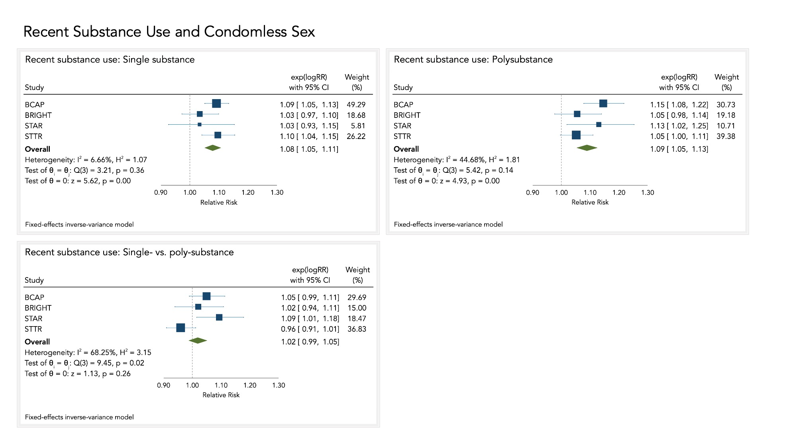
Supplemental Figure 2
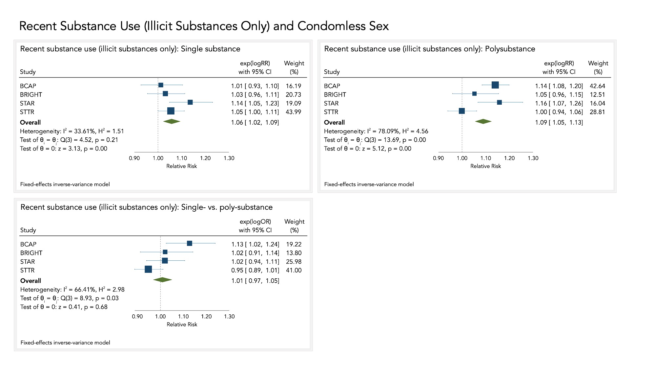

Supplemental Figure 3
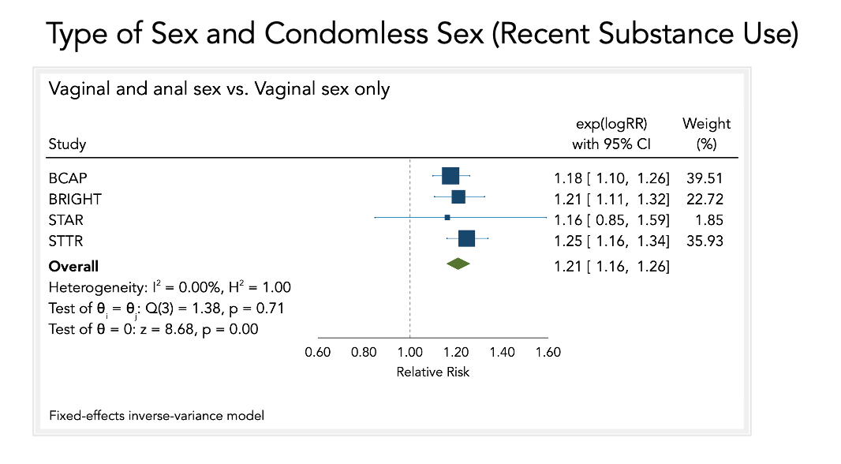
Supplemental Figure 4
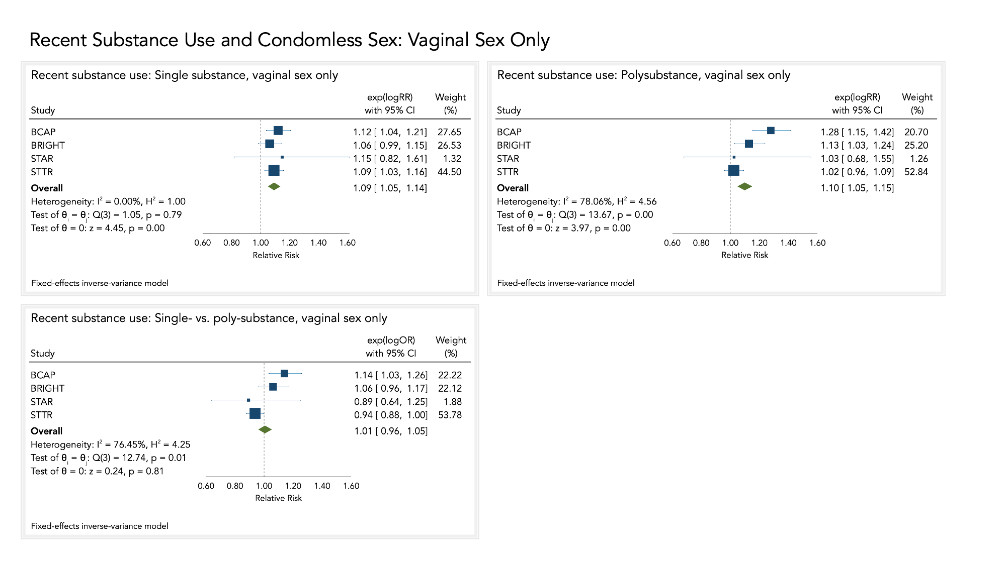
Supplemental Figure 5
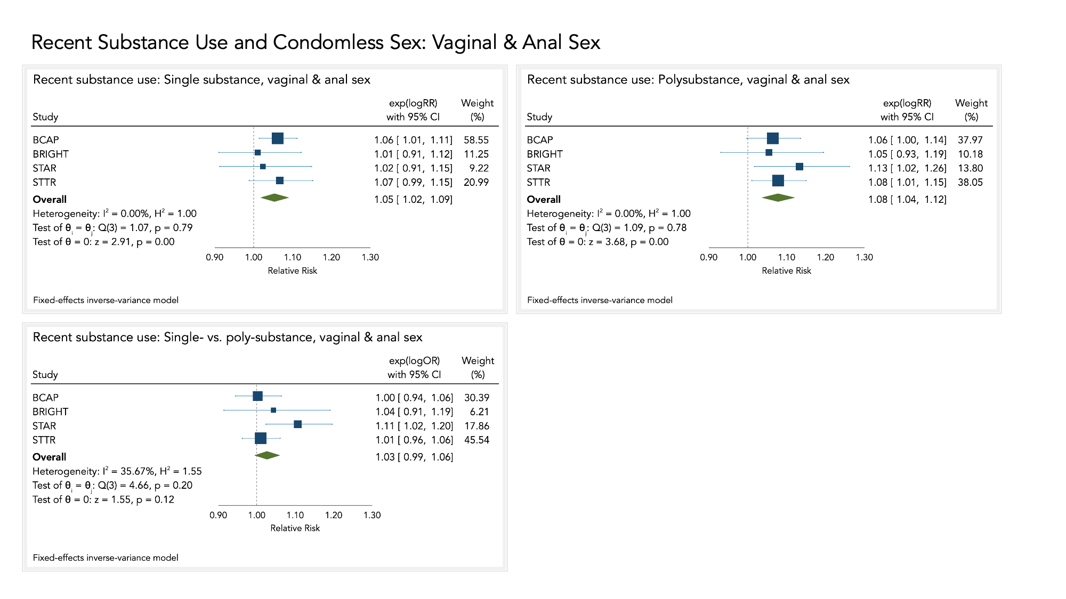

Supplemental Figure 6
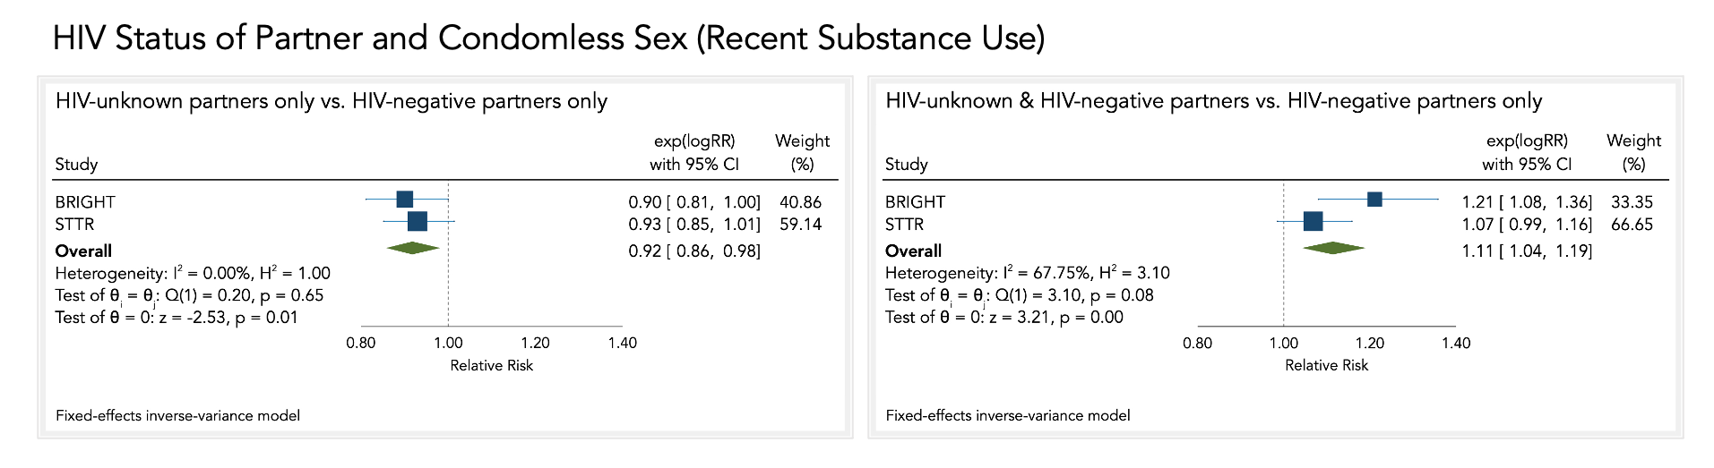
Supplemental Figure 7
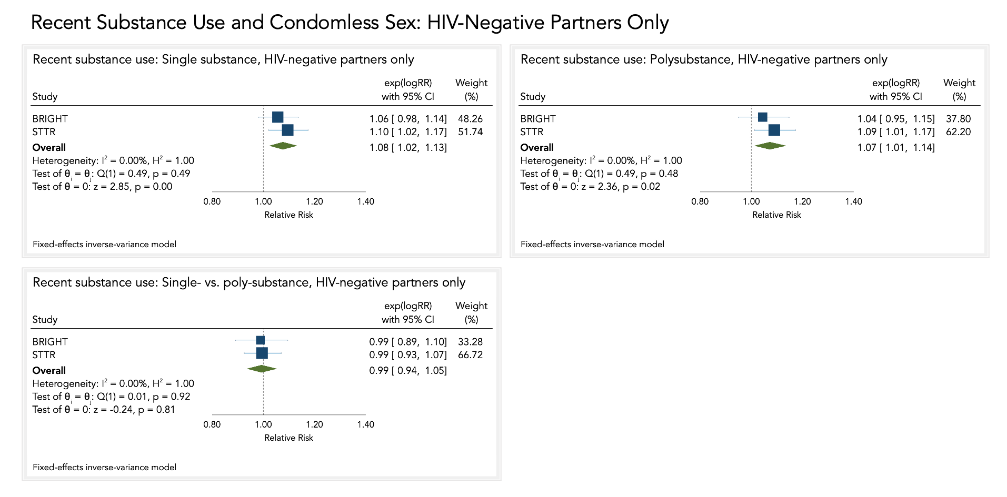
Supplemental Figure 8
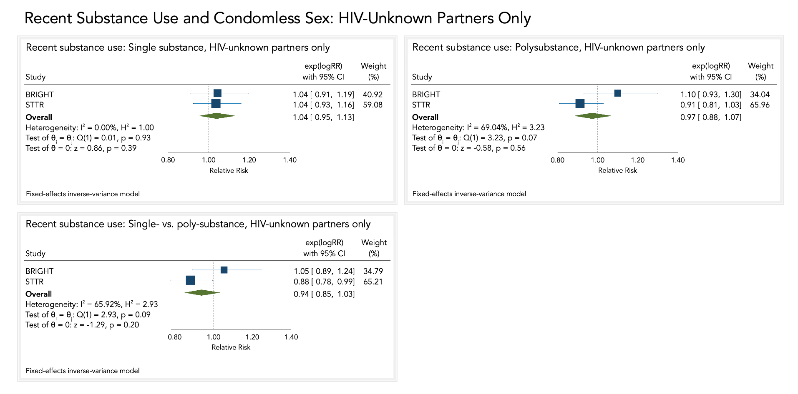
Supplemental Figure 9
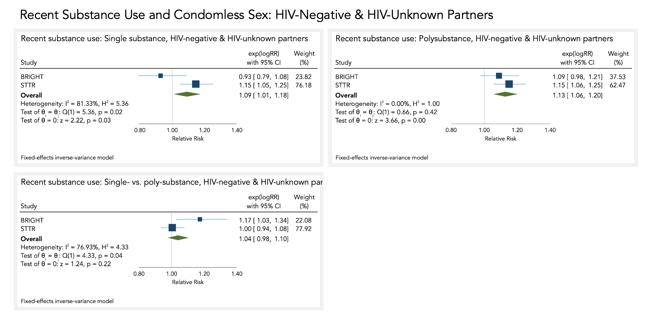
Supplemental Figure 10
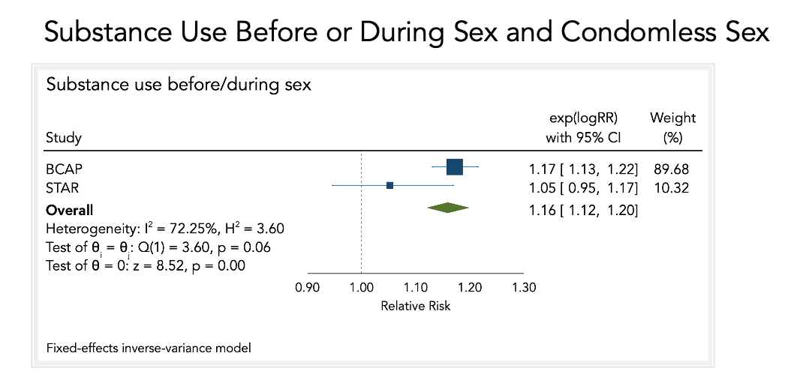
Supplemental Figure 11
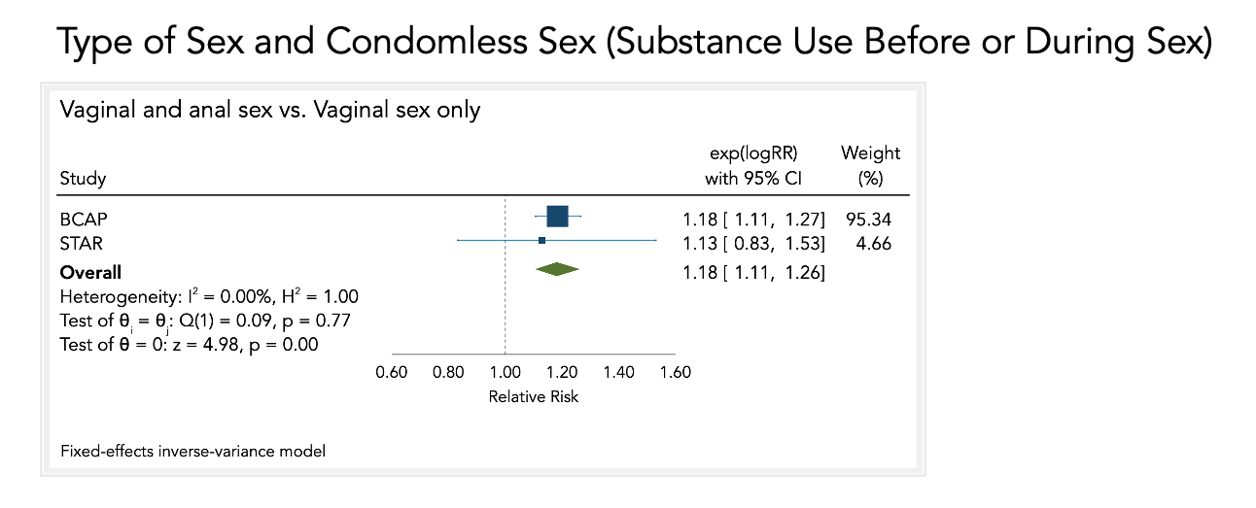
Supplemental Figure 12
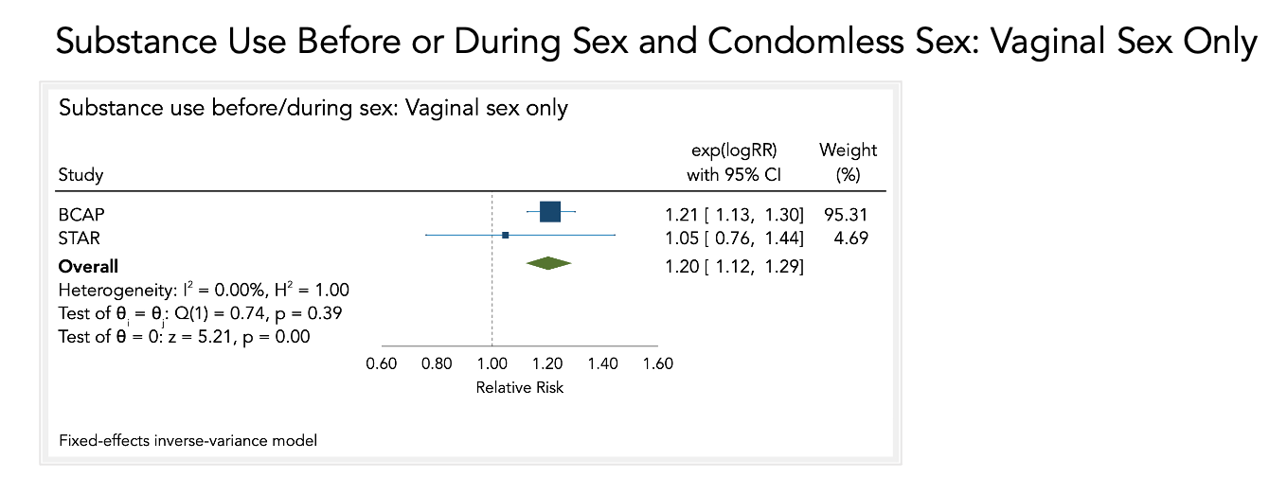
Supplemental Figure 13
