Supplementary Methods
MRI Acquisition. MRI data for participants in the 4RTNI study were acquired using 3 Tesla scanners at UCSF, UCSD, the University of Toronto, and MGH. At UCSF and MGH, imaging was performed on Siemens Tim Trio systems (Siemens, Iselin, NJ) equipped with 12-channel receiver head coils. Whole-brain structural images were obtained using a volumetric magnetization-prepared rapid gradient-echo (MPRAGE) sequence with the following parameters: TR = 2300 ms, TE = 2.98 ms, TI = 900 ms, flip angle = 9°, in-plane resolution = 1 x 1 mm, and slice thickness = 1 mm. At UCSD, scans were acquired on a GE Discovery MR750 system (GE, Milwaukee, WI) with a 32-channel head coil, while at the University of Toronto, a GE Signa HDx scanner with an 8-channel receiver head coil was used. Both UCSD and UToronto employed sagittal 3D inversion-recovery spoiled gradient echo (IR-SPGR) sequences: UCSD parameters were TR = 7.1 ms, TE = 3.00 ms, TI = 400 ms, flip angle = 11°, in-plane resolution = 1 x 1 mm, and slice thickness = 1.2 mm; UToronto parameters were TR = 7.0 ms, TE = 2.80 ms, TI = 400 ms, flip angle = 11°, in-plane resolution = 1 x 1 mm, and slice thickness = 1.2 mm.
For the DAV trial, MRI data were collected using forty-eight 1.5T or 3T scanners with different models but harmonized sequences based on protocols developed by the Mayo Clinic’s Aging and Dementia Imaging Research Laboratory (Rochester, MN, USA), as previously described. All T1-weighted images were acquired using either MPRAGE, coronal IR-SPGR, or sagittal IR-SPGR sequences.

Supplementary Figure 1. Flowchart of patient selection
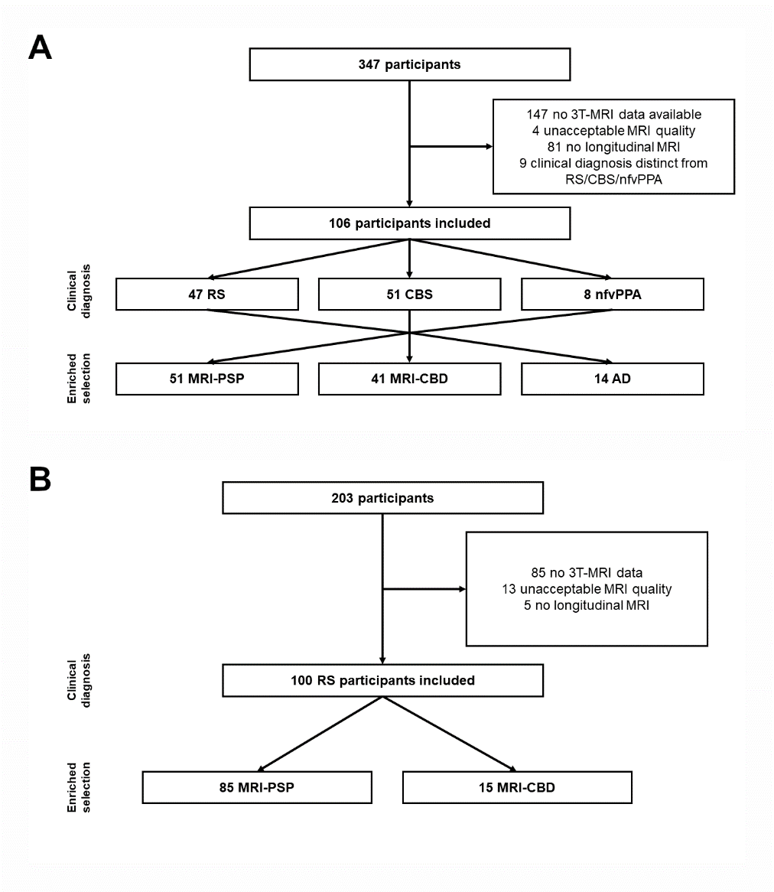
Footnote: Flowchart of patient selection for the 4RTNI (A) and Davunetide trial (B) cohorts.
Abbreviations: 3T-MRI, 3 Tesla-Magnetic Resonance Imaging; AD, Alzheimer’s Disease; CBS, corticobasal syndrome; CBD, corticobasal degeneration; nfvPPA, Non-fluent variant primary progressive aphasia; PSP, progressive supranuclear palsy; RS, Richardson’s syndrome.

Supplementary Figure 2. Predicted probability of PSP and optimal cut-off.
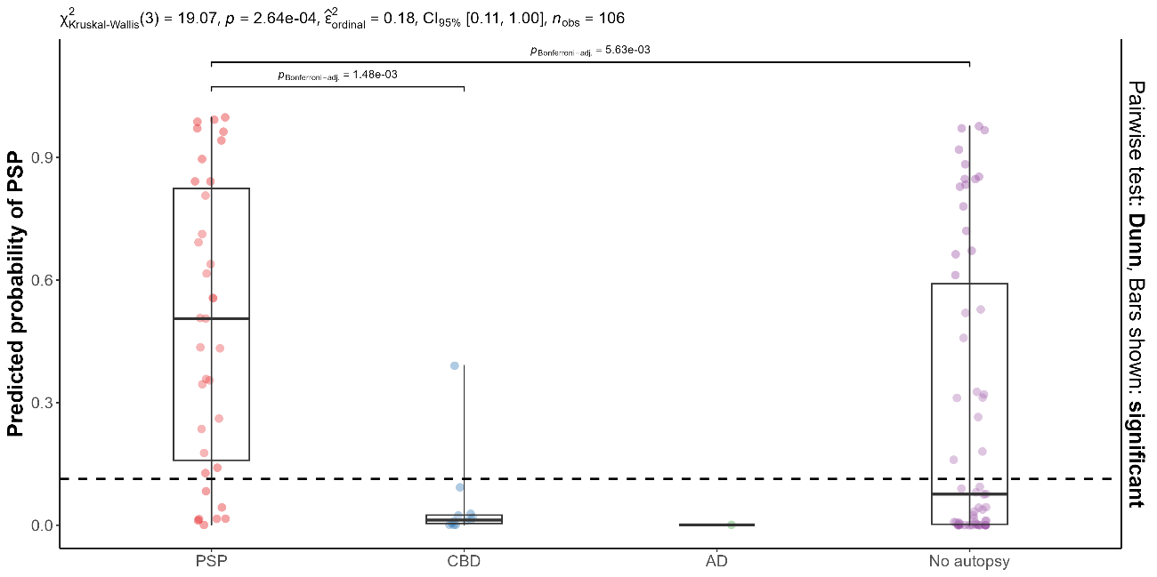
Footnotes: The panel shows the predicted probability of PSP vs CBD derived from the MLRM in the pathologically confirmed subsamples and the rest of the 4RTNI cohort. The dashed line showed the optimal cutoff for differentiating PSP vs CBD obtained from the autopsy-confirmed subsample using the cutpointr R package with 10,000 bootstrap iterations.
Abbreviations: AD, Alzheimer’s disease; CBD, corticobasal degeneration; PSP, progressive supranuclear palsy.
Supplementary Figure 3. Clinical change according to selection strategy
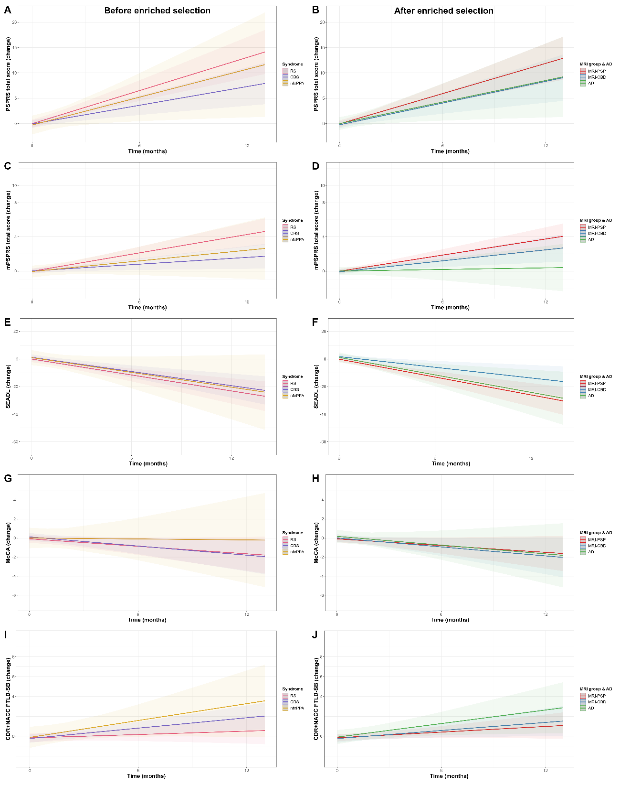
Footnotes: Linear mixed-effects models showing the longitudinal change in different scores according to clinical diagnosis only (A) and after the enriched selection using AD biomarkers and MLRM (B).
Abbreviations: AD, Alzheimer’s disease; CBD, corticobasal degeneration; CBS, corticobasal syndrome; CDR+NACC FTLD-SB, Clinical Dementia Rating plus National Alzheimer’s Coordinating Center Frontotemporal lobar degeneration sum of boxes; MRI, magnetic resonance imaging; MoCA, Montreal Cognitive Assessment; mPSPRS, modified Progressive supranuclear palsy rating scale; nfvPPA, non-fluent variant of primary progressive aphasia; PSP, progressive supranuclear palsy; RS, Richardson’s syndrome; SEADL, Schwab and England Activities of Daily Living scale.

Supplementary Figure 4. Patterns of atrophy at 12 months according to clinical diagnosis
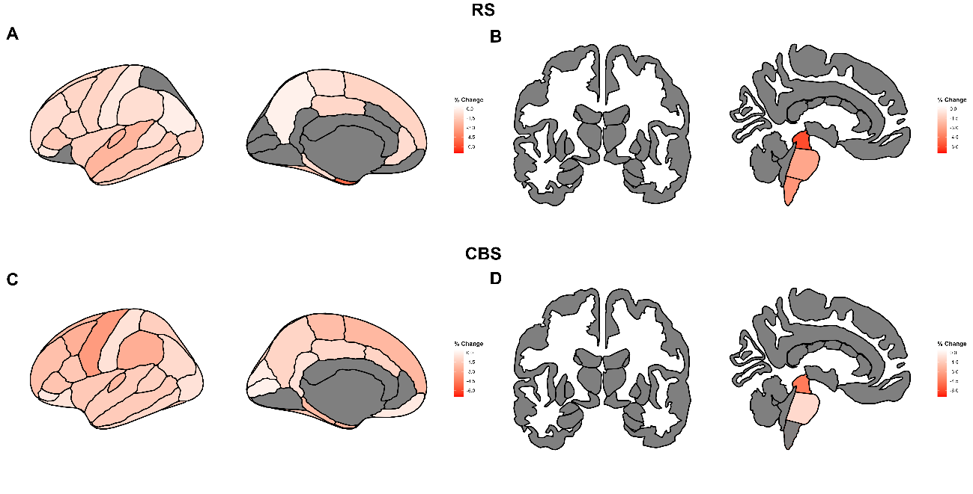
Footnotes: Predicted cortical thickness reduction and subcortical volume loss at 12 months in RS (A-B) and CBS (C-D). Values were derived from linear mixed-effects models.
Abbreviations: CBS, corticobasal syndrome; MRI, magnetic resonance imaging; RS, Richardson’s syndrome.

Supplementary Figure 5. Patterns of atrophy at 12 months according to different combinations of clinical diagnosis and predicted pathology
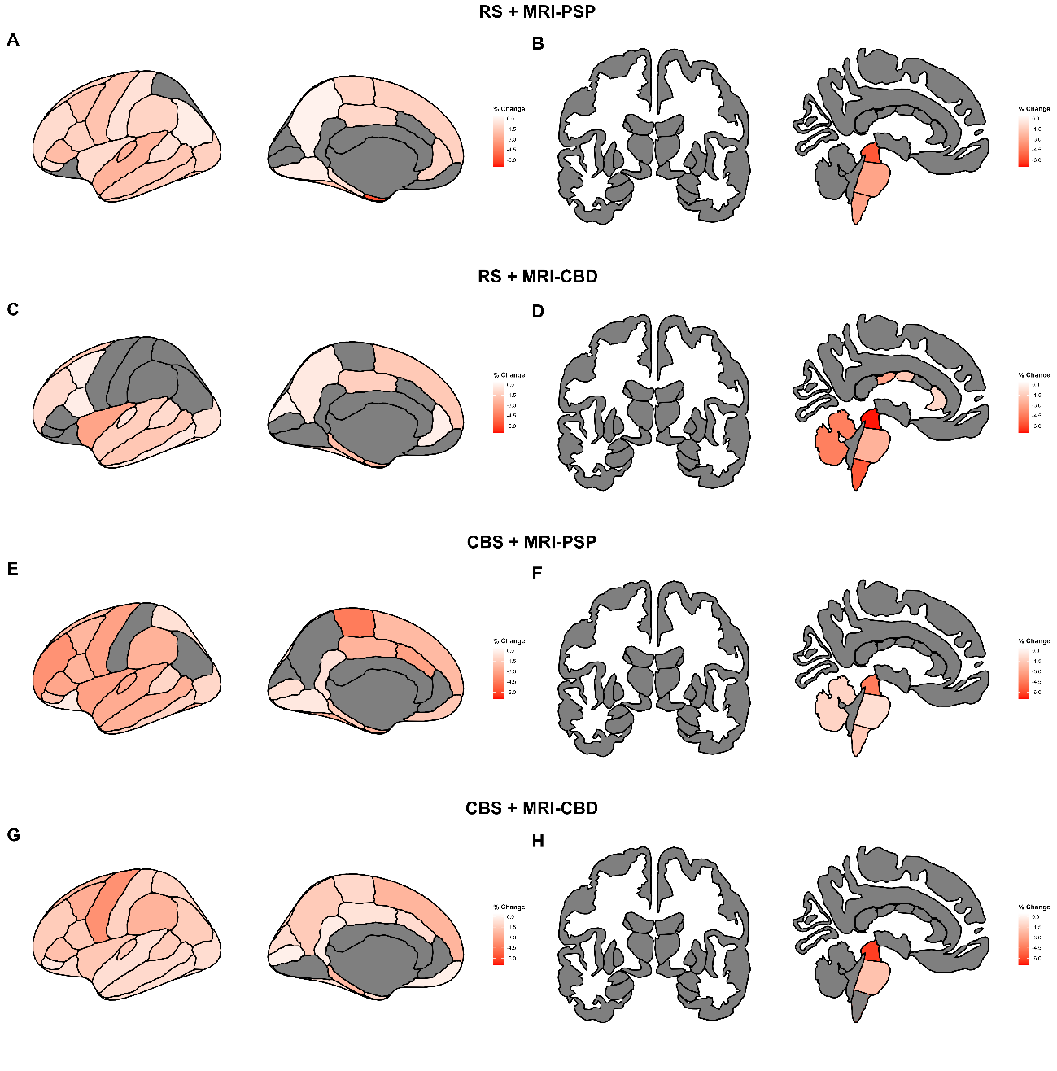
Footnotes: Predicted cortical thickness reduction and subcortical volume loss at 12 months in RS + MRI-PSP (A-B), RS + MRI-CBD (C-D), CBS + MRI-PSP (E-F) and CBS + MRI-CBD (G-H). Values were derived from linear mixed-effects models.
Abbreviations: CBD, corticobasal degeneration; CBS, corticobasal syndrome; MRI, magnetic resonance imaging; PSP, progressive supranuclear palsy; RS, Richardson’s syndrome.

Supplementary Figure 6. Patterns of atrophy at 12 months in DAV
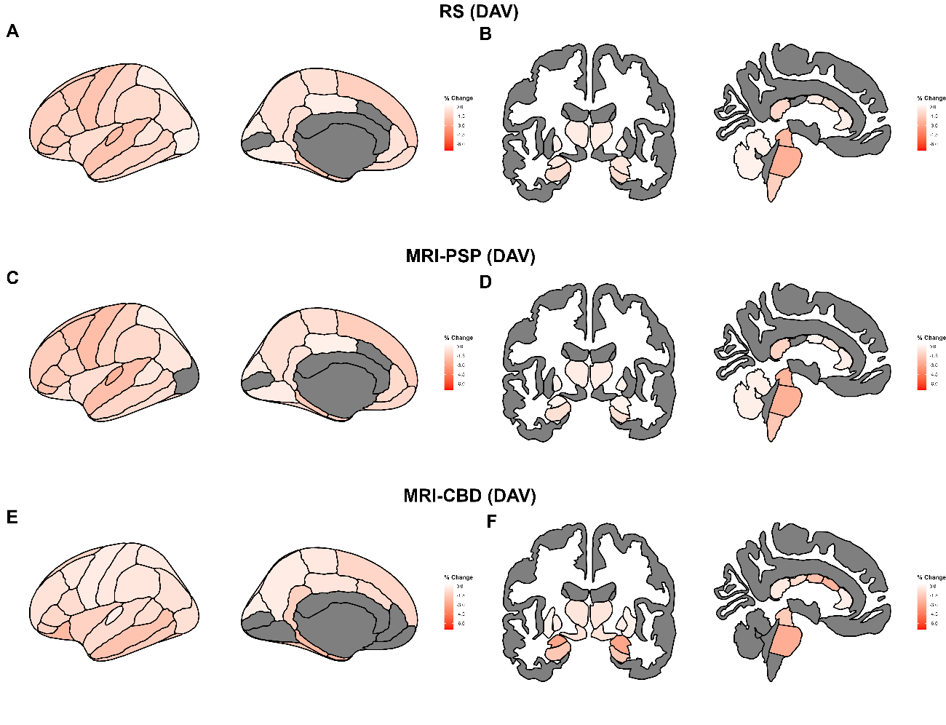
Footnotes: Predicted cortical thickness reduction and subcortical volume loss at 12 months in RS (A-B), MRI-PSP (C-D), and MRI-CBD (E-F).
Abbreviations: CBS, corticobasal syndrome; DAV, Dabunetide trial cohort; MRI, magnetic resonance imaging; PSP, progressive supranuclear palsy; RS, Richardson’s syndrome.

Supplementary Figure 7. Correlation between clinical scores and MRI signatures
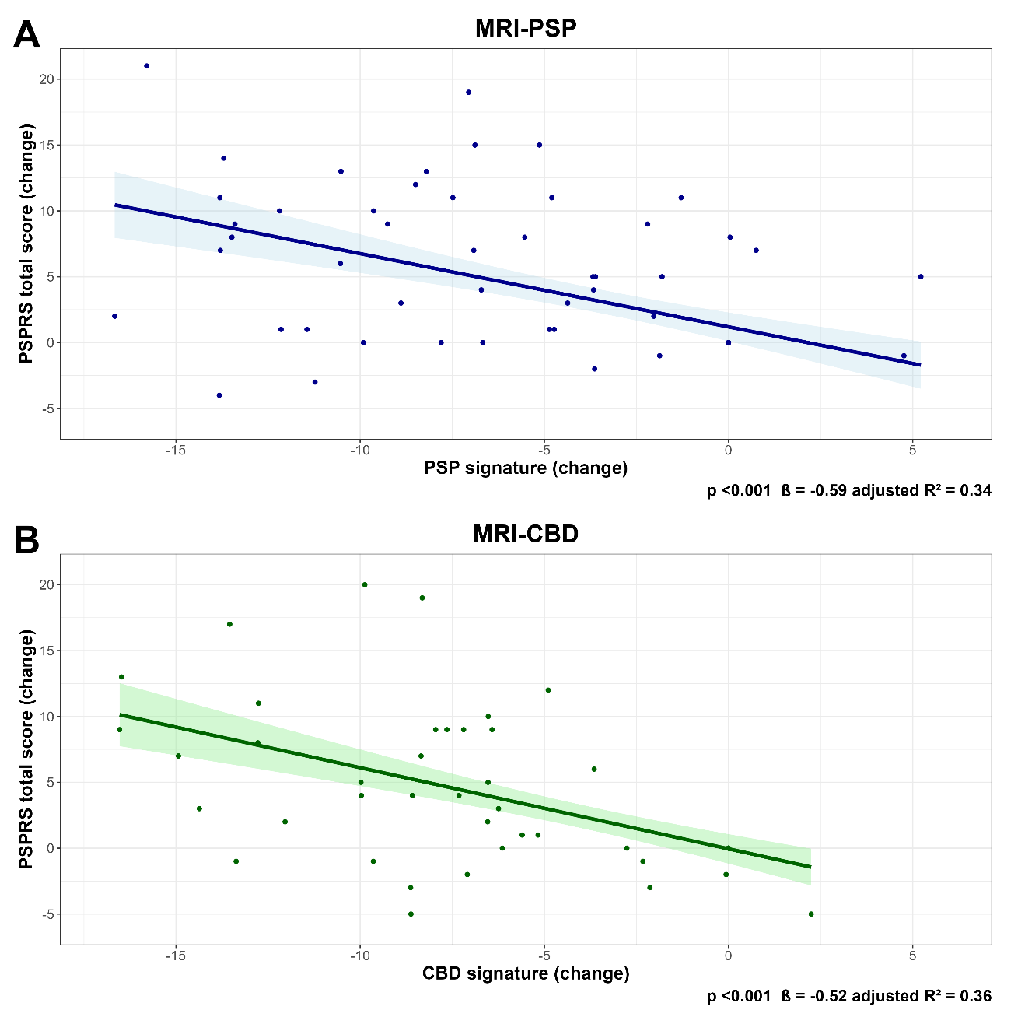
Footnotes: Panels show the correlation between clinical score change measured by PSPRS and the most efficient MRI-signatures to detect change for MRI-PSP (A) and MRI-CBD (B) groups. Spearman rho values and p-values are the result of nonparametric Spearman rank order correlations.
Abbreviations: MRI, magnetic resonance imaging; CBD, corticobasal degeneration; PSP, progressive supranuclear palsy; PSPRS, progressive supranuclear palsy rating scale.

Supplementary Figure 8. Longitudinal clinical change for RS and MRI-PSP groups
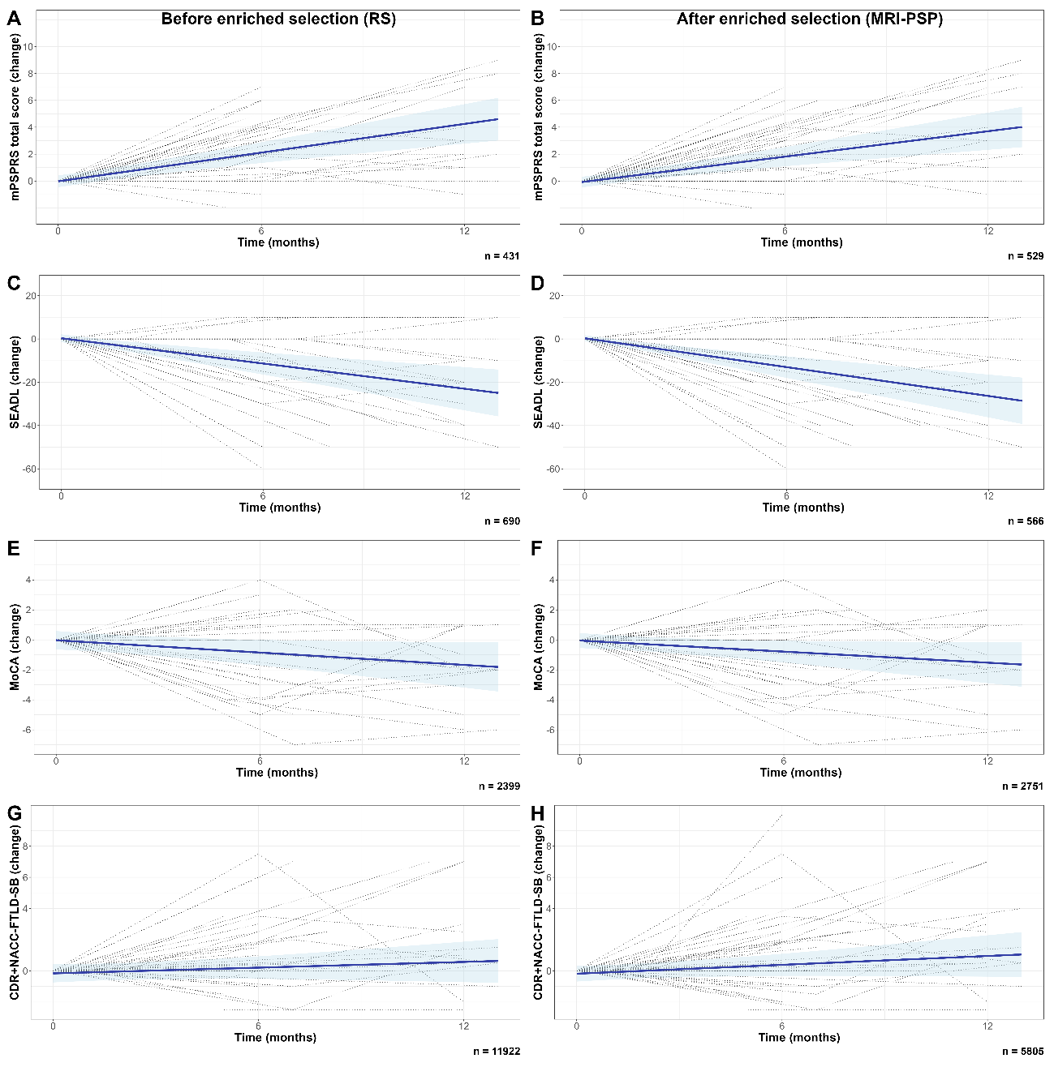
Footnotes: Panels show the predicted clinical change as measured by mPSPRS (A,B), SEADL (C,D), MoCA (E,F) and CDR+NACC FTLD-SB (G-H), derived from linear mixed-effects models before enriched selection (inclusion of all participants with RS) and after enriched selection (inclusion of all participants with predicted PSP by MRI [MRI-PSP], regardless of their clinical phenotype). Individual trajectories for each variable are superimposed (dotted lines). Each panel shows the bootstrapped estimated sample size for a clinical trial showing 30% reduction at 12 months with 10% attrition in each variable.
Abbreviations: CDR+NACC FTLD-SB, Clinical Dementia Rating plus National Alzheimer’s Coordinating Center Frontotemporal lobar degeneration sum of boxes; MoCA, Montreal cognitive assessment; mPSPRS, modified progressive supranuclear palsy rating scale; PSP, progressive supranuclear palsy; RS, Richardson’s syndrome; SEADL, Schwab and England Activities of Daily Living scale.

Supplementary Figure 9. Longitudinal clinical change for CBS and MRI-CBD groups
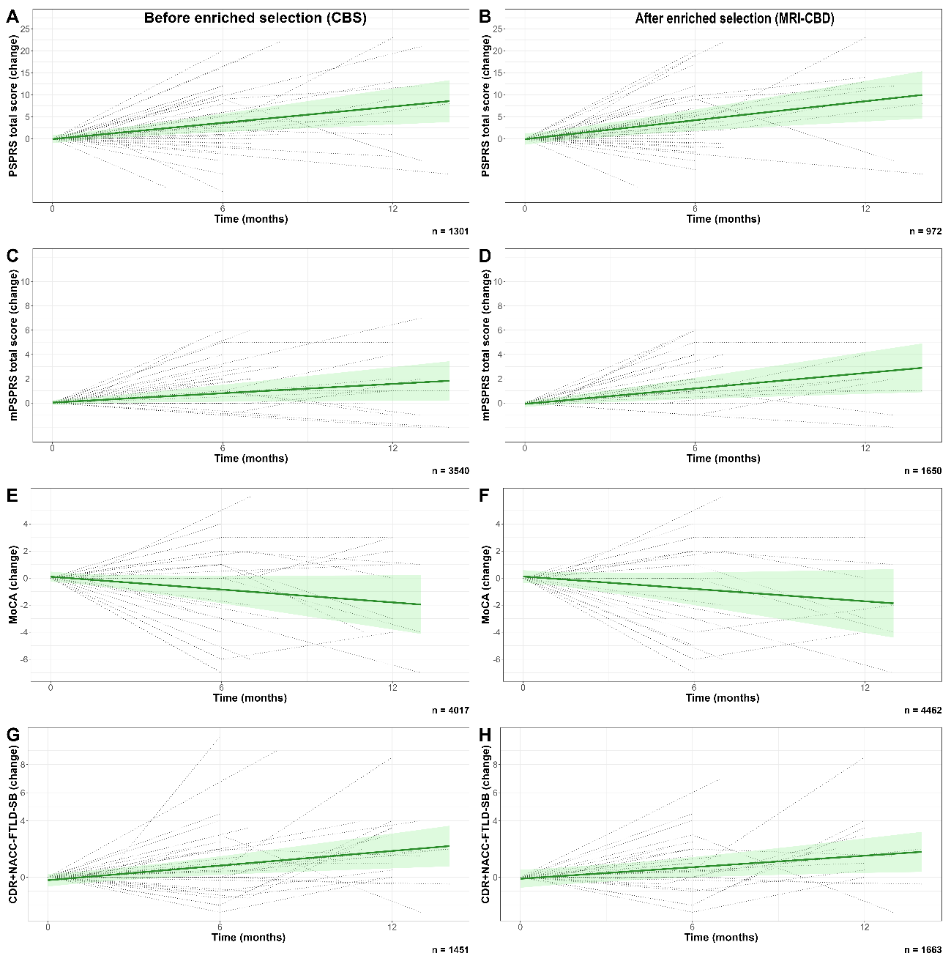
Footnotes: Panels show the predicted clinical change as measured by PSPRS (A,B), mPSPRS (C,D), MoCA (E,F) and CDR+NACC FTLD-SB (G-H), derived from linear mixed-effects models before enriched selection (inclusion of all participants with CBS) and after enriched selection (inclusion of all participants with predicted CBD by MRI [MRI-CBD], regardless of their clinical phenotype). Each panel shows the bootstrapped estimated sample size for a clinical trial showing 30% reduction at 12 months with 10% attrition in each variable.
Abbreviations: CDR+NACC FTLD-SB, Clinical Dementia Rating plus National Alzheimer’s Coordinating Center Frontotemporal lobar degeneration sum of boxes; MoCA, Montreal cognitive assessment; mPSPRS, modified progressive supranuclear palsy rating scale; PSRS, progressive supranuclear palsy rating scale; SEADL, Schwab and England Activities of Daily Living scale.

Supplementary Figure 10. Individual trajectories in midbrain percentage change in DAV
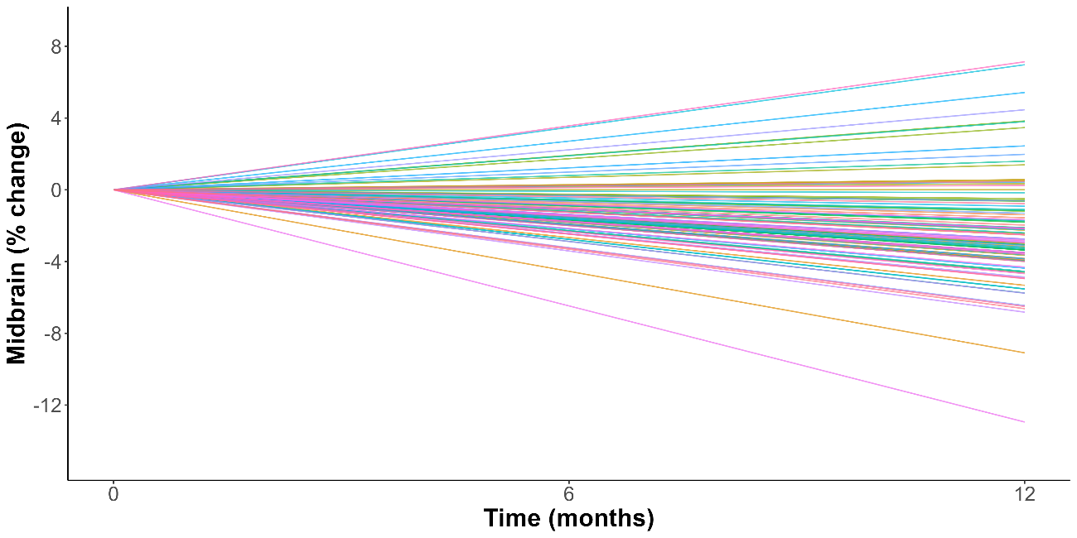
Abbreviations: DAV, Davunetide trial cohort.

Supplementary Table 1. Characteristics of the autopsy subsample
Characteristic | All participants, N = 106 | PSP,  N = 35 | CBD,  N = 12 | AD,  N = 1 | No autopsy, N = 58 | Adjusted p-value
Age | 68 (8) | 70 (7) | 65 (7) | 61 (NA) | 67 (9) | >0.9
Biological Sex |  |  |  |  |  | >0.9
Woman | 53 (50%) | 15 (43%) | 7 (58%) | 0 (0%) | 31 (53%) | >0.9
Man | 53 (50%) | 20 (57%) | 5 (42%) | 1 (100%) | 27 (47%) | >0.9
Years of education | 16.09 (2.97) | 15.03 (3.43) | 17.36 (1.69) | 20.00 (NA) | 16.41 (2.70) | 0.6
Number of visits |  |  |  |  |  | 0.5
2 | 23 (22%) | 9 (26%) | 0 (0%) | 0 (0%) | 14 (24%) | 0.5
3 | 63 (59%) | 15 (43%) | 9 (75%) | 1 (100%) | 38 (66%) | 0.5
>3 | 20 (19%) | 11 (31%) | 3 (25%) | 0 (0%) | 6 (10%) | 0.5
Clinical phenotype |  |  |  |  |  | <0.001
PSP-RS | 47 (44%) | 32 (91%) | 0 (0%) | 0 (0%) | 15 (26%) | <0.001
CBS | 51 (48%) | 2 (6%) | 12 (100%) | 1 (100%) | 36 (62%) | <0.001
nfvPPA | 8 (8%) | 1 (3%) | 0 (0%) | 0 (0%) | 7 (12%) | <0.001
PSPRS total score | 26 (15) | 33 (15) | 24 (14) | 14 (NA) | 22 (14) | 0.13
modified PSPRS total score | 4.8 (4.6) | 7.5 (5.4) | 3.0 (3.9) | 2.0 (NA) | 3.6 (3.4) | 0.064
SEADL total score | 63 (24) | 60 (25) | 56 (21) | 80 (NA) | 65 (24) | >0.9
MoCA | 22.0 (5.0) | 21.1 (4.6) | 22.5 (5.3) | 17.0 (NA) | 22.5 (5.2) | >0.9
CDR plus NACC FTLD Global score |  |  |  |  |  | >0.9
0 | 3 (2%) | 2 (5.7%) | 0 (0%) | 0 (0%) | 1 (1%) | >0.9
0.5 | 42 (40%) | 10 (29%) | 4 (33%) | 1 (100%) | 27 (47%) | >0.9
1 | 39 (37%) | 14 (40%) | 6 (50%) | 0 (0%) | 19 (33%) | >0.9
2 | 21 (20%) | 9 (26%) | 1 (8.3%) | 0 (0%) | 11 (19%) | >0.9
3 | 1 (1%) | 0 (0%) | 1 (8.3%) | 0 (0%) | 0 (0%) | >0.9
CDR plus NACC FTLD sum-of-boxes | 4.7 (3.4) | 4.9 (3.0) | 5.7 (5.1) | 3.5 (NA) | 4.3 (3.2) | >0.9
Midbrain | 5,404 (800) | 5,138 (740) | 5,688 (919) | 6,197 (NA) | 5,491 (781) | >0.9
AD biomarkers |  |  |  |  |  | >0.9
Negative | 63 (75%) | 23 (77%) | 8 (80%) | 0 (0%) | 32 (74%) | >0.9
Positive | 21 (25%) | 7 (23%) | 2 (20%) | 1 (100%) | 11 (26%) | >0.9
Amyloid-PET |  |  |  |  |  | >0.9
Negative | 39 (72%) | 6 (67%) | 5 (71%) | 0 (NA%) | 28 (74%) | >0.9
Positive | 15 (28%) | 3 (33%) | 2 (29%) | 0 (NA%) | 10 (26%) | >0.9
ptau-217 |  |  |  |  |  | >0.9
Negative | 59 (77%) | 22 (76%) | 8 (80%) | 0 (0%) | 29 (78%) | >0.9
Positive | 18 (23%) | 7 (24%) | 2 (20%) | 1 (100%) | 8 (22%) | >0.9
Tau-PET |  |  |  |  |  | >0.9
Negative | 38 (83%) | 7 (88%) | 4 (100%) | 0 (NA%) | 27 (79%) | >0.9
Positive | 8 (17%) | 1 (13%) | 0 (0%) | 0 (NA%) | 7 (21%) | >0.9
ppPSP | 0.32 (0.37) | 0.48 (0.35) | 0.03 (0.05) | 0.00 (NA) | 0.30 (0.38) | 0.019
ppPSPvsCBD | 0.32 (0.36) | 0.49 (0.35) | 0.05 (0.11) | 0.00 (NA) | 0.28 (0.35) | 0.005

Footnote: values reported are mean (standard deviation) or n (%). Bonferroni correction for multiple testing was applied in 4RTNI.
Abbreviations: AD, Alzheimer’s disease; CBD, corticobasal degeneration; CBS, corticobasal syndrome; CDR+NACC FTLD-GS, Clinical Dementia Rating plus National Alzheimer’s Coordinating Center Frontotemporal lobar degeneration global score; CDR+NACC FTLD-SB, Clinical Dementia Rating plus National Alzheimer’s Coordinating Center Frontotemporal lobar degeneration sum of boxes; MMSE, mini-mental state examination; MoCA, Montreal cognitive assessment; mPSPRS, modified progressive supranuclear palsy rating scale; MRI, magnetic resonance imaging; nfvPPA, non fluent variant of primary progressive aphasia; PET, positron emission tomography; PSP, progressive supranuclear palsy; pp, predicted probability; PSPRS, progressive supranuclear palsy rating scale; RS, Richardson’s syndrome; SEADL,Schwab and England Activities of Daily Living scale.

Supplementary Table 2. Additional sample characteristics
 | 4RTNI |  |  |  |  | DAV
Characteristic | All, N = 106 | MRI-PSP, N = 51 | MRI-CBD, N = 41 | AD, N = 14 | Adjusted p-value | All, N = 100 | MRI-PSP, N = 85 | MRI-CBD, N = 15 | p-value
Years of education | 16.09 (2.97) | 15.16 (3.15) | 16.75 (2.69) | 17.57 (1.95) | 0.11
Years of symptoms | 4.9 (3.4) | 5.1 (3.6) | 5.0 (3.2) | 4.0 (3.5) | >0.9
mPSPRS | 4.8 (4.6) | 7.3 (4.5) | 3.0 (3.7) | 1.5 (1.5) | <0.001
MoCA | 22.0 (5.0) | 22.0 (4.0) | 21.3 (6.0) | 23.8 (5.0) | >0.9
MMSE |  |  |  |  |  | 26.48 (3.06) | 26.58 (2.66) | 25.93 (4.85) | 0.6
CDR+NACC FTLD-GS |  |  |  |  | >0.9
0 | 3 (2%) | 3 (6%) | 0 (0%) | 0 (0%) | >0.9
0.5 | 42 (40%) | 21 (41%) | 14 (34%) | 7 (50%) | >0.9
1 | 39 (37%) | 15 (29%) | 18 (44%) | 6 (43%) | >0.9
2 | 21 (20%) | 11 (22%) | 9 (22%) | 1 (7%) | >0.9
3 | 1 (1%) | 1 (2%) | 0 (0%) | 0 (0%) | >0.9
CDR+NACC FTLD-SB | 4.7 (3.4) | 4.6 (3.6) | 5.0 (3.4) | 4.0 (2.6) | >0.9
Amyloid-PET |  |  |  |  | <0.001
Negative | 39 (72%) | 14 (82%) | 25 (100%) | 0 (0%) | <0.001
Positive | 15 (28%) | 3 (18%) | 0 (0%) | 12 (100%) | <0.001
ptau-217 |  |  |  |  | 0.001
Negative | 59 (77%) | 29 (85%) | 26 (90%) | 4 (29%) | 0.001
Positive | 18 (23%) | 5 (15%) | 3 (10%) | 10 (71%) | 0.001
Tau-PET |  |  |  |  | 0.14
Negative | 38 (83%) | 14 (93%) | 20 (91%) | 4 (44%) | 0.14
Positive | 8 (17%) | 1 (6.7%) | 2 (9.1%) | 5 (56%) | 0.14

Footnote: values reported are mean (standard deviation) or n (%). Bonferroni correction for multiple testing was applied in 4RTNI.
Abbreviations: AD, Alzheimer’s disease; CBD, corticobasal degeneration; CBS, corticobasal syndrome; CDR+NACC FTLD-GS, Clinical Dementia Rating plus National Alzheimer’s Coordinating Center Frontotemporal lobar degeneration global score; CDR+NACC FTLD-SB, Clinical Dementia Rating plus National Alzheimer’s Coordinating Center Frontotemporal lobar degeneration sum of boxes; MMSE, mini-mental state examination; MoCA, Montreal cognitive assessment; mPSPRS, modified progressive supranuclear palsy rating scale; MRI, magnetic resonance imaging; nfvPPA, non fluent variant of primary progressive aphasia; PET, positron emission tomography; PSP, progressive supranuclear palsy; RS, Richardson’s syndrome.

Supplementary Table 3. Sample characteristics - Clinical diagnosis only
Characteristic | All participants, N = 106 | RS,  N = 47 | CBS,  N = 51 | nfvPPA,  N = 8 | Adjusted p-value
Age | 68 (8) | 70 (8) | 65 (9) | 70 (7) | 0.7
Biological Sex |  |  |  |  | >0.9
Woman | 53 (50%) | 25 (53%) | 27 (53%) | 1 (13%) | >0.9
Man | 53 (50%) | 22 (47%) | 24 (47%) | 7 (88%) | >0.9
Years of education | 16.09 (2.97) | 15.15 (3.27) | 16.74 (2.46) | 17.50 (2.78) | 0.2
Number of visits |  |  |  |  | >0.9
2 | 23 (22%) | 13 (28%) | 8 (16%) | 2 (25%) | >0.9
3 | 63 (59%) | 26 (55%) | 33 (65%) | 4 (50%) | >0.9
>3 | 20 (19%) | 8 (17%) | 10 (20%) | 2 (25%) | >0.9
MRI-based classification |  |  |  |  | <0.001
CBD | 52 (49%) | 8 (17%) | 37 (73%) | 7 (88%) | <0.001
PSP | 54 (51%) | 39 (83%) | 14 (27%) | 1 (13%) | <0.001
Years of symptoms | 4.9 (3.4) | 5.5 (3.9) | 4.5 (2.9) | 4.1 (3.1) | >0.9
PSPRS total score | 26 (15) | 33 (15) | 23 (12) | 8 (5) | <0.001
modified PSPRS total score | 4.8 (4.6) | 7.5 (4.7) | 3.1 (3.3) | 0.6 (0.7) | <0.001
SEADL total score | 63 (24) | 58 (25) | 66 (22) | 76 (19) | >0.9
MoCA | 22.0 (5.0) | 21.6 (4.3) | 22.0 (5.5) | 24.2 (5.4) | >0.9
CDR plus NACC FTLD Global score |  |  |  |  | >0.9
0 | 3 (2%) | 3 (6%) | 0 (0%) | 0 (0%) | >0.9
0.5 | 42 (40%) | 14 (30%) | 24 (47%) | 4 (50%) | >0.9
1 | 39 (37%) | 17 (36%) | 20 (39%) | 2 (25%) | >0.9
2 | 21 (20%) | 13 (28%) | 6 (12%) | 2 (25%) | >0.9
3 | 1 (1%) | 0 (0%) | 1 (2%) | 0 (0%) | >0.9
CDR plus NACC FTLD sum-of-boxes | 4.7 (3.4) | 5.0 (3.1) | 4.4 (3.6) | 4.4 (4.1) | >0.9
Midbrain | 5,404 (800) | 5,063 (672) | 5,574 (797) | 6,321 (377) | <0.001
A+ |  |  |  |  | >0.9
Negative | 63 (75%) | 28 (80%) | 30 (71%) | 5 (71%) | >0.9
Positive | 21 (25%) | 7 (20%) | 12 (29%) | 2 (29%) | >0.9
Amyloid-PET |  |  |  |  | >0.9
Negative | 39 (72%) | 11 (79%) | 23 (70%) | 5 (71%) | >0.9
Positive | 15 (28%) | 3 (21%) | 10 (30%) | 2 (29%) | >0.9
ptau-217 |  |  |  |  | >0.9
Negative | 59 (77%) | 24 (77%) | 28 (72%) | 7 (100%) | >0.9
Positive | 18 (23%) | 7 (23%) | 11 (28%) | 0 (0%) | >0.9
Tau-PET |  |  |  |  | >0.9
Negative | 38 (83%) | 12 (86%) | 19 (76%) | 7 (100%) | >0.9
Positive | 8 (17%) | 2 (14%) | 6 (24%) | 0 (0%) | >0.9
Stability of MRI-based classification |  |  |  |  | >0.9
CBD to PSP | 14 (13%) | 4 (8.5%) | 10 (20%) | 0 (0%) | >0.9
Stable | 92 (87%) | 43 (91%) | 41 (80%) | 8 (100%) | >0.9

Footnote: values reported are mean (standard deviation) or n (%).
Abbreviations: AD, Alzheimer’s disease; CBD, corticobasal degeneration; CBS, corticobasal syndrome; CDR+NACC FTLD-GS, Clinical Dementia Rating plus National Alzheimer’s Coordinating Center Frontotemporal lobar degeneration global score; CDR+NACC FTLD-SB, Clinical Dementia Rating plus National Alzheimer’s Coordinating Center Frontotemporal lobar degeneration sum of boxes; MMSE, mini-mental state examination; MoCA, Montreal cognitive assessment; mPSPRS, modified progressive supranuclear palsy rating scale; MRI, magnetic resonance imaging; nfvPPA, non fluent variant of primary progressive aphasia; PET, positron emission tomography; PSP, progressive supranuclear palsy; PSPRS, progressive supranuclear palsy rating scale; RS, Richardson’s syndrome; SEADL,Schwab and England Activities of Daily Living scale.

Supplementary Table 4. Linear mixed effect model for PSPRS
Before enriched selection |  |  |  |  |  | After enriched selection
 | Estimate | Std. Error | df | t value | p-value |  | Estimate | Std. Error | df | t value | p-value
Intercept | 0,258 | 0,678 | 126,561 | 0,38 | 0,705 | Intercept | 0,196 | 0,65 | 129,297 | 0,301 | 0,764
Time (months) | 1,089 | 0,173 | 104,851 | 6,282 | <0.001 | Time (months) | 0,995 | 0,17 | 105,445 | 5,854 | <0.001
Sex (male) | -0,109 | 0,432 | 132,789 | -0,253 | 0,801 | Sex (male) | -0,058 | 0,431 | 132,212 | -0,135 | 0,893
Basal PSPRS | -0,011 | 0,017 | 131,747 | -0,644 | 0,521 | Basal PSPRS | -0,009 | 0,017 | 134,512 | -0,536 | 0,593
Group (CBS) | -0,059 | 0,49 | 116,406 | -0,12 | 0,904 | Group (MRI-CBD) | -0,175 | 0,512 | 117,893 | -0,342 | 0,733
Group (nfvPPA) | -0,263 | 0,989 | 116,95 | -0,266 | 0,791 | Group (AD) | 0,065 | 0,757 | 117,327 | 0,085 | 0,932
Time:Group (CBS) | -0,473 | 0,239 | 104,882 | -1,982 | 0,050 | Time:Group (MRI-CBD) | -0,28 | 0,25 | 106,675 | -1,121 | 0,265
Time:Group (nfvPPA) | -0,172 | 0,452 | 118,922 | -0,38 | 0,704 | Time:Group (AD) | -0,286 | 0,36 | 102,966 | -0,794 | 0,429

Footnote: Linear mixed-effects models showing the longitudinal change in PSPRS according to clinical diagnosis only and after the enriched selection using AD biomarkers and multinomial logistic regression model.
Abbreviations: AD, Alzheimer’s disease; CBD, corticobasal degeneration; CBS, corticobasal syndrome; df, degrees of freedom; MRI, magnetic resonance imaging; nfvPPA, non fluent variant of primary progressive aphasia; PSP, progressive supranuclear palsy; PSPRS, progressive supranuclear palsy rating scale, RS, Richardson’s syndrome.

Supplementary Table 5. Linear mixed effect model for midbrain volume
Before enriched selection |  |  |  |  |  | After enriched selection
 | Estimate | Std. Error | df | t value | p-value |  | Estimate | Std. Error | df | t value | p-value
Intercept | 0,915 | 0,866 | 169,869 | 1,056 | 0,293 | Intercept | 0,296 | 1,055 | 177,711 | 0,28 | 0,779
Time (months) | -0,485 | 0,061 | 124,551 | -7,89 | <0.001 | Time (months) | -0,44 | 0,056 | 125,309 | -7,896 | <0.001
Sex (male) | -0,039 | 0,261 | 172,328 | -0,148 | 0,883 | Sex (male | -0,096 | 0,263 | 177,02 | -0,364 | 0,716
Basal midbrain volume | 0 | 0 | 172,114 | -1,087 | 0,279 | Basal midbrain volume | 0 | 0 | 180,211 | -0,228 | 0,82
Group (CBS) | -0,032 | 0,262 | 136,356 | -0,12 | 0,905 | Group (MRI-CBD) | -0,178 | 0,346 | 150,78 | -0,513 | 0,609
Group (nfvPPA) | 0,502 | 0,522 | 133,463 | 0,961 | 0,338 | Group (AD) | -0,227 | 0,438 | 139,744 | -0,517 | 0,606
Time:Group (CBS) | 0,123 | 0,086 | 124,668 | 1,426 | 0,156 | Time:Group (MRI-CBD) | -0,099 | 0,085 | 126,201 | -1,166 | 0,246
Time:Group (nfvPPA) | -0,004 | 0,176 | 166,864 | -0,024 | 0,981 | Time:Group (AD) | 0,379 | 0,12 | 124,153 | 3,149 | 0,002

Footnote: Linear mixed-effects models showing the longitudinal change in midbrain volume according to clinical diagnosis only and after the enriched selection using AD biomarkers and multinomial logistic regression model.
Abbreviations: AD, Alzheimer’s disease; CBD, corticobasal degeneration; CBS, corticobasal syndrome; df, degrees of freedom; MRI, magnetic resonance imaging; nfvPPA, non fluent variant of primary progressive aphasia.

Supplementary Table 6. Linear mixed effect model for additional clinical variables
Before enriched selection |  |  |  |  |  |  | After enriched selection
mPSPRS
 | Estimate | SE | df | t value | p-value |  |  | Estimate | SE | df | t value | p-value
Intercept | 0,047 | 0,217 | 122,12 | 0,215 | 0,83 | Intercept |  | 0,072 | 0,203 | 124,323 | 0,357 | 0,722
Time (months) | 0,357 | 0,061 | 101,081 | 5,854 | <0.001 | Time (months) |  | 0,313 | 0,06 | 102,233 | 5,258 | <0.001
Sex (male) | -0,07 | 0,164 | 130,616 | -0,426 | 0,671 | Sex (male) |  | -0,046 | 0,163 | 130,532 | -0,282 | 0,778
Basal mPSPRS | -0,015 | 0,021 | 131,646 | -0,685 | 0,495 | Basal mPSPRS |  | -0,015 | 0,021 | 134,239 | -0,716 | 0,475
Group (CBS) | 0,034 | 0,197 | 113,458 | 0,171 | 0,864 | Group (MRI-CBD) |  | -0,064 | 0,201 | 114,668 | -0,318 | 0,751
Group (nfvPPA) | -0,034 | 0,368 | 111,404 | -0,093 | 0,926 | Group (AD) |  | 0,024 | 0,29 | 113,137 | 0,082 | 0,934
Time*Group (CBS) | -0,226 | 0,084 | 101,088 | -2,683 | 0,009 | Time*Group (MRI-CBD) |  | -0,099 | 0,088 | 103,655 | -1,131 | 0,261
Time*Group (nfvPPA) | -0,15 | 0,16 | 117,981 | -0,938 | 0,35 | Time*Group (AD) |  | -0,282 | 0,126 | 99,347 | -2,239 | 0,027
SEADL
 | Estimate | SE | df | t value | p-value |  |  | Estimate | SE | df | t value | p-value
Intercept | 1,743 | 1,84 | 127,044 | 0,947 | 0,345 | Intercept |  | 1,672 | 1,81 | 128,658 | 0,924 | 0,357
Time (months) | -1,928 | 0,401 | 101,14 | -4,809 | <0.001 | Time (months) |  | -2,16 | 0,38 | 103,347 | -5,679 | <0.001
Basal mPSPRS | 0,313 | 1,254 | 133,005 | 0,249 | 0,804 | Basal mPSPRS |  | -0,157 | 1,238 | 133,735 | -0,127 | 0,899
Sex (male) | -0,028 | 0,027 | 133,565 | -1,052 | 0,295 | Sex (male) |  | -0,028 | 0,026 | 136,488 | -1,05 | 0,295
Group (CBS) | 1,234 | 1,324 | 106,31 | 0,932 | 0,354 | Group (MRI-CBD) |  | 1,901 | 1,383 | 107,92 | 1,375 | 0,172
Group (nfvPPA) | 1,03 | 2,747 | 105,76 | 0,375 | 0,709 | Group (AD) |  | 1,311 | 2,049 | 106,986 | 0,64 | 0,524
Time*Group (CBS) | 0,216 | 0,555 | 101,427 | 0,389 | 0,698 | Time*Group (MRI-CBD) |  | 0,869 | 0,566 | 105,719 | 1,536 | 0,127
Time*Group (nfvPPA) | 0,142 | 1,123 | 127,122 | 0,126 | 0,9 | Time*Group (AD) |  | 0,049 | 0,82 | 99,35 | 0,06 | 0,952
MoCA
 | Estimate | SE | df | t value | p-value |  |  | Estimate | SE | df | t value | p-value
Intercept | -0,361 | 0,562 | 124,594 | -0,641 | 0,522 | Intercept |  | -0,322 | 0,563 | 124,588 | -0,571 | 0,569
Time (months) | -0,131 | 0,077 | 88,165 | -1,691 | 0,094 | Time (months) |  | -0,117 | 0,075 | 90,961 | -1,56 | 0,122
Sex (male) | -0,083 | 0,238 | 128,375 | -0,35 | 0,727 | Sex (male) |  | -0,105 | 0,238 | 128,3 | -0,442 | 0,659
Basal mPSPRS | 0,013 | 0,024 | 127,247 | 0,532 | 0,596 | Basal mPSPRS |  | 0,013 | 0,024 | 126,337 | 0,524 | 0,601
Group (CBS) | 0,202 | 0,256 | 103,584 | 0,788 | 0,432 | Group (MRI-CBD) |  | 0,115 | 0,271 | 104,502 | 0,423 | 0,673
Group (nfvPPA) | 0,085 | 0,55 | 103,39 | 0,155 | 0,877 | Group (AD) |  | 0,281 | 0,39 | 103,519 | 0,72 | 0,473
Time*Group (CBS) | -0,029 | 0,108 | 91,238 | -0,267 | 0,79 | Time*Group (MRI-CBD) |  | -0,039 | 0,113 | 92,582 | -0,347 | 0,729
Time*Group (nfvPPA) | 0,114 | 0,219 | 114,386 | 0,521 | 0,603 | Time*Group (AD) |  | -0,035 | 0,157 | 96,116 | -0,225 | 0,823
CDR + NACC FTLD-SB
 | Estimate | SE | df | t value | p-value |  |  | Estimate | SE | df | t value | p-value
Intercept | 0,041 | 0,279 | 144,525 | 0,148 | 0,882 | Intercept |  | 0,041 | 0,258 | 143,701 | 0,157 | 0,875
Time (months) | 0,057 | 0,057 | 109,571 | 0,992 | 0,323 | Time (months) |  | 0,095 | 0,056 | 112,762 | 1,685 | 0,095
Sex (male) | 0,023 | 0,238 | 175,729 | 0,095 | 0,924 | Sex (male) |  | 0,049 | 0,238 | 174,486 | 0,204 | 0,839
Basal mPSPRS | -0,045 | 0,036 | 170,304 | -1,264 | 0,208 | Basal mPSPRS |  | -0,046 | 0,036 | 168,72 | -1,28 | 0,202
Group (CBS) | -0,062 | 0,269 | 118,557 | -0,229 | 0,819 | Group (MRI-CBD) |  | -0,09 | 0,282 | 119,248 | -0,319 | 0,75
Group (nfvPPA) | 0,055 | 0,542 | 115,239 | 0,101 | 0,92 | Group (AD) |  | 0,056 | 0,409 | 118,168 | 0,138 | 0,89
Time*Group (CBS) | 0,117 | 0,08 | 109,871 | 1,458 | 0,148 | Time*Group (MRI-CBD) |  | 0,041 | 0,085 | 114,062 | 0,479 | 0,633
Time*Group (nfvPPA) | 0,226 | 0,168 | 178,108 | 1,344 | 0,181 | Time*Group (AD) |  | 0,132 | 0,122 | 110,862 | 1,081 | 0,282
Footnote: Linear mixed-effects models showing the longitudinal change in clinical scores according to clinical diagnosis only and after the enriched selection using AD biomarkers and multinomial logistic regression model.
Abbreviations: AD, Alzheimer’s disease; CBD, corticobasal degeneration; CBS, corticobasal syndrome; CDR+NACC FTLD-SB, Clinical Dementia Rating plus National Alzheimer’s Coordinating Center Frontotemporal lobar degeneration sum of boxes; df, degrees of freedom; mPSPRS, modified progressive supranuclear palsy rating scale; MoCA, Montreal cognitive assessment; MRI, magnetic resonance imaging; nfvPPA, non fluent variant of primary progressive aphasia; PSP, progressive supranuclear palsy; RS, Richardson’s syndrome; SE, standard error; SEADL,Schwab and England Activities of Daily Living scale

Supplementary Table 7. Linear models for PSPRS change and midbrain atrophy in the DAV cohort
PSPRS
 | Estimate | SE | t value | p-value
Intercept | 2.541 | 1.915 | 1.327 | 0.186
Time (months) | 0.960 | 0.092 | 10.462 | <0.001
Sex (female) | 0.179 | 1.025 | 0.175 | 0.861
Basal PSPRS | -0.066 | 0.043 | -1.546 | 0.124
Group (MRI-CBD) | -0.700 | 2.043 | -0.343 | 0.732
Time:Group (MRI-CBD) | 0.084 | 0.235 | 0.358 | 0.721
Midbrain
 | Estimate | SE | t value | p-value
Intercept | 1.281 | 1.422 | 0.900 | 0.369
Time (months) | -0.201 | 0.027 | -7.362 | <0.001
Sex (female) | -0.385 | 0.381 | -1.010 | 0.314
Basal midbrain volume | 0 | 0 | -0.744 | 0.458
Group (MRI-CBD) | 0.285 | 0.655 | 0.435 | 0.664
Time:Group (MRI-CBD) | 0.076 | 0.071 | 1.072 | 0.285

Footnote: Linear models showing the longitudinal change in PSPRS and midbrain volume after the enriched selection using the multinomial logistic regression model. MRI-PSP was used as the reference group.
Abbreviations: CBD, corticobasal degeneration; DAV, Davunetide trial cohort; PSPRS, progressive supranuclear palsy rating scale; MRI, magnetic resonance imaging; PSP, progressive supranuclear palsy; RS, Richardson’s syndrome; SE, standard error
Supplementary Table 8. Predicted atrophy at 12 months - MRI-PSP
 | ROI | Predicted atrophy | 95% CI | SE
1 | Superior cerebellar peduncle | -7.944 | -12.743 -- -3.145 | 2.422
2 | Midbrain | -5.215 | -6.407 -- -4.022 | 0.602
3 | Entorhinal | -4.959 | -7.385 -- -2.534 | 1.224
4 | Transverse temporal | -2.518 | -4.371 -- -0.664 | 0.935
5 | Pons | -2.398 | -3.194 -- -1.603 | 0.401
6 | Superior temporal | -2.391 | -3.404 -- -1.378 | 0.511
7 | Medulla | -2.307 | -5.242 -- 0.627 | 1.481
8 | Pars triangularis | -2.176 | -3.481 -- -0.871 | 0.659
9 | Paracentral | -1.961 | -3.958 -- 0.037 | 1.008
10 | Precentral | -1.931 | -3.537 -- -0.324 | 0.811
11 | Fusiform | -1.914 | -3.208 -- -0.621 | 0.653
12 | Middle temporal | -1.871 | -2.816 -- -0.925 | 0.477
13 | Caudal middle frontal | -1.831 | -2.934 -- -0.728 | 0.557
14 | Frontal pole | -1.724 | -4.646 -- 1.198 | 1.475
15 | Pars opercularis | -1.544 | -2.512 -- -0.576 | 0.488
16 | Rostral middle frontal | -1.506 | -2.925 -- -0.086 | 0.716
17 | Posterior cingulate | -1.449 | -2.892 -- -0.005 | 0.729
18 | Superior frontal | -1.422 | -2.49 -- -0.354 | 0.539
19 | Insula | -1.4 | -2.834 -- 0.034 | 0.724
20 | Temporal pole | -1.376 | -3.835 -- 1.084 | 1.241
21 | Inferior temporal | -1.372 | -2.448 -- -0.295 | 0.543
22 | Supramarginal | -1.364 | -2.537 -- -0.19 | 0.592
23 | Lateral occipital | -1.256 | -2.364 -- -0.147 | 0.56
24 | Pars orbitalis | -1.033 | -2.407 -- 0.34 | 0.693
25 | Parahippocampal | -0.876 | -2.568 -- 0.815 | 0.853
26 | Banks of the superior temporal sulcus | -0.865 | -2.056 -- 0.326 | 0.601
27 | Caudal anterior cingulate | -0.861 | -2.835 -- 1.114 | 0.996
28 | Rostral anterior cingulate | -0.732 | -2.694 -- 1.23 | 0.99
29 | Postcentral | -0.17 | -1.501 -- 1.16 | 0.671
30 | Lingual | -0.142 | -1.372 -- 1.089 | 0.621

Footnote: Predicted cortical thickness reduction and subcortical volume loss at 12 months in MRI-PSP. Values were derived from linear mixed-effects models
Abbreviations: CI, confidence interval; PSP, progressive supranuclear palsy; ROI, region of interest; SE, standard error.

Supplementary Table 9. Predicted atrophy at 12 months - MRI-CBD
 | ROI | Predicted atrophy | 95% CI | SE
1 | Midbrain | -6.543 | -7.839 -- -5.247 | 0.652
2 | Superior cerebellar peduncle | -3.58 | -7.647 -- 0.487 | 2.046
3 | Parahippocampal | -2.369 | -4.145 -- -0.592 | 0.894
4 | Pons | -2.245 | -3.076 -- -1.414 | 0.418
5 | Supramarginal | -2.178 | -3.862 -- -0.495 | 0.847
6 | Superior frontal | -2.124 | -3.377 -- -0.871 | 0.63
7 | Precentral | -1.933 | -5.581 -- 1.716 | 1.835
8 | Insula | -1.931 | -3.751 -- -0.11 | 0.916
9 | Frontal pole | -1.862 | -4.179 -- 0.456 | 1.166
10 | Caudal middle frontal | -1.645 | -3.903 -- 0.614 | 1.136
11 | Rostral middle frontal | -1.642 | -3.446 -- 0.163 | 0.908
12 | Banks of the superior temporal sulcus | -1.628 | -2.983 -- -0.273 | 0.682
13 | Postcentral | -1.612 | -4.138 -- 0.914 | 1.271
14 | Pars opercularis | -1.598 | -3.37 -- 0.174 | 0.892
15 | Pars triangularis | -1.567 | -3.217 -- 0.084 | 0.831
16 | Inferior parietal | -1.493 | -2.735 -- -0.25 | 0.625
17 | Transverse temporal | -1.433 | -3.383 -- 0.518 | 0.981
18 | Middle temporal | -1.362 | -2.192 -- -0.533 | 0.417
19 | Precuneus | -1.27 | -2.775 -- 0.234 | 0.757
20 | Entorhinal | -1.21 | -3.34 -- 0.92 | 1.072
21 | Superior temporal | -1.117 | -2.134 -- -0.1 | 0.511
22 | Superior parietal | -1.028 | -2.643 -- 0.586 | 0.812
23 | Posterior cingulate | -0.895 | -2.416 -- 0.627 | 0.765
24 | Inferior temporal | -0.892 | -1.819 -- 0.035 | 0.466
25 | Cerebellum cortex | -0.833 | -3.25 -- 1.584 | 1.216
26 | Fusiform | -0.695 | -2.139 -- 0.748 | 0.726
27 | Lateral occipital | -0.671 | -1.77 -- 0.427 | 0.553
28 | Cuneus | -0.632 | -2.202 -- 0.938 | 0.79
29 | Pars orbitalis | -0.509 | -2.397 -- 1.379 | 0.95
30 | Lateral orbitofrontal | -0.456 | -2.277 -- 1.365 | 0.916
31 | Isthmus cingulate | -0.243 | -2.029 -- 1.544 | 0.899
32 | Paracentral | -0.24 | -2.626 -- 2.145 | 1.2
33 | Caudal anterior cingulate | -0.096 | -2.604 -- 2.412 | 1.262

Footnote: Predicted cortical thickness reduction and subcortical volume loss at 12 months in MRI-CBD. Values were derived from linear mixed-effects models
Abbreviations: CBD, corticobasal degeneration; CI, confidence interval; ROI, region of interest; SE, standard error.

Supplementary Table 10. Predicted atrophy at 12 months – RS
 | ROI | Predicted atrophy | 95% CI | SE
1 | Superior cerebellar peduncle | -9.335 | -13.704 -- -4.965 | 2.203
2 | Midbrain | -5.904 | -6.867 -- -4.941 | 0.485
3 | Entorhinal | -5.006 | -7.45 -- -2.562 | 1.232
4 | Medulla | -3.549 | -5.744 -- -1.354 | 1.107
5 | Pons | -2.928 | -3.627 -- -2.228 | 0.353
6 | Superior temporal | -2.393 | -3.472 -- -1.314 | 0.544
7 | Transverse temporal | -2.333 | -4.216 -- -0.45 | 0.949
8 | Fusiform | -1.719 | -2.97 -- -0.467 | 0.631
9 | Middle temporal | -1.699 | -2.682 -- -0.716 | 0.496
10 | Pars triangularis | -1.573 | -2.696 -- -0.449 | 0.566
11 | Insula | -1.319 | -2.817 -- 0.178 | 0.755
12 | Inferior temporal | -1.31 | -2.351 -- -0.269 | 0.525
13 | Superior frontal | -1.204 | -2.288 -- -0.12 | 0.547
14 | Lateral occipital | -1.195 | -2.127 -- -0.263 | 0.47
15 | Precentral | -1.16 | -3.216 -- 0.897 | 1.037
16 | Caudal middle frontal | -1.127 | -2.468 -- 0.215 | 0.676
17 | Posterior cingulate | -1.065 | -2.548 -- 0.418 | 0.748
18 | Pars opercularis | -1.061 | -2.275 -- 0.154 | 0.612
19 | Parahippocampal | -0.875 | -2.58 -- 0.83 | 0.86
20 | Rostral middle frontal | -0.875 | -2.32 -- 0.57 | 0.729
21 | Rostral anterior cingulate | -0.869 | -2.908 -- 1.171 | 1.028
22 | Supramarginal | -0.815 | -2.151 -- 0.521 | 0.674
23 | Banks of the superior temporal sulcus | -0.759 | -2.036 -- 0.519 | 0.644
24 | Paracentral | -0.664 | -2.657 -- 1.328 | 1.005
25 | Pars orbitalis | -0.416 | -1.767 -- 0.935 | 0.681
26 | Postcentral | -0.41 | -1.818 -- 0.999 | 0.71
27 | Frontal pole | -0.397 | -3.252 -- 2.458 | 1.44
28 | Temporal pole | -0.252 | -2.984 -- 2.481 | 1.378
29 | Inferior parietal | -0.162 | -1.258 -- 0.934 | 0.552
30 | Precuneus | -0.066 | -1.552 -- 1.421 | 0.749

Footnote: Predicted cortical thickness reduction and subcortical volume loss at 12 months in RS. Values were derived from linear mixed-effects models
Abbreviations: CI, confidence interval; ROI, region of interest; RS, Richardson’s syndrome; SE, standard error.

Supplementary Table 11. Predicted atrophy at 12 months – CBS
 | ROI | Predicted atrophy | 95% CI | SE
1 | Midbrain | -4.497 | -6.2 -- -2.793 | 0.86
2 | Precentral | -3.359 | -5.851 -- -0.866 | 1.258
3 | Superior cerebellar peduncle | -3.311 | -7.57 -- 0.948 | 2.149
4 | Supramarginal | -2.634 | -3.678 -- -1.59 | 0.527
5 | Caudal middle frontal | -2.562 | -3.889 -- -1.236 | 0.669
6 | Frontal pole | -2.355 | -4.575 -- -0.134 | 1.12
7 | Entorhinal | -2.327 | -4.259 -- -0.395 | 0.975
8 | Superior frontal | -2.28 | -3.314 -- -1.246 | 0.522
9 | Transverse temporal | -2.232 | -4.224 -- -0.24 | 1.005
10 | Parahippocampal | -2.14 | -3.868 -- -0.411 | 0.872
11 | Paracentral | -2.06 | -4.186 -- 0.067 | 1.073
12 | Rostral middle frontal | -1.972 | -3.346 -- -0.598 | 0.693
13 | Pars triangularis | -1.826 | -3.266 -- -0.387 | 0.726
14 | Pars opercularis | -1.694 | -3.011 -- -0.378 | 0.664
15 | Insula | -1.597 | -3.024 -- -0.171 | 0.72
16 | Temporal pole | -1.536 | -3.616 -- 0.544 | 1.049
17 | Fusiform | -1.531 | -2.949 -- -0.114 | 0.715
18 | Middle temporal | -1.525 | -2.358 -- -0.692 | 0.421
19 | Superior temporal | -1.461 | -2.42 -- -0.502 | 0.484
20 | Superior parietal | -1.366 | -2.735 -- 0.002 | 0.691
21 | Banks of the superior temporal sulcus | -1.303 | -2.636 -- 0.029 | 0.672
22 | Caudal anterior cingulate | -1.181 | -3.179 -- 0.817 | 1.008
23 | Precuneus | -1.162 | -2.438 -- 0.114 | 0.644
24 | Posterior cingulate | -1.074 | -2.427 -- 0.28 | 0.683
25 | Inferior temporal | -1.055 | -2.024 -- -0.085 | 0.489
26 | Inferior parietal | -0.961 | -2.062 -- 0.14 | 0.556
27 | Pons | -0.934 | -1.8 -- -0.068 | 0.437
28 | Postcentral | -0.658 | -2.292 -- 0.976 | 0.825
29 | Isthmus cingulate | -0.639 | -2.036 -- 0.757 | 0.705
30 | Lateral occipital | -0.627 | -1.833 -- 0.579 | 0.609
31 | Lateral orbitofrontal | -0.617 | -2.402 -- 1.168 | 0.901
32 | Pars orbitalis | -0.432 | -1.913 -- 1.049 | 0.747
33 | Medial orbitofrontal | -0.34 | -1.818 -- 1.138 | 0.746
34 | Cuneus | -0.304 | -1.67 -- 1.061 | 0.689
35 | Pericalcarine | -0.07 | -2.716 -- 2.577 | 1.335

Footnote: Predicted cortical thickness reduction and subcortical volume loss at 12 months in CBS. Values were derived from linear mixed-effects models
Abbreviations: CBS, corticobasal syndrome; CI, confidence interval; ROI, region of interest; SE, standard error.

Supplementary Table 12. Data-driven top ten MRI-signature in MRI-PSP
 | Combination | Estimated sample size
1 | Midbrain + Superior temporal + Pons + Rostral middle frontal | 152
2 | Midbrain + Superior temporal + Rostral middle frontal | 158
3 | Midbrain + Superior temporal + Pons + Posterior cingulate + Rostral middle frontal | 161
4 | Midbrain + Superior temporal + Pons + Rostral middle frontal + Lateral occipital | 162
5 | Midbrain + Pars opercularis | 164
6 | Midbrain + Superior temporal + Pons + Pars opercularis + Rostral middle frontal | 164
7 | Midbrain + Superior temporal + Pars opercularis | 167
8 | Midbrain + Pons + Pars opercularis | 168
9 | Midbrain + Superior temporal + Pons + Pars opercularis | 170
10 | Midbrain + Superior temporal | 172

Footnote: The most efficient data-driven combinations of ROIs to detect 30% reduction in atrophy at 12 months with 10% attrition rate were derived from linear mixed-effects models.
Abbreviations: MRI, magnetic resonance imaging; PSP, progressive supranuclear palsy.

Supplementary Table 13. Data-driven top ten MRI-signature in MRI-CBD
 | Combination | Estimated sample size
1 | Midbrain + Pons + Superior frontal + Insula + Bank of the superior temporal sulcus | 81
2 | Midbrain + Pons + Superior frontal + Insula | 82
3 | Midbrain + Pons + Superior frontal + Insula + Middle temporal | 87
4 | Midbrain + Pons + Superior frontal + Entorhinal | 87
5 | Midbrain + Pons + Superior frontal + Insula + Lateral occipital | 88
6 | Midbrain + Pons + Insula + Bank of the superior temporal sulcus | 91
7 | Midbrain + Pons + Superior frontal + Insula + Inferior temporal | 91
8 | Midbrain + Pons + Superior frontal + Insula + Superior temporal | 94
9 | Midbrain + Superior frontal + Insula | 96
10 | Midbrain + Pons + Middle temporal + Entorhinal | 99

Footnote: The most efficient data-driven combinations of ROIs to detect 30% reduction in atrophy at 12 months with 10% attrition rate were derived from linear mixed-effects models.
Abbreviations: CBD, corticobasal degeneration; MRI, magnetic resonance imaging.

Supplementary Table 14. Data-driven top ten MRI-signature in RS
 | Combination | Estimated sample size
1 | Midbrain + Pons + Pars opercularis | 89
2 | Midbrain + Pons + Pars orbitalis | 91
3 | Midbrain + Pons + Pars triangularis | 92
4 | Midbrain + Pons + Superior temporal + Pars orbitalis | 104
5 | Midbrain + Pons + Middle temporal + Pars orbitalis | 106
6 | Midbrain + Pons + Caudal middle frontal + Pars orbitalis | 107
7 | Midbrain + Pons + Superior temporal + Rostral middle frontal | 109
8 | Midbrain + Pons + Pars opercularis + Lateral occipital | 109
9 | Midbrain + Pons | 109
10 | Midbrain + Pons + Pars orbitalis + Pars opercularis | 110

Footnote: The most efficient data-driven combinations of ROIs to detect 30% reduction in atrophy at 12 months with 10% attrition rate were derived from linear mixed-effects models.
Abbreviations: MRI, magnetic resonance imaging; RS, Richardson’s syndrome.

Supplementary Table 15. Data-driven top ten MRI-signature in CBS
 | Combination | Estimated sample size
1 | Midbrain + Supramarginal + Entorhinal + Superior frontal | 164
2 | Midbrain + Caudal middle frontal + Entorhinal + Superior frontal + Isthmus cingulate | 164
3 | Midbrain + Supramarginal + Entorhinal + Superior frontal + Isthmus cingulate | 170
4 | Midbrain + Supramarginal + Entorhinal + Superior frontal + Pons | 176
5 | Midbrain + Entorhinal + Superior frontal | 182
6 | Midbrain + Supramarginal + Entorhinal + Superior frontal + Middle temporal | 183
7 | Midbrain + Supramarginal + Entorhinal + Superior frontal + Insula | 184
8 | Midbrain + Entorhinal + Superior frontal + Isthmus cingulate | 190
9 | Midbrain + Entorhinal + Superior frontal + Middle temporal | 191
10 | Midbrain + Entorhinal + Superior frontal + Pons + Isthmus cingulate | 194

Footnote: The most efficient data-driven combinations of ROIs to detect 30% reduction in atrophy at 12 months with 10% attrition rate were derived from linear mixed-effects models.
Abbreviations: CBS, corticobasal syndrome; MRI, magnetic resonance imaging.

Supplementary Table 16. Linear mixed effect model for midbrain volume after ComBat harmonization
Before enriched selection |  |  |  |  |  | After enriched selection
 | Estimate | Std. Error | df | t value | p-value |  | Estimate | Std. Error | df | t value | p-value
Intercept | 0.775 | 0.869 | 170.325 | 0.891 | 0.374 | Intercept | 0.037 | 1.057 | 178.108 | 0.035 | 0.972
Time (months) | -0.486 | 0.061 | 125.201 | -7.935 | <0.001 | Time (months) | -0.443 | 0.056 | 126.092 | -7.954 | <0.001
Sex (male) | -0.058 | 0.263 | 173.026 | -0.223 | 0.824 | Sex (male | -0.131 | 0.265 | 177.86 | -0.493 | 0.623
Basal midbrain volume | 0 | 0 | 172.713 | -0.919 | 0.36 | Basal midbrain volume | 0 | 0 | 180.802 | 0.022 | 0.983
Group (CBS) | -0.045 | 0.264 | 137.037 | -0.169 | 0.866 | Group (MRI-CBD) | -0.236 | 0.347 | 151.331 | -0.682 | 0.497
Group (nfvPPA) | 0.473 | 0.524 | 134.115 | 0.902 | 0.369 | Group (AD) | -0.279 | 0.44 | 140.661 | -0.635 | 0.526
Time:Group (CBS) | 0.123 | 0.086 | 125.317 | 1.433 | 0.154 | Time:Group (MRI-CBD) | -0.097 | 0.085 | 126.996 | -1.144 | 0.255
Time:Group (nfvPPA) | 0.001 | 0.176 | 167.88 | 0.003 | 0.997 | Time:Group (AD) | 0.378 | 0.12 | 124.964 | 3.149 | 0.002

Footnote: Linear mixed-effects models showing the longitudinal change in midbrain volume according to clinical diagnosis only and after the enriched selection using AD biomarkers and multinomial logistic regression model.
Abbreviations: AD, Alzheimer’s disease; CBD, corticobasal degeneration; CBS, corticobasal syndrome; df, degrees of freedom; MRI, magnetic resonance imaging; nfvPPA, non-fluent variant of primary progressive aphasia.

Supplementary Table 17. Sample size estimation after ComBat harmonization

 | RS | MRI-PSP | CBS | MRI-CBD
Midbrain (% change) | 100 (92-106) | 236 (223-245) | 659 (604-692) | 112 (103-120)
MRI signature | 103 (98-111) | 151 (143-159) | 326 (307-339) | 81 (76-85)

The table shows the bootstrapped estimated sample size and 95% confidence interval after jackknife bootstrapping for a clinical trial (30% reduction at 12 months with 10% attrition).

Abbreviations: CBD, corticobasal degeneration; CBS, corticobasal syndrome; MRI, magnetic resonance imaging; PSP, progressive supranuclear palsy; RS, Richardson’s syndrome.

Supplementary Table 18. Subsample of participants in 4RTNI excluding participants with more than 5 years of symptoms
Characteristic | All, N = 75 | MRI-PSP, N = 37 | MRI-CBD, N = 26 | AD, N = 12 | Adjusted p-value
Age | 67 (9) | 69 (7) | 64 (10) | 67 (10) | >0.9
Biological Sex |  |  |  |  | >0.9
Woman | 39 (52%) | 22 (59%) | 12 (46%) | 5 (42%) | >0.9
Man | 36 (48%) | 15 (41%) | 14 (54%) | 7 (58%) | >0.9
Number of visits |  |  |  |  | >0.9
2 | 16 (21%) | 10 (27%) | 4 (15%) | 2 (17%) | >0.9
3 | 47 (63%) | 21 (57%) | 19 (73%) | 7 (58%) | >0.9
>3 | 12 (16%) | 6 (16%) | 3 (12%) | 3 (25%) | >0.9
Clinical phenotype |  |  |  |  | <0.001
RS | 31 (41%) | 29 (78%) | 2 (7.7%) | 0 (0%) | <0.001
CBS | 38 (51%) | 8 (22%) | 20 (77%) | 10 (83%) | <0.001
nfvPPA | 6 (8.0%) | 0 (0%) | 4 (15%) | 2 (17%) | <0.001
PSPRS | 24 (14) | 31 (14) | 20 (10) | 15 (11) | 0.004
SEADL | 64 (23) | 61 (23) | 67 (23) | 68 (21) | >0.9
Midbrain volume | 5,382 (803) | 4,846 (540) | 5,847 (691) | 6,032 (600) | <0.001
Stability of MRI-based classification |  |  |  |  | 0.004
CBD to PSP | 8 (11%) | 0 (0%) | 8 (31%) | 0 (0%) | 0.004
Stable | 67 (89%) | 37 (100%) | 18 (69%) | 12 (100%) | 0.004

Footnote: values reported are mean (standard deviation) or n (%). Bonferroni correction for multiple testing was applied.

Abbreviations: AD, Alzheimer’s disease; CBD, corticobasal degeneration; CBS, corticobasal syndrome; MRI, magnetic resonance imaging; nfvPPA, non-fluent variant of primary progressive aphasia; PSP, progressive supranuclear palsy; PSPRS, progressive supranuclear palsy rating scale; RS, Richardson’s syndrome; SEADL, Schwab and England Activities of Daily Living scale.

Supplementary Table 19. Sample size estimation in DAV
 | 3T MRI scans |  | All MRI scans
 | RS (n = 100) | PSP-MRI (n = 85) | RS (n = 162) | PSP-MRI (n = 138)
PSPRS | 147 (141-150) | 150 (143-154) | 141 (138-143) | 143 (139-145)
Midbrain (% change) | 343 (317-354) | 302 (290-328) | 393 (376-401) | 388 (387-417)
PSP MRI signature | 171 (164-175) | 146 (140-150) | 181 (178-184) | 166 (163-169)

Footnote: Sample size estimation and 95% confidence interval after jackknife bootstrapping for hypothetical clinical trials to detect 30% reduction in each outcome at 12 months with 10% attrition rate.
Abbreviations: DAV, Davunetide trial cohort; MRI, magnetic resonance imaging; PSP, progressive supranuclear palsy; PSPRS, progressive supranuclear palsy rating scale.

