Supplementary Material

Supplementary Data

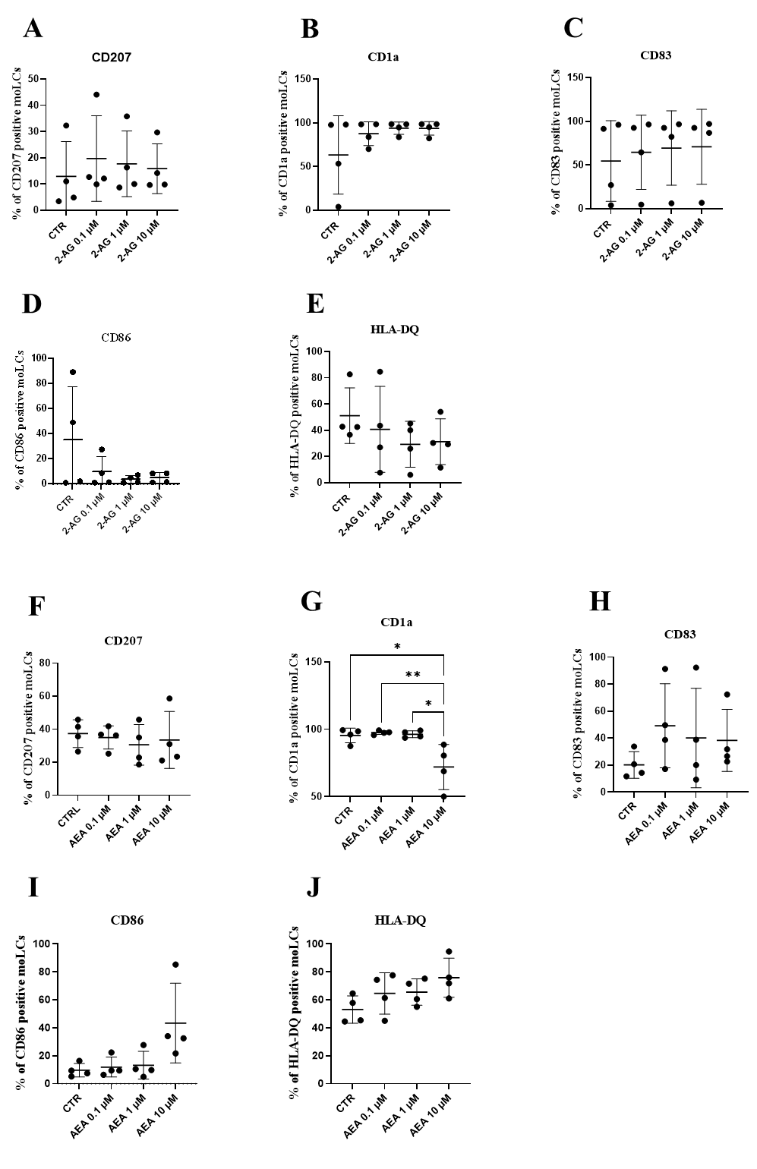
Supplementary Figures

Supplementary Figure 1. Broad concentration spectrum (0.1 - 10 µM) effects of anandamide and 2-AG on differentiation and maturation markers
Monocytes were cultured in the presence of GM-CSF, TNFα, TGFβ and IL-4 (for 48 hrs) for 5 days to generate moLCs in the presence of 0.1, 1, 10 µM 2-AG, 0.1, 1, 10 µM AEA, vehicle (0.1 v/v% absolute ethanol). N=4, lines mark mean±SD. Percentage of cells positive for CD207 (A, F), CD1a (B, G), CD83 (C, H), CD86 (D, I), HLA-DQ (E, J), following the indicated treatments.
*p < 0.05, ** p < 0.01, as indicated (determined by repeated measures one-way ANOVA). Individual donors are represented by symbols. CTRL: moLCs treated with 0.1 v/v% absolute ethanol, AEA: N-arachidonoylethanolamine, anandamide, 2-AG: 2-Arachidonoylglycerol

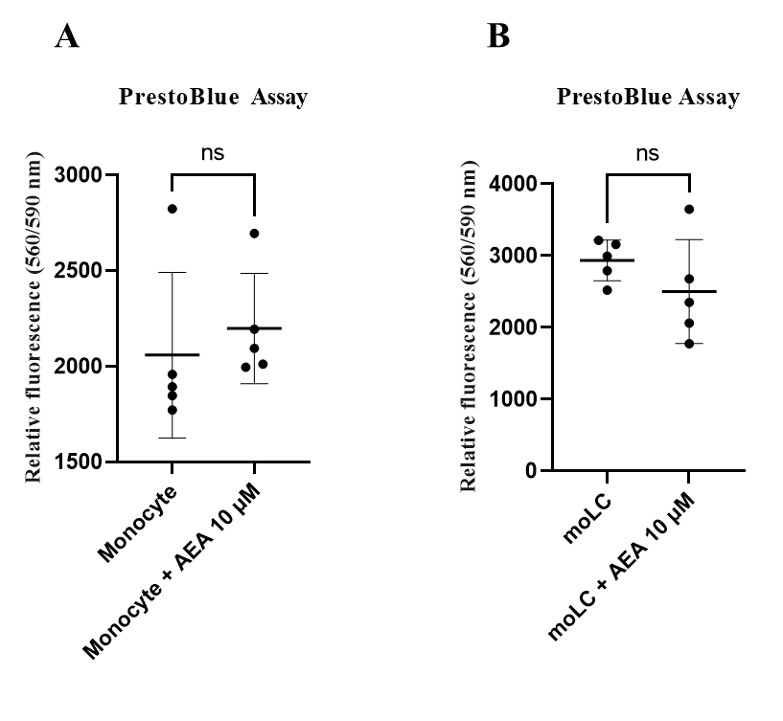
Supplementary Figure 2. Anandamide do not decrease viability of monocytes and moLCs.
Monocytes were cultured for 1 day without any added cytokines (monocytes), or for 5 days in the presence of GM-CSF, TNFα, TGFβ and IL-4 (for 48 hrs) to generate moLCs in the presence of 10 µM AEA, vehicle (0.1 v/v% absolute ethanol). N=5, lines mark mean±SD. Determination of monocytes viability (A) and moLCs viability by PrestoBlue Assay (B). Individual donors are represented by symbols. Monocytes and moLCs treated with 0.1 v/v% absolute ethanol, AEA: N-arachidonoylethanolamine, anandamide.

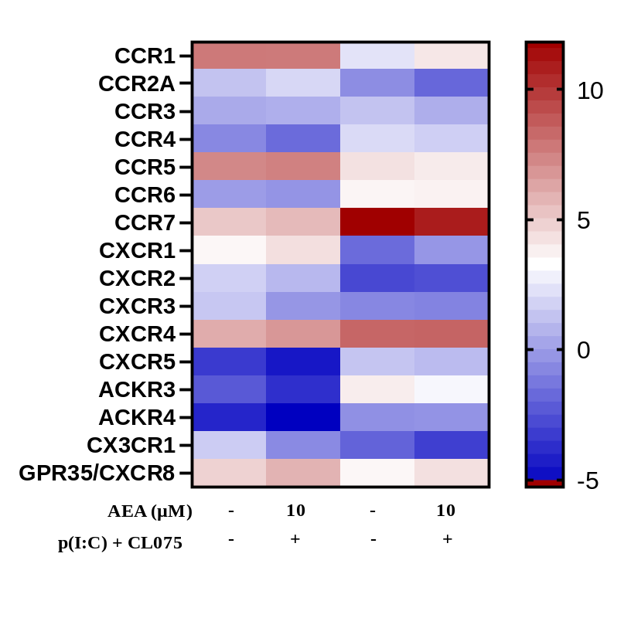
Supplementary Figure 3. Heatmap of chemokine receptors expressed on moLCs.
Monocytes were cultured in the presence of GM-CSF, TNFα, TGFβ and IL-4 (for 48 hrs) for 5 days to generate moLCs in the presence of 10 µM AEA, vehicle (0.1 v/v% absolute ethanol). Maturation was induced on day 4 by p(I:C) (20 µg/ml) and CL075 (0.5 µg/ml), both applied for 24 hours. N≥3 mean±SD. Heatmap shows expression of chemokine receptors. Monocytes and moLCs treated with 0.1 v/v% absolute ethanol, AEA: N-arachidonoylethanolamine, anandamide. AEA: N-arachidonoylethanolamine, anandamide, CL075: TLR7/8 agonist, p(I:C): Polyinosinic:polycytidylic acid, TLR3 agonist

