Supplementary Material
Long-term consequences of prenatal saccharin exposure: evidence of sex-specific molecular programming in the prefrontal cortex and behavior of adolescent rats
Beatriz Pacheco-Sánchez^{# 1,2}, Raquel López-Merchán^{#2}, Pablo Rubio², Pilar Martos³, Juan Suárez^{2,3}, Carlos Sanjuan⁴, Leticia Rubio^{2,3}, Stella Martin-de-las-Heras^{2,3}, Fernando Rodríguez de Fonseca^{2,5}, Francisco Alén⁶, Marialuisa de Ceglia^{1,2*}, Patricia Rivera^{2,8*}

Supplementary Figures and Tables
Table 1: Taqman® Gene Expression Assay IDs.
Gene symbol | Assay ID | Amplicon length (bp)
Actb | Rn00667869_m1 | 91
Cnr1 | Rn02758689_s1 | 92
Cnr2 | Rn01637601_m1 | 68
Napepld | Rn01786262_m1 | 71
Faah | Rn00577086_m1 | 63
Daglα | Rn01454304_m1 | 67
Daglβ | Rn01453770_m1 | 57
Mgll | Rn00593297_m1 | 78
Gpr55 | Rn03037213_s1 | 143
Grin1 | Rn01436034_m1 | 73
Grin2a | Rn00561341_m1 | 78
Grin2b | Rn00680474_m1 | 90
Grin2c | Rn00561359_m1 | 57
Gria1 | Rn00709588_m1 | 85
Gria2 | Rn00568514_m1 | 122
Gria3 | Rn00583547_m1 | 75
Gria4 | Rn00568544_m1 | 76
Grm3 | Rn01755349_m1 | 150
Grm5 | Rn00566628_m1 | 112
Gabra1 | Rn00788315_m1 | 75
Gabra2 | Rn01413643_m1 | 123
Gabrb1 | Rn00564146_m1 | 81
Gabrb2 | Rn00564149_m1 | 64
Gabrg1 | Rn00589841_m1 | 73
Gabrg2 | Rn01464079_m1 | 78
Gabbr1 | Rn00578911_m1 | 113
Gabbr2 | Rn00582550_m1 | 87
Insr | Rn00690703_m1 | 68
Irs1 | Rn02132493_s1 | 147
Irs2 | Rn01482270_s1 | 61

Table 2: Antibodies used for protein expression by Western blotting.
Antibody | Manufacturer and Catalogue Number | Host | Dilution
Adaptin | BD Biosciences 610385 | Mouse | 1/2000
IRS1 | Sigma Aldrich #06-248 | Rabbit | 1/10000
p-IRS1(Ser612) | Cell Signaling #3203 | Rabbit | 1/1000
p-IRS1(Tyr896) | Abcam #ab46800 | Rabbit | 1/500
PI3K | Cell Signaling #4257 | Rabbit | 1/1000
p-PI3K-p85(Tyr607) | Abcam #ab182651 | Rabbit | 1/1000
AKT | Cell Signaling #9272 | Rabbit | 1/1000
p-AKT(Ser473) | Santa Cruz #sc-16646R | Rabbit | 1/1000
GSK3β | Cell Signaling #12456 | Rabbit | 1/1000
p-GSK3β(Ser9) | Cell Signaling #5558 | Rabbit | 1/1000

Table 3: Two-way ANOVA details for open field test.
 | Factor | F (df) | p | Post-hoc test
OF Locomotion | Interaction | F (1, 28) = 0,132 | p=0,719 | Tukey
OF Locomotion | Sex | F (1, 28) = 1,395 | p=0,247
OF Locomotion | Treatment | F (1, 28) = 0,514 | p=0,479
OF Center | Interaction | F (1, 28) = 0,183 | p=0,672 | Fisher
OF Center | Sex | F (1, 28) = 0,267 | p=0,610
OF Center | Treatment | F (1, 28) = 7,644 | p=0,010
OF Periphery | Interaction | F (1, 28) = 1,372 | p=0,251 | Tukey
OF Periphery | Sex | F (1, 28) = 0,251 | p=0,620
OF Periphery | Treatment | F (1, 28) = 0,212 | p=0,649
Time spent in periphery (per minute) | Time | F (1,243, 34,79) = 1,736 | p=0,1972 | Tukey
Time spent in periphery (per minute) | Treatment | F (1, 28) = 0,2132 | p=0,6478
Time spent in periphery (per minute) | Sex | F (1, 28) = 0,2510 | p=0,6203
Time spent in periphery (per minute) | Time x Treatment | F (4, 112) = 0,4773 | p=0,7523
Time spent in periphery (per minute) | Time x Sex | F (4, 112) = 0,2065 | p=0,9344
Time spent in periphery (per minute) | Treatment x Sex | F (1, 28) = 1,373 | p=0,2512
Time spent in periphery (per minute) | Time x Treatment x Sex | F (4, 112) = 1,847 | p=0,1249
Time spent in center (per minute) | Time | F (2,425, 67,90) = 2,434 | p=0,0847 | Fisher
Time spent in center (per minute) | Treatment | F (1, 28) = 7,644 | p=0,0100
Time spent in center (per minute) | Sex | F (1, 28) = 0,2667 | p=0,6096
Time spent in center (per minute) | Time x Treatment | F (4, 112) = 1,050 | p=0,3847
Time spent in center (per minute) | Time x Sex | F (4, 112) = 1,886 | p=0,1179
Time spent in center (per minute) | Treatment x Sex | F (1, 28) = 0,1831 | p=0,6720
Time spent in center (per minute) | Time x Treatment x Sex | F (4, 112) = 0,7000 | p=0,5935

Table 4: Two-way ANOVA details for elevated plus maze test.
 | Factor | F (df) | p | Post hoc test
EPM Locomotion | Interaction | F (1, 28) = 1,276 | p=0,269 | Tukey
EPM Locomotion | Sex | F (1, 28) = 1,232 | p=0,277
EPM Locomotion | Treatment | F (1, 28) = 2,236 | p=0,147
EPM closed arms | Interaction | F (1, 28) = 1,392 | p=0,249 | Tukey
EPM closed arms | Sex | F (1, 28) = 0,036 | p=0,850
EPM closed arms | Treatment | F (1, 28) = 0,017 | p=0,897
EPM open arms | Interaction | F (1, 28) = 0,164 | p=0,689 | Tukey
EPM open arms | Sex | F (1, 28) = 0,215 | p=0,647
EPM open arms | Treatment | F (1, 28) = 0,315 | p=0,580
EPM total entries | Interaction | F (1, 28) = 2,871 | p=0,103 | Tukey
EPM total entries | Sex | F (1, 28) = 0,379 | p=0,538
EPM total entries | Treatment | F (1, 28) = 3,637 | p=0,068
EPM closed entries | Interaction | F (1, 28) = 1,460 | p=0,238 | Tukey
EPM closed entries | Sex | F (1, 28) = 1,066 | p=0,312
EPM closed entries | Treatment | F (1, 28) = 2,433 | p=0,131
EPM open entries | Interaction | F (1, 28) = 2,991 | p=0,096 | Tukey
EPM open entries | Sex | F (1, 28) = 0,290 | p=0,595
EPM open entries | Treatment | F (1, 28) = 2,658 | p=0,116
EPM open arms latency | Interaction | F (1, 28) = 3,101 | p=0,090 | Tukey
EPM open arms latency | Sex | F (1, 28) = 2,419 | p=0,132
EPM open arms latency | Treatment | F (1, 28) = 1,567 | p=0,222

Table 5: Two-way ANOVA details for gene and protein expression of the insulin pathway.
 | Factor | F (df) | p | Post hoc test
Insr | Interaction | F (1, 28) = 1,820 | p=0,1881 | Tukey
Insr | Sex | F (1, 28) = 0,05411 | p=0,8177
Insr | Treatment | F (1, 28) = 1,353 | p=0,2546
Irs1 | Interaction | F (1, 28) = 2,084 | p=0,1600 | Tukey
Irs1 | Sex | F (1, 28) = 1,875 | p=0,1817
Irs1 | Treatment | F (1, 28) = 1,875 | p=0,1817
Irs2 | Interaction | F (1, 28) = 0,08813 | p=0,7688 | Tukey
Irs2 | Sex | F (1, 28) = 1,513 | p=0,2290
Irs2 | Treatment | F (1, 28) = 0,01619 | p=0,8997
p-IRS1(Tyr896) | Interaction | F (1, 20) = 7,236 | p=0,0141 | Tukey
p-IRS1(Tyr896) | Sex | F (1, 20) = 5,588 | p=0,0283
p-IRS1(Tyr896) | Treatment | F (1, 20) = 0,3256 | p=0,5746
p-IRS1(Ser612) | Interaction | F (1, 20) = 4,423 | p=0,0483 | Tukey
p-IRS1(Ser612) | Sex | F (1, 20) = 4,658 | p=0,0432
p-IRS1(Ser612) | Treatment | F (1, 20) = 0,5176 | p=0,4802
total IRS1 | Interaction | F (1, 20) = 6,722 | p=0,0174 | Tukey
total IRS1 | Sex | F (1, 20) = 6,042 | p=0,0232
total IRS1 | Treatment | F (1, 20) = 0,5998 | p=0,4477
p-PI3K(Tyr607) | Interaction | F (1, 20) = 1,101 | p=0,3066 | Fisher
p-PI3K(Tyr607) | Sex | F (1, 20) = 8,109 | p=0,0100
p-PI3K(Tyr607) | Treatment | F (1, 20) = 1,230 | p=0,2806
total PI3K | Interaction | F (1, 20) = 0,2388 | p=0,6304 | Tukey
total PI3K | Sex | F (1, 20) = 0,9552 | p=0,3401
total PI3K | Treatment | F (1, 20) = 0,01493 | p=0,9040
p-AKT(Ser473) | Interaction | F (1, 20) = 3,786 | p=0,0659 | Fisher
p-AKT(Ser473) | Sex | F (1, 20) = 64,41 | p<0,0001
p-AKT(Ser473) | Treatment | F (1, 20) = 10,38 | p=0,0043
total AKT | Interaction | F (1, 20) = 16,30 | p=0,0006 | Tukey
total AKT | Sex | F (1, 20) = 24,11 | p<0,0001
total AKT | Treatment | F (1, 20) = 14,58 | p=0,0011
p-GSK3β(Ser9) | Interaction | F (1, 20) = 2,133 | p=0,1597 | Fisher
p-GSK3β(Ser9) | Sex | F (1, 20) = 2,996 | p=0,0989
p-GSK3β(Ser9) | Treatment | F (1, 20) = 0,2926 | p=0,5945
total GSK3β | Interaction | F (1, 20) = 3,904 | p=0,0621 | Fisher
total GSK3β | Sex | F (1, 20) = 4,819 | p=0,0401
total GSK3β | Treatment | F (1, 20) = 1,205 | p=0,2854

Table 6: Two-way ANOVA details for gene expression of the endocannabinoid system.
 | Factor | F (df) | P | Post hoc test
Cnr1 | Interaction | F (1, 28) = 1,546 | p=0,2240 | Tukey
Cnr1 | Sex | F (1, 28) = 1,278 | p=0,2679
Cnr1 | Treatment | F (1, 28) = 0,2045 | p=0,6546
Cnr2 | Interaction | F (1, 28) = 0,02649 | p=0,8719 | Fisher
Cnr2 | Sex | F (1, 28) = 0,1060 | p=0,7472
Cnr2 | Treatment | F (1, 28) = 6,282 | p=0,0183
Gpr55 | Interaction | F (1, 28) = 1,029 | p=0,3190 | Fisher
Gpr55 | Sex | F (1, 28) = 0,8013 | p=0,3783
Gpr55 | Treatment | F (1, 28) = 5,794 | p=0,0229
Dagla | Interaction | F (1, 28) = 3,146 | p=0,0870 | Tukey
Dagla | Sex | F (1, 28) = 3,486 | p=0,0724
Dagla | Treatment | F (1, 28) = 2,231 | p=0,1465
Daglb | Interaction | F (1, 28) = 13,16 | p=0,0011 | Tukey
Daglb | Sex | F (1, 28) = 3,032 | p=0,0926
Daglb | Treatment | F (1, 28) = 0,1895 | p=0,6667
Mgll | Interaction | F (1, 28) = 4,860 | p=0,0359 | Tukey
Mgll | Sex | F (1, 28) = 0,7052 | p=0,4081
Mgll | Treatment | F (1, 28) = 0,01102 | p=0,9171
Napepld | Interaction | F (1, 28) = 0,3736 | p=0,5460 | Tukey
Napepld | Sex | F (1, 28) = 0,9091 | p=0,3485
Napepld | Treatment | F (1, 28) = 0,07233 | p=0,7900
Faah | Interaction | F (1, 28) = 6,205 | p=0,0189 | Tukey
Faah | Sex | F (1, 28) = 1,775 | p=0,1935
Faah | Treatment | F (1, 28) = 0,5671 | p=0,4577
Dagla/Mgll | Interaction | F (1, 27) = 0,05477 | p=0,8167 | Tukey
Dagla/Mgll | Sex | F (1, 27) = 1,028 | p=0,3195
Dagla/Mgll | Treatment | F (1, 27) = 2,197 | p=0,1499
Daglb/Mgll | Interaction | F (1, 27) = 0,08529 | p=0,7725 | Tukey
Daglb/Mgll | Sex | F (1, 27) = 1,147 | p=0,2937
Daglb/Mgll | Treatment | F (1, 27) = 0,7676 | p=0,3887
Napepld/Faah | Interaction | F (1, 26) = 1,940 | p=0,1755 | Tukey
Napepld/Faah | Sex | F (1, 26) = 2,308 | p=0,1407
Napepld/Faah | Treatment | F (1, 26) = 1,158 | p=0,2917

Table 7: Two-way ANOVA details for gene expression of glutamatergic transmission.
 | Factor | F (df) | P | Post hoc test
Grin1 | Interaction | F (1, 28) = 1,397 | p=0,2472 | Fisher
Grin1 | Sex | F (1, 28) = 2,688 | p=0,1123
Grin1 | Treatment | F (1, 28) = 4,722 | p=0,0384
Grin2a | Interaction | F (1, 28) = 8,026 | p=0,0085 | Tukey
Grin2a | Sex | F (1, 28) = 4,803 | p=0,0369
Grin2a | Treatment | F (1, 28) = 3,500 | p=0,0719
Grin2b | Interaction | F (1, 28) = 0,001414 | p=0,9703 | Tukey
Grin2b | Sex | F (1, 28) = 0,06931 | p=0,7943
Grin2b | Treatment | F (1, 28) = 0,03536 | p=0,8522
Grin2c | Interaction | F (1, 28) = 9,053 | p=0,0055 | Tukey
Grin2c | Sex | F (1, 28) = 11,51 | p=0,0021
Grin2c | Treatment | F (1, 28) = 1,807 | p=0,1896
Gria1 | Interaction | F (1, 28) = 11,91 | p=0,0018 | Tukey
Gria1 | Sex | F (1, 28) = 2,978 | p=0,0954
Gria1 | Treatment | F (1, 28) = 1,762 | p=0,1951
Gria2 | Interaction | F (1, 28) = 1,267e-030 | p>0,9999 | Tukey
Gria2 | Sex | F (1, 28) = 1,028 | p=0,3192
Gria2 | Treatment | F (1, 28) = 1,481 | p=0,2338
Gria3 | Interaction | F (1, 28) = 0,6465 | p=0,4281 | Tukey
Gria3 | Sex | F (1, 28) = 2,740 | p=0,1090
Gria3 | Treatment | F (1, 28) = 3,761 | p=0,0626
Gria4 | Interaction | F (1, 28) = 0,05145 | p=0,8222 | Fisher
Gria4 | Sex | F (1, 28) = 4,643 | p=0,0399
Gria4 | Treatment | F (1, 28) = 2,174 | p=0,1515
Grm3 | Interaction | F (1, 28) = 3,609 | p=0,0678 | Tukey
Grm3 | Sex | F (1, 28) = 0,04455 | p=0,8344
Grm3 | Treatment | F (1, 28) = 1,114 | p=0,3003
Grm5 | Interaction | F (1, 28) = 12,82 | p=0,0013 | Tukey
Grm5 | Sex | F (1, 28) = 2,424 | p=0,1307
Grm5 | Treatment | F (1, 28) = 0,8727 | p=0,3582

Table 8: Two-way ANOVA details for gene expression of GABAergic transmission.
 | Factor | F (df) | p | Post hoc test
Gabra1 | Interaction | F (1, 28) = 0,01420 | p=0,9060 | Tukey
Gabra1 | Sex | F (1, 28) = 0,8344 | p=0,3688
Gabra1 | Treatment | F (1, 28) = 0,03943 | p=0,8440
Gabra2 | Interaction | F (1, 28) = 0,5676 | p=0,4575 | Tukey
Gabra2 | Sex | F (1, 28) = 0,07704 | p=0,7834
Gabra2 | Treatment | F (1, 28) = 0,001572 | p=0,9687
Gabrb1 | Interaction | F (1, 28) = 0,5979 | p=0,4459 | Tukey
Gabrb1 | Sex | F (1, 28) = 0,09567 | p=0,7594
Gabrb1 | Treatment | F (1, 28) = 0,05381 | p=0,8182
Gabrb2 | Interaction | F (1, 28) = 0,03106 | p=0,8614 | Tukey
Gabrb2 | Sex | F (1, 28) = 0,01118 | p=0,9165
Gabrb2 | Treatment | F (1, 28) = 0,1006 | p=0,7534
Gabrg1 | Interaction | F (1, 28) = 5,573 | p=0,0254 | Tukey
Gabrg1 | Sex | F (1, 28) = 26,67 | p<0,0001
Gabrg1 | Treatment | F (1, 28) = 8,278 | p=0,0076
Gabrg2 | Interaction | F (1, 28) = 0,02260 | p=0,8816 | Tukey
Gabrg2 | Sex | F (1, 28) = 0,3616 | p=0,5525
Gabrg2 | Treatment | F (1, 28) = 0,05085 | p=0,8232
Gabbr1 | Interaction | F (1, 28) = 0,6400 | p=0,4304 | Tukey
Gabbr1 | Sex | F (1, 28) = 0,006400 | p=0,9368
Gabbr1 | Treatment | F (1, 28) = 0,6400 | p=0,4304
Gabbr2 | Interaction | F (1, 28) = 1,595 | p=0,2170 | Fisher
Gabbr2 | Sex | F (1, 28) = 20,02 | p=0,0001
Gabbr2 | Treatment | F (1, 28) = 15,69 | p=0,0005

Supplementary Figures
Supplementary Figure 1: Graphical representation of the methodology of the study
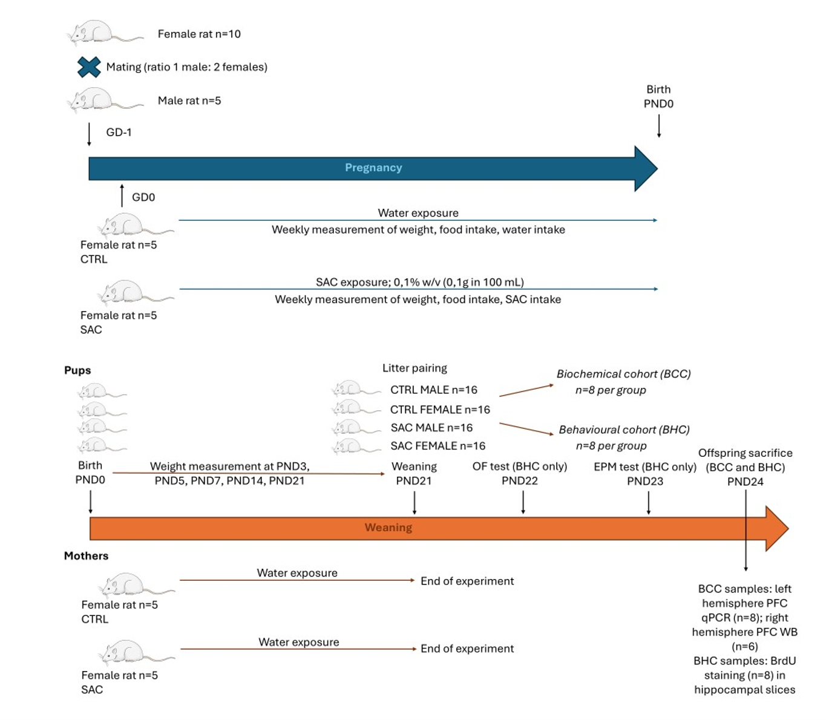
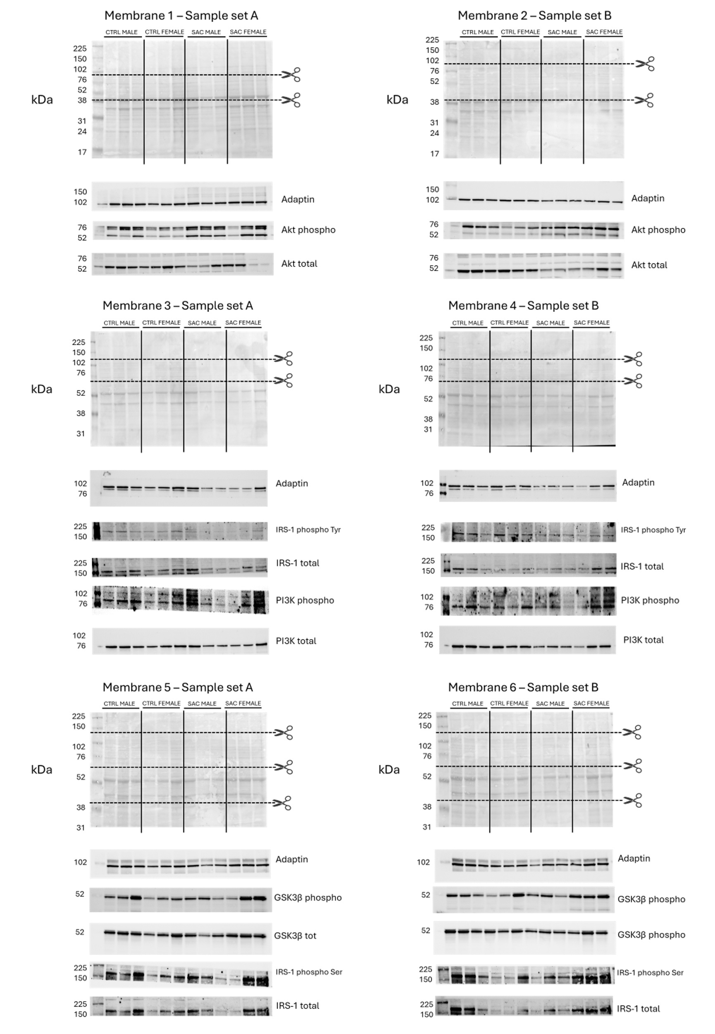
Supplementary Figure 2: Ponceau Red and constitutive bands for each gel

Supplementary Results:
  - Dams body weight during pregnancy
Supplementary Figure 3: Results of Dams body weight during pregnancy
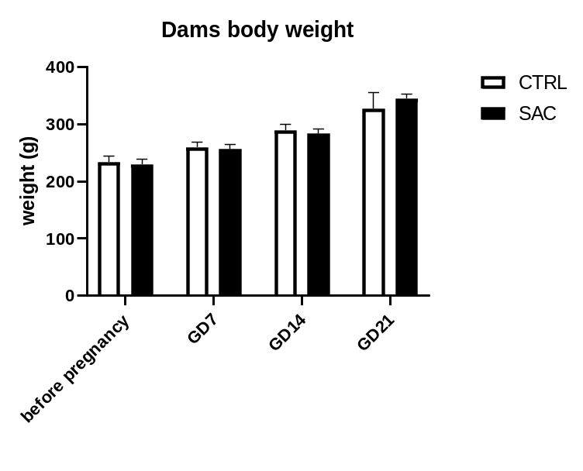
Body weight was measured in dams before pregnancy, and weekly during pregnancy. No significant variation was observed in dams body weight regardless of saccharin consumption.

  - Litter size and sex ratio
Litter sizes were 11.67±2.52 (SEM) for the control group and 11,6±4,78 for the saccharin group. Sex ratio was 42.9% males and 57.1% females in the control group and 43.1% males and 56.9% females in saccharin group.

  - Pups’ weight at PND3, PND7, PND14 and PND21
Supplementary Figure 4: Offspring weight at different time points after birth.
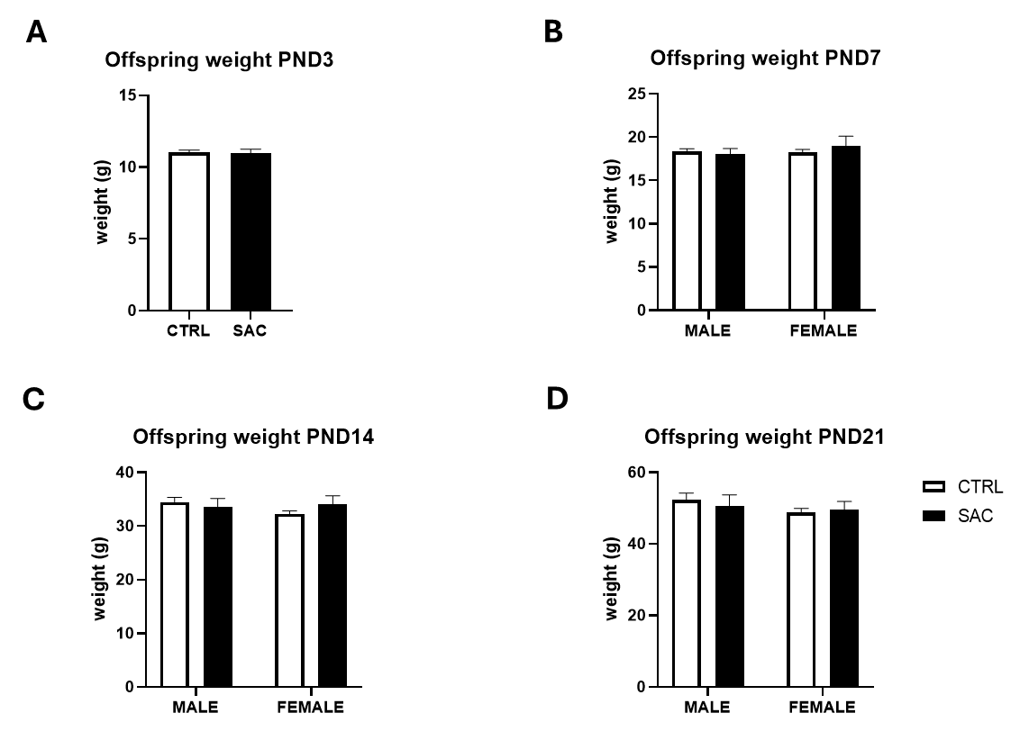
Animals were sexed on day 7. No significant difference was observed in the body weight of pups in any timepoint (One-way ANOVA (A); two-way ANOVA (B-D)).

  - Study of BrdU staining in the subventricular zone of hippocampus
Staining of BrdU in the hippocampus was made to assess the quantity of proliferating cells. BrdU was administered the day before sacrifice at a dosage of 100 mg/kg three times with a 3-hour interval between each administration. Anova shows a significant effect of treatment (p<0.05; F_{1,20}=6.556) but no significant effect of sex (F=2.786, p=0.36) or interaction (F=11.72; p=0.07); significant post-hoc as shown in figure (Fisher). Female offspring of saccharine-consuming mothers showed a significant decrease in BrdU staining when compared both to female controls and saccharine males; suggesting a reduction in cell proliferation in the subgranular zone of hippocampus. n=8 for each group.

Supplementary Figure 5: Results of BrdU staining quantification in the hippocampus

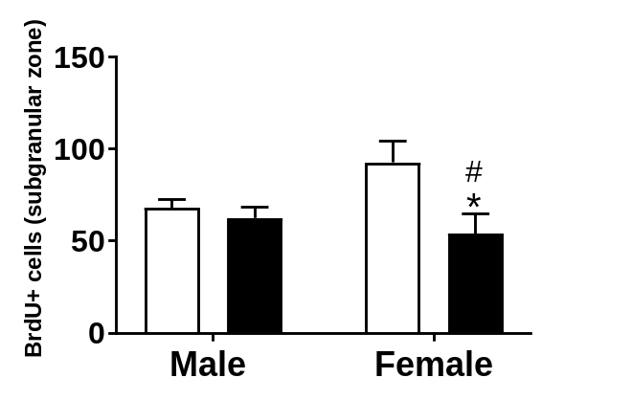

Supplementary Figure 6: Significant micrographs of BrdU staining realized at 10x.