Supplementary Material

A type II Cannabis extract and a 1:1 blend of Δ(9)-tetrahydrocannabinol and cannabidiol display distinct antinociceptive profiles and engage different endocannabinoid targets when administered into the subarachnoid space

Besma Benredjem*, Graciela Pineyro *
* Correspondence: Corresponding Author: besma.benredjem@umontreal.ca, graciela.pineyro.filpo@umontreal.ca

Supplementary Figures
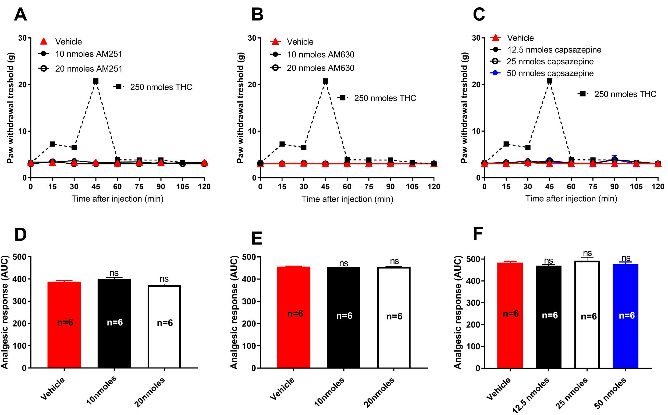
Supplementary Figure 1. Antagonists for membrane targets of cannabinoids do not modify baseline withdrawal thresholds. One week after administration of STZ, rats received i.t. injections of CB1R antagonist AM251 (A, B) CB2R antagonist AM630 (C, D) and TRPV1 antagonist capsazepine (E, F) at the indicated doses. The effect of THC (250 nmoles) is shown for comparison. Mechanical thresholds were assessed every 15 min after injection for a period of 120 min, thus allowing all responses to return to baseline. Histograms show AUC (mean ± SEM; n=6) corresponding to withdrawal thresholds integrated over 120 min and expressed in arbitrary units. One-way ANOVA followed by Sidak’s multiple comparisons test indicated no significant effect of (B) AM251 at 10 nmoles (p=0.2068) or 20 nmoles (p=0.1000); (D) AM630 at 10 nmoles (p=0.1393) or 20 nmoles (p=0.8466) and (D) capsazepine at 12.5 nmoles (p=0.6469) 25 nmoles (p=0.8946) or 50 nmoles (p=0.9100).

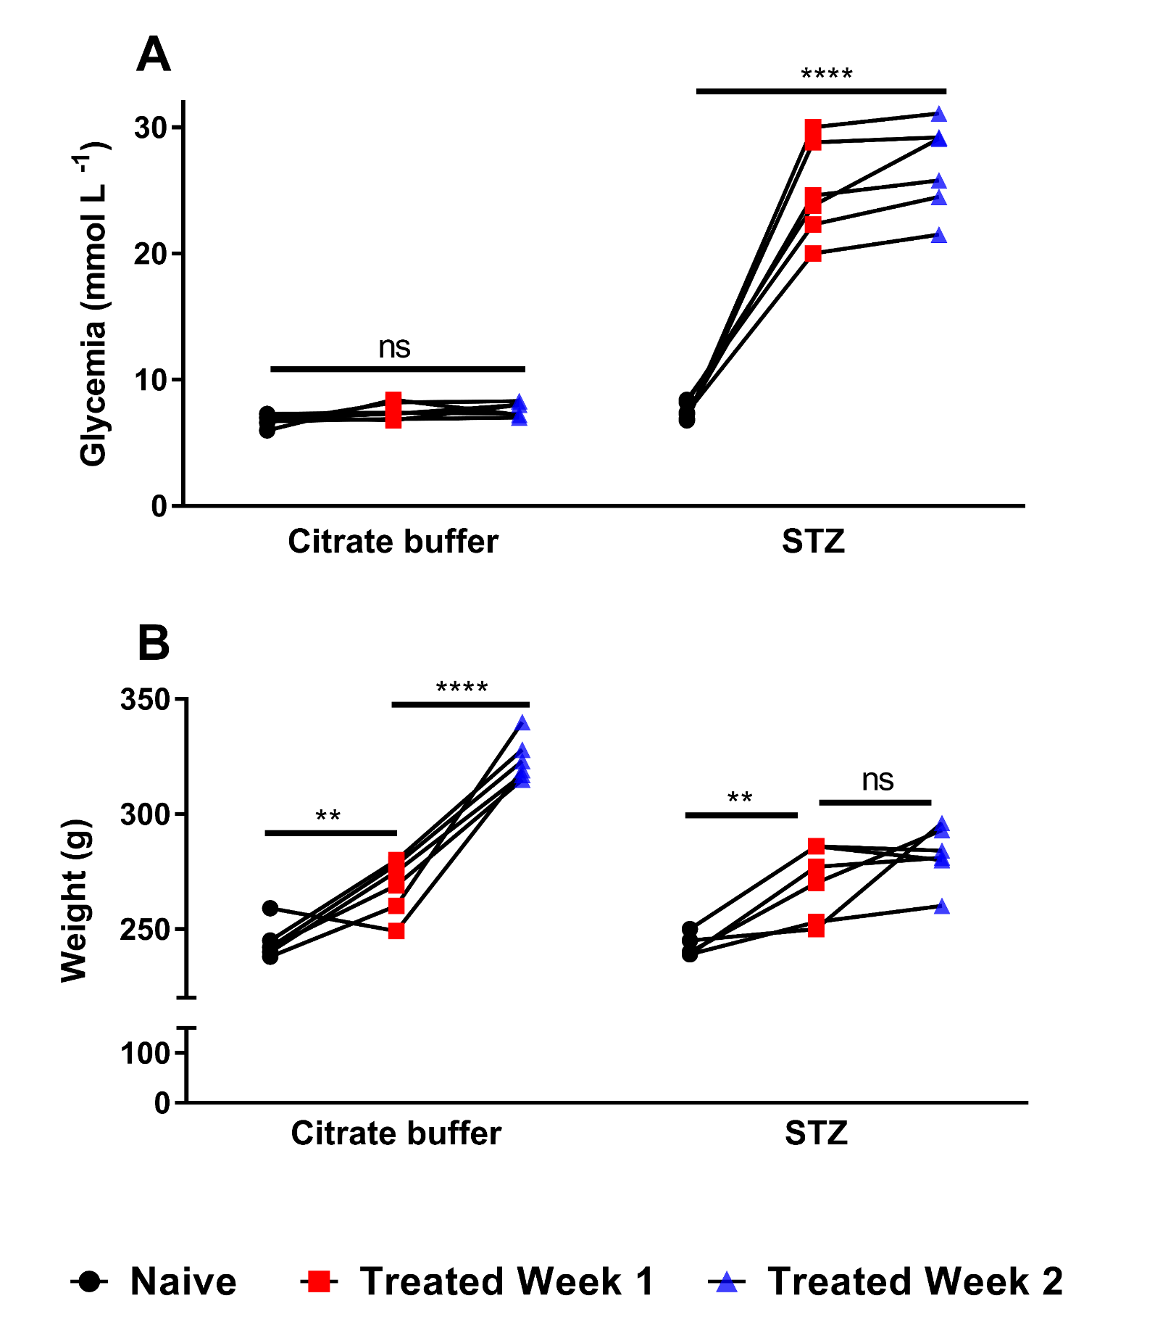
Supplementary Figure 2. Evolution of non-fasting glycemia and body weight in type 1 diabetic rats. (A) Non-fasting glycemia was measured before (naïve; black circles, n=6), one week (red squares, n=6) and two weeks (blue triangles, n=6) after the injection of vehicle (Citrate buffer) or Streptozotocin (STZ), as indicated. Statistical significance of STZ-induced changes in blood glucose levels was evaluated using two-way ANOVA, which showed an effect of treatment F (1,30) = 291.10 (p < 0.0001) an effect of time F (2,30) = 77.41 (p < 0.0001) and an interaction F (2,30) = 64.98 (p < 0.0001). Tukey’s post-hoc test indicated a significant increase in glucose levels one and two weeks after STZ but not after citrate injection (p < 0.0001). Sidaks’s post-hoc test showed a significant increase in glucose levels = 64.98 (p < 0.0001), following STZ injection (p < 0.0001). (B) Body weight was evaluated before (naïve; black circles, n=6), one week (red squares, n=6) and two weeks (blue triangles, n=6) after vehicle (Citrate buffer) or Streptozotocin (STZ) treatments, as indicated. Statistical significance of STZ-induced changes in body weight was evaluated by two-way ANOVA, which showed an effect of treatment F (1, 30) = 13.23 (p = 0.001), an effect of time F (2, 30) = 86.68 (p < 0.0001) and an interaction F (2, 30) = 14.62 (p < 0.0001). At week one, Sidaks’s post-hoc test showed a significant increase in body weight following injection of both citrate buffer (p < 0.01) and STZ (p < 0.01). During the second week, the citrate buffer treatment group continued to show a significant increase in body weight compared to week 1 (p<0.0001), but this was not the case for the STZ treatment group (p=0.6547).

Supplementary Tables

Supplementary Table 1. Vehicles used to assess analgesia induced by different doses of cannabinoids (*).
Vehicle used | Administered treatment
(1) 5% DMSO, 5% Cremophor | WIN 55, 212-2 (0.2- 60 nmoles)
(2) 15% ethanol, 7.5% Cremophor | THC, CBD (95-480 nmoles); Extract (95-250 nmoles)
(3) 25% ethanol, 7.5% Cremophor | Extract (480-725 nmoles); THC, CBD (725 nmoles)
(4) 32 % ethanol, 7.5% Cremophor | THC:CBD (95-480 nmoles)
(5) 48 % ethanol, 7.5% Cremophor | THC:CBD (725 nmoles)

(*) Vehicles used contained the minimal amount of ethanol that allowed for product dilution at increasing concentrations.

Supplementary Table 2. Vehicles used to assess analgesia induced by different cannabinoids had no effect on basal withdrawal thresholds (*).
 | Paw Withdrawal Threshold (g)
Treatments | Mean | SEM
Streptozotocin (n=5) | 3.30 | 0.17
(1) Vehicle (5% DMSO / 5% Cremophor) (n=5) | 3.66 | 0.26
(2) Vehicle (11.6% Ethanol / 7.5% Cremophor) (n=5) | 3.26 | 0.11
(3) Vehicle (24% Ethanol / 7.5% Cremophor) (n=5) | 3.37 | 0.18
(4) Vehicle (31.7% Ethanol / 7.5% Cremophor) (n=5) | 3.26 | 0.11
(5) Vehicle (48% Ethanol / 7.5% Cremophor) (n=5) | 3.40 | 0.17

(*) Note that despite lack of effects on thresholds, vehicles used contained the minimal amount of ethanol that allowed for product dilution at increasing concentrations.
Baseline measurement of mechanical sensitivity were taken 1 week following Streptozotocin administration (STZ, 50 mg·kg⁻¹ per injection). Rats then received i.t. injections of indicated vehicle and mechanical thresholds were assessed every 15 min for 120 min. The mean withdrawal threshold (± SEM) over this time period was calculated for each vehicle and compared to the mean withdrawal threshold obtained in STZ rats that received no treatment. Statistical significance of vehicle-induced changes in mechanical allodynia as compared to non-injected STZ rats was evaluated by one-way ANOVA, which showed no effect of vehicle (p=0.5886).

Supplementary Table 3. Vehicles used to assess how CB1, CB2 and TRPV1 blockers interfered with analgesia induced by different cannabinoid treatments.

Vehicles used | Antagonist/cannabinoid combination tested
1) VhAnt (2.5% DMF/5% Cremophor) +  VhTreat (5% DMSO/5% Cremophor) | AM630 (10nmoles) + WIN55212 (20 nmoles)
2) VhAnt (5% Ethanol/5% Cremophor) +  VhTreat (5% DMSO/5% Cremophor) | AM251(10 nmoles) + WIN55212 (20 nmoles)  CPZ (50 nmoles) + WIN55212 (20 nmoles)
3) VhAnt (5% DMF/5% Cremophor) +  VhTreat (25% Ethanol% /7.5%Cremophor) | AM630 (10 nmoles) + THC/Extract (250-480 nmoles)  AM630 (20 nmoles) + CBD (725 nmoles)
4) VhAnt (5% Ethanol/5% Cremophor) +  VhTreat (25% Ethanol% /7.5%Cremophor) | AM251 (10 nmoles) + THC/Extract (250-480 nmoles)  AM251 (20 nmoles) + CBD (725 nmoles)  CPZ (12.5-50 nmoles) + THC/Extract (250-480 nmoles)  CPZ (25-50 nmoles) + CBD (725 nmoles)
5) VhAnt (5% DMF/5% Cremophor) +  VhTreat (32% Ethanol% /7.5%Cremophor) | AM630 (10 nmoles) + THC-CBD (480 nmoles)
6) VhAnt (5% Ethanol/5% Cremophor) +  VhTreat (25% Ethanol% /7.5%Cremophor) | AM251 (10 nmoles) + THC-CBD (480 nmoles)  CPZ (25-50 nmoles) + THC-CBD (480 nmoles)

Supplementary Table 4. Vehicles used in experiments assessing the effect of CB1, CB2 and TRPV1 blockers on cannabinoid analgesia had no effect on basal withdrawal thresholds (*).
 | Paw Withdrawal Threshold (g)
Treatments | Mean | SEM
STZ (n=6) | 3.14 | 0.12
1) Vh_{Ant} (2.5% DMF) + Vh_{Treat} (5% DMSO) (n=6) | 3.06 | 0.02
2) Vh_{Ant} (5% Ethanol) + Vh_{Treat} (5% DMSO) (n=6) | 3.11 | 0.03
3) Vh_{Ant} (5% DMF) + Vh_{Treat} (25 % Ethanol) (n=6) | 3.03 | 0.01
4) Vh_{Ant} (5% Ethanol) + Vh_{Treat} (25 % Ethanol) (n=6) | 3.15 | 0.04
5) Vh_{Ant} (5% DMF) + Vh_{Treat} (32 % Ethanol) (n=6) | 3.03 | 0.01
6) Vh_{Ant} (5% Ethanol) + Vh_{Treat} (32 % Ethanol) (n=6) | 3.12 | 0.02

(*) Note that despite lack of effects on thresholds, vehicles used contained the minimal amount of ethanol that allowed for product dilution at increasing concentrations.
Baseline measurement of mechanical sensitivity were taken 1 week following Streptozotocin administration (STZ, 50 mg·kg⁻¹ per injection, n=6). Rats then received i.t. injections of vehicle for different antagonists (Vh_{Ant}), and 30 min later the vehicle for different active treatments (Vh_{Treat}). Mechanical thresholds were assessed every 15 min for 120 min following administration of the vehicle for treatment (Vh_{Treat}). The mean withdrawal threshold (± SEM) over this time period was calculated for each vehicle pair and compared to the mean withdrawal threshold obtained in STZ rats that received no treatment. Statistical significance of vehicle-induced changes in mechanical allodynia as compared to non-injected STZ rats was evaluated by one-way ANOVA, which showed no effect of vehicle (p=0.4093).

