Study period
Vaccine acceptance (%)
Event rate (%)

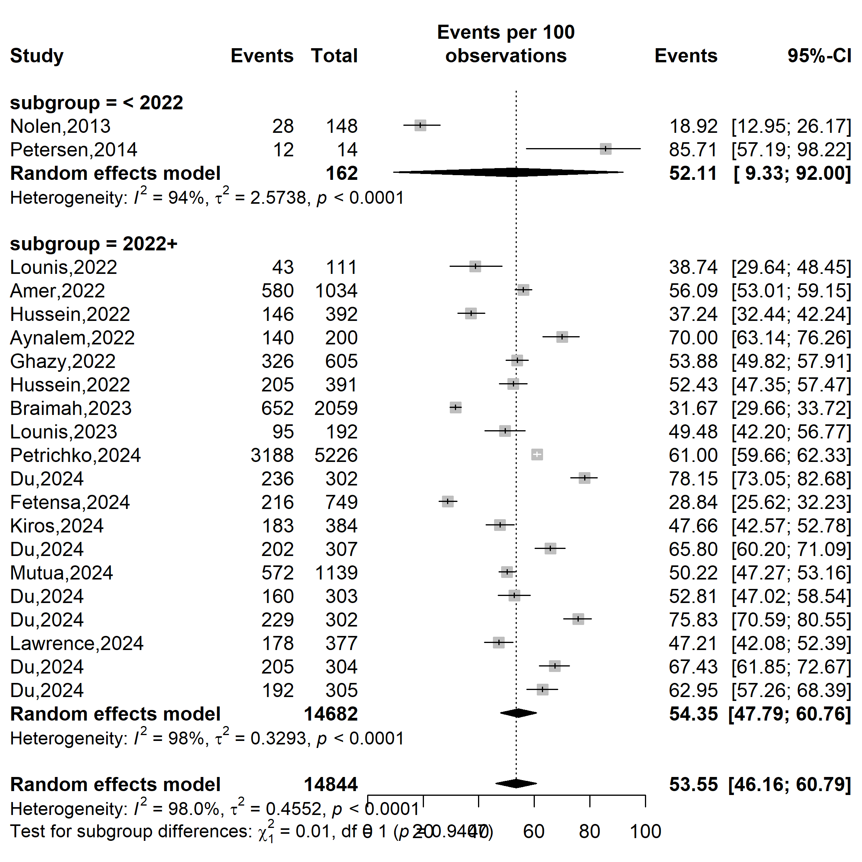
Supplementary Fig. 1 Pooled Mpox vaccine acceptance rate by study periods in Africa, 2013-2024

Country
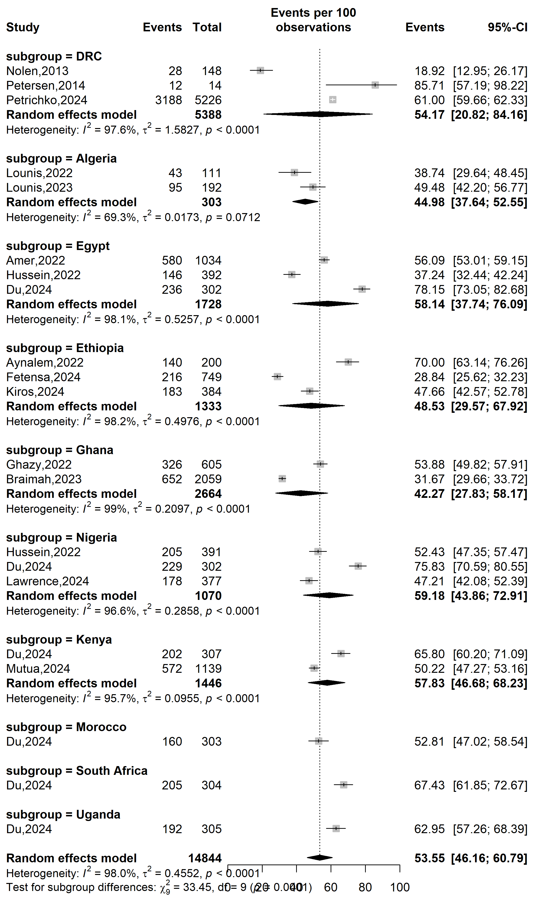
Event rate (%)

Vaccine acceptance (%)
Supplementary Fig. 2 Pooled Mpox vaccine acceptance rate by countries in Africa, 2013-2024
Abbreviation: DRC: Democratic Republic of Congo
Type of participants
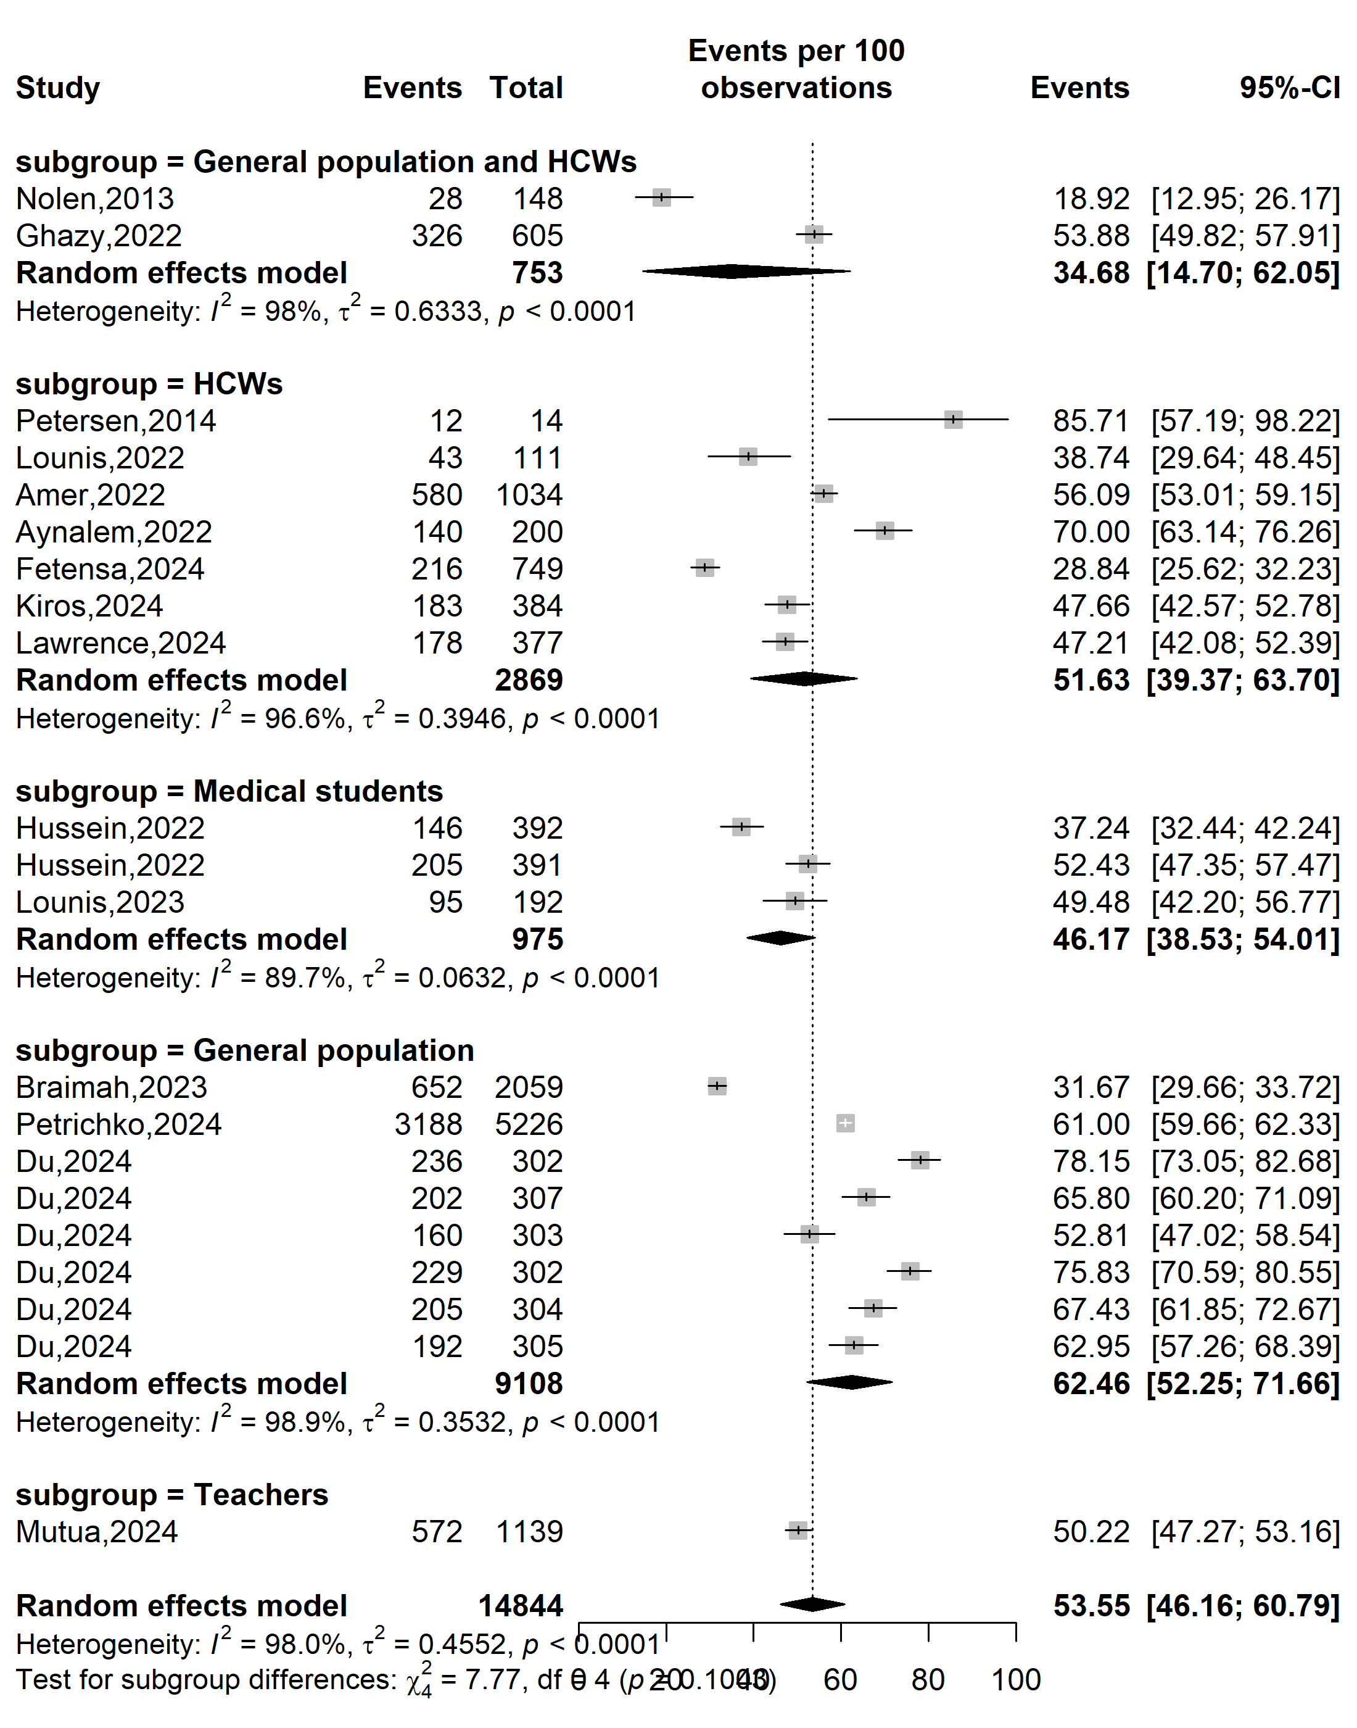
Vaccine acceptance (%)
Event rate (%)

Supplementary Fig. 3 Pooled Mpox vaccine acceptance rate in Africa by types of participants, 2013-2024
Abbreviation: HCW: Healthcare worker

WHO category
Vaccine acceptance (%)
Event rate (%)

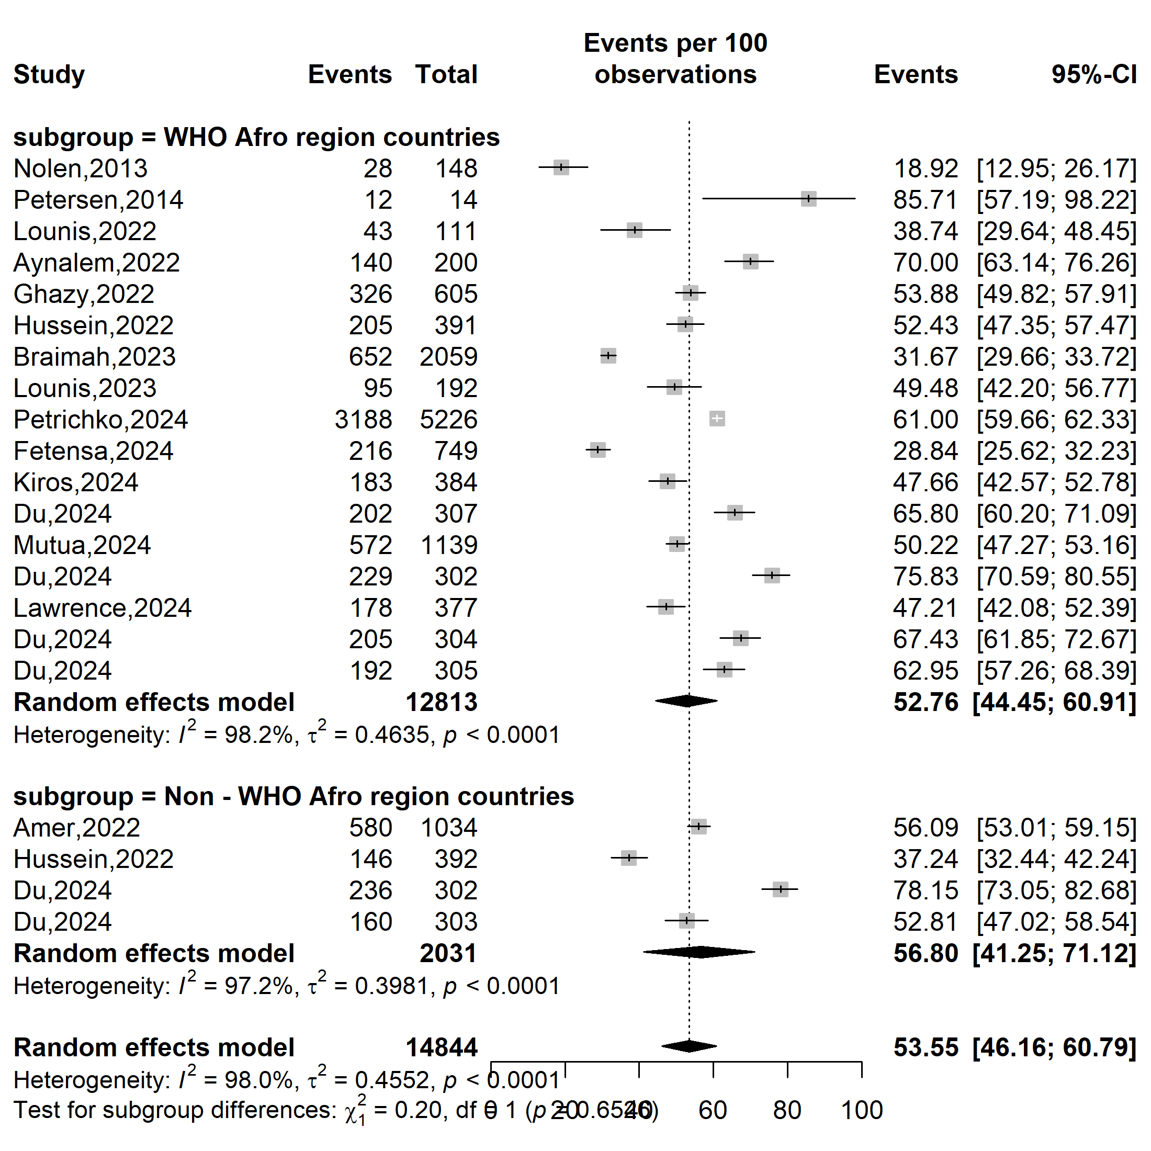
Supplementary Fig. 4 Pooled Mpox vaccine acceptance rate in Africa by WHO’s country categorization, 2013-2024

WHO Afro zone
Event rate (%)

Vaccine acceptance (%)
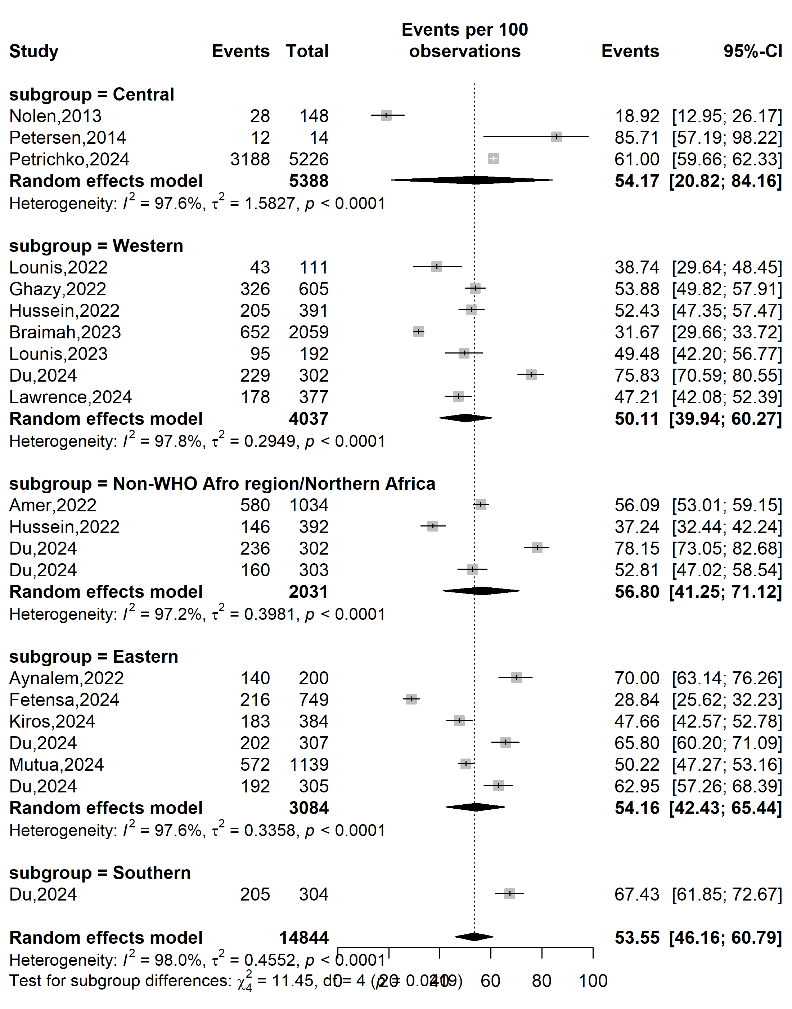
Supplementary Fig. 5 Pooled Mpox vaccine acceptance rate in Africa by WHO’s Afro zone, 2013-2024

Setting
Event rate (%)

Vaccine acceptance (%)
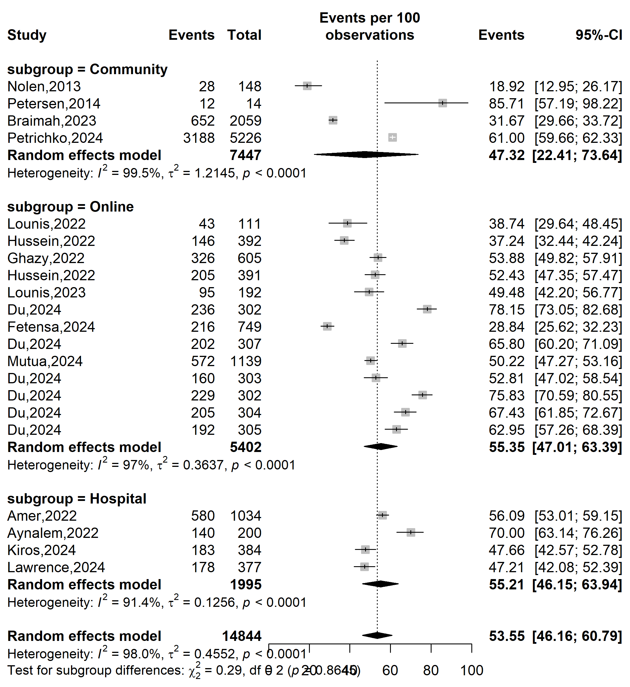
Supplementary Fig. 6 Pooled Mpox vaccine acceptance rate in Africa by study setting, 2013-2024

Type sampling
Event rate (%)

Vaccine acceptance (%)
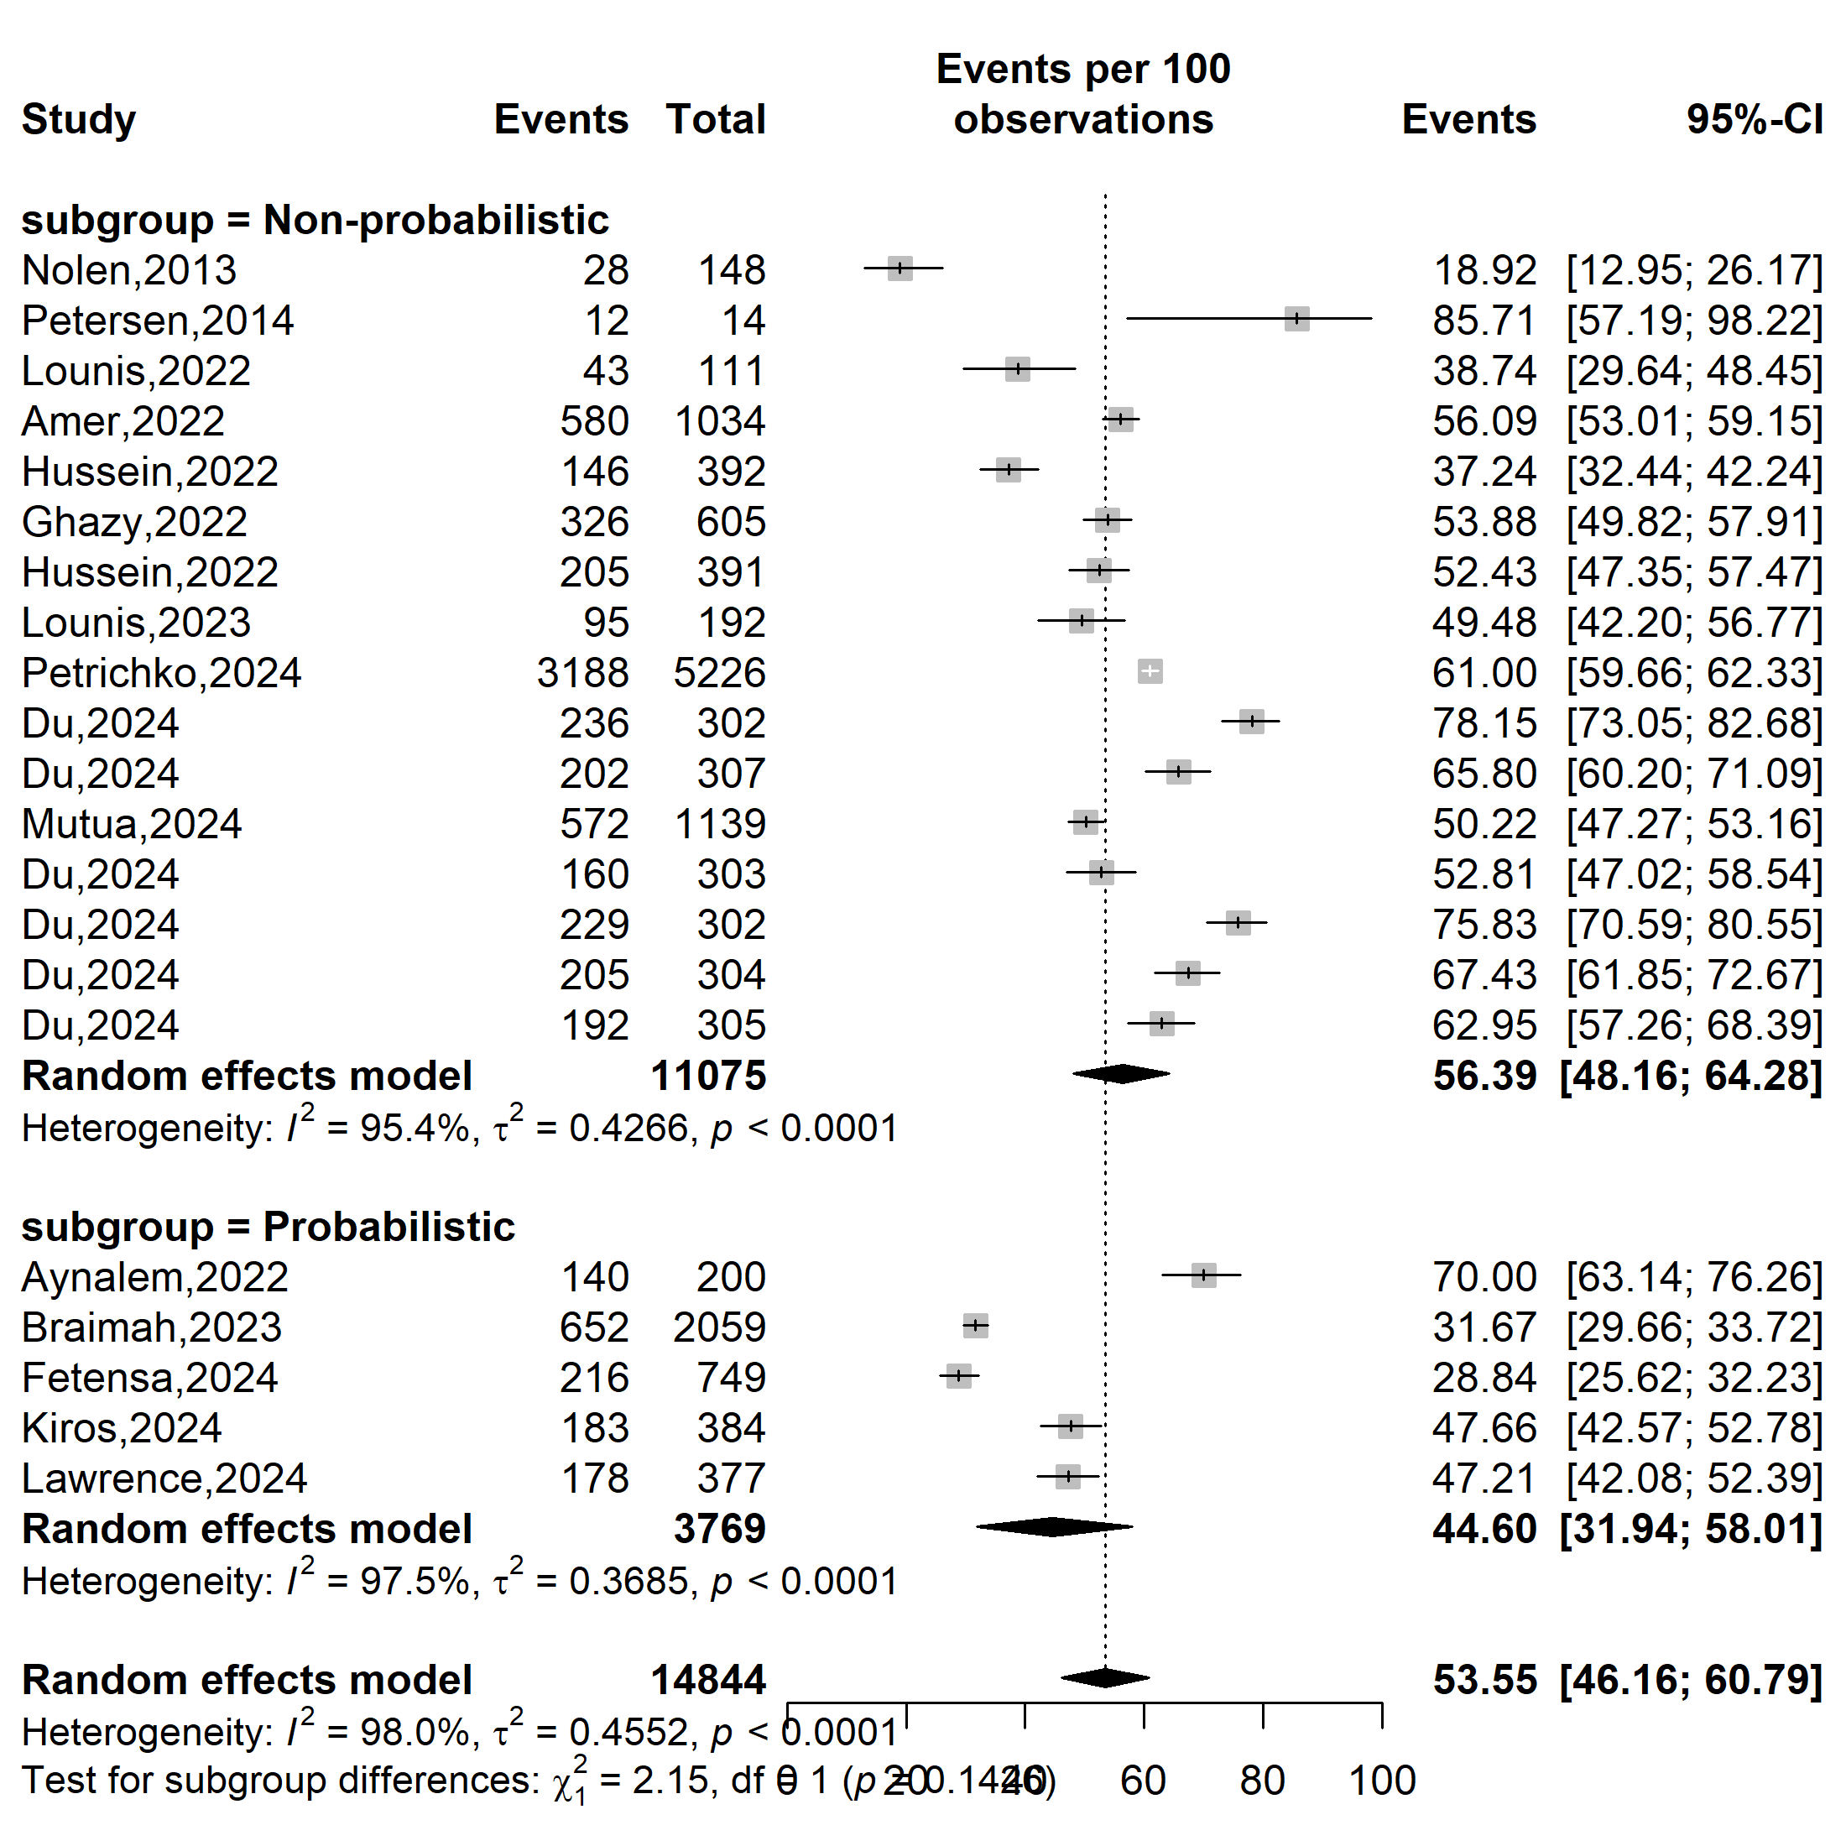
Supplementary Fig. 7 Pooled Mpox vaccine acceptance rate in Africa by sampling method, 2013-2024

Sample size
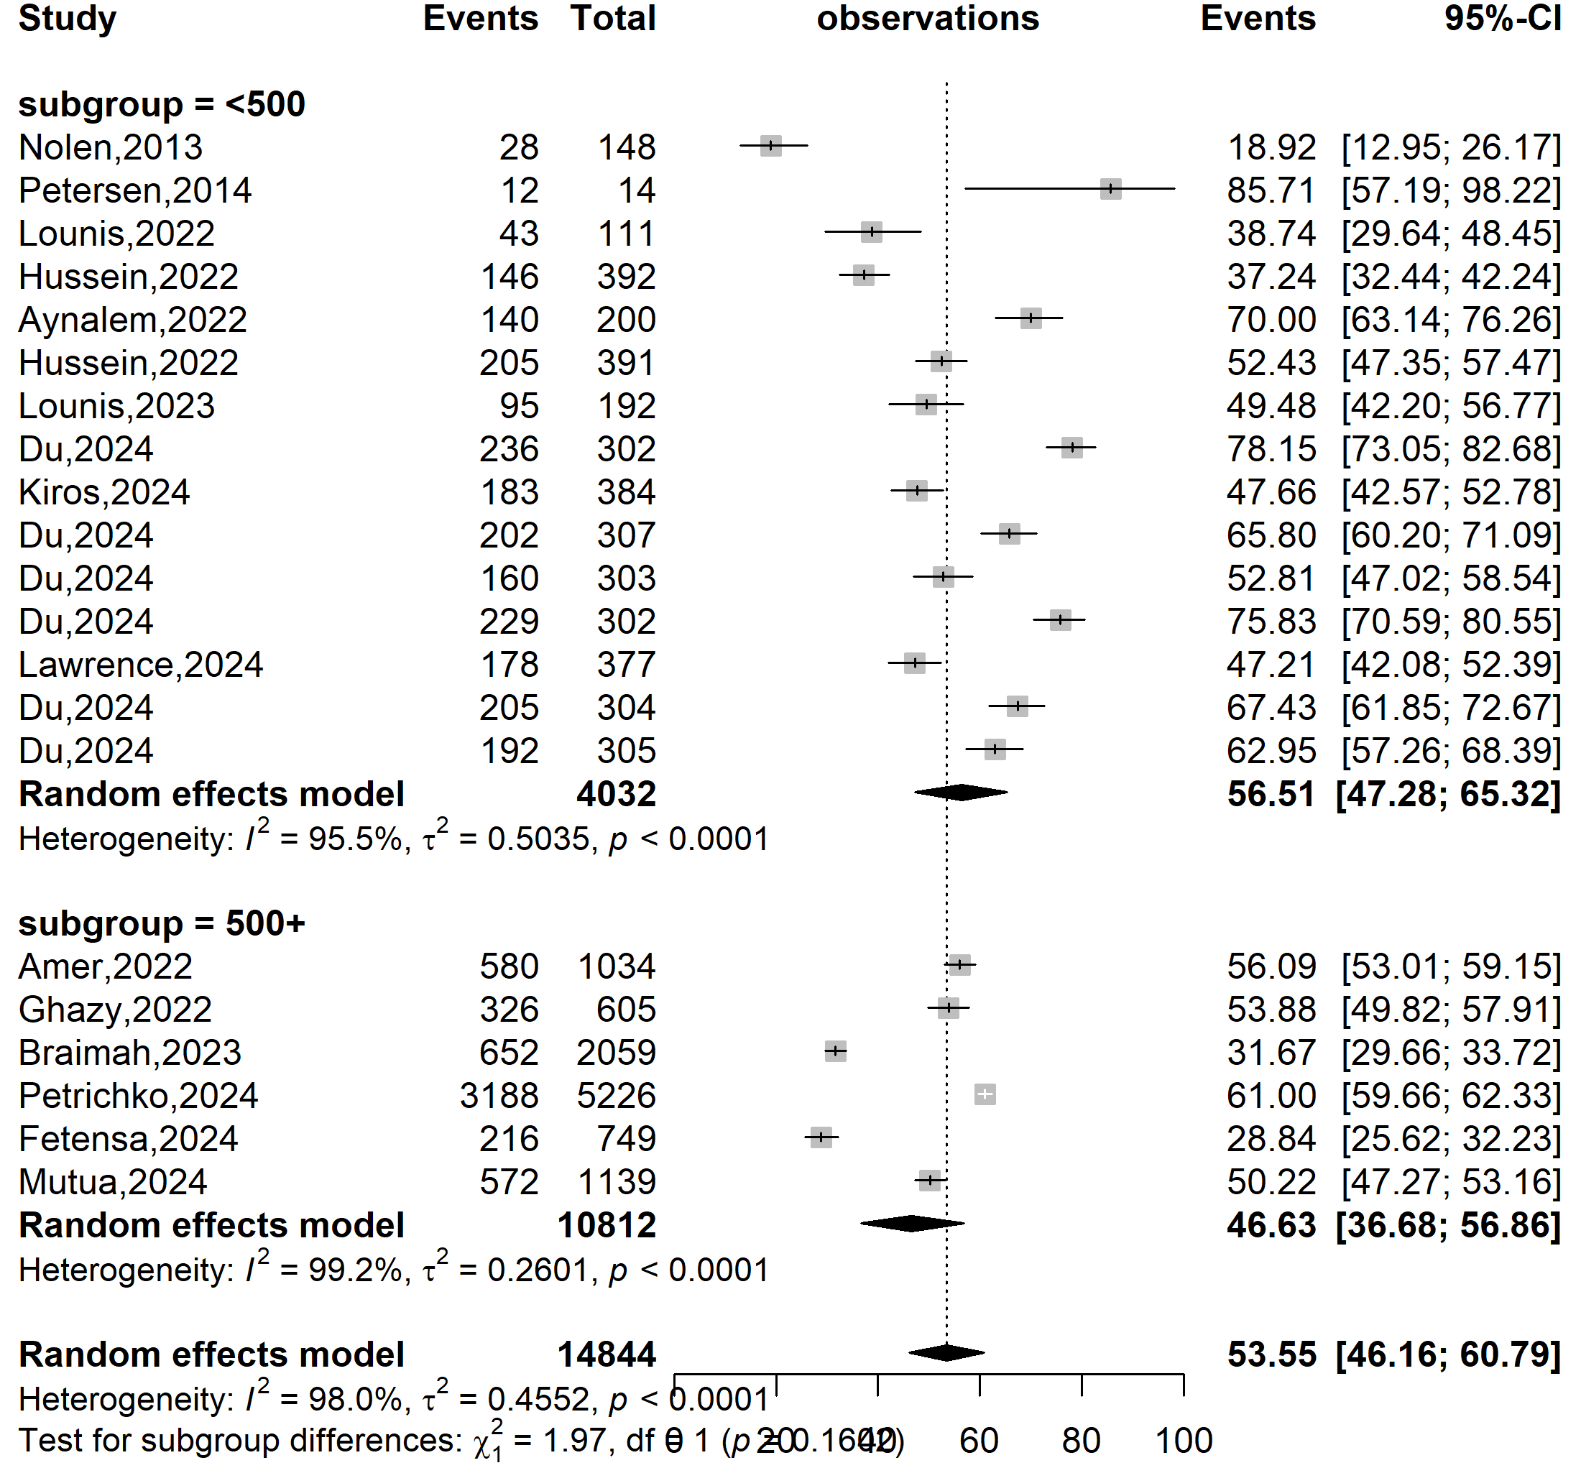
Vaccine acceptance (%)
Event rate (%)

Supplementary Fig. 8 Pooled Mpox vaccine acceptance rate in Africa by sample size, 2013-2024

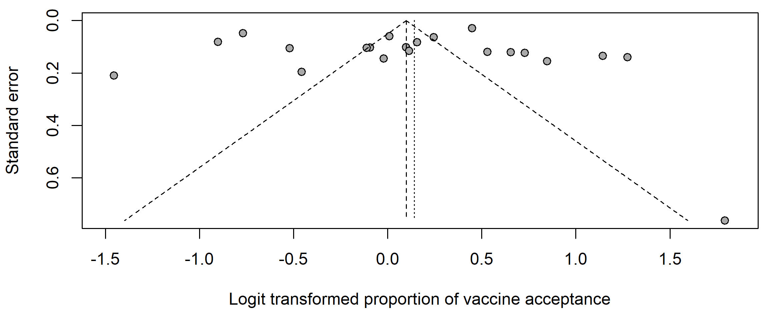
Egger’s test p-value = 0.874
Begg’s test p-value = 0.398

Supplementary Fig. 9 Funnel plot displaying the pseudo 95% confidence limits and tests assessing the publication bias of studies included, 2013-2024

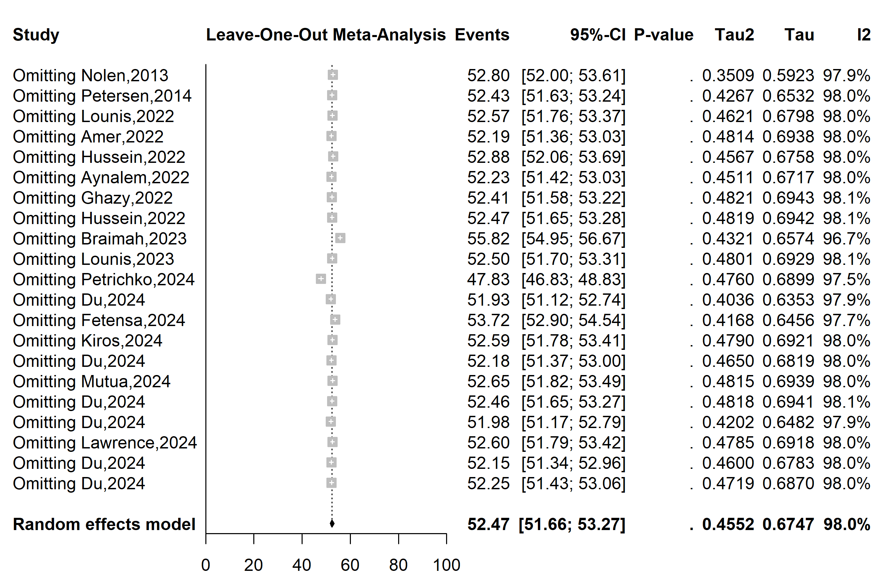
Supplementary Fig. 10 Sensitivity analysis of the Mpox vaccine acceptance in Africa, 2013-2024

