Supplementary material

Genome-wide DNA methylation analysis of heavy cannabis exposure in a New Zealand longitudinal cohort.

Amy J. Osborne,^{1,6}* John F. Pearson,^{2,6} Alexandra J. Noble,¹ Neil J. Gemmell,³ L. John Horwood,⁴ Joseph M. Boden,⁴ Miles Benton,⁵ Donia P. Macartney-Coxson,⁵ Martin A. Kennedy²**

 |  | Cases | Controls
Sex | Male | 37 | 37
Sex | Female | 11 | 11
Ethnicity | European | 35 | 45
Ethnicity | Other | 13 | 3
Socioeconomic status | Professional/managerial | 6 | 6
Socioeconomic status | Clerical/technical/skilled | 21 | 21
Socioeconomic status | Semi-skilled/unskilled | 21 | 21

Supplementary Table 1. Christchurch Health and Development Study (CHDS) participants selected for EPIC arrays. Cases and controls were matched as closely as possible by sex, ethnicity and parental socioeconomic status/occupation. Cases are comprised of regular cannabis users, half of whom have never used tobacco. Controls are comprised of individuals with no exposure to cannabis or tobacco. ‘Other’ ethnicity is a combination of Māori and Pacific Island participants.

 | Multiple methylation sites
 | hypermethylated | hypomethylated
TP73 | 8
DNAH1 | 4
TMEM190 | 4
DNALI1 | 3
MYO1G | 3
VSTM1 | 3
ARHGAP27 | 2
ARHGEF1 | 2
DBI | 2
DGKD | 2
DUS3L | 2
FBRSL1 | 1 | 1
GAS7 | 2
GATD3A | 2
KLHDC4 | 2
KRTAP2-1 | 2
LTBP3 | 2
MIR7-2 | 2
PRKN | 2
PSMB2 | 2
PTCHD3P1 | 2
PTCHD4 | 2
RAD51B |  | 2
RPS6KA2 | 2
SORL1 | 1 | 1
STEAP3 | 2
UBE2E2 | 2
ZDHHC1 | 2

Supplementary Table 2 – Genes with multiple nominally-significant CpG sites in cannabis-only participants.

Supplementary Table 3 - Differentially methylated loci in cannabis-only participants at a nominal P<0.001.

Illumina ID | effect | P Value | P value | GENEID | Location | Distance | up/down | in/out
cg00470351 | 0.02377 | 0.00001 | 0.629 | CDC20 | inside exon | 517 | hyper | in
cg06693983 | 0.08083 | 0.00001 | 0.688 | TMEM190 | inside exon | 1012 | hyper | in
cg26069230 | 0.01245 | 0.00001 | 0.688 | ADAP2 | inside exon | 1319 | hyper | in
cg25293806 | 0.05848 | 0.00002 | 0.776 | TMEM190 | inside exon | 1183 | hyper | in
cg09221413 | 0.02661 | 0.00002 | 0.776 | FKBP10 | inside exon | 290 | hyper | in
cg07178825 | 0.03047 | 0.00003 | 0.880 | TP73 | inside exon | 5532 | hyper | in
cg03938432 | 0.01322 | 0.00004 | 0.885 | ADGRB3 | inside exon | 204 | hyper | in
cg22030419 | 0.00376 | 0.00006 | 0.985 | ZNF416 | inside exon | 21 | hyper | in
cg10162691 | 0.00821 | 0.00009 | 0.985 | RND2 | inside exon | 151 | hyper | in
cg10098021 | 0.00621 | 0.00009 | 0.985 | PPP1R18 | inside exon | 1940 | hyper | in
cg00345862 | 0.01019 | 0.00009 | 0.985 | CNMD | inside exon | 102 | hyper | in
cg22897141 | 0.05364 | 0.00010 | 0.985 | MEN1 | inside exon | 1428 | hyper | in
cg22887000 | 0.05880 | 0.00014 | 0.985 | VSTM1 | inside exon | 147 | hyper | in
cg27390009 | 0.02987 | 0.00015 | 0.985 | FLII | inside exon | 11729 | hyper | in
cg27608102 | 0.02861 | 0.00015 | 0.985 | KRT19 | inside exon | 4137 | hyper | in
cg08941759 | 0.00354 | 0.00017 | 0.985 | CHCHD6 | inside exon | 24 | hyper | in
cg06044455 | 0.02146 | 0.00020 | 0.985 | SNED1 | inside exon | 17664 | hyper | in
cg15722151 | 0.01059 | 0.00021 | 0.985 | RTBDN | inside exon | 11 | hyper | in
cg00859792 | 0.02072 | 0.00021 | 0.985 | GCNT2 | inside exon | 120 | hyper | in
cg24716530 | 0.03871 | 0.00022 | 0.985 | LTBP3 | inside exon | 4911 | hyper | in
cg20371891 | 0.01001 | 0.00022 | 0.985 | RAB20 | inside exon | 319 | hyper | in
cg06108383 | 0.01947 | 0.00023 | 0.985 | LOC100507547 | inside exon | 1243 | hyper | in
cg17804348 | 0.08234 | 0.00026 | 0.985 | TP73 | inside exon | 5431 | hyper | in
cg16343401 | 0.03726 | 0.00028 | 0.985 | GFAP | inside exon | 3773 | hyper | in
cg23793397 | 0.01091 | 0.00028 | 0.985 | EPOP | inside exon | 1429 | hyper | in
cg01155426 | 0.02213 | 0.00028 | 0.985 | PSMB2 | inside exon | 68022 | hyper | in
cg04652097 | 0.02091 | 0.00029 | 0.985 | MAGI2-AS3 | inside exon | 169 | hyper | in
cg14700841 | 0.00692 | 0.00030 | 0.985 | TRIM27 | inside exon | 20392 | hyper | in
cg13263950 | 0.01972 | 0.00031 | 0.985 | PSMB2 | inside exon | 68049 | hyper | in
cg05619414 | 0.01576 | 0.00033 | 0.985 | XPNPEP3 | inside exon | 52049 | hyper | in
cg05333146 | 0.01459 | 0.00033 | 0.985 | B3GNT9 | inside exon | 1177 | hyper | in
cg22392708 | 0.01020 | 0.00033 | 0.985 | KRT23 | inside exon | 66 | hyper | in
cg12282552 | 0.01494 | 0.00039 | 0.985 | LTBP3 | inside exon | 4447 | hyper | in
cg00966482 | 0.02640 | 0.00039 | 0.985 | ERVFRD-1 | inside exon | 145 | hyper | in
cg03540165 | 0.00663 | 0.00040 | 0.985 | RASAL1 | inside exon | 337 | hyper | in
cg03048314 | 0.02950 | 0.00042 | 0.985 | NBL1 | inside exon | 129 | hyper | in
cg08758850 | 0.00478 | 0.00042 | 0.985 | NR6A1 | inside exon | 22 | hyper | in
cg04422168 | 0.01322 | 0.00045 | 0.985 | PTPRN | inside exon | 13 | hyper | in
cg17452880 | 0.00576 | 0.00045 | 0.985 | NUAK1 | inside exon | 72974 | hyper | in
cg02172711 | 0.03132 | 0.00046 | 0.985 | PATL2 | inside exon | 4464 | hyper | in
cg19971650 | 0.01088 | 0.00052 | 0.985 | GABRB2 | inside exon | 52 | hyper | in
cg25899024 | 0.01533 | 0.00055 | 0.985 | DBI | inside exon | 107 | hyper | in
cg16051421 | 0.01140 | 0.00055 | 0.985 | PML | inside exon | 11227 | hyper | in
cg20123729 | 0.00413 | 0.00056 | 0.985 | GFER | inside exon | 218 | hyper | in
cg06487289 | 0.01145 | 0.00059 | 0.985 | CHST2 | inside exon | 2568 | hyper | in
cg15030849 | 0.02569 | 0.00059 | 0.985 | FAM71E2 | inside exon | 8526 | hyper | in
cg21488617 | 0.01607 | 0.00059 | 0.985 | DNALI1 | inside exon | 66 | hyper | in
cg09731694 | 0.01541 | 0.00060 | 0.985 | C9orf50 | inside exon | 52 | hyper | in
cg15635600 | 0.02898 | 0.00060 | 0.985 | DNMT3L | inside exon | 265 | hyper | in
cg03743205 | 0.01764 | 0.00066 | 0.985 | ZFPM1 | inside exon | 80821 | hyper | in
cg21171625 | 0.01784 | 0.00066 | 0.985 | DNALI1 | inside exon | 87 | hyper | in
cg24969431 | 0.01397 | 0.00073 | 0.985 | TDRD5 | inside exon | 108 | hyper | in
cg03802998 | 0.01240 | 0.00074 | 0.985 | TP53I11 | inside exon | 113 | hyper | in
cg19402371 | 0.03487 | 0.00074 | 0.985 | TMEM190 | inside exon | 809 | hyper | in
cg13718185 | 0.02197 | 0.00074 | 0.985 | RHOBTB2 | inside exon | 20183 | hyper | in
cg16602500 | 0.03707 | 0.00075 | 0.985 | TUT4 | inside exon | 129187 | hyper | in
cg02924487 | 0.02714 | 0.00075 | 0.985 | TP73 | inside exon | 5302 | hyper | in
cg02386403 | 0.01316 | 0.00076 | 0.985 | FOXF2 | inside exon | 929 | hyper | in
cg25010998 | 0.00544 | 0.00076 | 0.985 | CAPNS1 | inside exon | 112 | hyper | in
cg21214758 | 0.00649 | 0.00081 | 0.985 | WASHC5 | inside exon | 81 | hyper | in
cg14532498 | 0.00592 | 0.00082 | 0.985 | HRAT92 | inside exon | 2147 | hyper | in
cg04018474 | 0.01494 | 0.00083 | 0.985 | STX1B | inside exon | 13826 | hyper | in
cg09989847 | 0.03306 | 0.00085 | 0.985 | NT5E | inside exon | 45734 | hyper | in
cg14630801 | 0.03884 | 0.00085 | 0.985 | FRMD4A | inside exon | 131988 | hyper | in
cg03501901 | 0.01123 | 0.00085 | 0.985 | ESPN | inside exon | 12674 | hyper | in
cg06355010 | 0.00682 | 0.00087 | 0.985 | ISM1 | inside exon | 71 | hyper | in
cg02038852 | 0.03040 | 0.00087 | 0.985 | SLC7A10 | inside exon | 251 | hyper | in
cg17783317 | 0.04148 | 0.00089 | 0.985 | VSTM1 | inside exon | 84 | hyper | in
cg14036830 | 0.01439 | 0.00093 | 0.985 | GRIK5 | inside exon | 66750 | hyper | in
cg11664903 | 0.02375 | 0.00095 | 0.985 | KIRREL3-AS3 | inside exon | 3039 | hyper | in
cg09096555 | 0.03444 | 0.00096 | 0.985 | GRIN2C | inside exon | 8608 | hyper | in
cg19234858 | 0.00017 | 0.00097 | 0.985 | AUP1 | inside exon | 602 | hyper | in
cg21919809 | 0.00655 | 0.00097 | 0.985 | ETV2 | inside exon | 195 | hyper | in
cg03937116 | 0.01236 | 0.00098 | 0.985 | PI4KB | inside exon | 33223 | hyper | in
cg02345493 | 0.00268 | 0.00098 | 0.985 | PTTG1IP | inside exon | 166 | hyper | in
cg15925718 | 0.00496 | 0.00098 | 0.985 | ADK | inside exon | 89 | hyper | in
cg23927367 | 0.00567 | 0.00099 | 0.985 | THYN1 | inside exon | 458 | hyper | in
cg26896762 | 0.01062 | 0.00099 | 0.985 | ISL1 | inside exon | 403 | hyper | in
cg12803068 | 0.09514 | 0.00000 | 0.385 | MYO1G | inside intron | 15785 | hyper | in
cg02234936 | 0.01209 | 0.00000 | 0.385 | ARHGEF1 | inside intron | 20615 | hyper | in
cg01695406 | 0.04914 | 0.00000 | 0.629 | TMEM190 | inside intron | 1072 | hyper | in
cg24875484 | 0.00956 | 0.00000 | 0.629 | MUCL3 | inside intron | 1806 | hyper | in
cg05009104 | 0.04998 | 0.00001 | 0.629 | MYO1G | inside intron | 15724 | hyper | in
cg04180046 | 0.04471 | 0.00001 | 0.688 | MYO1G | inside intron | 15968 | hyper | in
cg00241731 | 0.07676 | 0.00002 | 0.776 | MAP9 | inside intron | 22927 | hyper | in
cg01538731 | 0.06797 | 0.00003 | 0.776 | KLHDC4 | inside intron | 38628 | hyper | in
cg26396680 | 0.04000 | 0.00003 | 0.880 | PPP1R32 | inside intron | 7822 | hyper | in
cg02624701 | 0.05398 | 0.00004 | 0.885 | SLC17A7 | inside intron | 4395 | hyper | in
cg00699993 | 0.01021 | 0.00004 | 0.885 | GRIA2 | inside intron | 275 | hyper | in
cg04830098 | 0.01096 | 0.00004 | 0.885 | GLS2 | inside intron | 620 | hyper | in
cg20925841 | 0.00755 | 0.00004 | 0.885 | INHBB | inside intron | 681 | hyper | in
cg11267549 | 0.05111 | 0.00006 | 0.985 | APBB2 | inside intron | 67498 | hyper | in
cg27060391 | 0.02827 | 0.00006 | 0.985 | ARHGEF1 | inside intron | 17286 | hyper | in
cg06239618 | 0.01060 | 0.00007 | 0.985 | TBXAS1 | inside intron | 173343 | hyper | in
cg13139972 | 0.01375 | 0.00009 | 0.985 | DKK2 | inside intron | 247416 | hyper | in
cg17163168 | 0.04267 | 0.00009 | 0.985 | TP73 | inside intron | 31606 | hyper | in
cg24654681 | 0.03069 | 0.00010 | 0.985 | NOP53 | inside intron | 14441 | hyper | in
cg05830220 | 0.05425 | 0.00010 | 0.985 | KLHDC4 | inside intron | 38613 | hyper | in
cg04079760 | 0.03243 | 0.00011 | 0.985 | ESRP2 | inside intron | 442 | hyper | in
cg20781438 | 0.00828 | 0.00011 | 0.985 | MACF1 | inside intron | 78211 | hyper | in
cg19092096 | 0.01280 | 0.00013 | 0.985 | ALX3 | inside intron | 848 | hyper | in
cg24688471 | 0.03214 | 0.00013 | 0.985 | MMEL1 | inside intron | 21666 | hyper | in
cg05413199 | 0.02078 | 0.00014 | 0.985 | ZDHHC1 | inside intron | 19885 | hyper | in
cg16794070 | 0.01327 | 0.00014 | 0.985 | PARD6A | inside intron | 414 | hyper | in
cg00141479 | 0.00837 | 0.00014 | 0.985 | PIP4K2A | inside intron | 411 | hyper | in
cg17192115 | 0.01433 | 0.00015 | 0.985 | GAS7 | inside intron | 238968 | hyper | in
cg20768358 | 0.07349 | 0.00015 | 0.985 | TP73 | inside intron | 5870 | hyper | in
cg13721989 | 0.00731 | 0.00015 | 0.985 | PIP5KL1 | inside intron | 3823 | hyper | in
cg19359071 | 0.01118 | 0.00016 | 0.985 | PRDM2 | inside intron | 3275 | hyper | in
cg09816507 | 0.01932 | 0.00017 | 0.985 | PTCHD4 | inside intron | 42359 | hyper | in
cg07099839 | 0.02512 | 0.00018 | 0.985 | FGD6 | inside intron | 47839 | hyper | in
cg11041018 | 0.00649 | 0.00018 | 0.985 | PLCB1 | inside intron | 177595 | hyper | in
cg00752478 | 0.01505 | 0.00018 | 0.985 | ZDHHC1 | inside intron | 19980 | hyper | in
cg09618848 | 0.01527 | 0.00019 | 0.985 | KCTD1 | inside intron | 148402 | hyper | in
cg13476950 | 0.03488 | 0.00020 | 0.985 | DNAH1 | inside intron | 1345 | hyper | in
cg16761329 | 0.04430 | 0.00020 | 0.985 | C5orf66 | inside intron | 9143 | hyper | in
cg04665374 | 0.02084 | 0.00020 | 0.985 | ITGA7 | inside intron | 5011 | hyper | in
cg25069388 | 0.03908 | 0.00020 | 0.985 | CSNK2A1 | inside intron | 26476 | hyper | in
cg10443049 | 0.01969 | 0.00020 | 0.985 | NXPH1 | inside intron | 7952 | hyper | in
cg02449166 | 0.01562 | 0.00021 | 0.985 | EBF3 | inside intron | 13610 | hyper | in
cg04608239 | 0.01244 | 0.00021 | 0.985 | GATD3A | inside intron | 9036 | hyper | in
cg27076669 | 0.01351 | 0.00022 | 0.985 | CPM | inside intron | 29563 | hyper | in
cg02355924 | 0.04676 | 0.00023 | 0.985 | Mar-04 | inside intron | 68283 | hyper | in
cg06202149 | 0.01412 | 0.00023 | 0.985 | TP73 | inside intron | 36757 | hyper | in
cg27405731 | 0.03096 | 0.00023 | 0.985 | CUX1 | inside intron | 110321 | hyper | in
cg21610871 | 0.04520 | 0.00023 | 0.985 | CACNA2D4 | inside intron | 73853 | hyper | in
cg01854076 | 0.02166 | 0.00024 | 0.985 | NAT8L | inside intron | 1797 | hyper | in
cg24239518 | 0.00573 | 0.00024 | 0.985 | CDH23 | inside intron | 198416 | hyper | in
cg11575865 | 0.01309 | 0.00025 | 0.985 | SFMBT2 | inside intron | 32493 | hyper | in
cg25799458 | 0.01202 | 0.00025 | 0.985 | MTMR14 | inside intron | 9557 | hyper | in
cg03824573 | 0.01115 | 0.00025 | 0.985 | CACNA1C | inside intron | 153377 | hyper | in
cg27250236 | 0.04159 | 0.00026 | 0.985 | PTCHD4 | inside intron | 42326 | hyper | in
cg22494035 | 0.01807 | 0.00026 | 0.985 | CCDC33 | inside intron | 9189 | hyper | in
cg10717148 | 0.00370 | 0.00027 | 0.985 | TSKU | inside intron | 747 | hyper | in
cg20910202 | 0.02930 | 0.00027 | 0.985 | KBTBD11 | inside intron | 766 | hyper | in
cg21247398 | 0.02657 | 0.00027 | 0.985 | PRKAG2-AS1 | inside intron | 1150 | hyper | in
cg13017471 | 0.02039 | 0.00027 | 0.985 | FNDC3B | inside intron | 73964 | hyper | in
cg27364231 | 0.01393 | 0.00027 | 0.985 | ESAM | inside intron | 3294 | hyper | in
cg17060249 | 0.00622 | 0.00027 | 0.985 | CIDEC | inside intron | 38585 | hyper | in
cg05138148 | 0.01394 | 0.00027 | 0.985 | TRABD2B | inside intron | 12667 | hyper | in
cg03994942 | 0.01991 | 0.00028 | 0.985 | LARGE2 | inside intron | 783 | hyper | in
cg18545449 | 0.04833 | 0.00029 | 0.985 | SLC39A11 | inside intron | 81207 | hyper | in
cg11857646 | 0.01698 | 0.00032 | 0.985 | KCNH2 | inside intron | 30771 | hyper | in
cg18650670 | 0.01162 | 0.00033 | 0.985 | IGDCC4 | inside intron | 26258 | hyper | in
cg22599707 | 0.01418 | 0.00034 | 0.985 | CCDC69 | inside intron | 9348 | hyper | in
cg22482215 | 0.01016 | 0.00035 | 0.985 | CASP8AP2 | inside intron | 574 | hyper | in
cg23295886 | 0.01842 | 0.00036 | 0.985 | PTPRM | inside intron | 420385 | hyper | in
cg13742305 | 0.01072 | 0.00037 | 0.985 | CASKIN1 | inside intron | 1850 | hyper | in
cg05845767 | 0.01487 | 0.00038 | 0.985 | CDH22 | inside intron | 30765 | hyper | in
cg26739532 | 0.01109 | 0.00039 | 0.985 | SYBU | inside intron | 46321 | hyper | in
cg10313047 | 0.04843 | 0.00039 | 0.985 | DNAH1 | inside intron | 1020 | hyper | in
cg08325845 | 0.01774 | 0.00039 | 0.985 | ZNRD1ASP | inside intron | 54075 | hyper | in
cg10084993 | 0.01796 | 0.00040 | 0.985 | SLC9A3R2 | inside intron | 778 | hyper | in
cg10956403 | 0.04336 | 0.00040 | 0.985 | SPAG9 | inside intron | 8022 | hyper | in
cg04570735 | 0.01222 | 0.00041 | 0.985 | PDE4C | inside intron | 9361 | hyper | in
cg03302268 | 0.03886 | 0.00041 | 0.985 | TARM1 | inside intron | 4965 | hyper | in
cg06671242 | 0.02690 | 0.00042 | 0.985 | PRSS23 | inside intron | 16276 | hyper | in
cg23928920 | 0.05162 | 0.00044 | 0.985 | ST8SIA2 | inside intron | 7616 | hyper | in
cg20991988 | 0.02800 | 0.00045 | 0.985 | CREB5 | inside intron | 7767 | hyper | in
cg09765310 | 0.02113 | 0.00045 | 0.985 | TRPM2 | inside intron | 6978 | hyper | in
cg27302296 | 0.01198 | 0.00045 | 0.985 | TRIQK | inside intron | 51580 | hyper | in
cg04412755 | 0.04295 | 0.00046 | 0.985 | PTH1R | inside intron | 16239 | hyper | in
cg03107955 | 0.01107 | 0.00047 | 0.985 | LOC283177 | inside intron | 65769 | hyper | in
cg21629500 | 0.00781 | 0.00048 | 0.985 | C5orf38 | inside intron | 2491 | hyper | in
cg22295879 | 0.00338 | 0.00048 | 0.985 | PRIM1 | inside intron | 278 | hyper | in
cg23703946 | 0.03663 | 0.00048 | 0.985 | SLC8A1 | inside intron | 293621 | hyper | in
cg03128361 | 0.00975 | 0.00050 | 0.985 | DLEU1 | inside intron | 148648 | hyper | in
cg11936362 | 0.00748 | 0.00051 | 0.985 | PRKN | inside intron | 124210 | hyper | in
cg13136639 | 0.01748 | 0.00052 | 0.985 | ARHGAP27 | inside intron | 8439 | hyper | in
cg15507160 | 0.00613 | 0.00053 | 0.985 | ZNF487 | inside intron | 25181 | hyper | in
cg26105278 | 0.02536 | 0.00054 | 0.985 | TP73 | inside intron | 9444 | hyper | in
cg09839635 | 0.02584 | 0.00054 | 0.985 | RNF180 | inside intron | 132 | hyper | in
cg12606911 | 0.01321 | 0.00054 | 0.985 | RMND5A | inside intron | 89212 | hyper | in
cg04887826 | 0.02082 | 0.00056 | 0.985 | BOLA2 | inside intron | 506980 | hyper | in
cg02656472 | 0.05377 | 0.00056 | 0.985 | ITGB3 | inside intron | 69428 | hyper | in
cg13425938 | 0.01245 | 0.00057 | 0.985 | EGFL7 | inside intron | 2173 | hyper | in
cg01456368 | 0.04735 | 0.00057 | 0.985 | DNAH1 | inside intron | 1524 | hyper | in
cg09207494 | 0.00340 | 0.00057 | 0.985 | FNTB | inside intron | 357 | hyper | in
cg15215033 | 0.02618 | 0.00058 | 0.985 | SLC38A10 | inside intron | 10364 | hyper | in
cg03198578 | 0.02103 | 0.00059 | 0.985 | TMC4 | inside intron | 8340 | hyper | in
cg18913076 | 0.00439 | 0.00059 | 0.985 | MRPL30 | inside intron | 13059 | hyper | in
cg27505260 | 0.01865 | 0.00059 | 0.985 | GATD3A | inside intron | 10555 | hyper | in
cg02017733 | 0.02204 | 0.00060 | 0.985 | PISD | inside intron | 40244 | hyper | in
cg26055950 | 0.03376 | 0.00062 | 0.985 | TP73 | inside intron | 31723 | hyper | in
cg01146063 | 0.02014 | 0.00062 | 0.985 | CTNNA2 | inside intron | 17731 | hyper | in
cg23093164 | 0.05710 | 0.00062 | 0.985 | RCAN1 | inside intron | 87914 | hyper | in
cg04593523 | 0.04145 | 0.00062 | 0.985 | ETV6 | inside intron | 109415 | hyper | in
cg19013611 | 0.03433 | 0.00063 | 0.985 | PTPRN2 | inside intron | 712431 | hyper | in
cg16935813 | 0.00798 | 0.00063 | 0.985 | MXI1 | inside intron | 14742 | hyper | in
cg10872212 | 0.01547 | 0.00063 | 0.985 | KLHDC8B | inside intron | 142 | hyper | in
cg11198596 | 0.03691 | 0.00064 | 0.985 | LRIG1 | inside intron | 2728 | hyper | in
cg12954529 | 0.02063 | 0.00065 | 0.985 | NRG1 | inside intron | 41034 | hyper | in
cg02045669 | 0.03155 | 0.00066 | 0.985 | MAPK10 | inside intron | 357 | hyper | in
cg13886338 | 0.02323 | 0.00068 | 0.985 | MROH6 | inside intron | 4697 | hyper | in
cg24013620 | 0.04034 | 0.00068 | 0.985 | MAPK15 | inside intron | 181 | hyper | in
cg13537567 | 0.03618 | 0.00072 | 0.985 | CPLX2 | inside intron | 19960 | hyper | in
cg04651153 | 0.01207 | 0.00073 | 0.985 | GAS7 | inside intron | 145240 | hyper | in
cg00665971 | 0.01564 | 0.00073 | 0.985 | HRK | inside intron | 1462 | hyper | in
cg02254056 | 0.00924 | 0.00073 | 0.985 | BLOC1S5-TXNDC5 | inside intron | 153167 | hyper | in
cg15970457 | 0.00631 | 0.00073 | 0.985 | CTBP2 | inside intron | 56871 | hyper | in
cg11407215 | 0.00487 | 0.00074 | 0.985 | UXS1 | inside intron | 649 | hyper | in
cg18037921 | 0.02889 | 0.00075 | 0.985 | ALDH1A3 | inside intron | 19470 | hyper | in
cg07372166 | 0.03709 | 0.00075 | 0.985 | PRUNE2 | inside intron | 107337 | hyper | in
cg12749467 | 0.02389 | 0.00075 | 0.985 | BABAM2 | inside intron | 398414 | hyper | in
cg11782635 | 0.01475 | 0.00076 | 0.985 | KCNIP1 | inside intron | 150038 | hyper | in
cg00433654 | 0.01314 | 0.00076 | 0.985 | INO80B | inside intron | 2110 | hyper | in
cg03238513 | 0.02191 | 0.00078 | 0.985 | GPATCH2L | inside intron | 1135 | hyper | in
cg26661889 | 0.02281 | 0.00078 | 0.985 | MN1 | inside intron | 8734 | hyper | in
cg05355157 | 0.01103 | 0.00079 | 0.985 | C4BPB | inside intron | 5196 | hyper | in
cg10658345 | 0.04728 | 0.00079 | 0.985 | CLPX | inside intron | 2601 | hyper | in
cg09867343 | 0.00744 | 0.00079 | 0.985 | LOC652276 | inside intron | 11554 | hyper | in
cg24283375 | 0.01116 | 0.00080 | 0.985 | ST3GAL3 | inside intron | 24666 | hyper | in
cg27190014 | 0.01448 | 0.00080 | 0.985 | PVT1 | inside intron | 68636 | hyper | in
cg13574488 | 0.01088 | 0.00081 | 0.985 | EMX2 | inside intron | 4290 | hyper | in
cg15304012 | 0.02043 | 0.00081 | 0.985 | RPS6KA2 | inside intron | 399281 | hyper | in
cg00071692 | 0.01433 | 0.00082 | 0.985 | SFI1 | inside intron | 37756 | hyper | in
cg24058566 | 0.00892 | 0.00082 | 0.985 | LINC00461 | inside intron | 162 | hyper | in
cg24898675 | 0.01594 | 0.00082 | 0.985 | SMAD3 | inside intron | 32199 | hyper | in
cg20812052 | 0.00707 | 0.00082 | 0.985 | PTDSS2 | inside intron | 27581 | hyper | in
cg06547959 | 0.00892 | 0.00083 | 0.985 | CELF4 | inside intron | 172010 | hyper | in
cg21287054 | 0.04104 | 0.00083 | 0.985 | TTYH1 | inside intron | 1407 | hyper | in
cg04694615 | 0.01342 | 0.00083 | 0.985 | NUP210 | inside intron | 40861 | hyper | in
cg19295951 | 0.01044 | 0.00084 | 0.985 | DUOXA1 | inside intron | 77 | hyper | in
cg13126552 | 0.02579 | 0.00084 | 0.985 | DNAH1 | inside intron | 1264 | hyper | in
cg23708673 | 0.01337 | 0.00086 | 0.985 | ATP2A2 | inside intron | 35474 | hyper | in
cg14634738 | 0.02856 | 0.00086 | 0.985 | RBM6 | inside intron | 148623 | hyper | in
cg00424286 | 0.03469 | 0.00087 | 0.985 | RPS6KA2 | inside intron | 387892 | hyper | in
cg22729960 | 0.00894 | 0.00087 | 0.985 | PTPRU | inside intron | 47397 | hyper | in
cg06103395 | 0.01335 | 0.00087 | 0.985 | TRERF1 | inside intron | 24079 | hyper | in
cg15957050 | 0.04377 | 0.00088 | 0.985 | RAPGEF3 | inside intron | 1365 | hyper | in
cg16092310 | 0.01053 | 0.00088 | 0.985 | DAND5 | inside intron | 620 | hyper | in
cg19764668 | 0.03602 | 0.00088 | 0.985 | SP110 | inside intron | 22675 | hyper | in
cg21107223 | 0.00358 | 0.00089 | 0.985 | MPI | inside intron | 45 | hyper | in
cg15850878 | 0.00983 | 0.00089 | 0.985 | DGKD | inside intron | 25470 | hyper | in
cg06408459 | 0.05750 | 0.00090 | 0.985 | PRKN | inside intron | 1353650 | hyper | in
cg03739378 | 0.00768 | 0.00090 | 0.985 | ATXN7L1 | inside intron | 22605 | hyper | in
cg18618113 | 0.01474 | 0.00090 | 0.985 | MITF | inside intron | 43215 | hyper | in
cg00898478 | 0.01200 | 0.00090 | 0.985 | PTCH1 | inside intron | 6464 | hyper | in
cg20386705 | 0.00546 | 0.00090 | 0.985 | BTBD9 | inside intron | 629 | hyper | in
cg14372524 | 0.03691 | 0.00091 | 0.985 | GLIS1 | inside intron | 36017 | hyper | in
cg20352386 | 0.03287 | 0.00092 | 0.985 | FBRSL1 | inside intron | 16436 | hyper | in
cg00002749 | 0.00560 | 0.00093 | 0.985 | VMP1 | inside intron | 54675 | hyper | in
cg19322788 | 0.00883 | 0.00093 | 0.985 | TMEM132B | inside intron | 20005 | hyper | in
cg07842386 | 0.01878 | 0.00094 | 0.985 | IL23R | inside intron | 27438 | hyper | in
cg19771773 | 0.00578 | 0.00095 | 0.985 | CARD8 | inside intron | 45587 | hyper | in
cg13568258 | 0.00895 | 0.00095 | 0.985 | CCDC114 | inside intron | 1764 | hyper | in
cg25846723 | 0.01714 | 0.00095 | 0.985 | ATP10A | inside intron | 1369 | hyper | in
cg11306701 | 0.01514 | 0.00095 | 0.985 | CTSL | inside intron | 484 | hyper | in
cg26571193 | 0.01264 | 0.00096 | 0.985 | FAM110A | inside intron | 4610 | hyper | in
cg22581896 | 0.02222 | 0.00096 | 0.985 | FOXK1 | inside intron | 57295 | hyper | in
cg23928982 | 0.01511 | 0.00096 | 0.985 | AKT1 | inside intron | 22038 | hyper | in
cg02341310 | 0.00211 | 0.00096 | 0.985 | TXLNB | inside intron | 21797 | hyper | in
cg14347088 | 0.01955 | 0.00096 | 0.985 | LRFN5 | inside intron | 2137 | hyper | in
cg16734549 | 0.01832 | 0.00097 | 0.985 | ARHGAP27 | inside intron | 14461 | hyper | in
cg07867072 | 0.01938 | 0.00098 | 0.985 | NEB | inside intron | 83117 | hyper | in
cg13480228 | 0.02788 | 0.00098 | 0.985 | MYO10 | inside intron | 129368 | hyper | in
cg13485685 | 0.01204 | 0.00099 | 0.985 | SLIT2 | inside intron | 570 | hyper | in
cg08984500 | 0.00601 | 0.00100 | 0.985 | DPEP1 | inside intron | 5422 | hyper | in
cg07000467 | -0.00407 | 0.00002 | 0.776 | DAB2 | inside exon | 405 | hypo | in
cg21809744 | -0.01279 | 0.00005 | 0.985 | ZNF837 | inside exon | 11756 | hypo | in
cg02036827 | -0.00316 | 0.00008 | 0.985 | FBXO46 | inside exon | 18547 | hypo | in
cg13922111 | -0.00257 | 0.00013 | 0.985 | ABHD13 | inside exon | 37 | hypo | in
cg01206970 | -0.00728 | 0.00015 | 0.985 | LIN7B | inside exon | 3569 | hypo | in
cg07933493 | -0.01625 | 0.00020 | 0.985 | RDH16 | inside exon | 5484 | hypo | in
cg11824369 | -0.00053 | 0.00026 | 0.985 | SIRT5 | inside exon | 4 | hypo | in
cg27304199 | -0.00975 | 0.00035 | 0.985 | MRPS18B | inside exon | 2028 | hypo | in
cg27461800 | -0.00260 | 0.00050 | 0.985 | KDM5A | inside exon | 266 | hypo | in
cg19763025 | -0.01752 | 0.00054 | 0.985 | LAMB1 | inside exon | 66197 | hypo | in
cg07955541 | -0.00497 | 0.00055 | 0.985 | WDR60 | inside exon | 39148 | hypo | in
cg25308542 | -0.00032 | 0.00056 | 0.985 | MIR17HG | inside exon | 39 | hypo | in
cg20887442 | -0.01508 | 0.00059 | 0.985 | NUMA1 | inside exon | 66096 | hypo | in
cg05003890 | -0.00885 | 0.00064 | 0.985 | MYOM2 | inside exon | 53594 | hypo | in
cg24852756 | -0.00299 | 0.00074 | 0.985 | CRTC1 | inside exon | 202 | hypo | in
cg05915481 | -0.00129 | 0.00076 | 0.985 | TARS | inside exon | 40 | hypo | in
cg01554235 | -0.00180 | 0.00088 | 0.985 | NME7 | inside exon | 143 | hypo | in
cg05655106 | -0.00896 | 0.00094 | 0.985 | AHRR | inside exon | 31203 | hypo | in
cg04900999 | -0.00139 | 0.00098 | 0.985 | ATP6V0A1 | inside exon | 96 | hypo | in
cg14193825 | -0.01252 | 0.00005 | 0.939 | NXN | inside intron | 77474 | hypo | in
cg23045373 | -0.00226 | 0.00006 | 0.985 | FAM167A | inside intron | 228 | hypo | in
cg22584104 | -0.02924 | 0.00009 | 0.985 | GALNT18 | inside intron | 63327 | hypo | in
cg11855842 | -0.01971 | 0.00022 | 0.985 | ASAP3 | inside intron | 3565 | hypo | in
cg11293828 | -0.03687 | 0.00027 | 0.985 | PRMT8 | inside intron | 107820 | hypo | in
cg19304088 | -0.01586 | 0.00027 | 0.985 | PITX2 | inside intron | 15489 | hypo | in
cg21199251 | -0.01164 | 0.00028 | 0.985 | AJAP1 | inside intron | 113516 | hypo | in
cg22760037 | -0.01065 | 0.00031 | 0.985 | LINC00673 | inside intron | 170779 | hypo | in
cg00771778 | -0.00919 | 0.00031 | 0.985 | LYST | inside intron | 31513 | hypo | in
cg11709728 | -0.00549 | 0.00038 | 0.985 | LRRC1 | inside intron | 84396 | hypo | in
cg17461336 | -0.02095 | 0.00038 | 0.985 | CYP3A43 | inside intron | 15923 | hypo | in
cg17011300 | -0.00985 | 0.00041 | 0.985 | ESRRG | inside intron | 50267 | hypo | in
cg21079591 | -0.01771 | 0.00042 | 0.985 | ATP6V1G2-DDX39B | inside intron | 3890 | hypo | in
cg18908374 | -0.00751 | 0.00043 | 0.985 | SHANK2 | inside intron | 21731 | hypo | in
cg21758687 | -0.00232 | 0.00043 | 0.985 | PIAS1 | inside intron | 155 | hypo | in
cg10982668 | -0.00369 | 0.00048 | 0.985 | INMT | inside intron | 35822 | hypo | in
cg02859962 | -0.01410 | 0.00049 | 0.985 | LINC00284 | inside intron | 2394 | hypo | in
cg12678623 | -0.00208 | 0.00054 | 0.985 | ATP5MG | inside intron | 699 | hypo | in
cg06567964 | -0.00413 | 0.00059 | 0.985 | SREK1IP1 | inside intron | 630 | hypo | in
cg03956606 | -0.00408 | 0.00064 | 0.985 | MTOR | inside intron | 73551 | hypo | in
cg14210634 | -0.00184 | 0.00067 | 0.985 | LDLRAP1 | inside intron | 215 | hypo | in
cg21936550 | -0.00382 | 0.00068 | 0.985 | TBL2 | inside intron | 291 | hypo | in
cg04012872 | -0.01047 | 0.00070 | 0.985 | IPP | inside intron | 3712 | hypo | in
cg16062253 | -0.01198 | 0.00071 | 0.985 | NOTCH4 | inside intron | 21350 | hypo | in
cg05384198 | -0.00588 | 0.00072 | 0.985 | TBC1D2 | inside intron | 1812 | hypo | in
cg14963283 | -0.00793 | 0.00075 | 0.985 | CYFIP1 | inside intron | 5881 | hypo | in
cg19270965 | -0.00476 | 0.00075 | 0.985 | EZH1 | inside intron | 40083 | hypo | in
cg06673490 | -0.00923 | 0.00078 | 0.985 | GNG4 | inside intron | 61129 | hypo | in
cg25125469 | -0.04606 | 0.00084 | 0.985 | ACSM3 | inside intron | 3103 | hypo | in
cg00203456 | -0.00151 | 0.00085 | 0.985 | ZSCAN16-AS1 | inside intron | 12724 | hypo | in
cg21131421 | -0.01667 | 0.00087 | 0.985 | RAD51B | inside intron | 630719 | hypo | in
cg27492749 | -0.00205 | 0.00089 | 0.985 | SGCE | inside intron | 621 | hypo | in
cg08296556 | -0.00067 | 0.00090 | 0.985 | PHTF2 | inside intron | 552 | hypo | in
cg16893389 | -0.01237 | 0.00090 | 0.985 | FOXRED1 | inside intron | 4636 | hypo | in
cg01595204 | -0.00288 | 0.00091 | 0.985 | TCF3 | inside intron | 9491 | hypo | in
cg02555727 | -0.01178 | 0.00098 | 0.985 | SLC15A4 | inside intron | 26995 | hypo | in
cg12617928 | 0.02148 | 0.00012 | 0.985 | HBQ1 | close to 3' | 1409 | hyper | out
cg00602811 | 0.04467 | 0.00036 | 0.985 | ZEB2-AS1 | close to 3' | 1383 | hyper | out
cg05397074 | 0.01507 | 0.00043 | 0.985 | MIR4493 | close to 3' | 139 | hyper | out
cg16746471 | 0.01607 | 0.00001 | 0.688 | KIAA1324L | promoter | 374 | hyper | out
cg27208052 | 0.02457 | 0.00002 | 0.776 | MMP15 | promoter | 640 | hyper | out
cg20284913 | 0.00656 | 0.00003 | 0.885 | RFX1 | promoter | 109 | hyper | out
cg27402569 | 0.00566 | 0.00004 | 0.885 | ZMYM4 | promoter | 228 | hyper | out
cg21827892 | 0.03907 | 0.00005 | 0.939 | SLC7A9 | promoter | 360 | hyper | out
cg25424659 | 0.01596 | 0.00006 | 0.985 | RAB3D | promoter | 248 | hyper | out
cg04730882 | 0.00796 | 0.00009 | 0.985 | HOXD9 | promoter | 878 | hyper | out
cg14970695 | 0.04617 | 0.00010 | 0.985 | PTCHD3P1 | promoter | 36 | hyper | out
cg16213655 | 0.00900 | 0.00013 | 0.985 | PPL | promoter | 396 | hyper | out
cg06275875 | 0.01310 | 0.00013 | 0.985 | CTU1 | promoter | 690 | hyper | out
cg03363242 | 0.00692 | 0.00021 | 0.985 | INTS9 | promoter | 40 | hyper | out
cg20478750 | 0.01999 | 0.00023 | 0.985 | SH3RF2 | promoter | 842 | hyper | out
cg11539780 | 0.01048 | 0.00023 | 0.985 | ZNF471 | promoter | 196 | hyper | out
cg24453493 | 0.02450 | 0.00024 | 0.985 | ZNF503-AS1 | promoter | 6 | hyper | out
cg04117547 | 0.01362 | 0.00027 | 0.985 | C9orf47 | promoter | 2344 | hyper | out
cg00770085 | 0.01128 | 0.00028 | 0.985 | TTC39A | promoter | 51 | hyper | out
cg03381598 | 0.02046 | 0.00028 | 0.985 | GRM7 | promoter | 702 | hyper | out
cg25564272 | 0.01155 | 0.00029 | 0.985 | TTLL6 | promoter | 1679 | hyper | out
cg16565993 | 0.00731 | 0.00029 | 0.985 | GNA14 | promoter | 649 | hyper | out
cg03727732 | 0.01076 | 0.00031 | 0.985 | CLK3 | promoter | 465 | hyper | out
cg12465710 | 0.03116 | 0.00031 | 0.985 | UTF1 | promoter | 893 | hyper | out
cg17476312 | 0.02941 | 0.00032 | 0.985 | CS | promoter | 614 | hyper | out
cg17252960 | 0.01075 | 0.00032 | 0.985 | ID4 | promoter | 251 | hyper | out
cg06667339 | 0.01392 | 0.00033 | 0.985 | KIF5A | promoter | 450 | hyper | out
cg18643762 | 0.00784 | 0.00034 | 0.985 | STEAP3 | promoter | 212 | hyper | out
cg24624629 | 0.04316 | 0.00034 | 0.985 | KRTAP2-1 | promoter | 53 | hyper | out
cg05771342 | 0.05300 | 0.00034 | 0.985 | MRGPRF | promoter | 1352 | hyper | out
cg24112562 | 0.00187 | 0.00036 | 0.985 | SIM2 | promoter | 1950 | hyper | out
cg24621354 | 0.00987 | 0.00039 | 0.985 | TES | promoter | 165 | hyper | out
cg10085651 | 0.00993 | 0.00039 | 0.985 | PSMD7 | promoter | 437 | hyper | out
cg21007783 | 0.04543 | 0.00042 | 0.985 | SPIB | promoter | 14 | hyper | out
cg13322582 | 0.01270 | 0.00042 | 0.985 | DPF1 | promoter | 372 | hyper | out
cg02514528 | 0.00992 | 0.00043 | 0.985 | Mar-02 | promoter | 4 | hyper | out
cg23355952 | 0.00643 | 0.00045 | 0.985 | TEPSIN | promoter | 41 | hyper | out
cg10397322 | 0.02346 | 0.00045 | 0.985 | UBE2E2 | promoter | 602 | hyper | out
cg02652597 | 0.02374 | 0.00046 | 0.985 | VAMP5 | promoter | 239 | hyper | out
cg12648537 | 0.02595 | 0.00046 | 0.985 | RGS22 | promoter | 119 | hyper | out
cg23736485 | 0.00918 | 0.00048 | 0.985 | WIZ | promoter | 202 | hyper | out
cg16328342 | 0.01140 | 0.00049 | 0.985 | MSX2 | promoter | 6 | hyper | out
cg26608174 | 0.02987 | 0.00056 | 0.985 | MIR196A1 | promoter | 1114 | hyper | out
cg24533810 | 0.01279 | 0.00058 | 0.985 | GDNF | promoter | 134 | hyper | out
cg23744909 | 0.00727 | 0.00058 | 0.985 | ZFAND4 | promoter | 203 | hyper | out
cg10912268 | 0.00439 | 0.00059 | 0.985 | SPTLC1 | promoter | 212 | hyper | out
cg02990869 | 0.01279 | 0.00059 | 0.985 | Mar-01 | promoter | 435 | hyper | out
cg21269843 | 0.00915 | 0.00059 | 0.985 | OTP | promoter | 174 | hyper | out
cg12325311 | 0.03477 | 0.00060 | 0.985 | NCCRP1 | promoter | 1669 | hyper | out
cg25187161 | 0.05176 | 0.00060 | 0.985 | SRSF4 | promoter | 1388 | hyper | out
cg01768342 | 0.00846 | 0.00061 | 0.985 | CATSPER4 | promoter | 63 | hyper | out
cg04905434 | 0.00739 | 0.00063 | 0.985 | MAFA | promoter | 171 | hyper | out
cg02664349 | 0.00793 | 0.00066 | 0.985 | PIEZO2 | promoter | 1080 | hyper | out
cg16162391 | 0.04387 | 0.00068 | 0.985 | PTCHD3P1 | promoter | 115 | hyper | out
cg23670203 | 0.01113 | 0.00068 | 0.985 | STK38 | promoter | 609 | hyper | out
cg03699904 | 0.02116 | 0.00069 | 0.985 | SLC2A2 | promoter | 1261 | hyper | out
cg20743974 | 0.01321 | 0.00070 | 0.985 | LIN9 | promoter | 520 | hyper | out
cg19541444 | 0.00402 | 0.00071 | 0.985 | RAB6A | promoter | 4 | hyper | out
cg20772512 | 0.03592 | 0.00071 | 0.985 | DNALI1 | promoter | 161 | hyper | out
cg06758407 | 0.00302 | 0.00072 | 0.985 | TOB2 | promoter | 170 | hyper | out
cg16658020 | 0.02000 | 0.00073 | 0.985 | KRTAP2-1 | promoter | 73 | hyper | out
cg09866366 | 0.02716 | 0.00074 | 0.985 | ABCF3 | promoter | 548 | hyper | out
cg13468002 | 0.01855 | 0.00075 | 0.985 | CAMKV | promoter | 99 | hyper | out
cg21497218 | 0.00515 | 0.00078 | 0.985 | GRN | promoter | 107 | hyper | out
cg14400389 | 0.00405 | 0.00078 | 0.985 | NUP85 | promoter | 270 | hyper | out
cg18341059 | 0.00340 | 0.00087 | 0.985 | AHNAK | promoter | 175 | hyper | out
cg16541522 | 0.00450 | 0.00090 | 0.985 | DUS3L | promoter | 99 | hyper | out
cg17804112 | 0.03060 | 0.00091 | 0.985 | NCR1 | promoter | 12 | hyper | out
cg15237923 | 0.01260 | 0.00092 | 0.985 | CSMD1 | promoter | 96 | hyper | out
cg03496157 | 0.01524 | 0.00094 | 0.985 | BCL7A | promoter | 968 | hyper | out
cg11115427 | 0.02404 | 0.00094 | 0.985 | PHYH | promoter | 480 | hyper | out
cg18257541 | 0.01122 | 0.00096 | 0.985 | UBE2E2 | promoter | 591 | hyper | out
cg07263235 | 0.02188 | 0.00098 | 0.985 | LPL | promoter | 188 | hyper | out
cg22518632 | 0.01389 | 0.00099 | 0.985 | CSMD3 | promoter | 233 | hyper | out
cg08283932 | 0.00184 | 0.00099 | 0.985 | ADA | promoter | 331 | hyper | out
cg25506396 | 0.00364 | 0.00099 | 0.985 | DGKD | promoter | 286 | hyper | out
cg00362604 | 0.01582 | 0.00099 | 0.985 | SAYSD1 | promoter | 329 | hyper | out
cg12322720 | 0.05508 | 0.00001 | 0.688 | FOXB1 | downstream | 150921 | hyper | out
cg06955687 | 0.03721 | 0.00001 | 0.688 | DDX25 | downstream | 28769 | hyper | out
ch.22.707049R | 0.01251 | 0.00001 | 0.688 | TNRC6B | downstream | 159737 | hyper | out
cg09344183 | 0.01437 | 0.00001 | 0.688 | SP9 | downstream | 5964 | hyper | out
cg16514411 | 0.02231 | 0.00003 | 0.776 | COL20A1 | downstream | 29627 | hyper | out
cg15793577 | 0.01768 | 0.00006 | 0.985 | PSMB1 | downstream | 114674 | hyper | out
cg21323720 | 0.05601 | 0.00007 | 0.985 | CAMK2D | downstream | 325482 | hyper | out
cg06878681 | 0.00853 | 0.00007 | 0.985 | HSD17B3 | downstream | 86357 | hyper | out
cg15715743 | 0.02142 | 0.00008 | 0.985 | IKZF4 | downstream | 13805 | hyper | out
cg18049969 | 0.02942 | 0.00012 | 0.985 | DBI | downstream | 31315 | hyper | out
cg16399625 | 0.01101 | 0.00012 | 0.985 | ACTN1 | downstream | 123895 | hyper | out
cg08594650 | 0.04071 | 0.00014 | 0.985 | ACTR3B | downstream | 151039 | hyper | out
cg09644974 | 0.01997 | 0.00023 | 0.985 | MIR1246 | downstream | 107642 | hyper | out
cg10785622 | 0.01517 | 0.00024 | 0.985 | NKX6-1 | downstream | 15978 | hyper | out
cg08792388 | 0.02227 | 0.00026 | 0.985 | CCR6 | downstream | 24468 | hyper | out
cg27664085 | 0.08228 | 0.00026 | 0.985 | MIR7-2 | downstream | 2759 | hyper | out
cg25527770 | 0.01544 | 0.00028 | 0.985 | RPS15 | downstream | 6529 | hyper | out
cg03426023 | 0.01156 | 0.00031 | 0.985 | IRX5 | downstream | 6094 | hyper | out
cg08367035 | 0.00727 | 0.00033 | 0.985 | SORL1 | downstream | 132494 | hyper | out
cg16658180 | 0.01546 | 0.00037 | 0.985 | SERTAD4 | downstream | 14945 | hyper | out
cg00676711 | 0.01094 | 0.00039 | 0.985 | GFRA2 | downstream | 378004 | hyper | out
cg26963367 | 0.08216 | 0.00040 | 0.985 | MIR7-2 | downstream | 2785 | hyper | out
cg08591023 | 0.01918 | 0.00041 | 0.985 | VSTM1 | downstream | 27914 | hyper | out
cg03008525 | 0.00573 | 0.00043 | 0.985 | NRTN | downstream | 5597 | hyper | out
cg27082433 | 0.01744 | 0.00045 | 0.985 | TRAF1 | downstream | 34332 | hyper | out
ch.10.80205838R | 0.01014 | 0.00046 | 0.985 | ZMIZ1-AS1 | downstream | 291373 | hyper | out
cg22542050 | 0.02854 | 0.00046 | 0.985 | LINC01776 | downstream | 248244 | hyper | out
cg23923204 | 0.04011 | 0.00052 | 0.985 | TPBGL | downstream | 7389 | hyper | out
cg05883620 | 0.01629 | 0.00053 | 0.985 | WDFY3-AS2 | downstream | 118455 | hyper | out
cg09588555 | 0.01064 | 0.00054 | 0.985 | EDN2 | downstream | 102676 | hyper | out
cg15014586 | 0.01098 | 0.00055 | 0.985 | LINC00941 | downstream | 48980 | hyper | out
cg15852141 | 0.01231 | 0.00057 | 0.985 | DAD1 | downstream | 166760 | hyper | out
cg08084219 | 0.02338 | 0.00059 | 0.985 | ADCY9 | downstream | 169812 | hyper | out
cg03504160 | 0.01579 | 0.00063 | 0.985 | MRFAP1 | downstream | 17376 | hyper | out
cg19965949 | 0.01231 | 0.00064 | 0.985 | CCSER2 | downstream | 502549 | hyper | out
cg19624780 | 0.01462 | 0.00065 | 0.985 | ARHGAP12 | downstream | 231431 | hyper | out
cg15868235 | 0.03243 | 0.00066 | 0.985 | PPARG | downstream | 93113 | hyper | out
cg05637886 | 0.01553 | 0.00069 | 0.985 | RMI2 | downstream | 14371 | hyper | out
cg09982347 | 0.03056 | 0.00070 | 0.985 | SPTSSA | downstream | 105912 | hyper | out
cg17752901 | 0.02354 | 0.00077 | 0.985 | SRSF6 | downstream | 14531 | hyper | out
cg15043935 | 0.01927 | 0.00084 | 0.985 | GADD45B | downstream | 11696 | hyper | out
cg08687661 | 0.00917 | 0.00087 | 0.985 | KAZALD1 | downstream | 12628 | hyper | out
cg17373555 | 0.01605 | 0.00088 | 0.985 | MYO18A | downstream | 109670 | hyper | out
cg20687616 | 0.00630 | 0.00095 | 0.985 | PLPP3 | downstream | 161521 | hyper | out
cg15645372 | 0.01751 | 0.00095 | 0.985 | SOST | downstream | 41430 | hyper | out
cg24060040 | 0.02920 | 0.00001 | 0.629 | DUS3L | upstream | 11018 | hyper | out
cg07311956 | 0.04950 | 0.00004 | 0.885 | PTPN2 | upstream | 26693 | hyper | out
cg14337167 | 0.00853 | 0.00008 | 0.985 | WNT4 | upstream | 20582 | hyper | out
cg14459158 | 0.05356 | 0.00008 | 0.985 | BARX1 | upstream | 2954 | hyper | out
cg26444345 | 0.04331 | 0.00011 | 0.985 | CAPN2 | upstream | 12264 | hyper | out
cg00928167 | 0.02582 | 0.00011 | 0.985 | NKX2-1 | upstream | 4586 | hyper | out
cg05854154 | 0.03542 | 0.00011 | 0.985 | ADGRL1 | upstream | 15354 | hyper | out
cg06936869 | 0.01222 | 0.00016 | 0.985 | TBX18 | upstream | 252087 | hyper | out
cg13834112 | 0.03303 | 0.00020 | 0.985 | ANPEP | upstream | 3567 | hyper | out
cg14930963 | 0.01271 | 0.00021 | 0.985 | PTPN1 | upstream | 61321 | hyper | out
cg16614139 | 0.02279 | 0.00025 | 0.985 | CREB1 | upstream | 27829 | hyper | out
cg22607981 | 0.02220 | 0.00027 | 0.985 | WIPF1 | upstream | 5657 | hyper | out
cg01309428 | 0.02744 | 0.00027 | 0.985 | COL12A1 | upstream | 11515 | hyper | out
cg18793404 | 0.04420 | 0.00032 | 0.985 | COBL | upstream | 771974 | hyper | out
cg13990926 | 0.01750 | 0.00034 | 0.985 | CALCOCO1 | upstream | 12140 | hyper | out
cg08863620 | 0.01951 | 0.00036 | 0.985 | GRID1 | upstream | 10518 | hyper | out
cg04071225 | 0.04552 | 0.00037 | 0.985 | SLC35G2 | upstream | 31837 | hyper | out
ch.6.15091466F | 0.01746 | 0.00039 | 0.985 | JARID2 | upstream | 262247 | hyper | out
cg16204818 | 0.00436 | 0.00045 | 0.985 | TMEM106B | upstream | 99492 | hyper | out
cg26736812 | 0.01025 | 0.00047 | 0.985 | DLX4 | upstream | 4209 | hyper | out
cg12603039 | 0.01303 | 0.00048 | 0.985 | FAM163A | upstream | 18223 | hyper | out
cg00948749 | 0.02645 | 0.00051 | 0.985 | NEURL1B | upstream | 82145 | hyper | out
cg03287519 | 0.05753 | 0.00055 | 0.985 | OXR1 | upstream | 50752 | hyper | out
cg18031880 | 0.03908 | 0.00055 | 0.985 | LINC00900 | upstream | 198587 | hyper | out
cg04112567 | 0.00738 | 0.00055 | 0.985 | MIR34A | upstream | 30504 | hyper | out
cg16362863 | 0.01794 | 0.00059 | 0.985 | MSI1 | upstream | 19704 | hyper | out
cg09349604 | 0.00963 | 0.00068 | 0.985 | TMEM33 | upstream | 56390 | hyper | out
cg08863473 | 0.01710 | 0.00068 | 0.985 | MIR4472-1 | upstream | 95300 | hyper | out
cg23667554 | 0.02269 | 0.00068 | 0.985 | NAPG | upstream | 5852 | hyper | out
cg06326646 | 0.02224 | 0.00068 | 0.985 | INA | upstream | 11274 | hyper | out
cg16863619 | 0.02185 | 0.00070 | 0.985 | PIK3R1 | upstream | 28339 | hyper | out
cg07614295 | 0.00710 | 0.00073 | 0.985 | BRD7 | upstream | 25775 | hyper | out
cg06832677 | 0.03817 | 0.00074 | 0.985 | STEAP3 | upstream | 4620 | hyper | out
cg14637762 | 0.00988 | 0.00075 | 0.985 | HAO2 | upstream | 82009 | hyper | out
cg10062327 | 0.03015 | 0.00082 | 0.985 | MIR3977 | upstream | 166502 | hyper | out
cg02893529 | 0.01294 | 0.00093 | 0.985 | RAI1 | upstream | 17891 | hyper | out
cg21181942 | 0.01620 | 0.00093 | 0.985 | ADRA2C | upstream | 41846 | hyper | out
cg01174600 | 0.02110 | 0.00094 | 0.985 | CD69 | upstream | 3486 | hyper | out
cg02246928 | 0.03643 | 0.00094 | 0.985 | UTRN | upstream | 20812 | hyper | out
cg03468466 | 0.00861 | 0.00100 | 0.985 | EOMES | upstream | 7708 | hyper | out
cg17316185 | -0.00354 | 0.00002 | 0.776 | C1QL1 | promoter | 240 | hypo | out
cg19148051 | -0.00376 | 0.00004 | 0.885 | LRRC47 | promoter | 28 | hypo | out
cg09596027 | -0.00984 | 0.00038 | 0.985 | DPRX | promoter | 599 | hypo | out
cg12131707 | -0.00845 | 0.00043 | 0.985 | CERS3 | promoter | 785 | hypo | out
cg22981461 | -0.03906 | 0.00046 | 0.985 | OTUB2 | promoter | 250 | hypo | out
cg10069827 | -0.01829 | 0.00050 | 0.985 | PTPN11 | promoter | 2167 | hypo | out
cg26685825 | -0.02724 | 0.00056 | 0.985 | KRTAP4-5 | promoter | 1447 | hypo | out
cg14918391 | -0.00208 | 0.00062 | 0.985 | CAPN5 | promoter | 111 | hypo | out
cg07673866 | -0.00601 | 0.00069 | 0.985 | KIF11 | promoter | 1449 | hypo | out
cg03807314 | -0.01508 | 0.00070 | 0.985 | MAP3K8 | promoter | 272 | hypo | out
cg14252136 | -0.01017 | 0.00074 | 0.985 | CYB5B | promoter | 853 | hypo | out
cg22241850 | -0.01558 | 0.00076 | 0.985 | NPC1L1 | promoter | 157 | hypo | out
cg14875384 | -0.00406 | 0.00089 | 0.985 | DMBX1 | promoter | 1024 | hypo | out
cg05177459 | -0.02831 | 0.00089 | 0.985 | MCOLN2 | promoter | 1494 | hypo | out
cg17684613 | -0.00562 | 0.00091 | 0.985 | OSBP2 | promoter | 341 | hypo | out
cg08577022 | -0.00857 | 0.00008 | 0.985 | ARSB | downstream | 268920 | hypo | out
cg16562127 | -0.00729 | 0.00008 | 0.985 | DLK1 | downstream | 42743 | hypo | out
cg15248809 | -0.00499 | 0.00010 | 0.985 | SHISA9 | downstream | 343223 | hypo | out
cg22856771 | -0.00997 | 0.00012 | 0.985 | SORL1 | downstream | 204708 | hypo | out
cg16274893 | -0.01067 | 0.00016 | 0.985 | RAD51B | downstream | 917584 | hypo | out
cg11499696 | -0.01344 | 0.00026 | 0.985 | EFNA5 | downstream | 795054 | hypo | out
cg09152136 | -0.01012 | 0.00042 | 0.985 | RASAL2 | downstream | 43172 | hypo | out
cg16514717 | -0.00705 | 0.00042 | 0.985 | NLN | downstream | 73771 | hypo | out
cg09473396 | -0.03174 | 0.00048 | 0.985 | ADAMTS9-AS2 | downstream | 461433 | hypo | out
cg06154159 | -0.01121 | 0.00049 | 0.985 | NA | downstream | 8567 | hypo | out
cg22547771 | -0.02227 | 0.00065 | 0.985 | LINC-ROR | downstream | 21542 | hypo | out
cg13258539 | -0.06536 | 0.00075 | 0.985 | TP53TG3D | downstream | 13570 | hypo | out
cg10866026 | -0.00545 | 0.00078 | 0.985 | LARP6 | downstream | 51810 | hypo | out
cg22829408 | -0.01019 | 0.00085 | 0.985 | YTHDF3 | downstream | 154329 | hypo | out
cg27019158 | -0.00825 | 0.00086 | 0.985 | DHRS4-AS1 | downstream | 126896 | hypo | out
cg27272098 | -0.02645 | 0.00089 | 0.985 | LINC01257 | downstream | 272326 | hypo | out
cg22445217 | -0.02885 | 0.00090 | 0.985 | QKI | downstream | 585401 | hypo | out
cg14444715 | -0.02419 | 0.00018 | 0.985 | MIR4307 | upstream | 35489 | hypo | out
cg05498047 | -0.00499 | 0.00028 | 0.985 | ROBO3 | upstream | 20403 | hypo | out
cg16844564 | -0.00794 | 0.00031 | 0.985 | FILIP1 | upstream | 38988 | hypo | out
cg14139242 | -0.01647 | 0.00038 | 0.985 | IRX4 | upstream | 120023 | hypo | out
cg04282705 | -0.01800 | 0.00038 | 0.985 | SEMA3A | upstream | 341610 | hypo | out
cg25125937 | -0.00442 | 0.00039 | 0.985 | ZFPM2 | upstream | 362809 | hypo | out
cg04520945 | -0.00486 | 0.00055 | 0.985 | ULBP3 | upstream | 11276 | hypo | out
cg09202928 | -0.00914 | 0.00068 | 0.985 | FBRSL1 | upstream | 22163 | hypo | out
cg01195278 | -0.00969 | 0.00072 | 0.985 | LINC00593 | upstream | 77783 | hypo | out
cg08426030 | -0.02342 | 0.00075 | 0.985 | KCNN2 | upstream | 343853 | hypo | out
cg12113013 | -0.01075 | 0.00082 | 0.985 | TCERG1L | upstream | 98957 | hypo | out
cg20919587 | -0.02331 | 0.00084 | 0.985 | TUBB8 | upstream | 38442 | hypo | out
cg23064873 | -0.01764 | 0.00096 | 0.985 | ZNF703 | upstream | 95728 | hypo | out
cg24736167 | -0.02688 | 0.00097 | 0.985 | OR10H2 | upstream | 10259 | hypo | out

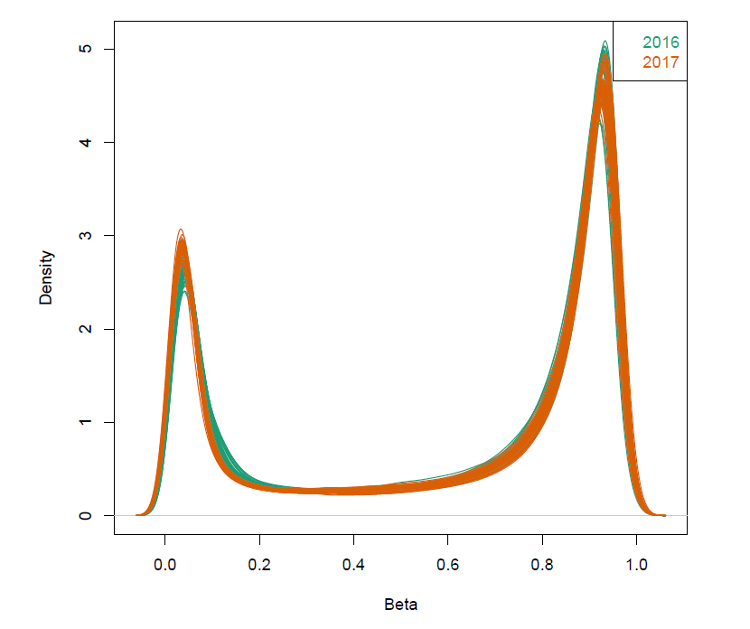

Supplementary Figure 1. Preprocessing using noob normalisation. The distribution of individuals as displayed as lines were plotted based on beta density post normalisation using noob. Data coloured based on year the measurements took place; 2016 (green) or 2017 (orange).

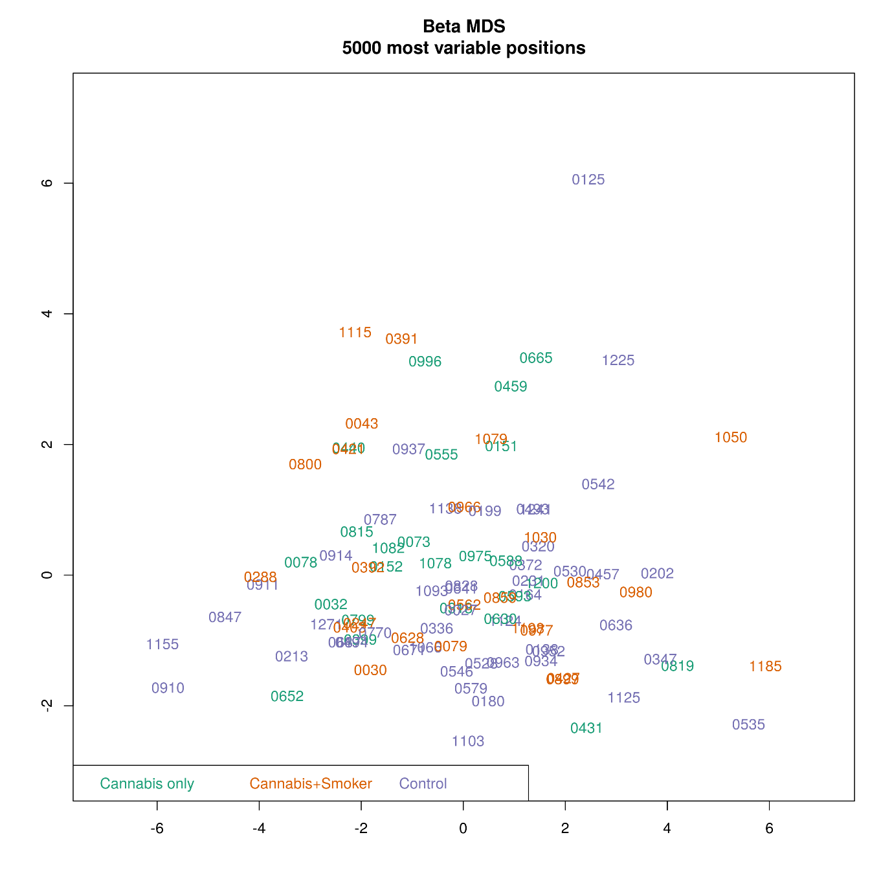
Supplementary Figure 2. A multidimensional plot displaying the 5000 most variable positions post normalisation using noob. Individuals are grouped in colour by status: cannabis-only users (green), cannabis with tobacco (orange) or control (purple).

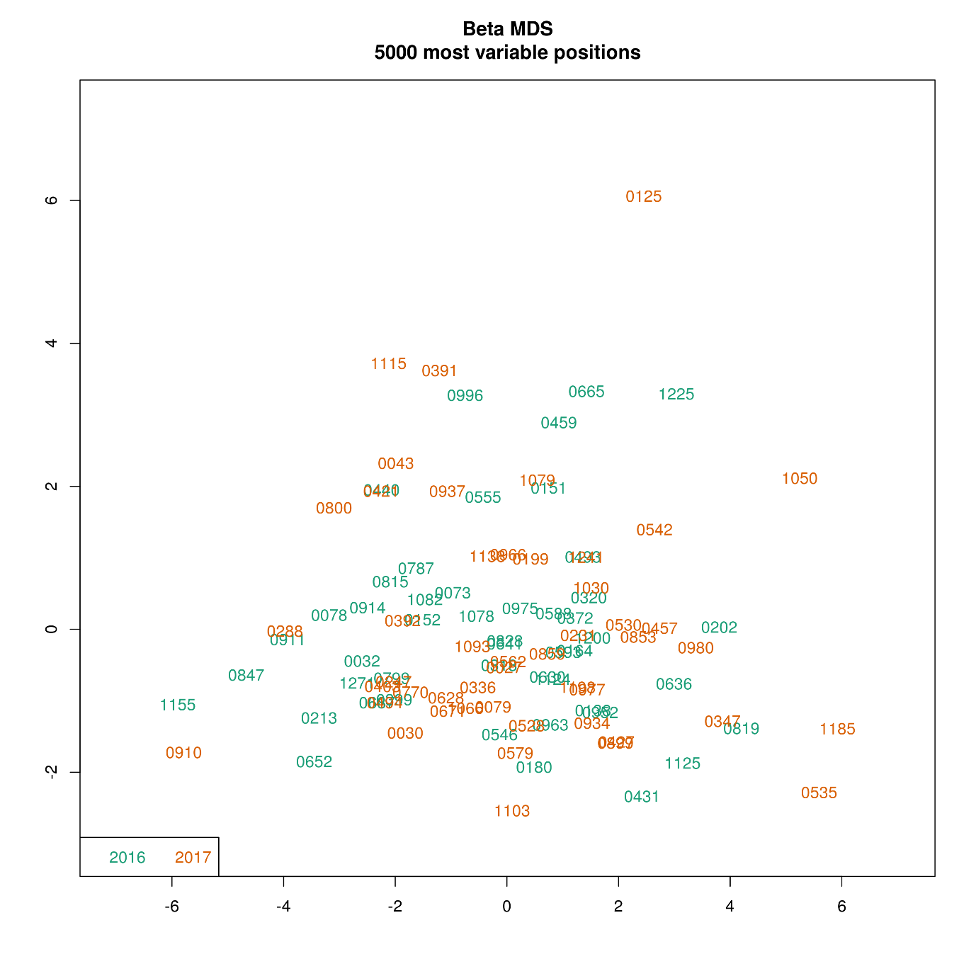
Supplementary Figure 3. A multidimensional plot displaying the 5000 most variable positions post normalisation using noob. Individuals are coloured on year the measurements were collected.

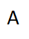
B
Supplementary Figure 4. Quantile- quantile plots. Quantile plots were used to assess for overfitting of models. A) Cannabis-only vs control samples B) Cannabis with tobacco vs control. Each dot displays the expected –log10 (p-values) under the model.

