Supplementary Appendix

“Complex models, marginal benefits--a multi-centre development and validation study of early warning scores across 2·16 million patient admissions addressing intercurrent medical interventions”

Corresponding author: alexandros.katsiferis@sund.ku.dk

Supplementary Table 1. 2
Supplementary Table 2. 3
Supplementary Table 3. 4
Supplementary Figure 1. 5
Supplementary Figure 2. 6
Supplementary Figure 3. 7
Supplementary Figure 4. 8
Supplementary Figure 5. 9
Supplementary Figure 6. 10
Supplementary Table 4. 11
Supplementary Table 5. 12
Supplementary Table 6. 14
Supplementary Table 7. 17
Supplementary Table 8. 18

Variable | Missing (N) | Missing (%)
Age | 0 | 0·0
Sex | 0 | 0·0
Previous hospitalizations | 0 | 0·0
Hospital | 30 307 | 1·4
Consciousness | 5 775 | 0·3
Supplemental oxygen | 699 | 0·0
Respiratory rate (breaths/min) | 5 792 | 0·3
Pulse (beats/min) | 5 284 | 0·2
Temperature (°C) | 6 898 | 0·3
Oxygen saturation (%) | 5 437 | 0·3
Systolic blood pressure (mm Hg) | 4 828 | 0·2
Diastolic blood pressure (mm Hg) | 6 181 | 0·3
Previous ICU/respiratory support | 0 | 0·0
NEWS score | 9 083 | 0·4
Day of initial NEWS measurement (Weekday/Weekend) | 0 | 0·0
Time of the day of initial NEWS measurement (Morning / Afternoon or Evening / Night) | 0 | 0·0
Month of initial NEWS measurement | 0 | 0·0
Embedding score | 0 | 0·0
Hemoglobin (g/L) | 560 672 | 25·9
Leukocytes (×10⁹/L) | 616 231 | 28·5
Platelets (×10⁹/L) | 650 114 | 30·1
Creatinine (μmol/L) | 552 387 | 25·6
Alanine aminotransferase (U/L) | 605 480 | 28·0
Lactate dehydrogenase (U/L) | 886 658 | 41·0
Albumin (g/L) | 748 087 | 34·6
C-reactive protein (mg/L) | 667 607 | 30·9
Lactate, arterial blood (mmol/L) | 1 757 081 | 81·3
Troponin T (ng/L) | 2 010 430 | 93·0
Lactate, venous blood (mmol/L) | 1 995 986 | 92·3
Variables related to previous data have a maximum lookback period of five years
The hematological and biochemical markers are historical averages

Supplementary Table 1.
Missing data summary of variables used in modelling

Parameter | NEWS | NEWS-Light | DEWS
Respiratory Rate (breaths/min)
≤8 | 3 | 3 | —
9-11 | 1 | 1 | —
12-20 | 0 | 0 | 0
21-24 | 2 | 2 | 2
≥25 | 3 | 3 | 3
Oxygen Saturation (%)
≤91 | 3 | 3 | 3
92-93 | 2 | 2 | 1
94-95 | 1 | 1 | 1
≥96 | 0 | 0 | 0
Supplemental Oxygen
Air | 0 | 0 | 0
Oxygen | 2 | 2 | 1
Systolic Blood Pressure (mmHg)
≤90 | 3 | — | —
91-100 | 2 | — | —
101-110 | 1 | — | —
111-219 | 0 | — | —
≥220 | 3 | — | —
Pulse Rate (beats/min)
≤40 | 3 | 3 | —
41-50 | 1 | 1 | 1
51-90 | 0 | 0 | 0
91-110 | 1 | 1 | 1
111-130 | 2 | 2 | 2
≥131 | 3 | 3 | 2
Level of Consciousness
Alert | 0 | 0 | 0
Voice/Pain/Unresponsive | 3 | 3 | 5
Temperature (°C)
≤35·0 | 3 | — | —
35·1-36·0 | 1 | — | —
36·1-38·0 | 0 | — | —
38·1-39·0 | 1 | — | —
≥39·1 | 2 | — | —
Sex
Female | — | — | 0
Male | — | — | 1
Age (years)
<41 | — | — | 0
41-50 | — | — | 1
51-60 | — | — | 2
61-65 | — | — | 3
66-75 | — | — | 4
76-80 | — | — | 5
81-90 | — | — | 6
≥91 | — | — | 7
Total Score Range
0-20 | 0-20 | 0-14 | 0-22
— indicates parameter not included in scoring system. All scoring systems used the first recorded vital sign measurement per hospitalization.

Supplementary Table 2.
Analytical description of the scoring systems used in the current study
Parameter | Parameter Name | Value
`tree_depth` | Maximum Tree Depth | 6
`trees` | Number of Trees | 100
`learn_rate` | Learning Rate | 0·3
`mtry` | Predictors per Split | 30
`min_n` | Minimal Node Size | 1
`loss_reduction` | Minimum Loss Reduction | 0
`sample_size` | Proportion of Data Sampled | 1
Default values from the tidymodels engine were used, with the exception of 'Number of Trees' and 'Predictors per Split'.

Supplementary Table 3.
XGB-EWS hyperparameter configuration

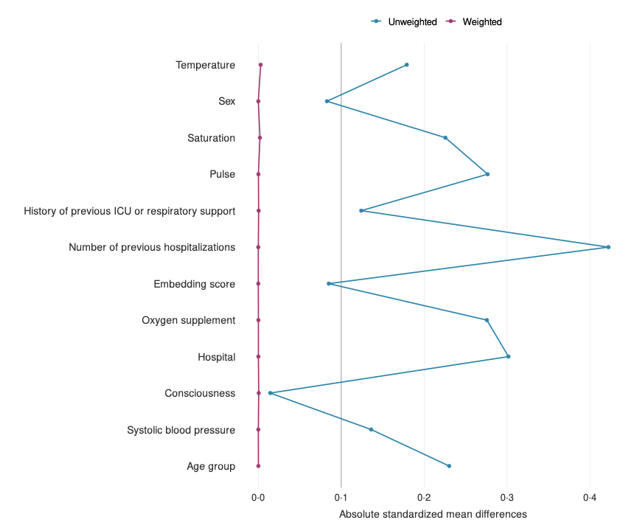
Supplementary Figure 1.
Covariate balance assessment before and after the weighting. Absolute standardized mean differences between treatment groups are shown for key baseline covariates before (unweighted, blue) and after (weighted, red) weighting. Each point represents the standardized mean difference for the corresponding covariate listed on the y-axis.

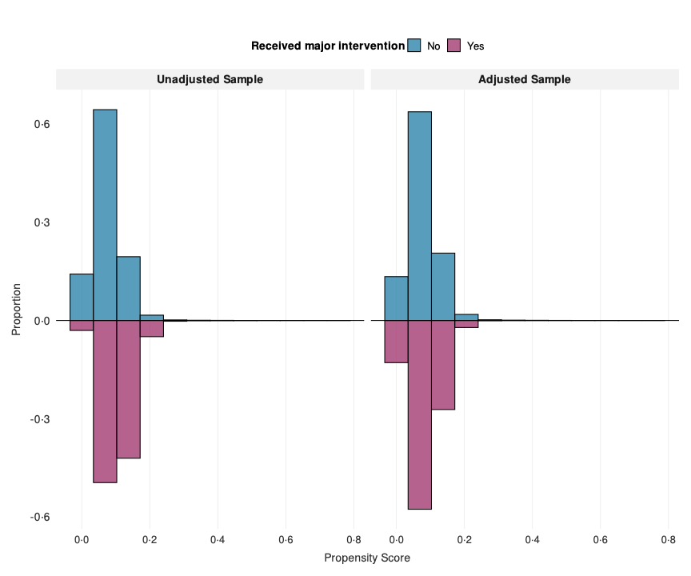
Supplementary Figure 2.
Distribution of propensity scores before and after inverse probability weighting. Propensity score distributions for patients who did and did not receive major clinical interventions within 24 hours, shown before (left panel) and after (right panel) applying inverse probability weighting. Propensity scores represent the predicted probability of receiving major interventions based on baseline characteristics including age, sex, hospital, vital signs, medical history, and clinical embedding scores. The mirrored histogram displays the proportion of patients (y-axis) across propensity score values (x-axis). Blue bars represent patients who did not receive major interventions; purple bars represent patients who received major interventions. Successful balancing is demonstrated by the similar distributions between groups in the weighted sample (right panel) compared to the substantial overlap reduction in the unweighted sample (left panel).

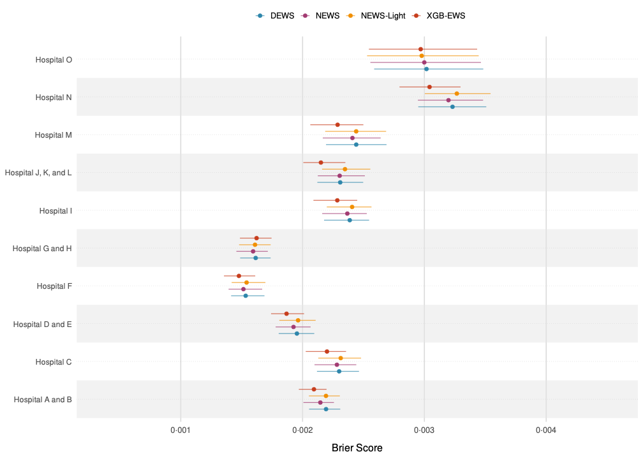
Supplementary Figure 3.
Forest plot of hospital-specific predictive performance of EWS algorithms. The Brier Score with 95% confidence intervals for predicting 24-hour mortality across the 10 hospital clusters is illustrated. Each point represents the Brier Score of the four prediction models within individual hospital settings. Confidence intervals were calculated using 200 bootstrap resamples with the percentile method (2·5th and 97·5th percentiles). The four models evaluated were XGB-EWS, DEWS, NEWS, and NEWS-Light, all of which were assessed across all participating hospitals in the study’s hospital network.

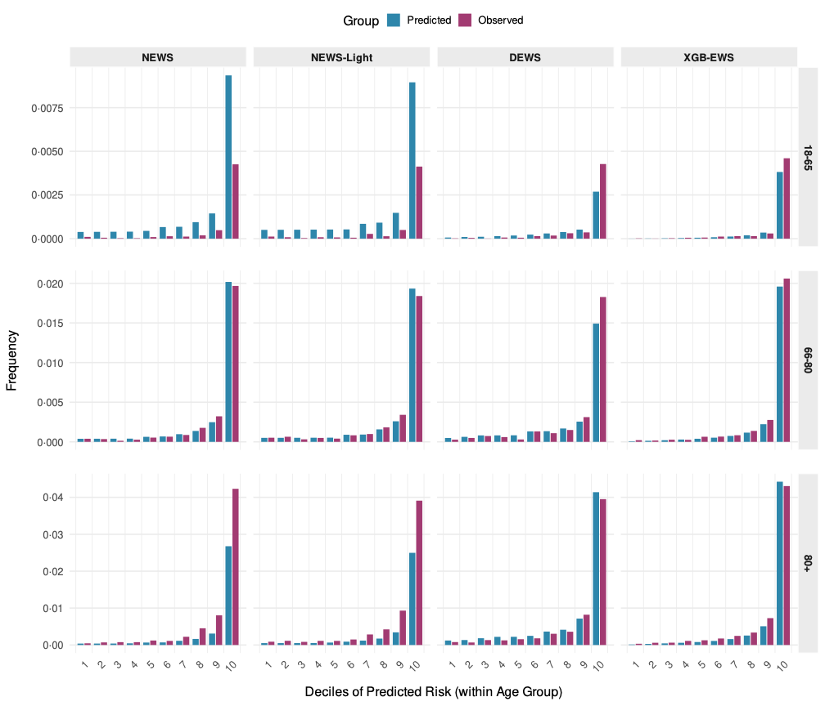
Supplementary Figure 4.
Model calibration by age group. Calibration performance comparing predicted versus observed 24-hour mortality frequencies across deciles of predicted risk for all four models across the three age groups of the study. Patients were divided into ten equal groups (deciles) based on predicted risk, with predicted frequencies (blue bars) compared against observed mortality frequencies (purple bars) within each decile. Perfect calibration is indicated when predicted and observed frequencies align closely. Frequencies were calculated using inverse probability weights to reflect the target population.

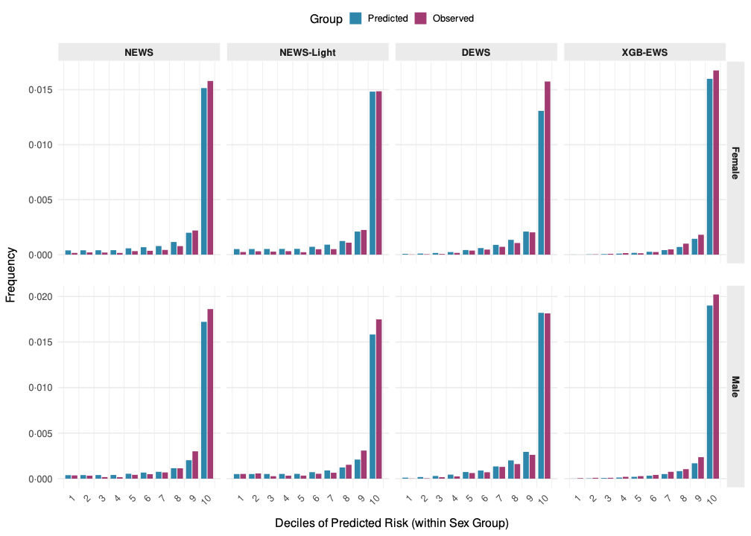
Supplementary Figure 5.
Model calibration across sexes. Calibration performance comparing predicted versus observed 24-hour mortality frequencies across deciles of predicted risk for all four models across males and females of the study. Patients were divided into ten equal groups (deciles) based on predicted risk, with predicted frequencies (blue bars) compared against observed mortality frequencies (purple bars) within each decile. Perfect calibration is indicated when predicted and observed frequencies align closely. Frequencies were calculated using inverse probability weights to reflect the target population.

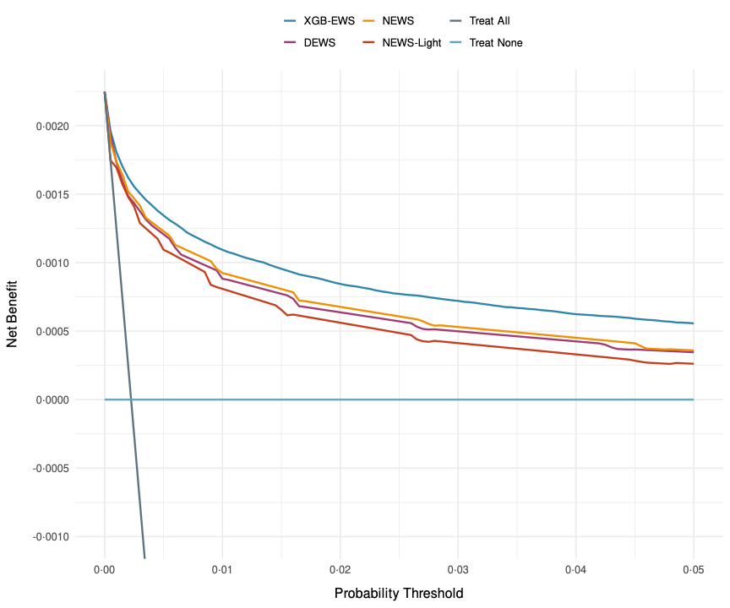
Supplementary Figure 6.
Decision curve analysis comparing model performance across probability thresholds. The Net Benefit is plotted against probability/risk thresholds for the four predictive models (XGB-EWS in blue, NEWS in orange, DEWS in purple, NEWS-Light in red) compared to two reference strategies: “Treat All” (dark gray) and “Treat None” (light blue horizontal line). The Decision curve analysis evaluates the potential clinical utility of prediction models by weighing the benefits of true positive classifications against the harms of false positive classifications at different probability thresholds. Models with curves above the reference strategies indicate potential clinical utility, with higher curves representing greater Net Benefit at the corresponding threshold.

 | Net Benefit per 10 000 Patients |  |  |  |  | Net Benefit Difference per 10 000 Patients
Risk Threshold | Treat All | Treat None | NEWS | NEWS-Light | XGB-EWS | NEWS vs. XGB-EWS | NEWS vs. NEWS-Light
18-65
0·0005 | 0·0 | 0·0 | 2·4 | 2·9 | 4·0 | -1·6 | -0·5
0·0011 | -5·4 | 0·0 | 2·1 | 2·6 | 3·6 | -1·5 | -0·5
0·0022 | -16·2 | 0·0 | 2·5 | 2·1 | 3·2 | -0·7 | 0·4
0·0043 | -38·0 | 0·0 | 1·8 | 1·4 | 2·8 | -1·0 | 0·4
0·0054 | -48·9 | 0·0 | 1·4 | 1·5 | 2·6 | -1·2 | -0·1
0·0108 | -103·8 | 0·0 | 1·3 | 0·8 | 2·1 | -0·8 | 0·5
0·0162 | -159·3 | 0·0 | 0·7 | 0·7 | 1·7 | -1·0 | 0·0
66-80
0·0027 | 0·0 | 0·0 | 17·4 | 16·3 | 17·7 | -0·3 | 1·1
0·0055 | -27·5 | 0·0 | 14·1 | 12·7 | 15·0 | -0·9 | 1·4
0·0109 | -82·8 | 0·0 | 10·6 | 9·2 | 12·0 | -1·4 | 1·4
0·0218 | -195·4 | 0·0 | 7·5 | 6·3 | 8·8 | -1·3 | 1·2
0·0273 | -252·6 | 0·0 | 6·5 | 5·3 | 7·9 | -1·4 | 1·2
0·0546 | -548·7 | 0·0 | 4·0 | 3·1 | 5·4 | -1·4 | 0·9
0·0819 | -862·4 | 0·0 | 3·1 | 1·9 | 4·2 | -1·1 | 1·2
80+
0·0062 | 0·0 | 0·0 | 34·2 | 32·5 | 38·0 | -3·8 | 1·7
0·0123 | -62·3 | 0·0 | 27·3 | 24·4 | 31·0 | -3·7 | 2·9
0·0246 | -189·4 | 0·0 | 20·4 | 17·0 | 24·4 | -4·0 | 3·4
0·0493 | -453·4 | 0·0 | 11·8 | 8·5 | 18·0 | -6·2 | 3·3
0·0616 | -590·6 | 0·0 | 10·8 | 7·6 | 15·5 | -4·7 | 3·2
0·1232 | -1 334·3 | 0·0 | 5·6 | 3·7 | 9·8 | -4·2 | 1·9
0·1847 | -2 190·4 | 0·0 | 3·9 | 2·3 | 6·1 | -2·2 | 1·6
Positive values indicate NEWS has higher net benefit, whereas negative values indicate the comparator is better. Risk thresholds are chosen as multiples of the age-specific prevalence.

Supplementary Table 4.
Net Benefit comparison of different strategies and models across age groups at specified risk thresholds.

 | Net Benefit per 10 000 Patients |  |  |  |  | Net Benefit Difference per 10 000 Patients
Risk Threshold | Treat All | Treat None | NEWS | NEWS-Light | XGB-EWS | NEWS vs. XGB-EWS | NEWS vs. NEWS-Light
Female
0·0020 | 0·0 | 0·0 | 13·6 | 13·2 | 14·5 | -0·9 | 0·4
0·0040 | -20·1 | 0·0 | 11·7 | 10·9 | 12·7 | -1·0 | 0·8
0·0080 | -60·7 | 0·0 | 9·5 | 8·6 | 10·6 | -1·1 | 0·9
0·0161 | -142·8 | 0·0 | 6·7 | 5·5 | 8·3 | -1·6 | 1·2
0·0201 | -184·3 | 0·0 | 6·0 | 4·9 | 7·5 | -1·5 | 1·1
0·0401 | -397·2 | 0·0 | 4·0 | 2·7 | 5·6 | -1·6 | 1·3
0·0602 | -619·3 | 0·0 | 2·8 | 1·9 | 4·5 | -1·7 | 0·9
Male
0·0025 | 0·0 | 0·0 | 16·3 | 15·7 | 17·3 | -1·0 | 0·6
0·0050 | -25·0 | 0·0 | 13·6 | 12·0 | 14·9 | -1·3 | 1·6
0·0100 | -75·4 | 0·0 | 10·1 | 9·0 | 12·0 | -1·9 | 1·1
0·0199 | -177·8 | 0·0 | 7·5 | 6·3 | 9·4 | -1·9 | 1·2
0·0249 | -229·8 | 0·0 | 6·8 | 5·6 | 8·5 | -1·7 | 1·2
0·0498 | -497·9 | 0·0 | 4·0 | 3·0 | 6·1 | -2·1 | 1·0
0·0747 | -780·3 | 0·0 | 2·8 | 1·9 | 4·7 | -1·9 | 0·9
Positive values indicate NEWS has higher net benefit, whereas negative values indicate the comparator is better. Risk thresholds are chosen as multiples of the sex-specific prevalence.

Supplementary Table 5.
Net benefit comparison of different strategies and models across sex groups at specified risk thresholds.

 | Net Benefit per 10 000 Patients |  |  |  |  | Net Benefit Difference per 10 000 Patients
Risk Threshold | Treat All | Treat None | NEWS | NEWS-Light | XGB-EWS | NEWS vs. XGB-EWS | NEWS vs. NEWS-Light
Cardiopulmonary
0·0016 | 0·0 | 0·0 | 9·4 | 8·9 | 10·3 | -0·9 | 0·5
0·0031 | -15·7 | 0·0 | 6·9 | 6·2 | 8·6 | -1·7 | 0·7
0·0063 | -47·3 | 0·0 | 5·0 | 3·8 | 6·9 | -1·9 | 1·2
0·0125 | -111·2 | 0·0 | 2·9 | 1·6 | 4·7 | -1·8 | 1·3
0·0157 | -143·4 | 0·0 | 1·9 | 1·4 | 4·1 | -2·2 | 0·5
0·0314 | -307·6 | 0·0 | 0·9 | -0·2 | 3·0 | -2·1 | 1·1
0·0470 | -477·2 | 0·0 | -0·2 | -0·9 | 2·0 | -2·2 | 0·7
Critical Care
0·0006 | 0·0 | 0·0 | 2·0 | 2·8 | 4·6 | -2·6 | -0·8
0·0013 | -6·3 | 0·0 | 3·2 | 1·8 | 4·0 | -0·8 | 1·4
0·0025 | -19·0 | 0·0 | 2·7 | 2·0 | 4·0 | -1·3 | 0·7
0·0051 | -44·5 | 0·0 | 2·2 | 2·7 | 3·6 | -1·4 | -0·5
0·0063 | -57·2 | 0·0 | 3·0 | 2·3 | 3·6 | -0·6 | 0·7
0·0126 | -121·6 | 0·0 | 1·9 | 1·8 | 3·0 | -1·1 | 0·1
0·0190 | -186·8 | 0·0 | 1·3 | 0·9 | 1·9 | -0·6 | 0·4
Gastroenterology
0·0014 | 0·0 | 0·0 | 8·0 | 8·0 | 9·7 | -1·7 | 0·0
0·0028 | -14·1 | 0·0 | 7·6 | 6·0 | 6·9 | 0·7 | 1·6
0·0056 | -42·4 | 0·0 | 5·4 | 4·4 | 6·3 | -0·9 | 1·0
0·0112 | -99·5 | 0·0 | 4·4 | 2·5 | 4·8 | -0·4 | 1·9
0·0140 | -128·2 | 0·0 | 3·7 | 1·7 | 4·7 | -1·0 | 2·0
0·0281 | -274·6 | 0·0 | 1·5 | 0·9 | 2·8 | -1·3 | 0·6
0·0421 | -425·3 | 0·0 | 0·3 | -0·3 | 1·9 | -1·6 | 0·6
Geriatrics & Palliative
0·0017 | 0·0 | 0·0 | 10·9 | 10·7 | 9·0 | 1·9 | 0·2
0·0033 | -16·6 | 0·0 | 8·4 | 7·9 | 7·4 | 1·0 | 0·5
0·0066 | -49·8 | 0·0 | 7·7 | 5·1 | 4·4 | 3·3 | 2·6
0·0132 | -117·1 | 0·0 | 5·8 | 1·5 | 3·4 | 2·4 | 4·3
0·0165 | -151·0 | 0·0 | 4·3 | 3·6 | 3·3 | 1·0 | 0·7
0·0330 | -324·2 | 0·0 | 2·9 | 0·9 | 2·9 | 0·0 | 2·0
0·0495 | -503·5 | 0·0 | 2·8 | 1·7 | 2·1 | 0·7 | 1·1
Internal & Acute Medicine
0·0028 | 0·0 | 0·0 | 18·5 | 17·7 | 19·4 | -0·9 | 0·8
0·0055 | -27·7 | 0·0 | 15·7 | 14·0 | 16·9 | -1·2 | 1·7
0·0110 | -83·5 | 0·0 | 11·9 | 10·5 | 13·8 | -1·9 | 1·4
0·0220 | -197·1 | 0·0 | 9·0 | 7·4 | 10·8 | -1·8 | 1·6
0·0275 | -254·9 | 0·0 | 7·7 | 6·0 | 10·0 | -2·3 | 1·7
0·0551 | -553·7 | 0·0 | 5·0 | 3·6 | 7·0 | -2·0 | 1·4
0·0826 | -870·5 | 0·0 | 3·8 | 2·4 | 5·5 | -1·7 | 1·4
Nephrology
0·0014 | 0·0 | 0·0 | 9·4 | 8·8 | 9·1 | 0·3 | 0·6
0·0028 | -13·9 | 0·0 | 7·6 | 7·8 | 7·6 | 0·0 | -0·2
0·0055 | -41·9 | 0·0 | 5·2 | 4·1 | 4·2 | 1·0 | 1·1
0·0111 | -98·2 | 0·0 | 2·6 | 2·2 | 3·9 | -1·3 | 0·4
0·0139 | -126·6 | 0·0 | 1·9 | 1·5 | 3·3 | -1·4 | 0·4
0·0277 | -271·1 | 0·0 | 1·6 | 0·3 | 2·5 | -0·9 | 1·3
0·0416 | -419·8 | 0·0 | -0·2 | -0·9 | 1·5 | -1·7 | 0·7
Neurology
0·0019 | 0·0 | 0·0 | 13·7 | 13·0 | 13·0 | 0·7 | 0·7
0·0038 | -19·2 | 0·0 | 9·6 | 9·3 | 11·4 | -1·8 | 0·3
0·0076 | -57·7 | 0·0 | 6·4 | 7·9 | 8·7 | -2·3 | -1·5
0·0153 | -135·8 | 0·0 | 4·2 | 3·2 | 6·9 | -2·7 | 1·0
0·0191 | -175·3 | 0·0 | 2·8 | 3·0 | 5·4 | -2·6 | -0·2
0·0382 | -377·4 | 0·0 | 1·0 | 0·6 | 3·3 | -2·3 | 0·4
0·0573 | -587·7 | 0·0 | 0·6 | 0·4 | 2·1 | -1·5 | 0·2
Oncology & Hematology
0·0019 | 0·0 | 0·0 | 11·9 | 11·3 | 12·2 | -0·3 | 0·6
0·0039 | -19·5 | 0·0 | 10·1 | 9·4 | 9·8 | 0·3 | 0·7
0·0078 | -58·8 | 0·0 | 7·7 | 6·8 | 7·7 | 0·0 | 0·9
0·0156 | -138·3 | 0·0 | 5·5 | 4·0 | 5·8 | -0·3 | 1·5
0·0194 | -178·5 | 0·0 | 4·0 | 3·0 | 4·4 | -0·4 | 1·0
0·0389 | -384·5 | 0·0 | 1·5 | 1·7 | 3·1 | -1·6 | -0·2
0·0583 | -599·0 | 0·0 | 1·2 | 0·7 | 2·8 | -1·6 | 0·5
Surgical
0·0011 | 0·0 | 0·0 | 7·0 | 7·1 | 8·0 | -1·0 | -0·1
0·0022 | -11·0 | 0·0 | 6·3 | 5·9 | 6·9 | -0·6 | 0·4
0·0044 | -33·1 | 0·0 | 5·1 | 4·3 | 5·6 | -0·5 | 0·8
0·0088 | -77·6 | 0·0 | 3·9 | 3·2 | 4·5 | -0·6 | 0·7
0·0110 | -100·0 | 0·0 | 3·1 | 2·7 | 4·1 | -1·0 | 0·4
0·0220 | -213·6 | 0·0 | 1·9 | 1·6 | 2·8 | -0·9 | 0·3
0·0330 | -329·7 | 0·0 | 1·1 | 1·0 | 2·2 | -1·1 | 0·1
Positive values indicate NEWS has higher net benefit, whereas negative values indicate the comparator is better. Risk thresholds are chosen as multiples of the clinical specialty-specific prevalence.

Supplementary Table 6.
Net Benefit comparison of different strategies and models across clinical specialties at specified risk thresholds.

 | Net Benefit per 10,000 Patients |  |  |  |  | Net Benefit Difference per 10,000 Patients
Risk Threshold | Treat All | Treat None | NEWS | NEWS-Light | XGB-EWS | NEWS vs. XGB-EWS | NEWS vs. NEWS-Light
Certain infectious and parasitic diseases
0·0039 | 0·0 | 0·0 | 25·2 | 24·8 | 27·1 | -1·9 | 0·4
0·0078 | -39·5 | 0·0 | 22·1 | 21·1 | 23·2 | -1·1 | 1·0
0·0157 | -119·5 | 0·0 | 17·9 | 15·3 | 19·7 | -1·8 | 2·6
0·0314 | -283·3 | 0·0 | 13·8 | 11·1 | 15·0 | -1·2 | 2·7
0·0392 | -367·2 | 0·0 | 12·2 | 9·8 | 13·2 | -1·0 | 2·4
0·0784 | -808·2 | 0·0 | 7·4 | 3·8 | 9·1 | -1·7 | 3·6
0·1176 | -1 288·4 | 0·0 | 4·2 | 2·5 | 6·9 | -2·7 | 1·7
Diseases of the blood and blood-forming organs and certain disorders involving the immune mechanism
0·0034 | 0·0 | 0·0 | 22·3 | 19·1 | 21·2 | 1·1 | 3·2
0·0068 | -34·2 | 0·0 | 18·9 | 13·4 | 19·3 | -0·4 | 5·5
0·0136 | -103·2 | 0·0 | 13·3 | 12·0 | 15·1 | -1·8 | 1·3
0·0272 | -244·2 | 0·0 | 7·8 | 4·0 | 10·7 | -2·9 | 3·8
0·0339 | -316·2 | 0·0 | 7·0 | 3·8 | 8·7 | -1·7 | 3·2
0·0679 | -691·9 | 0·0 | 2·9 | 3·3 | 6·0 | -3·1 | -0·4
0·1018 | -1 095·9 | 0·0 | 3·1 | 2·2 | 2·9 | 0·2 | 0·9
Diseases of the circulatory system
0·0040 | 0·0 | 0·0 | 22·9 | 21·5 | 27·1 | -4·2 | 1·4
0·0079 | -39·9 | 0·0 | 18·8 | 17·4 | 23·2 | -4·4 | 1·4
0·0158 | -120·7 | 0·0 | 14·4 | 9·4 | 18·7 | -4·3 | 5·0
0·0317 | -286·2 | 0·0 | 8·6 | 6·3 | 13·9 | -5·3 | 2·3
0·0396 | -371·0 | 0·0 | 8·0 | 5·6 | 12·5 | -4·5 | 2·4
0·0792 | -817·0 | 0·0 | 4·5 | 2·5 | 8·1 | -3·6 | 2·0
0·1188 | -1 303·0 | 0·0 | 3·6 | 1·6 | 6·5 | -2·9 | 2·0
Diseases of the digestive system
0·0020 | 0·0 | 0·0 | 12·0 | 11·6 | 12·8 | -0·8 | 0·4
0·0040 | -19·9 | 0·0 | 10·3 | 9·7 | 10·4 | -0·1 | 0·6
0·0079 | -59·9 | 0·0 | 8·3 | 7·2 | 8·4 | -0·1 | 1·1
0·0158 | -140·8 | 0·0 | 6·7 | 4·2 | 7·1 | -0·4 | 2·5
0·0198 | -181·7 | 0·0 | 4·9 | 3·9 | 6·0 | -1·1 | 1·0
0·0396 | -391·6 | 0·0 | 2·9 | 1·7 | 4·2 | -1·3 | 1·2
0·0594 | -610·3 | 0·0 | 1·9 | 0·9 | 3·4 | -1·5 | 1·0
Diseases of the ear and mastoid process
0·0001 | 0·0 | 0·0 | 0·0 | 0·0 | 0·6 | -0·6 | 0·0
0·0002 | -1·2 | 0·0 | -1·2 | -1·2 | 0·4 | -1·6 | 0·0
0·0005 | -3·6 | 0·0 | -0·9 | -3·6 | 0·4 | -1·3 | 2·7
0·0010 | -8·4 | 0·0 | -0·4 | 0·1 | 0·4 | -0·8 | -0·5
0·0012 | -10·8 | 0·0 | 0·3 | -0·1 | 0·5 | -0·2 | 0·4
0·0024 | -22·8 | 0·0 | 0·5 | 0·1 | 0·5 | 0·0 | 0·4
0·0036 | -34·9 | 0·0 | 0·6 | 0·6 | 0·6 | 0·0 | 0·0
Diseases of the eye and adnexa
0·0006 | 0·0 | 0·0 | 3·4 | 4·0 | 4·7 | -1·3 | -0·6
0·0012 | -5·9 | 0·0 | 4·8 | 4·4 | 4·7 | 0·1 | 0·4
0·0024 | -17·7 | 0·0 | 4·8 | 4·4 | 4·8 | 0·0 | 0·4
0·0047 | -41·3 | 0·0 | 2·9 | 4·5 | 4·7 | -1·8 | -1·6
0·0059 | -53·2 | 0·0 | 3·2 | 3·1 | 4·7 | -1·5 | 0·1
0·0118 | -113·0 | 0·0 | 3·1 | 3·0 | 4·7 | -1·6 | 0·1
0·0176 | -173·4 | 0·0 | 1·3 | 1·4 | 2·9 | -1·6 | -0·1
Diseases of the genitourinary system
0·0016 | 0·0 | 0·0 | 10·3 | 9·7 | 11·1 | -0·8 | 0·6
0·0033 | -16·4 | 0·0 | 8·4 | 7·1 | 9·0 | -0·6 | 1·3
0·0065 | -49·3 | 0·0 | 6·1 | 5·8 | 7·6 | -1·5 | 0·3
0·0131 | -115·9 | 0·0 | 4·5 | 3·6 | 6·1 | -1·6 | 0·9
0·0163 | -149·5 | 0·0 | 4·0 | 2·6 | 5·6 | -1·6 | 1·4
0·0327 | -320·9 | 0·0 | 2·6 | 1·0 | 4·7 | -2·1 | 1·6
0·0490 | -498·3 | 0·0 | 1·1 | 0·7 | 3·5 | -2·4 | 0·4
Diseases of the musculoskeletal system and connective tissue
0·0009 | 0·0 | 0·0 | 6·5 | 4·8 | 7·2 | -0·7 | 1·7
0·0018 | -8·8 | 0·0 | 6·3 | 6·0 | 6·7 | -0·4 | 0·3
0·0035 | -26·4 | 0·0 | 5·1 | 4·8 | 6·2 | -1·1 | 0·3
0·0070 | -61·7 | 0·0 | 4·2 | 3·8 | 4·9 | -0·7 | 0·4
0·0088 | -79·5 | 0·0 | 3·9 | 2·8 | 4·5 | -0·6 | 1·1
0·0175 | -169·4 | 0·0 | 2·2 | 1·7 | 2·7 | -0·5 | 0·5
0·0263 | -260·9 | 0·0 | 1·7 | 1·3 | 1·8 | -0·1 | 0·4
Diseases of the nervous system
0·0011 | 0·0 | 0·0 | 7·5 | 7·6 | 8·4 | -0·9 | -0·1
0·0022 | -10·8 | 0·0 | 6·3 | 6·6 | 7·4 | -1·1 | -0·3
0·0043 | -32·5 | 0·0 | 4·8 | 4·8 | 5·4 | -0·6 | 0·0
0·0086 | -76·2 | 0·0 | 3·0 | 2·7 | 3·2 | -0·2 | 0·3
0·0108 | -98·2 | 0·0 | 2·5 | 2·6 | 3·2 | -0·7 | -0·1
0·0216 | -209·5 | 0·0 | -0·1 | 0·5 | 1·9 | -2·0 | -0·6
0·0324 | -323·4 | 0·0 | 0·2 | -0·2 | 1·9 | -1·7 | 0·4
Diseases of the respiratory system
0·0040 | 0·0 | 0·0 | 23·9 | 22·7 | 26·3 | -2·4 | 1·2
0·0080 | -40·1 | 0·0 | 17·6 | 16·2 | 20·7 | -3·1 | 1·4
0·0159 | -121·4 | 0·0 | 11·6 | 11·7 | 16·1 | -4·5 | -0·1
0·0319 | -287·9 | 0·0 | 8·7 | 6·8 | 11·9 | -3·2 | 1·9
0·0398 | -373·2 | 0·0 | 6·2 | 3·7 | 9·7 | -3·5 | 2·5
0·0796 | -822·0 | 0·0 | 4·2 | 1·7 | 5·8 | -1·6 | 2·5
0·1194 | -1 311·3 | 0·0 | 0·5 | -0·3 | 3·6 | -3·1 | 0·8
Diseases of the skin and subcutaneous tissue
0·0007 | 0·0 | 0·0 | 3·9 | 3·6 | 5·1 | -1·2 | 0·3
0·0013 | -6·7 | 0·0 | 4·7 | 4·1 | 5·0 | -0·3 | 0·6
0·0027 | -20·3 | 0·0 | 4·5 | 3·7 | 4·3 | 0·2 | 0·8
0·0054 | -47·4 | 0·0 | 4·3 | 4·4 | 3·7 | 0·6 | -0·1
0·0067 | -61·1 | 0·0 | 4·3 | 4·1 | 3·7 | 0·6 | 0·2
0·0135 | -129·8 | 0·0 | 4·0 | 3·9 | 3·8 | 0·2 | 0·1
0·0202 | -199·5 | 0·0 | 3·7 | 2·5 | 3·8 | -0·1 | 1·2
Endocrine, nutritional and metabolic diseases
0·0027 | 0·0 | 0·0 | 15·2 | 15·2 | 17·6 | -2·4 | 0·0
0·0054 | -27·3 | 0·0 | 12·9 | 9·3 | 15·2 | -2·3 | 3·6
0·0109 | -82·4 | 0·0 | 8·6 | 6·7 | 12·0 | -3·4 | 1·9
0·0217 | -194·4 | 0·0 | 6·6 | 4·2 | 8·0 | -1·4 | 2·4
0·0272 | -251·4 | 0·0 | 5·8 | 2·8 | 7·0 | -1·2 | 3·0
0·0543 | -545·9 | 0·0 | 3·1 | 2·1 | 4·1 | -1·0 | 1·0
0·0815 | -857·9 | 0·0 | 1·3 | 1·5 | 2·6 | -1·3 | -0·2
Factors influencing health status and contact with health services
0·0020 | 0·0 | 0·0 | 13·2 | 13·3 | 14·0 | -0·8 | -0·1
0·0040 | -20·3 | 0·0 | 11·4 | 11·2 | 12·3 | -0·9 | 0·2
0·0081 | -61·1 | 0·0 | 9·2 | 8·6 | 10·1 | -0·9 | 0·6
0·0162 | -143·7 | 0·0 | 6·6 | 5·4 | 7·7 | -1·1 | 1·2
0·0202 | -185·5 | 0·0 | 6·0 | 4·9 | 7·0 | -1·0 | 1·1
0·0404 | -399·8 | 0·0 | 4·2 | 2·8 | 4·8 | -0·6 | 1·4
0·0606 | -623·3 | 0·0 | 2·4 | 1·8 | 3·4 | -1·0 | 0·6
Injury, poisoning and certain other consequences of external causes
0·0015 | 0·0 | 0·0 | 10·4 | 9·5 | 10·8 | -0·4 | 0·9
0·0030 | -15·1 | 0·0 | 8·9 | 8·0 | 9·5 | -0·6 | 0·9
0·0060 | -45·4 | 0·0 | 6·7 | 6·3 | 7·6 | -0·9 | 0·4
0·0120 | -106·5 | 0·0 | 5·4 | 4·8 | 6·1 | -0·7 | 0·6
0·0150 | -137·3 | 0·0 | 5·0 | 4·2 | 5·6 | -0·6 | 0·8
0·0301 | -294·4 | 0·0 | 3·1 | 3·0 | 4·3 | -1·2 | 0·1
0·0451 | -456·4 | 0·0 | 2·3 | 2·1 | 3·7 | -1·4 | 0·2
Mental, Behavioral and Neurodevelopmental disorders
0·0012 | 0·0 | 0·0 | 4·3 | 4·4 | 6·7 | -2·4 | -0·1
0·0023 | -11·6 | 0·0 | 4·0 | 3·1 | 6·5 | -2·5 | 0·9
0·0046 | -34·9 | 0·0 | 1·9 | 1·2 | 5·5 | -3·6 | 0·7
0·0093 | -81·8 | 0·0 | 0·9 | 0·9 | 3·7 | -2·8 | 0·0
0·0116 | -105·4 | 0·0 | 1·5 | 0·2 | 3·7 | -2·2 | 1·3
0·0232 | -225·1 | 0·0 | 0·7 | -0·8 | 2·9 | -2·2 | 1·5
0·0347 | -347·8 | 0·0 | 0·5 | -0·9 | 2·7 | -2·2 | 1·4
Neoplasms
0·0026 | 0·0 | 0·0 | 17·0 | 15·9 | 17·0 | 0·0 | 1·1
0·0052 | -26·1 | 0·0 | 14·8 | 12·2 | 15·0 | -0·2 | 2·6
0·0104 | -78·7 | 0·0 | 10·6 | 9·0 | 12·7 | -2·1 | 1·6
0·0208 | -185·6 | 0·0 | 7·1 | 6·1 | 8·5 | -1·4 | 1·0
0·0260 | -239·9 | 0·0 | 6·6 | 5·6 | 7·6 | -1·0 | 1·0
0·0519 | -520·4 | 0·0 | 4·3 | 2·7 | 6·5 | -2·2 | 1·6
0·0779 | -816·7 | 0·0 | 3·4 | 2·2 | 4·8 | -1·4 | 1·2
Symptoms, signs and abnormal clinical and laboratory findings, not elsewhere classified
0·0024 | 0·0 | 0·0 | 16·1 | 15·6 | 16·7 | -0·6 | 0·5
0·0047 | -23·8 | 0·0 | 14·0 | 12·9 | 14·7 | -0·7 | 1·1
0·0095 | -71·6 | 0·0 | 11·3 | 9·8 | 12·3 | -1·0 | 1·5
0·0189 | -168·7 | 0·0 | 8·2 | 7·3 | 10·0 | -1·8 | 0·9
0·0236 | -217·9 | 0·0 | 7·7 | 6·7 | 9·3 | -1·6 | 1·0
0·0473 | -471·5 | 0·0 | 4·8 | 4·0 | 7·4 | -2·6 | 0·8
0·0709 | -738·0 | 0·0 | 4·1 | 3·3 | 6·2 | -2·1 | 0·8
Positive values indicate NEWS has higher net benefit, whereas negative values indicate the comparator is better. Risk thresholds are chosen as multiples of the disease-specific prevalence.

Supplementary Table 7.
Net Benefit comparison of different strategies and models across diseases at specified risk thresholds

 | Net Benefit per 10 000 Patients |  |  |  |  | Net Benefit Difference per 10 000 Patients
Risk Threshold | Treat All | Treat None | NEWS | NEWS-Light | XGB-EWS | NEWS vs. XGB-EWS | NEWS vs. NEWS-Light
NEWS at admission of 0
0·0002 | 0·0 | 0·0 | -0·0 | -0·0 | 0·9 | -0·9 | 0·0
0·0004 | -2·1 | 0·0 | 0·0 | -2·1 | 0·5 | -0·5 | 2·1
0·0008 | -6·2 | 0·0 | 0·0 | 0·0 | -0·1 | 0·1 | 0·0
0·0017 | -14·6 | 0·0 | 0·0 | 0·0 | -0·1 | 0·1 | 0·0
0·0021 | -18·7 | 0·0 | 0·0 | 0·0 | -0·1 | 0·1 | 0·0
0·0042 | -39·6 | 0·0 | 0·0 | 0·0 | -0·1 | 0·1 | 0·0
0·0062 | -60·6 | 0·0 | 0·0 | 0·0 | -0·1 | 0·1 | 0·0
NEWS at admission between 1-3
0·0009 | 0·0 | 0·0 | 2·7 | 2·3 | 4·4 | -1·7 | 0·4
0·0019 | -9·4 | 0·0 | 0·9 | 0·6 | 2·6 | -1·7 | 0·3
0·0038 | -28·4 | 0·0 | 0·0 | 0·0 | 1·3 | -1·3 | 0·0
0·0075 | -66·4 | 0·0 | 0·0 | 0·0 | 0·5 | -0·5 | 0·0
0·0094 | -85·6 | 0·0 | 0·0 | 0·0 | 0·3 | -0·3 | 0·0
0·0188 | -182·3 | 0·0 | 0·0 | 0·0 | 0·0 | 0·0 | 0·0
0·0282 | -281·0 | 0·0 | 0·0 | 0·0 | -0·0 | 0·0 | 0·0
NEWS at admission equal or higher than 4
0·0160 | 0·0 | 0·0 | 71·3 | 57·3 | 85·4 | -14·1 | 14·0
0·0321 | -165·7 | 0·0 | 47·5 | 36·6 | 64·9 | -17·4 | 10·9
0·0642 | -514·2 | 0·0 | 27·4 | 18·9 | 44·3 | -16·9 | 8·5
0·1283 | -1 288·0 | 0·0 | 14·3 | 6·0 | 26·5 | -12·2 | 8·3
0·1604 | -1 719·3 | 0·0 | 10·4 | 5·8 | 20·8 | -10·4 | 4·6
0·3208 | -4 486·9 | 0·0 | 2·3 | -0·4 | 7·3 | -5·0 | 2·7
0·4812 | -8 965·6 | 0·0 | -1·5 | -1·0 | 0·3 | -1·8 | -0·5
NEWS = National Early Warning Score
Positive values indicate NEWS has higher net benefit, whereas negative values indicate the comparator is better. Risk thresholds are chosen as multiples of the NEWS-at-admission-specific prevalence.

Supplementary Table 8.
Net Benefit comparison of different strategies and models across admission NEWS scores at specified risk thresholds

