SUPPLEMENTARY MATERIAL

Clinicopathological and prognostic correlations of plasma biomarkers in neurodegenerative diseases

Maura Malpetti^{1,2} PhD, Leonidas Chouliaras^{3,4} PhD, Alexander G Murley¹ PhD,
Peter Swann³ MD, Ian Coyle-Gilchrist¹ PhD, W Richard Bevan-Jones³ PhD,
George Savulich³ PhD, Marlou N Perquin¹ PhD, Julie Wiggins¹ BSc, Lucy Bowns¹ BSc,
Li Su^{3,5} PhD, Laura Hughes¹ PhD, Annelies Quaegebeur¹ PhD, Kieren Allinson¹ MD,
Timothy Rittman¹ PhD, Young Hong¹ PhD, Tim Fryer¹ PhD, Rhys Roberts¹ PhD,
Nicholas J Ashton^{6,7,8} PhD, Kaj Blennow^{6,9} PhD, Henrik Zetterberg^{6,9,10,11,12,13,14} PhD,
John T O’Brien^{3†} DM, and James B Rowe^{1,15†} PhD

Author affiliations:
1 University of Cambridge Department of Clinical Neurosciences and Cambridge University Hospitals NHS Trust, Cambridge, CB2 0SZ, UK
2 UK Dementia Research Institute at University of Cambridge, Cambridge CB2 0XY, UK
3 Department of Psychiatry, University of Cambridge, Cambridge, CB2 0QQ, UK
4 Essex Partnership University NHS Foundation Trust, St Margaret’s Hospital Epping, CM16 6TN5
5 Sheffield Institute of Translational Neuroscience, University of Sheffield, S10 2HQ, UK
6 Department of Psychiatry and Neurochemistry, Institute of Neuroscience and Physiology, The Sahlgrenska Academy, University of Gothenburg, Mölndal, S-431 80, Sweden
7 Banner Alzheimer's Institute and University of Arizona, Phoenix, AZ, USA
8 Banner Sun Health Research Institute, Sun City, AZ 85351, USA
9 Clinical Neurochemistry Laboratory, Sahlgrenska University Hospital, Mölndal, S-431 80, Sweden
10 UK Dementia Research Institute at UCL, London, WC1N 6BG, UK
11 Department of Neurodegenerative Disease, UCL Institute of Neurology, London, WC1N 6BG, UK
12 Hong Kong Center for Neurodegenerative Diseases, Clear Water Bay, Hong Kong, China
13 Wisconsin Alzheimer’s Disease Research Center, University of Wisconsin School of Medicine and Public Health, University of Wisconsin-Madison, Madison, WI, 53792, USA
14 Centre for Brain Research, Indian Institute of Science, CV Raman Avenue, Bangalore 560012, India
15 Medical Research Council Cognition and Brain Sciences Unit, Cambridge, UK

Supplementary table 1. Survival model with plasma markers, age, sex and diagnosis. P values < 0.05 of predictors in the final model are highlighted in yellow.

 | HR | SE | Lower 95% | Upper 95% | z | Pr(>|z|)
pTau217 (std) | 0.997 | 0.080 | 0.852 | 1.165 | -0.041 | 0.967
pTau231 (std) | 1.037 | 0.079 | 0.888 | 1.212 | 0.459 | 0.646
NfL (std) | 1.174 | 0.077 | 1.011 | 1.365 | 2.097 | 0.036
GFAP (std) | 1.022 | 0.068 | 0.895 | 1.167 | 0.319 | 0.750
Aβ42/40 Ratio (std) | 1.012 | 0.062 | 0.897 | 1.143 | 0.199 | 0.842
NfL/pTau217 Ratio (std) | 1.062 | 0.095 | 0.882 | 1.280 | 0.638 | 0.523
Age (std) | 1.243 | 0.067 | 1.090 | 1.419 | 3.235 | 0.001
Sex (Male) | 1.214 | 0.122 | 0.956 | 1.543 | 1.591 | 0.112
Group (MCI ref) - AD | 2.478 | 0.366 | 1.209 | 5.078 | 2.478 | 0.013
Group (MCI ref) - LBD | 4.887 | 0.340 | 2.510 | 9.516 | 4.666 | 0.000
Group (MCI ref) - SVPPA | 2.430 | 0.410 | 1.089 | 5.422 | 2.167 | 0.030
Group (MCI ref) - NFPPA | 4.206 | 0.378 | 2.005 | 8.820 | 3.802 | 0.000
Group (MCI ref) - BVFTD | 6.198 | 0.355 | 3.092 | 12.423 | 5.142 | 0.000
Group (MCI ref) - MND | 12.484 | 0.329 | 6.557 | 23.770 | 7.684 | 0.000
Group (MCI ref) - PSP | 13.041 | 0.313 | 7.055 | 24.107 | 8.192 | 0.000
Group (MCI ref) - CBS | 8.550 | 0.341 | 4.385 | 16.673 | 6.298 | 0.000

Supplementary Figure 1. Proportion of patients with different clinical diagnoses across NfL/p-tau217 quartiles.
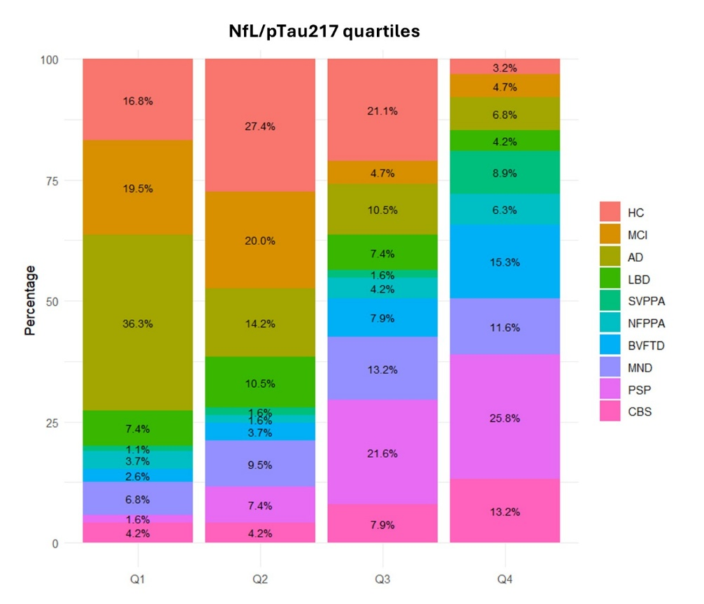

Supplementary Figure 2. Direct comparisons of p-tau217 and NfL/p-tau217 ratio’s performance in discriminating patients with a diagnosis of AD vs other groups (A and B respectively), and across all pairwise group comparisons (C and D).

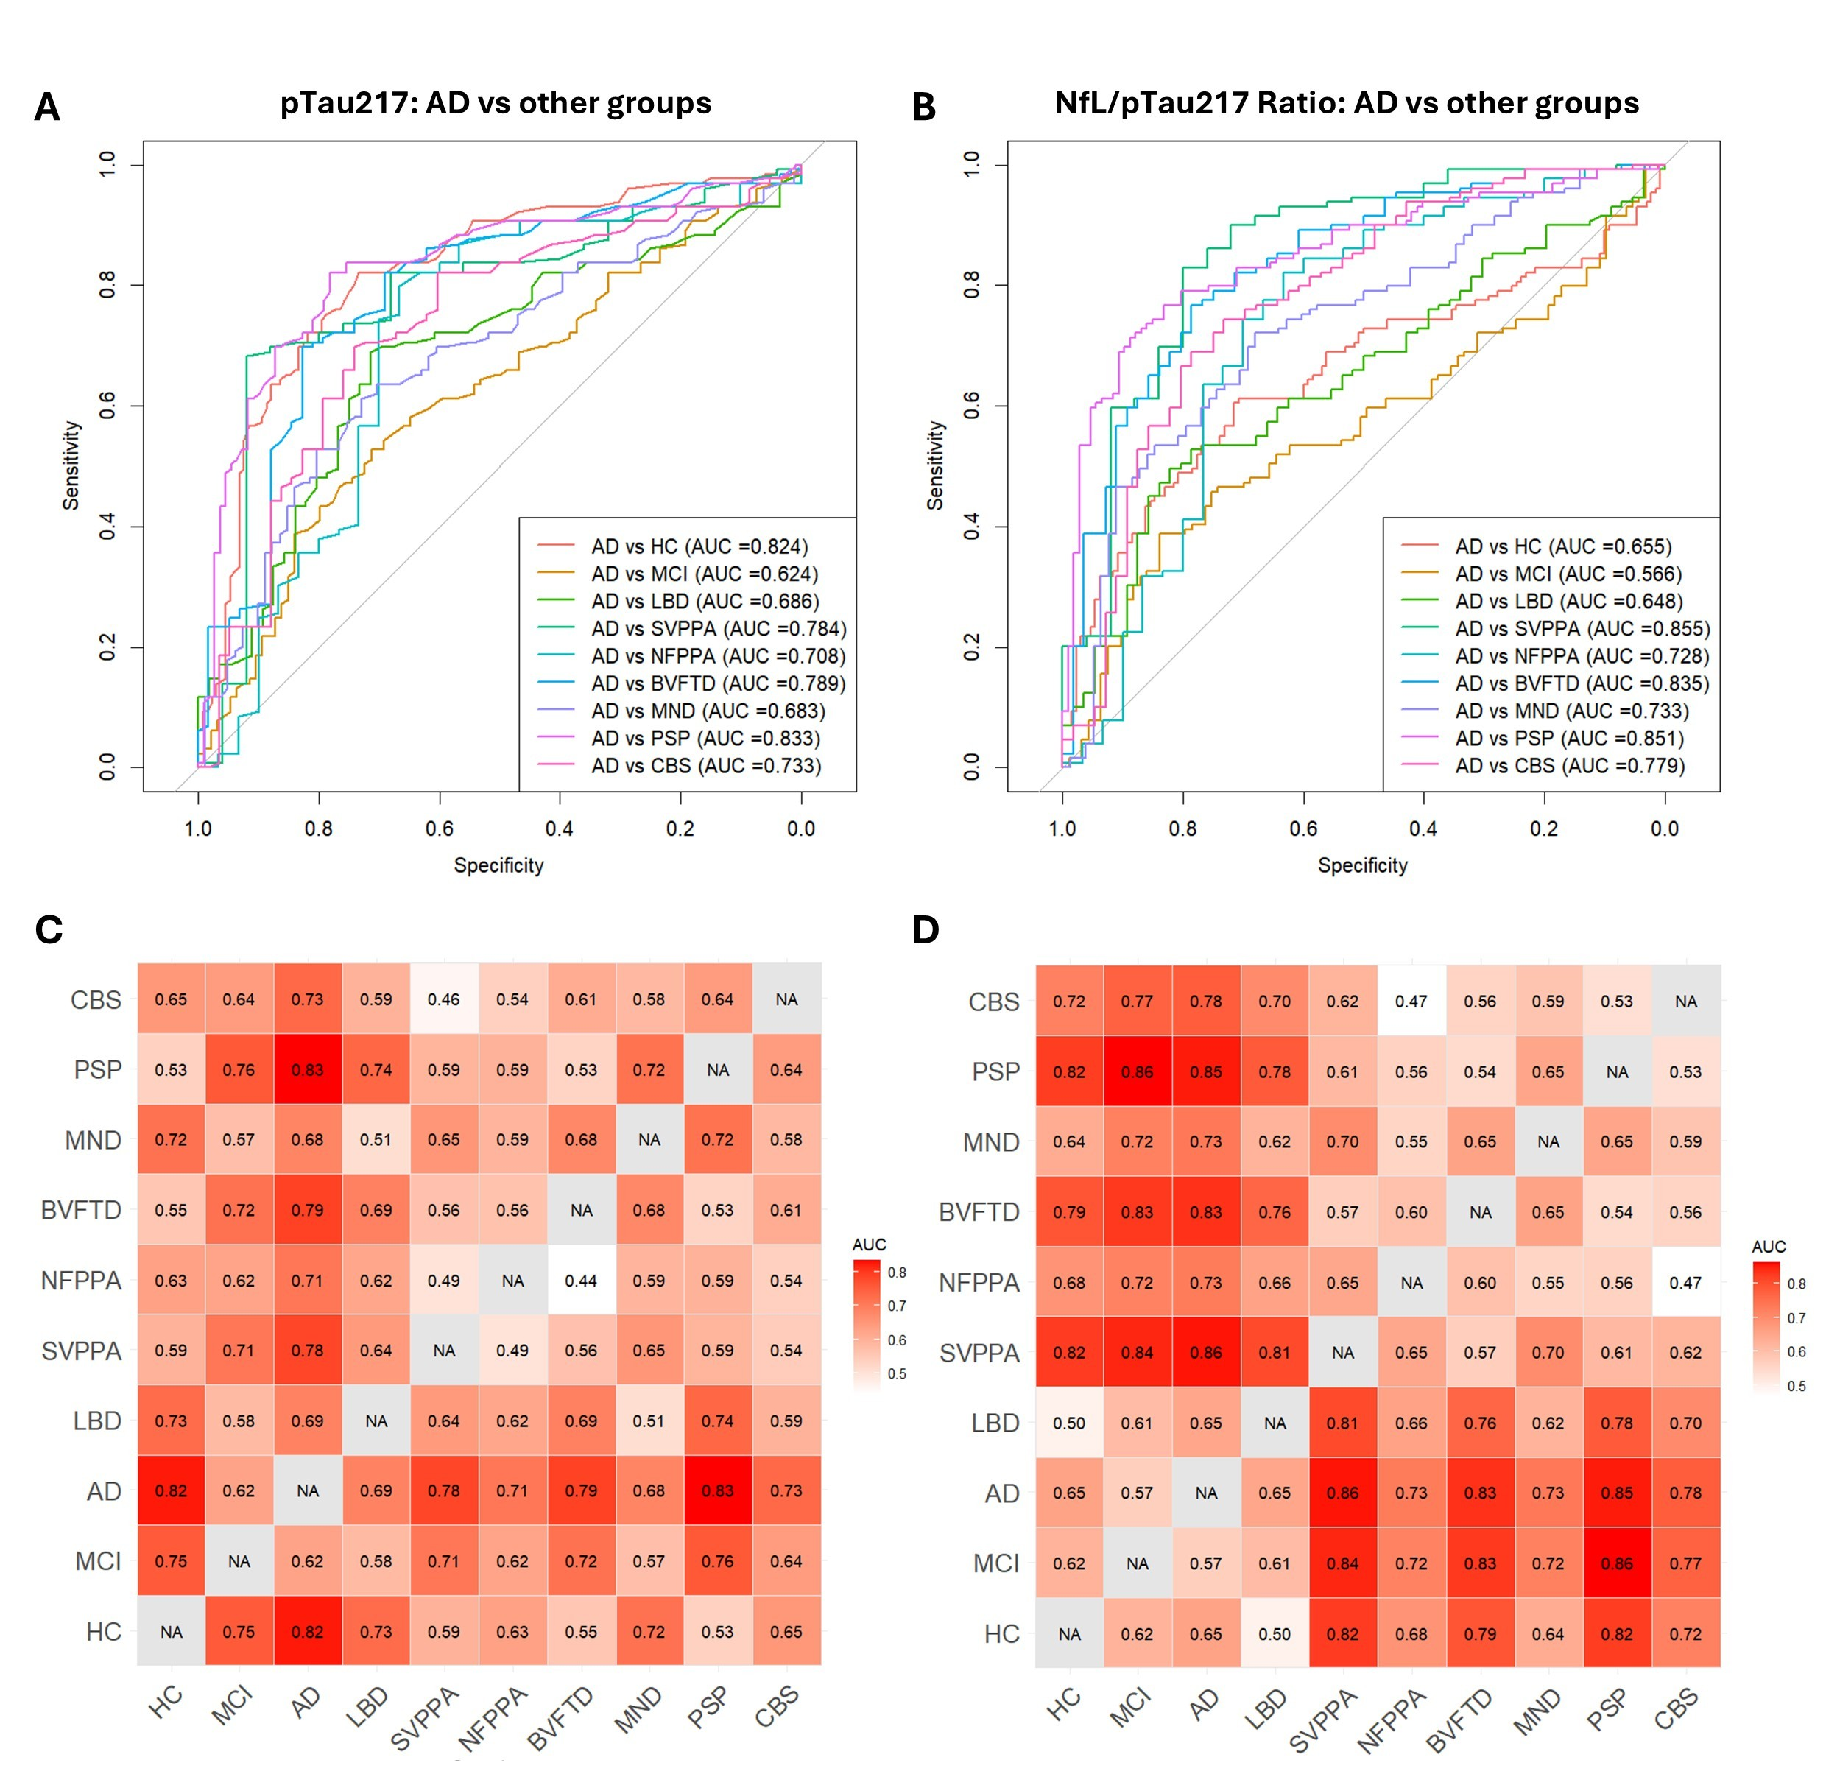

Supplementary Figure 3. Comparisons on plasma markers in AD and FTLD cohorts with confirmed pathology.
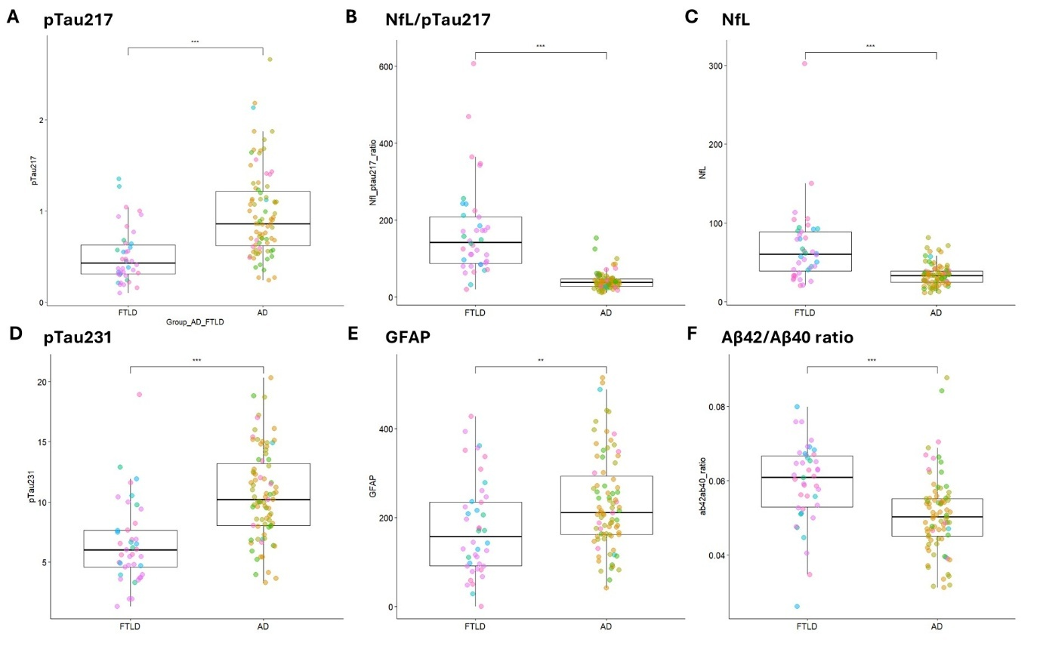

Supplementary Figure 4. Plasma p-tau217 performance across clinical syndromes and pathological groups.

