Supplementary Table 1: Characteristics of studies included
Author | Study year¹ | Country | Design | Setting | Participant | Sampling | Mpox gene sequencing | Risk of bias | Confirmed cases (n) | Case fatality rate (%)
Breman et al. [1] | 1970 | Liberia | Cross-sectional | Community | General population | Non-probabilistic | Not reported | Low | 4 | 0.0
Breman et al. [1] | 1971 | Nigeria | Cross-sectional | Community | General population | Non-probabilistic | Not reported | Low | 2 | 0.0
Breman et al. [1] | 1979 | DRC | Cross-sectional | Community | General population | Non-probabilistic | Not reported | Low | 38 | 21.1
Arita et al. [2] | 1983 | Multinational | Cross-sectional | Community | General population | Non-probabilistic | Not reported | Low | 131 | 13.0
Durski et al. [3] | 1984 | CAR | Cross-sectional | Community | General population | Non-probabilistic | Not reported | Moderate | 6 | 0.0
Jezek et al. [4] | 1985 | DRC | Cross-sectional | Community | General population | Non-probabilistic | Not reported | Low | 282 | 9.6
Jezek et al. [5] | 1986 | DRC | Cross-sectional | Community | General population | Non-probabilistic | Not reported | Low | 276 | 2.2
Durski et al. [3] | 1987 | Gabon | Cross-sectional | Community | General population | Non-probabilistic | Not reported | Moderate | 5 | 40.0
Meyer et al. [6] | 2001 | DRC | Cross-sectional | Community | General population | Non-probabilistic | Not reported | Low | 16 | 31.3
Durski et al. [3] | 2003 | Congo | Cross-sectional | Community | General population | Non-probabilistic | Not reported | Moderate | 11 | 9.1
Boumandouki et al. [7] | 2003 | Congo | Case series | Hospital | General population | Non-probabilistic | Not reported | Low | 3 | 0.0
Formenty et al. [8] | 2005 | Sudan | Cross-sectional | Community | General population | Non-probabilistic | Clade Ia | Low | 10 | 0.0
Damon et al. [9] | 2005 | Sudan | Case report | Community | General population | Non-probabilistic | Clade Ia | Low | 2 | 0.0
Durski et al. [3] | 2009 | Congo | Cross-sectional | Community | General population | Non-probabilistic | Not reported | Moderate | 2 | 0.0
Durski et al. [3] | 2010 | CAR | Cross-sectional | Community | General population | Non-probabilistic | Not reported | Moderate | 2 | 0.0
Berthet et al. [10] | 2010 | CAR | Case report | Community | General population | Non-probabilistic | Clade Ia | Low | 2 | 0.0
Pittman et al. [11] | 2011 | DRC | CS | Hospital | General population | Non-probabilistic | Not reported | Moderate | 216 | 1.4
Durski et al. [3] | 2015 | CAR | Cross-sectional | Community | General population | Non-probabilistic | Not reported | Moderate | 12 | 25.0
Kalthan et al. [12] | 2015 | CAR | Cross-sectional | Community | General population | Non-probabilistic | Not reported | Low | 12 | 25.0
Kalthan et al. [12] | 2016 | CAR | Cross-sectional | Community | General population | Non-probabilistic | Not reported | Low | 26 | 3.8
Nakoune et al. [13] | 2016 | CAR | Cross-sectional | Community | General population and HCWs | Non-probabilistic | Not reported | Moderate | 10 | 20.0
Durski et al. [3] | 2017 | CAR | Cross-sectional | Community | General population | Non-probabilistic | Not reported | Moderate | 2 | 0.0
Durski et al. [3] | 2017 | CAR | Cross-sectional | Community | General population | Non-probabilistic | Not reported | Moderate | 6 | 0.0
Doshi et al. [3] | 2017 | Congo | Case series | Community | General population | Non-probabilistic | Not reported | Moderate | 7 | 85.7
Durski et al. [3] | 2017 | Liberia | Cross-sectional | Community | General population | Non-probabilistic | Not reported | Moderate | 2 | 0.0
Ogoina et al. [14] | 2017 | Nigeria | Cross-sectional | Hospital | General population | Non-probabilistic | Not reported | Low | 18 | 0.0
Ita et al. [15] | 2017 | Nigeria | Cross-sectional | Hospital | General population | Non-probabilistic | Not reported | Low | 6 | 0.0
Ibegu et al. [16] | 2017 | Nigeria | Cross-sectional | Hospital | General population | Non-probabilistic | Not reported | Moderate | 11 | 0.0
Reynolds et al. [17] | 2017 | Sierra Leone | Case series | Community | General population | Non-probabilistic | Not reported | Low | 2 | 0.0
Vaughan et al. [18] | 2018 | Nigeria | Case report | Hospital | General population | Non-probabilistic | Clade II | Low | 2 | 0.0
Yinka-ogunleye et al. [19] | 2018 | Nigeria | Cross-sectional | Community | General population | Non-probabilistic | Clade II | Low | 118 | 5.9
Ogoina et al. [20] | 2018 | Nigeria | Cross-sectional | Hospital | General population | Non-probabilistic | Not reported | Low | 40 | 12.5
Echekwube et al. [21] | 2018 | Nigeria | Case series | Hospital | General population | Non-probabilistic | Not reported | Low | 4 | 0.0
Hobson et al. [22] | 2021 | Nigeria | Case report | Hospital | General population | Non-probabilistic | Clade II | Low | 3 | 0.0
Amao et al. [23] | 2021 | Nigeria | Cross-sectional | Community | General population | Non-probabilistic | Not reported | Low | 3 | 0.0
Djuicy et al. [24] | 2022 | Cameroon | Cross-sectional | Community and hospital | General population | Non-probabilistic | Clade I and II | Low | 32 | 3.1
Yadouleton et al. [25] | 2022 | Benin | Case series | Community | General population | Non-probabilistic | Clade II | Low | 3 | 0.0
Mmerem et al. [26] | 2023 | Nigeria | Cohort study | Hospital | General population | Non-probabilistic | Clade Ib | Low | 56 | 8.9
Kibungu et al. [27] | 2023 | DRC | Case series | Community | General population | Non-probabilistic | Clade Ia | Low | 5 | 0.0
Nizigiyimana et al. [28] | 2024 | Burundi | Cross-sectional | Community | General population | Non-probabilistic | Clade Ib | Low | 154 | 0.0
Brosius et al. [29] | 2024 | DRC | Cohort study | Hospital | General population | Non-probabilistic | Clade Ib | Moderate | 431 | 0.5
Mukadi-Bamuleka et al. [30] | 2024 | DRC | Cross-sectional | Community | General population | Non-probabilistic | Clade Ib | Low | 9 | 0.0
Malembi et al. [31] | 2024 | DRC | Cross-sectional | Community | General population | Non-probabilistic | Clade Ib | Low | 4895 | 1,0
1: Last year that the study was conducted; DRC: Democratic Republic of Congo; CAR: Central African Republic

Study period
Event rate (%)

Case fatality rate (%)
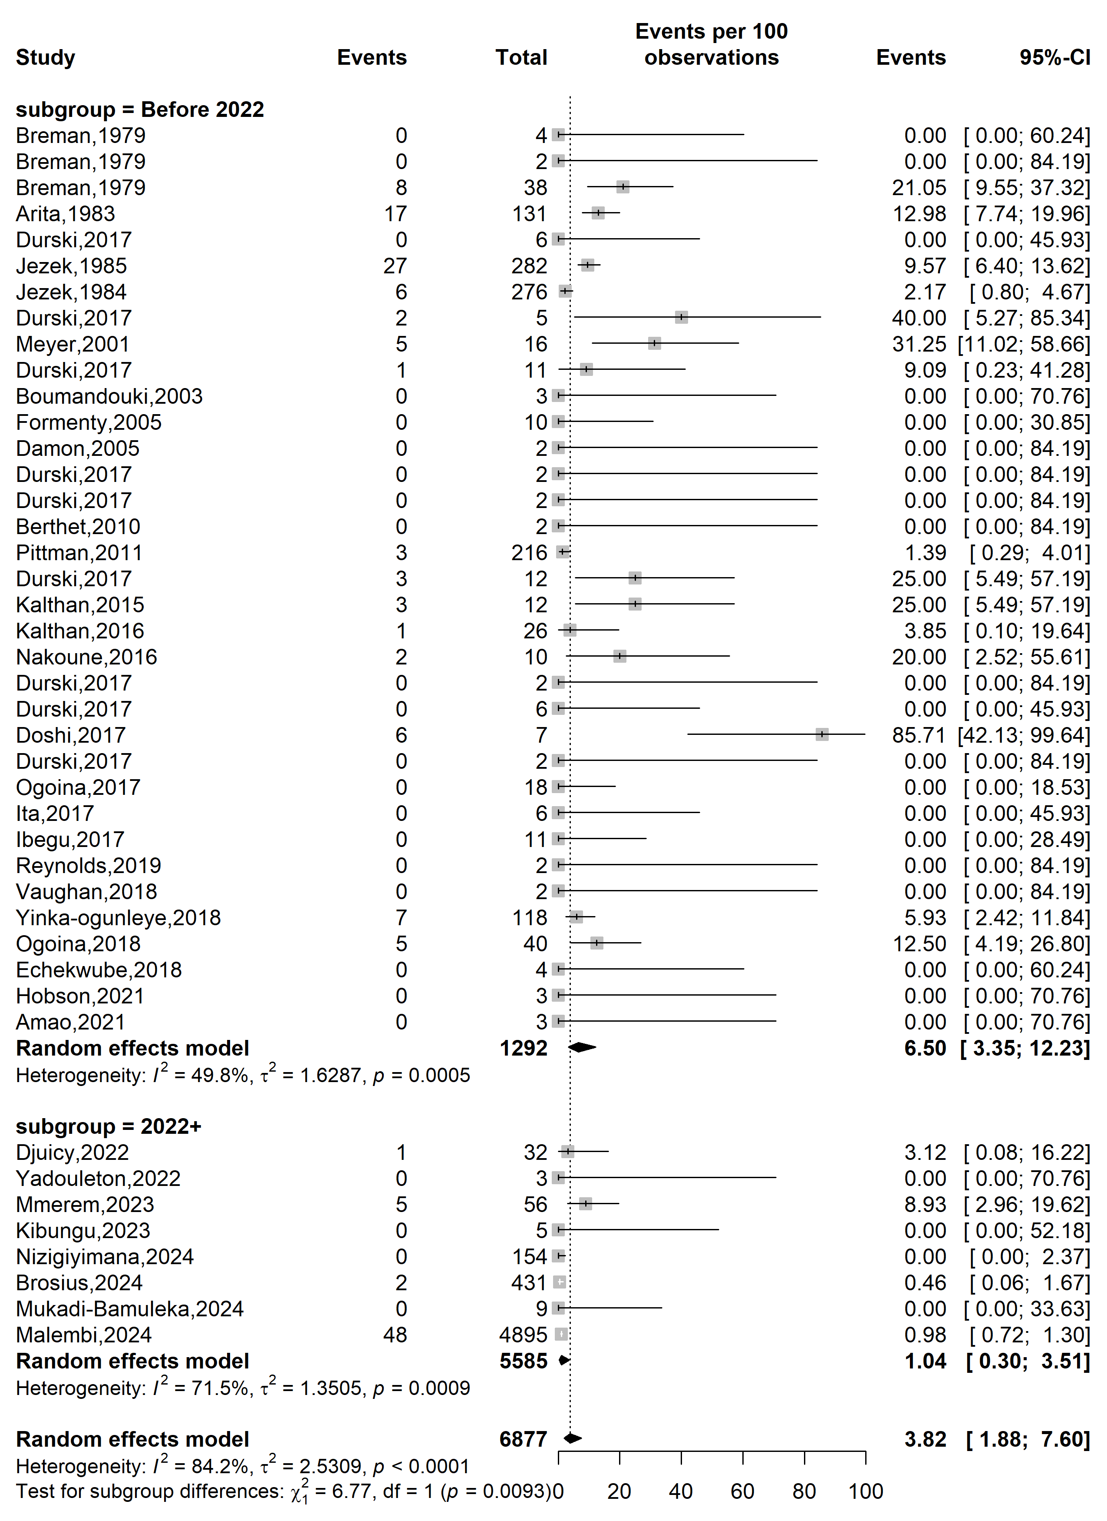
Supplementary Fig. 1 Case fatality rate among confirmed mpox case in Africa by study periods
Country
Event rate (%)

Case fatality rate (%)
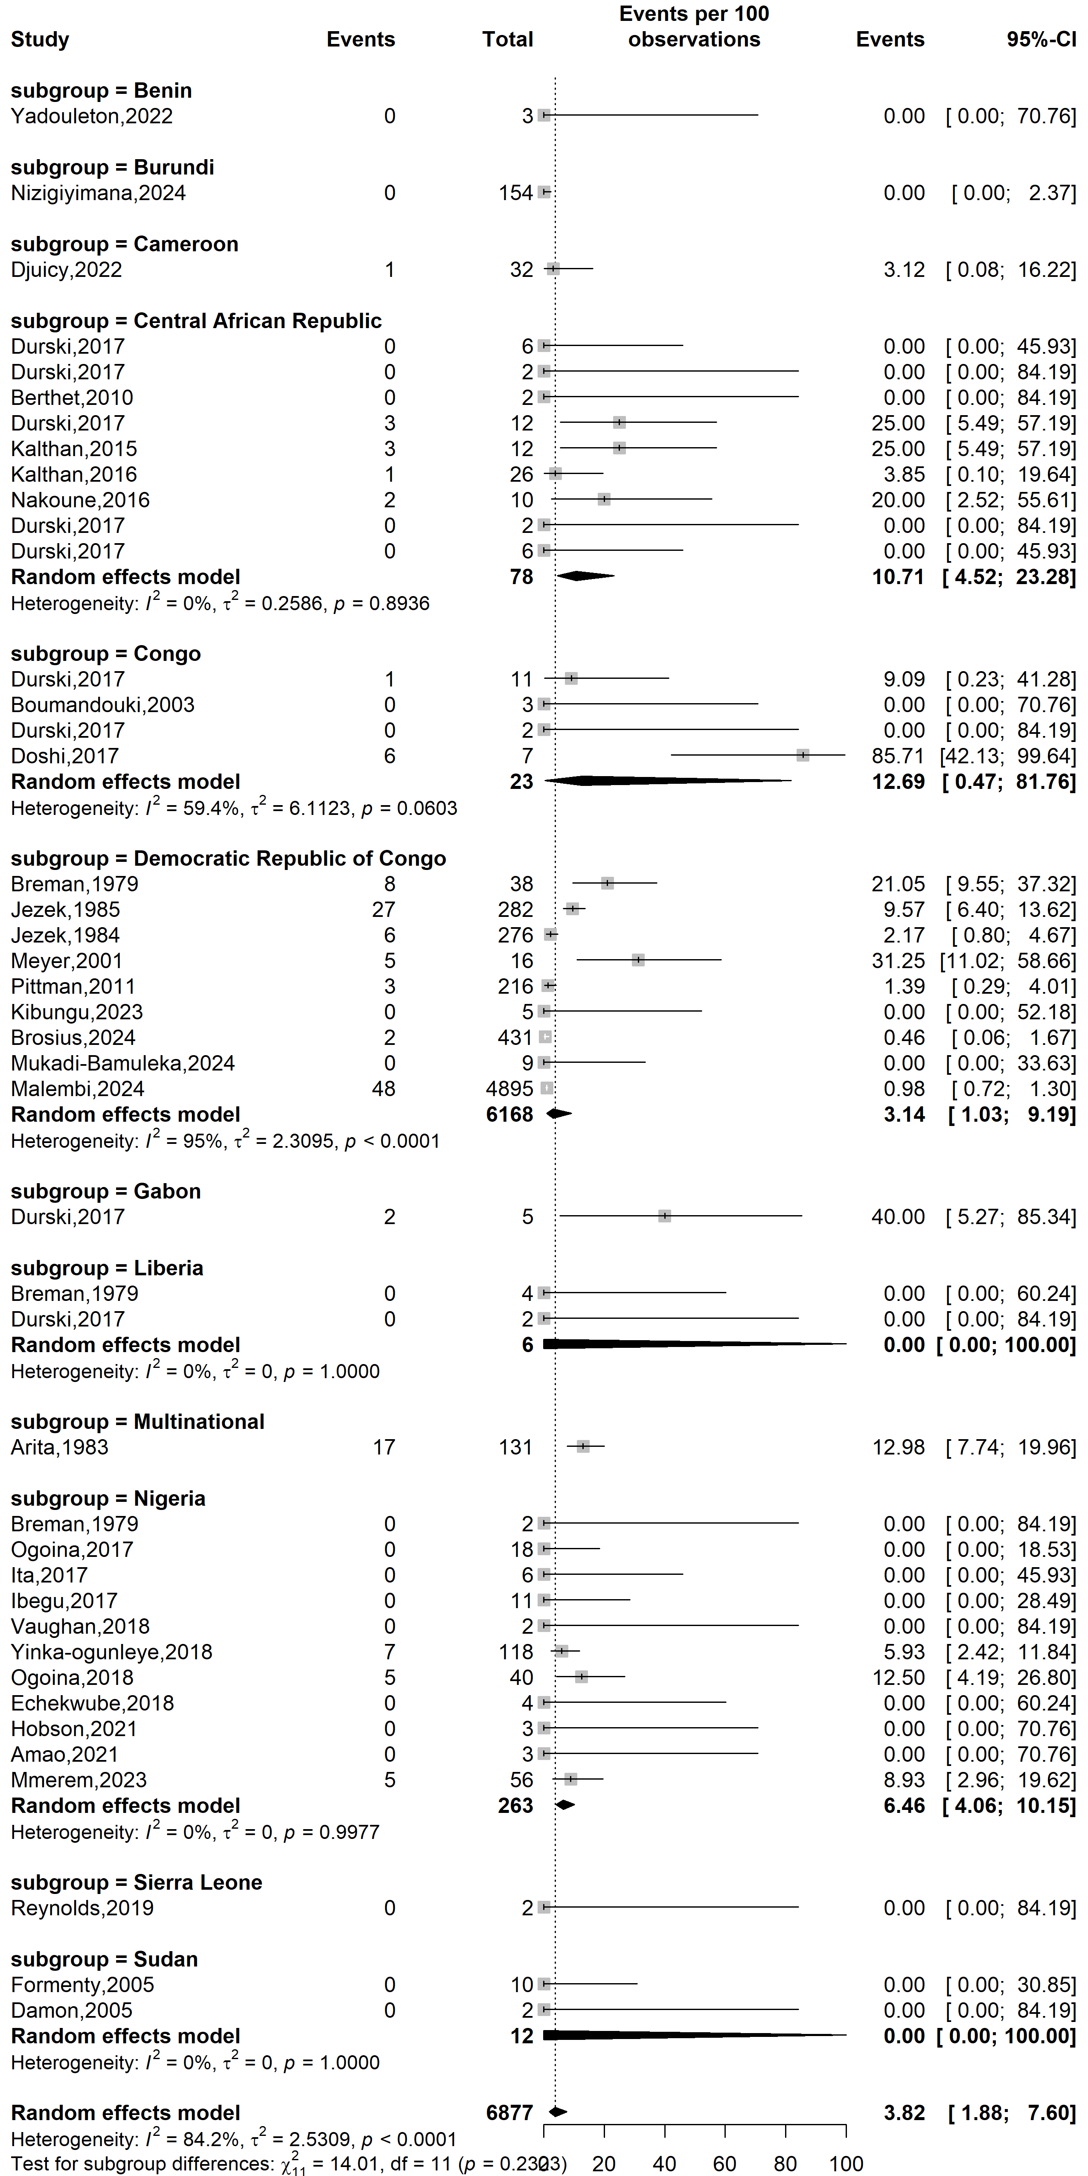
Supplementary Fig. 2 Case fatality rate among confirmed mpox case by African countries
Study design
Event rate (%)

Case fatality rate (%)
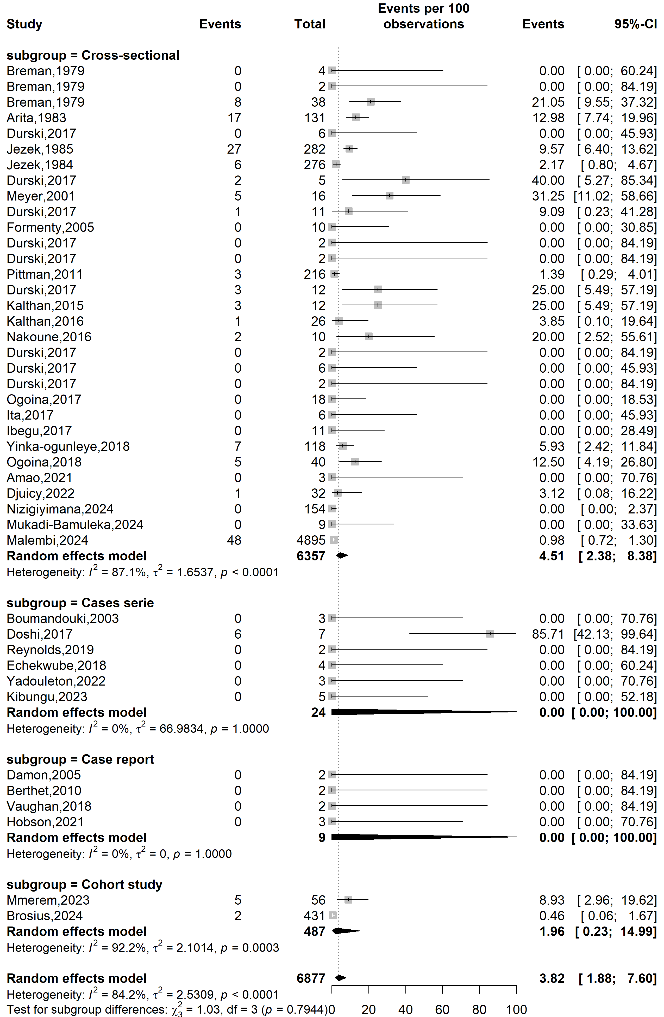
Supplementary Fig. 3 Case fatality rate among confirmed mpox case in Africa by countries
Study setting
Case fatality rate (%)
Event rate (%)

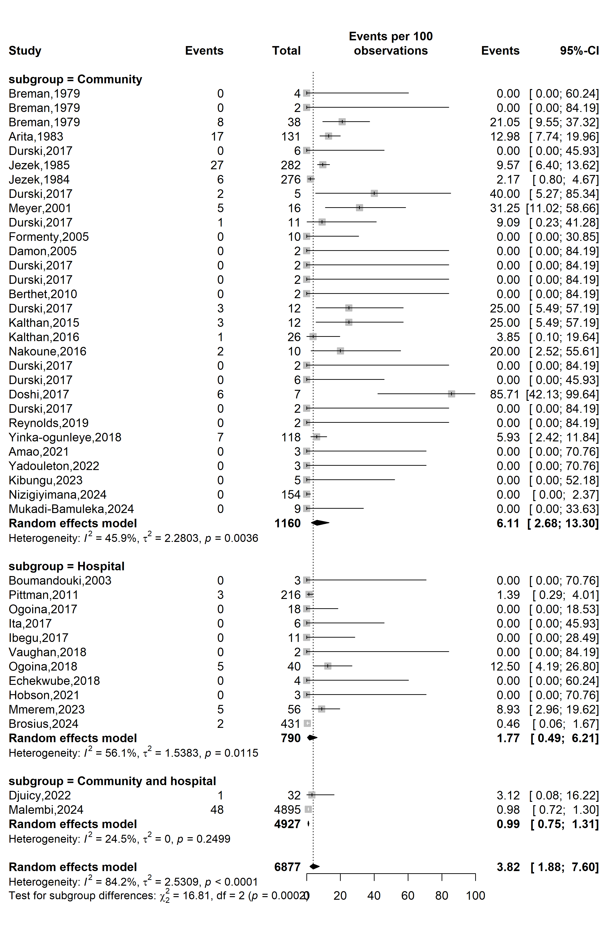
Supplementary Fig. 4 Case fatality rate among confirmed mpox case in Africa by study setting
Mpox clade stratification
Event rate (%)

Case fatality rate (%)
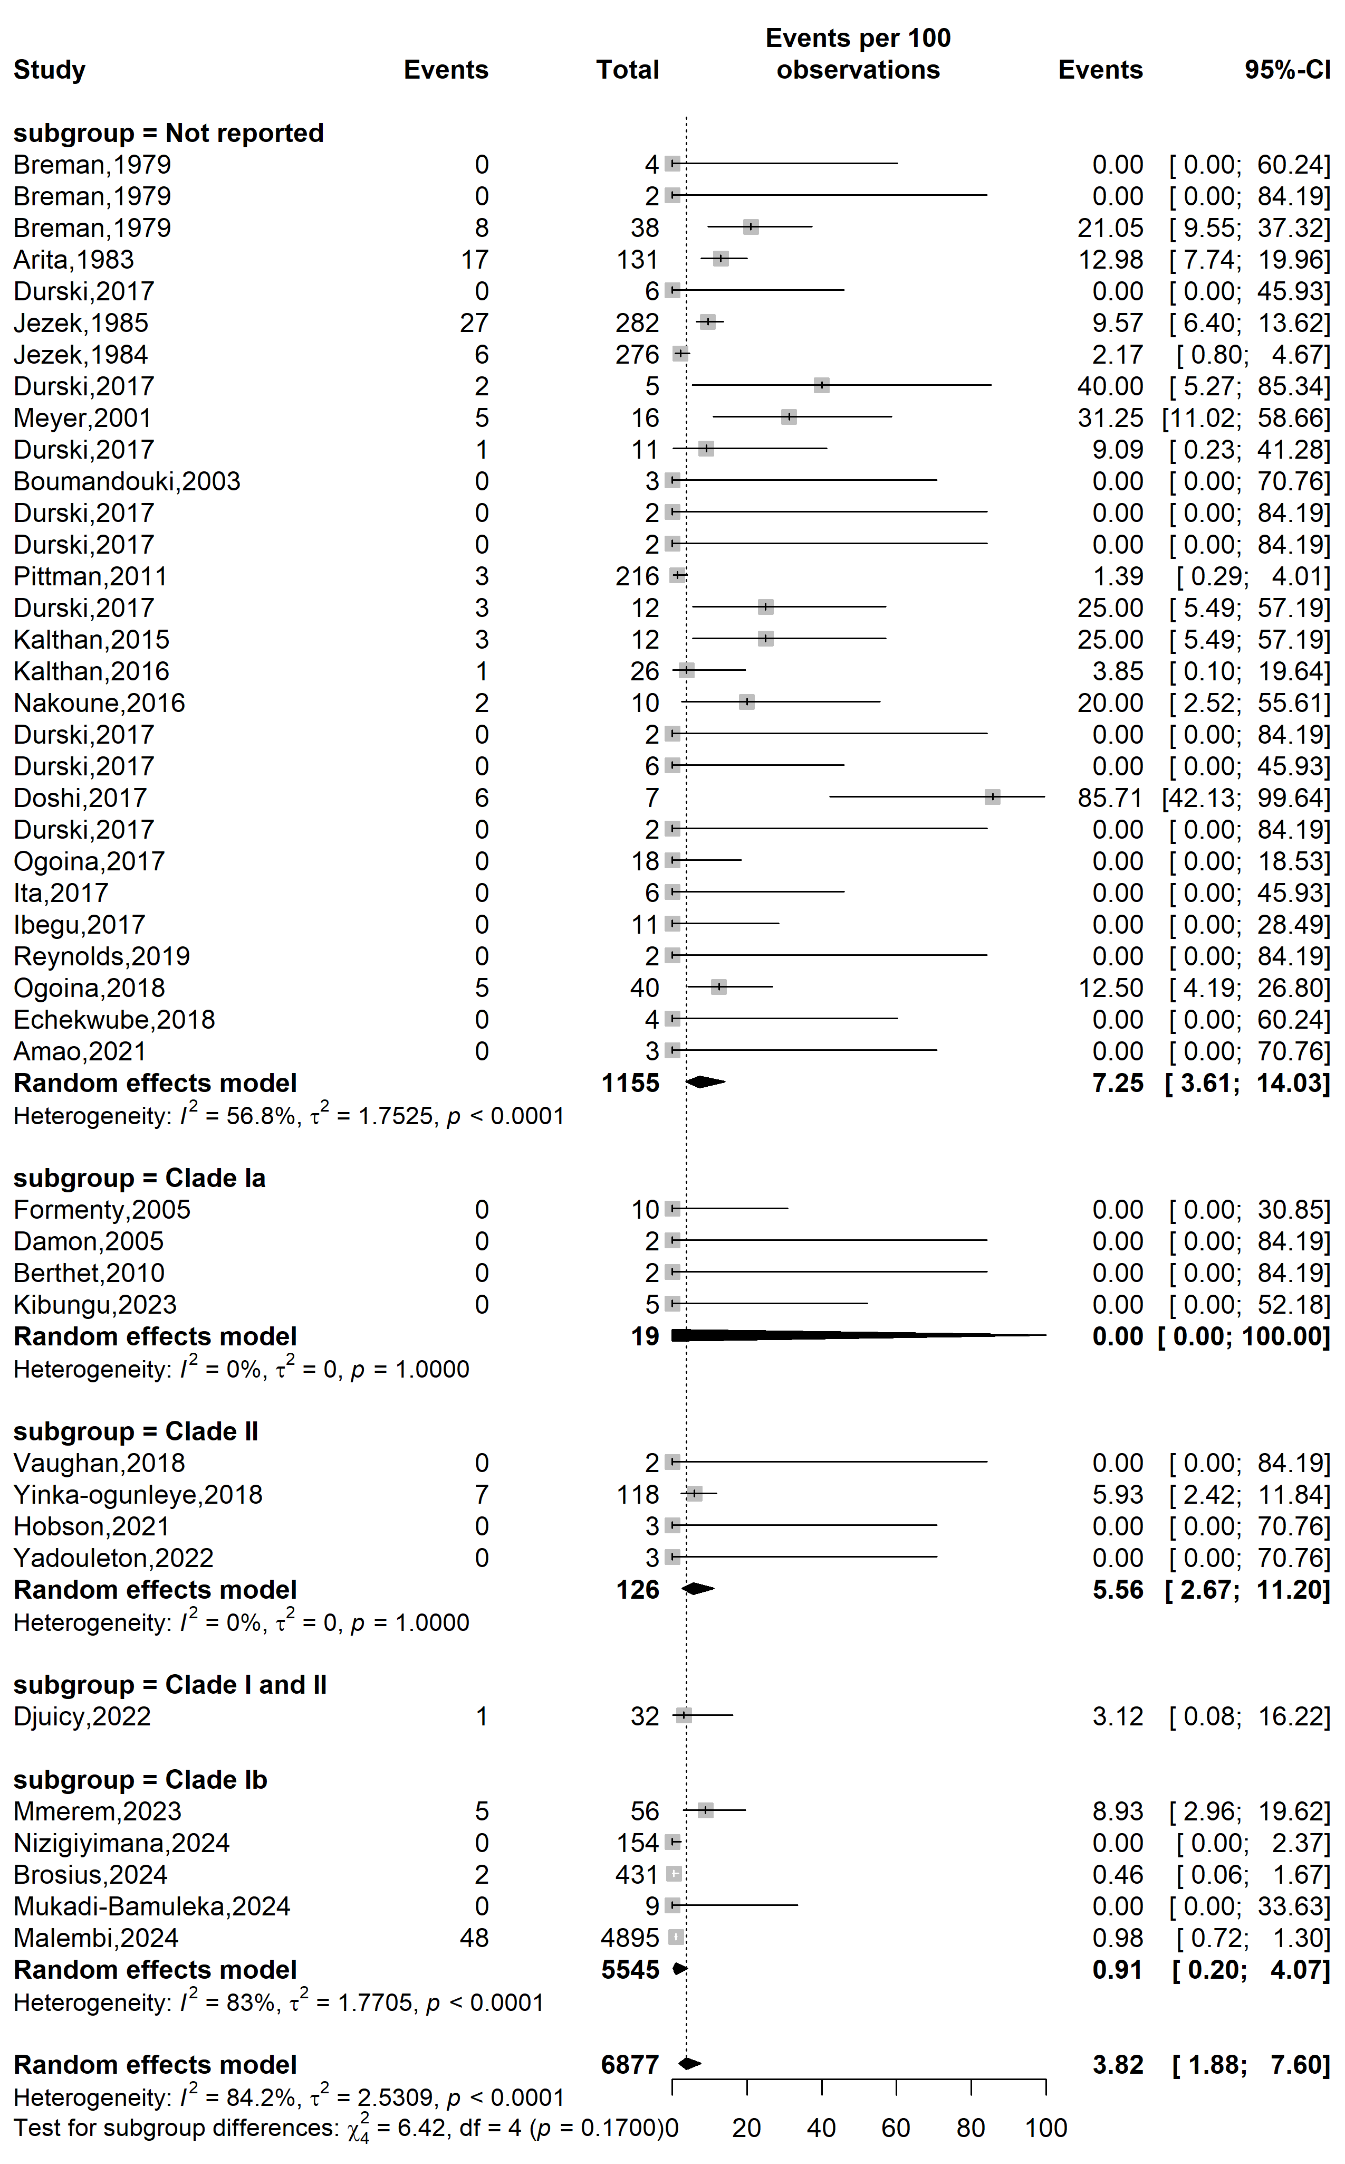
Supplementary Fig. 5 Case fatality rate among confirmed mpox case in Africa by clade
WHO Afro region
Event rate (%)

Case fatality rate (%)
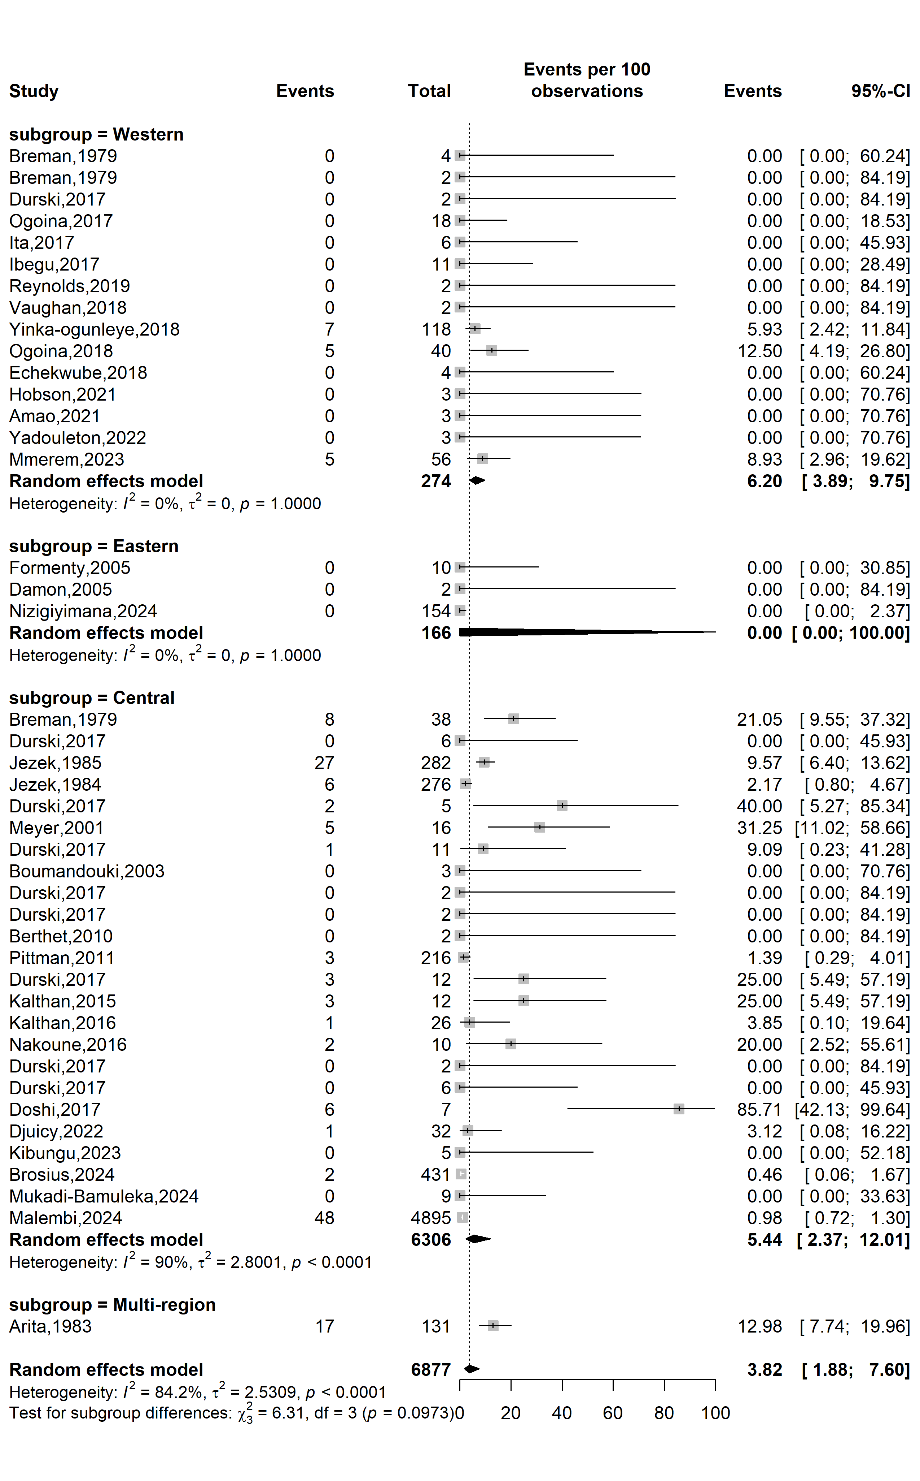
Supplementary Fig. 6 Case fatality rate among confirmed mpox case by WHO Afro region

Publication bias assessment
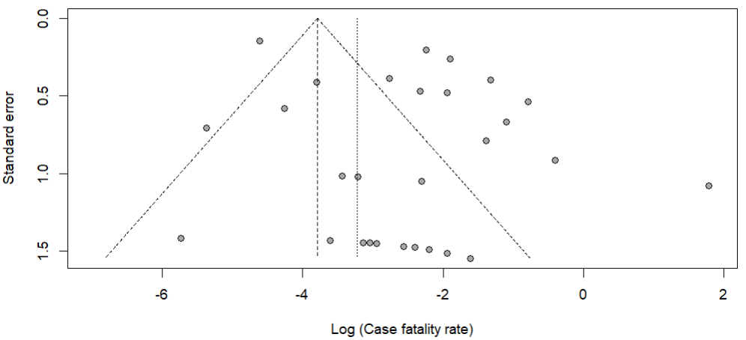
Egger’s test p-value = 0.011
Begg’s test p-value = 0.300

Supplementary Fig. 7 Funnel plot displaying the pseudo 95% confidence limits and tests assessing the publication bias of studies included

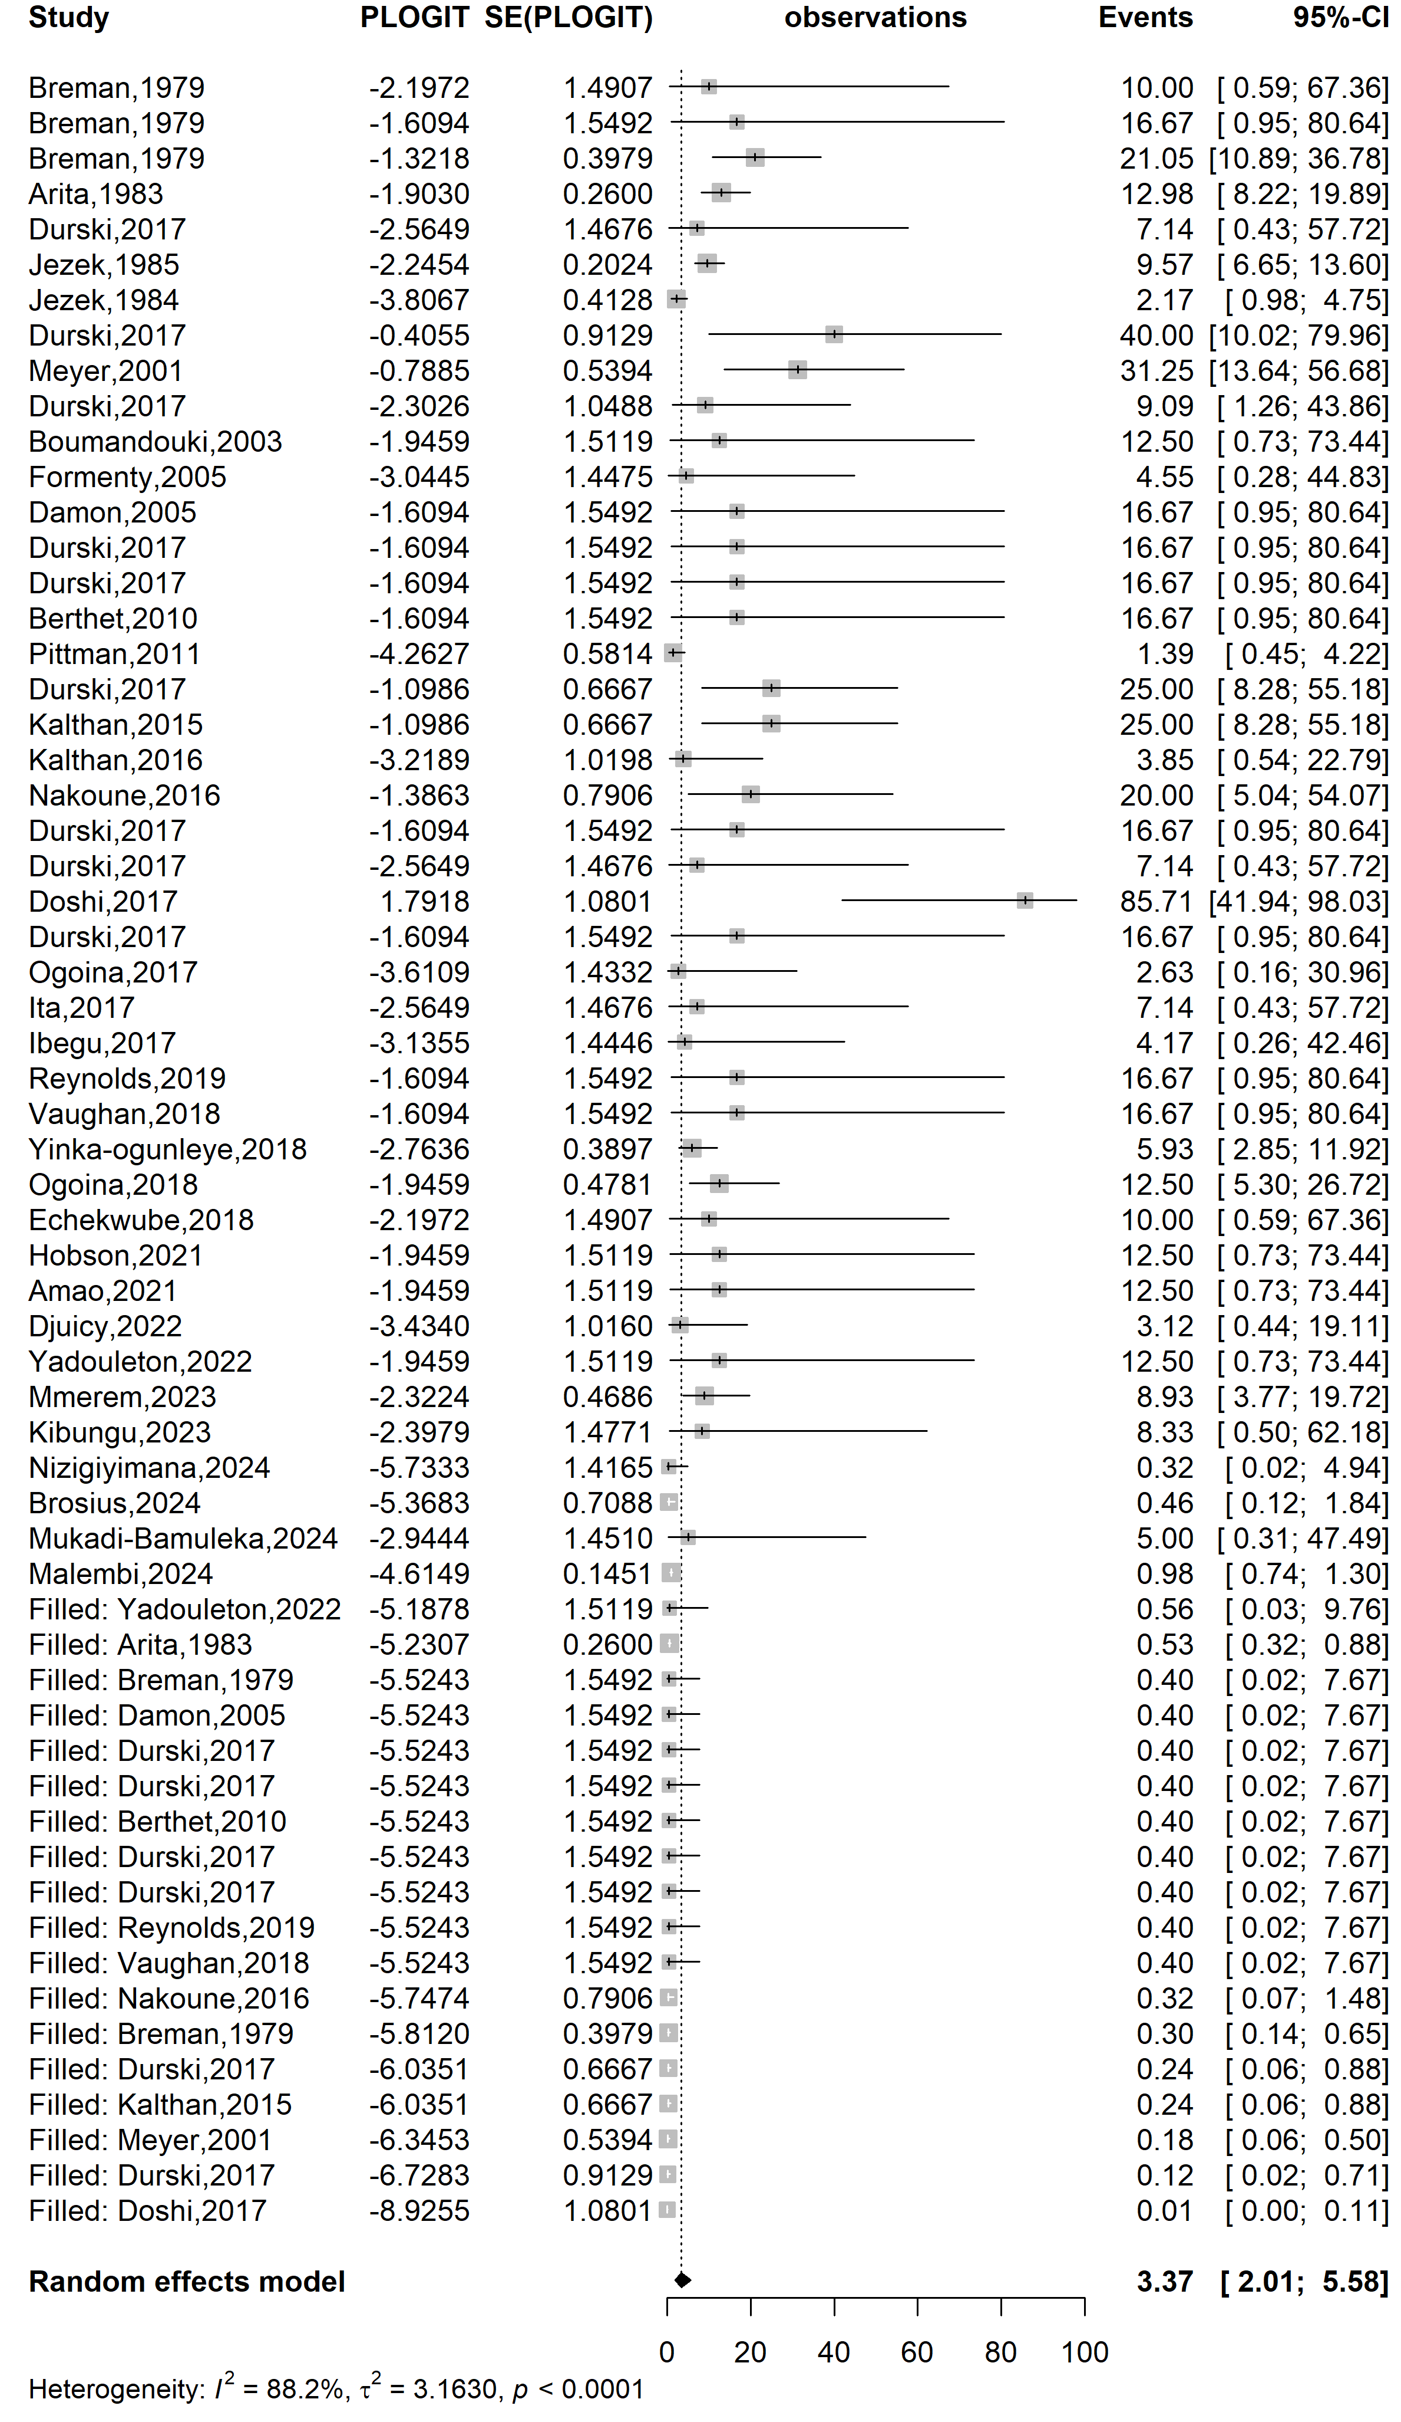
Event rate (%)

Case fatality rate (%)
Supplementary Fig. 8 Trim and fill analysis of included study
Sensitivity analysis
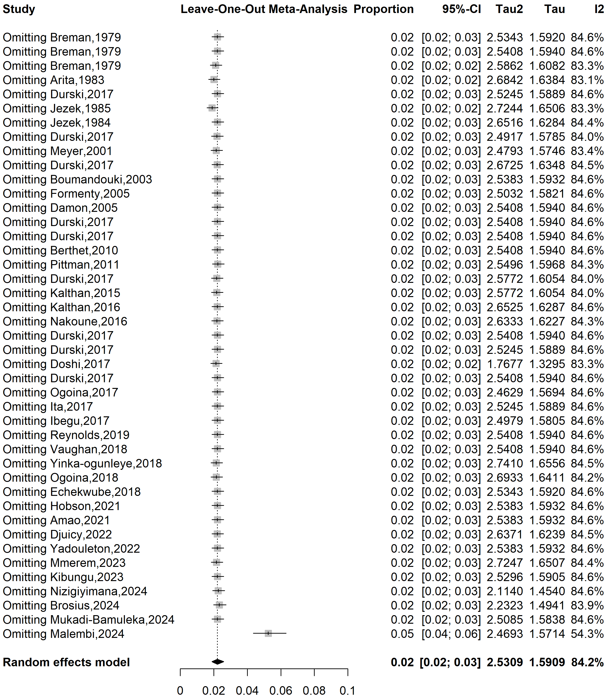
Supplementary Fig. 9 Sensitivity analysis of the case fatality rate among confirmed mpox cases in Africa

References
1. Breman JG, Kalisa-Ruti, Steniowski MV, Zanotto E, Gromyko AI, Arita I. Human monkeypox, 1970-79. Bull World Health Organ. 1980;58(2):165–82.
2. Arita I, Jezek Z, Khodakevich L, Ruti K. Human monkeypox: a newly emerged orthopoxvirus zoonosis in the tropical rain forests of Africa. Am J Trop Med Hyg. 1985;34(4):781–9.
3. Durski KN. Emergence of Monkeypox — West and Central Africa, 1970–2017. MMWR Morb Mortal Wkly Rep [Internet]. 2018 [cited 2025 Jun 29];67. Available from: https://www.cdc.gov/mmwr/volumes/67/wr/mm6710a5.htm
4. Jezek Z, Szczeniowski M, Paluku KM, Mutombo M. Human Monkeypox: Clinical Features of 282 Patients. J Infect Dis. 1987;156(2):293–8.
5. Jezek Z, Marennikova SS, Mutumbo M, Nakano JH, Paluku KM, Szczeniowski M. Human Monkeypox: A Study of 2,510 Contacts of 214 Patients. J Infect Dis. 1986;154(4):551–5.
6. Meyer H, Perrichot M, Stemmler M, Emmerich P, Schmitz H, Varaine F, et al. Outbreaks of Disease Suspected of Being Due to Human Monkeypox Virus Infection in the Democratic Republic of Congo in 2001. J Clin Microbiol. 2002;40(8):2919–21.
7. Boumandouki P, Bileckot R, Ibara JR, Satounkazi C, Wassa Wassa D, Libama E, et al. [Simian smallpox (or monkey smallpox): study of 8 cases observed at Impfondo Hospital in Republic of Congo]. Bull Soc Pathol Exot 1990. 2007;100(1):17–21.
8. Formenty P, Muntasir MO, Damon I, Chowdhary V, Opoka ML, Monimart C, et al. Human Monkeypox Outbreak Caused by Novel Virus Belonging to Congo Basin Clade, Sudan, 2005. Emerg Infect Dis. 2010;16(10):1539–45.
9. Damon IK, Roth CE, Chowdhary V. Discovery of Monkeypox in Sudan. N Engl J Med. 2006;355(9):962–3.
10. Berthet N, Nakouné E, Whist E, Selekon B, Burguière AM, Manuguerra JC, et al. Maculopapular lesions in the Central African Republic. The Lancet. 2011;378(9799):1354.
11. Pittman PR, Martin JW, Kingebeni PM, Tamfum JJM, Mwema G, Wan Q, et al. Clinical characterization and placental pathology of mpox infection in hospitalized patients in the Democratic Republic of the Congo. Bowman N, editor. PLoS Negl Trop Dis. 2023;17(4):e0010384.
12. Kalthan E, Dondo-Fongbia JP, Yambele S, Dieu-Creer LR, Zepio R, Pamatika CM. Epidémie de 12 cas de maladie à virus monkeypox dans le district de Bangassou en République Centrafricaine en décembre 2015. Bull Société Pathol Exot. 2016;109(5):358–63.
13. Nakoune E, Lampaert E, Ndjapou SG, Janssens C, Zuniga I, Van Herp M, et al. A Nosocomial Outbreak of Human Monkeypox in the Central African Republic. Open Forum Infect Dis. 2017;4(4):ofx168.
14. Ogoina D, Izibewule JH, Ogunleye A, Ederiane E, Anebonam U, Neni A, et al. The 2017 human monkeypox outbreak in Nigeria—Report of outbreak experience and response in the Niger Delta University Teaching Hospital, Bayelsa State, Nigeria. PLOS ONE. 2019;14(4):e0214229.
15. Ita OI, Amuzi C, Udo U, Uwa A. Descriptive epidemiology of monkeypox outbreak in Akwa Ibom State, Nigeria—5th October to 7th November 2017. East Afr Sch J Med Sci. 2019;2(5):224–7.
16. Ibegu M, Numbere TW, Balogun M, Nguku P. Descriptive epidemiology of Monkeypox outbreak in Bayelsa State South-South Nigeria, November 2017. Int J Infect Dis. 2020;101:255.
17. Reynolds MG, Wauquier N, Li Y, Satheshkumar PS, Kanneh LD, Monroe B, et al. Human Monkeypox in Sierra Leone after 44-Year Absence of Reported Cases. Emerg Infect Dis. 2019;25(5):1023–5.
18. Vaughan A, Aarons E, Astbury J, Balasegaram S, Beadsworth M, Beck CR, et al. Two cases of monkeypox imported to the United Kingdom, September 2018. Eurosurveillance. 2018;23(38):1800509.
19. Yinka-Ogunleye A, Aruna O, Dalhat M, Ogoina D, McCollum A, Disu Y, et al. Outbreak of human monkeypox in Nigeria in 2017-18: a clinical and epidemiological report. Lancet Infect Dis. 2019;19(8):872–9.
20. Ogoina D, Iroezindu M, James HI, Oladokun R, Yinka-Ogunleye A, Wakama P, et al. Clinical Course and Outcome of Human Monkeypox in Nigeria. Clin Infect Dis. 2020;71(8):e210–4.
21. Echekwube PO, Mbaave PT, Abidakun OA, Utoo BT, Swende TZ. Human monkeypox and human immunodeficiency virus co-infection: a case series in Makurdi, Benue State, Nigeria. J Biomed Res Clin Pract. 2020;3(2):375–81.
22. Hobson G, Adamson J, Adler H, Firth R, Gould S, Houlihan C, et al. Family cluster of three cases of monkeypox imported from Nigeria to the United Kingdom, May 2021. Eurosurveillance. 2021;26(32):2100745.
23. Amao LK, Olatunji DI, Igbodo G, Okoli SC, Amaechi I, Goni MI, et al. Trend and enhanced surveillance of Monkeypox during COVID-19 pandemic in Nigeria. J Public Health Afr. 2022;13(1):2184.
24. Djuicy DD, Sadeuh-Mba SA, Bilounga CN, Yonga MG, Tchatchueng-Mbougua JB, Essima GD, et al. Concurrent Clade I and Clade II Monkeypox Virus Circulation, Cameroon, 1979–2022. Emerg Infect Dis. 2024;30(3):433–43.
25. Yadouleton A, Faye M, Tchibozo C, Oke M, Faye O, Lawale T, et al. Introduction of monkeypox virus in Benin, 2022. Mil Med Res. 2022 Nov 9;9(1):63.
26. Mmerem JI, Umenzekwe CC, Johnson SM, Onukak AE, Chika-Igwenyi NM, Chukwu SK, et al. Mpox and Chickenpox Coinfection: Case Series From Southern Nigeria. J Infect Dis. 2024;229(Supplement_2):S260-4.
27. Kibungu EM, Vakaniaki EH, Kinganda-Lusamaki E, Kalonji-Mukendi T, Pukuta E, Hoff NA, et al. Clade I–Associated Mpox Cases Associated with Sexual Contact, the Democratic Republic of the Congo. Emerg Infect Dis. 2024;30(1):172–6.
28. Nizigiyimana A, Ndikumwenayo F, Houben S, Manirakiza M, Lettow M van, Liesenborghs L, et al. Epidemiological analysis of confirmed mpox cases, Burundi, 3 July to 9 September 2024. Eurosurveillance. 2024;29(42):2400647.
29. Brosius I, Vakaniaki EH, Mukari G, Munganga P, Tshomba JC, Vos ED, et al. Epidemiological and clinical features of mpox during the clade Ib outbreak in South Kivu, Democratic Republic of the Congo: a prospective cohort study. The Lancet. 2025;405(10478):547–59.
30. Mukadi-Bamuleka D, Kinganda-Lusamaki E, Mulopo-Mukanya N, Amuri-Aziza A, O’Toole Á, Modadra-Madakpa B, et al. First imported Cases of MPXV Clade Ib in Goma, Democratic Republic of the Congo: Implications for Global Surveillance and Transmission Dynamics [Internet]. medRxiv; 2024 [cited 2025 Feb 24]. Available from: http://medrxiv.org/lookup/doi/10.1101/2024.09.12.24313188
31. Malembi E, Escrig-Sarreta R, Ntumba J, Beiras CG, Shongo R, Bengehya J, et al. Clinical presentation and epidemiological assessment of confirmed human mpox cases in DR Congo: a surveillance-based observational study. The Lancet. 2025;405(10490):1666–75.

