Choice set example/display with budget reminder
Shop for products to use for the next month
Flower
(dispensary)
Flower
(street)
Edibles
(dispensary)
Cartridges
(dispensary)

Flower (from dispensaries)

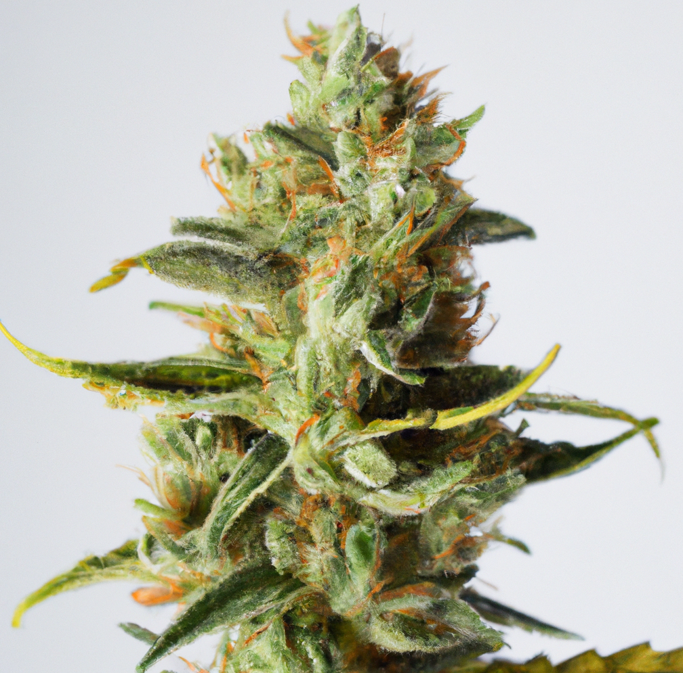 | Flower (dispensary)
 | Size: 1/8 ounce or 3.5 grams
 | THC level: XX% or XX mg
 | CBD level: Your preferred choice
 | Unit Price: $XX
 | Excise Tax: [Insert rate & base]
 | Sales Tax: $XX
 | Total Price: $XX
Add [ ] items to cart

Flower (from street vendors or friends)
Flower (street vendor)
Size: 1/8 ounce or 3.5 grams
THC level: XX% or XX mg
CBD level: Your preferred choice
Unit Price: $XX
Excise Tax: None
Sales Tax: None
Total Price: : $XX
Add [ ] items to cart

Edibles (from dispensaries)
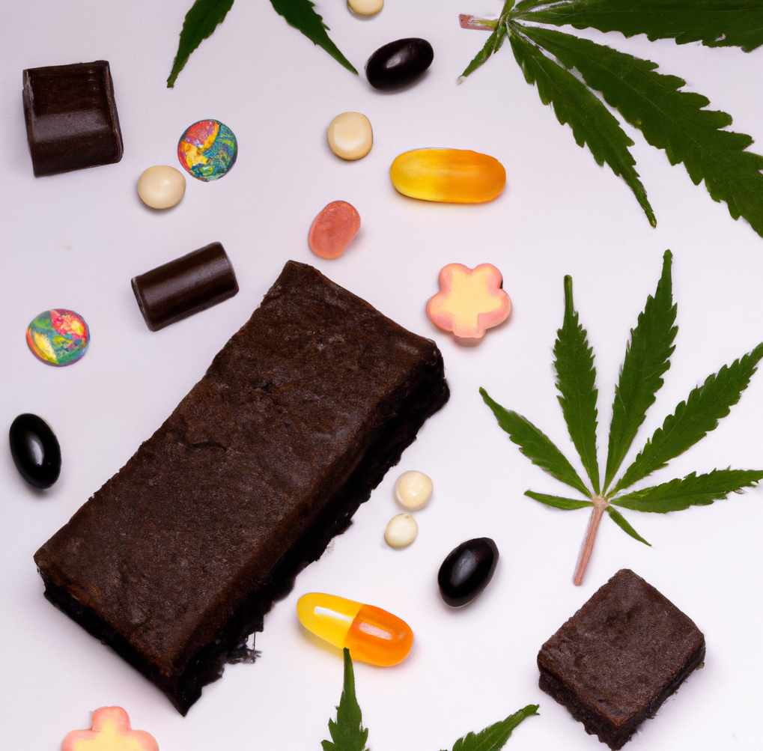 | Edibles (dispensary)
 | Size: One
 | THC level: XX% or XX mg
 | CBD level: Your preferred choice
 | Unit Price: $XX
 | Excise Tax: [Insert rate & base]
 | Sales Tax: $XX
 | Total Price: $XX
Add [ ] items to cart

Prefilled cartridge (from dispensaries)
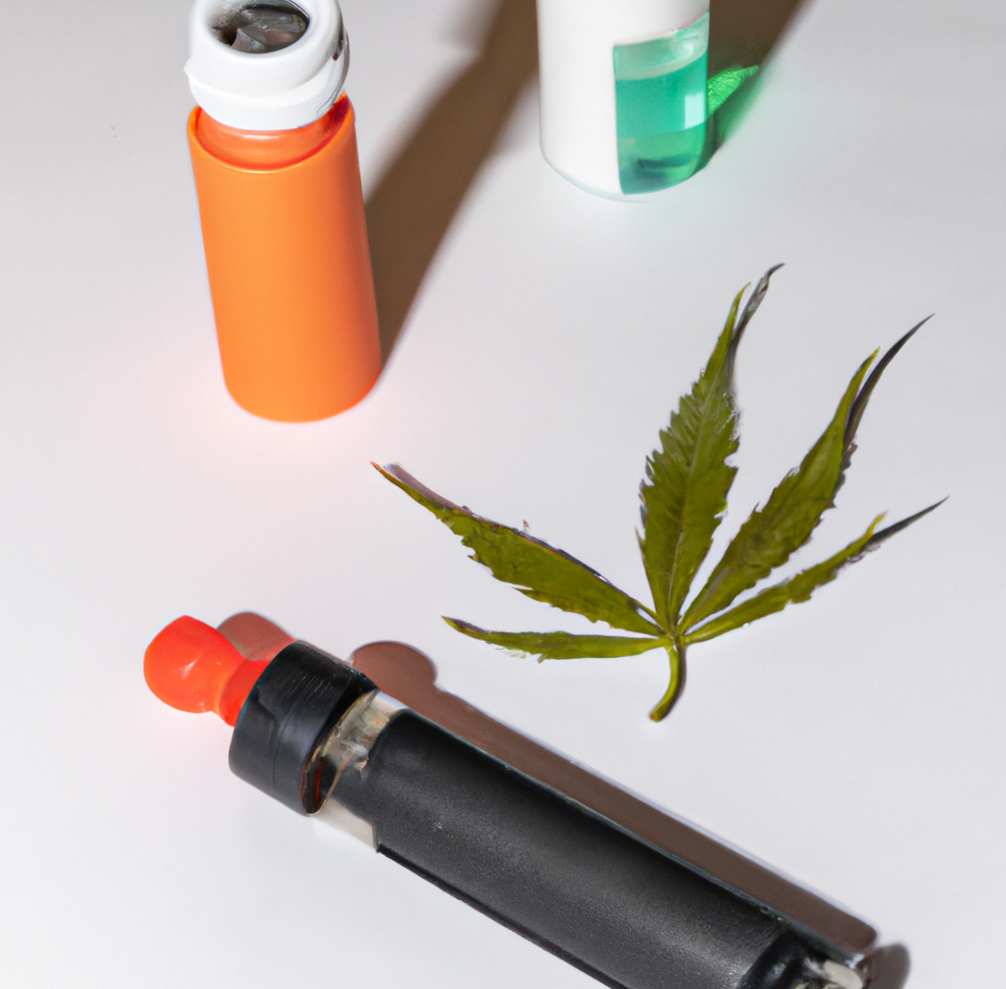 | Prefilled cartridge (dispensary)
 | Size: One
 | THC level: XX% or XX mg
 | CBD level: Your preferred choice
 | Unit Price: $XX
 | Excise Tax: [Insert rate & base]
 | Sales Tax: $XX
 | Total Price: $XX
Add [ ] items to cart

I would not buy any of these [check box]

Cart: [fill in unit_total]
Total: $[fill in total_cost]
Your usual monthly budget: $[fill in monbudget]

<< Store 1 out of # >>

[continue to stores 2-#]

