Supplemental Fig. 1. Total number of prescriptions (a, c) and corrected for number of enrollees (b, d) for dronabinol (a, b) and cannabidiol (c, d) to Medicaid patients for 2016 to 2020. The mean number of prescriptions among 50 states and Washington DC and the three highest/lowest states (corrected) are also shown.
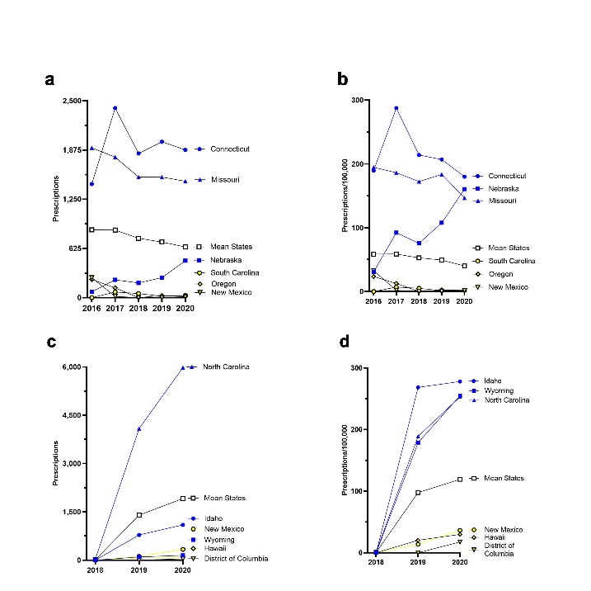

Supplemental Fig. 2. The total drug reimbursement in Medicaid of dronabinol and cannabidiol in millions ($) from 2016 to 2020.
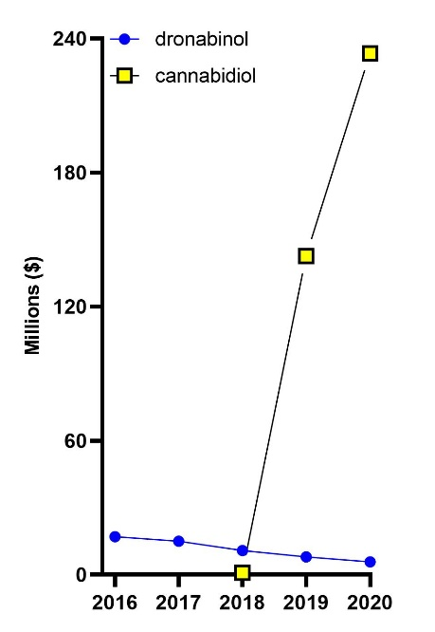
Supplemental Table 1. Product names and national drug codes in Medicaid.
__________________________________________________________________
Product name | National Drug Code
Marinol | 51002321
Marinol | 51002121
dronabinol | 378817191
dronabinol | 527145006
dronabinol | 527145206
dronabinol | 591359160
dronabinol | 591359260
dronabinol | 591359360
dronabinol | 904659761
dronabinol | 904659804
dronabinol | 904674561
dronabinol | 904674604
dronabinol | 17478076106
dronabinol | 17478076206
dronabinol | 17478076306
dronabinol | 31722096060
dronabinol | 31722096160
dronabinol | 31722096260
dronabinol | 42858086706
dronabinol | 42858086806
dronabinol | 42858086906
dronabinol | 49884086702
dronabinol | 49884086802
dronabinol | 49884086902
dronabinol | 60687037501
dronabinol | 67877056860
dronabinol | 67877056960
dronabinol | 67877057060
dronabinol | 68084017401
dronabinol | 68084017411
dronabinol | 68084017511
dronabinol | 68084017521
Syndros | 20482033530
Epidiolex | 70127010001
__________________________________________________________________

Supplemental Table 2. Total number of Medicaid/Chip enrollees for all 50 states and D.C 2016-2020.
STATE | 2020 Medicaid Enrollees (as of Dec 2020) | 2019 Medicaid enrollees (as of Dec. 2019) | 2018 Medicaid/CHIP Enrollees (as of Dec. 2018) | 2017 Medicaid/CHIP Enrollees (as of Dec. 2017) | 2016 Medicaid/CHIP Enrollees (as of Dec. 2016)
Alabama | 1,141,138 | 1,048,624 | 911,983 | 899,570 | 892,753
Alaska | 226,515 | 214,474 | 211,912 | 200,369 | 176,799
Arizona | 2,094,748 | 1,884,150 | 1,700,470 | 1,716,236 | 1,739,041
Arkansas | 919,628 | 835,370 | 850,580 | 913,552 | 948,181
California | 13,159,326 | 12,227,356 | 11,927,676 | 12,220,546 | 12,405,352
Colorado | 1,410,227 | 1,212,588 | 1,305,951 | 1,357,645 | 1,387,165
Connecticut | 1,042,833 | 956,280 | 855,943 | 836,906 | 761,310
DC | 239,025 | 212,146 | 259,243 | 264,016 | 264,849
Delaware | 259,261 | 262,775 | 248,964 | 247,948 | 241,664
Florida | 4,445,313 | 3,739,717 | 4,207,568 | 4,297,880 | 4,337,514
Georgia | 2,193,172 | 2,035,551 | 1,821,852 | 1,812,561 | 1,755,450
Hawaii | 357,869 | 309,262 | 331,075 | 346,747 | 345,975
Idaho | 394,092 | 291,968 | 280,570 | 297,688 | 299,841
Illinois | 2,937,593 | 2,653,924 | 2,860,188 | 3,062,268 | 3,065,331
Indiana | 1,641,919 | 1,318,948 | 1,450,933 | 1,478,130 | 1,508,219
Iowa | 677,628 | 604,168 | 691,918 | 668,047 | 622,071
Kansas | 389,858 | 358,036 | 389,535 | 389,441 | 408,885
Kentucky | 1,506,916 | 1,260,844 | 1,222,239 | 1,272,976 | 1,230,475
Lousiana | 1,816,232 | 1,581,072 | 1,449,085 | 1,455,541 | 1,415,385
Maine | 330,923 | 283,009 | 256,900 | 263,741 | 269,428
Maryland | 1,383,758 | 1,245,534 | 1,316,115 | 1,323,306 | 1,281,890
Massachusetts | 1,765,345 | 1,685,220 | 1,598,878 | 1,683,846 | 1,655,529
Michigan | 2,724,152 | 2,391,528 | 2,333,409 | 2,366,223 | 2,330,154
Minnesota | 1,176,859 | 1,033,487 | 1,069,346 | 1,082,484 | 1,049,566
Mississippi | 741,177 | 670,013 | 620,567 | 646,923 | 684,094
Missouri | 1,008,795 | 833,214 | 888,597 | 957,642 | 976,256
Montana | 262,664 | 246,051 | 279,675 | 274,234 | 245,360
Nebraska | 291,951 | 236,655 | 247,510 | 245,863 | 243,657
Nevada | 709,613 | 582,213 | 636,208 | 638,420 | 623,574
New_Hampshire | 209,658 | 182,328 | 184,476 | 189,811 | 191,363
New_Jersey | 1,760,094 | 1,602,059 | 1,739,718 | 1,780,672 | 1,795,251
New_Mexico | 907,868 | 829,475 | 728,327 | 743,780 | 775,020
New_York | 6,777,532 | 6,062,348 | 6,523,404 | 6,477,870 | 6,420,227
North_Carolina | 2,363,887 | 2,161,348 | 2,097,759 | 2,101,517 | 2,084,900
North_Dakota | 108,654 | 88,055 | 91,072 | 93,983 | 94,681
Ohio | 2,987,643 | 2,773,266 | 2,651,092 | 2,845,785 | 2,910,351
Oklahoma | 792,404 | 632,428 | 774,952 | 780,488 | 804,355
Oregon | 1,120,109 | 966,536 | 979,447 | 976,182 | 986,111
Pennsylvania | 3,161,673 | 2,828,468 | 2,949,567 | 2,986,599 | 2,918,260
Rhode_Island | 320,587 | 288,686 | 311,254 | 312,705 | 300,924
South_Carolina | 1,357,644 | 1,276,521 | 1,044,270 | 1,036,707 | 1,032,898
South_Dakota | 115,367 | 102,372 | 116,290 | 118,085 | 119,956
Tennessee | 1,676,327 | 1,568,950 | 1,396,302 | 1,548,572 | 1,636,770
Texas | 4,901,254 | 4,140,124 | 4,308,644 | 4,474,461 | 4,799,893
Utah | 388,599 | 295,804 | 288,403 | 302,585 | 311,117
Vermont | 183,394 | 163,672 | 160,114 | 163,649 | 169,092
Virginia | 1,574,108 | 1,313,429 | 1,053,309 | 1,028,297 | 993,220
Washington | 1,910,704 | 1,731,143 | 1,739,111 | 1,782,832 | 1,818,225
West_Virginia | 575,310 | 518,356 | 532,144 | 549,678 | 567,064
Wisconsin | 1,353,048 | 1,183,923 | 1,020,034 | 1,034,480 | 1,037,863
Wyoming | 58,017 | 54,231 | 58,118 | 61,072 | 61,925
Total | 81,852,411 | 72,977,699 | 72,972,697 | 74,610,559 | 74,995,234

