eTable 1. GRADE Evaluation
Outcome | Period (W) | Starting grade | Reason |  | GRADE
Outcome | Period (W) | Starting grade | Upgrading | Downgrade | GRADE
Responder rate | 12 | L | Negative bias | - | M
Responder rate | 24 | L | Negative bias | - | M
Responder rate | 48 | L | Negative bias | Publication bias | L
Responder rate | 72 | L | Negative bias | Publication bias | L
Responder rate | 96 | L | Negative bias | Publication bias | L
Responder rate | 144 | L | Negative bias | Imprecision | L
Free seizure rate | 12 | L | Negative bias | Publication bias | L
Free seizure rate | 24 | L | Negative bias | Publication bias | L
Free seizure rate | 48 | L | Negative bias | Publication bias | L
Free seizure rate | 72 | L | Negative bias | - | M
Free seizure rate | 96 | L | Negative bias | Publication bias | L
Free seizure rate | 144 | L | Negative bias | Imprecision | L
Adverse events rate | 12 | L | - | - | L
Adverse events rate | 24 | L | - | - | L
Adverse events rate | 48 | L | - | - | L
Adverse events rate | 72 | L | - | Imprecision | VL
Adverse events rate | 96 | L | - | - | L
Adverse events rate | 144 | L | - | - | L
Serious adverse events rate | 12 | L | - | - | L
Serious adverse events rate | 24 | L | - | - | L
Serious adverse events rate | 48 | L | - | - | L
Serious adverse events rate | 96 | L | - | - | L
Serious adverse events rate | 144 | L | - | - | L
Note: L: Low. M: Moderate. VL: Very low.

eFigure legends
eFigure 1. The MINORS scores and risk of bias summary. Note: If diagnostic criteria for DRE were not clearly written in literature, selection bias would be assessed as uncertain. If the use of CBD was not clearly written in literature, intervention bias would be assessed as uncertain. If measurement method of seizure was not clearly written in literature, measurement bias of the study was assessed as uncertain. If more than 10% of patients were lost to follow-up, follow-up bias would be assessed as high risk, 5%-10% and literatures reporting only PP set would be assessed as uncertain. Reporting bias was assessed as inconclusive if data were extracted from abstracts, such as conference abstracts.
eFigure 2. Forest plot of responder rates. (A). 12-week. (B). 24-week. (C). 48-week. (D). 72-week. (E). 96-week. (F). 144-week.
eFigure 3. Sensitivity analyses. (A). Responder rates. (B). Free seizure rate. (C). Proportion of adverse events. (D). Proportion of serious adverse events.
eFigure 4. Sensitivity analyses of subgroup analyses of age. (A). Responder rates. (B). Free seizure rate. (C). Proportion of adverse events. (D). Proportion of serious adverse events.
The left graphs are main analyses: > 14 group and <= 14 group. The right graphs are sensitivity analyses: > 18 group and <= 18.
eFigure 5. Sensitivity analyses of subgroup analyses of epilepsy syndromes. (A). Responder rates. (B). Free seizure rate. (C). Proportion of adverse events. (D). Proportion of serious adverse events.
The left graphs are main analyses: LGS & DS group and other syndromes group were divided by the constituent ratio of epilepsy syndromes greater than 50%. The right graphs are sensitivity analyses: LGS & DS group and other syndromes group were divided by the constituent ratio of epilepsy syndromes greater than 95%.
eFigure 6. Funnel plot. (A). Responder rates. (B). Free seizure rate. (C). Proportion of adverse events. (D). Proportion of serious adverse events.
eFigure 7. Forest plot of free seizure rates. (A). 12-week. (B). 24-week. (C). 48-week. (D). 72-week. (E). 96-week. (F). 144-week.
eFigure 8. Forest plot of proportion of adverse events. (A). 12-week. (B). 24-week. (C). 48-week. (D). 72-week. (E). 96-week. (F). 144-week.
eFigure 9. Forest plot of serious proportion of adverse events. (A). 12-week. (B). 24-week. (C). 48-week. (D). 96-week. (E). 144-week.

eFigure 1. The MINORS scores and risk of bias summary.
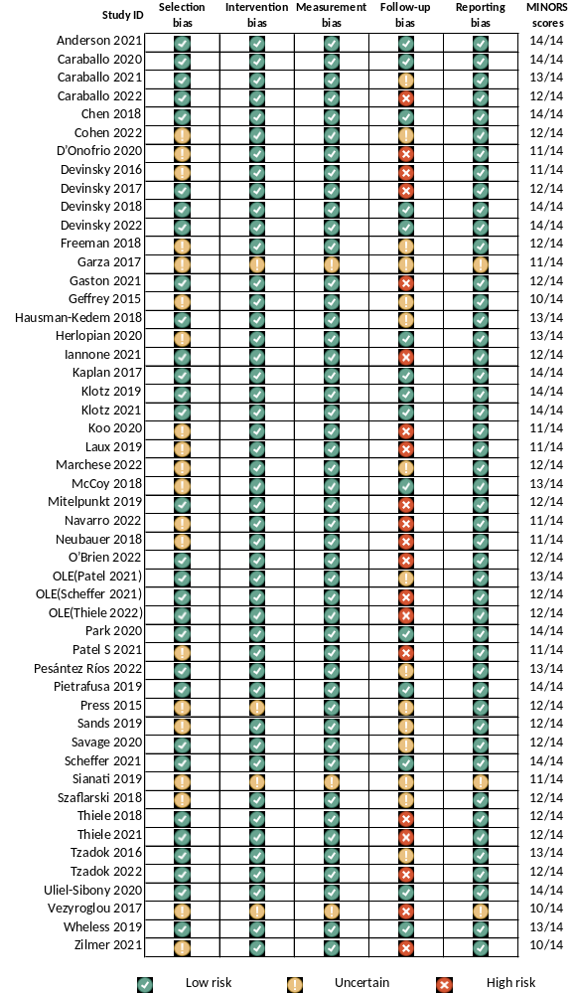

eFigure 2. Forest plot of responder rates. (A). 12-week. (B). 24-week. (C). 48-week. (D). 72-week. (E). 96-week. (F). 144-week.
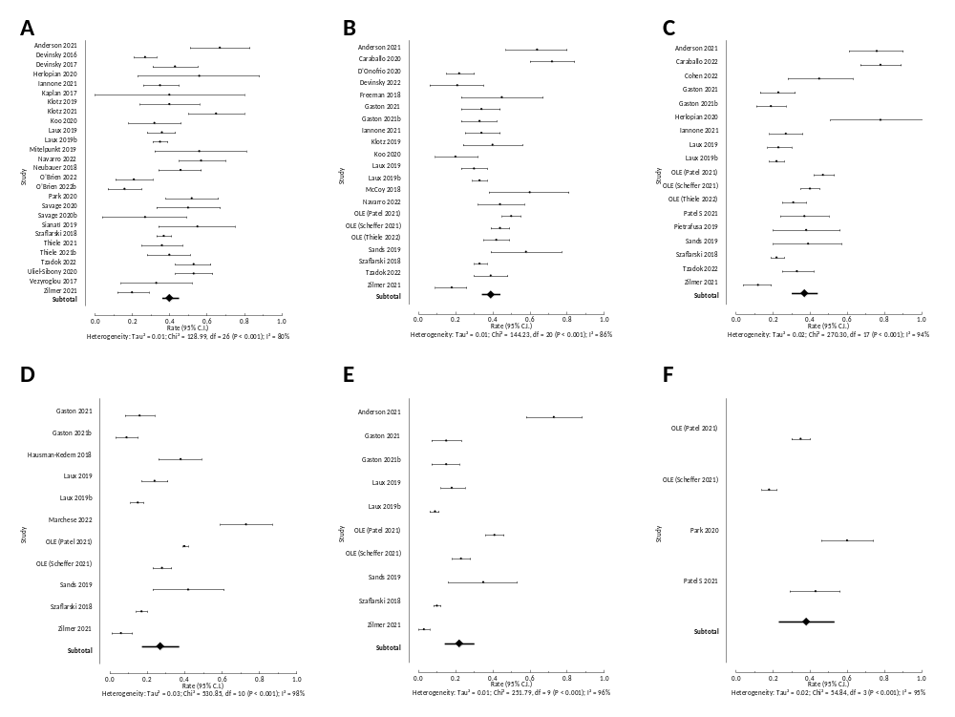
eFigure 3. Sensitivity analyses. (A). Responder rates. (B). Free seizure rate. (C). Proportion of adverse events. (D). Proportion of serious adverse events.
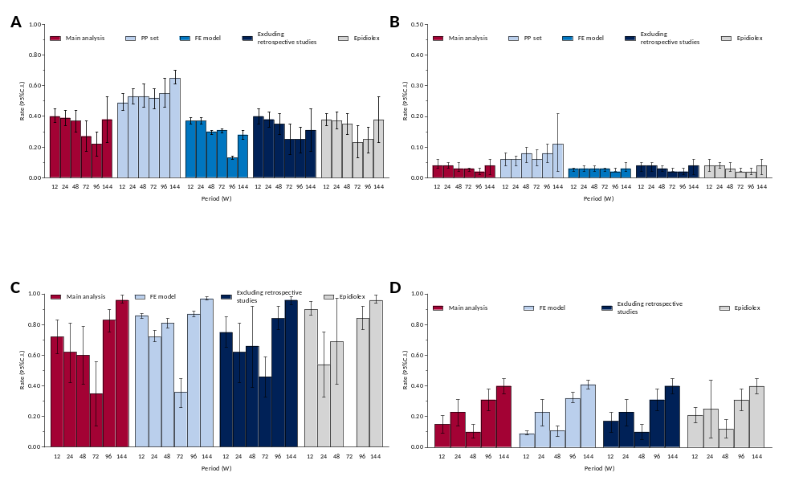

eFigure 4. Sensitivity analyses of subgroup analyses of age. (A). Responder rates. (B). Free seizure rate. (C). Proportion of adverse events. (D). Proportion of serious adverse events.
The left graphs are main analyses: > 14 group and <= 14 group. The right graphs are sensitivity analyses: > 18 group and <= 18.
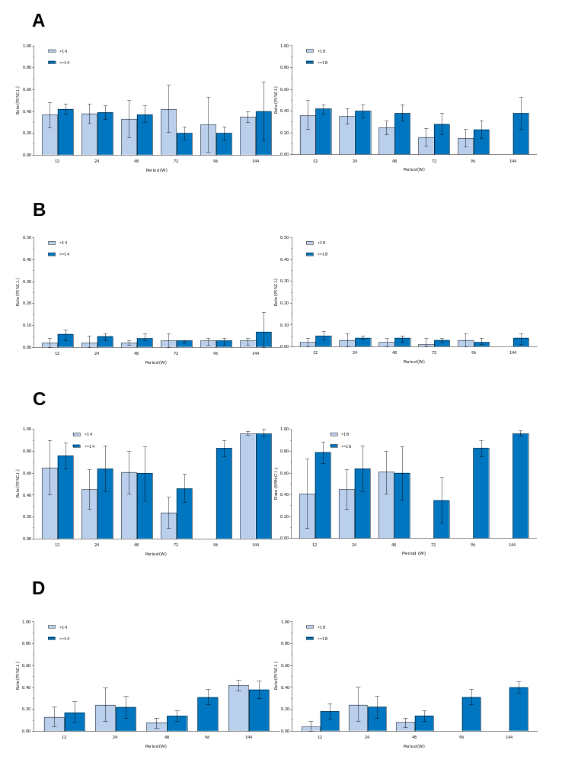
eFigure 5. Sensitivity analyses of subgroup analyses of epilepsy syndromes. (A). Responder rates. (B). Free seizure rate. (C). Proportion of adverse events. (D). Proportion of serious adverse events.
The left graphs are main analyses: LGS & DS group and other syndromes group were divided by the constituent ratio of epilepsy syndromes greater than 50%. The right graphs are sensitivity analyses: LGS & DS group and other syndromes group were divided by the constituent ratio of epilepsy syndromes greater than 95%.
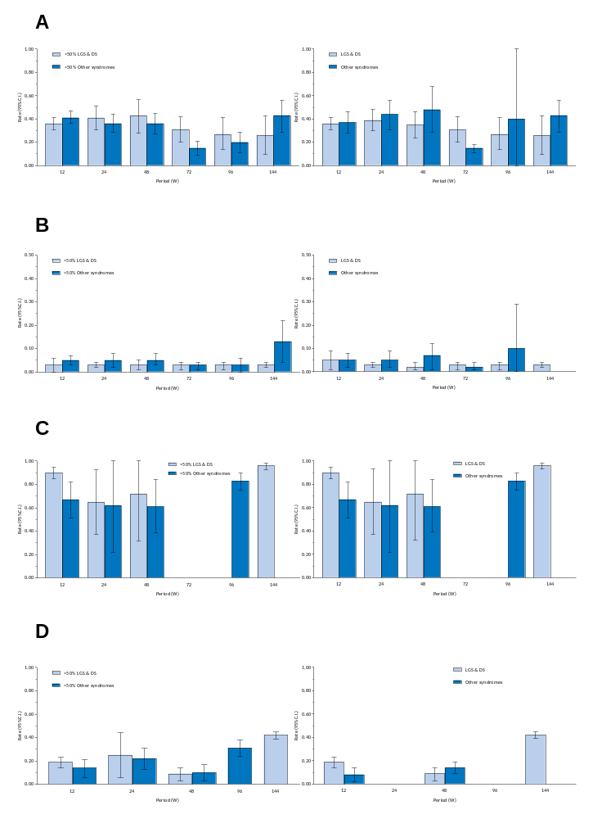
eFigure 6. Funnel plot. (A). Responder rates. (B). Free seizure rate. (C). Proportion of adverse events. (D). Proportion of serious adverse events.
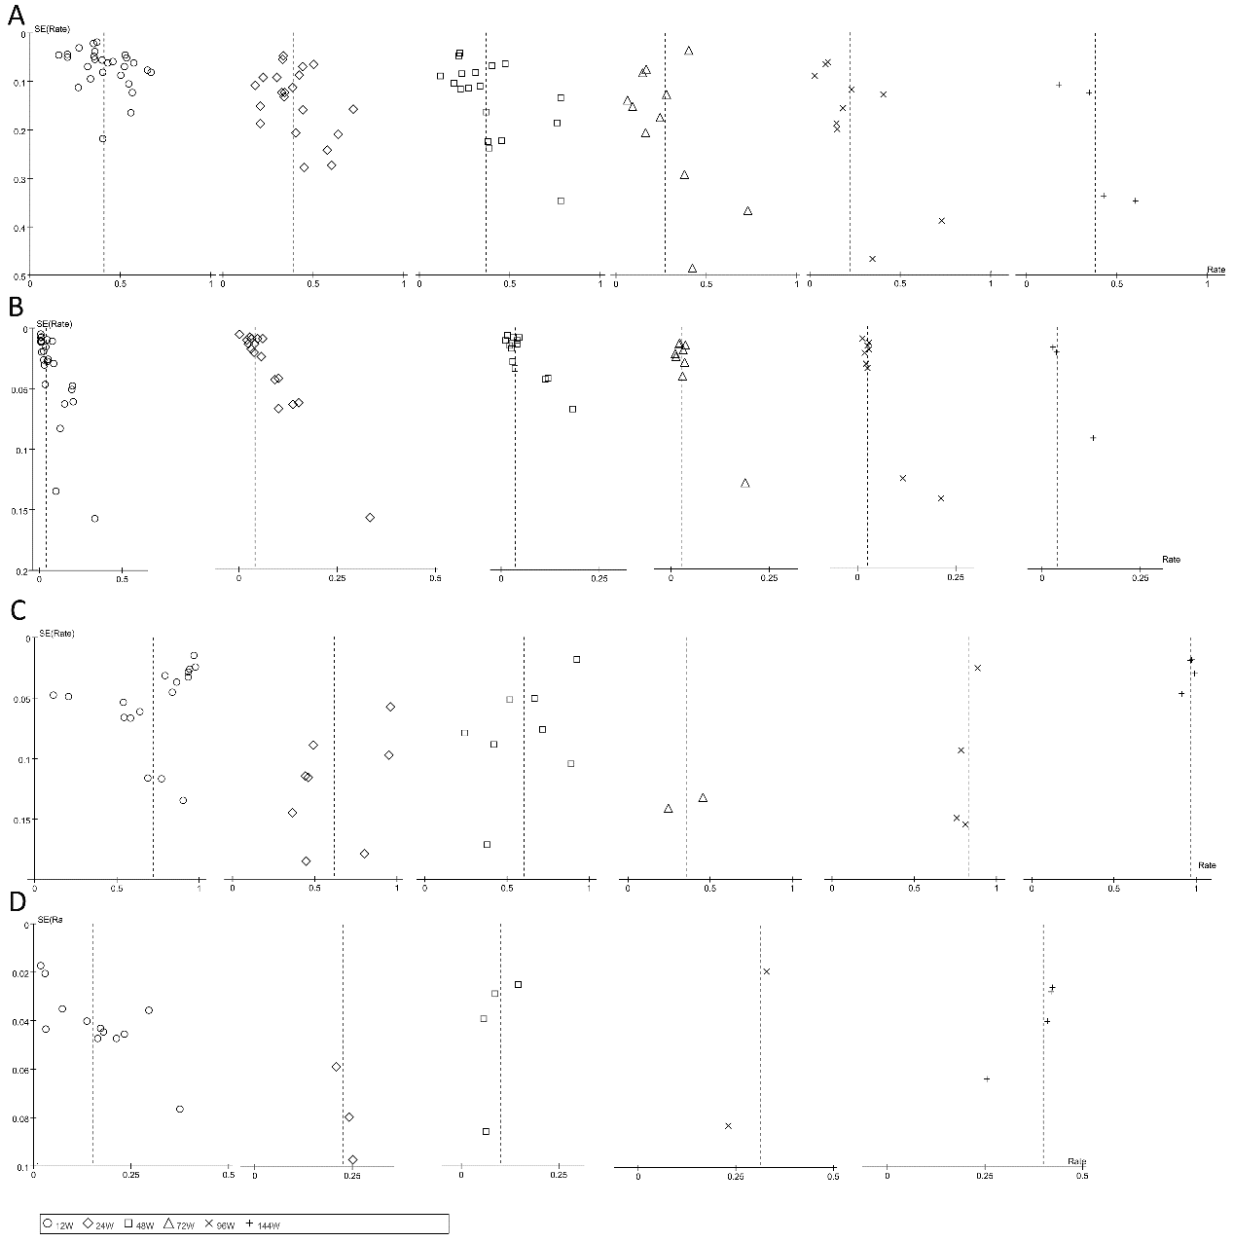
eFigure 7. Forest plot of free seizure rates. (A). 12-week. (B). 24-week. (C). 48-week. (D). 72-week. (E). 96-week. (F). 144-week.
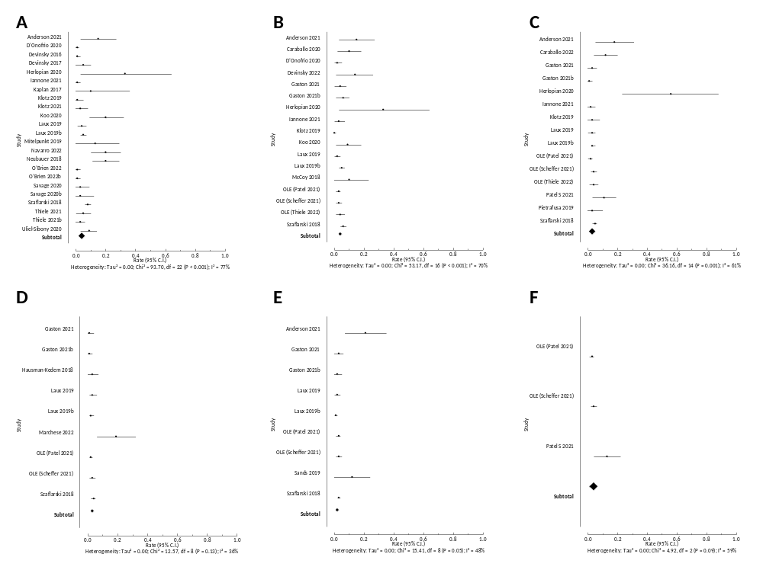
eFigure 8. Forest plot of proportion of adverse events. (A). 12-week. (B). 24-week. (C). 48-week. (D). 72-week. (E). 96-week. (F). 144-week.
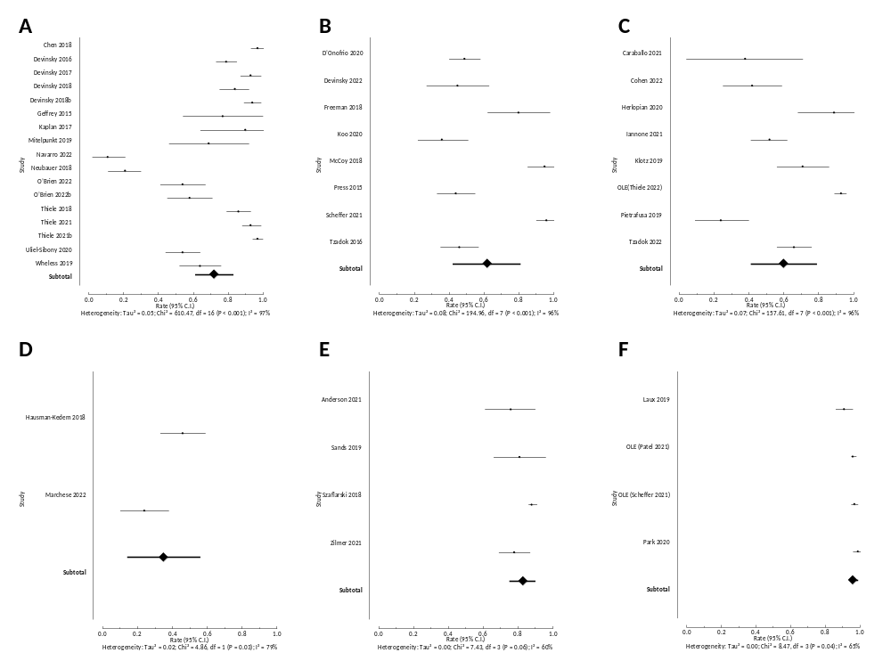
eFigure 9. Forest plot of serious proportion of adverse events. (A). 12-week. (B). 24-week. (C). 48-week. (D). 96-week. (E). 144-week.
