Supplementary Material

Table 1. Commercially available cannabis galenical products in Italy.
Cannabinoid product | Variety | % THC | % CBD
Bedrocan® | Cannabis sativa | 21 | < 1
Bediol® | Cannabis sativa | 6.5 | 8
Bedrolite®  Bedrobinol®  Bedica®  FM2 | Cannabis sativa  Cannabis sativa  Cannabis sativa  Cannabis sativa | <1  12  14  5-8 | ~ 9  <1  <1  7-12

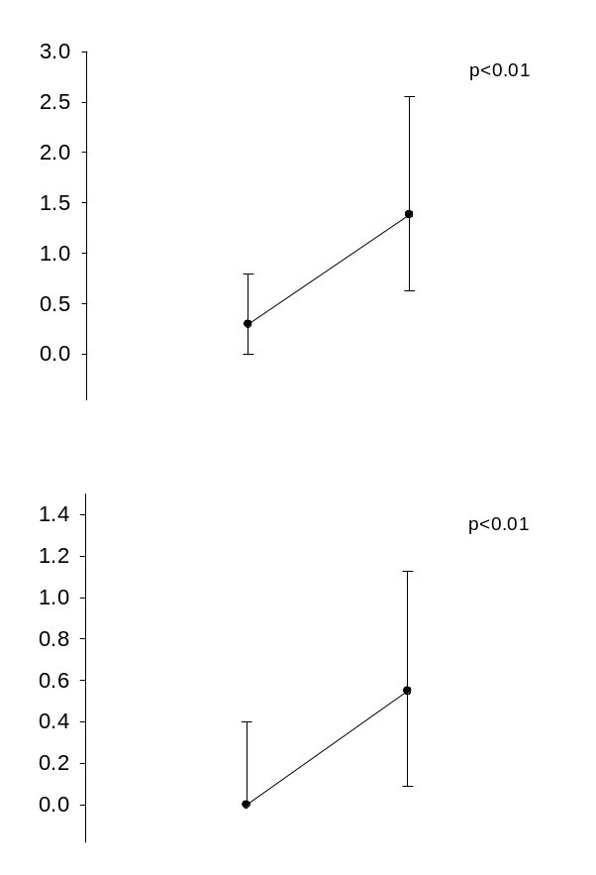
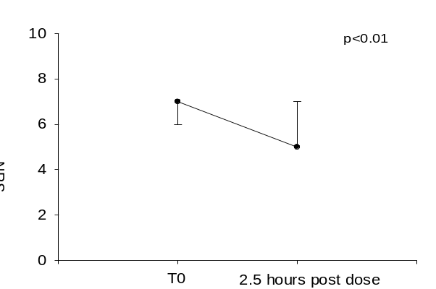

Figure 1. Median plasma concentrations of tetrahydrocannabinol (THC), cannabidiol (CBD)
and matched NRS scores in patients after THC/CBD dosing. Capped bars indicate
25th–75th percentiles.
Table 2. Clinical and therapeutic characteristics of patients who self-assessed their main disease
symptoms by NRS scale pre and post morning CBs dosing.
Disease | Cannabinoid products
 | Sativex®  (n) | Bediol®  (n) | Bedrocan®  (n) | Bedrolite®  (n)
Multiple sclerosis | 13 | 3 | 2 | 1
Neuropathic pain |  | 1
Spastic paraparesis |  | 1 |  | 2

