Supplemental material
Schwerdtfeger et al. The effect of N-arachidonoylethanolamide administration on energy and fat metabolism of early lactating dairy cows

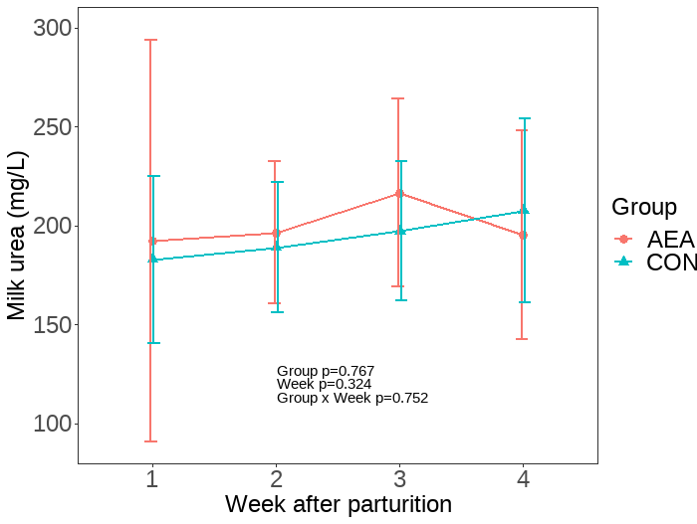
Supplementary Figure 1. Milk urea concentration of cows treated intraperitoneally with N-arachidonoylethanolamide (AEA, n = 10) or NaCl (CON, n = 10) postpartum. Data are presented as means ± SD.

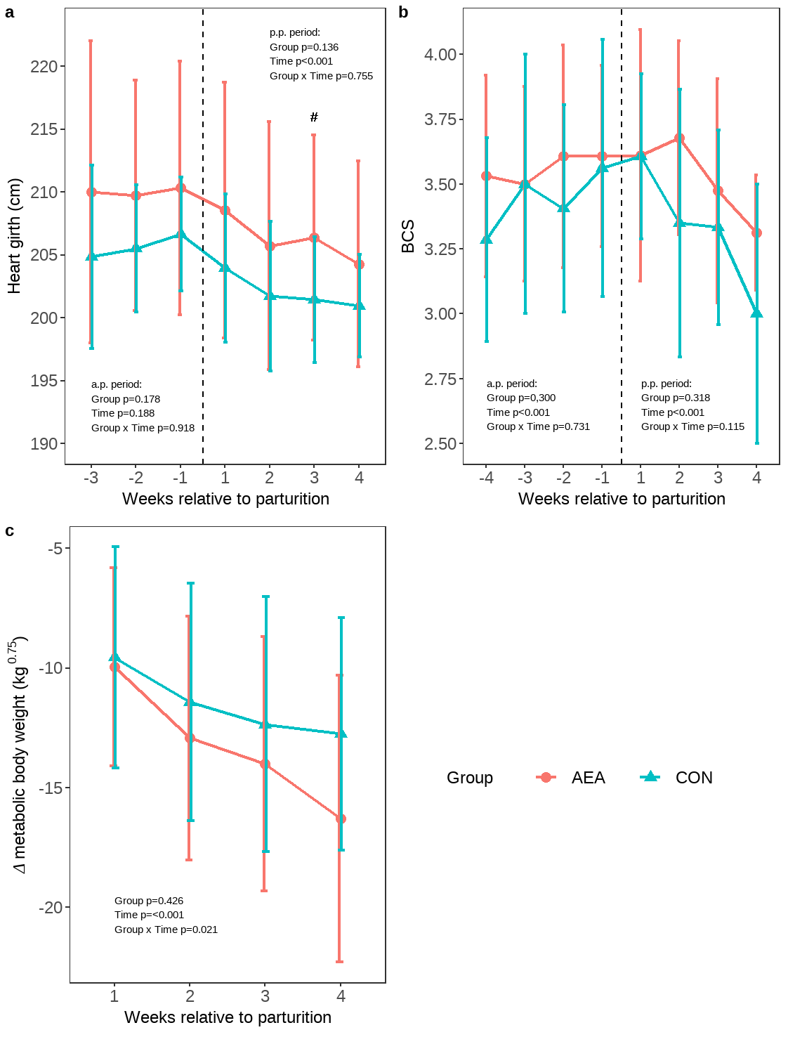
Supplementary Figure 2. Heart girth (a), body condition score (BCS; b), and change in metabolic body weight (c) of cows treated intraperitoneally with NaCl (CON, n = 10) or N-arachidonoylethanolamide (AEA, n = 10) postpartum. Data are presented as means ± SD; # P < 0.1.

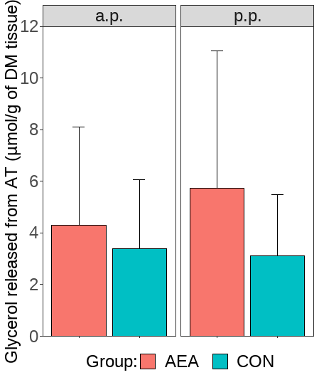
Supplementary Figure 3. Noradrenaline stimulated glycerol released after 120min incubation from adipose tissue (AT) of cows treated intraperitoneally with N-arachidonoylethanolamide (AEA, n = 8) or NaCl (CON, a.p. n = 10, p.p. n = 9 ) postpartum. Data are presented as means ± SD.

Supplementary Table 1. Devices and probes used for the ultrasound measurements.
Ultrasound measurement | Calculated Fat Depot | Device | Probe
R12 | AAT, RPAT, SCAT | SonoSite MicroMaxx; Fujifilm SonoSite Inc., Bothell, WA | L52x Rectal Transducer (10-5MHz) Fujifilm SonoSite Inc., Bothell, WA
BFT | OMAT, SCAT | SonoSite MicroMaxx; Fujifilm SonoSite Inc., Bothell, WA | L52x Rectal Transducer (10-5MHz) Fujifilm SonoSite Inc., Bothell, WA
AW1b | AAT, MAT | SonoSite MicroMaxx; Fujifilm SonoSite Inc., Bothell, WA | L52x Rectal Transducer (10-5MHz) Fujifilm SonoSite Inc., Bothell, WA
AW3b | OMAT, MAT | SonoSite MicroMaxx; Fujifilm SonoSite Inc., Bothell, WA | L52x Rectal Transducer (10-5MHz) Fujifilm SonoSite Inc., Bothell, WA
AW3c | MAT, SCAT | SonoSite MicroMaxx; Fujifilm SonoSite Inc., Bothell, WA | L52x Rectal Transducer (10-5MHz) Fujifilm SonoSite Inc., Bothell, WA
KD2c | AAT, MAT | SonoSite Titan; Fujifilm SonoSite Inc., Bothell, WA | C60/5-2MHz convex transducer, Fujifilm SonoSite Inc., Bothell, WA
KD3b | RPAT | SonoSite Titan; Fujifilm SonoSite Inc., Bothell, WA | C60/5-2MHz convex transducer, Fujifilm SonoSite Inc., Bothell, WA
R12 = subcutaneous fat over the 12th rib; BFT = back fat thickness; AW1b = the distance from the skin to the distal muscle margin above the peritoneum at the point of interception of a vertical line trough the last lumbar vertebra and a horizontal line trough the patella; AW3b = the distance from the skin to the distal muscle margin above the peritoneum at the center of the paralumbar fossa; AW3c = the thickness of the abdominal wall at the center of the paralumbar fossa; KD2c = the distance from the skin to the peritoneum in the intertransverse space directly cranial to intertransverse space where the caudal pole of the kidney is visible; KD3b = the distance from the skin to the distal kidney margin in the intertransverse space directly cranial to KD2; AAT = total abdominal adipose tissue; MAT = mesenteric adipose tissue; OMAT = omental adipose tissue; RPAT = retroperitoneal adipose tissue; SCAT = subcutaneous adipose tissue

Supplementary Table 2. Primer sequences, PCR product sizes and amplification efficiency for genes analysed in liver tissue.
Gene | Function | Primer sequence (5´to 3´) | Accession ID | Size (bp) | Efficiency  (day -25/+16/+30) | Reference
EIF3K | Forward | CCAGGCCCACCAAGAAGAA | NM_001034489 | 125 | 1.81/1.81/1.79 | 1
EIF3K | Reverse | TTATACCTTCCAGGAGGTCCATGT | NM_001034489 | 125 | 1.81/1.81/1.79
EMD | Forward | GCCCTCAGCTTCACTCTCAGA | NM_203361 | 100 | 1.88/1.87 | 1
EMD | Reverse | GAGGCGTTCCCGATCCTT | NM_203361 | 100 | 1.88/1.87
GPR55 | Forward | TGCTGCCTGGATGTTTTCTG | XM_024982054 | 207 | 1.81/1.8/1.82 | 2
GPR55 | Reverse | TCAGCCCACCACATCAGG | XM_024982054 | 207 | 1.81/1.8/1.82
CNR1 | Forward | AAGCCCGCATGGACATTCGGCTGG | NM_001242341 | 79 | 1.9/1.9/1.88 | 2
CNR1 | Reverse | AGCAGAGGGCCCCAGCAGAT | NM_001242341 | 79 | 1.9/1.9/1.88
DGAT1 | Forward | GACCCCTAACCTTTGACCCC | NM_174693 | 163 | 1.82/1.83/1.85 | 2
DGAT1 | Reverse | CCCAACCTCCCGCTAAGTTT | NM_174693 | 163 | 1.82/1.83/1.85
DGAT2 | Forward | GAAAGGTAGGAGCACGGGTC | NM_205793 | 132 | 1.82/1.82/1.86 | 2
DGAT2 | Reverse | AGCCCAACACTATTCACGCA | NM_205793 | 132 | 1.82/1.82/1.86

Gene | Function | Primer sequence (5´to 3´) | Accession ID | Size (bp) | Efficiency  (day -25/+16/+30) | Reference
FAAH | Forward | TTCCTGCCAAGCAACATACCT | NM_001099102 | 105 | 1.69/1.70/1.77 | 2
FAAH | Reverse | CACGAAATCACCTTTGAAGTTCTG | NM_001099102 | 105 | 1.69/1.70/1.77
NAPEPLD | Forward | AGAGATCACAGCAGCGTTCCAT | NM_001015680 | 95 | 1.81/1.82/1.84 | 3
NAPEPLD | Reverse | ACTCCAGCTTCTTCAGGGTCATC | NM_001015680 | 95 | 1.81/1.82/1.84
ABCA1 | Forward | TGGAAGAATGTGAAGCTCTCTG | NM_001024693 | 157 | 1.75/1.74/1.76
ABCA1 | Reverse | TGTACAGGCTTCAGGTCAGG | NM_001024693 | 157 | 1.75/1.74/1.76
APOB100 | Forward | GCCAGAGATGAAGTGCTGGA | XM_024999521 | 149 | 1.84/1.83/1.85
APOB100 | Reverse | ATCTTGGTGGCGCTTCTTGA | XM_024999521 | 149 | 1.84/1.83/1.85
MTTP | Forward | TCATCCAATGTGGATGTCGC | NM_001101834 | 267 | 1.71/1.71/1.79
MTTP | Reverse | GAGATTTTCTATGGCTGCTG | NM_001101834 | 267 | 1.71/1.71/1.79
PPARA | Forward | CGGAAGTCCGCATTTTCCAC | NM_001034036 | 171 | 1.81/1.81/1.80 | 2
PPARA | Reverse | TCACAGAAGACAGCATCGCA | NM_001034036 | 171 | 1.81/1.81/1.80
SREBF1 | Forward | GCACCGAGGCCAAGTTGAAT | NM_001113302 | 148 | 1.87/1.86/1.87 | 2
SREBF1 | Reverse | CACCAGTCCTTCAGCGATT | NM_001113302 | 148 | 1.87/1.86/1.87
PPIA, peptidylprolyl isomerase A; EIE3K, eukaryotic translation initiation factor 3 subunit K; EMD, emerin; GPR55, G protein-coupled receptor 55; CNR1, cannabinoid receptor 1; DGAT1, diacylglycerol o-acyltransferase 1; DGAT2, diacylglycerol o-acyltransferase 2; FAAH, fatty acid amide hydrolase; NAPEPLD, N-acyl phosphatidylethanolamine phospholipase D; ABCA1, ATP binding cassette subfamily A member 1; APOB100, apolipoprotein B; MTTP, microsomal triglyceride transfer protein; PPARA, peroxisome proliferator activated receptor alpha; SREBF1, sterol regulatory element binding transcription factor 1
Supplementary Table 3. Primer sequences, PCR product sizes and amplification efficiency for mRNA analysed in mammary gland.
Gene | Function | Primer sequence (5´to 3´) | Accession ID | Size (bp) | Efficiency | Reference
EIF3K | Forward | CCAGGCCCACCAAGAAGAA | NM_001034489 | 125 | 1.81 | 1
EIF3K | Reverse | TTATACCTTCCAGGAGGTCCATGT | NM_001034489 | 125 | 1.81
PPIA | Forward | GGATTTATGTGCCAGGGTGGTGA | NM_178320 | 120 | 1.90 | 3
PPIA | Reverse | CAAGATGCCAGGACCTGTATG | NM_178320 | 120 | 1.90
CNR1 | Forward | AAGCCCGCATGGACATTCGGCTGG | NM_001242341 | 79 | 1.87 | 2
CNR1 | Reverse | AGCAGAGGGCCCCAGCAGAT | NM_001242341 | 79 | 1.87
ACC1 | Forward | TCCTGCTGCTATTGCTACTCCA | NM_174224 | 95 | 1.86
ACC1 | Reverse | CAGTCCCCGCACTCACATAA | NM_174224 | 95 | 1.86
DGAT1 | Forward | GACCCCTAACCTTTGACCCC | NM_174693 | 163 | 1.83 | 2
DGAT1 | Reverse | CCCAACCTCCCGCTAAGTTT | NM_174693 | 163 | 1.83
DGAT2 | Forward | GAAAGGTAGGAGCACGGGTC | NM_205793 | 132 | 1.84 | 2
DGAT2 | Reverse | AGCCCAACACTATTCACGCA | NM_205793 | 132 | 1.84
FASN | Forward | ACCTCGTGAAGGCTGTGACTCA | NM_001012669 | 92 | 1.88
FASN | Reverse | TGAGTCGAGGCCAAGGTCTGAA | NM_001012669 | 92 | 1.88
SCD | Forward | CCCTTTCCTTGAGCTGTCTG | NM_173959 | 181 | 1.86 | 4
SCD | Reverse | ATGCTGACTCTCTCCCCTGA | NM_173959 | 181 | 1.86
SREBF1 | Forward | GCACCGAGGCCAAGTTGAAT | NM_001113302 | 148 | 1.89 | 2
SREBF1 | Reverse | CACCAGGTCCTTCAGCGATT | NM_001113302 | 148 | 1.89
EIE3K, eukaryotic translation initiation factor 3 subunit K; PPIA, peptidylprolyl isomerase A; CNR1, cannabinoid receptor 1; ACC1, acetyl-CoA carboxylase alpha; DGAT1, diacylglycerol o-acyltransferase 1; DGAT2, diacylglycerol o-acyltransferase 2; FASN, fatty acid synthase; SCD, stearoyl-CoA desaturase; SREBF1, sterol regulatory element binding transcription factor 1

1 Saremi, B., Sauerwein, H., Dänicke, S. & Mielenz, M. Technical note: Identification of reference genes for gene expression studies in different bovine tissues focusing on different fat depots. Journal of Dairy Science 95, 3131-3138, doi:https://doi.org/10.3168/jds.2011-4803 (2012).
2 van Ackern, I., Wulf, R., Dannenberger, D., Tuchscherer, A. & Kuhla, B. Effects of endocannabinoids on feed intake, stress response and whole-body energy metabolism in dairy cows. Scientific Reports 11, 23657, doi:10.1038/s41598-021-02970-0 (2021).
3 van Ackern, I., Kuhla, A. & Kuhla, B. A Role for Peripheral Anandamide and 2-Arachidonoylglycerol in Short-Term Food Intake and Orexigenic Hypothalamic Responses in a Species with Continuous Nutrient Delivery. Nutrients 13, doi:10.3390/nu13103587 (2021).
4 Gervais, R., McFadden, J. W., Lengi, A. J., Corl, B. A. & Chouinard, P. Y. Effects of intravenous infusion of trans-10, cis-12 18:2 on mammary lipid metabolism in lactating dairy cows. Journal of Dairy Science 92, 5167-5177, doi:https://doi.org/10.3168/jds.2009-2281 (2009).

