Supplementary Material
Post-traumatic stress and future substance use outcomes: leveraging antecedent factors to stratify risk
Henri M Garrison-Desany¹; Christy A Denckla¹; Jacquelyn L Meyers²; Sarah D Linnstaedt³; Karestan C Koenen⁴; Stacey L House⁵; Francesca L Beaudoin^{6,7}; Xinming An³; Jennifer S Stevens⁸; Donglin Zeng⁹; Thomas C Neylan¹⁰; Gari D Clifford^{11,12}; Tanja Jovanovic¹³; Laura T Germine^{14,15,16}; Kenneth A Bollen¹⁷; Scott L Rauch^{14,18,16}; John P Haran¹⁹; Alan B Storrow²⁰; Christopher Lewandowski²¹; Paul I Musey Jr.²²; Phyllis L Hendry²³; Sophia Sheikh²³; Christopher W Jones²⁴; Brittany E Punches²⁵; Robert A Swor²⁶; Nina T Gentile²⁷; Vishnu P Murty²⁸; Lauren A Hudak²⁹; Jose L Pascual^{30,31}; Mark J Seamon^{32,31}; Erica Harris³³; Anna M Chang³⁴; Claire Pearson³⁵; David A Peak³⁶; Roland C Merchant³⁷; Robert M Domeier³⁸; Niels K Rathlev³⁹; Brian J O'Neil⁴⁰; Paulina Sergot⁴¹; Leon D Sanchez^{37,42}; Steven E Bruce⁴³; Jutta Joormann⁴⁴; Steven E Harte^{45,46}; Samuel A McLean^{47,48}; Kerry J Ressler^{50,16}
* Correspondence: Henri M. Garrison-Desany; hgarrisondesany@hsph.harvard.edu

Supplementary Figures and Tables

Supplemental Figure 1. Principal component analysis of past 30 day use frequency variables for tobacco, alcohol, cannabis, opiates, cocaine, hallucinogens, barbiturates, stimulants, and sedatives.

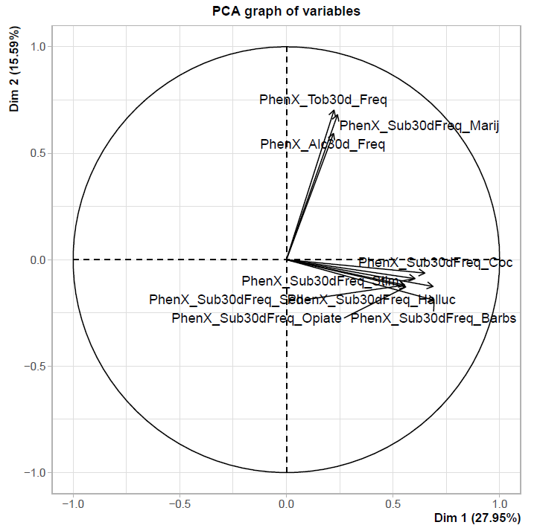

Supplemental Figure 2. Correlogram of past 30 day substance use frequency for tobacco, alcohol, cannabis, cocaine, opiates, stimulants, sedatives, hallucinogens, and barbiturates.
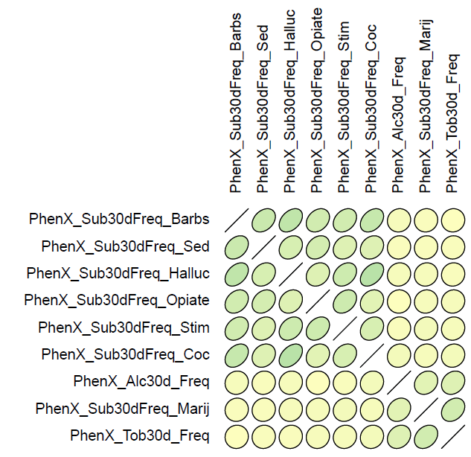
Supplemental Table 1. Specific class of index traumatic event in AURORA sample.
 | No likely PTSD  N (%) | Likely PTSD  N (%)
Motor vehicle collision
Occupant of motor vehicle on a public road | 710 (71.7%) | 596 (63.1%)
Rider on a motor vehicle (motorcycle, ATV) on a public road | 31 (3.1%) | 30 (3.2%)
Occupant of a motor vehicle off road | 2 (0.2%) | 2 (0.2%)
Rider on a motor vehicle (motorcycle, ATV) off road | 3 (0.3%) | 5 (0.5%)
Non-occupant hit by a motor vehicle on a public road | 60 (6.1%) | 36 (0.1%)
Non-occupant hit by a motor vehicle off road | 3 (0.3%) | 5 (0.5%)
Other motor vehicle collision | 0 (0%) | 1 (0.1%)
Physical assault
Fight or brawl (participant intentionally started or joined) | 12 (1.2%) | 23 (2.4%)
Attacked or jumped (participant was targeted and did not voluntarily participate; includes being struck by thrown object or pushed) | 52 (5.3%) | 118 (12.5%)
Other physical assault | 3 (0.3%) | 9 (10.0%)
Fall >10 feet
During sport or recreational activity | 0 (0%) | 3 (0.3%)
Not during sport or recreational activity | 16 (1.6%) | 13 (1.4%)
Mass event
Accidental | 5 (0.5%) | 2 (0.2%)
Targeted/involuntary | 0 (0%) | 0 (0%)
Fall <10 feet
During sport or recreational activity | 5 (0.5%) | 7 (0.7%)
Not during sport or recreational activity | 50 (5.1%) | 56 (5.9%)
Poisoning
Accidental | 1 (0.1%) | 0 (0%)
Targeted/involuntary | 0 (0%) | 0 (0%)
Burn
Accidental | 3 (0.3%) | 7 (0.7%)
Targeted/involuntary | 0 (0%) | 0 (0%)
Other
Accidental | 30 (3.0%) | 27 (2.9%)
Targeted/involuntary | 4 (0.4%) | 5 (0.5%)
Note: Sexual assault is included in physical assault, under “attacked.”

Supplemental Table 2. Generalized estimating equations using Poisson model of post-traumatic stress symptoms and tobacco smoking frequency, controlling for sociodemographic factors using three timepoints.
 | Tobacco Frequency² |  | Tobacco Quantity³ |  |  | Alcohol Frequency |  |  | Alcohol Quantity³ |  |  | Cannabis
 | Incidence Rate  (95% CI) | P-Value | Incidence Rate  (95% CI) | P-Value | Incidence Rate  (95% CI) |  | P-Value | Incidence Rate  (95% CI) |  | P-Value | Incidence Rate  (95% CI) |  | P-Value
PTSD Symptoms¹ | 1.004 (1.001, 1.01) | 0.02 | 1.01 (1.002, 1.01) | 0.004 | 1.002 (1, 1.004) |  | 0.12 | 1.004 (1.001, 1.006) |  | 0.003 | 1.003 (1, 1.01) |  | 0.04
Time | 0.96 (0.92, 1.01) | 0.14 | 0.99 (0.92, 1.06) | 0.76 | 1.01 (0.97, 1.05) |  | 0.71 | 0.97 (0.93, 1.01) |  | 0.16 | 0.98 (0.93, 1.04) |  | 0.55
Marital status
Married (Ref)
Never married | 1.11 (0.93, 1.33) | 0.26 | 1.10 (0.86, 1.41) | 0.44 | 1.13 (0.98, 1.29) |  | 0.10 | 1.17 (1.02, 1.34) |  | 0.03 | 1.4 (1.12, 1.73) |  | 0.003
Divorced | 1.27 (1.05, 1.55) | 0.02 | 1.51 (1.15, 1.97) | 0.003 | 0.98 (0.83, 1.16) |  | 0.81 | 1.1 (0.94, 1.29) |  | 0.25 | 1.32 (1.02, 1.71) |  | 0.04
Widowed/Other | 1.06 (0.71, 1.57) | 0.79 | 0.98 (0.59, 1.65) | 0.94 | 1.24 (0.88, 1.75) |  | 0.21 | 1.12 (0.8, 1.58) |  | 0.51 | 1.36 (0.84, 2.21) |  | 0.21
Gender
Cisgender female (Ref)
Cisgender male | 1.36 (1.21, 1.52) | <0.001 | 1.45 (1.23, 1.69) | <0.001 | 1.15 (1.04, 1.26) |  | 0.004 | 1.24 (1.13, 1.35) |  | <0.001 | 1.31 (1.14, 1.49) |  | <0.001
Transgender | 1.61 (0.53, 4.92) | 0.4 | 2.38 (0.5, 11.46) | 0.28 | 0.89 (0.38, 2.1) |  | 0.79 | 0.8 (0.41, 1.55) |  | 0.5 | 1.94 (0.66, 5.73) |  | 0.23
Race/ethnicity
Hispanic (Ref)
Non- Hispanic Black | 0.96 (0.37, 2.49) | 0.93 | 0.78 (0.25, 2.44) | 0.67 | 0.77 (0.35, 1.72) |  | 0.53 | 0.89 (0.53, 1.5) |  | 0.67 | 0.65 (0.3, 1.4) |  | 0.27
Non-Hispanic Other | 0.85 (0.31, 2.33) | 0.75 | 0.66 (0.19, 2.3) | 0.52 | 0.67 (0.29, 1.54) |  | 0.34 | 0.78 (0.45, 1.38) |  | 0.40 | 0.55 (0.24, 1.28) |  | 0.17
Non- Hispanic White | 1.21 (0.46, 3.16) | 0.70 | 1.14 (0.36, 3.57) | 0.83 | 0.87 (0.39, 1.94) |  | 0.73 | 0.92 (0.55, 1.54) |  | 0.75 | 0.68 (0.32, 1.47) |  | 0.33
Age | 0.999 (0.99, 1.004) | 0.58 | 1.004 (0.997, 1.01) | 0.25 | 1.00 (0.995, 1.004) |  | 0.83 | 0.99 (0.99, 1) |  | 0.001 | 0.98 (0.98, 0.99) |  | <0.001
Income
>$35k and <=$75k (Ref)
<=$35k | 1.34 (1.14, 1.57) | <0.001 | 1.41 (1.13, 1.77) | 0.003 | 0.89 (0.77, 1.01) |  | 0.08 | 0.95 (0.85, 1.07) |  | 0.4 | 1.14 (0.94, 1.38) |  | 0.18
>$75k | 0.67 (0.51, 0.86) | 0.002 | 0.5 (0.32, 0.76) | 0.001 | 1.29 (1.08, 1.53) |  | 0.004 | 1.13 (0.98, 1.3) |  | 0.11 | 0.79 (0.59, 1.05) |  | 0.11
Did not report | 1.15 (0.93, 1.44) | 0.20 | 1.24 (0.92, 1.65) | 0.15 | 1.06 (0.9, 1.24) |  | 0.49 | 1.001 (0.83, 1.2) |  | 0.99 | 1.08 (0.86, 1.37) |  | 0.50
¹PTSD symptoms were assessed via the PTSD Checklist for the DSM – 5 (PCL-5) given at timepoints week 8, month 3, and month 6 following an index traumatic event.
²Substance use variables were recorded as past-month use, given at timepoints month 3, month 6, and month 12 and lagged one timepoint ahead of the PTSD symptom assessments in order to maintain a prospective relationship between PTSD symptoms and substance use.
³Quantity was defined as average amount used when a person was typically using. For tobacco, this was equivalent to average amount of cigarettes consumed, and for alcohol this was equivalent to average number of drinks consumed.

Supplemental Table 3. List of 128 variables considered as potential effect modifiers of the relationship between PTSD and substance use outcomes.
Variable Name | Domain | Variable Description
ED_Event_BroadClass | Traumatic event type | Major event indicator
ED_Event_SpecificClass | Traumatic event type | Specific event indicator
ED_ChiefPain_MuscSkel | Chief complaint at emergency department visit | Musculoskeletal Pain
ED_ChiefPain_Neck | Chief complaint at emergency department visit | Neck pain
ED_ChiefPain_Back | Chief complaint at emergency department visit | Back pain
ED_ChiefPain_Headache | Chief complaint at emergency department visit | Headache
ED_ChiefPain_Lac | Chief complaint at emergency department visit | Lacerration
ED_ChiefPain_HeadInj | Chief complaint at emergency department visit | Head injury
ED_ChiefPain_Arm | Chief complaint at emergency department visit | Arm pain
ED_ChiefPain_Leg | Chief complaint at emergency department visit | Leg pain
ED_ChiefPain_Abdomil | Chief complaint at emergency department visit | Abdominal pain
ED_ChiefPain_Pelvic | Chief complaint at emergency department visit | Pelvic pain
ED_ChiefPain_Chest | Chief complaint at emergency department visit | Chest pain
ED_ChiefPain_Breast | Chief complaint at emergency department visit | Breast pain
WK2_CTQSF_EmoAbu_RS | Childhood Trauma Questionnaire – Short Form | Childhood emotional abuse (raw score)
WK2_CTQSF_PhyAbu_RS | Childhood Trauma Questionnaire – Short Form | Childhood physical abuse (raw score)
WK2_CTQSF_SexAbu_RS | Childhood Trauma Questionnaire – Short Form | Childhood sexual abuse (raw score)
WK2_CTQSF_EmoNeg_RS | Childhood Trauma Questionnaire – Short Form | Childhood emotional neglect (raw score)
WK2_CTQSF_PhyNeg_RS | Childhood Trauma Questionnaire – Short Form | Childhood physical neglect (raw score)
WK2_CTQSF_Total_RS | Childhood Trauma Questionnaire – Short Form | Total childhood abuse and neglect (raw score)
ED_BriefPCL_RS | Brief PTSD Check List | Brief PCL raw score
ED_BriefPCL | Brief PTSD Check List | Brief PCL binary indicator of likely diagnosis
WK2_BriefPCL_RS | Brief PTSD Check List | Brief PCL raw score
WK2_BriefPCL | Brief PTSD Check List | Brief PCL binary indicator of likely diagnosis
ED_DisturbingMemories | Specific PTSD items from PTSD Checklist for the DSM-5 | Disturbing memories (5 pt scale)
WK2_DisturbingMemories | Specific PTSD items from PTSD Checklist for the DSM-5 | Disturbing memories (5 pt scale)
ED_FeelingUpset | Specific PTSD items from PTSD Checklist for the DSM-5 | Feeling upset (5 pt scale)
WK2_FeelingUpset | Specific PTSD items from PTSD Checklist for the DSM-5 | Feeling upset (5 pt scale)
ED_FeelingCutOff | Specific PTSD items from PTSD Checklist for the DSM-5 | Feeling cut-off (5 pt scale)
WK2_FeelingCutOff | Specific PTSD items from PTSD Checklist for the DSM-5 | Feeling cut-off (5 pt scale)
ED_FeelingIrritable | Specific PTSD items from PTSD Checklist for the DSM-5 | Feeling irritable (5 pt scale)
WK2_FeelingIrritable | Specific PTSD items from PTSD Checklist for the DSM-5 | Feeling irritable (5 pt scale)
ED_BadDreams | Specific PTSD items from PTSD Checklist for the DSM-5 | Having bad dreams (5 pt scale)
WK2_BadDreams | Specific PTSD items from PTSD Checklist for the DSM-5 | Having bad dreams (5 pt scale)
ED_RelivingEvent | Specific PTSD items from PTSD Checklist for the DSM-5 | Reliving the event (5 pt scale)
WK2_RelivingEvent | Specific PTSD items from PTSD Checklist for the DSM-5 | Reliving the event (5 pt scale)
ED_StrongPhysicalReactions | Specific PTSD items from PTSD Checklist for the DSM-5 | Strong physical reactivity (5 pt scale)
WK2_StrongPhysicalReactions | Specific PTSD items from PTSD Checklist for the DSM-5 | Strong physical reactivitiy (5 pt scale)
ED_TroubleRemember | Specific PTSD items from PTSD Checklist for the DSM-5 | Trouble remembering event (5 pt scale)
WK2_TroubleRemember | Specific PTSD items from PTSD Checklist for the DSM-5 | Trouble remembering event (5 pt scale)
ED_BlamingSelf | Specific PTSD items from PTSD Checklist for the DSM-5 | Blaming yourself for what happened (5 pt scale)
WK2_BlamingSelf | Specific PTSD items from PTSD Checklist for the DSM-5 | Blaming yourself for what happened (5 pt scale)
ED_FeelingFear | Specific PTSD items from PTSD Checklist for the DSM-5 | Feeling fearful or horror (5 pt scale)
WK2_FeelingFear | Specific PTSD items from PTSD Checklist for the DSM-5 | Feeling fearful or horror (5 pt scale)
ED_LossOfInterest | Specific PTSD items from PTSD Checklist for the DSM-5 | Lost interest in activities you used to enjoy (5 pt scale)
WK2_LossOfInterest | Specific PTSD items from PTSD Checklist for the DSM-5 | Lost interest in activity you used to enjoy (5 pt scale)
ED_LackPositiveEmotions | Specific PTSD items from PTSD Checklist for the DSM-5 | Trouble experiencing positive emotions (5 pt scale)
WK2_LackPositiveEmotions | Specific PTSD items from PTSD Checklist for the DSM-5 | Trouble experiencing positive emotions (5 pt scale)
ED_TakingRisks | Specific PTSD items from PTSD Checklist for the DSM-5 | Taking too many risks (5 pt scale)
WK2_TakingRisks | Specific PTSD items from PTSD Checklist for the DSM-5 | Taking too many risks (5 pt scale)
ED_Superalert | Specific PTSD items from PTSD Checklist for the DSM-5 | Being superalert or watchful (5 pt scale)
WK2_Superalert | Specific PTSD items from PTSD Checklist for the DSM-5 | Being superalert or watchful (5 pt scale)
ED_FeelingJumpy | Specific PTSD items from PTSD Checklist for the DSM-5 | Feeling jumpy or easily startled (5 pt scale)
WK2_FeelingJumpy | Specific PTSD items from PTSD Checklist for the DSM-5 | Feeling jumpy or easily startled (5 pt scale)
ED_SleepProblems | Specific PTSD items from PTSD Checklist for the DSM-5 | Trouble falling or staying asleep (5 pt sclae)
WK2_SleepProblems | Specific PTSD items from PTSD Checklist for the DSM-5 | Trouble falling or staying asleep (5 pt scale)
Wk2_Polytrauma | Polytrauma | Defined as positively endorsing 2 or more: PTSD symptoms, somatic symptoms, and pain symptoms
WK2_PROM_EmoSup4a_RS | PROMIS emotional support metric | Emotional support (raw score)
WK2_AffInt_Ppl_Num | Supportive and negative social interaction scale | Number of social interactions in the past month (raw score)
WK2_AffInt_Ppl_Num_pre_std | Supportive and negative social interaction scale | Number of social interactions in the past month (standardized)
WK2_AffInt_Ppl_Freq_RS | Supportive and negative social interaction scale | Frequency of social interacctions (how often)
WK2_AffInt_Grp_Freq_RS | Supportive and negative social interaction scale | Frequency of social interactions with affiliated social or religious groups
WK2_SIS_NetPos_RS | Supportive and negative social interaction scale | Network positive interactions for social support with a serious issue (raw score)
WK2_SIS_NetPos_Num | Supportive and negative social interaction scale | Number of network positive relationships you can rely on (number)
WK2_SIS_NetPos_Num_pre_std | Supportive and negative social interaction scale | Number of network positive relationships you can rely on (standardized)
WK2_SIS_NetPos_Conf | Supportive and negative social interaction scale | Number of network positive relationships you can confide in (number)
WK2_SIS_NetPos_Conf_pre_std | Supportive and negative social interaction scale | Number of network positive relationships you can confide in (standardized)
WK2_CDRISC10_RS | Connor-Davidson Resiliency Scale – 10 | Ability to cope with adversity (10 item scale)
ED_Stress_MAX | Chronic Stress scale (10 point) | Maximum stress severity in past 30 days
WK2_Stress_MAX | Chronic Stress scale (10 point) | Maximum stress severity in past 30 days
WK2_FFMQ_RS | Five-Facet Mindfulness Questionnaire | Mindfulness related to observing, describing, acting with awareness. Non-judgment of experience, non-reacitivity to inner experience
ED_PSQI_SlpDur_RS | Pittsburgh Sleep Quality Index | Sleep hours/night
WK2_PSQI_SlpDur_RS | Pittsburgh Sleep Quality Index | Sleep hours/night
ED_PSQI_SlpDur_Gen_RS | Pittsburgh Sleep Quality Index | Sleep hours/night in general
ED_PSQI_SlpDur_Gen | Pittsburgh Sleep Quality Index | Sleep hours/night in general
ED_PSQI_SlpDur | Pittsburgh Sleep Quality Index | Sleep quality per night
WK2_PSQI_SlpDur | Pittsburgh Sleep Quality Index | Sleep quality per night
ED_ISI_RS | Insomnia Severity | Insomnia severity raw score
WK2_ISI_RS | Insomnia Severity | Insomnia severity raw score
ED_ISI | Insomnia Severity | Non-significant, subthreshold, clinical moderate, or clinical severe insomnia
WK2_ISI | Insomnia Severity | Non-significant, subthreshold, clinical moderate, or clinical severe insomnia
ED_RaceEthCode | Race/ethnicity | Hispanic, non-Hispanic Black, non-Hispanic White, Asian American/Pacific Islander, American Indian/Native American, other
CensusDivision | Census division
CensusRegion | Census region
ADI_tRank | Area deprivation index | Total national rank percentile
ADI_StateRank | Area deprivation index | Within-state decile
ED_Age | Individual sociodemographic factor | Age at enrollment
ED_GenderBirthCert | Individual sociodemographic factor | Male, female
ED_GenderNow | Individual sociodemographic factor | Male, female, transgender, do not identify
ED_Marital | Individual sociodemographic factor | Never married, divorced, separated, annulled, widowed, married
ED_HighestGrade | Individual sociodemographic factor | Numeric highest grade achieved, some college no degree, associate degree, bachelor’s degree, master’s degree, professional school degree, doctoral degree
WK2_EmploymentCode | Individual sociodemographic factor | Current employment: Currently work, laid off, on leave, other on leave, retired, homemaker, student, unemployed, disabled, other work
WK2_IncomeCode | Individual sociodemographic factor | Household income:  <$19k, $19001 to $35k, $35001 to $50k, $50001 to $75k, $75001 to $100k, >=$100k
ED_SF12_PCS | Short Form Health Survey (12-item) | Measure of general health, 2 summary scales and 4 health concepts in each scale
WK2_SF12_PCS | Short Form Health Survey (12-item) | Measure of general health, 2 summary scales and 4 health concepts in each scale
ED_PROM_Dep8b_RS | PROMIS Depression scale | Shortform depression score (raw score)
ED_PROM_Dep8b_T | PROMIS Depression scale | Shortform depression score (T score)
ED_PROM_Dep8b_SE | PROMIS Depression scale | Shortform depression score (standard error of T score)
ED_PROM_Dep8b | PROMIS Depression scale | Binary indicator of likely depression
WK2_PROM_Dep8b_RS | PROMIS Depression scale | Shortform depression score (raw score)
WK2_PROM_Dep8b_T | PROMIS Depression scale | Shortform depression score (T score)
WK2_PROM_Dep8b_SE | PROMIS Depression scale | Shortform depression score (standard error of T score)
WK2_PROM_Dep8b | PROMIS Depression scale | Binary indicator of likely depression
ED_PROM_AnxBank_RS | PROMIS Anxiety Bank Items | Anxiety sensitivity index (raw score)
WK2_PROM_AnxBank_RS | PROMIS Anxiety Bank Items | Anxiety sensitivity index (raw score)
ED_SCRN_GAD_RS | PROMIS Generalized Anxiety Disorder Screener | Generalized anxiety screener score (raw score)
WK2_SCRN_GAD_RS | PROMIS Generalized Anxiety Disorder Screener | Generalized anxiety screener score (raw score)
state | Participant state | State of residence at enrolment
ED_Event_BroadClass_fct | Sociodemographic factor (recode)
ED_Marital_fct | Sociodemographic factor (recode)
ED_GenderNow_fct | Sociodemographic factor (recode)
edu | Sociodemographic factor (recode)
marital | Sociodemographic factor (recode)
gender | Sociodemographic factor (recode)
income | Sociodemographic factor (recode)
lt_sub_age | Lifetime substance use | Age of initation of lifetime substance use
lt_sub_yrs | Lifetime substance use | Years of lifetime substance use
lt_sub_maxfreq | Lifetime substance use | Maximum frequency of substance use during period highest lifetime use
time | Time period | Retrospective recall of 30 days before ED, ED baseline, week 2, week 8, month 3, month 6, month 12 (categorical)
time2 | Time period (recode) | Time variable recoded as ordinal
LT_youtrauma | Life Events Checklist | Experienced traumatic event directly
LT_witnesstrauma | Life Events Checklist | Witnessed traumatic event happen to someone else
LT_jobtrauma | Life Events Checklist | Exposed to traumatic events as part of your job
LT_sotrauma | Life Events Checklist | Something traumatic happened to someone close to you
lt_ciguse_wrst | Lifetime substance use | Lifetime worst cigarette use during year of highest use
trauma.type | Traumatic event type (recode)
employ | Sociodemographic factor (recode) | Recoded employment
adi_cat | Sociodemographic factor (recode) | Recoded area deprivation index category

Supplemental Table 4. Variable cutoffs of stratification tau predictions using 25th/75th and 10th/90th cutoff of conditional average treatment effects.
Substance² | Less than 25th | Greater than 75th | Less than 10th | Greater than 90th
 | ATE¹ (95% CI) | ATE (95% CI) | ATE (95% CI) | ATE (95% CI)
Tobacco | -0.02 (-0.08, 0.05) | 0.08 (0.004, 0.16) | -0.02 (-0.16, 0.11) | 0.17 (0.03, 0.31)
Alcohol | -0.03 (-0.04, -0.02) | 0.001 (-0.03, 0.03) | -0.04 (-0.05, -0.02) | -0.003 (-0.02, 0.01)
Cannabis | 0.004 (-0.02, 0.02) | 0.01 (-0.005, 0.02) | 0.01 (-0.02, 0.02) | 0.02 (0.002, 0.04)

¹ ATE: Average Treatment Effect, indicative of the effect of PTSD on prospective substance use using 3-timepoint lagging and linear model.
²Substance use was assessed as frequency of use in the past 30 days.
Tau predictions are the average treatment effect conditioned on all included moderators in the causal forest. Estimates from the causal forest are used to predict the relationship between PTSD and substance use, maximizing the difference in the stratified estimates at each decision node. Aggregating across the trees, we may use the predicted tau similar to a propensity score, where it represents the overall effect of all moderators for the conditional ATE.

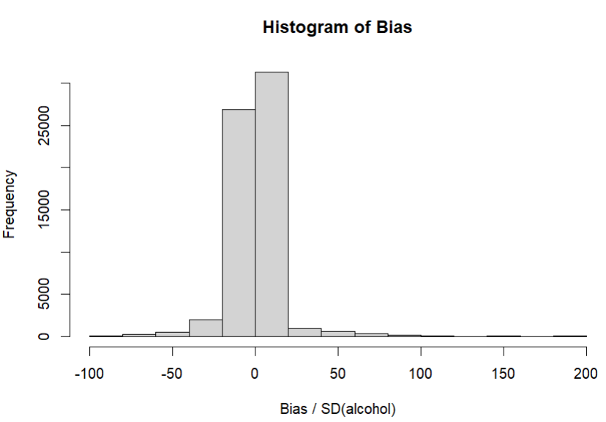
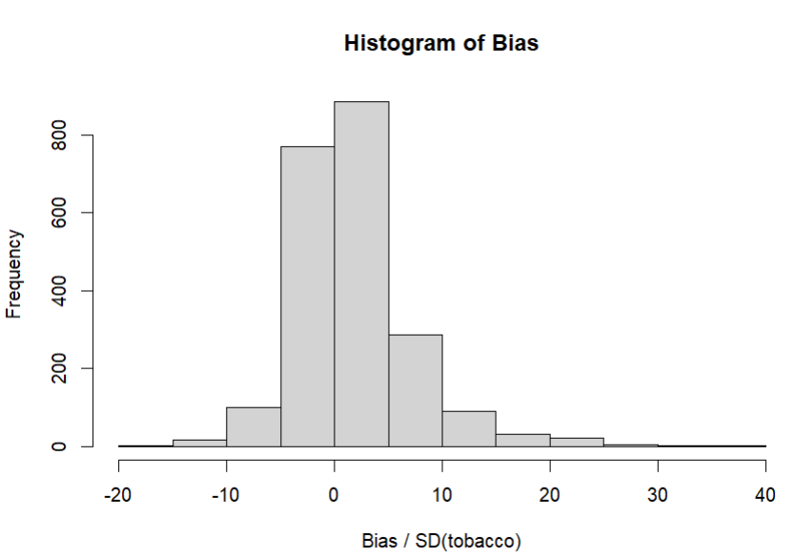
Supplmental Figure 3. Histogram of bias in causal forest predictions compared to standard deviation of substance use for tobacco, alcohol, and cannabis.
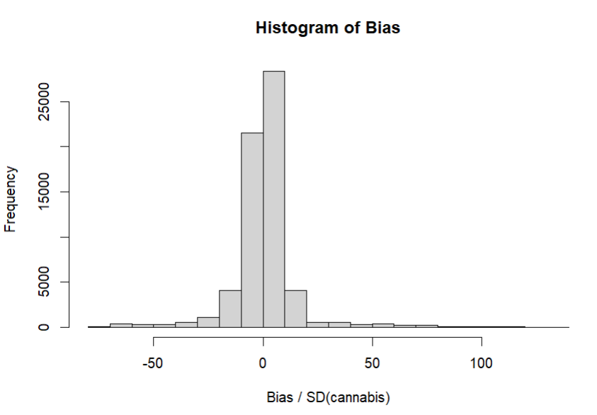

Bias estimates were generated bias(x)=(e(x)−p)×(p(μ(0,x)−μ0)+(1−p)(μ(1,x)−μ1), in short, the bias is the difference between the observed average treatment effect and the estimated average treatment effect (tau), calculated proportional to the covariance of the propensity score and the weighted average of conditional expected, as per Athey et al., 2017. Bias estimates centered around 0 suggest reasonable fit.
Frequency estimates reflect across all datasets used in multiple imputation (20 datasets)

