Inclusion and Exclusion Criteria
Inclusion criteria
- Signed informed consent prior to any study-mandated procedure
- Healthy male or female subjects, 18 to 45 years of age, inclusive at screening.
- Body mass index (BMI) between 18 and 30 kg/m², inclusive at screening, and with a minimum weight of 50 kg.
- All females of child bearing potential and all males must practice effective contraception during the study and be willing and able to continue contraception for at least 90 days after their last dose of study treatment.
- Has the ability to communicate well with the Investigator in the Dutch language and willing to comply with the study restrictions.
- Occasional cannabis users with
  - Lifetime cannabis use on at least 10 occasions.
  - In the past 6 months, the mean cannabis use should not exceed one occasion per week.
  - Subjects should be able to refrain from using cannabinoids at least 3 weeks prior to dosing up to the end of the study.
  - Urine drug screen for THC must be negative prior to dosing.
Exclusion criteria
- Evidence of any active or chronic disease or condition that could interfere with, or for which the treatment of might interfere with, the conduct of the study, or that would pose an unacceptable risk to the subject in the opinion of the investigator (following a detailed medical history, physical examination, vital signs (systolic and diastolic blood pressure, pulse rate, body temperature) and12-lead electrocardiogram (ECG)). Minor deviations from the normal range may be accepted, if judged by the Investigator to have no clinical relevance.
- Clinically significant abnormalities, as judged by the investigator, in laboratory test results (including hepatic and renal panels, complete blood count, chemistry panel and urinalysis). In the case of uncertain or questionable results, tests performed during screening may be repeated before randomization to confirm eligibility or judged to be clinically irrelevant for healthy subjects.
- Positive Hepatitis B surface antigen (HBsAg), Hepatitis C antibody (HCV Ab), or human immunodeficiency virus antibody (HIV Ab) at screening.
- Systolic blood pressure (SBP) consistently greater than 130 or less than 90 mm Hg, and diastolic blood pressure (DBP) greater than 95 or less than 50 mm Hg at screening.
- Abnormal findings in the resting ECG at screening defined as:
  - QTcF> 450 or < 300 msec for men and QTcF> 470 or < 300 msec for women
  - Notable resting bradycardia (HR < 40 bpm) or tachycardia (HR > 100 bpm)
  - Personal or family history of congenital long QT syndrome or sudden death;
  - ECG with QRS and/or T wave judged to be unfavourable for a consistently accurate QT measurement (e.g., neuromuscular artefact that cannot be readily eliminated, arrhythmias, indistinct QRS onset, low amplitude T wave, merged T- and U-waves, prominent U waves);
  - Evidence of atrial fibrillation, atrial flutter, complete branch block, Wolf-Parkinson-White Syndrome, or cardiac pacemaker
- Use of any medications (prescription or over-the-counter [OTC]), within 7 days of study drug administration, or less than 5 half-lives (whichever is longer). Exceptions are paracetamol (up to 4 g/day) and ibuprofen (up to 1g/day) and topical medications that are not expected to reach a meaningful systemic exposure, as judged by the investigator. Other exceptions will only be made if the rationale is clearly documented by the investigator.
- Use of any vitamin, mineral, herbal, and dietary supplements within 7 days of study drug administration, or less than 5 half-lives (whichever is longer). Exceptions will only be made if the rationale is clearly documented by the investigator.
- Participation in an investigational drug or device study (last dosing of previous study was within 90 days prior to first dosing of this study).
- History of abuse of addictive substances (alcohol, illegal substances) or current use of more than 21 units alcohol per week, drug abuse, or regular user of sedatives, hypnotics, tranquillisers, or any other addictive agent other than recreative use of THC
- Positive test for drugs of abuse (other than THC) at screening.
- Positive test for drugs of abuse pre-dose (including THC).
- Alcohol will not be allowed from at least 24 hours before screening or pre-dose.
- Smoker of more than 10 cigarettes per day prior to screening or who use tobacco products equivalent to more than 10 cigarettes per day and unable to abstain from smoking whilst in the unit.
- Is demonstrating excess in caffeine consumption (more than eight cups of coffee or equivalent per day.
- Any confirmed significant allergic reactions (urticaria or anaphylaxis) against any drug, or multiple drug allergies (non-active hay fever is acceptable).
- Loss or donation of blood over 500 mL within three months (males) or four months (females) prior to screening or intention to donate blood or blood products during the study.
- If a female: pregnant, or breast-feeding, or planning to become pregnant during the study.
- Any known factor, condition, or disease that might interfere with treatment compliance, study conduct or interpretation of the results such as drug or alcohol dependence or psychiatric disease.
- Clinically significant suicidal ideation in the past 5 years as judged by the investigator or any life-time suicide attempts.
- History of cannabis-induced psychosis, schizophrenia or other clinically relevant psychiatric disorders, as judged by the investigator.
- History of a clinically significant mood disorder, including but not limited to major depressive disorder, as judged by the investigator.

Bioanalytic method
ANEB-001
ANEB-001 and its internal standard (D9-ANED-001) were isolated from human K2-EDTA plasma by liquid-liquid extraction. After extraction, the samples were evaporated under a stream of nitrogen and reconstituted in injection solvent. After preparation, all samples were injected into the chromatographic system. Chromatographic separation was performed on an Acquity UPLC BEH C18 100 x 2.1 mm, 1.7µm column using a Shimadzu UHPLC system. A SCIEXAPI4000 tandem mass spectrometer equipped with an Atmospheric Pressure Chemical Ionisation probe operating in positive multiple reaction monitoring mode was used as a detector.
The mobile phase consisted of an aqueous solution of 20 mM ammonium acetate in 5% acetonitrile (ACN). An isocratic elution was used according to the following program: 3.00 min 20 mM ammonium acetate in 5% acetonitrile with a flow rate of 0.5 mL/min.
ANEB-001 was quantified using positive multiple reaction monitoring (MRM) mode. The results were based on the peak area ratio between the analyte (ANEB-001) and the internal standard (D9-ANEB-001).
The following MRM transitions of the respective precursor and product ions were used to quantify the analytes in human K2-EDTA plasma:
ANEB-001: m/z = 441 → m/z = 269
D9-ANEB-001: m/z = 450 → m/z = 269
The mass spectrometer was operating using Unit Q1 and Q3 resolution, the curtain gas was set at 25 psi, CAD collision gas at 4 psi, GS1 nebulizer gas at 30 psi and the source temperature was 400 °C.
The method was validated with regard to response function, selectivity (including blank matrix evaluation, matrix effect, haemolysed plasma effect, lipemic plasma effect, mutual interference and potential interference from co-administered drugs (THC, 11-OH-THC and THC-COOH) and other xenobiotics (concomitant medications: ibuprofen, aspirin, paracetamol, naproxen, and diclofenac and two other xenobiotics: nicotine and caffeine)), carryover, precision, accuracy, recovery, stability (including bench-top stability, re-injection stability, processed sample stability, freeze/thaw stability, stock/spike solution stability, whole blood stability and long-term frozen sample storage stability), dilution (10 fold), and batch size determination. These parameters were evaluated to ensure the applicability of the analytical method to the determination of bioanalytical samples originated from a clinical study^{1,2}.
The method was validated in the analytical range 2.00 to 2000 ng/mL of ANEB-001 in human plasma. Concentrations were calculated using 11-point curves ranging from 2.00 to 2000 ng/mL with weighted linear regression, according to the following formula:
y = a + bx (weighting factor = 1/x²)
where: x = ANEB-001 concentration in ng/mL
y = Peak-area ratio
a = Intercept
b = Slope
Data acquisition was performed using Analyst software (version 1.6.2) from AB SCIEX (Framingham, MA, U.S.A).
The calibration curves of the validation runs showed accuracy and precision of the calibrators within the predefined criteria for bioanalytical method validation, i.e., bias ±20.0% for the lowest calibrator and ±15.0% for all other calibrators. The overall CV of the ANEB-001 calibration standards were within 20.0% for lowest calibrator and within 15.0% for all other calibrators). In addition, the mean biases were within ±20.0% of the nominal value for the lowest calibrator and within ±15.0% for all other calibrators.
The assay was linear over the concentration range of 2.00 to 2000 ng/mL in human K2-EDTA plasma with coefficients of determination (r) ≥0.99.
The within run accuracy of the quality control samples (measured as %bias) ranged from
-1.9% to 2.3% and the between run-accuracy of the quality control samples (measured as %bias) ranged from -3.1% to 1.0%. The precision of the method was measured in terms of between run precision (%CV) and ranged from 1.6% to 6.9%.

A chromatogram of the lower limit of quantitation sample (lowest calibrator) is shown below.

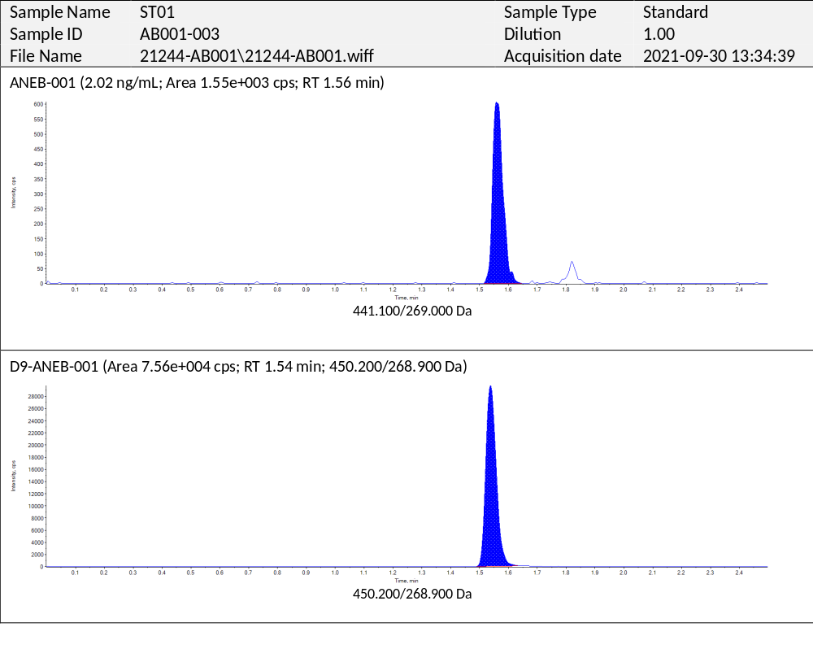

THC, 11-OH-THC
∆⁹-Tetrahydrocannabinol (THC) and 11-hydroxy-∆9-tetrahydrocannabinol (11-OH-THC) and their internal standards were isolated from human K2-EDTA plasma by liquid-liquid extraction. After extraction the samples were derivatized and thereafter purified by solid-phase extraction (SPE) using an MCX SPE-column. The samples were evaporated under a stream of nitrogen and reconstituted in injection solvent. After preparation, all samples were injected into the chromatographic system. Chromatographic separation is performed on an Acquity UPLC BEH Phenyl column 2.1 x 50 mm, 1.7 μm a Shimadzu UHPLC system. A SCIEX API 6500+ tandem mass spectrometer equipped with a Turbo Ion Spray probe operating in the positive multiple reaction monitoring mode is used for quantification.
The mobile phase consisted of solvent A (5% ACN in UPW) and solvent B (100 mM Ammonium Formate in 5% ACN and 1% Ammonium Hydroxide) and Solvent C (ACN). A ternary gradient elution was used according to the following program: 25% solvent A and 10% solvent B was supplemented with solvent C according to the following program:0 - 0.20 min 65%C; 0.20 – 1.00 min 65-90%C; 1.00 – 3.75 min 90%C; 3.75 – 3.85.min 90 – 65% C.
The results were based on the peak area ratio between the analyte (THC and 11-OH-THC) and their internal standards (THC-D3 and 11-OH-THC-D3, respectively).
The following MRM transitions of the respective precursor and product ions were used to quantify the analytes in human K2-EDTA plasma:
THC: m/z = 548 → m/z = 171
THC-D3: m/z = 551 → m/z = 171
11-OH-THC: m/z = 564 → m/z = 256
11-OH-THC-D3: m/z = 567 → m/z = 256
The mass spectrometer operated using Unit Q1 and Q3 resolution, the curtain gas was set at 30 psi, CAD collision gas at 10 psi, GS1 nebulizer gas at 60 psi, GS2 turbo gas at 80 psi, ion spray voltage was set at 5500 V and the source temperature was 550 °C.
Extraction of THC and 11-OH-THC from human K2-EDTA plasma samples was performed using Liquid Liquid Extraction (LLE), followed by derivatization, purification using off line Solid Phase Extraction (SPE) and analysis using a SCIEX API 6500+ LC-MS/MS. The method was validated with regard to response function, selectivity (including blank matrix evaluation, matrix effect, haemolysed plasma effect, lipemic plasma effect, mutual interference), carryover, precision, accuracy, recovery, stability (including bench-top stability, re-injection stability, processed sample stability, freeze/thaw stability, stock/spike solution stability, whole blood stability and long-term frozen sample storage stability), dilution (10- and 100-fold), and batch size determination. These parameters were evaluated to ensure the applicability of the analytical method to the determination of bioanalytical samples originated from a clinical study^{1,2}.
The method was validated in the calibration range 0.100 to 20.0 ng/mL of THC and 11-OH-THC in human plasma. Concentrations were calculated using 9-point curves ranging from 0.100 to 20.0 ng/mL with weighted quadratic regression, according to the following formula:
y = a + bx + cx² (weighting factor = 1/x²)
where: x = THC or 11-OH-THC concentration in ng/mL
y = Peak-area ratio
a = Intercept
b = Slope
c = Curvature
Data acquisition was performed using Analyst software (version 1.6.2) from AB SCIEX (Framingham, MA, U.S.A).

The calibration curves of the validation runs showed accuracy and precision of the calibrators within the predefined criteria for bioanalytical method validation, i.e., bias ±20.0% for the lowest calibrator and ±15.0% for all other calibrators. The overall CV of the THC and 11-OH-THC calibration standards were within 20.0% for lowest calibrator and within 15.0% for all other calibrators). In addition, the mean biases were within ±20.0% of the nominal value for the lowest calibrator and within ±15.0% for all other calibrators.
The assay was over the concentration range of 0.100 to 20.0 ng/mL in human K2-EDTA plasma with coefficients of determination (r) ≥0.99.
The within run accuracy of the quality control samples (measured as %bias) ranged from
-5.0% to -3.7% for THC from -1.1% to 2.0% for 11-OH-THC and the between run-accuracy of the quality control samples (measured as %bias) ranged from -8.2% to -2.8% for THC and from -0.7% to 0.5% for 11-OH-THC. The precision of the method was measured in terms of between run precision (%CV) and ranged from 3.9% to 7.0% for THC and ranged from 4.0% to 6.6% for 11-OH-THC.

Chromatograms of the lower limit of quantitation sample (lowest calibrator) for THC and 11-OH-THC are shown below.

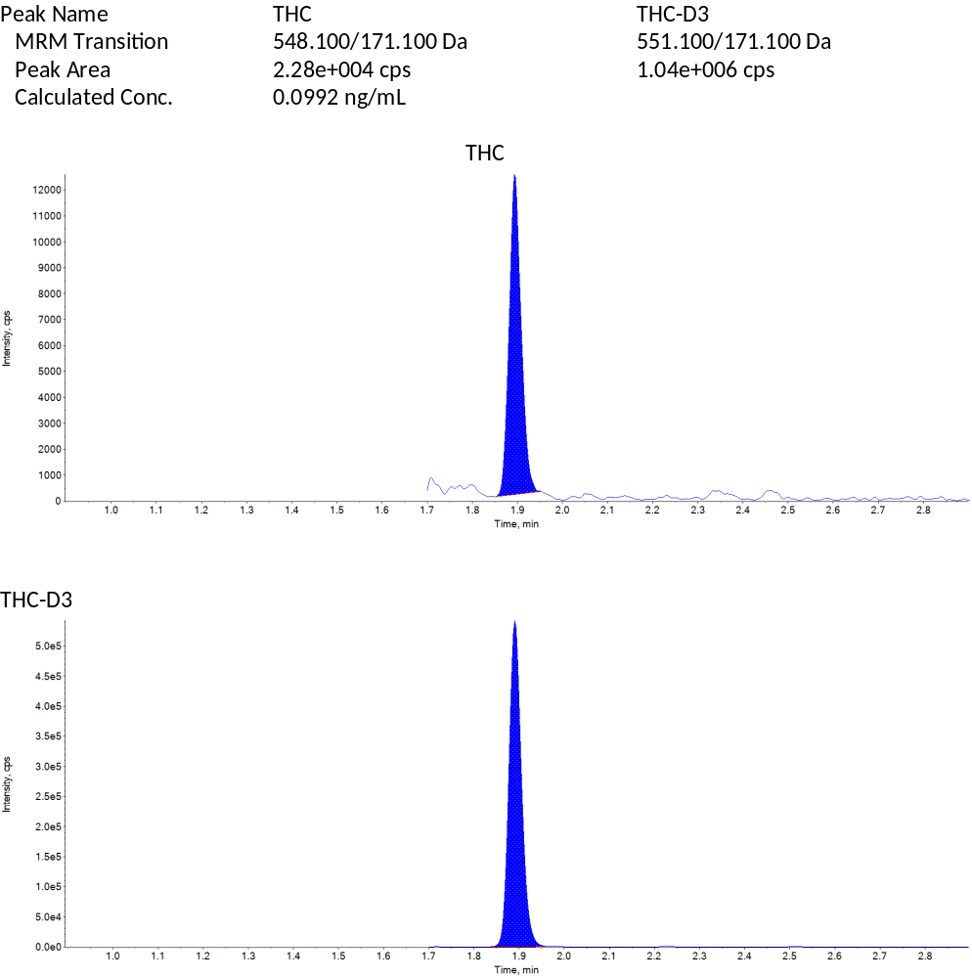

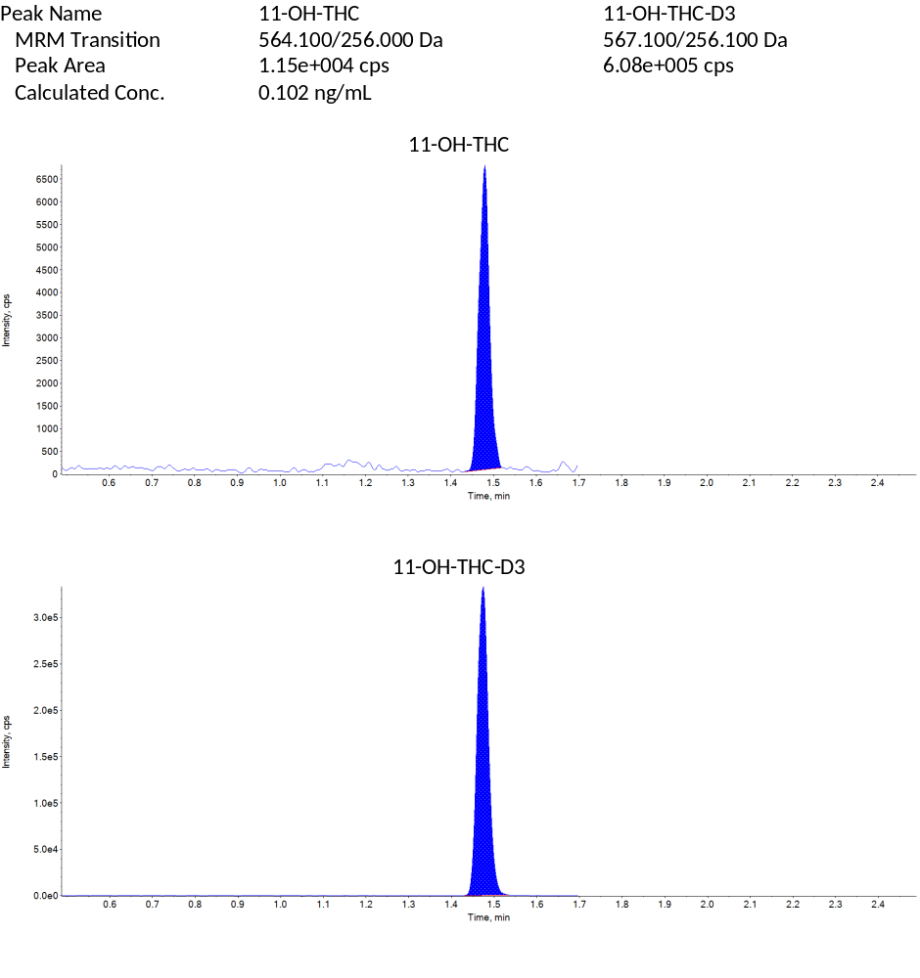
References:
- Guidance for Industry: Bioanalytical Method Validation. U.S. Department of Health and Human Services, Food and Drug Administration, Centre for Drug Evaluation and Research (CDER), Center for Veterinary Medicine (CVM), May 2018, BP.
- Guideline on bioanalytical method validation European Medicines Agency (EMA), Committee for Medicinal Products for Human Use (CHMP), EMEA/CHMP/EWP/192217/2009, 21 July 2011.

Table S1. Demographics.
 |  | Part A (10.5 mg THC) |  |  | Part B, Cohorts 1 and 2 (21 mg THC)
 | All participants  (n=85) | 50 mg Selonabant  (n=20) | 100 mg Selonabant  (n=20) | Placebo  (n=20) | 30 mg Selonabant  (n=9) | 10 mg Selonabant  (n=7) | Placebo  (n=9)
Age (years)
Mean (SD) | 23.8 (4.8) | 25.4 (6.6) | 23.4 (4.6) | 23.7 (4.9) | 21.8 (1.4) | 24.1 (3.9) | 23.0 (2.8)
Median | 23 | 23 | 22 | 24 | 22 | 23 | 22
Min, Max | 18, 42 | 19, 42 | 18, 34 | 18, 36 | 20, 24 | 20, 31 | 19, 27
Height (cm)
Mean (SD) | 179.7 (7.5) | 182.1 (7.5) | 180.7 (4.1) | 179.4 (6.3) | 177.5 (9.9) | 174.2 (12.1) | 179.8 (8.1)
Median | 180.4 | 181.9 | 181.2 | 178.5 | 176.7 | 169.1 | 183.0
Min, Max | 162.6, 200.9 | 169.0, 194.0 | 171.8, 186.4 | 170.0, 194.9 | 162.6, 192.0 | 166.1, 200.9 | 164.1, 188.6
Weight (kg)
Mean (SD) | 74.61 (8.78) | 73.26 (7.44) | 79.39 (8.76) | 75.49 (6.89) | 72.87 (11.55) | 68.17 (11.92) | 71.76 (5.52)
Median | 74.25 | 70.90 | 78.08 | 75.83 | 68.85 | 67.55 | 70.45
Min, Max | 55.00, 94.05 | 64.15, 93.55 | 63.10, 92.55 | 62.45, 88.60 | 58.80, 94.05 | 55.00, 91.95 | 64.65, 79.60
BMI (kg/m²)
Mean (SD) | 23.1 (2.2) | 22.1 (2.1) | 24.3 (2.5) | 23.5 (1.6) | 23.0 (1.9) | 22.4 (2.3) | 22.2 (1.7)
Median | 23.1 | 21.7 | 24.1 | 23.5 | 23.4 | 22.0 | 22.1
Min, Max | 18.7, 29.2 | 19.0, 27.0 | 20.1, 29.2 | 21.0, 28.2 | 20.1, 25.5 | 18.7, 25.3 | 19.6, 24.4
Sex
Female | 19 (22.4%) | 3 (15.0%) | 0 (0%) | 5 (25.0%) | 2 (22.2%) | 6 (85.7%) | 3 (33.3%)
Male | 66 (77.6%) | 17 (85.0%) | 20 (100%) | 15 (75.0%) | 7 (77.8%) | 1 (14.3%) | 6 (66.7%)
Race
Asian | 2 (2.4%) | 0 (0%) | 1 (5.0%) | 0 (0%) | 0 (0%) | 0 (0%) | 1 (11.1%)
Black or African American | 2 (2.4%) | 0 (0%) | 1 (5.0%) | 0 (0%) | 0 (0%) | 1 (14.3%) | 0 (0%)
Mixed | 3 (3.5%) | 1 (5.0%) | 1 (5.0%) | 0 (0%) | 0 (0%) | 0 (0%) | 1 (11.1%)
White | 78 (91.8%) | 19 (95.0%) | 17 (85.0%) | 20 (100%) | 9 (100%) | 6 (85.7%) | 7 (77.8%)
Abbreviations: BMI, body mass index; max, maximum; min, minimum; n, number; SD, standard deviation; THC, Δ9-tetrahydrocannabinol.

Table S2. Overall treatment effects on selected secondary pharmacodynamic outcome measures (estimated mean differences with 95% CI and p-values).
Study part | Part A (10.5 mg THC) |  | Part B (21 mg THC)
Parameter | 100 mg Selonabant  vs Placebo | 50 mg Selonabant  vs Placebo | 30 mg Selonabant  vs Placebo | 10 mg Selonabant  vs Placebo
VAS “External Perception” (log(mm)) | -0.13  (-0.22, -0.04)  p=0.007 | -0.17  (-0.27, -0.08)  p<0.001 | -0.43  (-0.66, -0.20)  p=0.001 | -0.40  (-0.66, -0.15)  p=0.004
VAS “Internal Perception” (log(mm)) | -0.03  (-0.08, 0.02)  p=0.217 | -0.02  (-0.07, 0.04)  p=0.552 | -0.26  (-0.41, -0.11)  p=0.002 | -0.22  (-0.39, -0.05)  p=0.012
Adaptive tracking (%) | -0.14  (-1.65, 1.37)  p=0.852 | -0.91  (-2.41, 0.59)  p=0.230 | 4.85  (2.17, 7.52)  p=0.001 | 3.22  (0.45, 5.99)  p=0.025
The figures in bold indicate statistical significance. Abbreviations: bpm, beat per minute; CI, confidence interval; THC, THC, Δ9-tetrahydrocannabinol; VAS, visual analogue scale

Figure S3. Concentration-time profiles of THC and 11-OH-THC following oral administration, displayed as means with standard deviation.
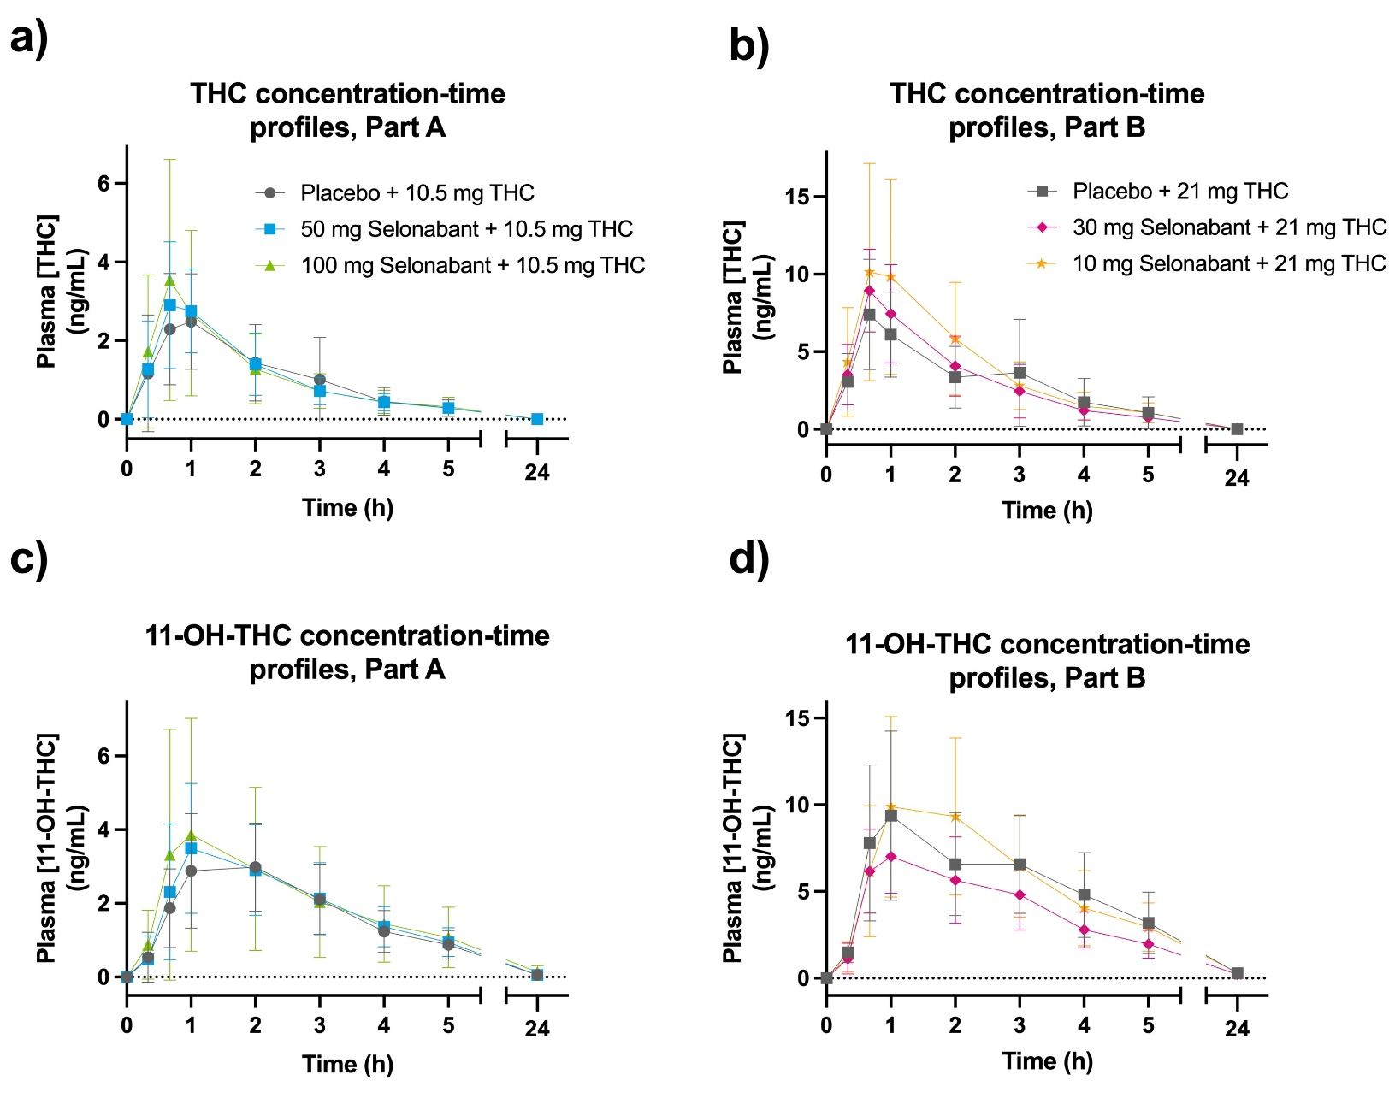
Table S4. Pharmacokinetic parameters of Selonabant, THC and 11-OH-THC. AUC_{last} and C_{max} shown as mean (CV%), T_{lag} and T_{max} as median (min, max).
 |  | Part A (10.5 mg THC) |  |  | Part B (21 mg THC)
Parameter | Unit | 100 mg Selonabant (n=20) | 50 mg Selonabant (n=20) | Placebo  (n=20) | 30 mg Selonabant (n=9) | 10 mg Selonabant (N=7) | Placebo  (N=9)
ANEB-001
AUC_{last} | h*ng/mL | 14525.1 (35.4) | 9486.3 (30.1) | - | 4622.9 (23.6) | 2391.6 (31.5) | -
C_{max} | ng/mL | 857.7 (36.9) | 514.3 (27.8) | - | 316.7 (35.5) | 126.4 (23.4) | -
t_{lag} | h | 0.00 (0.00, 0.33) | 0.33 (0.00. 0.40) | - | 0.00 (0.00, 0.33) | 0.33 (0.00, 0.35) | -
t_{max} | h | 1.00 (0.67, 2.00) | 1.00 (0.67, 3.00) | - | 1.00 (0.67, 3.00) | 2.00 (1.00, 3.00) | -
THC
AUC_{last} | h*ng/mL | 6.128 (65.8) | 5.976 (36.8) | 5.722 (47.8) | 21.82 (74.4) | 22.81 (56.3) | 18.59 (80.5)
C_{max} | ng/mL | 3.769 (75.4) | 3.395 (39.9) | 3.147 (50.4) | 9.781 (28.9) | 11.263 (56.7) | 7.477 (47.2)
t_{lag} | h | 0.00 (0.00, 0.00) | 0.00 (0.00, 0.00) | 0.00 (0.00,0.33) | 0.00 (0.00, 0.00) | 0.00 (0.00, 0.00) | 0.00 (0.00, 0.00)
t_{max} | h | 0.67 (0.33, 2.00) | 1.00 (0.67, 2.02) | 1.00 (0.33, 3.02) | 0.67 (0.42, 1.00) | 1.00 (0.67,2.00) | 0.67 (0.67, 1.02)
11-OH-THC
AUC_{last} | h*ng/mL | 18.389 (87.9) | 13.586 (57.8) | 12.878 (56.5) | 34.80 (39.5) | 52.32 (44.7) | 51.48 (46.0)
C_{max} | ng/mL | 4.370 (80.4) | 3.935 (40.9) | 3.497 (41.3) | 7.907 (28.1) | 11.236 (40.1) | 9.672 (47.2)
t_{lag} | h | 0.00 (0.00,0.33) | 0.00 (0.00,0.37) | 0.00 (0.00,0.33) | 0.00 (0.00, 0.00) | 0.00 (0.00, 0.00) | 0.00 (0.00, 0.00)
t_{max} | h | 1.00 (0.67, 3.00) | 1.00 (0.67, 4.00) | 2.00 (0.67, 3.02) | 1.00 (0.67, 3.00) | 1.00 (1.00, 2.07) | 1.00 (0.67, 3.00)
Abbreviations: AUC_{last} = area under the concentration-time curve from time zero to time of last measurable; C_{max} = maximum concentration; CV = coefficient of variation; max = maximum; min = minimum; N = number; SD = standard deviation; THC = Δ9-Tetrahydrocannabinol; t_{lag} = absorption lag time; t_{max} = time to attain C_{max}.
Table S5. Summary of TEAEs by Treatment, SOC and PT (full overview).
 | Part A (10.5 mg THC) |  |  |  |  |  | Part B, Cohorts 1 and 2 (21 mg THC)
 | 50 mg Selonabant  (n=20) |  | 100 mg Selonabant  (n=20) |  | Placebo  (n=20) |  | 30 mg Selonabant  (n=9) |  | 10 mg Selonabant  (n=7) |  | Placebo  (n=9)
System Organ Class/  Preferred Term | Events  N | Participants  N (%) | Events  N | Participants  N (%) | Events  N | Participants  N (%) | Events  N | Participants  N (%) | Events  N | Participants  N (%) | Events  N | Participants  N (%)
ANY EVENTS | 71 | 18 (90.0) | 68 | 17 (85.0) | 50 | 20 (100.0) | 27 | 9 (100.0) | 20 | 7 (100.0) | 38 | 9 (100.0)
CARDIAC DISORDERS | - | - | 1 | 1 (5.0) | - | - | - | - | - | - | - | -
Palpitations | - | - | 1 | 1 (5.0) | - | - | - | - | - | - | - | -
EAR AND LABYRINTH DISORDERS | - | - | - | - | - | - | - | - | - | - | 1 | 1 (11.1)
Tinnitus | - | - | - | - | - | - | - | - | - | - | 1 | 1 (11.1)
EYE DISORDERS | - | - | 3 | 3 (15.0) | 2 | 2 (10.0) | - | - | - | - | - | -
Dry eye | - | - | 1 | 1 (5.0) | - | - | - | - | - | - | - | -
Dyschromatopsia | - | - | 1 | 1 (5.0) | 2 | 2 (10.0) | - | - | - | - | - | -
Visual impairment | - | - | 1 | 1 (5.0) | - | - | - | - | - | - | - | -
GASTROINTESTINAL DISORDERS | 27 | 14 (70.0) | 20 | 12 (60.0) | 4 | 4 (20.0) | 15 | 6 (66.7) | 6 | 4 (57.1) | 7 | 5 (55.6)
Abdominal discomfort | - | - | - | - | - | - | 1 | 1 (11.1) | 1 | 1 (14.3) | - | -
Abdominal pain | - | - | 1 | 1 (5.0) | - | - | - | - | - | - | - | -
Abdominal pain upper | 1 | 1 (5.0) | - | - | - | - | - | - | - | - | - | -
Diarrhoea | 4 | 3 (15.0) | 1 | 1 (5.0) | - | - | - | - | - | - | - | -
Dry mouth | - | - | - | - | 2 | 2 (10.0) | - | - | 1 | 1 (14.3) | 3 | 3 (33.3)
Frequent bowel movements | - | - | - | - | - | - | 1 | 1 (11.1) | - | - | - | -
Nausea | 18 | 14 (70.0) | 8 | 8 (40.0) | 2 | 2 (10.0) | 4 | 4 (44.4) | 3 | 3 (42.9) | 4 | 4 (44.4)
Retching | 1 | 1 (5.0) | 1 | 1 (5.0) | - | - | - | - | - | - | - | -
Tongue pruritus | - | - | - | - | - | - | - | - | 1 | 1 (14.3) | - | -
Vomiting | 3 | 2 (10.0) | 9 | 6 (30.0) | - | - | 9 | 3 (33.3) | - | - | - | -
GENERAL DISORDERS AND ADMINISTRATION SITE CONDITIONS | 18 | 10 (50.0) | 13 | 10 (50.0) | 8 | 6 (30.0) | 4 | 4 (44.4) | 5 | 4 (57.1) | 8 | 7 (77.8)
Asthenia | 1 | 1 (5.0) | - | - | 1 | 1 (5.0) | - | - | - | - | - | -
Chills | 1 | 1 (5.0) | - | - | - | - | - | - | - | - | - | -
Early satiety | 1 | 1 (5.0) | - | - | - | - | - | - | - | - | - | -
Fatigue | 6 | 6 (30.0) | 6 | 6 (30.0) | 5 | 4 (20.0) | 2 | 2 (22.2) | 4 | 3 (42.9) | 5 | 5 (55.6)
Feeling abnormal | 1 | 1 (5.0) | 1 | 1 (5.0) | 1 | 1 (5.0) | - | - | 1 | 1 (14.3) | - | -
Feeling cold | 1 | 1 (5.0) | - | - | - | - | - | - | - | - | 1 | 1 (11.1)
Feeling hot | 7 | 6 (30.0) | 4 | 4 (20.0) | - | - | 2 | 2 (22.2) | - | - | - | -
Feeling of relaxation | - | - | 2 | 2 (10.0) | 1 | 1 (5.0) | - | - | - | - | - | -
Sluggishness | - | - | - | - | - | - | - | - | - | - | 2 | 2 (22.2)
INFECTIONS AND INFESTATIONS | 1 | 1 (5.0) | 2 | 2 (10.0) | 2 | 2 (10.0) | - | - | - | - | 1 | 1 (11.1)
COVID-19 | 1 | 1 (5.0) | 1 | 1 (5.0) | 1 | 1 (5.0) | - | - | - | - | 1 | 1 (11.1)
Nasopharyngitis | - | - | 1 | 1 (5.0) | - | - | - | - | - | - | - | -
Pharyngitis | - | - | - | - | 1 | 1 (5.0) | - | - | - | - | - | -
INJURY, POISONING AND PROCEDURAL COMPLICATIONS | 1 | 1 (5.0) | - | - | - | - | - | - | - | - | - | -
Skin abrasion | 1 | 1 (5.0) | - | - | - | - | - | - | - | - | - | -
INVESTIGATIONS | - | - | 1 | 1 (5.0) | - | - | - | - | - | - | - | -
Blood pressure systolic increased | - | - | 1 | 1 (5.0) | - | - | - | - | - | - | - | -
METABOLISM AND NUTRITION DISORDERS | 1 | 1 (5.0) | 2 | 2 (10.0) | 1 | 1 (5.0) | - | - | - | - | - | -
Decreased appetite | 1 | 1 (5.0) | 2 | 2 (10.0) | - | - | - | - | - | - | - | -
Increased appetite | - | - | - | - | 1 | 1 (5.0) | - | - | - | - | - | -
MUSCULOSKELETAL AND CONNECTIVE TISSUE DISORDERS | 1 | 1 (5.0) | - | - | 1 | 1 (5.0) | - | - | 1 | 1 (14.3) | 1 | 1 (11.1)
Back pain | - | - | - | - | - | - | - | - | - | - | 1 | 1 (11.1)
Limb discomfort | - | - | - | - | 1 | 1 (5.0) | - | - | 1 | 1 (14.3) | - | -
Myalgia | 1 | 1 (5.0) | - | - | - | - | - | - | - | - | - | -
NERVOUS SYSTEM DISORDERS | 5 | 4 (20.0) | 6 | 4 (20.0) | 14 | 8 (40.0) | 2 | 2 (22.2) | 1 | 1 (14.3) | 11 | 6 (66.7)
Disturbance in attention | - | - | - | - | 1 | 1 (5.0) | - | - | - | - | - | -
Dizziness | - | - | - | - | 5 | 5 (25.0) | 2 | 2 (22.2) | - | - | 5 | 4 (44.4)
Dizziness postural | - | - | 1 | 1 (5.0) | - | - | - | - | - | - | - | -
Headache | 4 | 4 (20.0) | 3 | 2 (10.0) | 4 | 4 (20.0) | - | - | - | - | 2 | 2 (22.2)
Muscle contractions involuntary | - | - | 1 | 1 (5.0) | - | - | - | - | - | - | - | -
Paraesthesia | - | - | - | - | 3 | 3 (15.0) | - | - | 1 | 1 (14.3) | 3 | 3 (33.3)
Presyncope | - | - | - | - | 1 | 1 (5.0) | - | - | - | - | 1 | 1 (11.1)
Tremor | 1 | 1 (5.0) | 1 | 1 (5.0) | - | - | - | - | - | - | - | -
PSYCHIATRIC DISORDERS | 7 | 6 (30.0) | 10 | 9 (45.0) | 17 | 15 (75.0) | 3 | 3 (33.3) | 6 | 3 (42.9) | 9 | 7 (77.8)
Affect lability | 1 | 1 (5.0) | - | - | - | -
Body dysmorphic disorder | 1 | 1 (5.0) | - | - | - | -
Bradyphrenia | - | - | 1 | 1 (5.0) | 4 | 4 (20.0) | 1 | 1 (11.1) | 1 | 1 (14.3) | 2 | 2 (22.2)
Depressed mood | 1 | 1 (5.0) | 2 | 2 (10.0) | - | -
Euphoric mood | 4 | 3 (15.0) | 3 | 3 (15.0) | 12 | 11 (55.0) | 2 | 2 (22.2) | 3 | 3 (42.9) | 5 | 5 (55.6)
Inappropriate affect | - | - | - | - | - | - | - | - | - | - | 2 | 2 (22.2)
Insomnia | - | - | 1 | 1 (5.0) | - | - | - | - | - | - | - | -
Libido decreased | - | - | 1 | 1 (5.0) | - | - | - | - | - | - | - | -
Paranoia | - | - | - | - | - | - | - | - | 1 | 1 (14.3) | - | -
Pseudohallucination | - | - | - | - | - | - | - | - | 1 | 1 (14.3) | - | -
Social avoidant behaviour | - | - | 1 | 1 (5.0) | - | - | - | - | - | - | - | -
Time perception altered | - | - | 1 | 1 (5.0) | 1 | 1 (5.0) | - | - | - | - | - | -
RESPIRATORY, THORACIC AND MEDIASTINAL DISORDERS | 3 | 3 (15.0) | 1 | 1 (5.0) | - | - | - | - | 1 | 1 (14.3) | - | -
Hiccups | 1 | 1 (5.0) | 1 | 1 (5.0) | - | - | - | - | - | - | - | -
Nasal congestion | 1 | 1 (5.0) | - | - | - | - | - | - | - | - | - | -
Oropharyngeal pain | - | - | - | - | - | - | - | - | 1 | 1 (14.3) | - | -
Yawning | 1 | 1 (5.0) | - | - | - | - | - | - | - | - | - | -
SKIN AND SUBCUTANEOUS TISSUE DISORDERS | 7 | 7 (35.0) | 9 | 7 (35.0) | - | - | 3 | 3 (33.3) | - | - | - | -
Dermatitis contact | 1 | 1 (5.0) | - | - | - | - | - | - | - | - | - | -
Ecchymosis | - | - | 1 | 1 (5.0) | - | - | - | - | - | - | - | -
Hyperhidrosis | 6 | 6 (30.0) | 7 | 6 (30.0) | - | - | 3 | 3 (33.3) | - | - | - | -
Piloerection | - | - | 1 | 1 (5.0) | - | - | - | - | - | - | - | -
VASCULAR DISORDERS | - | - | - | - | 1 | 1 (5.0) | - | - | - | - | - | -
Peripheral coldness | - | - | - | - | 1 | 1 (5.0) | - | - | - | - | - | -
Abbreviations: n = number; TEAE = treatment-emergent adverse event; PT = preferred term; SOC = system organ class; THC = Δ9-Tetrahydrocannabinol

Figure S6. Beck’s Depression Inventory Scores, displayed as means with standard deviation.

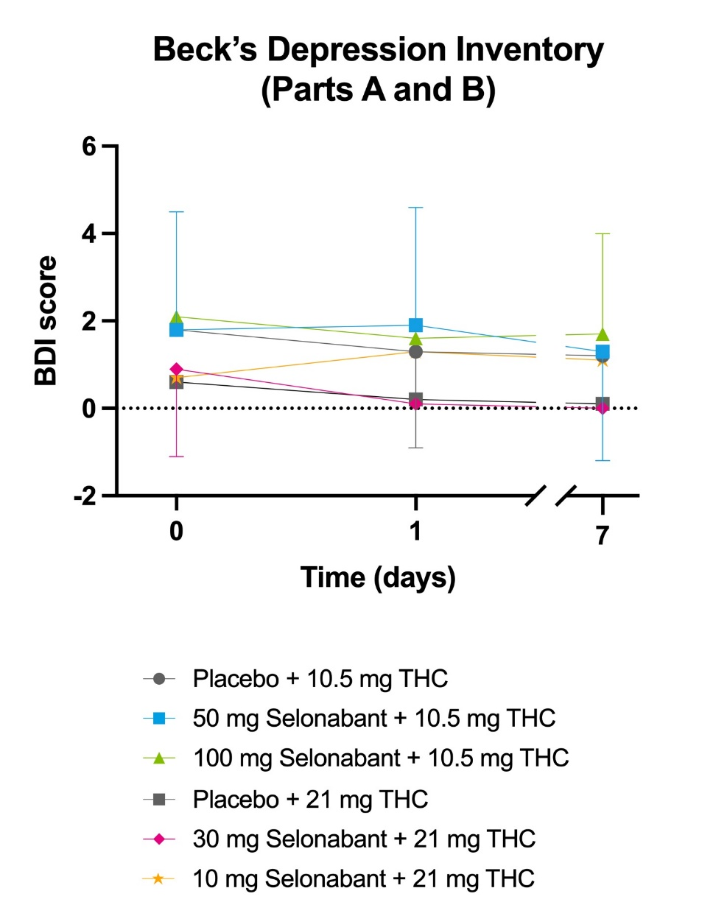

The urine drug screen included tests for THC, cocaine, amphetamines, benzodiazepines and opiates.
Since all participants were occasional cannabis users, a positive urine drug test for THC was permitted at screening. However, participants were required to have a negative urine drug screening for THC (and other drugs) pre-dose to be eligible for dosing.

