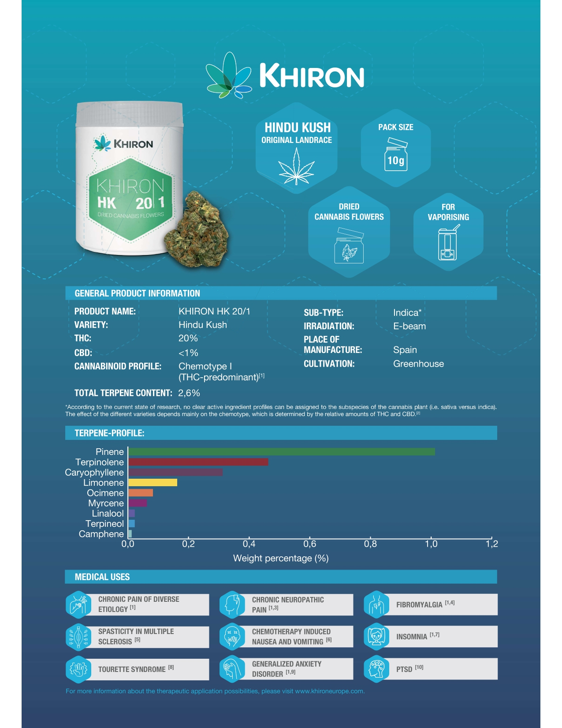
Supplementary Figure 1. Specifications of the cannabis-based medicinal product, KHIRON HK 20/1.

