7,3 ', 4' - tri-O-acetyl luteolin（A）IR
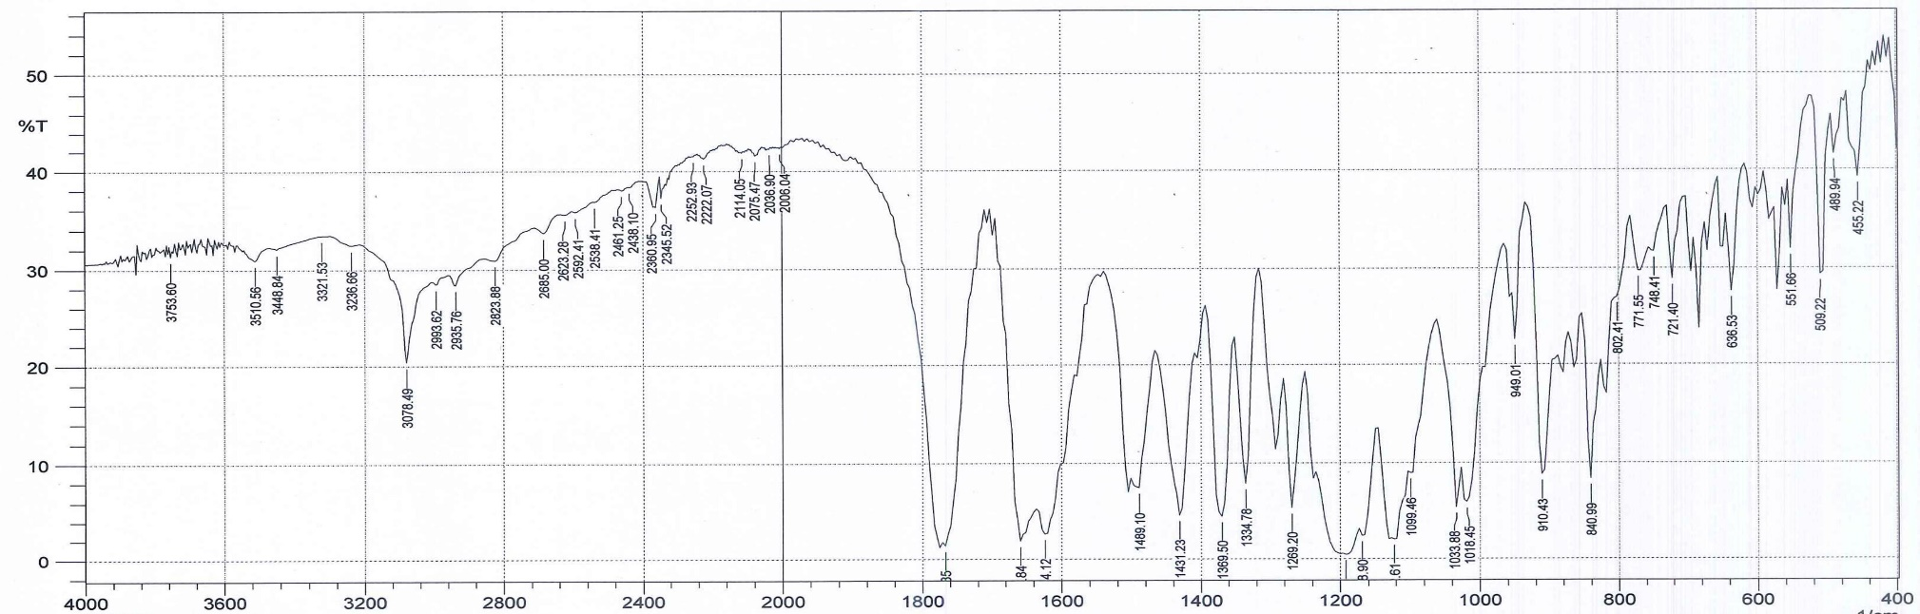
7,3 ', 4' - tri-O-propylated luteolin（B）IR
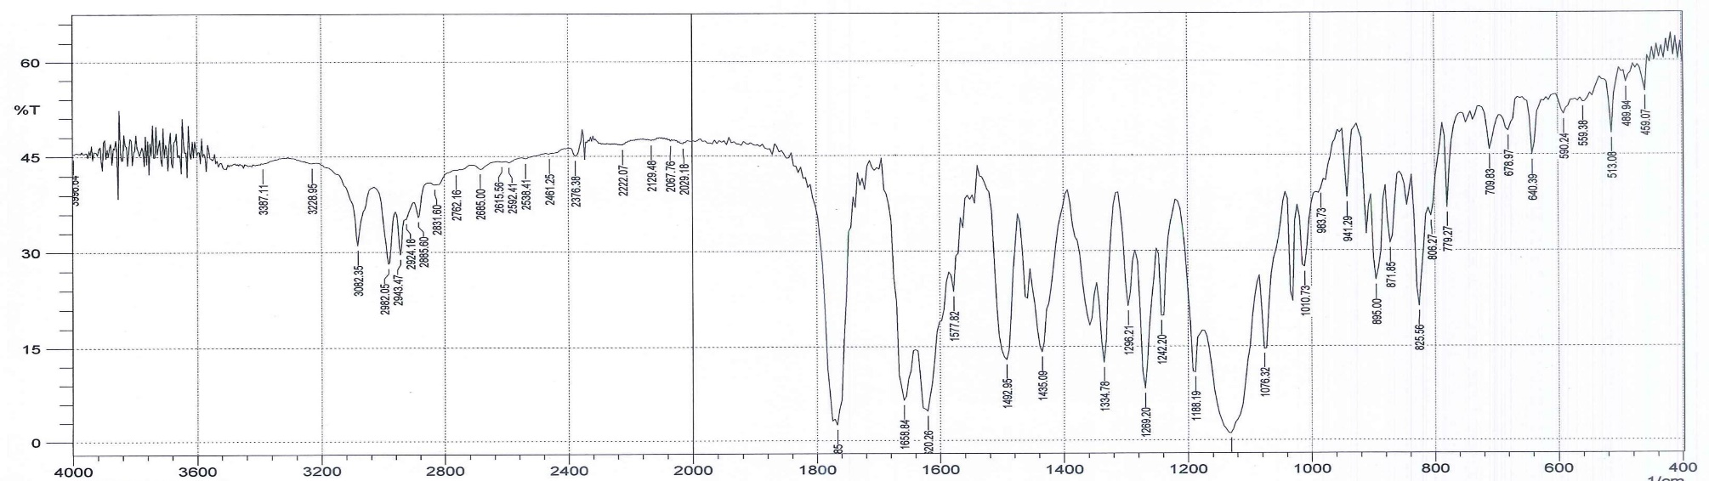

7,3 ', 4' - tri-O-acetyl luteolin（C）IR
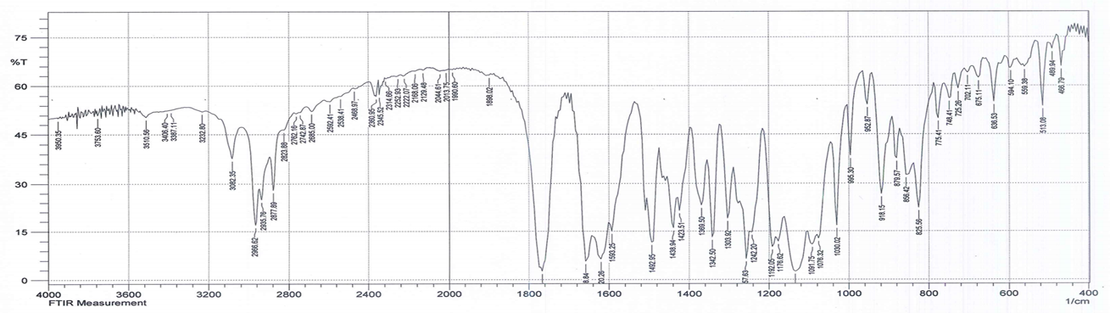

5,7,3 ', 4' - tetra-O-acetyl luteolin（D）IR
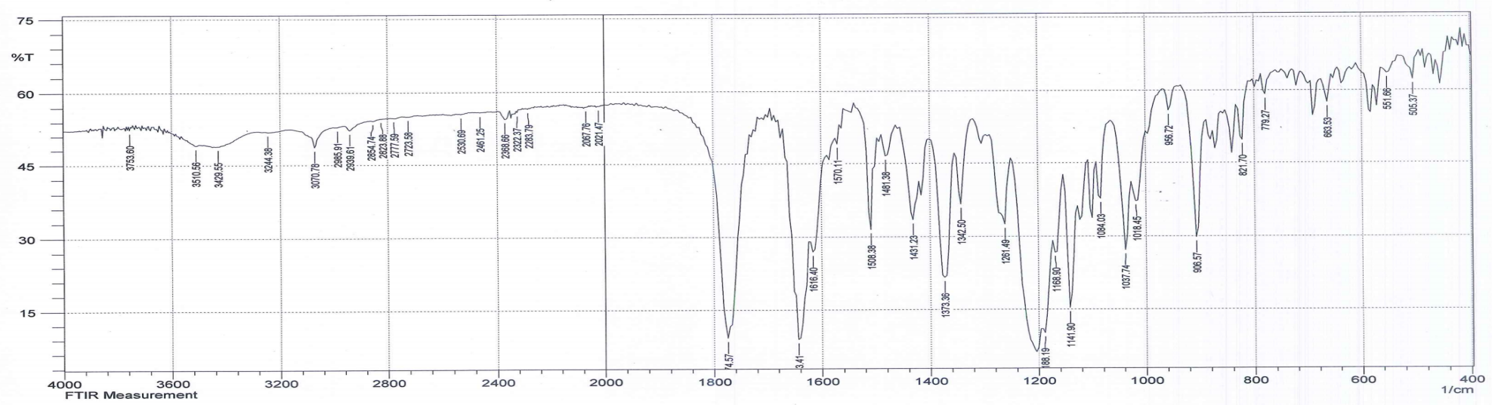

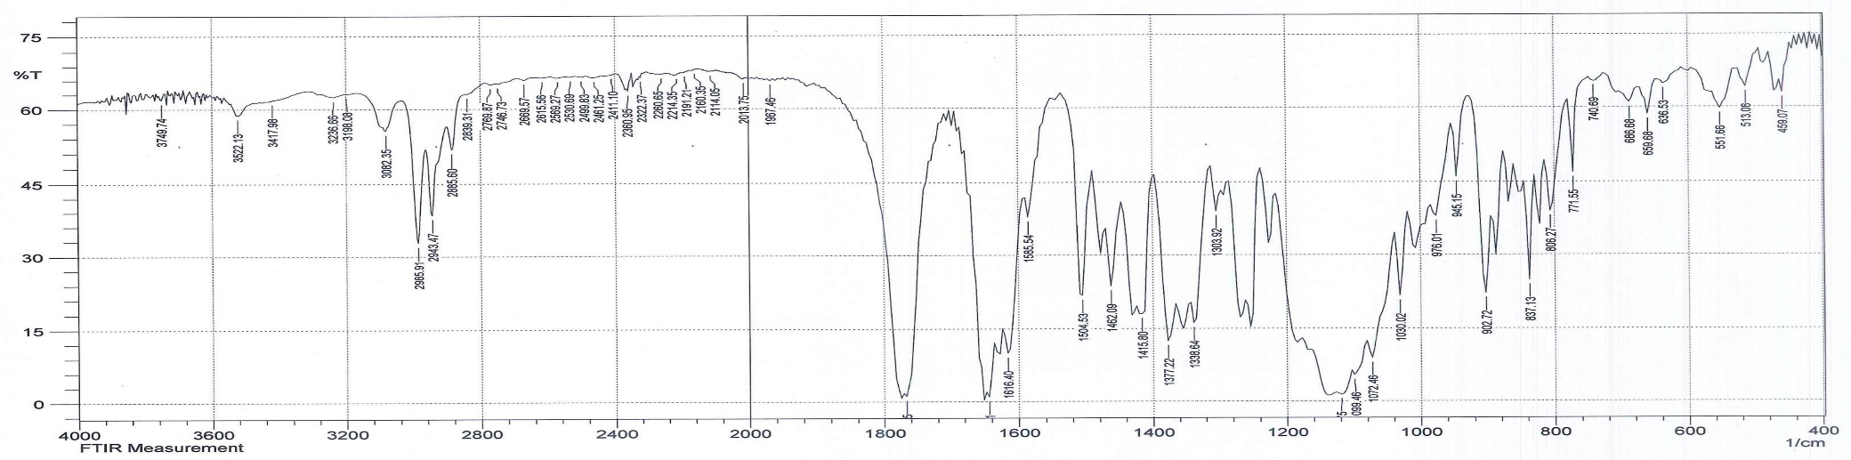
5,7,3 ', 4' - tetra-O-propionylated luteolin（E）IR
5,7,3 ', 4' - tetra-O-butyrylated luteolin（F）IR
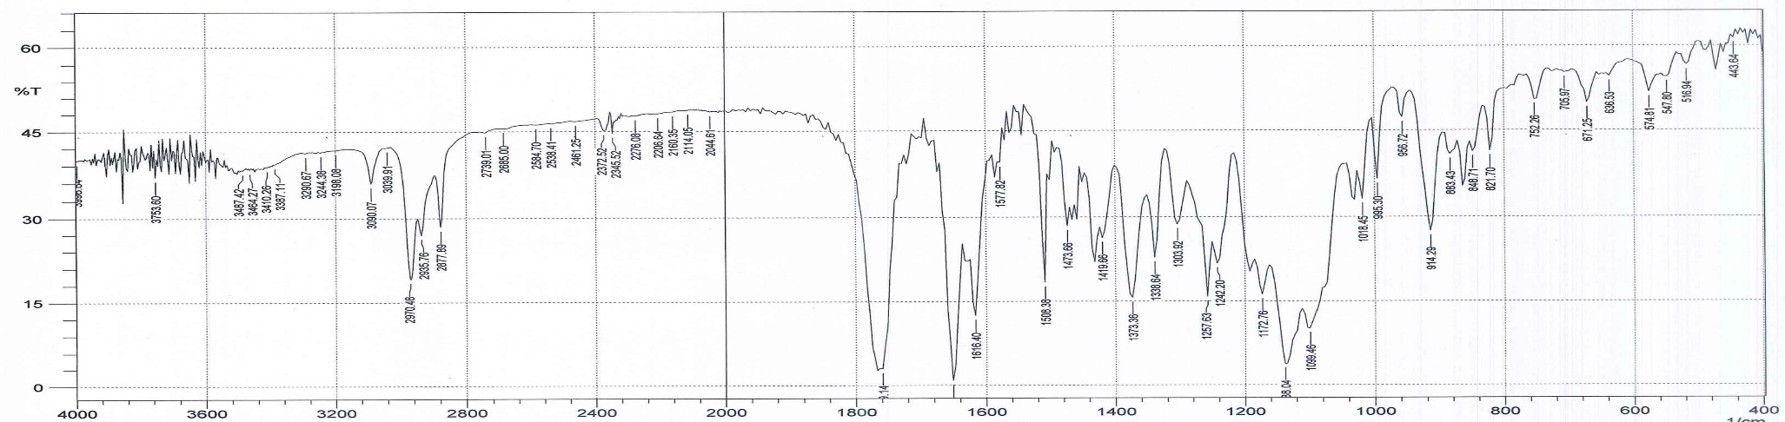

7,3 ', 4' - tri-O-acetyl luteolin（A）¹HNMR
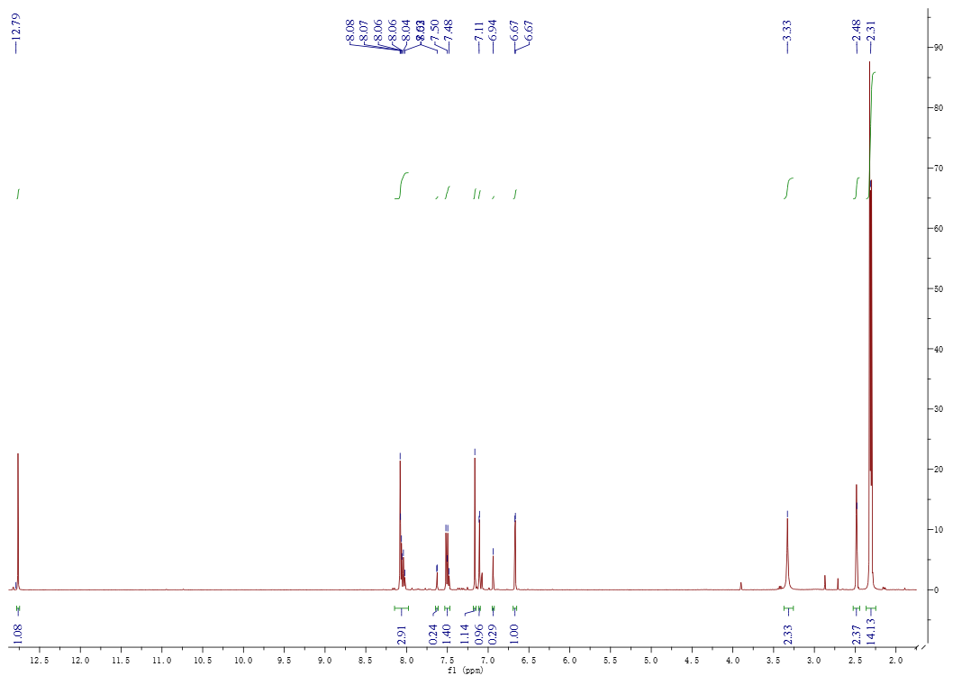

7,3 ', 4' - tri-O-propylated luteolin（B）¹HNMR
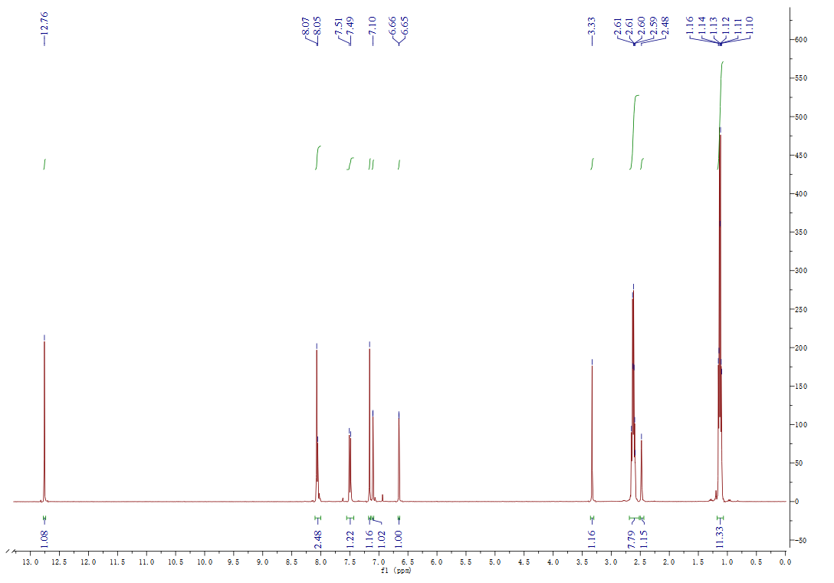

7,3 ', 4' - tri-O-butyrylated luteolin（C）¹HNMR

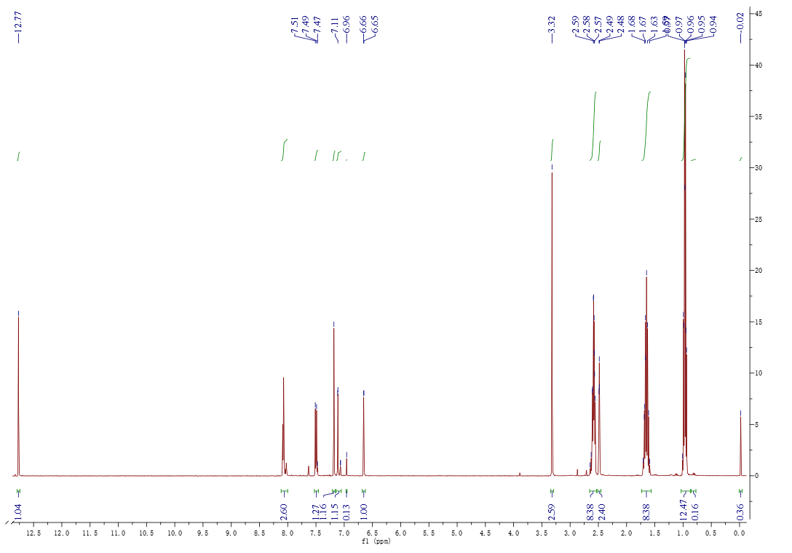

5,7,3 ', 4' - tetra-O-acetyl luteolin（D）¹HNMR
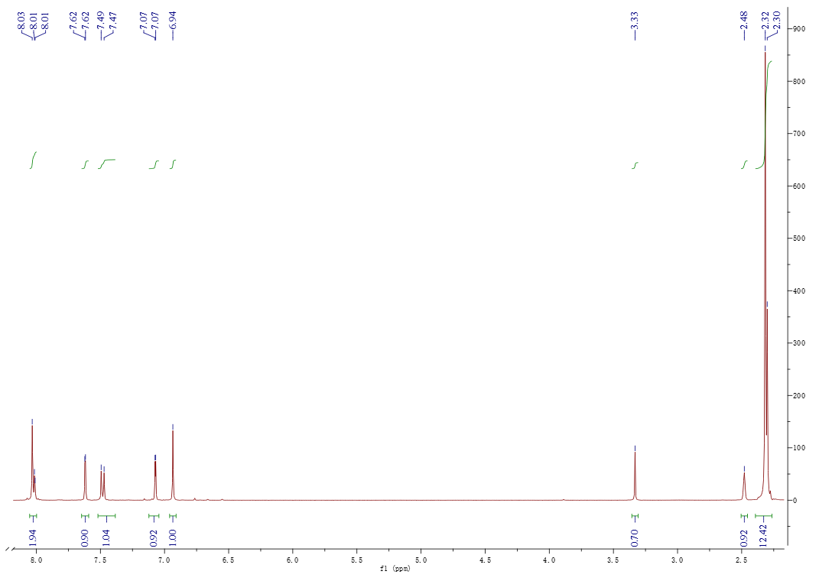

5,7,3 ', 4' - tetra-O-propionylated luteolin（E）¹HNMR
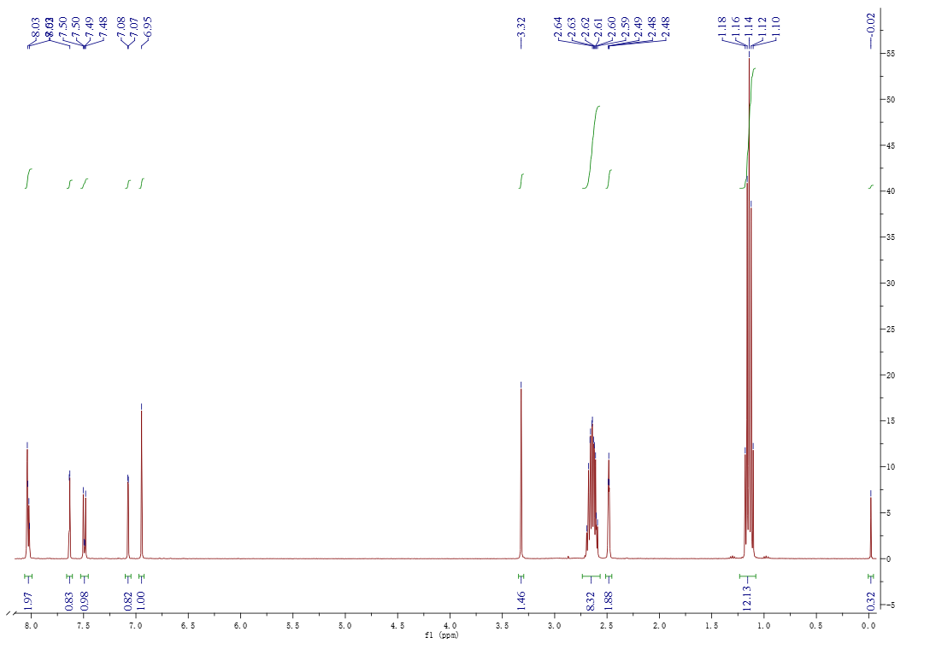

5,7,3 ', 4' - tetra-O-butyrylated luteolin（F）¹HNMR

