Supplementary Tables:
Table s1: Details on the datasets utilised in this study:

Dataset | Description | Coverage | Timescale
The Welsh Demographics Service (WDS) | Register of all individuals who have ever had contact with the NHS or registered with a Welsh GP. | All individuals in Wales | Whole of the study period
Welsh Index of Multiple Deprivation (WIMD) | Dataset assigning a deprivation score derived from eight domains including employment, income and education to all Lower Super Output Areas (LSOAs; geographical areas comprising of around 1500 individuals). Individuals are assigned a deprivation index based on the LSOA of their current address in WDS. | All individuals in Wales | Whole of the study period
General Practice Database (GPD) | Attendance and clinical information for all primary care contacts. Includes diagnoses, symptoms and prescriptions. | 79% of individuals in Wales from 333/432 GP practices | Whole of the study period
Patient Episode Database for Wales (PEDW) | Attendance and clinical information for all NHS Wales hospital admissions (both inpatient and day cases). Includes diagnoses, and specialty. | All individuals in Wales | Whole of the study period
Emergency Department Dataset | Administrative and clinical information for all NHS Wales Accident and Emergency Department attendances. | All individuals in Wales | Data available since 2009
Full details of these datasets are available at www.saildatabank.com

Table s2: List of read codes, ICD-10 codes and prescription codes utilised to identify ADHD and ASD:

Concept | Read codes and prescription codes | ICD-10 codes
ADHD | Eu900, 9Ngp.., Eu9y7, E2E01, EU900, 6A61, 8BPT.., EU901, EU90.., E2E.., Zs91.00, zS91.11, ZS91.12, dc1.., dw1.., dw2.., dw3.., | F90, F90.0, F90.1, F90.2, F90.8, F90.9
ASD | E140, Eu840, Eu841, Eu845, Eu84z-1, 1J9 | F84.0, F84.5, F84.9

Table S3: Cox’s regression analysis: ADHD associations with outcomes

 | Model 1 |  | Model 2 |  | Model 3
 | HR | 95% CI | HR | 95% CI | HR | 95% CI
Anxiety/depression
ADHD | 2.36 | 2.20, 2.53 | 2.36 | 2.20, 2.53 | 2.32 | 2.17, 2.50
Sex |  |  | 0.44 | 0.41, 0.47 | 0.44 | 0.41, 0.47
Deprivation** |  |  |  |  | 1.05 | 1.02, 1.07
Self-harm
ADHD | 5.70 | 5.07, 6.40 | 5.70 | 5.06, 6.39 | 5.52 | 4.91, 6.20
Sex |  |  | 0.53 | 0.47, 0.60 | 0.43 | 0.47, 0.60
Deprivation** |  |  |  |  | 1.12 | 1.08, 1.17
Alcohol use
ADHD | 3.95 | 3.42, 4.56 | 3.95 | 3.42, 4.56 | 3.85 | 3.33, 4.44
Sex |  |  | 1.07 | 0.88, 1.28 | 1.06 | 0.88, 1.28
Deprivation** |  |  |  |  | 1.10 | 1.05, 1.16
Drug use
ADHD | 5.88 | 5.08, 6.80 | 5.88 | 5.09, 6.81 | 5.68 | 4.90, 6.57
Sex |  |  | 1.49 | 1.21, 1.83 | 1.49 | 1.21, 1.83
Deprivation** |  |  |  |  | 1.15 | 1.09, 1.21
Emergency Departmentroom use
ADHD | 1.36 | 1.31, 1.41 | 1.36 | 1.31, 1.41 | 1.34 | 1.30, 1.39
Sex |  |  | 0.96 | 0.92, 1.00 | 0.96 | 0.92, 1.00
Deprivation** |  |  |  |  | 1.04 | 1.02, 1.05
Any primary care use
ADHD | 2.63 | 2.46, 2.80 | 2.62 | 2.46, 2.80 | 2.58 | 2.42, 2.76
Sex |  |  | 0.50 | 0.46, 0.53 | 0.50 | 0.46, 0.53
Deprivation** |  |  |  |  | 1.06 | 1.03, 1.08
Any hospital use (inc ED)
ADHD | 1.36 | 1.31, 1.41 | 1.36 | 1.31, 1.41 | 1.35 | 1.30, 1.40
Sex |  |  | 0.95 | 0.91, 0.99 | 0.95 | 0.91, 0.99
Deprivation** |  |  |  |  | 1.03 | 1.02, 1.05
Models incrementally adjusting for covariates. * Age at end of follow up period as time variable; **WIMD quintile
Table s4: Binomial analysis of number of recorded incidents: ADHD and ASD associations with number of Anxiety/depression, self-harm and Emergency Department events

 | n | B | St. error | 95% CI
ADHD
Number of self-harm events | 1216 | 0.43 | 0.004 | 0.35, 0.51
Number of Emergency Department visits | 14916 | 0.53 | 0.009 | 0.51, 0.55
ASD
Number of self-harm events | 484 | 0.53 | 0.06 | 0.42, 0.64
Number of Emergency Department visits | 7514 | 0.26 | 0.01 | 0.23, 0.29
* Controlling for sex, age at end of follow up, proportion of follow up and deprivation

Table s5: Cox’s regression analysis: ADHD associations with self-harm using GP or hospital records only

 | Model 1 |  | Model 2 |  | Model 3
 | HR | 95% CI | HR | 95% CI | HR | 95% CI
GP records
ADHD | 6.61 | 5.65, 7.72 | 5.72 | 4.88, 6.70 | 5.52 | 4.71, 6.47
Sex |  |  | 0.43 | 0.37, 0.50 | 0.43 | 0.36, 0.50
Deprivation** |  |  |  |  | 1.14 | 1.08, 1.20
Hospital records
ADHD | 7.07 | 5.91, 8.48 | 5.94 | 4.95, 7.13 | 5.76 | 4.80, 6.92
Sex |  |  | 0.44 | 0.37, 0.52 | 0.44 | 0.37, 0.52
Deprivation** |  |  |  |  | 1.12 | 1.05, 1.19
Models incrementally adjusting for covariates. * Age at end of follow up period as time variable; ** WIMD quintile

Table s6: Cox’s regression analysis: ADHD associations with outcomes MALES

 | Model 1 |  | Model 2
 | HR | 95% CI | HR | 95% CI
Anxiety/depression
ADHD | 2.36 | 2.16, 2.57 | 2.32 | 2.13, 2.54
Deprivation** |  |  | 1.06 | 1.03, 1.09
Self-harm
ADHD | 5.75 | 5.00, 6.61 | 5.53 | 4.80, 6.36
Deprivation** |  |  | 1.16 | 1.10, 1.22
Alcohol use
ADHD | 3.70 | 3.16, 4.33 | 3.58 | 3.06, 4.19
Deprivation** |  |  | 1.13 | 1.07, 1.20
Drug use
ADHD | 5.67 | 4.85, 6.62 | 5.47 | 4.67, 6.39
Deprivation** |  |  | 1.14 | 1.08, 1.21
Emergency Department use
ADHD | 1.32 | 1.27, 1.38 | 1.31 | 1.26, 1.36
Deprivation** |  |  | 1.03 | 1.02, 1.04
Any primary care use
ADHD | 2.70 | 2.50, 2.92 | 2.65 | 2.45, 2.87
Deprivation** |  |  | 1.07 | 1.04, 1.10
Any hospital use (inc ED)
ADHD | 1.32 | 1.27, 1.38 | 1.31 | 1.26, 1.37
Deprivation** |  |  | 1.03 | 1.02, 1.04
Models incrementally adjusting for covariates. * Age at end of follow up period as time variable; ** WIMD quintile

Table s7: Cox’s regression analysis: ADHD associations with outcomes FEMALES

 | Model 1 |  | Model 2
 | HR | 95% CI | HR | 95% CI
Anxiety/depression
ADHD | 2.35 | 2.09, 2.65 | 2.34 | 2.07, 2.64
Deprivation** |  |  | 1.03 | 0.99, 1.07
Self-harm
ADHD | 5.57 | 4.51, 6.88 | 5.50 | 4.45, 6.80
Deprivation** |  |  | 1.05 | 0.98, 1.130
Alcohol use
ADHD | 5.45 | 3.84, 7.75 | 5.49 | 3.86, 7.80
Deprivation**
Drug use
ADHD | 7.69 | 5.05, 11.71 | 7.41 | 4.86, 11.30
Deprivation** |  |  | 1.17 | 1.01, 1.35
Emergency Department use
ADHD | 1.51 | 1.39, 1.63 | 1.49 | 1.38, 1.61
Deprivation** |  |  | 1.05 | 1.03, 1.08
Any primary care use
ADHD | 2.47 | 2.20, 2.77 | 2.44 | 2.18, 2.75
Deprivation** |  |  | 1.04 | 0.99, 1.08
Any hospital use (inc ED)
ADHD | 1.52 | 1.41, 1.64 | 1.50 | 1.39, 1.62
Deprivation** |  |  | 1.05 | 1.03, 1.08
Models incrementally adjusting for covariates. * Age at end of follow up period as time variable; ** WIMD quintile

Table s8: Cox’s regression – associations between ADHD and outcomes, stratified by Welsh index of multiple deprivation (WIMD):

 | Model 1* |  | Model 2**
 | HR | 95% CI | HR | 95% CI
Anxiety/depression
WIMD 1: | 2.34 | 1.93, 2.84 | 2.38 | 1.97, 2.89
WIMD 2: | 2.97 | 2.47, 3.57 | 2.92 | 2.43, 3.51
WIMD 3: | 2.41 | 2.04, 2.86 | 2.35 | 1.99, 2.78
WIMD 4: | 2.10 | 1.81, 2.45 | 2.12 | 1.82, 2.47
WIMD 5: | 2.20 | 1.95, 2.94 | 2.21 | 1.96, 2.50
Self-harm
WIMD 1: | 5.17 | 3.61, 7.39 | 5.26 | 3.68, 7.53
WIMD 2: | 10.51 | 7.43, 14.86 | 10.43 | 7.37, 14.75
WIMD 3: | 6.58 | 4.97, 8.71 | 6.41 | 4.85, 8.49
WIMD 4: | 4.72 | 3.72, 5.99 | 4.75 | 3.75, 6.03
WIMD 5: | 4.46 | 3.66, 5.43 | 4.47 | 3.67, 5.44
Alcohol use
WIMD 1: | 5.74 | 3.58, 9.23 | 5.78 | 3.60, 9.28
WIMD 2: | 4.16 | 2.80, 6.14 | 4.15 | 2.81, 6.13
WIMD 3: | 3.19 | 2.37, 4.29 | 3.19 | 2.37, 4.29
WIMD 4: | 4.38 | 3.21, 5.96 | 4.37 | 3.21, 5.96
WIMD 5: | 3.48 | 2.70, 4.49 | 3.48 | 2.70, 4.48
Drug use:
WIMD 1: | 5.40 | 3.50, 8.33 | 5.36 | 3.47, 8.27
WIMD 2: | 8.06 | 5.23, 12.42 | 8.12 | 5.27, 12.51
WIMD 3: | 5.62 | 4.01, 7.88 | 5.65 | 4.03, 7.92
WIMD 4: | 6.61 | 4.74, 9.20 | 6.57 | 4.72, 9.16
WIMD 5: | 4.75 | 3.75, 6.01 | 4.74 | 3.75, 6.01
ED Use:
WIMD 1: | 1.36 | 1.23, 1.50 | 1.36 | 1.23, 1.50
WIMD 2: | 1.35 | 1.23, 1.48 | 1.35 | 1.23, 1.48
WIMD 3: | 1.37 | 1.26, 1.48 | 1.36 | 1.26, 1.48
WIMD 4: | 1.27 | 1.18, 1.37 | 1.27 | 1.18, 1.37
WIMD 5: | 1.38 | 1.29, 1.47 | 1.38 | 1.29, 1.47
Any primary care use:
WIMD 1: | 2.41 | 2.00, 2.89 | 2.44 | 2.03, 2.93
WIMD 2: | 3.29 | 2.77, 3.91 | 3.24 | 2.73, 3.85
WIMD 3: | 2.74 | 2.36, 3.19 | 2.31 | 2.31, 3.12
WIMD 4: | 2.42 | 2.11, 2.79 | 2.44 | 2.12, 2.81
WIMD 5: | 2.42 | 2.16, 2.71 | 2.42 | 2.16, 2.72
Any hospital use (inc ED)
WIMD 1: | 1.36 | 1.24, 1.50 | 1.36 | 1.24, 1.50
WIMD 2: | 1.36 | 1.23, 1.49 | 1.36 | 1.23, 1.49
WIMD 3: | 1.37 | 1.26, 1.49 | 1.37 | 1.26, 1.48
WIMD 4: | 1.28 | 1.18, 1.38 | 1.28 | 1.19, 1.38
WIMD 5: | 1.38 | 1.29, 1.46 | 1.38 | 1.29, 0.99

* Unadjusted association with ADHD; ** Association with ADHD, controlling for Sex.

Table s9: Cox’s regression analysis: ADHD associations with outcomes, sample with complete data coverage only

 | Model 1 |  | Model 2 |  | Model 3
 | HR | 95% CI | HR | 95% CI | HR | 95% CI
Anxiety/depression
ADHD | 2.23 | 2.07, 2.40 | 2.23 | 2.07, 2.40 | 2.20 | 2.04, 2.37
Sex |  |  | 0.43 | 0.39, 0.46 | 0.43 | 0.39, 0.46
Deprivation** |  |  |  |  | 1.05 | 1.02, 1.07
Self-harm
ADHD | 5.46 | 4.83, 6.18 | 5.46 | 4.83, 6.17 | 5.30 | 4.68, 5.99
Sex |  |  | 0.53 | 0.46, 0.60 | 0.53 | 0.46, 0.60
Deprivation** |  |  |  |  | 1.12 | 1.07, 1.17
Alcohol use
ADHD | 3.81 | 3.29, 4.43 | 3.82 | 3.29, 4.43 | 3.71 | 3.19, 4.31
Sex |  |  | 1.06 | 0.87, 1.30 | 1.06 | 0.87, 1.30
Deprivation** |  |  |  |  | 1.11 | 1.05, 1.17
Drug use
ADHD | 5.59 | 4.80, 6.51 | 5.59 | 4.80, 6.51 | 5.39 | 4.62, 6.28
Sex |  |  | 1.52 | 1.22, 1.90 | 1.52 | 1.22, 1.90
Deprivation** |  |  |  |  | 1.14 | 1.08, 1.21
Emergency Department use
ADHD | 1.36 | 1.31, 1.41 | 1.36 | 1.31, 1.41 | 1.35 | 1.30, 1.40
Sex |  |  | 0.94 | 0.91, 0.99 | 0.95 | 0.91, 1.04
Deprivation** |  |  |  |  | 1.03 | 1.02, 1.04
Any primary care use
ADHD | 2.46 | 2.30, 2.63 | 2.46 | 2.30, 2.63 | 2.42 | 2.26, 2.59
Sex |  |  | 0.48 | 0.45, 0.52 | 0.48 | 0.45, 0.52
Deprivation** |  |  |  |  | 1.06 | 1.03, 1.08
Any hospital use (inc ED)
ADHD | 1.36 | 1.32, 1.42 | 1.36 | 1.32, 1.42 | 1.35 | 1.30, 1.40
Sex |  |  | 0.94 | 0.90, 0.98 | 0.94 | 0.90, 0.98
Deprivation** |  |  |  |  | 1.03 | 1.02, 1.04
Models incrementally adjusting for covariates. * Age at end of follow up period as time variable; **WIMD quintile
Table S10: Cox’s regression analysis: ASD associations with outcomes

 | Model 1 |  | Model 2 |  | Model 3
 | HR | 95% CI | HR | 95% CI | HR | 95% CI
Anxiety/depression
ASD | 2.11 | 1.91, 2.34 | 2.14 | 1.93, 2.36 | 2.14 | 1.93, 2.63
Sex |  |  | 0.47 | 0.42, 0.52 | 0.47 | 0.42, 0.52
Deprivation** |  |  |  |  | 1.06 | 1.03, 1.10
Self-harm
ASD | 2.93 | 2.45, 3.50 | 2.96 | 2.48, 3.54 | 2.96 | 2.48, 3.54
Sex |  |  | 0.49 | 0.41, 0.59 | 0.50 | 0.41, 0.60
Deprivation** |  |  |  |  | 1.10 | 1.03, 1.17
Alcohol use
ASD | 1.19 | 0.91, 1.55 | 1.19 | 0.91, 1.55 | 1.19 | 0.91, 1.55
Sex |  |  | 1.19 | 0.88, 1.61 | 1.21 | 0.89, 1.63
Deprivation** |  |  |  |  | 1.10 | 1.01, 1.20
Drug use
ASD | 2.21 | 1.66, 2.95 | 2.20 | 1.65, 2.93 | 2.20 | 1.65, 2.94
Sex |  |  | 2.37 | 1.51, 3.73 | 2.42 | 1.54, 3.81
Deprivation** |  |  |  |  | 1.19 | 1.07, 1.31
Emergency Department use
ASD | 0.95 | 0.90, 1.00 | 0.95 | 0.90, 1.00 | 0.95 | 0.90, 1.00
Sex |  |  | 0.99 | 0.93, 1.04 | 0.99 | 0.94, 1.05
Deprivation** |  |  |  |  | 1.05 | 1.04, 1.07
Any primary care use
ASD | 1.99 | 1.81, 2.19 | 2.01 | 1.82, 2.21 | 2.01 | 1.82, 2.22
Sex |  |  | 0.50 | 0.46, 0.56 | 0.51 | 0.46, 0.56
Deprivation** |  |  |  |  | 1.06 | 1.02, 1.10
Any hospital use (inc ED)
ASD | 0.96 | 0.91, 1.01 | 0.96 | 0.91, 1.01 | 0.96 | 0.91, 1.01
Sex |  |  | 0.98 | 0.93, 1.04 | 0.99 | 0.94, 1.04
Deprivation** |  |  |  |  | 1.05 | 1.04, 1.07
Models incrementally adjusting for covariates. * Age at end of follow up period as time variable; **WIMD quintile

Table s11: Cox’s regression analysis: ASD associations with self-harm using GP or hospital records only

 | Model 1 |  | Model 2 |  | Model 3
 | HR | 95% CI | HR | 95% CI | HR | 95% CI
GP records
ASD | 3.60 | 2.86, 4.53 | 3.25 | 2.58, 4.10 | 3.26 | 2.58, 4.10
Sex |  |  | 0.40 | 0.31, 0.50 | 0.40 | 0.32, 0.50
Deprivation** |  |  |  |  | 1.09 | 1.002, 1.18
Hospital records
ASD | 3.75 | 2.85, 4.93 | 3.32 | 2.52, 4.37 | 3.32 | 2.52, 4.37
Sex |  |  | 0.40 | 0.30, 0.52 | 0.40 | 0.30, 0.52
Deprivation** |  |  |  |  | 1.03 | 0.93, 1.13
Models incrementally adjusting for covariates. * Age at end of follow up period as time variable; ** WIMD quintile

Table s12: Cox’s regression analysis: ASD associations with outcomes MALES

 | Model 1 |  | Model 2
 | HR | 95% CI | HR | 95% CI
Anxiety/depression
ASD | 2.39 | 2.10, 2.71 | 2.39 | 2.11, 2.72
Deprivation** |  |  | 1.08 | 1.03, 1.13
Self-harm
ASD | 2.65 | 2.12, 3.32 | 2.66 | 2.12, 3.33
Deprivation** |  |  | 1.14 | 1.06, 1.24
Alcohol use
ASD | 1.08 | 0.80, 1.46 | 1.08 | 0.80, 1.47
Deprivation** |  |  | 1.13 | 1.03, 1.24
Drug use
ASD | 1.98 | 1.46, 2.70 | 1.99 | 1.46, 2.70
Deprivation** |  |  | 1.17 | 1.05, 1.31
Emergency Department use
ASD | 0.90 | 0.84, 0.95 | 0.90 | 0.85, 0.95
Deprivation** |  |  | 1.06 | 1.04, 1.08
Any primary care use
ASD | 2.21 | 1.95, 2.49 | 2.21 | 1.96, 2.49
Deprivation** |  |  | 1.08 | 1.03, 1.12
Any hospital use
ASD | 0.91 | 0.90, 0.96 | 0.91 | 0.86, 0.97
Deprivation** |  |  | 1.06 | 1.04, 1.08
Models incrementally adjusting for covariates. * Age at end of follow up period as time variable; ** WIMD quintile

Table s13: Cox’s regression analysis: ASD associations with outcomes FEMALES

 | Model 1 |  | Model 2
 | HR | 95% CI | HR | 95% CI
Anxiety/depression
ASD | 1.78 | 1.50, 2.10 | 1.78 | 1.51, 2.10
Deprivation** |  |  | 1.04 | 0.98, 1.10
Self-harm
ASD | 3.60 | 2.68, 4.83 | 3.60 | 2.68, 4.83
Deprivation** |  |  | 1.03 | 0.93, 1.15
Alcohol use
ASD | 1.72 | 0.98, 3.02 | 1.72 | 0.98, 3.02
Deprivation** |  |  | 1.01 | 0.84, 1.23
Drug use
ASD | 4.99 | 2.07, 12.05 | 5.05 | 2.09, 12.19
Deprivation** |  |  | 1.30 | 0.93, 1.81
Emergency Department use
ASD | 1.16 | 1.04, 1.29 | 1.16 | 1.04, 1.29
Deprivation** |  |  | 1.04 | 1.01, 1.08
Any primary care use
ASD | 1.70 | 1.44, 2.01 | 1.70 | 1.44, 2.01
Deprivation** |  |  | 1.03 | 0.98, 1.09
Any hospital use (inc ED)
ASD | 1.15 | 1.04, 1.29 | 1.16 | 1.04, 1.29
Deprivation** |  |  | 1.05 | 1.01, 1.08
Models incrementally adjusting for covariates. * Age at end of follow up period as time variable; **Proportion of follow up period with valid records ***WIMD quintile

Table s14: Cox’s regression – associations between ASD and outcomes, stratified by Welsh index of multiple deprivation (WIMD):

 | Model 1* |  | Model 2**
 | HR | 95% CI | HR | 95% CI
Anxiety/depression
WIMD 1: | 2.13 | 1.66, 2.72 | 2.17 | 1.70, 2.78
WIMD 2: | 2.14 | 1.64, 2.79 | 2.22 | 1.70, 2.89
WIMD 3: | 2.56 | 2.04, 3.22 | 2.45 | 1.95, 3.07
WIMD 4: | 1.96 | 1.58, 2.42 | 2.02 | 1.63, 2.50
WIMD 5: | 1.98 | 1.63, 2.40 | 2.00 | 1.65, 2.42
Self-harm
WIMD 1: | 3.09 | 1.88, 5.09 | 3.17 | 1.93, 5.22
WIMD 2: | 2.80 | 1.80, 4.37 | 2.91 | 1.86, 4.53
WIMD 3: | 4.02 | 2.68, 6.04 | 3.81 | 2.54, 5.73
WIMD 4: | 2.14 | 1.50, 3.06 | 2.20 | 1.53, 3.15
WIMD 5: | 3.10 | 2.19, 4.38 | 3.12 | 2.20, 4.41
Alcohol use
WIMD 1: | 1.45 | 0.73, 2.89 | 1.45 | 0.73, 2.88
WIMD 2: | 1.04 | 0.53, 2.00 | 1.03 | 0.54, 1.99
WIMD 3: | 1.48 | 0.80, 2.74 | 1.46 | 0.79, 2.70
WIMD 4: | 0.74 | 0.40, 1.37 | 0.73 | 0.39, 1.35
WIMD 5: | 1.45 | 0.89, 2.34 | 1.44 | 0.89, 2.32
Drug use:
WIMD 1: | 1.53 | 0.65, 3.57 | 1.51 | 0.64, 3.53
WIMD 2: | 2.12 | 1.01, 4.44 | 2.07 | 0.99, 4.34
WIMD 3: | 3.34 | 1.52, 7.33 | 3.42 | 1.56, 7.52
WIMD 4: | 2.45 | 1.45, 4.14 | 2.38 | 1.41, 4.02
WIMD 5: | 1.88 | 1.09, 3.24 | 1.86 | 1.08, 3.22
ED Use:
WIMD 1: | 0.94 | 0.82, 1.07 | 0.94 | 0.82, 1.07
WIMD 2: | 0.96 | 0.83, 1.09 | 0.96 | 0.84, 1.09
WIMD 3: | 1.03 | 0.92, 1.15 | 1.02 | 0.91, 1.15
WIMD 4: | 0.90 | 0.80, 0.99 | 0.89 | 0.80, 1.00
WIMD 5: | 0.96 | 0.86, 1.06 | 0.95 | 0.86, 1.06
Any primary care use:
WIMD 1: | 1.96 | 1.54, 2.50 | 2.00 | 1.57, 2.54
WIMD 2: | 1.88 | 1.47, 2.42 | 1.95 | 1.52, 2.51
WIMD 3: | 2.38 | 1.91, 2.96 | 2.28 | 1.83, 2.85
WIMD 4: | 1.94 | 1.58, 2.39 | 1.99 | 1.62, 2.45
WIMD 5: | 1.89 | 1.57, 2.29 | 1.91 | 1.58, 2.30
Any hospital use (inc ED)
WIMD 1: | 0.94 | 0.83, 1.07 | 0.94 | 0.83, 1.08
WIMD 2: | 0.97 | 0.85, 1.10 | 0.96 | 0.85, 1.10
WIMD 3: | 1.04 | 0.93, 1.17 | 1.03 | 0.92, 1.16
WIMD 4: | 0.91 | 0.82, 1.01 | 0.91 | 0.81, 1.01
WIMD 5: | 0.96 | 0.86, 1.07 | 0.95 | 0.86, 1.07

* Unadjusted association with ADHD; ** Association with ADHD, controlling for Sex and proportion of follow up.

Table s15: Cox’s regression analysis: ASD associations with outcomes

 | Model 1 |  | Model 2 |  | Model 3
 | HR | 95% CI | HR | 95% CI | HR | 95% CI
Anxiety/depression
ASD | 2.00 | 1.81, 2.22 | 2.02 | 1.82, 2.24 | 2.02 | 1.82, 2.24
Sex |  |  | 0.46 | 0.41, 0.51 | 0.46 | 0.41, 0.51
Deprivation** |  |  |  |  | 1.06 | 1.02, 1.09
Self-harm
ASD | 2.96 | 2.45, 3.57 | 2.98 | 2.47, 3.60 | 2.98 | 2.47, 3.60
Sex |  |  | 0.46 | 0.38, 0.56 | 0.47 | 0.38, 0.57
Deprivation** |  |  |  |  | 1.08 | 1.01, 1.15
Alcohol use
ASD | 1.27 | 0.96, 1.68 | 1.27 | 0.96, 1.68 | 1.27 | 0.96, 1.68
Sex |  |  | 1.12 | 0.81, 1.54 | 1.13 | 0.82, 1.56
Deprivation** |  |  |  |  | 1.10 | 1.00, 1.21
Drug use
ASD | 1.95 | 1.43, 2.67 | 1.94 | 1.42, 2.65 | 1.94 | 1.43, 2.65
Sex |  |  | 2.23 | 1.38, 3.60 | 2.27 | 1.41, 3.67
Deprivation** |  |  |  |  | 1.19 | 1.07, 1.33
Emergency Department use
ASD | 0.95 | 0.90, 1.00 | 0.95 | 0.90, 1.00 | 0.95 | 0.90, 1.00
Sex |  |  | 0.97 | 0.92, 1.03 | 0.98 | 0.92, 1.03
Deprivation** |  |  |  |  | 1.05 | 1.03, 1.06
Any primary care use
ASD | 1.86 | 1.68, 2.06 | 1.87 | 1.69, 2.07 | 1.87 | 1.70, 2.07
Sex |  |  | 0.49 | 0.44, 0.54 | 0.49 | 0.44, 0.54
Deprivation** |  |  |  |  | 1.05 | 1.02, 1.09
Any hospital use (inc ED)
ASD | 0.96 | 0.91, 1.01 | 0.96 | 0.91, 1.01 | 0.96 | 0.91, 1.01
Sex |  |  | 0.97 | 0.92, 1.03 | 0.98 | 0.92, 1.03
Deprivation** |  |  |  |  | 1.05 | 1.03, 1.06
Models incrementally adjusting for covariates. * Age at end of follow up period as time variable; **WIMD quintile

Supplementary table s16: Directly assessed ADHD hybrid cohort and e-cohort only sample comparisons:

 | Nested ADHD sample | e-cohort sample | OR (95% CI) or t
N | 154 | 9379
 | Mean (sd) or N (%)
Male gender | 134 (87.0) | 7583 (80.90) | 1.587 (0.99, 2.55)
Age at end of follow up (GP records) | 19.11 (2.20) | 21.20 (3.80) | t=11.320, p<0.001
Deprivation index quintile | 3.435 (1.56) | 3.421 (1.40) | t=-0.11, p=0.91
Age at ADHD diagnosis: Mean (sd) | 8.41 (3.34) | 10.57 (3.86) | t= 7.95 p<0.001
Age at ASD diagnosis: Mean (sd) | 9.33 (5.44) | 10.96 (5.09) | t=1.45, p=0.15
With comorbid ASD: N (%) | 26 (16.90) | 1340 (14.30) | t=1.36, p=0.19
Anxiety/depression- any: N (%) | 15 (9.70) | 1977 (21.10) | 0.40 (0.24, 0.69)
Anxiety/depression events: Mean (sd) | 0.14 (0.50) | 0.50 (1.45) | t=8.223, p=<0.001
Drug use - any: N (%) | 10 (6.50) | 800 (8.50) | 0.745 (0.39, 1.42)
Drug use - events: Mean (sd) | 0.08 (0.34) | 0.27 (2.50) | t=0.15, p=0.36
Alcohol use – any: N (%) | 5 (3.20) | 675 (7.20) | 0.43 (0.18, 1.06)
Alcohol use – events: Mean (sd) | 0.06 (0.37) | 0.19 (1.71) | t=0.93, p=0.35
Self-harm – any: N (%) | 6 (3.9) | 1158 (12.3) | t=6.947, p<0.001
Self-harm – events: Mean (sd) | 0.09 (0.50) | 0.40 (1.91) | 0.288 (0.13, 0.65)
Emergency Department – any: N (%) | 98 (63.6) | 6021 (64.2) | 0.976 (0.701, 1.36)
Emergency Department – events: Mean (sd) | 2.36 (3.81) | 3.53 (7.18) | 3.69, p<0.001

Supplementary figures:
Figure S1: Databases and process to identify directly assessed ADHD cohort:
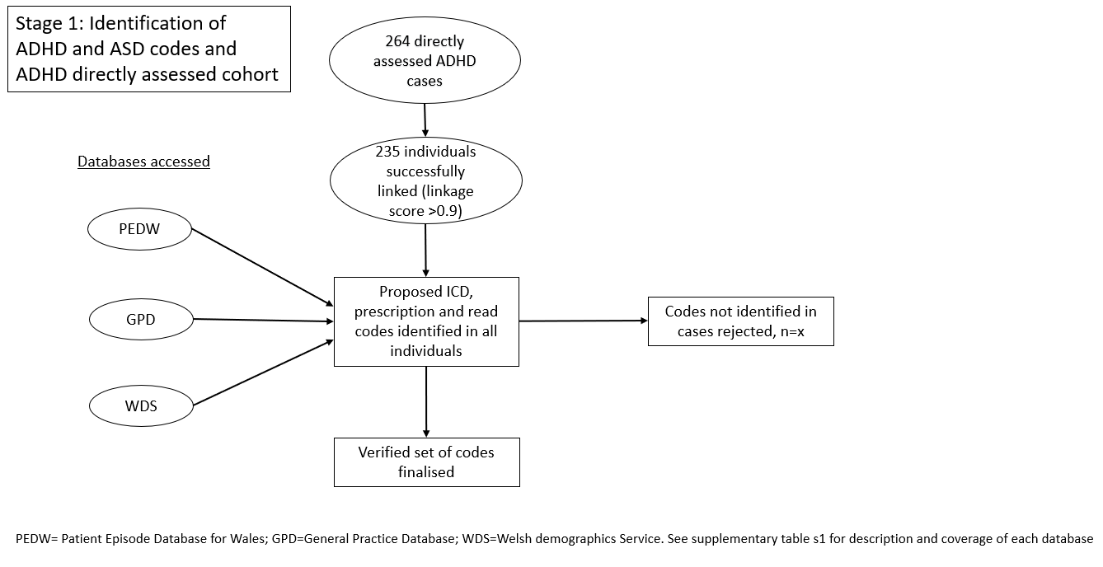
Figure S2: Databases and process to identify individuals with ADHD and ASD:

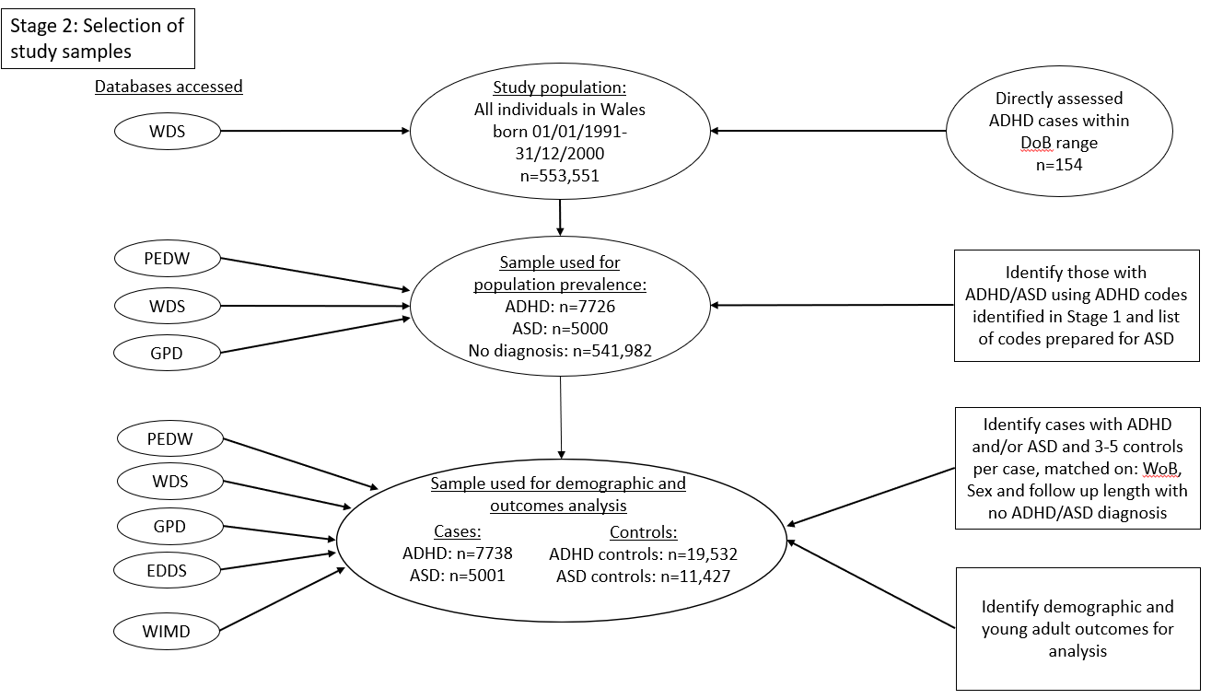

Figure S3: Associations between ADHD and early adult outcomes, by deprivation index:
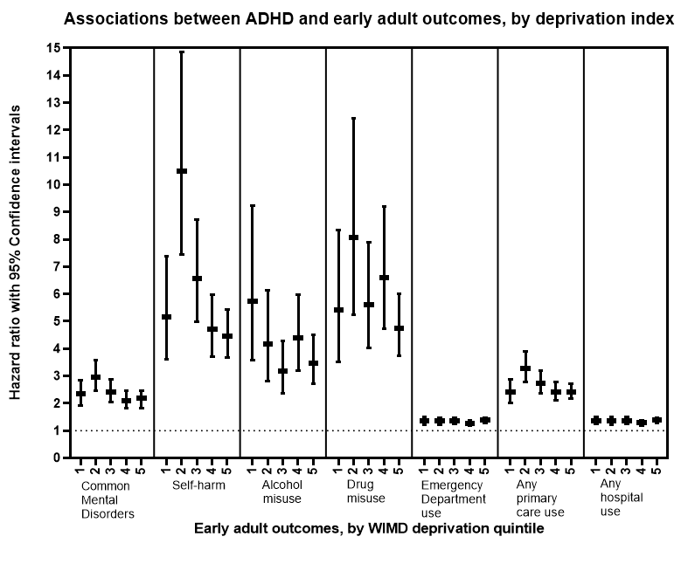

Supplementary Figure S4: Associations between ASD and early adult outcomes,:




