Supplementary Material

Supplementary figure and table

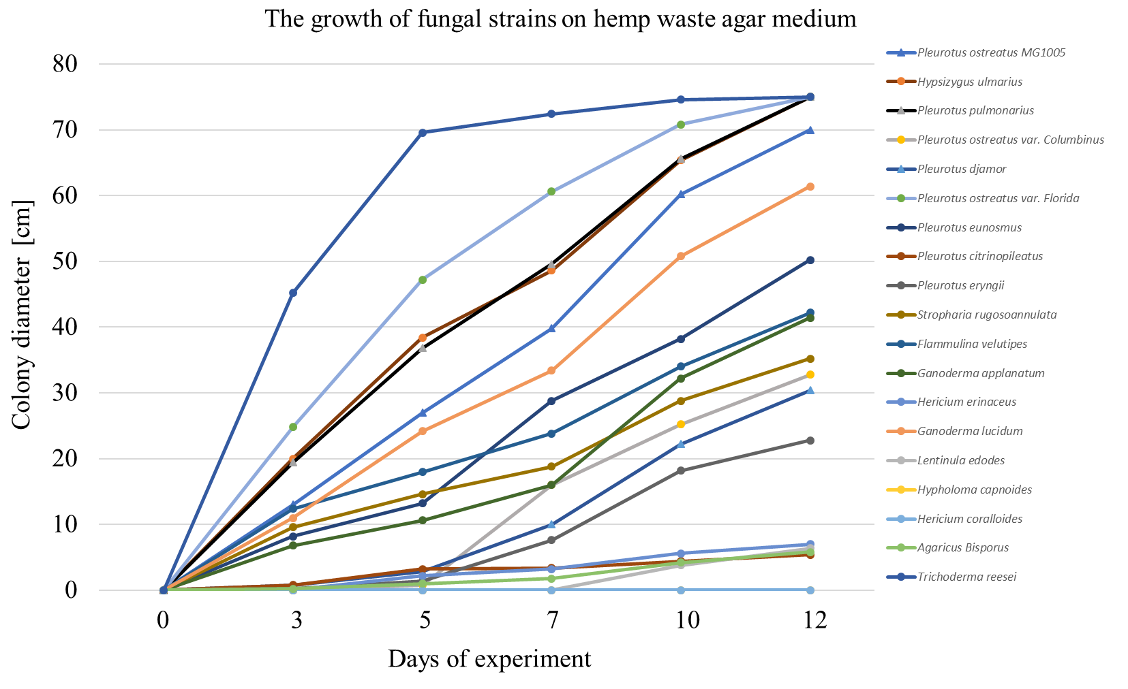

Supplementary Figure S1: The growth of different fungal strains on the hemp-waste agar medium.
.

Supplementary Table S1: Flavonoid content in the initial “untreated" (K1), autoclaved (K2), or the hemp-waste substrate fermented with Pleurotus ostreatus (PO), Hypsizygus ulmarius (HU), Ganoderma lucidum (GL), or Trichoderma reesei (TR).
 | Initial substrate | Substrate after sold state fermentation
Flavonoid compound | K1 | TR | GL | HU | PO | K2
Apigenin derivate | 1.26
Apigenin derivate | 2.50
Apigenin derivate | 2.18
Apigenin-hexoside-pentoside | 2.63
Luteolin-glucoronide | 1.68 |  |  |  |  | 0.40
Apigenin-glucoronide | 6.93 | 1.75 |  |  | 0.10 | 3.50
Luteolin | 0.06
Apigenin | 0.33
Total | 17.56 | 1.75 |  |  | 0.10 | 3.89

