Supplemental Figures
Supplemental Figure 1. Regional plots of OPRM1 gene region on chromosome 6 for EUR OUD GWAS top OPRM1 associations (a) rs1799971 (p=4.92x10⁻⁰⁹ ) and (b) rs79704991 (p=1.11x10⁻⁰⁸; r²=0.02).
Supplemental Figure 2. Manhattan plot of African-ancestry OUD GWAS results.
Supplemental Figure 3. Manhattan plot of cross-ancestry OUD GWAS results.
Supplemental Figure 4. Manhattan plot of EUR ancestry OUD gene-based results.
Supplemental Figure 5. Manhattan plot of cross-ancestry OUD gene-based results.
Supplemental Figure 6. Circos plots for chromosomes containing genome-wide significant loci for the OUD EUR GWAS.
Supplemental Figure 7. Circos plots for chromosomes containing genome-wide significant loci for the OUD-MTAG GWAS.
Supplemental Figure 8. Manhattan plot of OUD-MTAG gene-based results.
Supplemental Figure 9. BioVU PheWAS results for EUR OUD GWAS (OUD-META; left panel) and OUD multi-trait analysis (OUD-MTAG; right panel).

Supplemental Figure 1. Regional plots of OPRM1 gene region on chromosome 6 for EUR OUD GWAS top OPRM1 associations (a) rs1799971 (p=4.92x10⁻⁰⁹ ) and (b) rs79704991 (p=1.11x10⁻⁰⁸; r²=0.02).
(a)
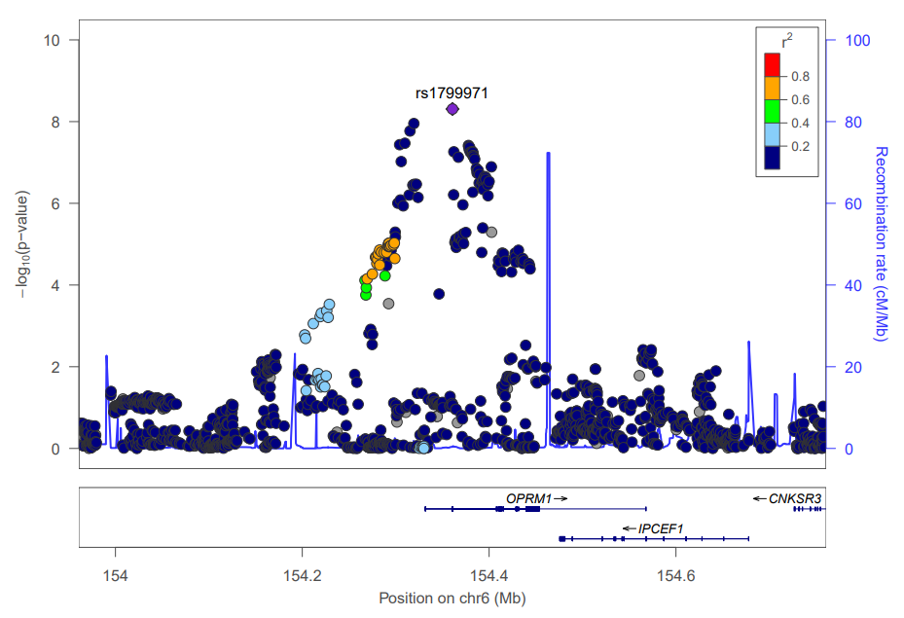
(b)
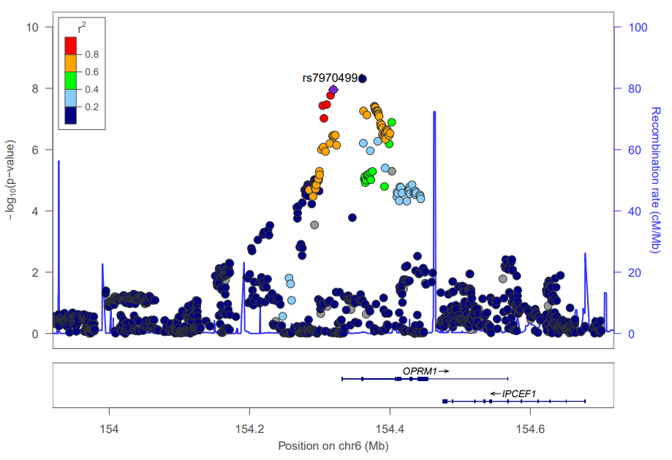
Supplemental Figure 2. Manhattan plot of African-ancestry OUD GWAS results
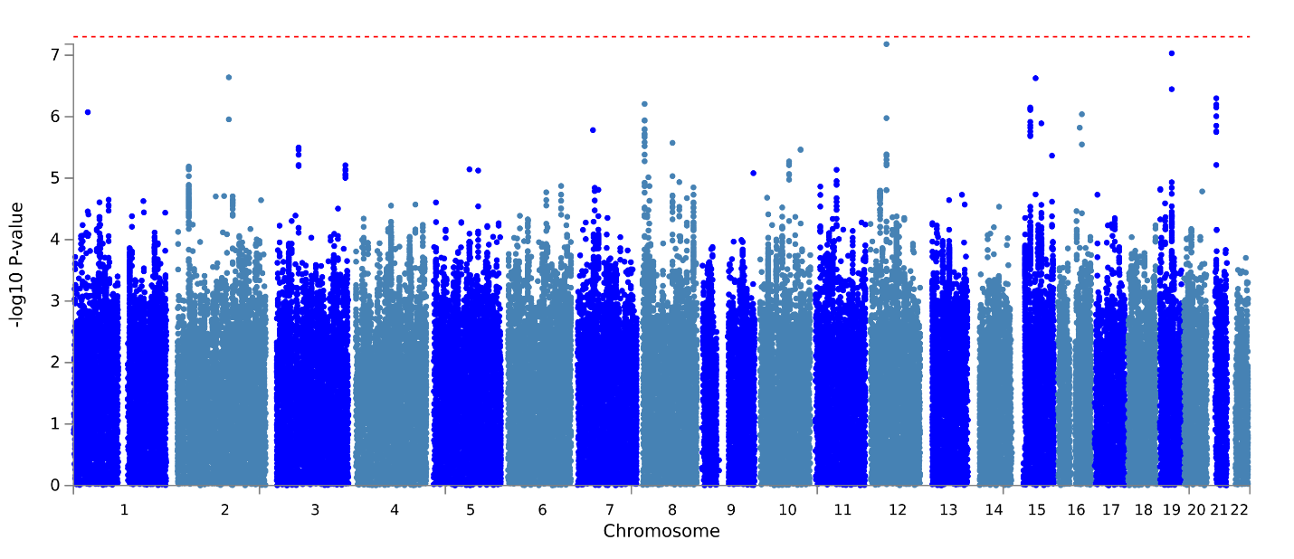

Supplemental Figure 3. Manhattan plot of cross-ancestry OUD GWAS results.

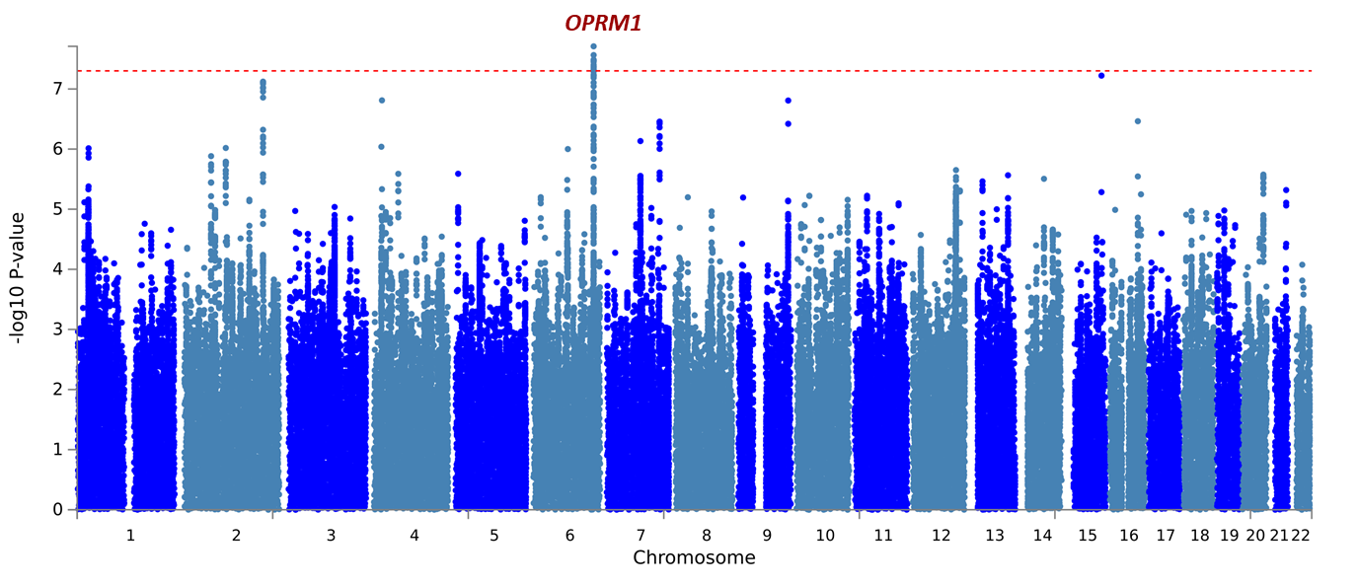

Supplemental Figure 4. Manhattan plot of EUR ancestry OUD gene-based results.
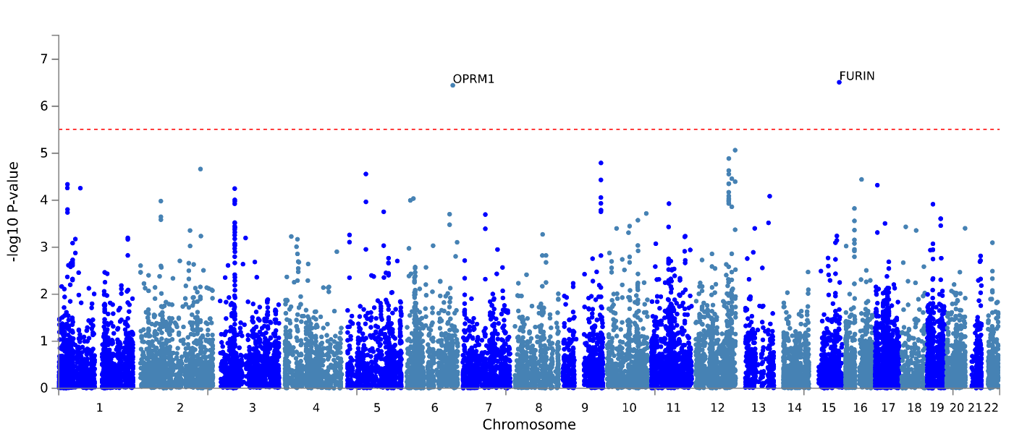

Supplemental Figure 5. Manhattan plot of cross-ancestry OUD gene-based results.
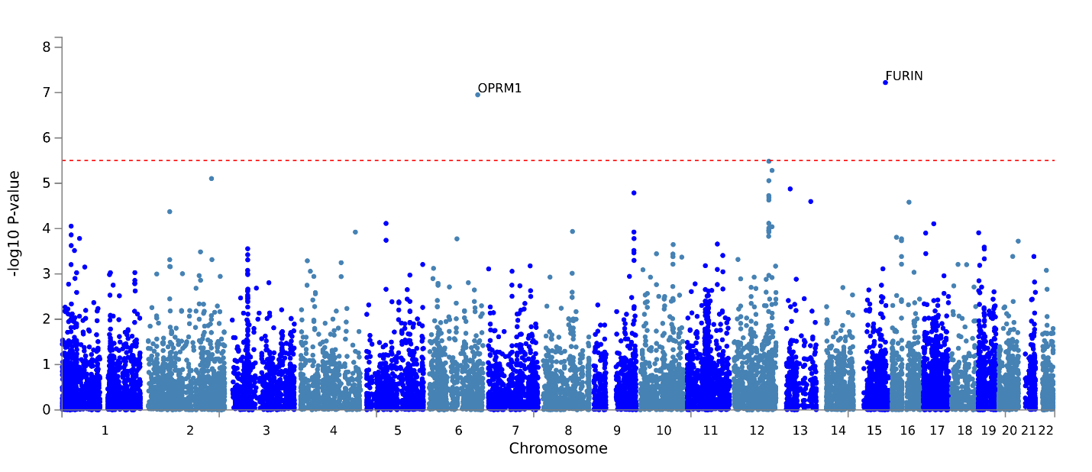

Supplemental Figure 6. Circos plots for chromosomes containing genome-wide significant loci for the OUD EUR GWAS.
Note. Outer most layer is a manhattan plot of genome-wide association study (GWAS) single-nucleotide polymorphisms (SNPs) with p≤0.05. SNPs are plotted by chromosomal position along the x-axis with their corresponding -log⁻¹⁰ p-value on the y-axis. Linkage-disequilibrium (LD) between the identified lead SNP and surrounding SNPs is indicated from r²>0.8 (red), r²>0.6 (orange), r²>0.4 (green), r²>0.2 (blue). SNPs that are not in LD with the lead SNP (r²≤0.02) are gray. Second layer (chromosome ring): Chromosomal regions containing identified genomic risk loci are colored in blue. The names of genes implicated based upon variant associations with brain tissue expression quantitative trait loci (eQTLs) are colored green. The names of genes implicated based upon 3D chromatin interactions (Hi-C) are colored orange. Genes that are mapped based upon both eQTLs and Hi-C associations are colored red. Third layer (chromosome ring): Variants mapped to genes based upon associations with brain tissue eQTLs are linked in green. Variants mapped to genes based upon Hi-C data are linked in orange.

- Chromosome 6
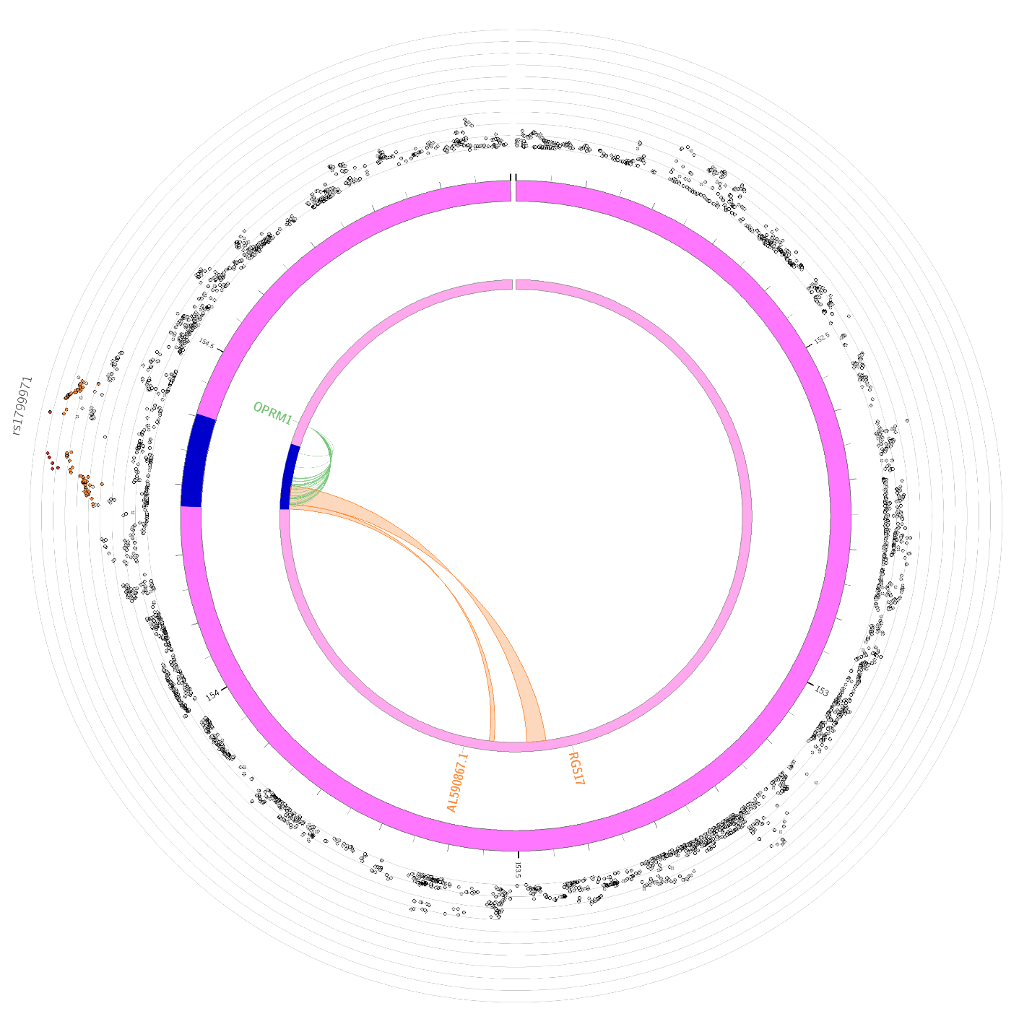
- Chromosome 15
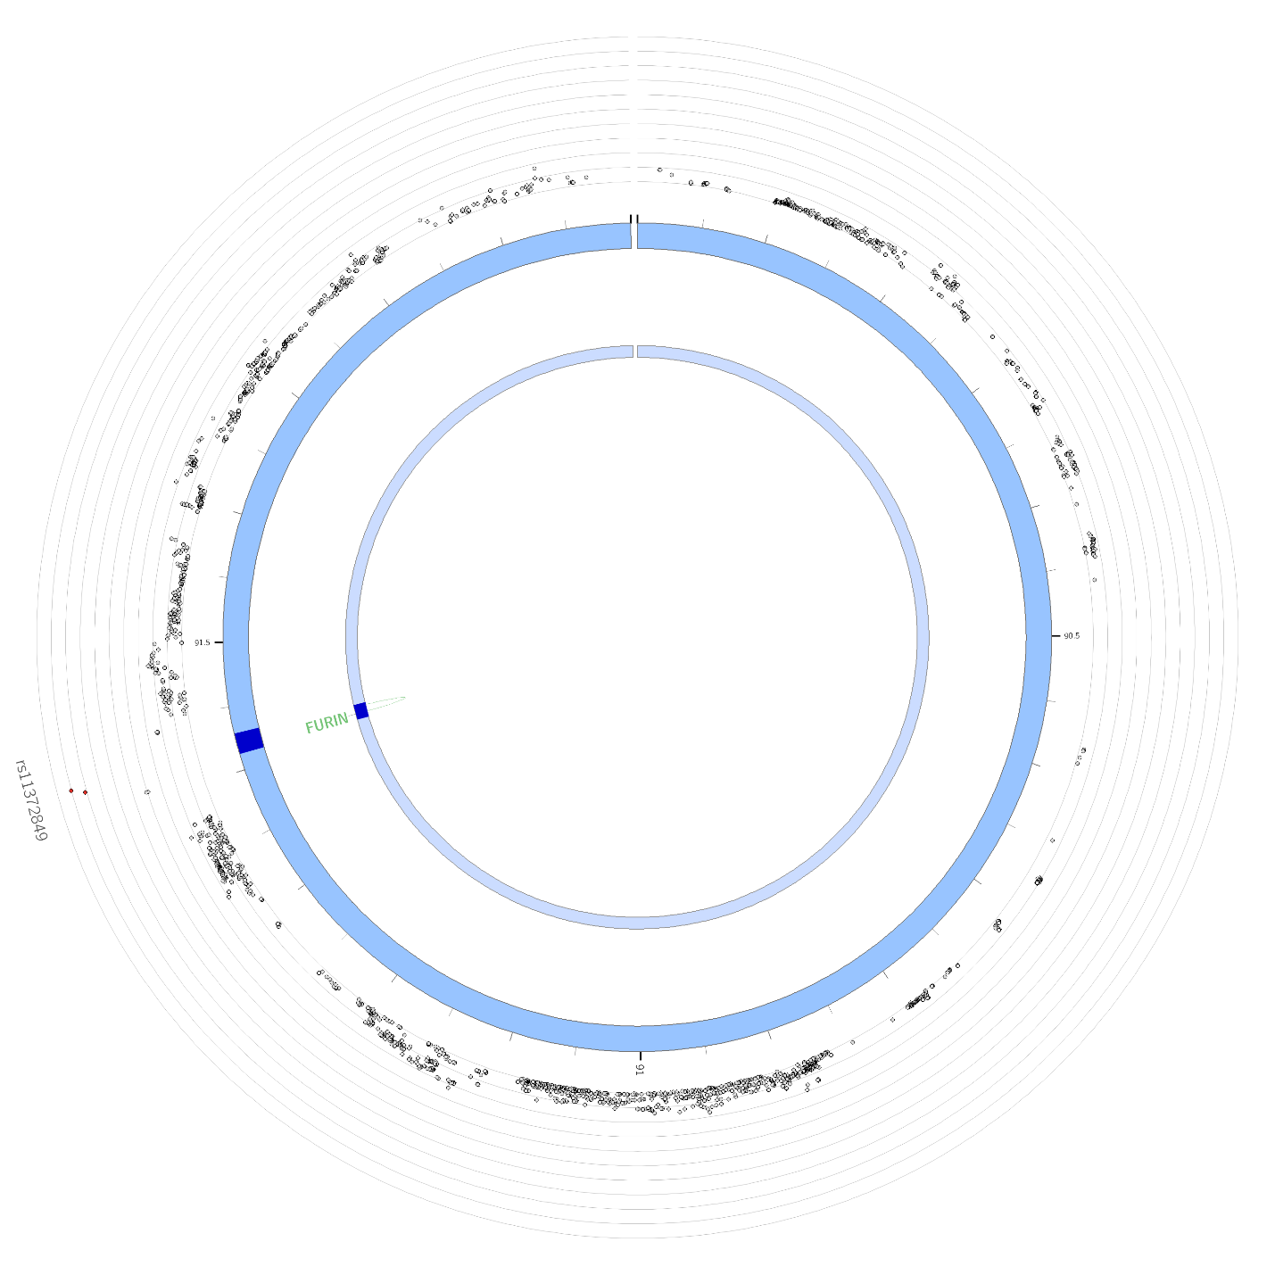

Supplemental Figure 7. Circos plots for chromosomes containing genome-wide significant loci for the OUD-MTAG GWAS.
Note. Outer most layer is a manhattan plot of genome-wide association study (GWAS) single-nucleotide polymorphisms (SNPs) with p≤0.05. SNPs are plotted by chromosomal position along the x-axis with their corresponding -log⁻¹⁰ p-value on the y-axis. Linkage-disequilibrium (LD) between the identified lead SNP and surrounding SNPs is indicated from r²>0.8 (red), r²>0.6 (orange), r²>0.4 (green), r²>0.2 (blue). SNPs that are not in LD with the lead SNP (r²≤0.02) are gray. Second layer (chromosome ring): Chromosomal regions containing identified genomic risk loci are colored in blue. The names of genes implicated based upon variant associations with brain tissue expression quantitative trait loci (eQTLs) are colored green. The names of genes implicated based upon 3D chromatin interactions (Hi-C) are colored orange. Genes that are mapped based upon both eQTLs and Hi-C associations are colored red. Third layer (chromosome ring): Variants mapped to genes based upon associations with brain tissue eQTLs are linked in green. Variants mapped to genes based upon Hi-C data are linked in orange.

- Chromosome 1
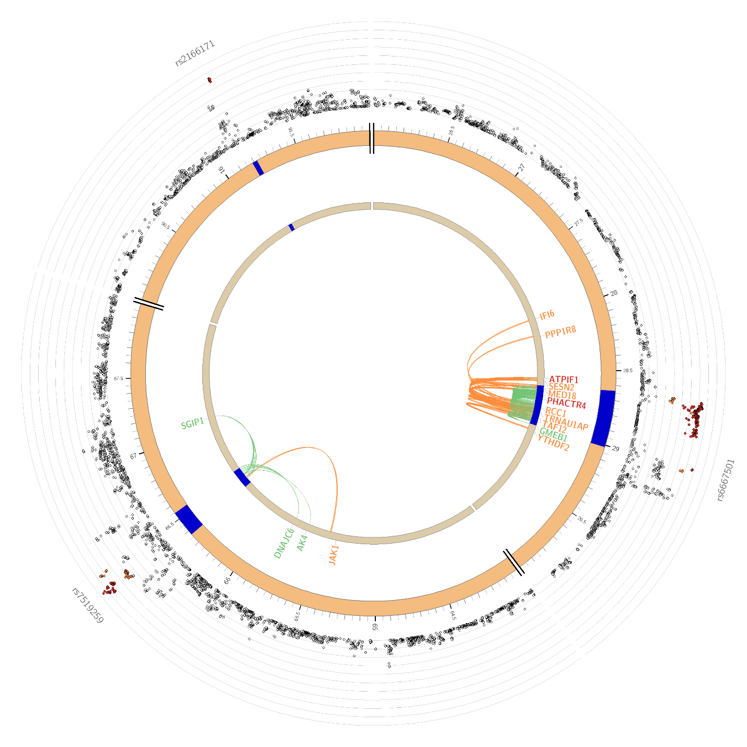

- Chromosome 3
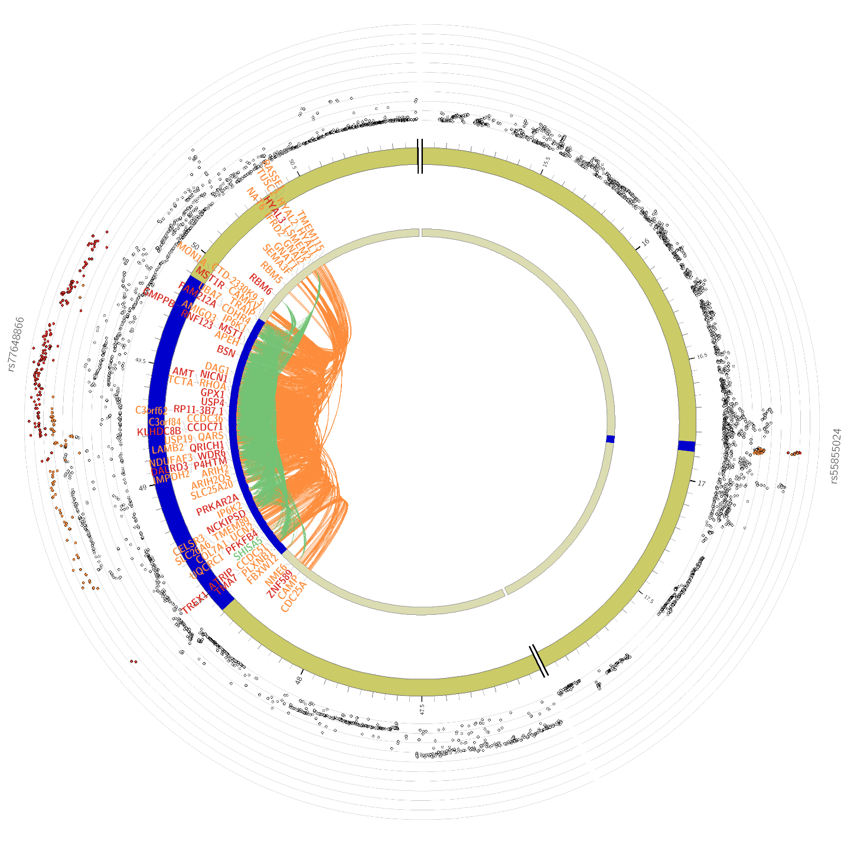

- Chromosome 4
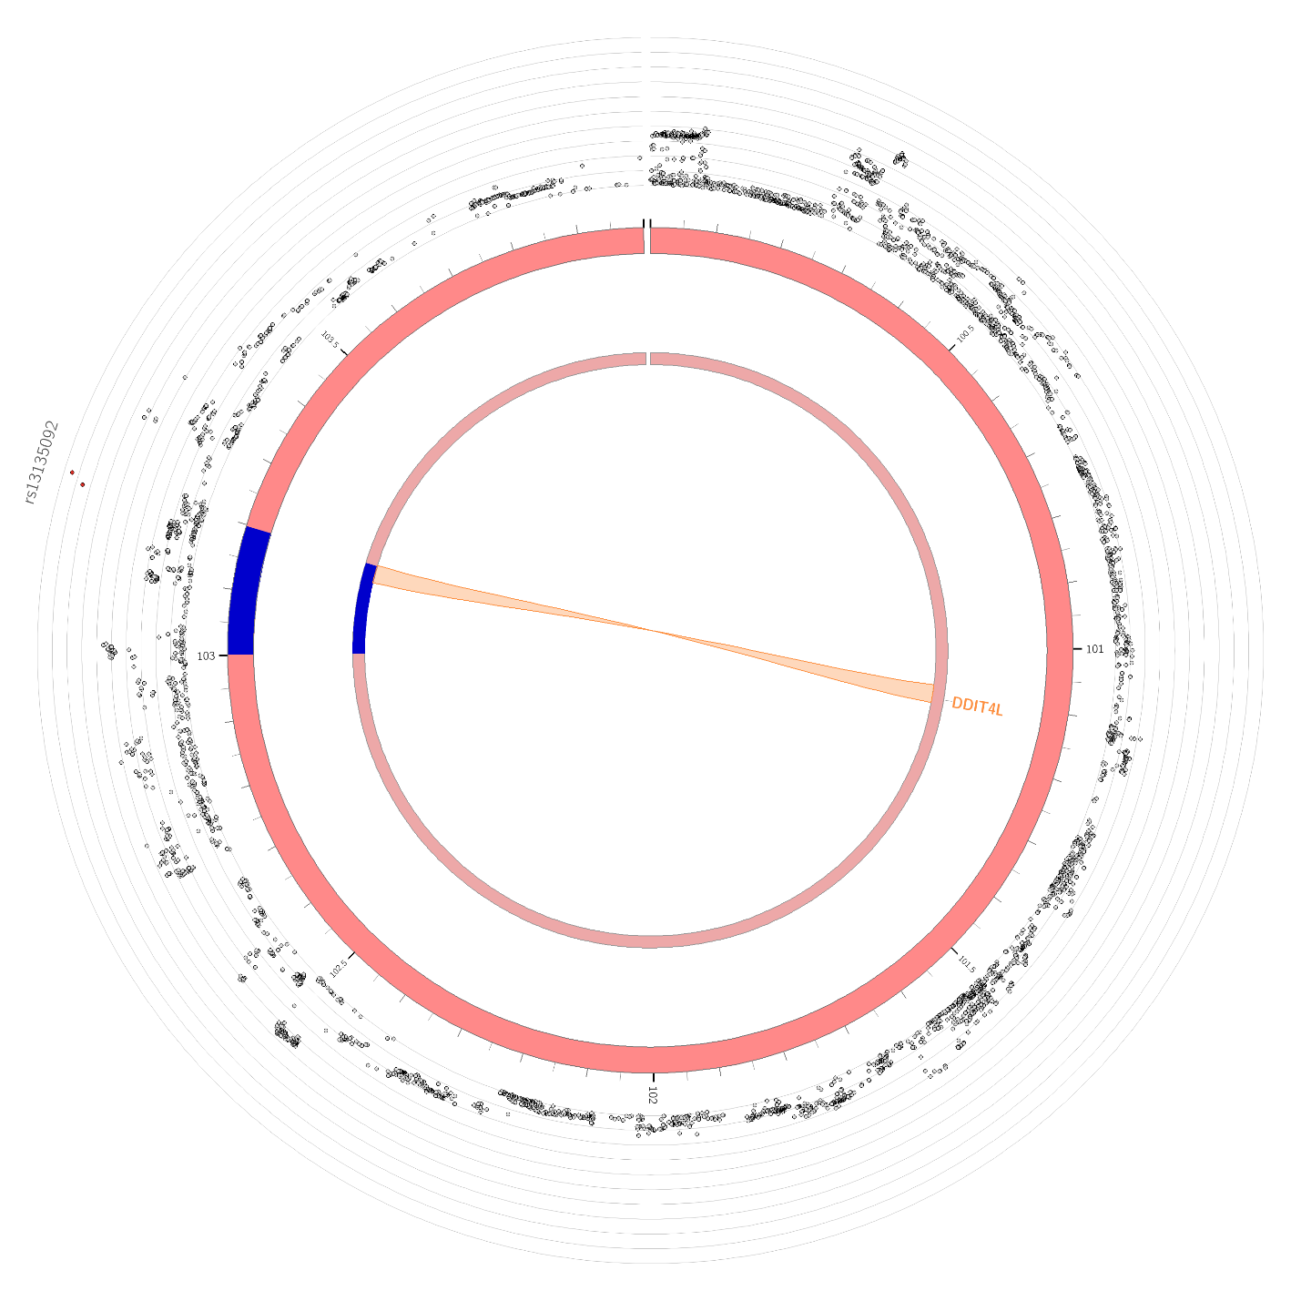

- Chromosome 6
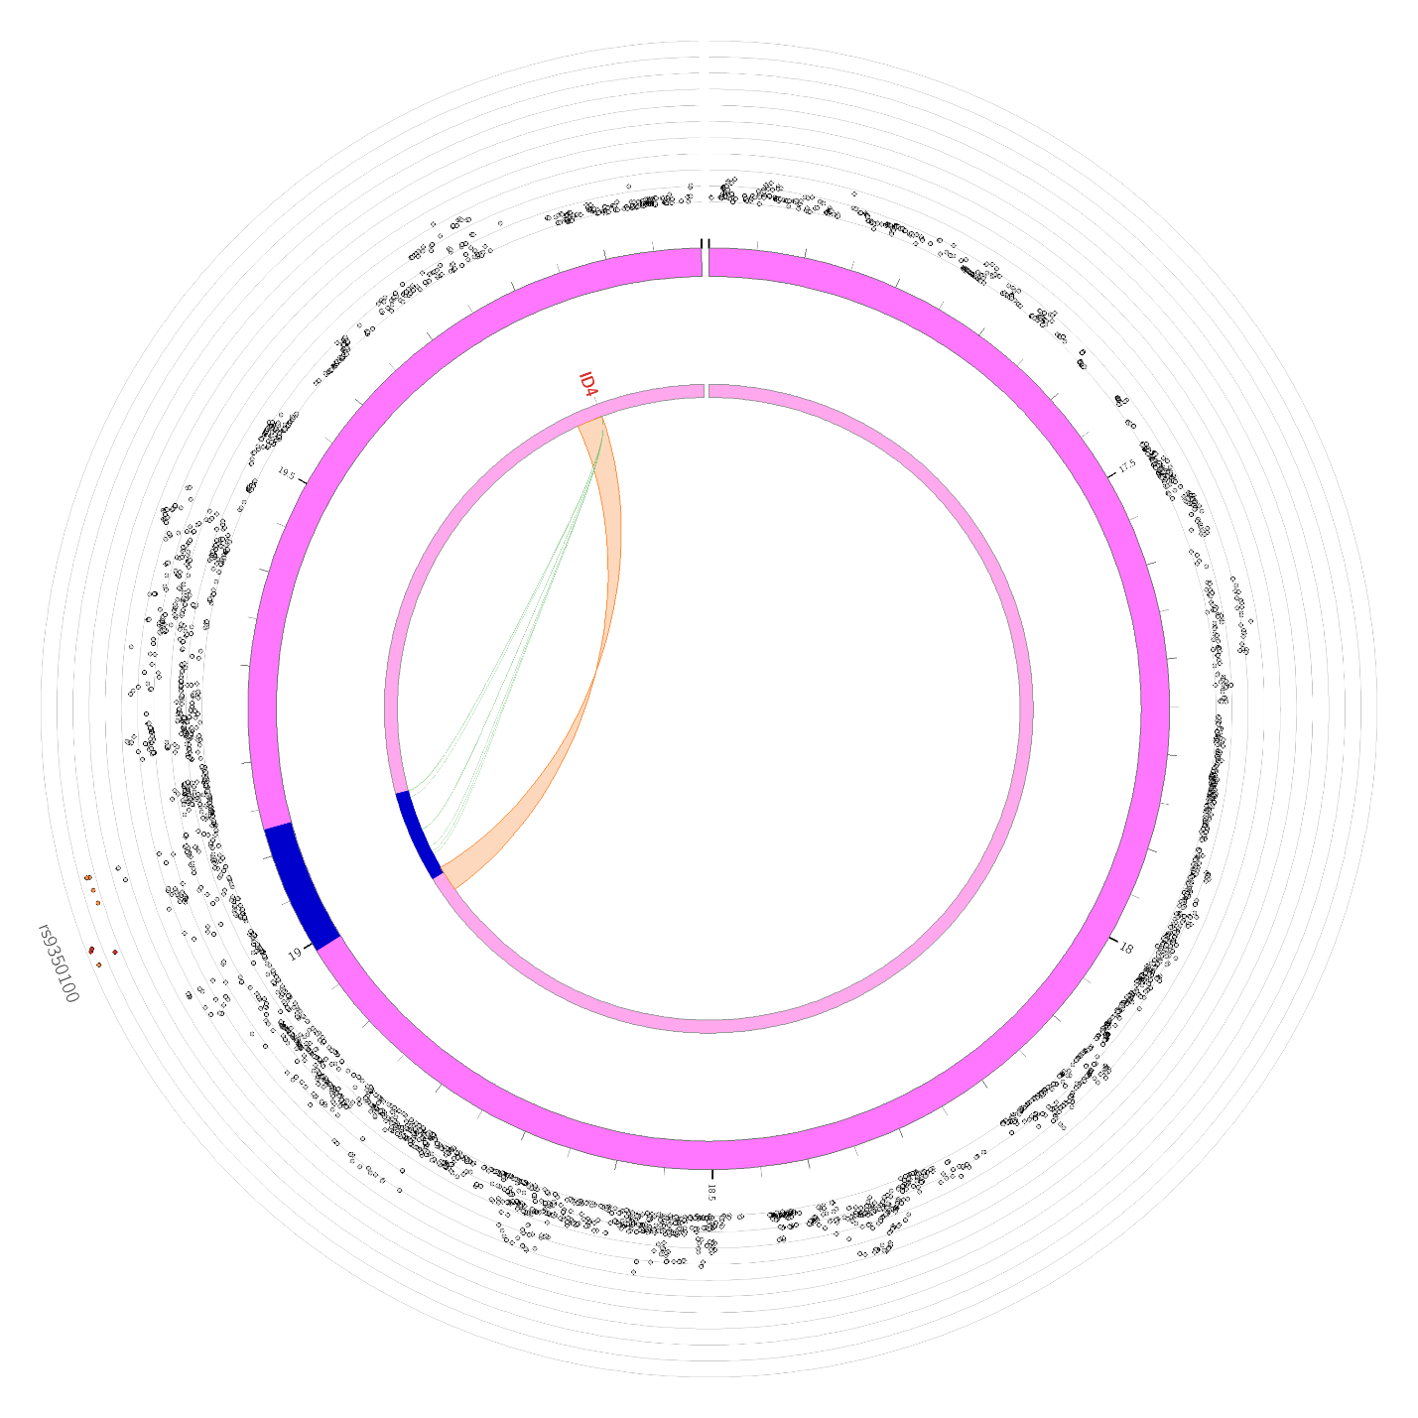

- Chromosome 7
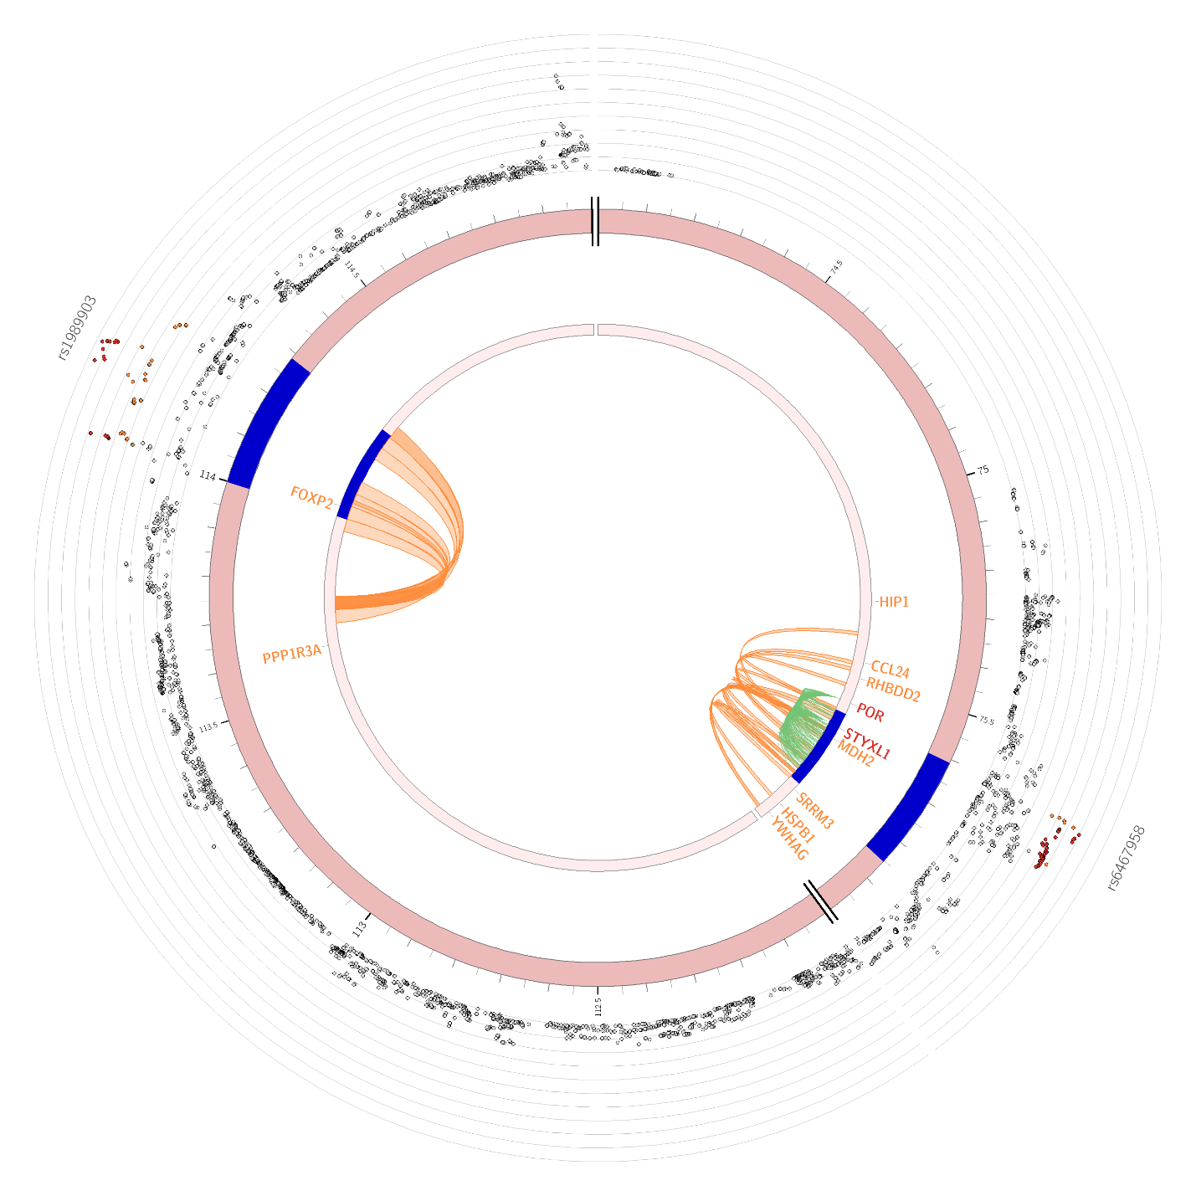

- Chromosome 9
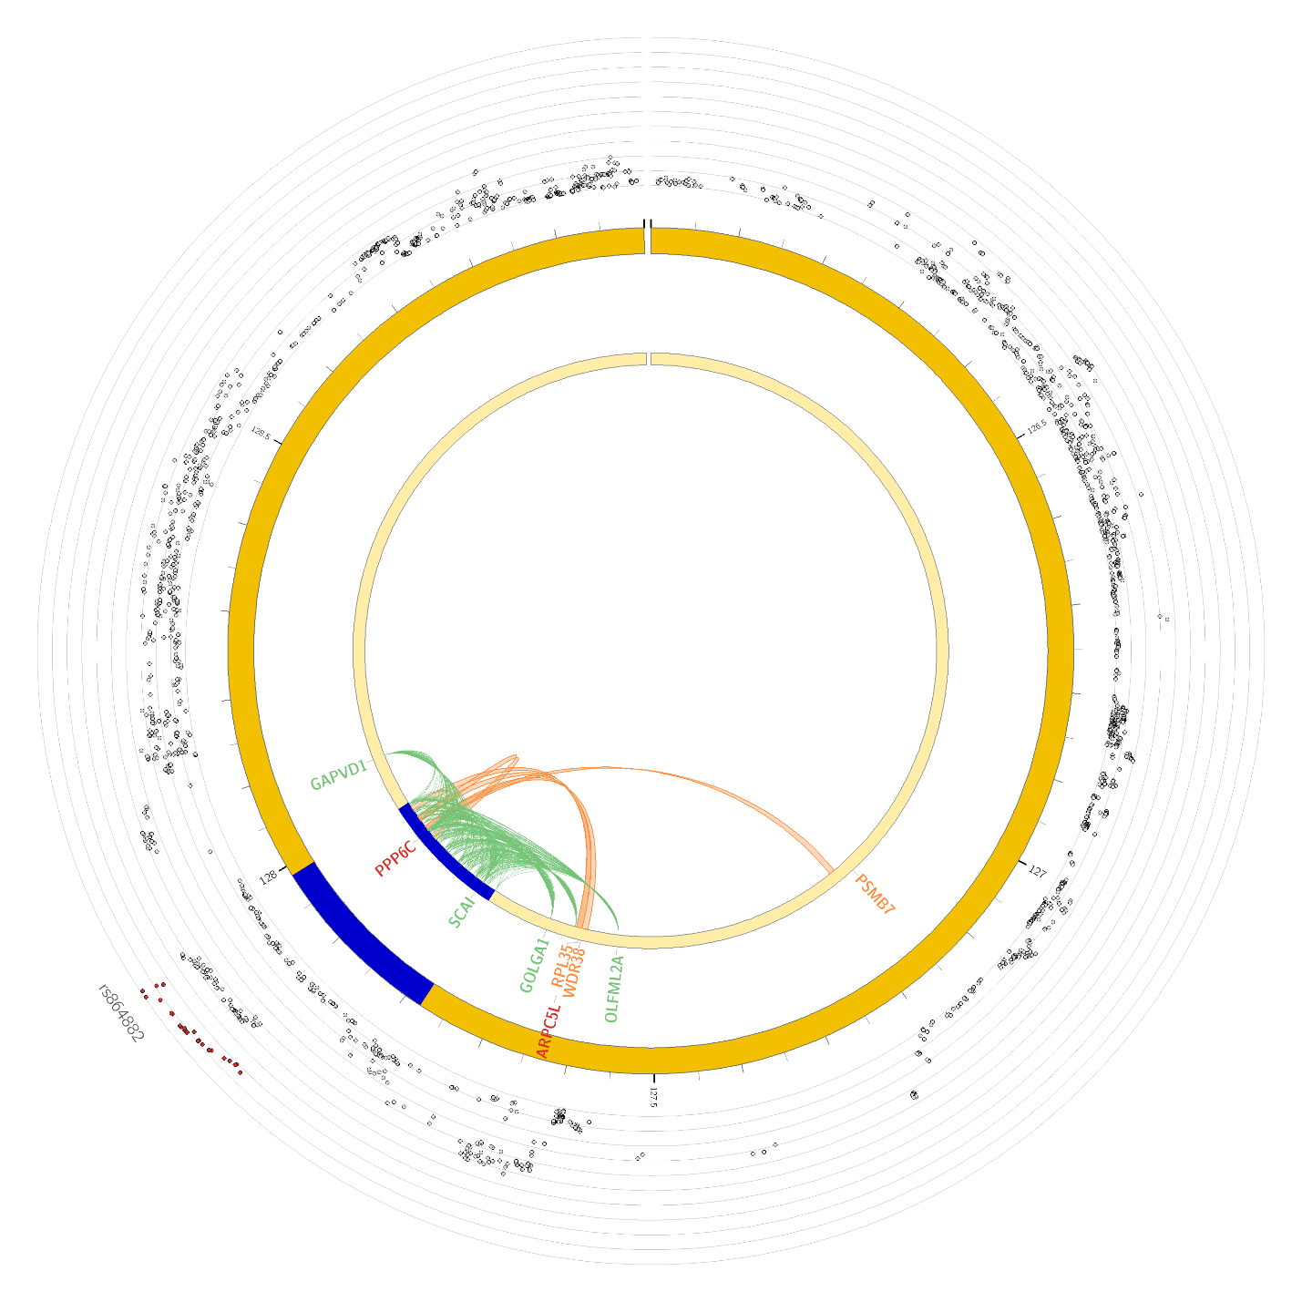

- Chromosome 11
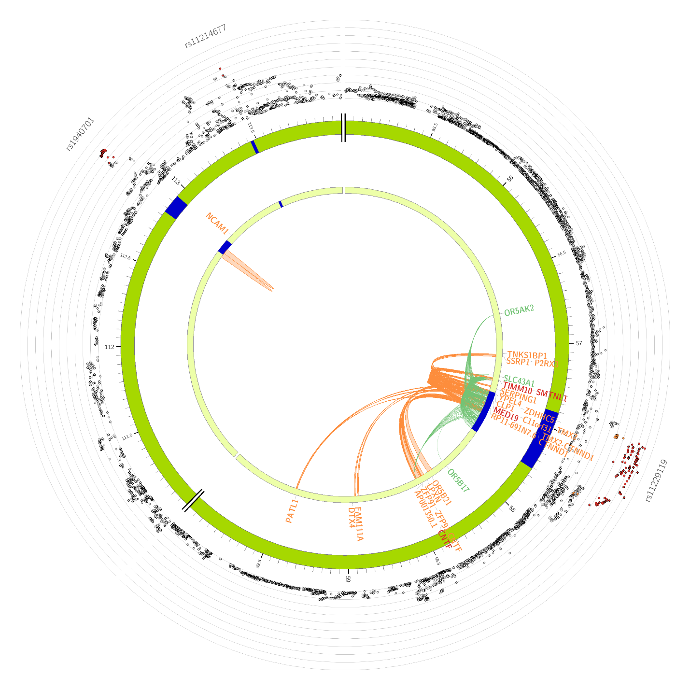

- Chromosome 13
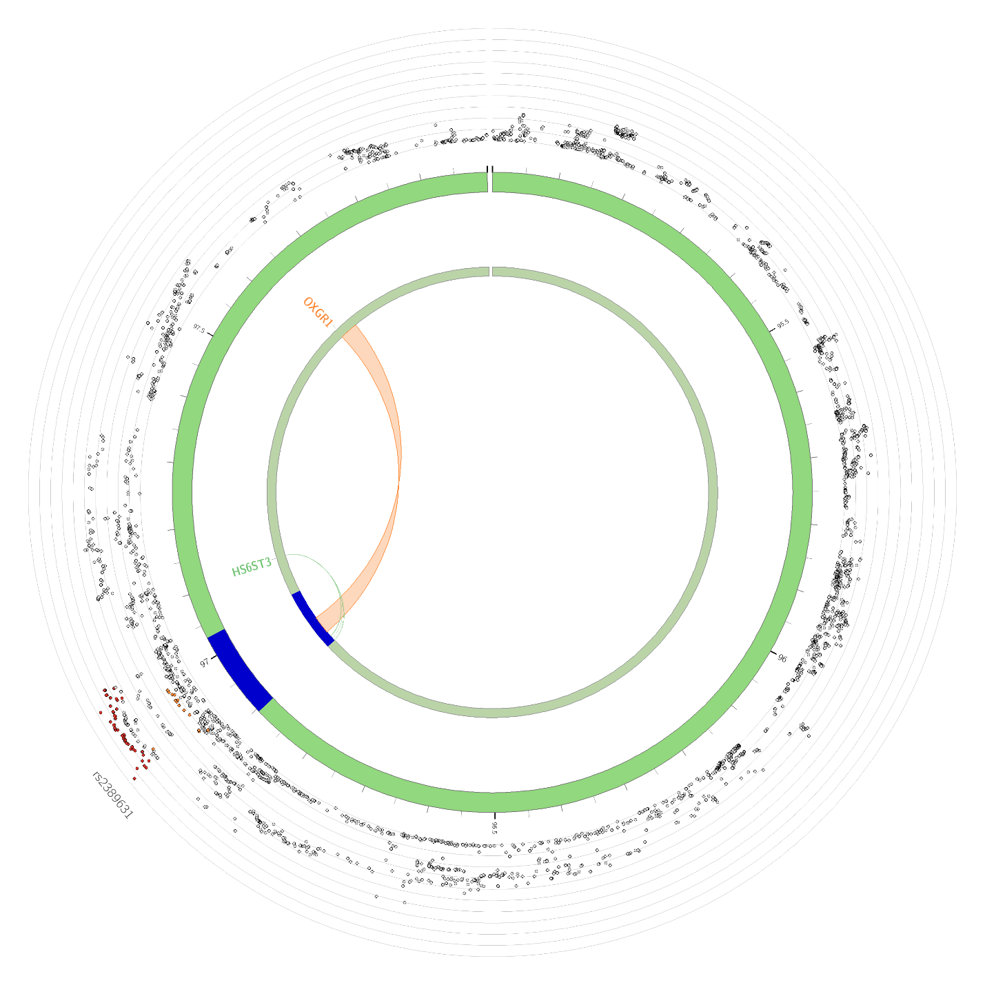

- Chromosome 15
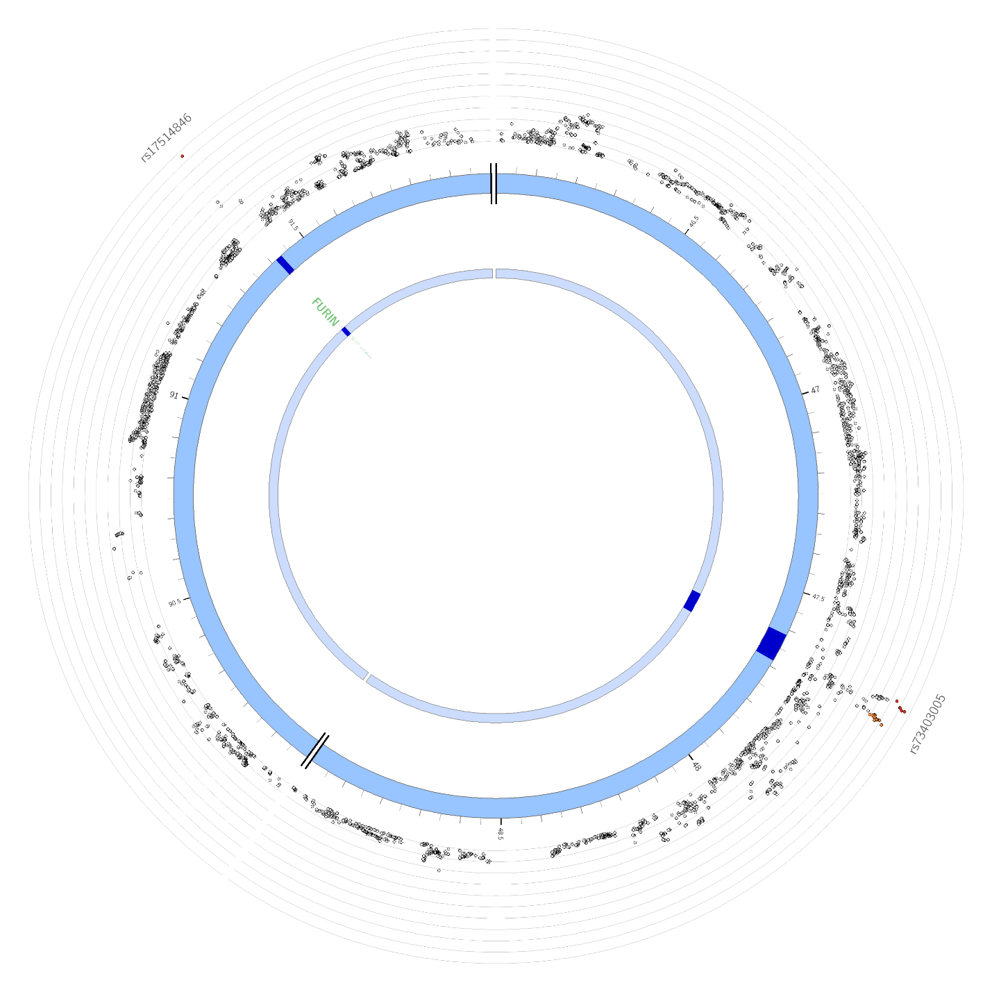

- Chromosome 16
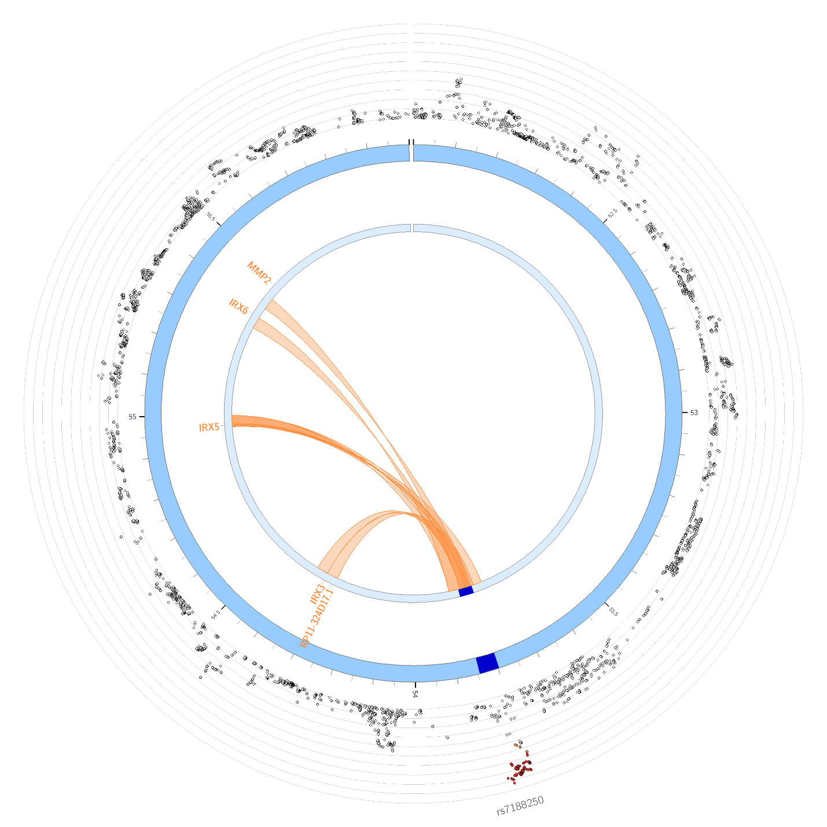

- Chromosome 19
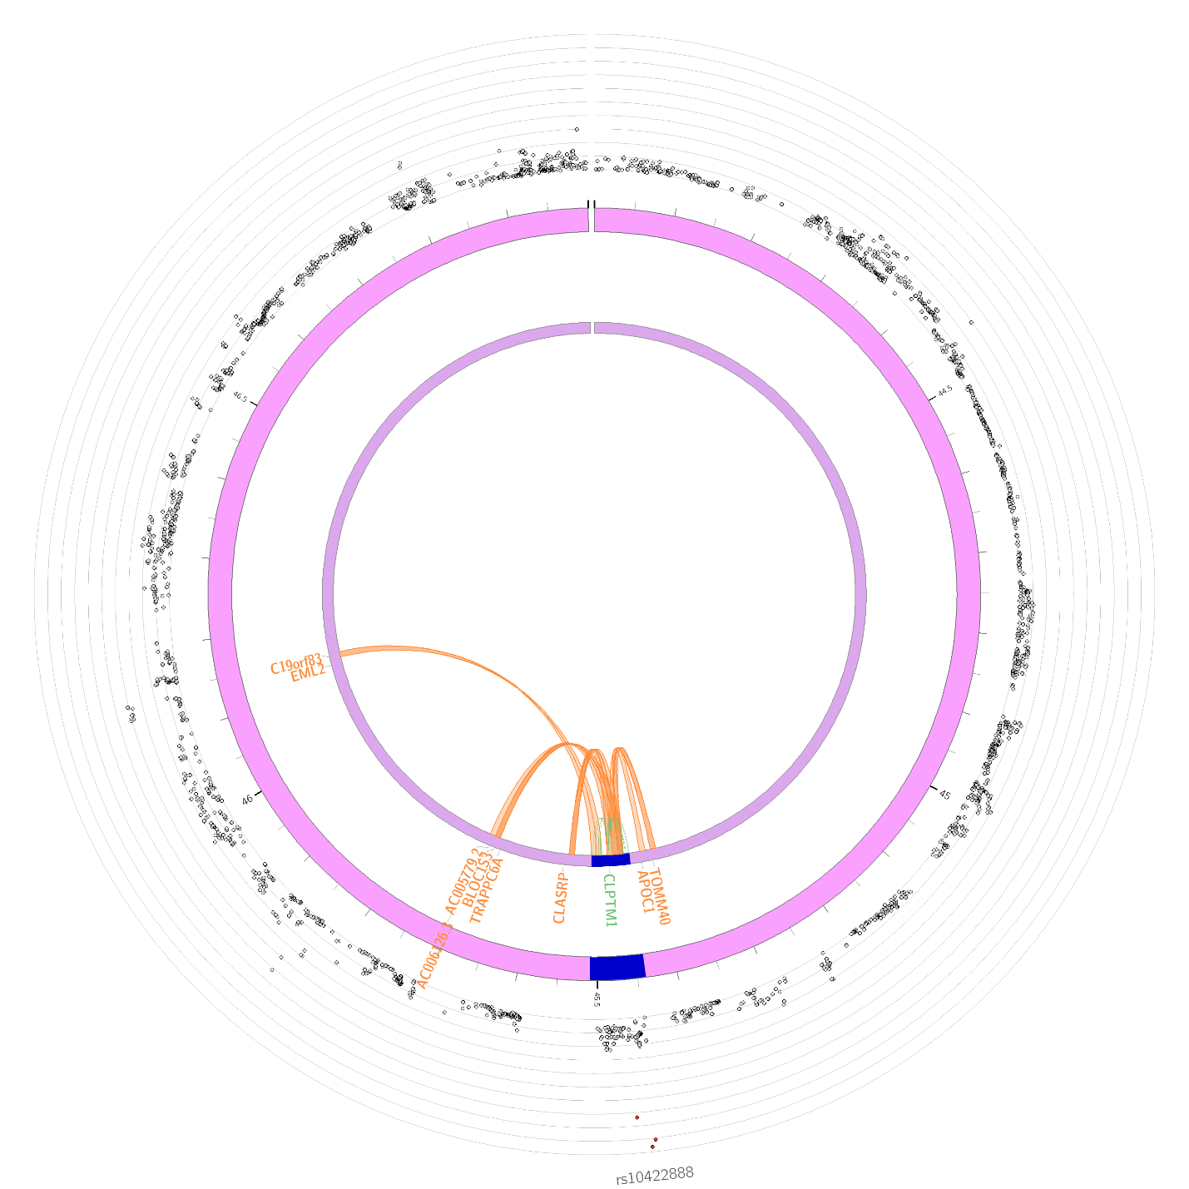

Supplemental Figure 8. Manhattan plot of OUD-MTAG gene-based results.
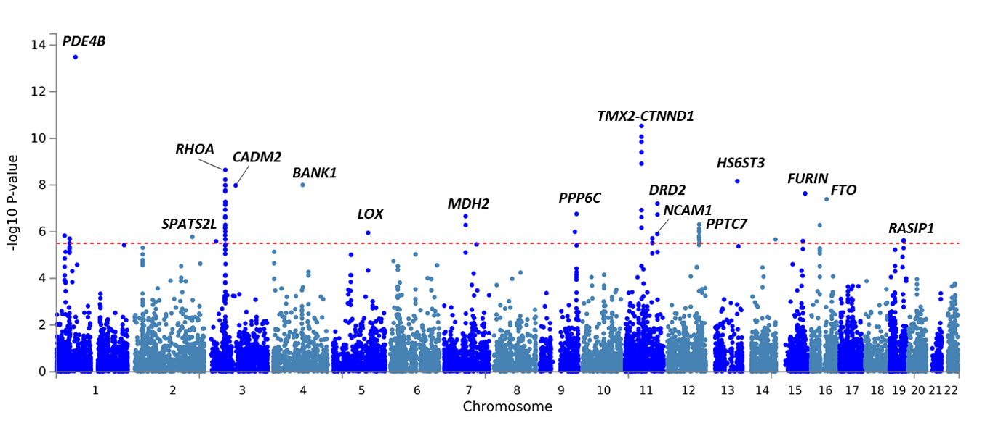

Supplemental Figure 9. BioVU PheWAS results for EUR OUD GWAS (OUD-META; left panel) and OUD multi-trait analysis (OUD-MTAG; right panel).
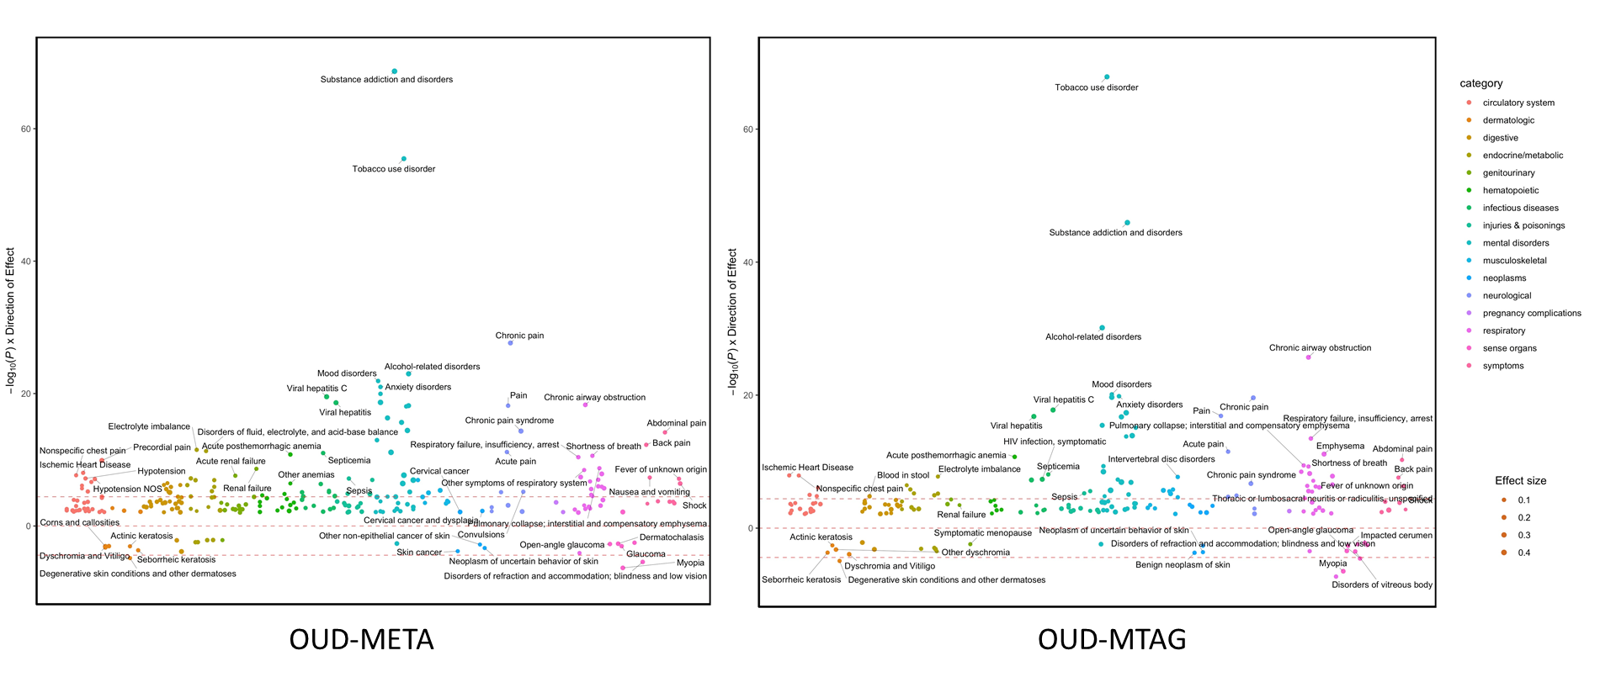
Note. Phenome-wide association study (PheWAS) results for 1291 clinical outcomes in BioVU. Y-axis represents the -log₁₀(p-value) multiplied by the direction of effect. Diameter of data point corresponds to magnitude of effect size (i.e., larger dot=larger effect size). Data points below and above lower and upper red dashed line, respectively, indicate significant PheWAS association exceeding Bonferroni correction (p=3.87x10⁻⁰⁵).

