Supplementary Material

Supplementary Figures
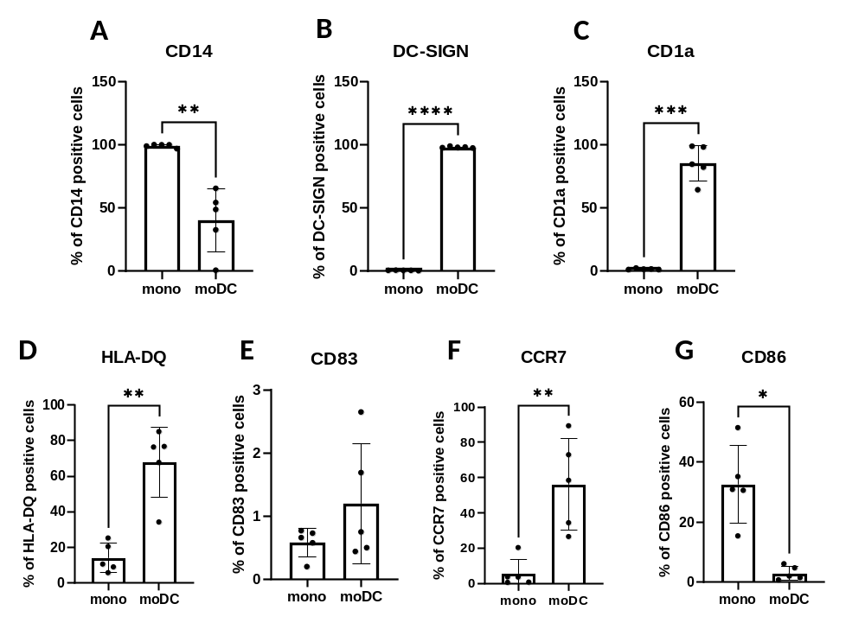
Supplementary Figure 1. Changes in differentiation and maturation markers between monocytes and moDCs. Monocytes were stained directly after magnetic separation (mono) or cultured in the presence of GM-CSF and IL-4 for five days to generate moDCs in the presence of 0.1 v/v% absolute ethanol. Percentage of cells positive for CD14 (A), DC-SIGN (B), CD1a (C), HLA-DQ (D), CD83 (E) CCR7 (F) and CD86 (G). N=5, mean±SD, *p < 0.05, **p < 0.01, ***p < 0.001, ****p < 0.0001 as indicated (determined by paired T-test). Individual donors are represented by symbols.
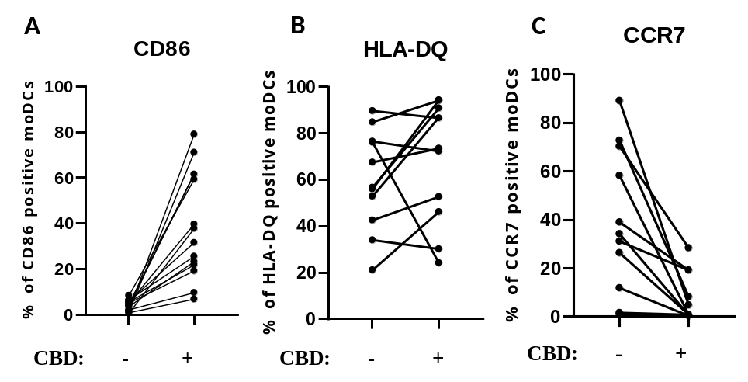
Supplementary Figure 2. Pairwise comparison of CD86, HLA-DQ and CCR7 expression between vehicle- and CBD-treated moDCs. Monocytes were cultured in the presence of GM-CSF and IL-4 for five days to generate moDCs in the presence of 10 µM CBD or vehicle (0.1 v/v% absolute ethanol). Percentage of cells positive for CD86 (A), HLA-DQ (B), and CCR7 (C). N=11-14 donors, mean±SD. Individual donors in each treatment group are represented by symbols. Connecting lines mark cells from the same donor. CBD: (-)-cannabidiol
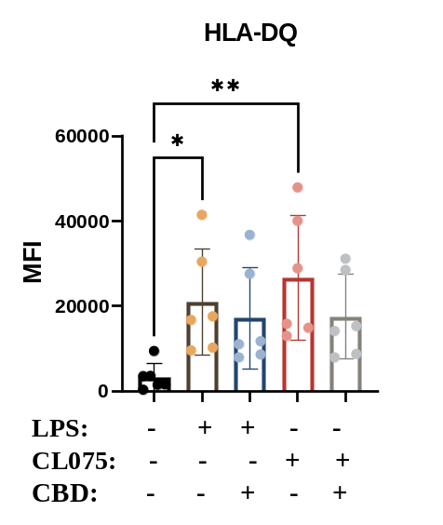
Supplementary Figure 3. CBD-treated moDCs show minimally lower HLA-DQ expression after TLR ligand challenge compared to vehicle-treated cells. Monocytes were cultured in the presence of GM-CSF and IL-4 for five days to generate moDCs in the presence 10 µM CBD or vehicle (0.1 v/v% absolute ethanol). Maturation was induced by lipopolysaccharide (LPS: 250 ng/ml) and TLR7/8 activation (CL075: 500 ng/ml, both for 24 hours on day 5). Mean fluorescence intensity (MFI) of HLA-DQ staining is shown. N=6 donors, mean±SD, *p < 0.05, **p < 0.01 by repeated measures one-way ANOVA, as indicated. Individual donors are represented by symbols. CBD: (-)-cannabidiol, CL075: TLR7/8 agonist, LPS: lipopolysaccharide.
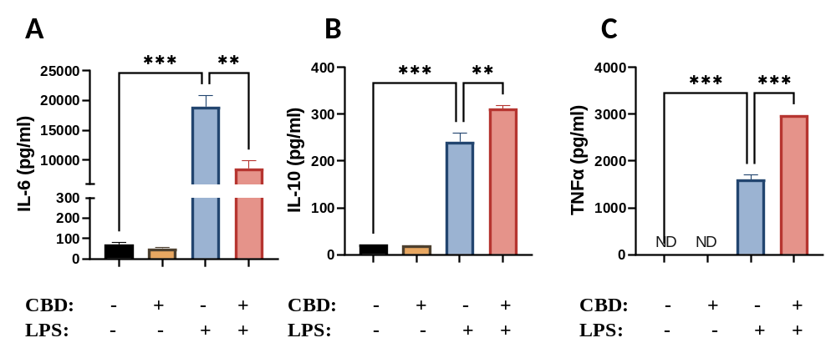
Supplementary Figure 4. Acute CBD treatment increases IL-10 and TNFα cytokine production induced by TLR4 and TLR7/8 activation on moDCs, while decreasing the production of IL-6. Monocytes were cultured in the presence of GM-CSF and IL-4 for five days to generate moDCs. CBD or vehicle (0.1 v/v% absolute ethanol) treatment was applied on day 5, 10 min prior to lipopolysaccharide (LPS) treatment. Maturation was induced by applying (LPS: 250 ng/ml) for 24 h, also on day 5. IL-6 (A), IL-10 (B), and TNFα (C) production was determined with ELISA from supernatants. Bar plots represent mean ± SD of representative results from N=3 independent experiments, ** p < 0.01, ***p < 0.001, **** p<0.0001 compared to the marked groups as determined by repeated measures one-way ANOVA. ND, not determined. CBD: (-)-cannabidiol, LPS: lipopolysaccharide.
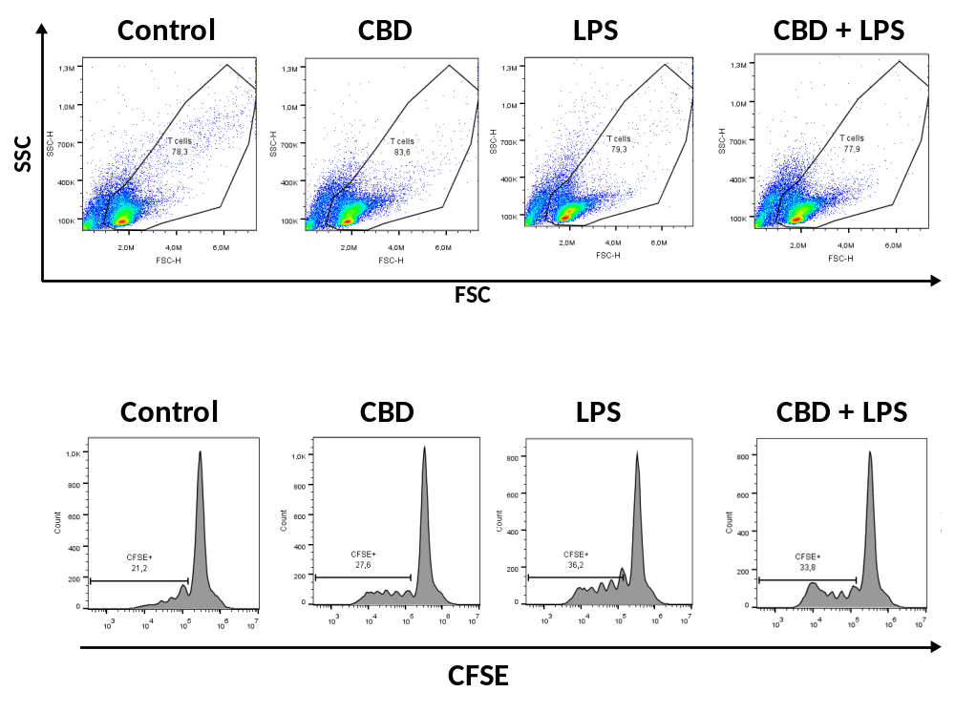
Supplementary Figure 5. Representative flow cytometry dot plots and histograms showing forward and side scatter (FSC, SSC) as well as CFSE fluorescence intensity in moDC-T cell cocultures. Monocytes were cultured in the presence of GM-CSF and IL-4 for five days to generate immature moDCs in the presence of 10 µM concentration of CBD or vehicle (0.1 v/v% absolute ethanol). Maturation was induced by applying lipopolysaccharide (LPS: 250 ng/ml) treatment for 24 h on day 5. Percentage of proliferating T cells after 5 days of coculture of naïve T cells and moDCs at a ratio of 10:1 is shown by CFSE+ marker on histograms. CBD: (-)-cannabidiol, LPS: lipopolysaccharide.
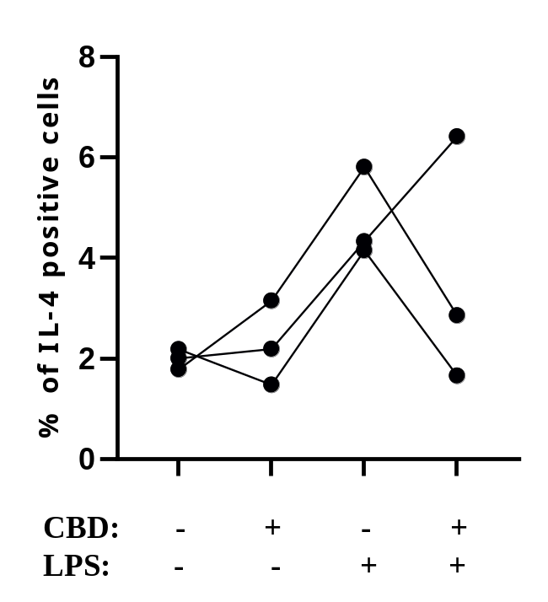
Supplementary Figure 6. CBD treated, LPS stimulated moDCs were less effective at inducing Th2 polarization of T cells. Monocytes were cultured in the presence of GM-CSF and IL-4 for five days to generate immature moDCs in the presence of 10 µM concentration of CBD or vehicle (0.1 v/v% absolute ethanol). Maturation was induced by applying lipopolysaccharide (LPS: 250 ng/ml) treatment for 24 h on day 5. Percentage of IL-4⁺ T cells after 5 days of coculture of naïve T cells and moDCs at a ratio of 10:1. N=3, individual donors are represented by symbols. Connecting lines mark cells from the same donor. CBD: (-)-cannabidiol, LPS: lipopolysaccharide
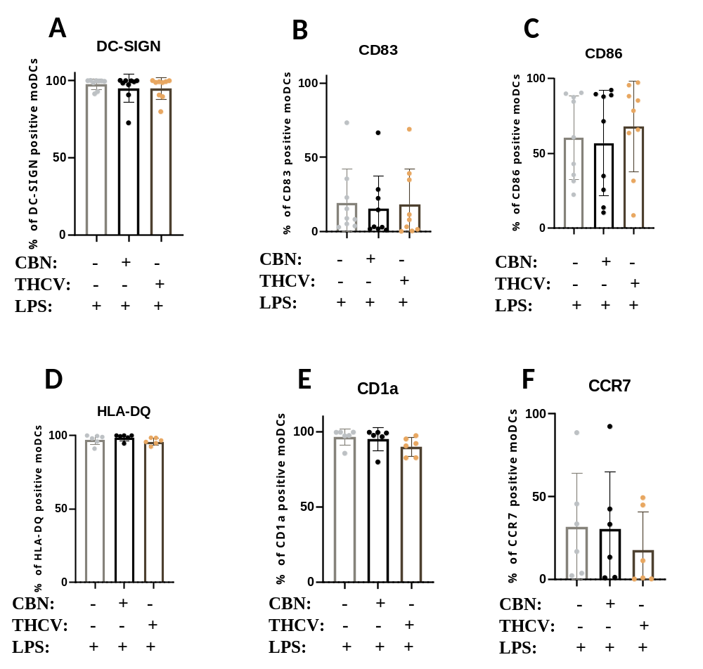
Supplementary Figure 7. Non-psychotropic pCBs do not influence LPS and CL075-induced maturation of moDCs. Monocytes were cultured in the presence of GM-CSF and IL-4 for five days to generate moDCs in the presence 10 µM CBN, THCV or vehicle (0.1 v/v% absolute ethanol). Maturation was induced by lipopolysaccharide (LPS: 250 ng/ml) and TLR7/8 activation (CL075: 500 ng/ml for 24 hours on day 5). Percentage of cells positive for DC-SIGN (A), CD83 (B), CD86 (C), HLA-DQ (D), CD1a (E), and CCR7 (F) are shown. N=6-9 donors, mean±SD. Individual donors are represented by symbols. CBN: (-)-cannabinol, THCV: (-)-Δ⁹-tetrahydrocannabivarin, CL075: TLR7/8 agonist, LPS: lipopolysaccharide.

