Study period
Event rate (%)

Vaccine uptake (%)
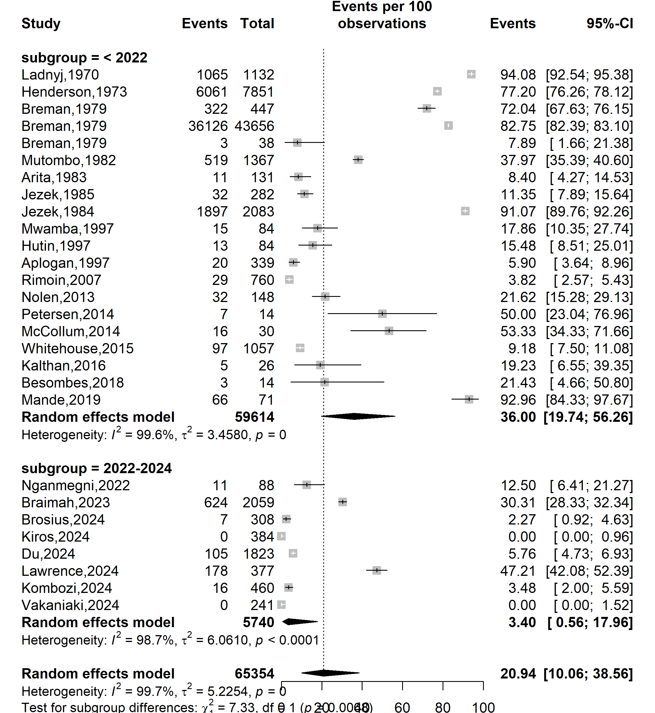
Supplementary Fig. 1 Pooled Mpox vaccine uptake rate by study periods in Africa, 1970-2024

Country
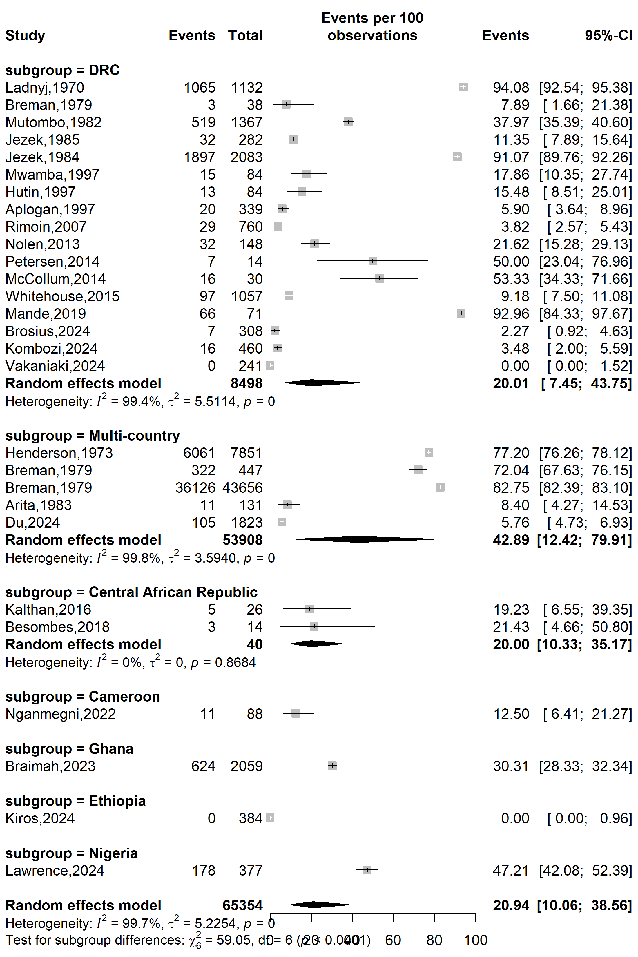
Vaccine uptake (%)
Event rate (%)

Supplementary Fig. 2 Pooled Mpox vaccine uptake rate by countries in Africa, 1970-2024
Abbreviation: DRC: Democratic Republic of Congo
Type of participants
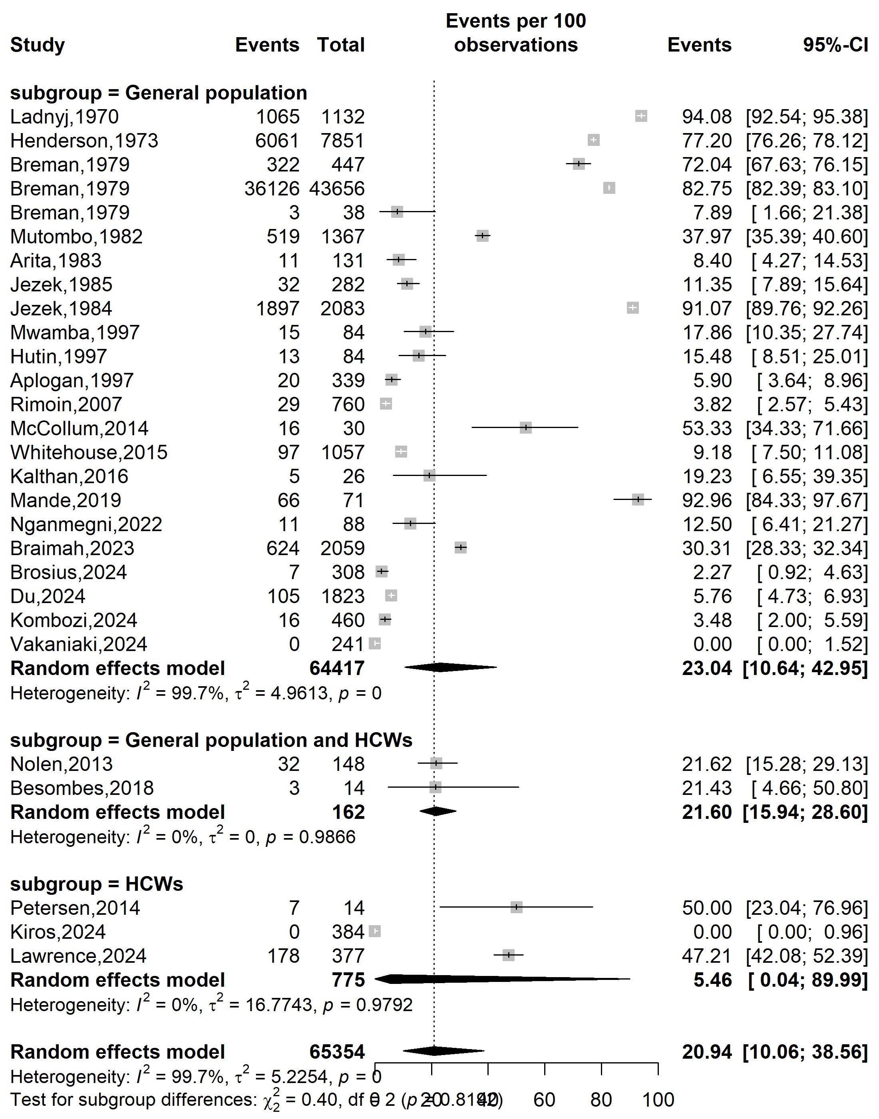
Vaccine uptake (%)
Event rate (%)

Supplementary Fig. 3 Pooled Mpox vaccine acceptance rate in Africa by types of participants, 2013-2024
Abbreviation: HCW: Healthcare worker

WHO Afro zone
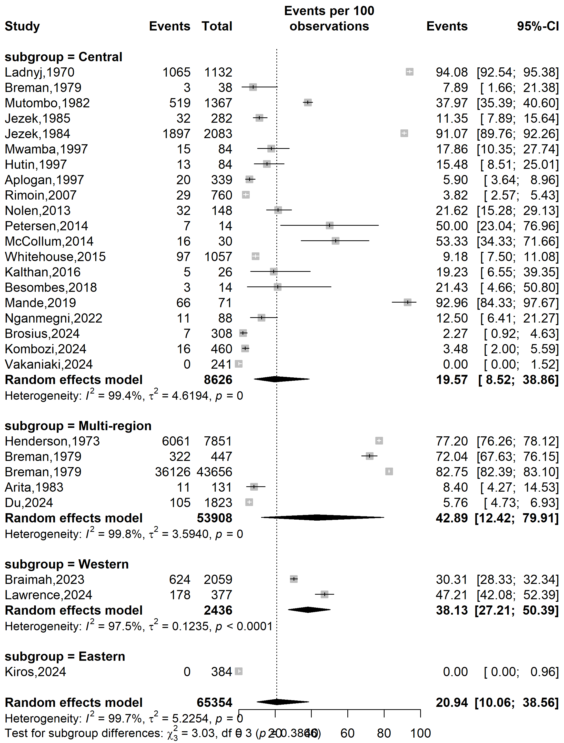
Event rate (%)

Vaccine uptake (%)
Supplementary Fig. 4 Pooled Mpox vaccine uptake rate in Africa by WHO’s country categorization, 1970-2024
Setting
Event rate (%)

Vaccine uptake (%)
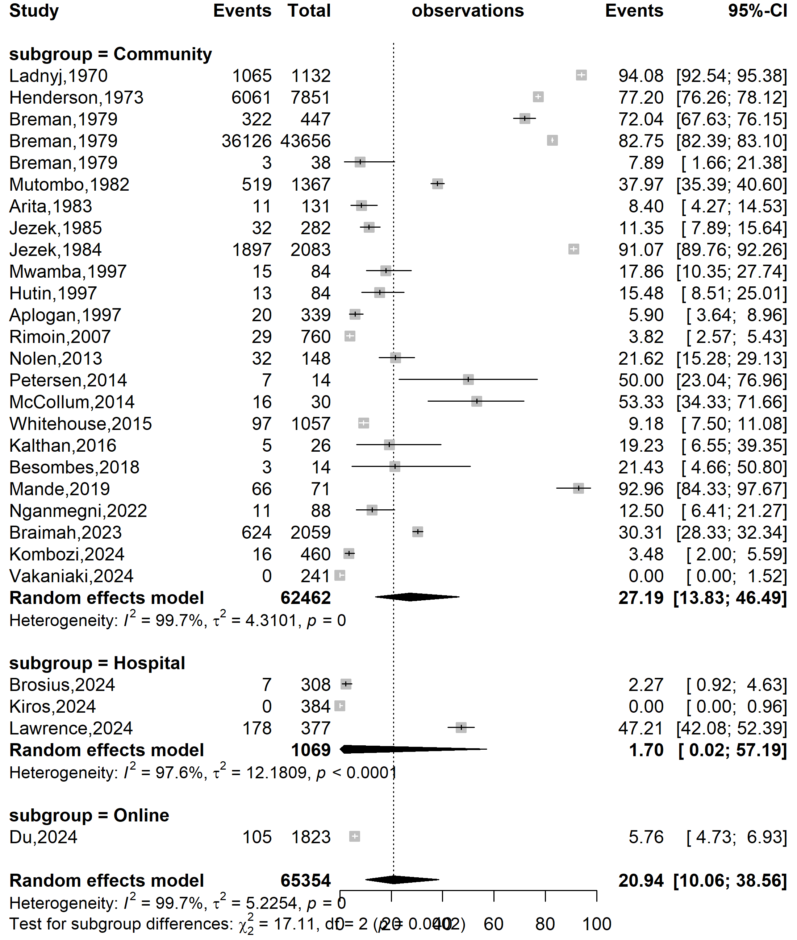
Supplementary Fig. 5 Pooled Mpox vaccine uptake rate in Africa by study setting, 1970-2024
Type sampling
Vaccine uptake (%)
Event rate (%)

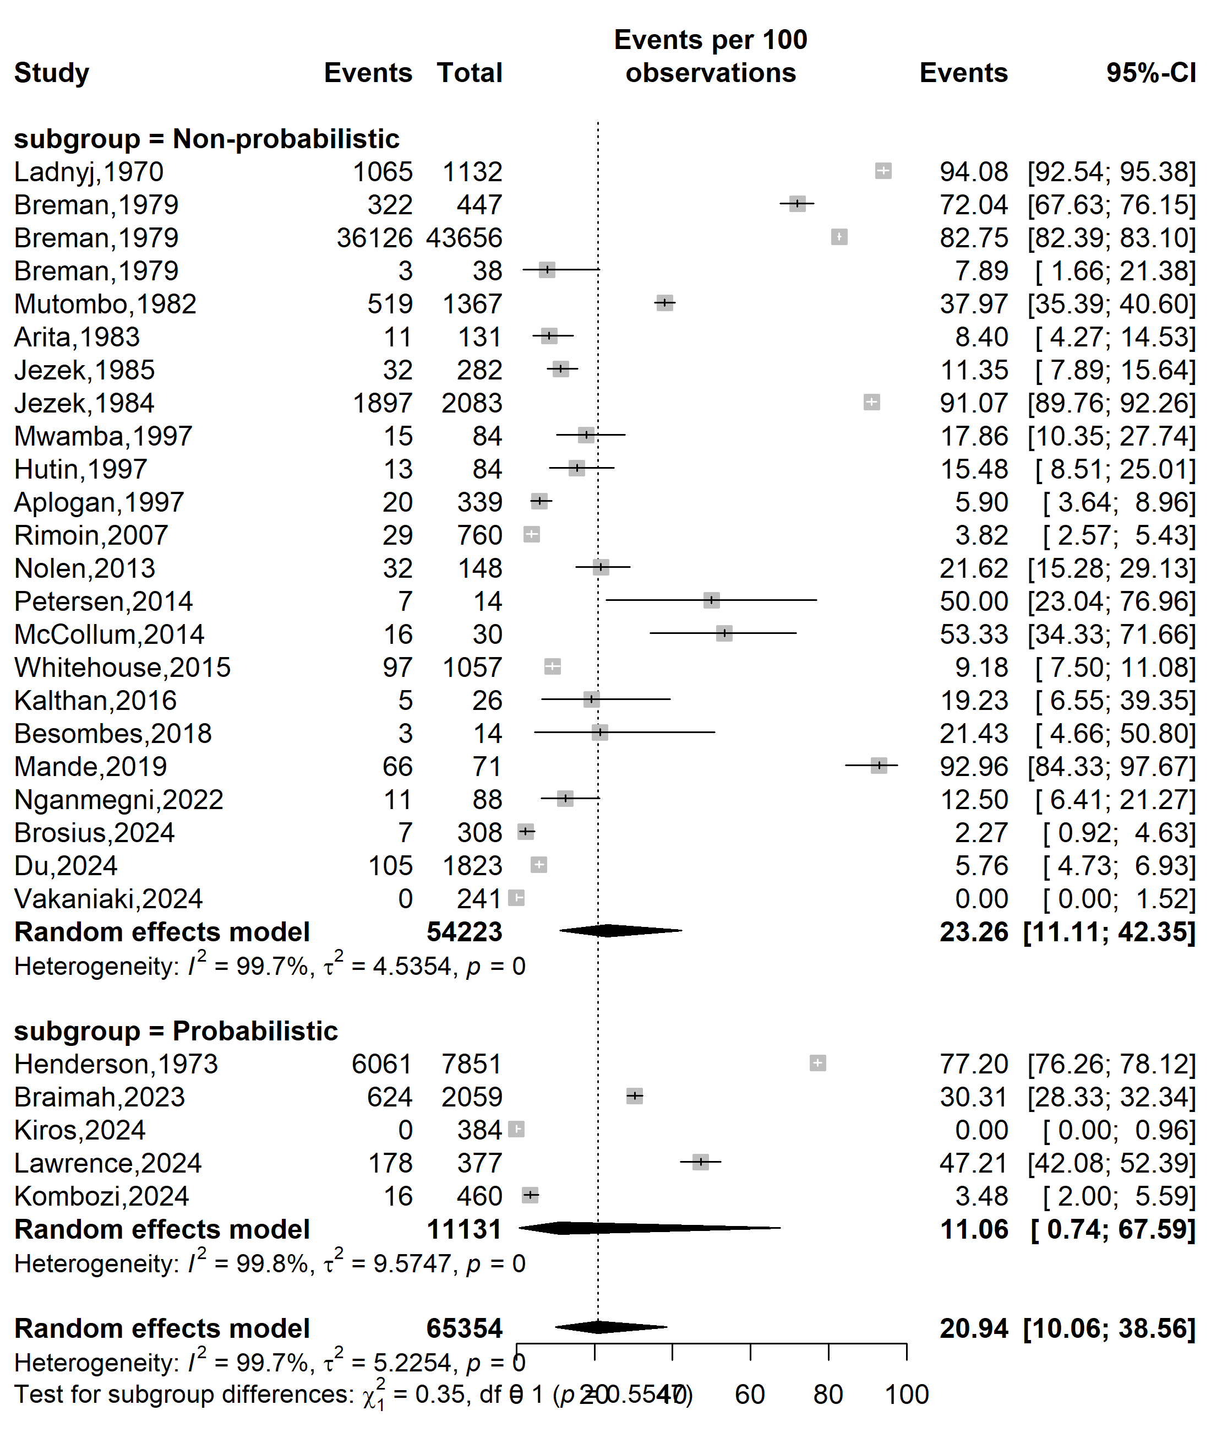
Supplementary Fig. 6 Pooled Mpox vaccine uptake rate in Africa by sampling method, 1970-2024

Sample size
Vaccine uptake (%)
Event rate (%)

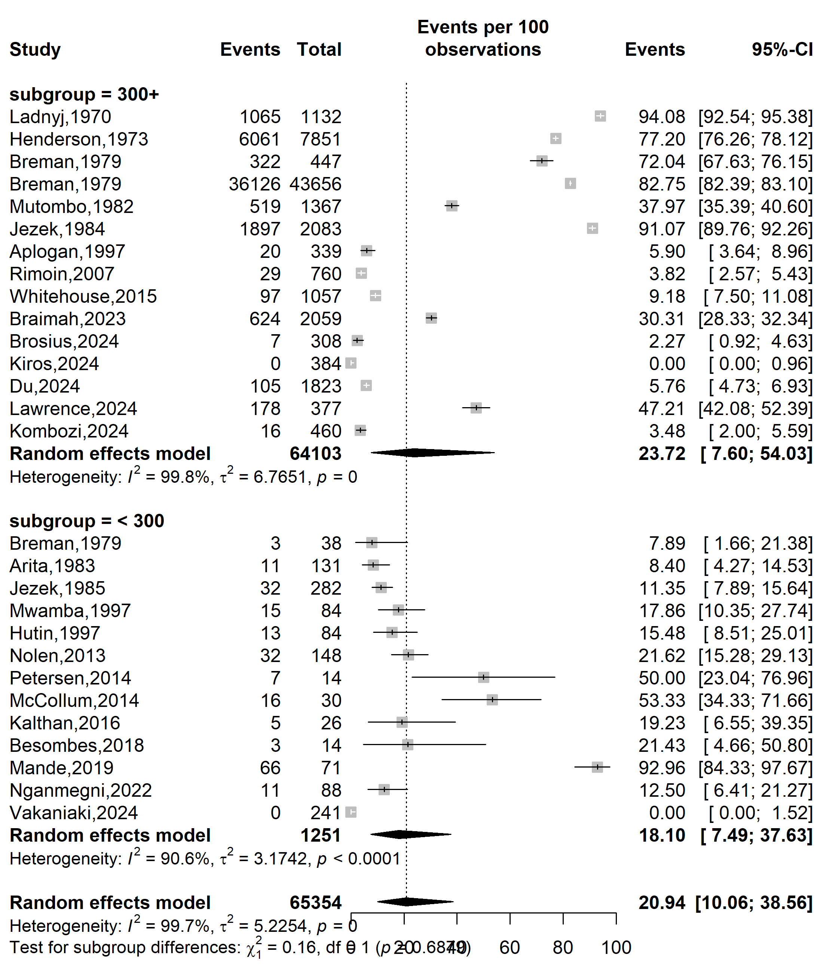
Supplementary Fig. 7 Pooled Mpox vaccine uptake rate in Africa by sample size, 1970-2024

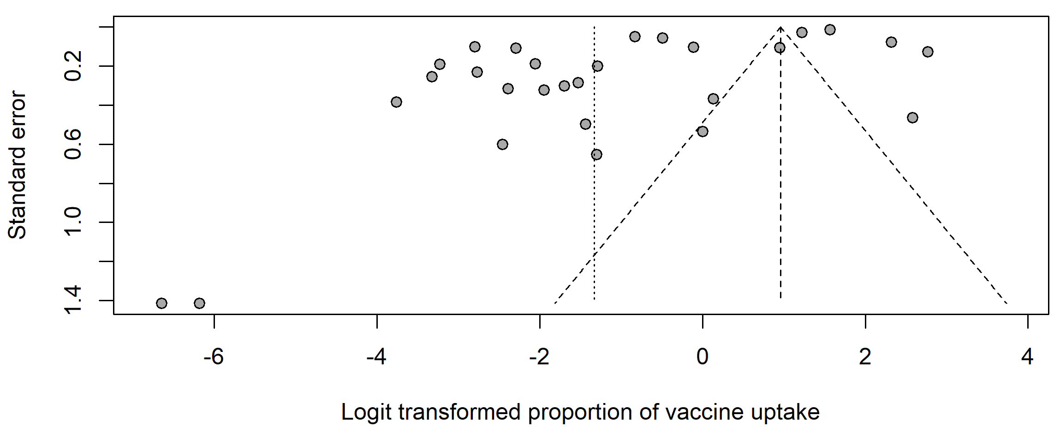
Egger’s test p-value < 0.001
Begg’s test p-value = 0.143

Supplementary Fig. 8 Funnel plot displaying the pseudo 95% confidence limits and tests assessing the publication bias of studies included, 1970-2024

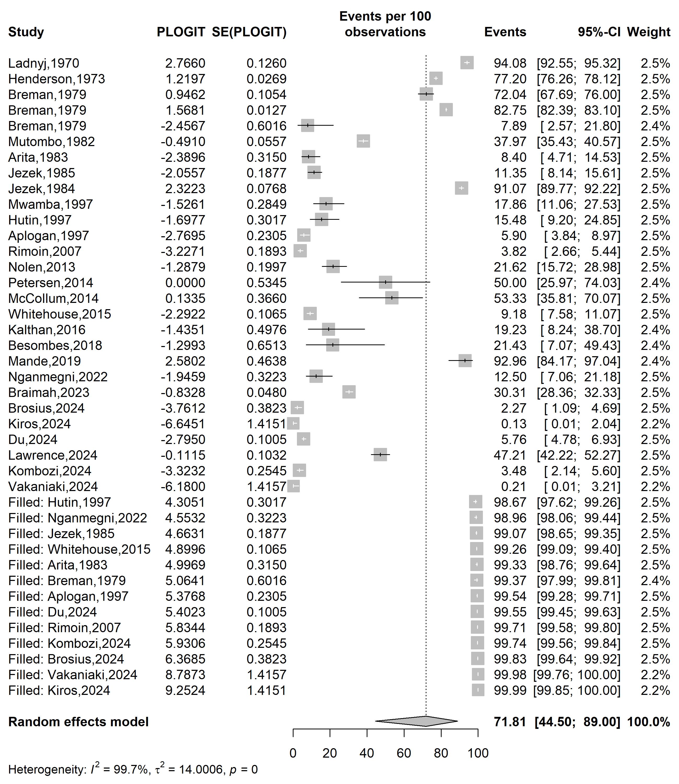
Event rate (%)

Vaccine uptake (%)
Supplementary Fig. 9 Trim and fill plot of the vaccine uptake rate in Africa, 1970-2024
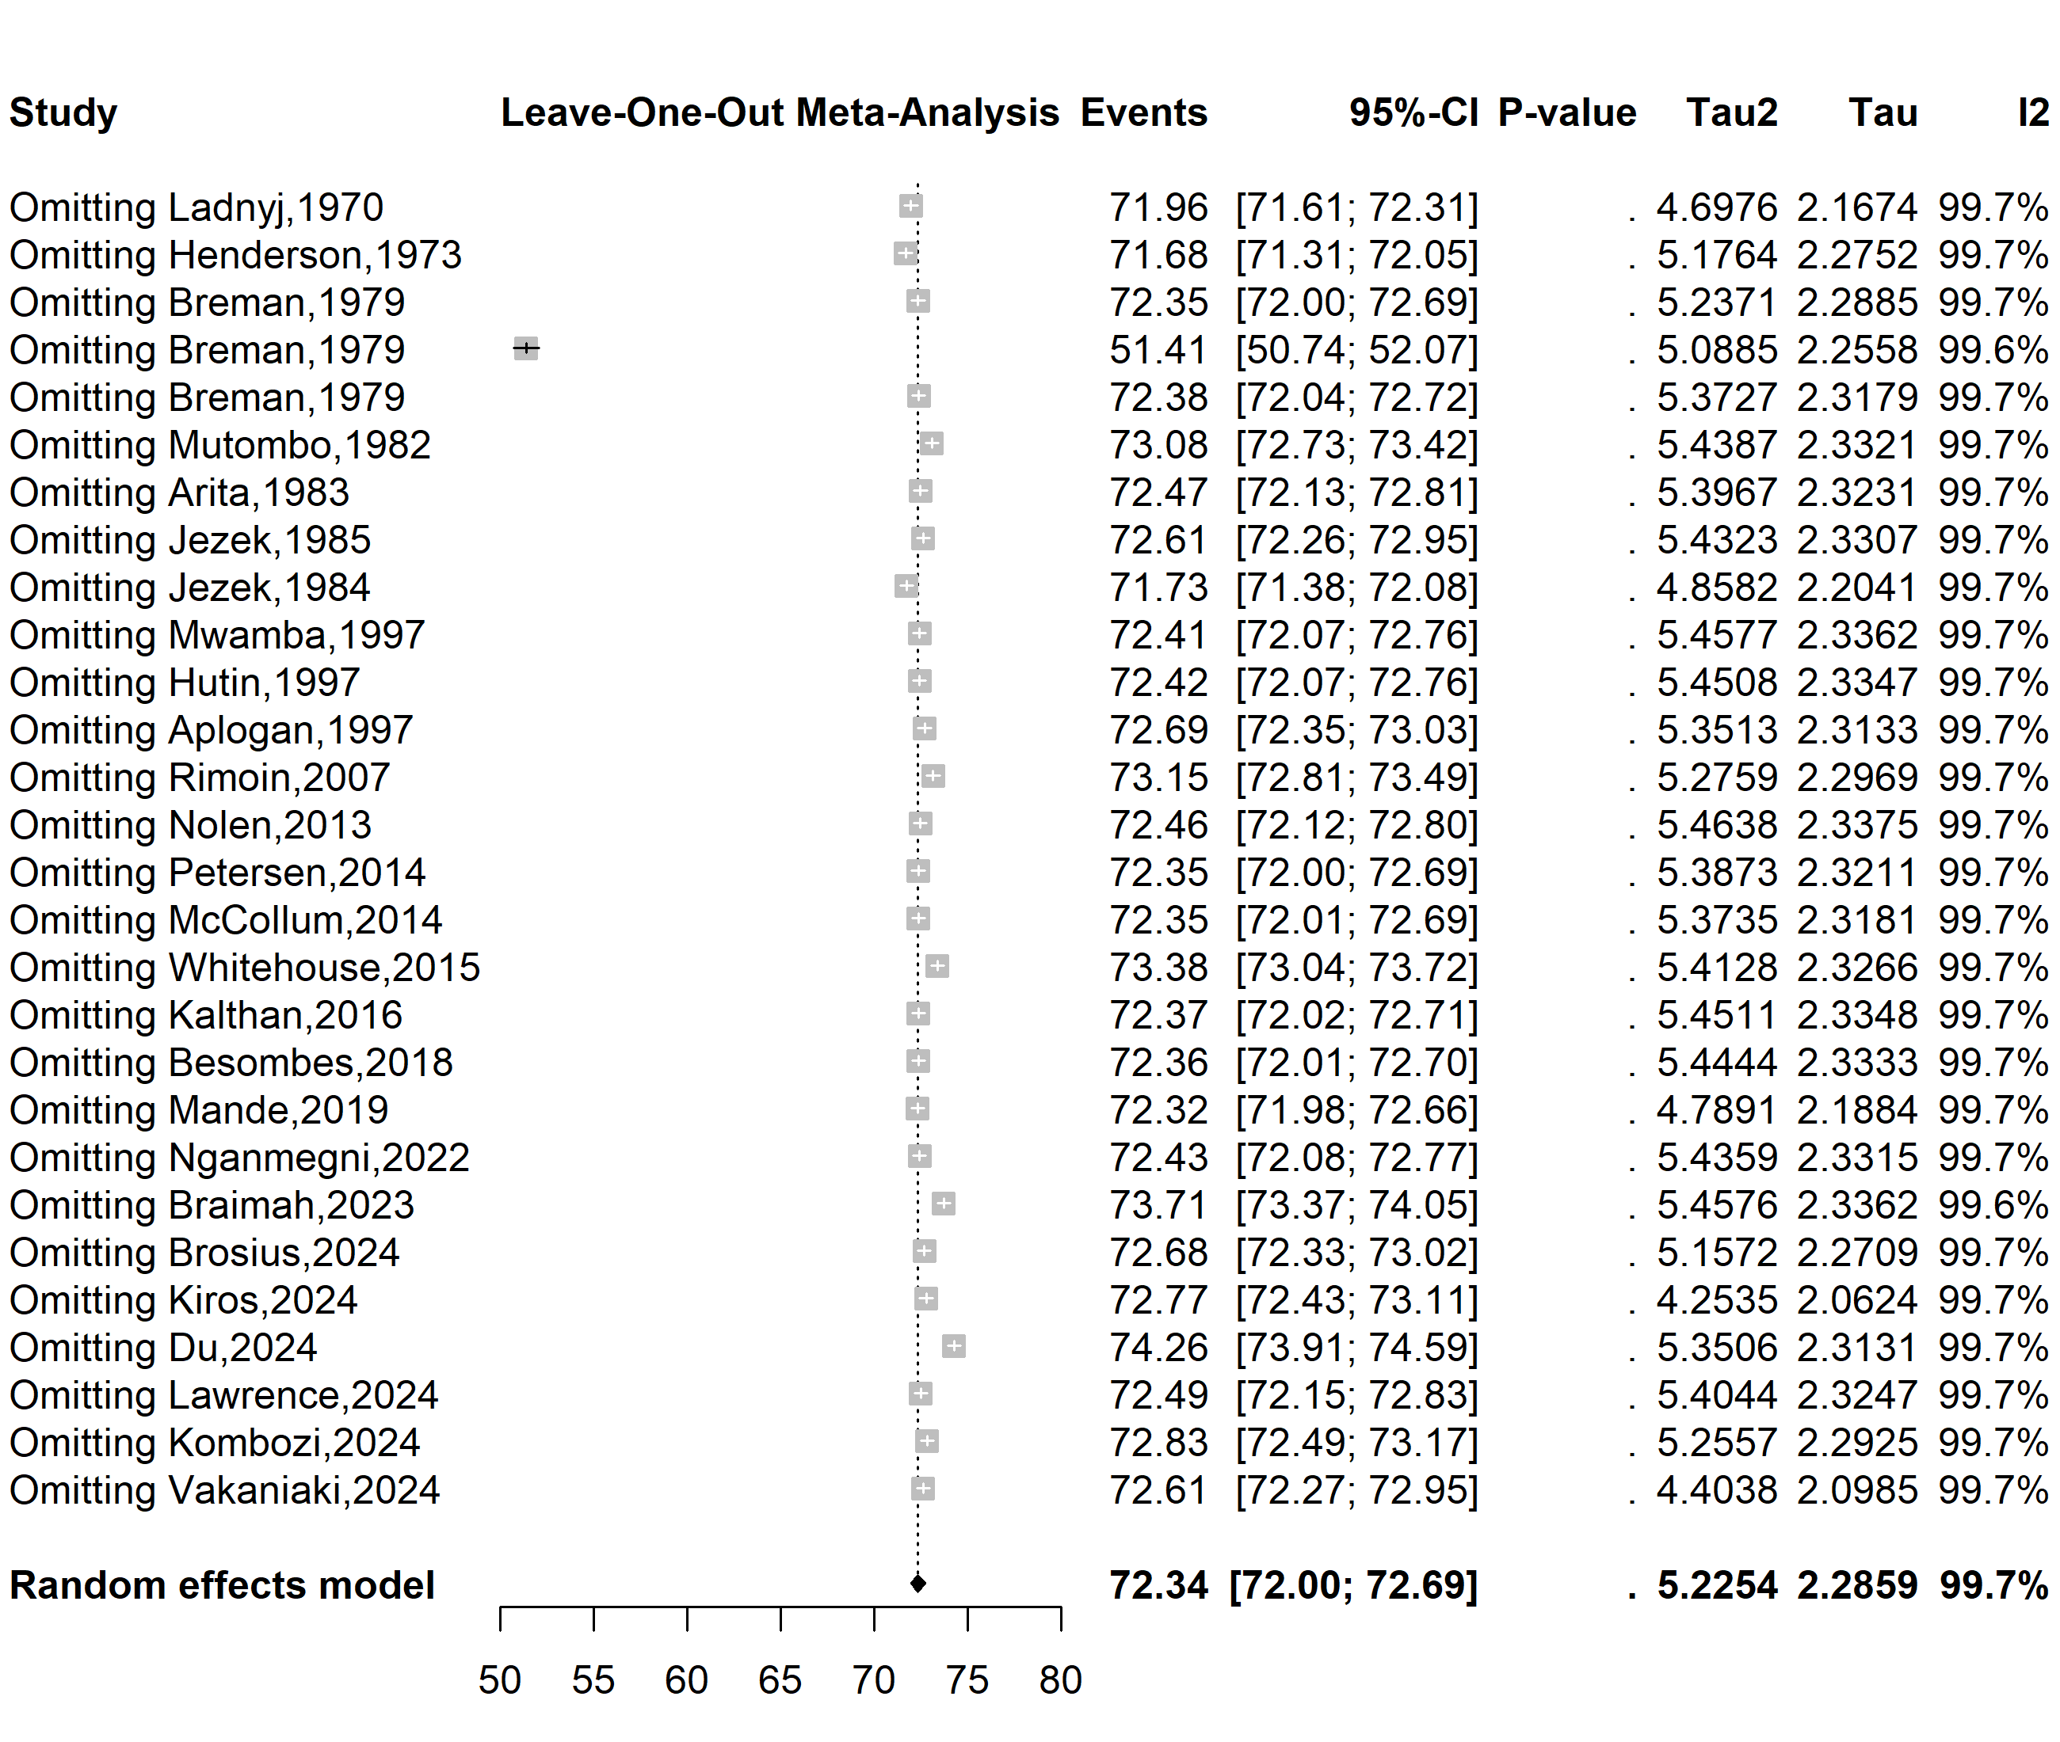
Supplementary Fig. 10 Sensitivity analysis of the Mpox vaccine uptake in Africa, 2013-2024

