Supplementary materials 2 – Forest plots
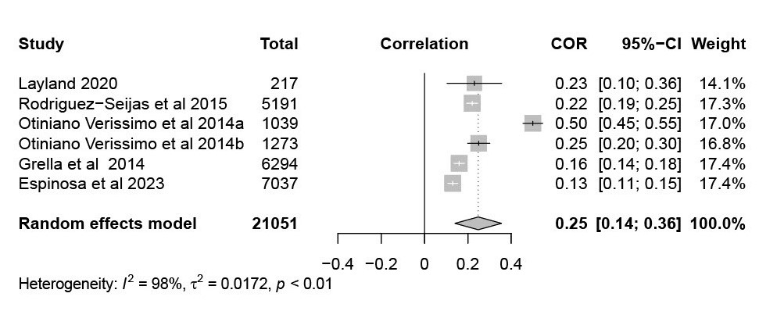
Substance use disorder forest plot
*Containing Pearson, Biserial and Tetrachoric correlations. I.e. outcome is measured continuously or is measured as a false dichotomy.

Substance use problems forest plot
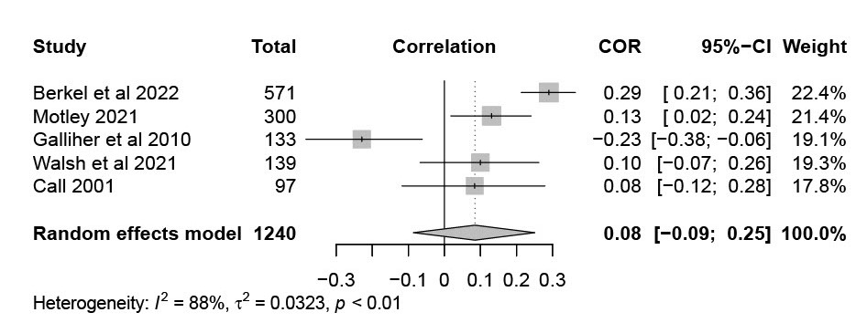

*Containing Pearson, Biserial and Tetrachoric correlations. I.e. outcome is measured continuously or is measured as a false dichotomy.

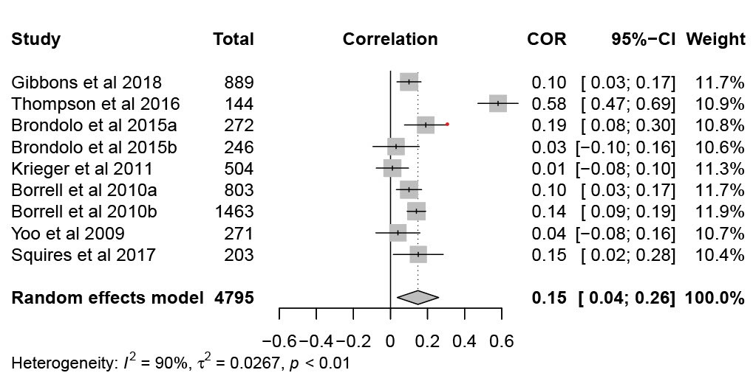
Smoking status forest plot

*Containing point-biserial correlations, i.e. outcomes represent true dichotomy
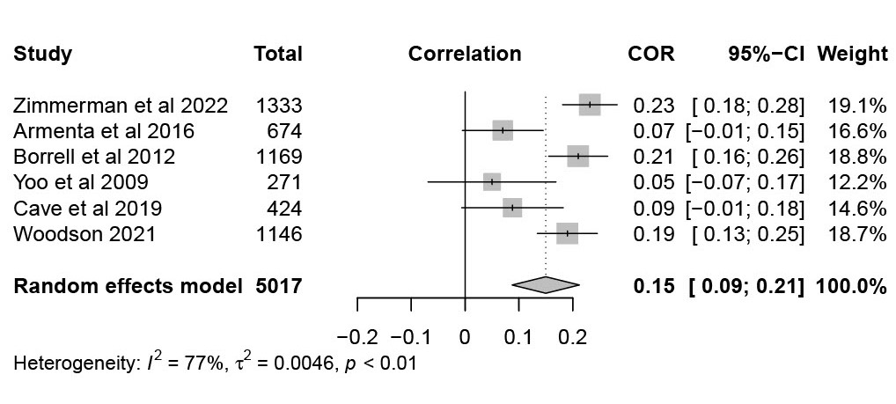
Presence – absence of alcohol use forest plot
*Containing point-biserial correlations, i.e. outcomes represent true dichotomy

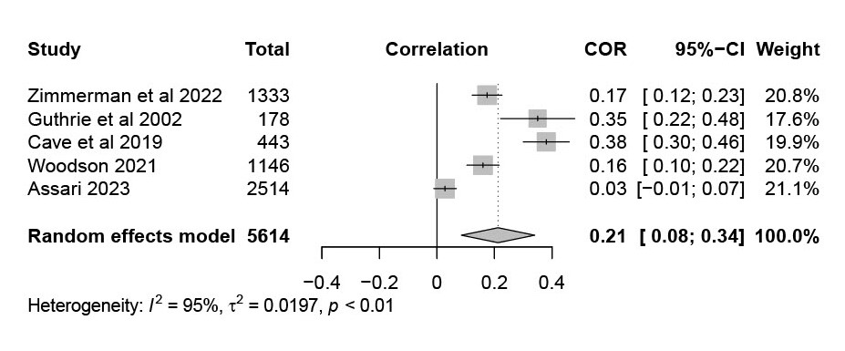
Presence – absence of tobacco use forest plot
*Containing point-biserial correlations, i.e. outcomes represent true dichotomy

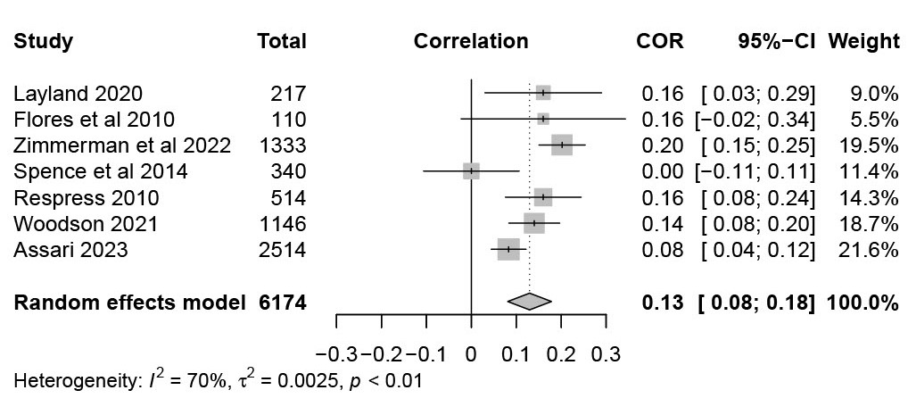
Presence – absence of cannabis use forest plot
*Containing point-biserial correlations, i.e. outcomes represent true dichotomy
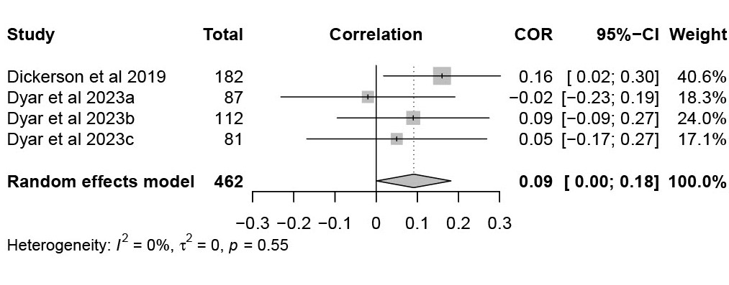
Cannabis use problems/consequences forest plot
*Containing Pearson, Biserial and Tetrachoric correlations. I.e. outcome is measured continuously or is measured as a false dichotomy.

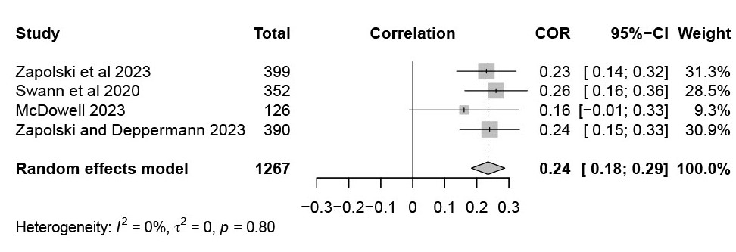
At-risk/hazardous cannabis use forest plot
*Containing Pearson, Biserial and Tetrachoric correlations. I.e. outcome is measured continuously or is measured as a false dichotomy.
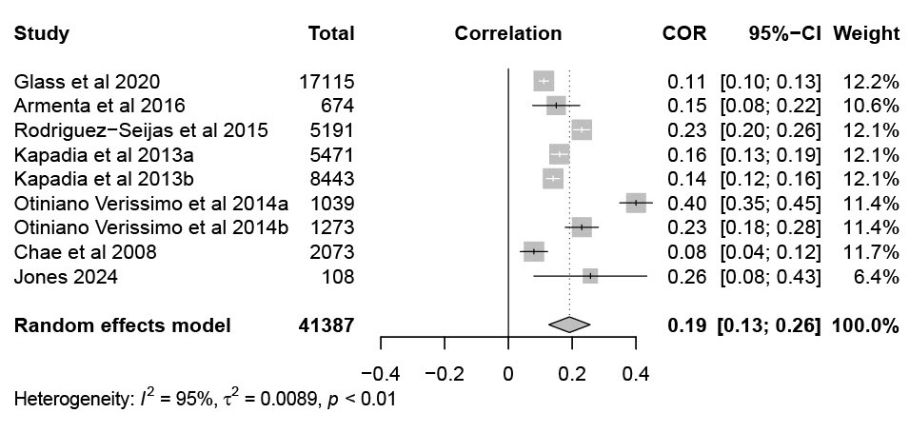
Alcohol use disorder forest plot
*Containing Pearson, Biserial and Tetrachoric correlations. I.e. outcome is measured continuously or is measured as a false dichotomy.

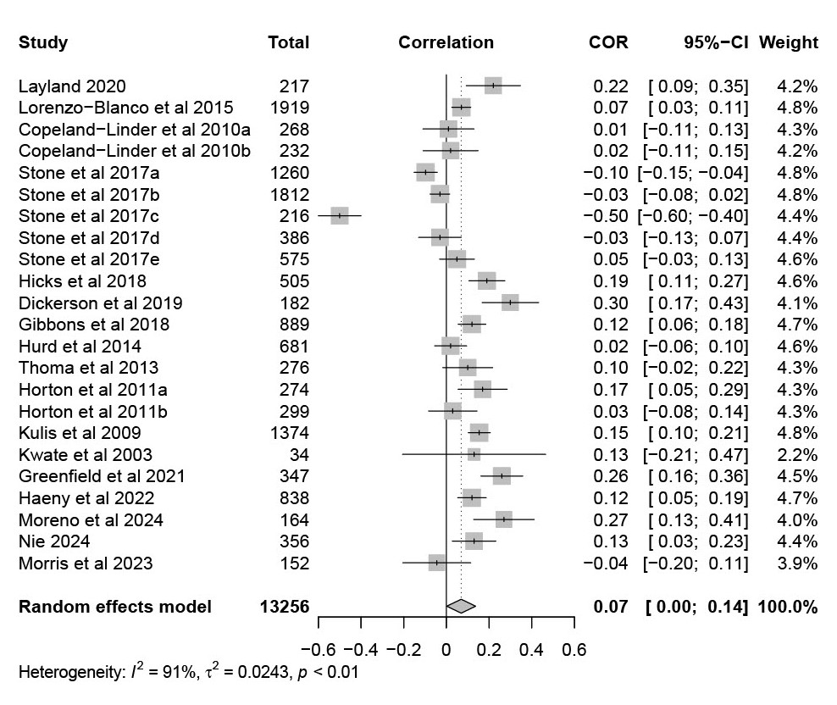
Tobacco use forest plot

*Containing Pearson, Biserial and Tetrachoric correlations. I.e. outcome is measured continuously or is measured as a false dichotomy.

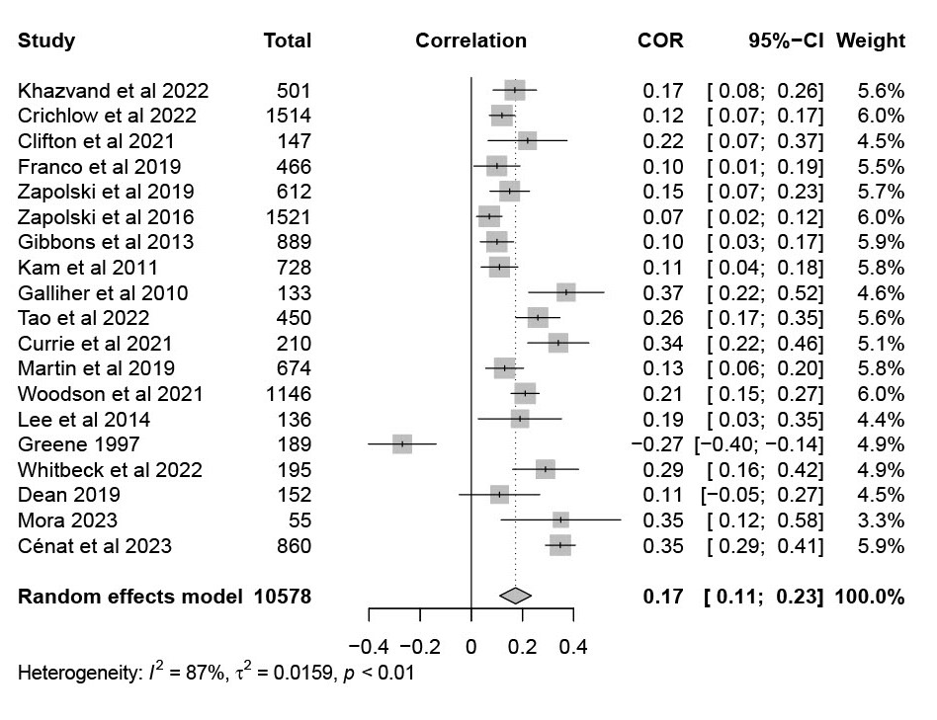
Composite substance use forest plot
*Containing Pearson, Biserial and Tetrachoric correlations. I.e. outcome is measured continuously or is measured as a false dichotomy.

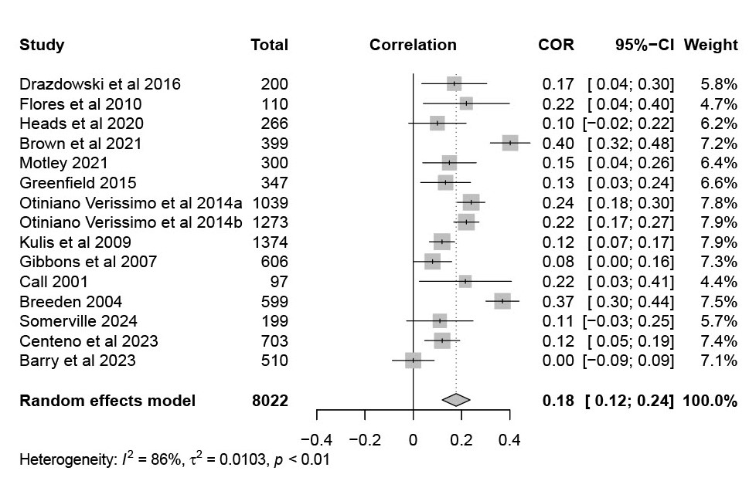
Illicit substance use forest plot

*Containing Pearson, Biserial and Tetrachoric correlations. I.e. outcome is measured continuously or is measured as a false dichotomy.

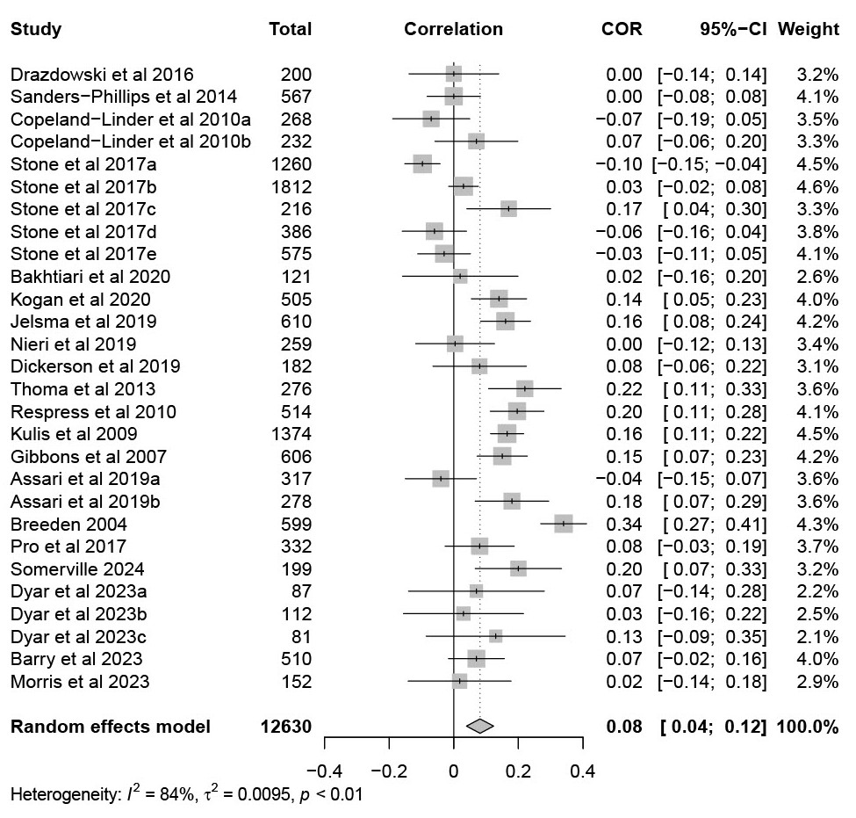
Cannabis use forest plot
*Containing Pearson, Biserial and Tetrachoric correlations. I.e. outcome is measured continuously or is measured as a false dichotomy.

Binge drinking forest plot
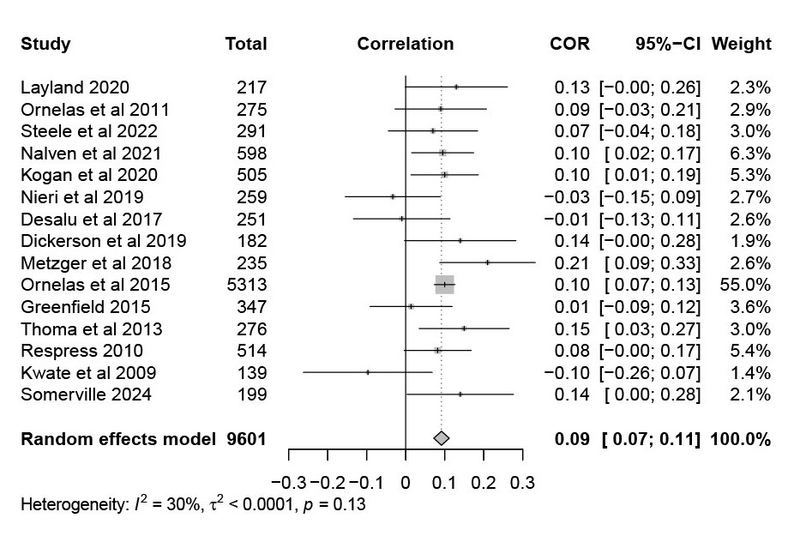
*Containing Pearson, Biserial and Tetrachoric correlations. I.e. outcome is measured continuously or is measured as a false dichotomy.

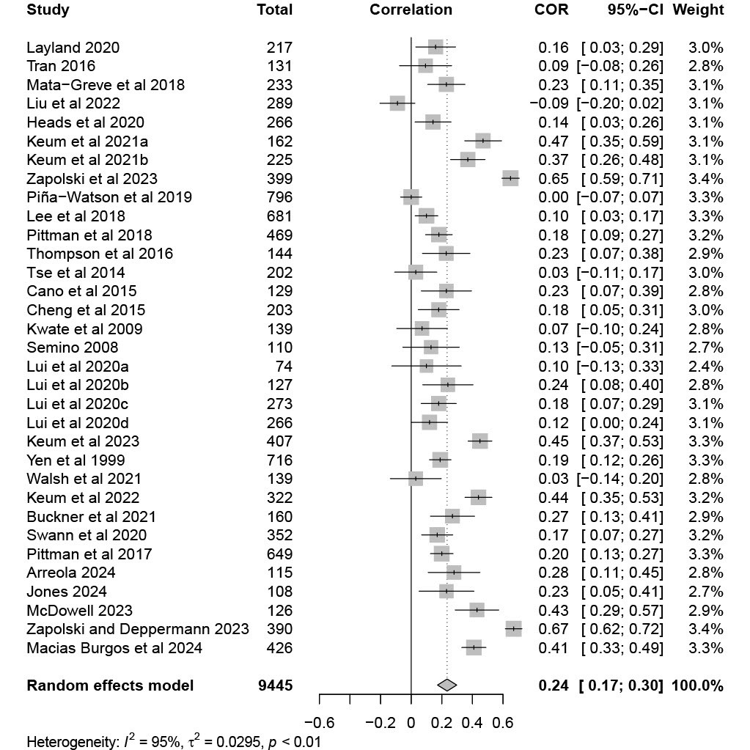
At-risk/hazardous alcohol use forest plot

*Containing Pearson, Biserial and Tetrachoric correlations. I.e. outcome is measured continuously or is measured as a false dichotomy.

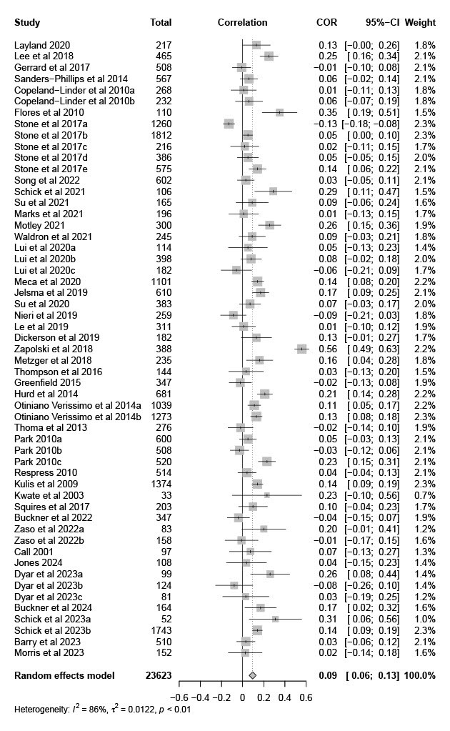
Alcohol use forest plot

*Containing Pearson, Biserial and Tetrachoric correlations. I.e. outcome is measured continuously or is measured as a false dichotomy.

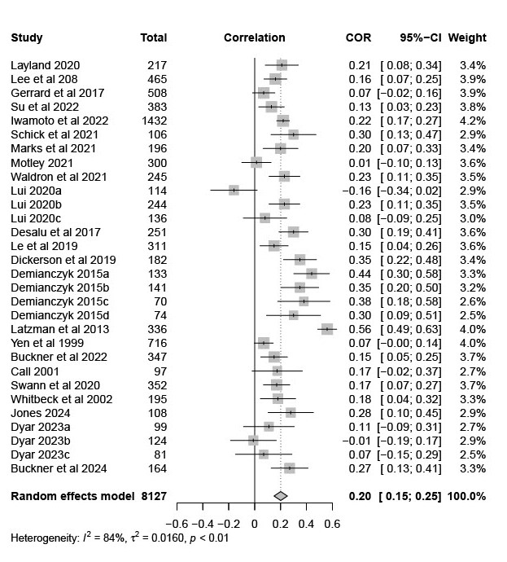
Alcohol problems/consequences forest plot

*Containing Pearson, Biserial and Tetrachoric correlations. I.e. outcome is measured continuously or is measured as a false dichotomy.

