Supplement
S1 Table. Odds of dengue infection for selected characteristics, SEDSS, May 2012–June 2024 (N = 49679).
S2 Table. Machine learning models and hyperparameter tuning.
S3 Table. Additional pathogens in study population, SEDSS, May 2012–June 2024 (N = 49679).
S4 Table. Performance of each algorithm for predicting dengue infection on the training set, SEDSS, May 2012–June 2024.
S5 Table. Performance of eXtreme Gradient Boosting Model for predicting dengue infection on the test set 1) with IgG testing and 2) without leukopenia and thrombocytopenia, SEDSS, May 2012–June 2024.
S6 Table. Adjusted odds of dengue infection for characteristics identified by stepwise selection from the 48-variable feature set, SEDSS, May 2012–June 2024.
S1 Fig. Feature importance for 8-variable feature set for each machine learning model, SEDSS, May 2012–June 2024.
S2 Fig. Feature importance for 20-variable feature set for each machine learning model, SEDSS, May 2012–June 2024.
S3 Fig. Feature importance for 32-variable feature set for each machine learning model, SEDSS, May 2012–June 2024.
S4 Fig. Feature importance for 48-variable feature set for each machine learning model, SEDSS, May 2012–June 2024.
S5 Fig. Incremental improvement in AUC by sequentially adding features identified from XGBoost models, SEDSS, May 2012–June 2024.
S1 Table. Crude odds of dengue infection compared to non-dengue cases for selected characteristics, SEDSS, May 2012–June 2024 (N = 49679).
 | OR (95% CI) | p-value
Month (ref: January) |  | <0.001
February | 0.74 (0.57, 0.96)
March | 0.50 (0.37, 0.66)
April | 0.54 (0.41, 0.72)
May | 0.69 (0.53, 0.89)
June | 1.00 (0.79, 1.27)
July | 0.93 (0.73, 1.18)
August | 1.06 (0.85, 1.34)
September | 1.04 (0.83, 1.32)
October | 1.02 (0.81, 1.29)
November | 1.34 (1.07, 1.68)
December | 1.10 (0.87, 1.40)
Days post onset (ref: 0) |  | <0.001
1-3 | 1.70 (1.41, 2.07)
4-6 | 7.19 (5.95, 8.76)
7+ | 2.61 (1.92, 3.51)
Age group (ref: <1) |  | <0.001
1-4 | 1.13 (0.77, 1.72)
5-9 | 4.03 (2.81, 5.98)
10-19 | 10.90 (7.72, 15.99)
20-29 | 4.10 (2.85, 6.11)
30-39 | 3.05 (2.07, 4.64)
40-49 | 3.03 (2.03, 4.64)
50+ | 2.61 (1.81, 3.89)
Male sex (ref: female) | 1.30 (1.18, 1.44) | <0.001
Health region (ref: Ponce) |  | <0.001
Aguadilla | 1.56 (0.25, 5.07)
Arecibo | 0.68 (0.21, 1.60)
Bayamon | 0.84 (0.55, 1.22)
Caguas | 1.64 (1.09, 2.36)
Fajardo | 1.53 (0.89, 2.44)
Mayaguez | 1.75 (0.69, 3.66)
Metro | 1.87 (1.65, 2.11)
Unknown | 0.23 (0.01, 1.04)
Traveled to another country in past two weeks (ref: no) | 1.54 (1.21, 1.95) | <0.001
Household member with dengue (ref: no) | 8.64 (7.06, 10.50) | <0.001
Reported mosquito bites in past month | 3.11 (2.80, 3.44) | <0.001
Comorbidities
Chronic pulmonary disease or asthma | 1.04 (0.92, 1.18) | 0.525
Cancer | 0.86 (0.57, 1.25) | 0.450
Chronic kidney disease | 0.59 (0.31, 0.99) | 0.048
Congenital heart disease | 0.86 (0.64, 1.12) | 0.266
Diabetes | 0.76 (0.62, 0.93) | 0.006
High cholesterol | 0.78 (0.62, 0.98) | 0.029
Hypertension | 0.63 (0.53, 0.74) | <0.001
Arthritis | 0.32 (0.21, 0.48) | <0.001
Thyroid disease | 0.68 (0.53, 0.86) | 0.001
Obesity | 0.60 (0.51, 0.69) | <0.001
Gastritis | 1.58 (1.04, 2.28) | 0.032
Warning signs
Persistent vomiting | 1.44 (1.29, 1.62) | <0.001
Abdominal pain | 2.78 (2.52, 3.07) | <0.001
Restlessness | 1.50 (1.36, 1.66) | <0.001
Clinical fluid accumulation | 0.89 (0.71, 1.10) | 0.278
Mucosal bleeding | 2.02 (1.75, 2.31) | <0.001
Hepatomegaly | 17.63 (12.03, 25.54) | <0.001
Other clinical signs
Fever | 19.10 (10.56, 39.83) | <0.001
Conjunctivitis | 2.51 (2.08, 3.01) | <0.001
Chills | 3.53 (3.13, 3.99) | <0.001
Nausea | 2.60 (2.34, 2.89) | <0.001
No appetite | 2.42 (2.15, 2.72) | <0.001
Rash | 6.14 (5.55, 6.79) | <0.001
Yellow skin | 2.82 (2.17, 3.61) | <0.001
Itchy skin | 4.10 (3.69, 4.54) | <0.001
Headache | 3.72 (3.26, 4.27) | <0.001
Eye pain | 4.00 (3.62, 4.43) | <0.001
Myalgia | 3.24 (2.89, 3.62) | <0.001
Arthralgia | 2.53 (2.29, 2.80) | <0.001
Tachypnea | 3.50 (3.16, 3.86) | <0.001
Back pain | 2.12 (1.92, 2.34) | <0.001
Calf pain | 1.75 (1.58, 1.94) | <0.001
Arthritis | 1.95 (1.69, 2.24) | <0.001
Nasal discharge | 0.29 (0.26, 0.32) | <0.001
Sore throat | 0.68 (0.61, 0.75) | <0.001
Cough | 0.34 (0.30, 0.37) | <0.001
Diarrhea | 2.03 (1.84, 2.25) | <0.001
Hypotension | 3.46 (2.86, 4.16) | <0.001
Narrow pulse pressure | 1.46 (1.04, 1.99) | 0.031
Seizure | 1.32 (0.88, 1.89) | 0.176
Capillary refill <3 | 1.02 (0.82, 1.24) | 0.878
Pale skin | 3.18 (2.88, 3.51) | <0.001
Blue lips | 3.18 (2.45, 4.06) | <0.001
Laboratory
Leukopenia | 23.37 (21.03, 25.98) | <0.001
Thrombocytopenia | 8.83 (7.97, 9.78) | <0.001
Monthly dengue incidence per 100,000 people (10-unit increase) | 2.23 (2.17, 2.30) | <0.001

S2 Table. Machine learning models and hyperparameter tuning. To optimize the performance of various machine learning models for predicting a dengue diagnosis, a grid search strategy was employed across several algorithms. The details of the grid search strategy and the specific hyperparameters evaluated for each model are outlined below. We also included the optimal values identified through this process that were included in the final models.
Model, R package | Parameter | Definition | Included in final model  8-variable set | Included in final model  20-variable set | Included in final model  32-variable set | Included in final model  48-variable set
XGBoost,  xgboost [40] | booster type | specifies type of model to use | decision tree | decision tree | decision tree | decision tree
XGBoost,  xgboost [40] | objective | defines the learning task and the corresponding loss function | binary:logistic | binary:logistic | binary:logistic | binary:logistic
XGBoost,  xgboost [40] | nrounds | number of boosting iterations | 1000 | 1000 | 1000 | 1000
XGBoost,  xgboost [40] | max_depth | maximum depth of a tree | 2 | 2 | 3 | 7
XGBoost,  xgboost [40] | eta | learning rate | 0.20 | 0.07 | 0.25 | 0.19
XGBoost,  xgboost [40] | gamma | minimum loss reduction required to make a further partition on a leaf node of the tree | 0 | 0 | 0 | 0
XGBoost,  xgboost [40] | colsample_bytree | subsample ratio of columns when constructing each tree | 0.7 | 0.5 | 1 | 0.4
XGBoost,  xgboost [40] | min_child_weight | minimum sum of instance weight (hessian) needed in a child | 1 | 2 | 1.1 | 1
LightGBM,  lightgbm [39] | booster type | specifies type of model to use | decision tree | decision tree | decision tree | decision tree
LightGBM,  lightgbm [39] | objective | defines the learning task | binary | binary | Binary | binary
LightGBM,  lightgbm [39] | num_leaves | maximum tree leaves for base learners | 30 | 60 | 65 | 30
LightGBM,  lightgbm [39] | max_depth | maximum depth of a tree | -1 (no limit) | -1 (no limit) | -1 (no limit) | -1 (no limit)
LightGBM,  lightgbm [39] | learning_rate | shrinks the contribution of each tree by learning_rate | 0.1 | 0.1 | 0.1 | 0.1
LightGBM,  lightgbm [39] | nrounds | number of boosting iterations | 1000 | 1000 | 1000 | 1000
LightGBM,  lightgbm [39] | min_split_gain | minimum gain to make a split | 0 | 0 | 0 | 0
LightGBM,  lightgbm [39] | feature_fraction | randomly select a subset of features for each tree during training | 0.70 | 0.45 | 0.80 | 0.80
LightGBM,  lightgbm [39] | bagging_fraction | randomly sample fraction of data used for each training iteration | 0.90 | 0.96 | 0.80 | 0.80
LightGBM,  lightgbm [39] | bagging_freq | perform bagging at every k iteration | 6 | 5 | 6 | 5
AdaBoost,  ada [38] | type | type of boosting algorithm | discrete boosting | discrete boosting | discrete boosting | discrete boosting
AdaBoost,  ada [38] | nu | shrinkage parameter for boosting | 0.1 | 0.1 | 0.1 | 0.1
AdaBoost,  ada [38] | iter | number of boosting iterations | 100 | 100 | 100 | 100
AdaBoost,  ada [38] | loss | loss function used to evaluate the model’s performance | exponential | exponential | exponential | exponential
SVM,  e1071 [36] | kernel type | specifies kernel function used to map data into a higher-dimensional space | linear | linear | linear | linear
SVM,  e1071 [36] | Gamma | Kernel coefficient | 1/n_features = 0.125 | 1/n_features = 0.050 | 1/n_features = 0.031 | 1/n_features = 0.021
SVM,  e1071 [36] | Cost | controls trade-off between maximizing the margin and minimizing classification errors | 1 | 1 | 1 | 1
SVM,  e1071 [36] | probability | enables probability predictions | TRUE | TRUE | TRUE | TRUE
ANN,  nnet [37] | size | number of units in the hidden layer | 10 | 10 | 10 | 10
ANN,  nnet [37] | decay | weight decay for regularization to avoid overfitting | 0.10 | 0.40 | 0.45 | 0.55
ANN,  nnet [37] | rang | initial range of weights | 0.5 | 0.6 | 0.6 | 0.6
ANN,  nnet [37] | maxit | maximum number of iterations | 500 | 500 | 500 | 500
ANN,  nnet [37] | entropy | maximum conditional likelihood | least-squares error | least-squares error | least-squares error | least-squares error
RF,  randomForest [35] | ntree | number of trees in forest | 500 | 500 | 500 | 500
RF,  randomForest [35] | mtry | controls randomness of forest | 2 | 2 | 26 | 38

S3 Table. Additional pathogens in study population, SEDSS, May 2012–June 2024 (N = 49679).
 | N (%)
Tested for chikungunya virus
Positive | 2291 ( 8.4)
Negative | 24901 (91.6)
Tested for Zika virus
Positive | 1899 ( 8.8)
Negative | 19651 (91.2)
Tested for influenza A virus
Positive | 4296 ( 9.4)
Negative | 41555 (90.6)
Tested for influenza B virus
Positive | 1726 ( 3.8)
Negative | 44126 (96.2)
Tested for respiratory syncytial virus
Positive | 1576 ( 3.4)
Negative | 44402 (96.6)
Tested for human metapneumovirus
Positive | 1043 ( 2.3)
Negative | 44936 (97.7)
Tested for human adenovirus
Positive | 1835 ( 4.0)
Negative | 44144 (96.0)
Tested for human parainfluenza virus 1
Positive | 478 ( 1.0)
Negative | 45498 (99.0)
Tested for human coronavirus
Positive | 46 ( 2.5)
Negative | 1786 (97.5)
Tested for SARS-CoV-2
Positive | 2322 (15.2)
Negative | 12968 (84.8)

S4 Table. Performance of each algorithm for predicting dengue infection on the training set, SEDSS, May 2012–June 2024.
Model | Accuracy | Sensitivity | Specificity | PPV | NPV | F1 Score | Kappa | AUC
8-variable feature set
Logistic Regression | 0.8188 | 0.9085 | 0.7291 | 0.7703 | 0.8885 | 0.8337 | 0.6376 | 0.8825
Support Vector Machine | 0.7853 | 0.8693 | 0.7012 | 0.7442 | 0.8429 | 0.8019 | 0.5706 | 0.8697
Random Forest | 0.8158 | 0.9024 | 0.7291 | 0.7691 | 0.8820 | 0.8305 | 0.6315 | 0.8789
Artificial Neural Network | 0.8240 | 0.9111 | 0.7369 | 0.7760 | 0.8924 | 0.8381 | 0.6481 | 0.8899
Adaptive Boosting | 0.8179 | 0.8763 | 0.7596 | 0.7847 | 0.8600 | 0.8280 | 0.6359 | 0.8909
Light Gradient Boosting | 0.8249 | 0.9190 | 0.7308 | 0.7735 | 0.9002 | 0.8400 | 0.6498 | 0.8929
eXtreme Gradient Boosting | 0.8206 | 0.9138 | 0.7274 | 0.7702 | 0.8940 | 0.8359 | 0.6411 | 0.8871
20-variable feature set
Logistic Regression | 0.8280 | 0.8737 | 0.7822 | 0.8005 | 0.8610 | 0.8355 | 0.6559 | 0.9067
Support Vector Machine | 0.8210 | 0.8763 | 0.7657 | 0.7890 | 0.8609 | 0.8304 | 0.6420 | 0.8794
Random Forest | 0.8645 | 0.9242 | 0.8049 | 0.8257 | 0.9139 | 0.8721 | 0.7291 | 0.9341
Artificial Neural Network | 0.8415 | 0.8632 | 0.8197 | 0.8272 | 0.8570 | 0.8448 | 0.6829 | 0.9119
Adaptive Boosting | 0.8389 | 0.8659 | 0.8118 | 0.8215 | 0.8582 | 0.8431 | 0.6777 | 0.9286
Light Gradient Boosting | 0.8567 | 0.8789 | 0.8345 | 0.8415 | 0.8733 | 0.8598 | 0.7134 | 0.9310
eXtreme Gradient Boosting | 0.8332 | 0.8345 | 0.8319 | 0.8323 | 0.8341 | 0.8334 | 0.6664 | 0.9132
32-variable feature set
Logistic Regression | 0.8637 | 0.8693 | 0.8580 | 0.8596 | 0.8678 | 0.8644 | 0.7274 | 0.9350
Support Vector Machine | 0.8628 | 0.8981 | 0.8275 | 0.8389 | 0.8903 | 0.8675 | 0.7256 | 0.9329
Random Forest | 1 | 1 | 1 | 1 | 1 | 1 | 1 | 1
Artificial Neural Network | 0.8916 | 0.9129 | 0.8702 | 0.8755 | 0.909 | 0.8938 | 0.7831 | 0.9491
Adaptive Boosting | 0.9294 | 0.9382 | 0.9207 | 0.9221 | 0.9371 | 0.9301 | 0.8589 | 0.9822
Light Gradient Boosting | 0.8567 | 0.8789 | 0.8345 | 0.8415 | 0.8733 | 0.8598 | 0.7134 | 0.9947
eXtreme Gradient Boosting | 0.9338 | 0.9547 | 0.9129 | 0.9164 | 0.9527 | 0.9352 | 0.8676 | 0.9840
48-variable feature set
Logistic Regression | 0.8676 | 0.8406 | 0.8946 | 0.8886 | 0.8488 | 0.8639 | 0.7352 | 0.9393
Support Vector Machine | 0.8693 | 0.9068 | 0.8319 | 0.8436 | 0.8992 | 0.8741 | 0.7387 | 0.9376
Random Forest | 1 | 1 | 1 | 1 | 1 | 1 | 1 | 1
Artificial Neural Network | 0.9029 | 0.9181 | 0.8876 | 0.8910 | 0.9155 | 0.9043 | 0.8057 | 0.9552
Adaptive Boosting | 0.9456 | 0.9521 | 0.9390 | 0.9398 | 0.9515 | 0.9459 | 0.8911 | 0.9840
Light Gradient Boosting | 0.9608 | 0.9652 | 0.9564 | 0.9568 | 0.9649 | 0.9610 | 0.9216 | 0.9930
eXtreme Gradient Boosting | 0.9647 | 0.9747 | 0.9547 | 0.9556 | 0.9742 | 0.9651 | 0.9294 | 0.9941
PPV: positive predictive value; NPV: negative predictive value; AUC: area under receiver operating characteristic curve.

S5 Table. Performance of eXtreme Gradient Boosting Model for predicting dengue infection on the test set 1) with IgG testing and 2) without leukopenia and thrombocytopenia, SEDSS, May 2012–June 2024.
Model | Accuracy | Sensitivity | Specificity | PPV | NPV | F1 Score | Kappa | AUC
With IgG testing
8-variable feature set | 0.8374 | 0.8862 | 0.7886 | 0.8074 | 0.8739 | 0.8450 | 0.6748 | 0.8972
20-variable feature set | 0.8435 | 0.9024 | 0.7846 | 0.8073 | 0.8894 | 0.8522 | 0.6870 | 0.9145
32-variable feature set | 0.8882 | 0.9228 | 0.8537 | 0.8631 | 0.9170 | 0.8919 | 0.7764 | 0.9472
48-variable feature set | 0.8872 | 0.9472 | 0.8272 | 0.8457 | 0.9400 | 0.8936 | 0.7744 | 0.9493
Without leukopenia and thrombocytopenia
8-variable feature set | 0.7439 | 0.7480 | 0.7398 | 0.7419 | 0.7459 | 0.7449 | 0.4878 | 0.8158
20-variable feature set | 0.8018 | 0.7764 | 0.8272 | 0.8180 | 0.7872 | 0.7967 | 0.6037 | 0.8675
32-variable feature set | 0.8699 | 0.8780 | 0.8618 | 0.8640 | 0.8760 | 0.8710 | 0.7398 | 0.9353
48-variable feature set | 0.8811 | 0.8557 | 0.9065 | 0.9015 | 0.8627 | 0.8780 | 0.7622 | 0.9408

S6 Table. Adjusted odds of dengue infection for characteristics identified by stepwise selection from the 48-variable feature set, SEDSS, May 2012–June 2024 (N = 49679).
 | aOR (95% CI) | p-value
Days post onset (ref: 0) |  | <0.001
1-3 | 1.32 (0.90, 1.96)
4-6 | 2.88 (1.81, 4.62)
7+ | 4.10 (1.86, 9.10)
Age group (ref: <1) |  | <0.001
1-4 | 1.48 (0.68, 3.40)
5-9 | 2.49 (1.12, 5.79)
10-19 | 4.50 (2.03, 10.43)
20-29 | 2.58 (1.09, 6.32)
30-39 | 2.17 (0.86, 5.65)
40-49 | 2.65 (1.02, 7.04)
50+ | 2.68 (1.16, 6.44)
Household member with dengue (ref: no) | 5.43 (2.28, 13.98) | <0.001
Reported mosquito bites in past month | 2.01 (1.45, 2.81) | <0.001
Warning signs
Persistent vomiting | 0.55 (0.38, 0.81) | <0.001
Restlessness | 0.67 (0.49, 0.90) | <0.001
Other clinical signs
Fever | 5.03 (2.04, 14.93) | <0.001
Conjunctivitis | 1.96 (1.11, 3.47) | <0.001
Chills | 1.43 (1.01, 2.01) | <0.001
Nausea | 1.29 (0.94, 1.77) | <0.001
No appetite | 1.41 (1.03, 1.94) | <0.001
Rash | 2.36 (1.70, 3.30) | <0.001
Itchy skin | 1.56 (1.06, 2.30) | <0.001
Eye pain | 1.49 (1.09, 2.04) | <0.001
Myalgia | 1.36 (0.91, 2.04) | <0.001
Arthralgia | 1.34 (0.89, 2.01) | <0.001
Tachypnea | 1.37 (1.00, 1.89) | <0.001
Back pain | 0.65 (0.44, 0.96) | <0.001
Nasal discharge | 0.68 (0.50, 0.92) | <0.001
Sore throat | 0.53 (0.39, 0.72) | <0.001
Cough | 0.68 (0.50, 0.93) | <0.001
Pale skin | 1.32 (0.96, 1.81) | <0.001
Laboratory
Leukopenia | 4.93 (3.49, 7.01) | <0.001
Thrombocytopenia | 2.36 (1.57, 3.58) | <0.001
Monthly dengue incidence per 100,000 people (10-unit increase) | 2.63 (2.28, 3.05) | <0.001

S1 Fig. Feature importance for 8-variable feature set for each machine learning model, SEDSS, May 2012–June 2024. The feature importance metrics differ across the various machine learning models depicted. In Random Forest, AdaBoost, LightGBM, and XGBoost, feature importance is measured as the mean decrease in impurity or gain, indicating each feature’s contribution to reducing the overall prediction error. For Support Vector Machine, feature importance is derived from the magnitude of the coefficients of the support vectors, reflecting the influence of features on the decision boundary. Artificial Neural Network uses permutation importance, which quantifies the impact of feature perturbation on model performance. Consequently, these importance scores are on different scales and represent distinct notions of feature contribution, and therefore, direct comparisons across models should be made cautiously.
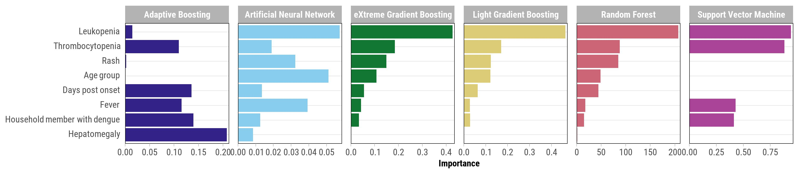

S2 Fig. Feature importance for 20-variable feature set for each machine learning model, SEDSS, May 2012–June 2024. The feature importance metrics differ across the various machine learning models depicted. In Random Forest, AdaBoost, LightGBM, and XGBoost, feature importance is measured as the mean decrease in impurity or gain, indicating each feature’s contribution to reducing the overall prediction error. For Support Vector Machine, feature importance is derived from the magnitude of the coefficients of the support vectors, reflecting the influence of features on the decision boundary. Artificial Neural Network uses permutation importance, which quantifies the impact of feature perturbation on model performance. Consequently, these importance scores are on different scales and represent distinct notions of feature contribution, and therefore, direct comparisons across models should be made cautiously.
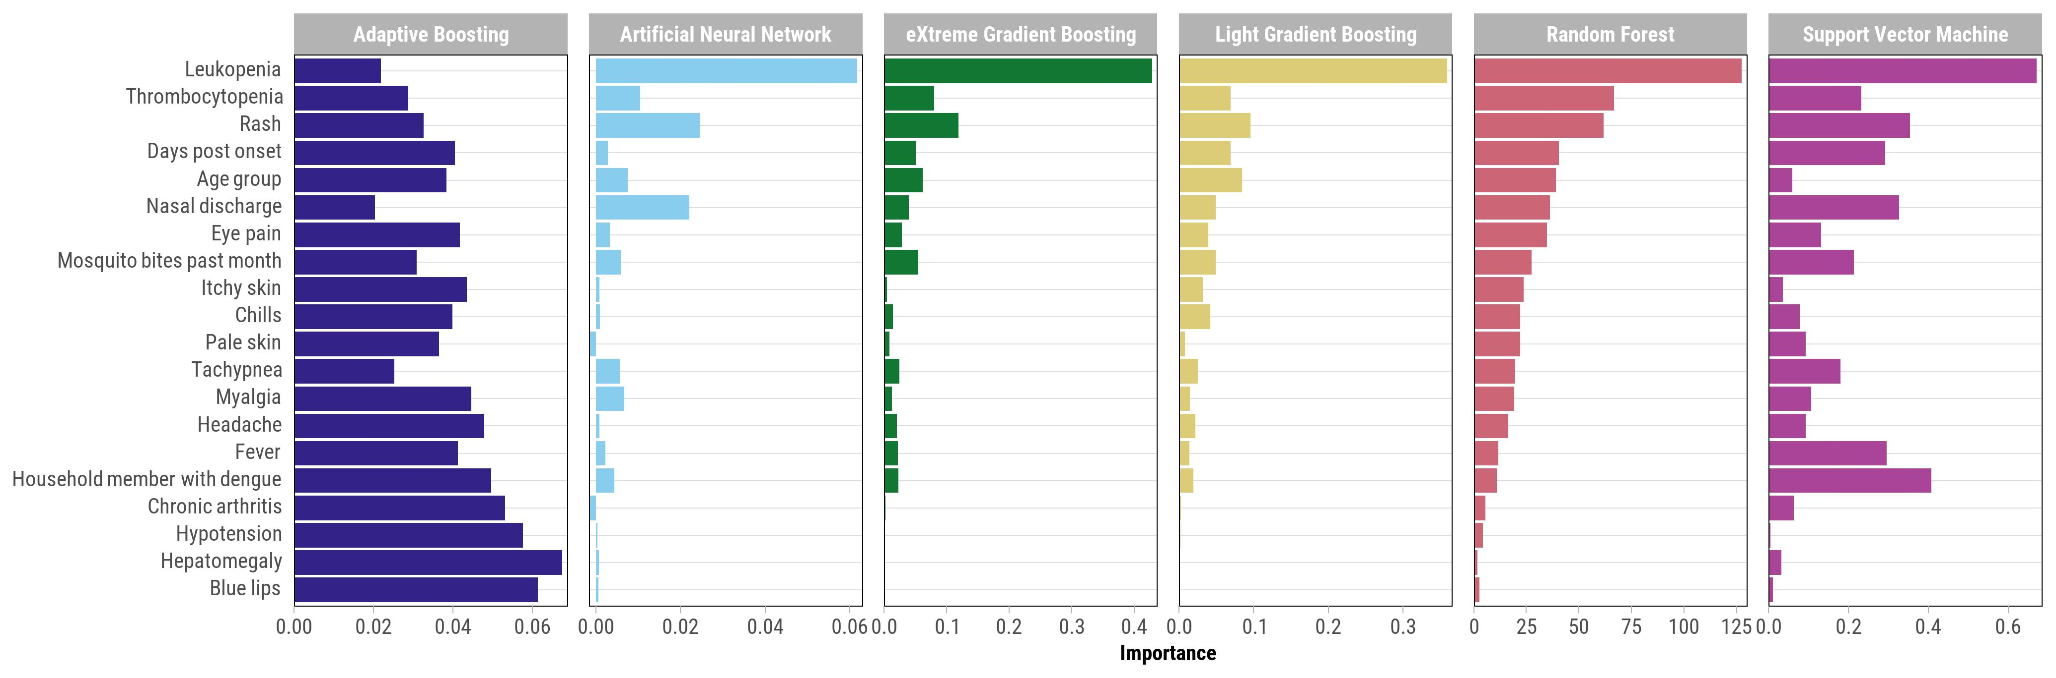

S3 Fig. Feature importance for 32-variable feature set for each machine learning model, SEDSS, May 2012–June 2024. The feature importance metrics differ across the various machine learning models depicted. In Random Forest, AdaBoost, LightGBM, and XGBoost, feature importance is measured as the mean decrease in impurity or gain, indicating each feature’s contribution to reducing the overall prediction error. For Support Vector Machine, feature importance is derived from the magnitude of the coefficients of the support vectors, reflecting the influence of features on the decision boundary. Artificial Neural Network uses permutation importance, which quantifies the impact of feature perturbation on model performance. Consequently, these importance scores are on different scales and represent distinct notions of feature contribution, and therefore, direct comparisons across models should be made cautiously.
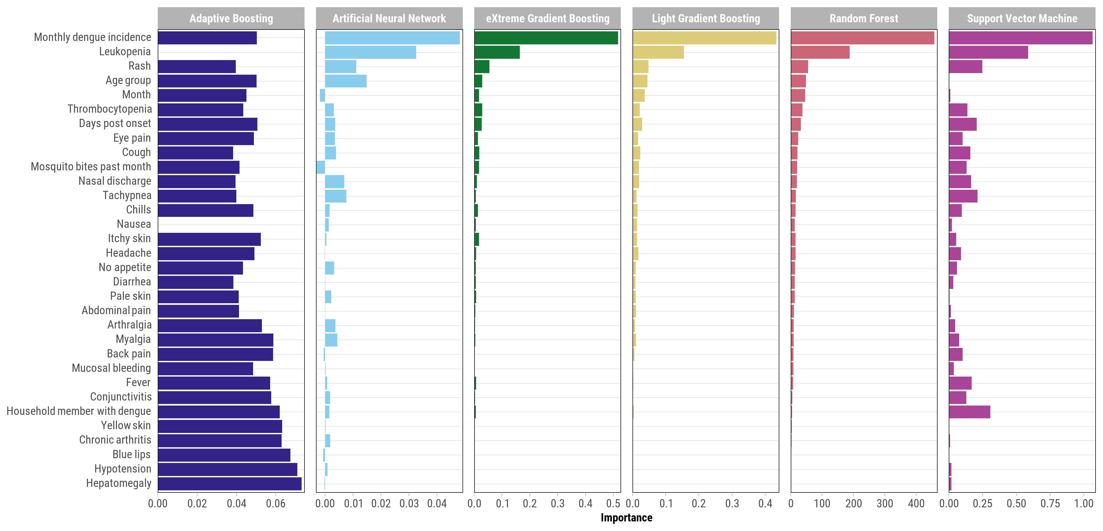

S4 Fig. Feature importance for 48-variable feature set for each machine learning model, SEDSS, May 2012–June 2024. The feature importance metrics differ across the various machine learning models depicted. In Random Forest, AdaBoost, LightGBM, and XGBoost, feature importance is measured as the mean decrease in impurity or gain, indicating each feature’s contribution to reducing the overall prediction error. For Support Vector Machine, feature importance is derived from the magnitude of the coefficients of the support vectors, reflecting the influence of features on the decision boundary. Artificial Neural Network uses permutation importance, which quantifies the impact of feature perturbation on model performance. Consequently, these importance scores are on different scales and represent distinct notions of feature contribution, and therefore, direct comparisons across models should be made cautiously.
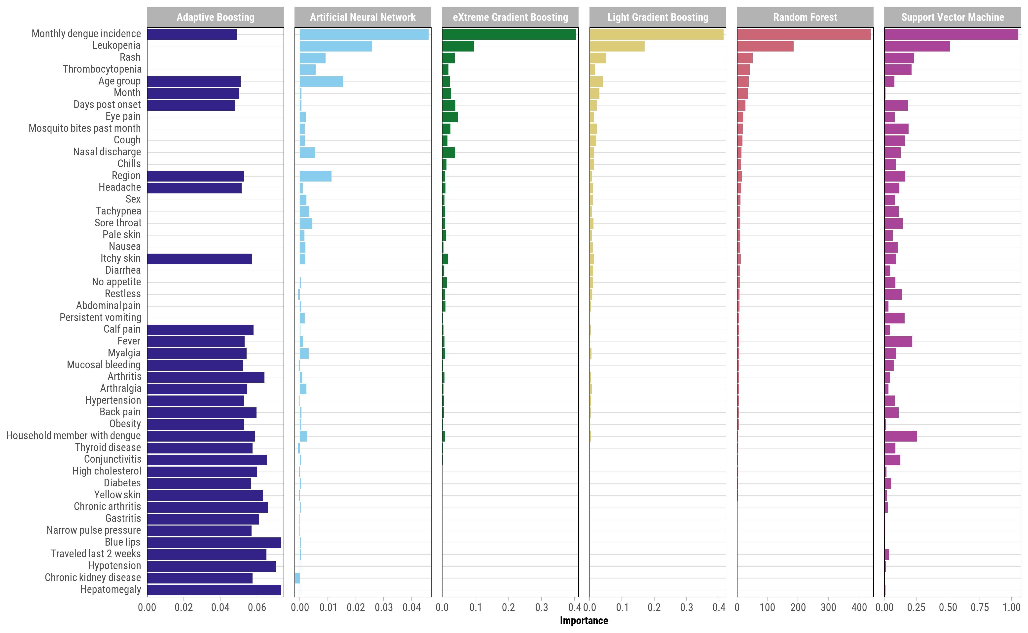

S5 Fig. Incremental improvement in AUC by sequentially adding features identified from XGBoost models, SEDSS, May 2012–June 2024.

