Supplementary information:
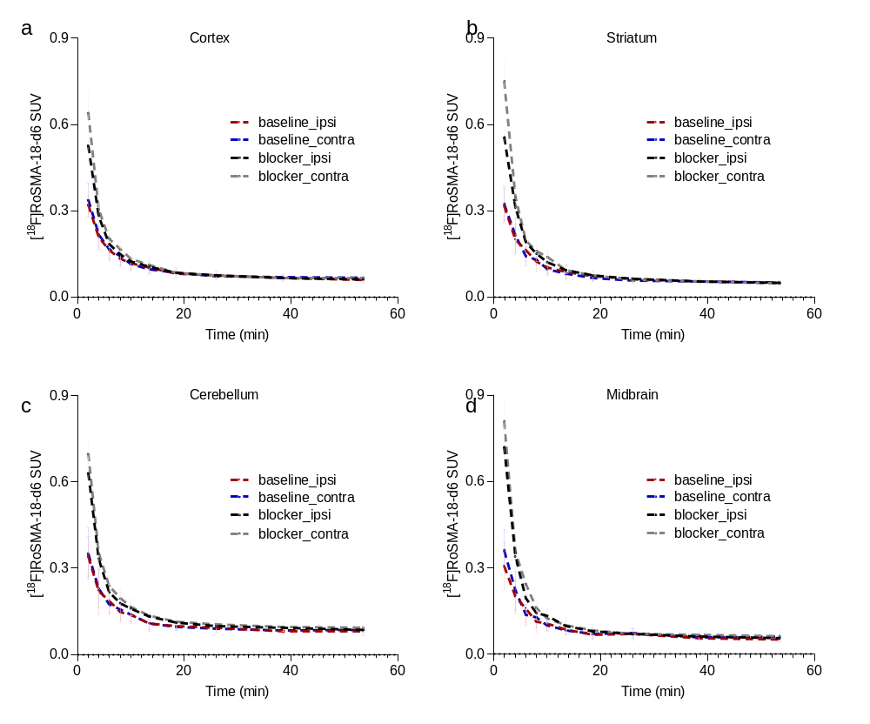
Supplementary Figure 1. Time activity curves of [¹⁸F]RoSMA-18-d6 in vivo microPET imaging in tMCAO mouse brain. (a-d) In the cortex, striatum, cerebellum and midbrain under baseline (n = 6) and blockade (n = 4) conditions. No difference in [¹⁸F]RoSMA-18-d6 SUV was observed in different brain regions at ipsilateral vs contralateral side under baseline or blockade conditions. Data represent mean ± standard deviation.

Supplementary Fig 2. In vivo microPET imaging of tMCAO mouse brain using [¹⁸F]RoSMA-18-d6. Representative whole head PET images of horizontal mouse brain sections at different time frames after intravenous injection of [¹⁸F]RoSMA-18-d6; SUV: 0-0.5;

Supplementary Table 1: Primers used for the quantitative polymerase chain reaction assay on mouse brain tissue
RNA | Primer
beta-actin (ACTB) | forward 5′-AGACCTCTATGCCAACACAGT-3′, reverse 5′-TGCTAGGAGCCAGAGCAGTAA-3′
Cannabinoid Receptor 2 (CNR2) | forward 5′-CTACAAAGCTCTAGTCACCCGT-3′, reverse 5′-CCATGAGCGGCAGGTAAGAAA-3’
ionized calcium binding adaptor molecule 1 (Iba1) | forward 5’-GTCCTTGAAGCGAATGCTGG-3’, reverse 5’-CATTCTCAAGATGGCAGATC-3’
Tumor necrosis factor (TNF-a) | forward 5′-AATGGCCTCCCTCTCATCAGTT-3′, reverse 5′-CCACTTGGTGGTTTGCTACGA-3′
Matrix metallopeptidase 9 (MMP9) | forward 5’-AACATCTGGCACTCCACACC-3’, reverse 5’-GCAGAAGTTCTTTGGCCTGC-3’
Glial fibrillary acidic protein (GFAP) | forward 5’-CGGAGACGCATCACCTCTG-3’, reverse 5’-TGGAGGAGTCATTCGAGACAA-3’
microtubule-associated protein 2 (MAP-2) | forward 5’-GCCAGCCTCAGAACAAACAG-3’, reverse 5’-AAGGTCTTGGGAGGGAAGAAC-3’

