Supplementary Figures and Tables

Fig S1. Plasma cortisol concentrations in response to ACTH-challenge of postpartum dairy cows supplemented with n-3 (21 DIM). The cows were divided into two nutritional groups from –21 to 60 days PP; 1) Control group (CTL)—a standard lactating diet, 2) Flaxseed (FLX)—a standard diet supplemented with encapsulated flaxseed oil enriched with C18:3n-3. Synacthen- an analog to ACTH

Fig S2. Distribution of adipocytes according to adipocyte area. Adipose tissue of PP dairy cows supplemented with n-3 fatty acids or control diet. Dairy cows were divided into two nutritional groups from 21 d before expected calving to 60 days PP; 1) Control group (CTL)—a standard lactating diet, 2) FLX—a standard lactating diet supplemented with flaxseed oil containing n-3. ⁺P = 0.07

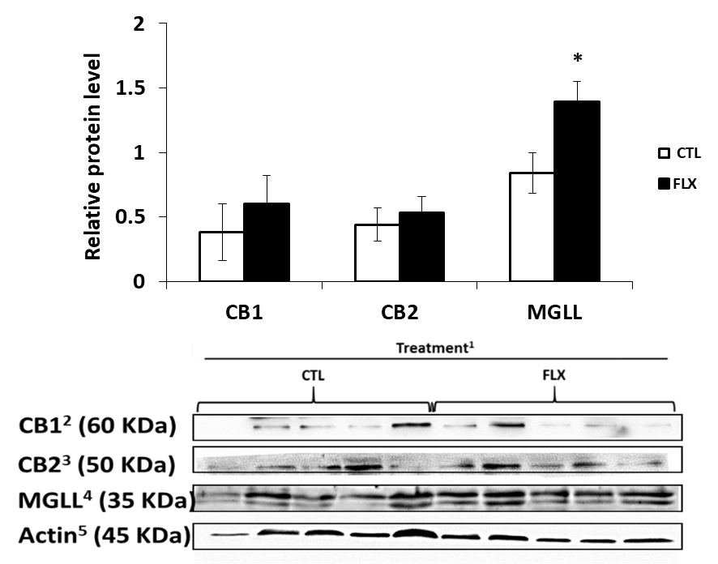

Fig. S3. Peripheral blood mononuclear cells (PBMC) protein abundance of ECS-related proteins during the 1st week PP of dairy cows supplemented with n-3 fatty acids. P < 0.05. ¹Dairy cows were divided into two nutritional regiment groups from –21 to 60 days PP; 1) Control group (CTL)—a standard Israeli diet, 2) FLX—a standard diet supplemented with flaxseed oil containing n-3. n=5 per treatment. ²Cannabinoid receptor 1; ³Cannabinoid receptor 2; ⁴ Monoglyceride lipase; ⁵β-Actin which was used as reference protein

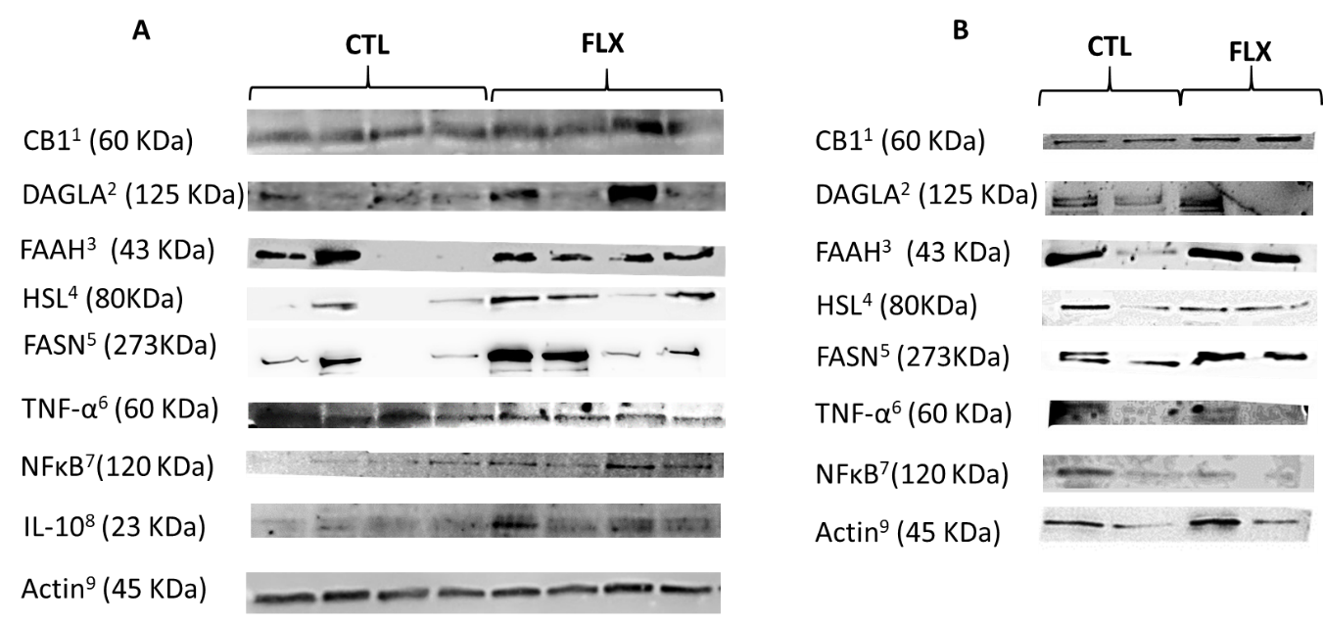

Fig. S4. Western blot images of adipose tissue average protein expression of ECS-related, lipid metabolism and inflammatory proteins of PP dairy cows supplemented with n-3 fatty acids. Dairy cows were divided into two nutritional regiment groups from –21 to 60 days PP; 1) Control group (CTL)—a standard Israeli diet, 2) FLX—a standard diet supplemented with flaxseed oil containing n-3. A: 1st set of samples, n=4 per treatment; B: 2nd set of samples, n=2 per treatment. ¹Cannabinoid receptor 1; ²Diacylglycerol lipase alpha; ³Fatty acid amide hydrolase; ⁴Hormone sensitive lipase; ⁵Fatty acid synthase; ⁶Tumor necrosis factor α; ⁷Nuclear factor kappa-light-chain-enhancer of activated B cells; ⁸Interleukin 10; ⁹All samples were corrected by the β-Actin protein expression levels

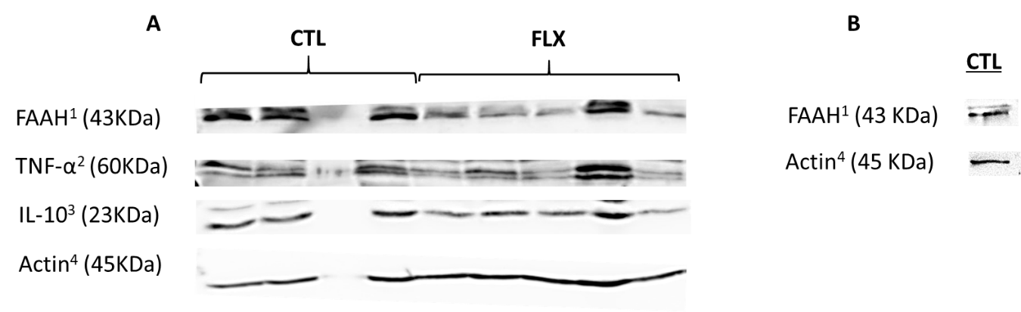

Fig. S5. Western blot images of liver average protein expression of ECS-related, lipid metabolism and inflammatory proteins of PP dairy cows supplemented with n-3 fatty acids. Dairy cows were divided into two nutritional regiment groups from –21 to 60 days PP; 1) Control group (CTL)—a standard Israeli diet, 2) FLX—a standard diet supplemented with flaxseed oil containing n-3. A: 1st set of samples, n=4 for CTL and n=5 for FLX treatment; B: 2nd set of samples n=1 of CTL treatment. ¹Fatty acid amide hydrolase; ²Tumor necrosis factor α; ³Interleukin 10; ⁴All samples were corrected by the β-Actin protein expression levels

Table S1. List of primers used to determine gene transcription levels
Gene | Description | GenBank accession no. | Sequence 5`→3` (Forward, Reverse)
GAPDH | Glyceraldehyde-3-phosphate dehydrogenase | NM_001034034.2 | F:GATTGTCAGCAATGCCTCCT  R:GGTCATAAGTCCCTCCACGA
ACTB | Beta- actin | AY_141970.1 | F: CTCTTCCAGCCTTCCTTCCT  R: AGAGGTCCTTGCGGATGTC
YWHAZ | Tyrosine 3-monooxygenase/tryptophan 5-monooxygenase activation protein zeta | NM_174814.2 | F:GGAGGGTCGTCTCCAGTATTGA  R:CGAGCCATCTGCTGTTTTTTC
HPRT1 | hypoxanthine Phosphoribosyltransferase 1 | NM_001034035.2 | F:CACTGGGAAGACATGCAGA  R: ACACTTCGAGGGGTCCTTTT
CNR1 | Cannabinoid receptor 1 | NM_001242341.2 | F:AAGCCCGCATGGACATTAGGTTAG  R: AGCAGAGGGCCCCAGCAGAT
CNR2 | Cannabinoid receptor 2 | NM_001192303.1 | F: TCTTCGCCGGCATCATCTAC  R: CATCCGGGCTATTCCAGACA
MGLL | Monoglyceride lipase | NM_001206681.1 | F: GCAACCAGCTGCTCAACAC  R: AGCGTCTTGTCCTGGCTCTT
FAAH | Fatty acid amide hydrolase | NM_001099102.2 | F: TTCCTGCCAAGCAACATACCT  R: CACGAAATCACCTTTGAAGTTCTG
NAPEPLD | N-Acyl phosphatidylethanolamine phospholipase D | NM_001015680.1 | F: AGAGATCACAGCAGCGTTCCAT  R: ACTCCAGCTTCTTCAGGGTCATC
DAGLA | Diacylglycerol lipase alpha | NM_001192583.3 | F: GGCTCAAAGTGTTCCTCTGC  R: TGTCCAGGTCTCGGAAAAAC
PPARA | Peroxisome proliferator activated receptor alpha | NM_001034036.1 | F: CCCTCTTTGTGGCTGCTATC  R: GCACAATACCCTCCTGCATT
PPARG | Peroxisome proliferator activated receptor gamma | NM_181024.2 | F: TGCTGTGGGGATGTCTCATA  R: GGTCAGCAGACTCTGGGTTC
MLXIPL | Carbohydrate-responsive element-binding protein Carbohydrate-responsive element-binding protein | NM 001205408.1 | F: ATCCGCCTCAACAACGC  R: TCCCTCCAAGACGACG
ACOX1 | Acyl-CoA oxidase 1 | NC 015500.1 | F: TAAGCCTTTGCCAGGTATT  R: ATGGTCCCGTAGGTCAG
ACSL | Acyl-coA synthetase long chain Family Member 1 | NM 001076085.1 | F: CAAGCCTCCAGTACCTGAAGATC  R: AACGTGTTCTCTGTCATTTTCACAA
FABP1 | Fatty acid binding protein 1 | NC 007309.4 | F: AAGTACCAAGTCCAGACCCAG  R: CACGATTTCCGACACCC
CPT1A | Carnitine palmitoyltransferase 1A | NC 007330.4 | F: GGTCAACAGCAACTACTACG  R: TGAACATCCTCTCCATCTGG
CPT2 | Carnitine palmitoyltransferase 2 | NM 001045889.1 | F: ACGCCGTGAAGTATAACCCT  R: CCAAAAATCGCTTGTCCCTT
TNF | Tumor necrosis factor α | NM_173966.3 | F: CCATCAACAGCCCTCTGGTT  R:GGGCTACCGGCTTGTTACTT
IL6 | Interleukin 6 | NM_173923.2 | F:GCCCAAGGTTAACGCTACAG  R:TGATCTCTCTGGGGTTCAGG
NFKB1 | nuclear factor kappa B subunit 1 | NM_001076409.1 | F:CACGTATGGCGGAATTACCT  R:GCCACAACTTTCAGGGTCAT
IL1B | Interleukin 1 beta | NM_174093.1 | F:CCATGGAGAAGCTGAGGAAC  R:GGAGGACGTTTCGAAGATGA
TLR4 | Tall like receptor 4 | NM_174198.6 | F:AGGCAGCATACTTCTCCA  R:GCCCTGAAATGTGTCGTCTT
CD14 | CD14 molecule | NM_174008.1 | F:CCGACAACCAGAGAGAGG  R:CAGACACACGCAGCAGTGAC
SAA2 | Serum amyloid A2 | NM_001075260.2 | F: CAGCCAGTGGATGTCCTTCT  R: GCACCCTTGTAGTTGGCTTC
HP | Haptoglobin | NM_001040470.2 | F: CCTATTACACACTGCGCACCT  R: GCACACTGCCTCACATTCAG
PTGS2 | Prostaglandin-endoperoxide synthase 2 | NM_174445.2 | F: CCAGACAAGCAGGCTAATCC  R: GCAGCTCTGGGTCAAACTTC
PLA2G2A | Phospholipase A2 group IIA | NM_001075820.2 | F: AGATGAAGACCCTCCTGCTG  R: CTTTCCTGTCGTGTGCTTGA
LIPE | lipase E, hormone sensitive type | NM_001080220.1 | F: TCGTGGCTCAACTCCTTCTT  R: AGGGCTGCTTCAGACACACT
FABP4 | fatty acid binding protein4 | NM_174313.2 | F: TTCAAGCTGGGAGTCGAGTT  R: TGTCCATTCCACTTCTGCAC
FASN | Fatty acid synthase | NM_001012669.1 | F: ACCTCGTGAAGGCTGTGACTCA  R: TGAGTCGAGGCCAAGGTCTGAA
IL10 | Interleukin 10 | NM_174088.1 | F: CTGTATCCACTTGCCAACCA  R:AAGCTGTGCAGTTGGTCCTT
Amplicon size was 90–120 bp in all primers. The primers were all used in a final concentration of 1 µmol/L. The thermal profile was composed of 15 min in 95 °C followed by 40 cycles of 15 s in 95 °C and 1 min in 60 °C

Table S2. List of immunoblot Ab's used to measure protein abundance
Antigen | Abbreviation | Host | Dilution | Source
Cannabinoid receptor1 | CB1 | Rabbit | 1:200 | Abcam biotech, Cambridge, UK, ab23703
Cannabinoid receptor2 | CB2 | Rabbit | 1µg/ml | Enzo, NY, USA, ADI-905-820-100
Monoglyceride lipase | MGLL | Rabbit | 1:200 | Abcam biotech, Cambridge, UK, ab24701
Fatty acid amide hydrolase | FAAH | Rabbit | 1µg/ml | Aviva systems biology, CA, USA, ARP33121_P050
Diacylglycerol lipase alpha | DAGLA | Goat | 0.3µg/ml | Aviva systems biology, CA, USA, OAEB01139
Tumor necrosis factor α | TNF-α | Rabbit | 1:1000 | Aviva systems biology, CA, USA, OACA04183
Nuclear factor kappa B | NFκB | Rabbit | 1:1000 | Cell signaling, MA, USA, 4717
Interleukin 10 | IL-10 | Rabbit | 1µg/ml | Aviva systems biology, CA, USA, OACD04543
Hormone sensitive lipase | HSL | Rabbit | 1:1000 | Cell signaling, MA, USA, 4107P
Fatty acid synthase | FASN | Rabbit | 1:2000 | Abcam biotech, Cambridge, UK, ab99359

Table S3. Fatty acid (FA) profile in plasma of postpartum dairy cows supplemented with n-3.
FA, % |  | Treatment¹ |  |  | P-value
 |  | CTL | FLX | SEM
 | C14:0 | 1.1 | 0.9 | 0.07 | 0.16
 | C16:0 | 17.3 | 17.3 | 0.80 | 0.99
 | C16:1 | 0.6 | 0.4 | 0.07 | 0.12
 | C16:2 | 1.5 | 1.5 | 0.11 | 0.65
 | C16:3 | 1.8 | 1.5 | 0.15 | 0.17
 | C18:0 | 12.8 | 14.1 | 0.56 | 0.12
 | C18:1n-9 | 8.6 | 6.9 | 1.05 | 0.27
 | C18:1n-7 | 1.9 | 3.3 | 0.96 | 0.35
 | C18:2n-6 | 44.0 | 41.5 | 2.13 | 0.44
 | C18:3n-6 | 0.7 | 0.7 | 0.06 | 0.96
 | C18:3n-3 | 1.8ª | 3.9^{b} | 0.15 | <0.0001
 | C20:1n9 | 0.2 | 0.2 | 0.03 | 0.62
 | C20:2n-6 | 1.1 | 1.0 | 0.10 | 0.51
 | C20:3n-6 | 1.4 | 1.3 | 0.12 | 0.41
 | C20:4n-6 | 2.0 | 2.1 | 0.14 | 0.85
 | C20:4n-3 | 0.2 | 0.3 | 0.02 | 0.13
 | C20:5n-3 | 0.3ª | 0.4^{b} | 0.03 | <0.001
 | C22:5n-3 | 0.3 | 0.2 | 0.02 | 0.38
 | C22:6n-6 | 0.2 | 0.3 | 0.05 | 0.30
 | C22:6n-3 | 0.1 | 0.1 | 0.02 | 0.67
 | C24:1n-9 | 2.2 | 2.1 | 0.40 | 0.97
 | Saturated FA | 31.1 | 32.3 | 1.31 | 0.55
 | MUFA² | 13.5 | 12.9 | 0.74 | 0.62
 | PUFA³ | 52.1 | 51.8 | 1.88 | 0.93
 | n-3 | 2.6ª | 4.9^{b} | 0.17 | <0.0001
 | n-6 | 49.4 | 46.9 | 1.96 | 0.38
 | n-6:n-3 | 24.2 | 9.9 | 5.32 | 0.07
¹Dairy cows were divided into two nutritional groups from –21 to 60 days PP; 1) Control group (CTL)—a standard Israeli diet, 2) FLX—a standard diet supplemented with flaxseed oil containing n-3. n=8 per treatment ²monounsaturated FA; ³polyunsaturated FA

Table S4. White blood cells (WBC) average gene transcription levels (relative quantities; RQ) of ECS-related genes during the 1st week PP of dairy cows supplemented with n-3 fatty acids.
Gene |  |  |  | Treatment¹ |  |  |  | SEM |  | P-value
 |  | Control |  |  | FLX
 | CNR1² |  | 0.01 |  |  | 0.00 |  | 0.001 |  |  | 0.113
 | CNR2³ |  | 0.04 |  |  | 0.04 |  | 0.012 |  |  | 0.637
 | MGLL⁴ |  | 0.03 |  |  | 0.01 |  | 0.008 |  |  | 0.159
¹Dairy cows were divided into two nutritional regiment groups from –21 to 60 days PP; 1) Control group (CTL)—a standard Israeli diet, 2) FLX—a standard diet supplemented with flaxseed oil containing n-3. n=6 per treatment. ²Cannabinoid receptor 1; ³Cannabinoid receptor 2; ⁴Monoglyceride lipase

Table S5. Adipose tissue relative protein abundance of ECS-related, lipid metabolism and inflammatory proteins of PP dairy cows supplemented with n-3 fatty acids
 |  |  |  |  | Treatment¹
 |  | Control |  |  |  | FLX |  |  | SEM |  |  |  | P-value
Protein abundance, AU
 | CB1² |  |  | 1.0 |  |  |  | 0.8 |  | 0.14 |  |  |  | 0.37
 | DAGLA³ |  |  | 1.0 |  |  |  | 1.5 |  | 0.40 |  |  |  | 0.41
 | FAAH⁴ |  |  | 0.7 |  |  |  | 0.9 |  | 0.22 |  |  |  | 0.72
 | HSL⁵ |  |  | 1.4 |  |  |  | 0.7 |  | 0.31 |  |  |  | 0.16
 | FASN⁶ |  |  | 1.5 |  |  |  | 0.8 |  | 0.40 |  |  |  | 0.28
 | TNF-α⁷ |  |  | 1.1 |  |  |  | 1.3 |  | 0.26 |  |  |  | 0.50
 | NFkB⁸ |  |  | 1.3 |  |  |  | 1.8 |  | 0.40 |  |  |  | 0.37
 | IL-10⁹ |  |  | 1.0 |  |  |  | 1.6 |  | 0.27 |  |  |  | 0.19
¹Dairy cows were divided into two nutritional regiment groups from –21 to 60 days PP; 1) Control group (CTL)—a standard Israeli diet, 2) FLX—a standard diet supplemented with flaxseed oil containing n-3. ²Cannabinoid receptor 1; ³Diacylglycerol lipase alpha; ⁴Fatty acid amide hydrolase; ⁵Hormone sensitive lipase; ⁶Fatty acid synthase; ⁷Tumor necrosis factor α; ⁸Nuclear factor kappa-light-chain-enhancer of activated B cells; ⁹Interleukin 10. Full blots are presented in supplementary Fig. S4

Table S6. Liver tissue relative protein abundance of ECS-related, lipid metabolism and inflammatory proteins of PP dairy cows supplemented with n-3 fatty acids

 |  |  |  |  | Treatment¹
 |  | Control |  |  |  | FLX |  | SEM |  |  |  | P-value
Protein abundance, AU
 | FAAH² |  |  | 2.8 |  | 2.1 |  |  | 0.58 |  |  |  | 0.43
 | TNF-α³ |  |  | 1.2 |  | 1.4 |  |  | 0.27 |  |  |  | 0.67
 | IL-10⁴ |  |  | 3.3 |  | 3.9 |  |  | 0.86 |  |  |  | 0.68
¹Dairy cows were divided into two nutritional regiment groups from –21 to 60 days PP; 1) Control group (CTL)—a standard Israeli diet, 2) FLX—a standard diet supplemented with flaxseed oil containing n-3. ²Fatty acid amide hydrolase; ³Tumor necrosis factor α; ⁴Interleukin 10. Full blots are presented in supplementary Fig. S5

