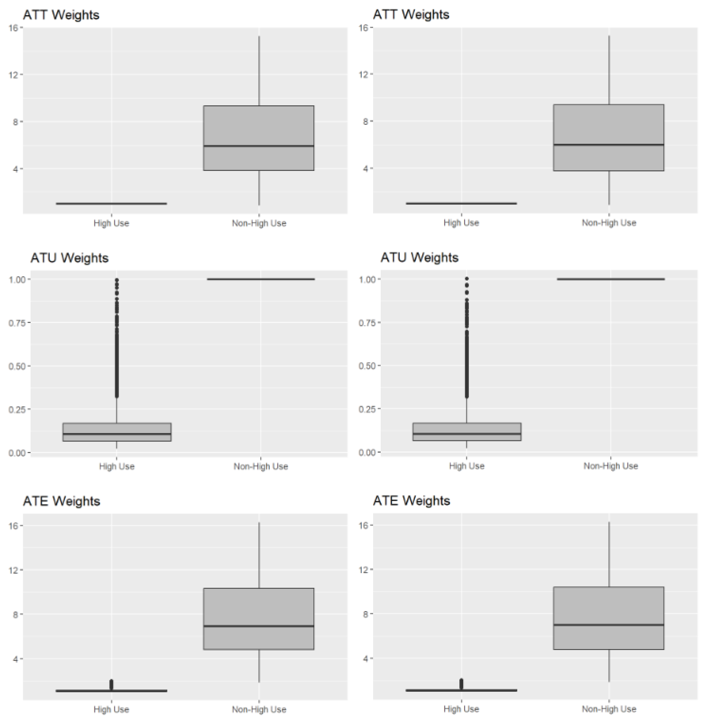
Supplemental Figure 2. Weights from propensity score models for being in the high-use groups for the outcome of non-prescribed opioid use (left) and ODUD symptoms (right). Data from the Monitoring the Future Study, 1976-2019.

