Supplementary Material

Supplementary Tables

Table S1. Diagnostic capacity of preoperative examination
Preoperative examination | Found clips [n (%)] | Unfound clips [n (%)]
CT | 12 (92.3) | 1 (7.7)
MRCP | 2 (25.0) | 6 (75.0)
Choledochoscopy via T-tube sinus tract | 6 (100) | 0
Cholangiography via T-tube | 1 (11.1) | 8 (88.9)
ERCP | 1 (50) | 1 (50)
Ultrasound | 0 | 1 (100)
EGD | 1 (100) | 0
MRCP: magnetic resonance cholangiopancreatography, CT: computed tomography, ERCP: endoscopic retrograde cholangiopancreatography, EDG: esophagogastroduodenoscopy

Table S2. Summary of initial operation, migration position and treatment
 | n (%)
Initial operation
LCBDE with T tube drainage | 33 (91.7)
LCBDE with primary closure | 3 (8.3)
Migration position
CBD | 28 (77.8)
T-tube sinus tract | 6 (16.7)
Duodenum | 1 (2.8)
Unknown | 1 (2.8)
Treatment
LCBDE or laparotomy operation | 12 (33.3)
ERCP | 5 (13.9)
Removed by choledochoscopy | 16 (44.4)
Observation | 3 (8.3)
CBD: common bile duct, ERCP: endoscopic retrograde cholangiopancreatography, LCBDE: laparoscopic common bile duct exploration

Supplementary Figures
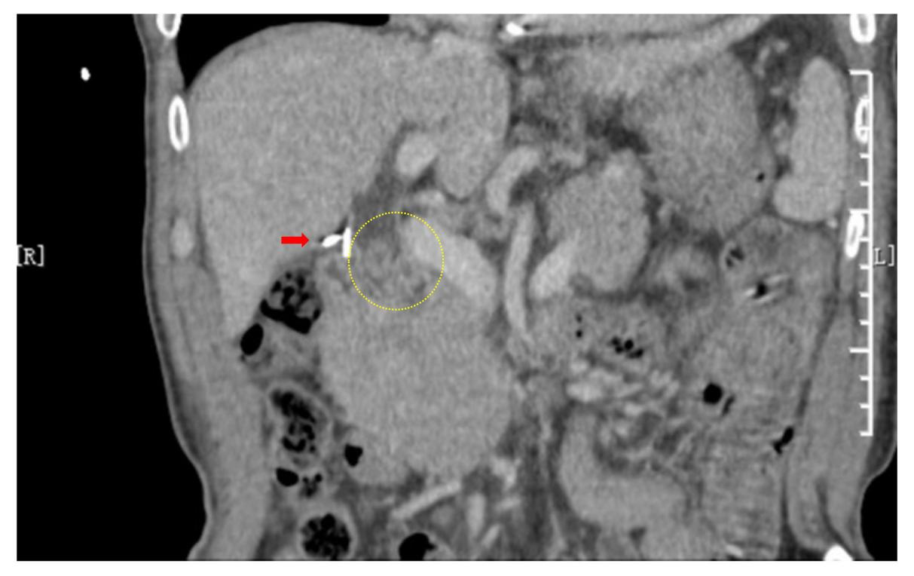
Supplementary Figure 1. CT scan revealed that two surgical clips on the cystic duct were still in place (red arrows), with CBD dilation accompanied by stone formation (yellow ellipse).

