Changing trends in anabolic-androgenic steroid use within Scottish prisons: Detection, prevalence, and quantitation

Supplementary Information

Section 1: Extraction efficiency for anabolic-androgenic steroid quantitation method
Section 2: Method validation data for mestanolone quantitation method
Section 3: Method validation data for methyltestosterone quantitation method
Section 4: Method validation data for metandienone quantitation method
Section 5: Method validation data for stanozolol quantitation method
Section 6: Method validation data for oxymetholone quantitation method
Section 7: Method validation data for oxandrolone quantitation method
Section 8: Full qualitative data for samples found to contain AASs seized in Scottish prisons.
Section 9: Example photographs of other samples types seized from the Scottish prisons found positive for AASs.
Section 10: Full tablet markings data for samples of tablets found to contain AASs seized in Scottish prisons.
Section 11: Full quantitative data for samples found to contain AASs seized in Scottish prisons.
Section 12: R Script for quantitation

Section 1: Extraction efficiency for anabolic-androgenic steroid quantitation method
To ensure near-exhaustive extraction of the AAS compounds from test samples, sequential extractions in methanol, or acetonitrile for oxymetholone, were carried out using representative tablet samples known to contain each AAS. Samples were extracted using 1 min centrifuging. These were then analyzed using the quantitative GC-MS method. Five sequential extractions in methanol were found to be sufficient to extract all detectable mestanolone, methyltestosterone, stanozolol, and metandienone and >99% for oxandrolone. Six sequential extractions in acetonitrile were found to be sufficient to extract >99% for oxymetholone.

Table S1.1: Analytical data for calculation of extraction efficiency using methanol for all drugs, except oxymetholone, which used acetonitrile.
Drug | Extraction | RT | Peak Area | % Extracted | Total % extracted
Mestanolone | 1 | 7.514 | 37659664 | 76.31% | 76.31%
Mestanolone | 2 | 7.510 | 6854354 | 13.89% | 90.19%
Mestanolone | 3 | 7.510 | 2988589 | 6.06% | 96.25%
Mestanolone | 4 | 7.510 | 1211730 | 2.46% | 98.70%
Mestanolone | 5 | 7.512 | 639128 | 1.30% | 100.00%
Mestanolone | 6 | 0 | 0 | 0.00% | -
Methyltestosterone | 1 | 7.811 | 4934901 | 92.76% | 92.76%
Methyltestosterone | 2 | 7.810 | 385014 | 7.24% | 100.00%
Methyltestosterone | 3 | 0 | 0 | 0.00% | -
Methyltestosterone | 4 | 0 | 0 | 0.00% | -
Methyltestosterone | 5 | 0 | 0 | 0.00% | -
Stanozolol | 1 | 10.208 | 69925036 | 55.97% | 55.97%
Stanozolol | 2 | 10.206 | 34030327 | 27.24% | 83.20%
Stanozolol | 3 | 10.205 | 15238545 | 12.20% | 95.40%
Stanozolol | 4 | 10.206 | 4844746 | 3.88% | 99.28%
Stanozolol | 5 | 10.208 | 904532 | 0.72% | 100.00%
Stanozolol | 6 | 0 | 0 | 0.00%
Oxymetholone | 1 | 8.411 | 731422649 | 49.94% | 49.94%
Oxymetholone | 2 | 8.384 | 435028376 | 29.71% | 79.65%
Oxymetholone | 3 | 8.354 | 154128804 | 10.52% | 90.17%
Oxymetholone | 4 | 8.342 | 75038647 | 5.12% | 95.30%
Oxymetholone | 5 | 8.339 | 38917105 | 2.66% | 97.96%
Oxymetholone | 6 | 8.334 | 20043556 | 1.37% | 99.32%
Oxymetholone | 7 | 8.334 | 7048491 | 0.48% | 99.81%
Oxymetholone | 8 | 8.337 | 742908 | 0.05% | 99.86%
Oxymetholone | 9 | 9.339 | 2106246 | 0.14% | 100.00%
Oxymetholone | 10 | 0 | 0 | 0.00%
Metandienone | 1 | 8.043 | 860659309 | 78.60% | 78.60%
Metandienone | 2 | 7.984 | 215513070 | 19.68% | 98.28%
Metandienone | 3 | 7.957 | 9617765 | 0.88% | 99.15%
Metandienone | 4 | 7.956 | 8883481 | 0.81% | 99.97%
Metandienone | 5 | 7.955 | 376774 | 0.03% | 100.00%
Metandienone | 6 | 0 | 0 | 0.00% | -
Oxandrolone | 1 | 8.335 | 1120526515 | 39.90% | 39.90%
Oxandrolone | 2 | 8.293 | 618325197 | 22.02% | 61.92%
Oxandrolone | 3 | 8.274 | 423833059 | 15.09% | 77.01%
Oxandrolone | 4 | 8.288 | 568936614 | 20.26% | 97.27%
Oxandrolone | 5 | 8.227 | 57973497 | 2.06% | 99.34%
Oxandrolone | 6 | 8.224 | 17886068 | 0.64% | 99.98%
Oxandrolone | 7 | 8.219 | 504701 | 0.02% | 99.99%
Oxandrolone | 8 | 8.216 | 160460 | 0.01% | 100.00%
Oxandrolone | 9 | 0 | 0 | 0.00% | -

Section 2: Method validation data for mestanolone quantitation method

2.1 Example Calibration Data

Table S2.1 Mestanolone calibration curve data for 22/09/2023
Concentration (µg/mL) | Internal Standard Peak Area | Mestanolone Peak Area | Peak Area Ratio
25 | 15093293 | 39379198 | 0.38
50 | 35831508 | 43244698 | 0.83
75 | 57271926 | 42564439 | 1.35
100 | 78719386 | 44745184 | 1.76
150 | 127540590 | 45192170 | 2.82
200 | 162178875 | 47096117 | 3.44
250 | 199446389 | 50660210 | 3.94

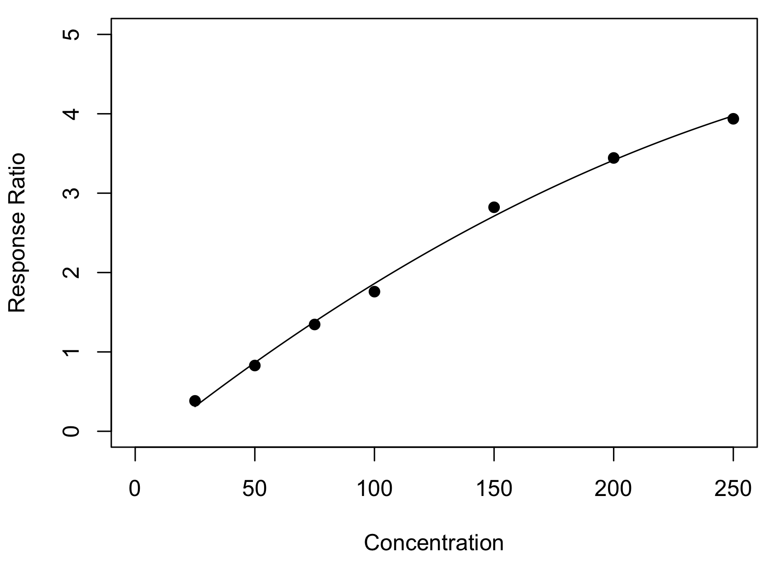
y = (-2.9×10⁻⁵)x² + 0.024x – 0.28
R² = 0.997
Figure S2.1 Mestanolone calibration curve from 22/09/2023

Table S2.2 Mestanolone Quality Assurance Data for 22/09/2023
Check Standard Concentration (µg/mL) | Mestanolone Peak Area | Internal Standard Peak Area | Peak Area Ratio | Calculated Concentration (µg/mL) | Bias  (%)
40 | 28588097 | 42171713 | 0.68 | 41.37 | 3.44
40 | 31248532 | 46624721 | 0.67 | 41.02 | 2.56
125 | 110022444 | 47692615 | 2.31 | 125.16 | 0.13
125 | 113460708 | 50338210 | 2.25 | 122.06 | 2.35

2.2 Limit of Detection (LOD)
To determine the limit of detection, mestanolone solutions were prepared at 5, 10, 15 and 20 μg/mL. Each solution was analyzed in replicate five times and the signal to noise ratio calculated. For each replicate, the mestanolone peak was compared to the SWGDRUG mass spectral library (version 3.11, released 1 June 2022), and the (reverse) match factor was required to be greater than 850/1,000 for positive identification.

Table S2.3: Full analytical data for calculation of limit of detection
Concentration (µg/mL) | Injection | Max Peak Height | Max Noise Height | R Match | Signal to Noise Ratio
5 | 1 | 74342 | 23469 | 849 | 3.17
5 | 2 | 31473 | 12532 | 720 | 2.51
5 | 3 | 20607 | 9334 | 622 | 2.21
5 | 4 | 12666 | 6199 | 502 | 2.04
5 | 5 | 8594 | 5116 | 464 | 1.68
10 | 1 | 146379 | 24664 | 852 | 5.93
10 | 2 | 76971 | 12396 | 851 | 6.21
10 | 3 | 51299 | 7932 | 805 | 6.47
10 | 4 | 33428 | 5439 | 760 | 6.15
10 | 5 | 24255 | 4019 | 686 | 6.04
15 | 1 | 194701 | 17688 | 911 | 11.01
15 | 2 | 115287 | 11927 | 858 | 9.67
15 | 3 | 77961 | 8304 | 854 | 9.39
15 | 4 | 48956 | 6258 | 793 | 7.82
15 | 5 | 39422 | 3799 | 752 | 10.38
20 | 1 | 299290 | 18071 | 918 | 16.56
20 | 2 | 175526 | 13788 | 882 | 12.73
20 | 3 | 120510 | 9489 | 844 | 12.70
20 | 4 | 82427 | 5786 | 832 | 14.25
20 | 5 | 59902 | 4202 | 795 | 14.26

Evaluation of the results demonstrated an acceptable signal to noise ratio above 10 μg/mL (>3.3), however these replicates did not meet the requirements specified for positive identification of mestanolone. Therefore, the LOD for this method was determined to be 20 μg/mL.

2.3 Lower Limit of Quantitation (LLOQ)

LLOQ was defined using the lowest non-zero calibrator. The 25 μg/mL calibration standard was analyzed across 5 separate runs and the bias was evaluated. As defined in Standard 036 (25), to be accepted, the bias of these replicates was required to fall below 20%.

Table S2.4 Analytical data for calculation of lower limit of quantitation.
Nominal Concentration (µg/mL) | Calculated Concentration (µg/mL)
25 | 28.30
25 | 26.96
25 | 28.15
25 | 27.08
25 | 28.61
Grand Mean | 27.82
Bias | 11.28%

Equation 2.1: Calculation of Bias (%)
$$Bias \left(\%\right)=\left\{\frac{Grand Mean of Calculated Concentration-Nominal Concentration}{Nominal Concentration}\right\} × 100$$

The LLOQ was defined as the lowest non-zero calibrator at 25 μg/mL with bias within 11.28% of the nominal concentration.

2.4 Calculation of Bias
To evaluate bias, low, medium and high check standards of mestanolone were analyzed over five separate runs. Each run was carried out on a different day, with a new calibration curve. Each check standard was analyzed in triplicate within each run, giving a total of 15 replicates for each concentration. The maximum acceptable bias for each concentration was defined as ±20%. This method was determined to be accurate with bias within ±17% across all check standards.

Table S2.5 Check standard data for bias calculations.
 | Low Check Standard (40 µg/mL) |  | Medium Check Standard (125 µg/mL) |  | High Check Standard (225 µg/mL)
 | Calculated Conc. | Bias | Calculated Conc. | Bias | Calculated Conc. | Bias
Run 1 | 41.54 | 3.85 | 118.98 | 4.82 | 249.45 | 10.87
Run 1 | 42.35 | 5.87 | 128.45 | 2.76 | 232.90 | 3.51
Run 1 | 41.34 | 3.35 | 127.97 | 2.37 | 253.60 | 12.71
Run 2 | 41.37 | 3.44 | 125.16 | 0.13 | 244.70 | 8.76
Run 2 | 41.02 | 2.56 | 122.06 | 2.35 | 237.37 | 5.50
Run 2 | 40.23 | 0.58 | 122.53 | 1.97 | 253.44 | 12.64
Run 3 | 41.43 | 3.58 | 127.74 | 2.19 | 247.68 | 10.08
Run 3 | 41.04 | 2.60 | 133.18 | 6.54 | 253.43 | 12.64
Run 3 | 42.09 | 5.22 | 132.85 | 6.28 | 253.74 | 12.77
Run 4 | 38.38 | 4.05 | 118.44 | 5.25 | 207.18 | 7.92
Run 4 | 37.33 | 6.67 | 115.01 | 7.99 | 211.31 | 6.09
Run 4 | 36.03 | 9.91 | 116.72 | 6.62 | 212.61 | 5.51
Run 5 | 43.34 | 8.35 | 126.50 | 1.20 | 261.13 | 16.06
Run 5 | 42.71 | 6.77 | 128.03 | 2.42 | 258.92 | 15.07
Run 5 | 44.49 | 11.23 | 126.49 | 1.19 | 256.06 | 13.81
Grand Mean | 41.07 | 5.24 | 124.91 | 3.55 | 241.65 | 9.84

2.5 Calculation of Precision
To evaluate precision, low, medium and high check standards were analyzed over five separate runs. Each run was carried out on a different day, with a new calibration curve. Each check standard was analyzed in triplicate within each run, giving a total of 15 replicates for each concentration. Within-run and between-run precision was calculated as CV% using a single factor ANOVA. The maximum acceptable CV% for each concentration was defined as 20%. This method was determined reproducible with precision determined as being within 3% for within-run results and 17% for between-run results.

Within-run precision was calculated for each concentration using Equation 2.2, where MS_{wg} is the mean square within groups obtained from the ANOVA table.

Equation 2.2: Calculation of Within-Group Precision.
$$Within-Run CV \left(\%\right)= \left[\frac{\sqrt{{MS}_{wg}}}{Grand Mean for each concentration}\right]× 100$$

Between-run precision was calculated for each concentration using Equation 2.3, where MS_{bg} is the mean square between groups obtained from the ANOVA table and n is the number of observations in each group.

Equation 2.3: Calculation of Between-Group Precision.
$$Between-Run CV \left(\%\right)= \left[\frac{\frac{\sqrt{{MS}_{bg}}+\left(n-1\right) × {MS}_{wg}}{n}}{Grand Mean for each concentration}\right]× 100$$

Table 2.6 Mestanolone low check standard data for precision calculations (40 µg/mL)

Run 1  (µg/mL) | Run 2  (µg/mL) | Run 3  (µg/mL) | Run 4  (µg/mL) | Run 5  (µg/mL)
41.54 | 41.37 | 41.43 | 38.38 | 43.34
42.35 | 41.02 | 41.04 | 37.33 | 42.71
41.34 | 40.23 | 42.09 | 36.03 | 44.49

Anova: Single Factor

Groups | Count | Sum | Average | Variance
Run 1 | 3.00 | 125.23 | 41.74 | 0.29
Run 2 | 3.00 | 122.62 | 40.87 | 0.34
Run 3 | 3.00 | 124.56 | 41.52 | 0.28
Run 4 | 3.00 | 111.75 | 37.25 | 1.38
Run 5 | 3.00 | 130.54 | 43.51 | 0.81
Grand Mean (µg/mL) | 41.07
Within Run Precision | 1.92%
Between Run Precision | 4.25%

Source of Variation | SS | df | MS | F | P-value | F crit
Between Groups | 63.68 | 4.00 | 15.92 | 25.65 | 0.00 | 3.48
Within Groups | 6.21 | 10.00 | 0.62
Total | 69.89 | 14.00

Table 2.7 Mestanolone medium check standard data for precision calculations (125 µg/mL)

Run 1  (µg/mL) | Run 2  (µg/mL) | Run 3  (µg/mL) | Run 4  (µg/mL) | Run 5  (µg/mL)
118.98 | 125.16 | 127.74 | 118.44 | 126.50
128.45 | 122.06 | 133.18 | 115.01 | 128.03
127.97 | 122.53 | 132.85 | 116.72 | 126.49

Anova: Single Factor

Groups | Count | Sum | Average | Variance
Run 1 | 3.00 | 375.40 | 125.13 | 28.46
Run 2 | 3.00 | 369.75 | 123.25 | 2.79
Run 3 | 3.00 | 393.77 | 131.26 | 9.30
Run 4 | 3.00 | 350.17 | 116.72 | 2.94
Run 5 | 3.00 | 381.02 | 127.01 | 0.79
Grand Mean (µg/mL) | 124.91
Within Run Precision | 2.38%
Between Run Precision | 7.20%

Source of Variation | SS | df | MS | F | P-value | F crit
Between Groups | 342.61 | 4.00 | 85.65 | 9.67 | 0.02 | 3.48
Within Groups | 88.55 | 10.00 | 8.86
Total | 431.16 | 14.00

Table 2.8 Mestanolone high check standard data for precision calculations (225 µg/mL)

Run 1  (µg/mL) | Run 2  (µg/mL) | Run 3  (µg/mL) | Run 4  (µg/mL) | Run 5  (µg/mL)
249.45 | 244.7 | 247.68 | 207.18 | 261.13
232.90 | 237.37 | 253.43 | 211.31 | 258.92
253.60 | 253.44 | 253.74 | 212.61 | 256.06

Anova: Single Factor

Groups | Count | Sum | Average | Variance
Run 1 | 3.00 | 631.10 | 210.37 | 8.04
Run 2 | 3.00 | 735.51 | 245.17 | 64.73
Run 3 | 3.00 | 754.85 | 251.62 | 11.65
Run 4 | 3.00 | 631.09 | 210.36 | 8.03
Run 5 | 3.00 | 776.11 | 258.70 | 6.46
Grand Mean (µg/mL) | 241.65
Within Run Precision | 2.69%
Between Run Precision | 16.09%

Source of Variation | SS | df | MS | F | P-value | F crit
Between Groups | 4179.21 | 4.00 | 1044.80 | 24.78 | 0.00 | 3.48
Within Groups | 421.61 | 10.00 | 42.16
Total | 4600.82 | 14.00

2.6 Carryover
To evaluate carryover, the highest mestanolone calibration standard (250 µg/mL) and subsequent methanol blank were analyzed over three separate runs. Each run was carried out on a different day, with a new calibration curve. This method was determined to produce no carryover.
A

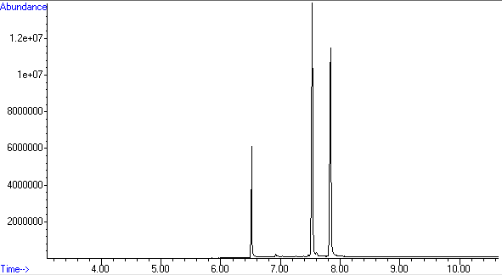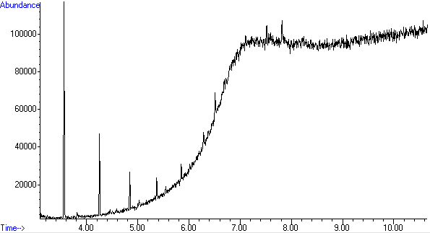
B

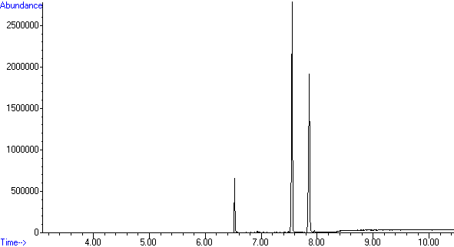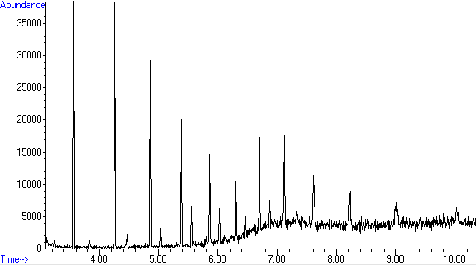

C

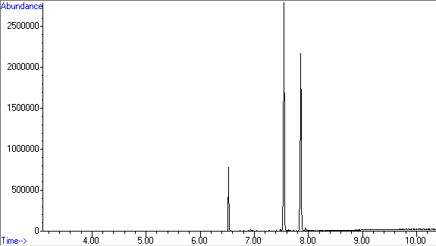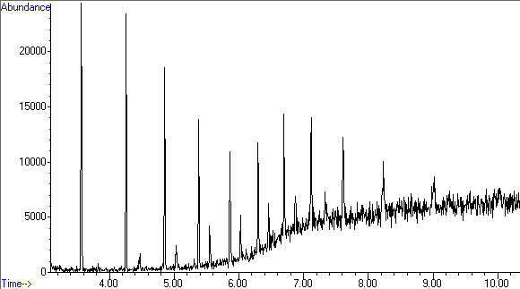

Figure S2.2 Mestanolone and methyltestosterone 250 µg/mL calibration standard (left) and subsequent methanol blank (right) run on three different days: (A) on 22-09-2023, (B) on 30-08-2023, and (C) on 29-08-2023.

Section 3: Method validation data for methyltestosterone quantitation method

3.1 Example Calibration Data

Table S3.1 Methyltestosterone calibration curve data for 22/09/2023
Concentration (µg/mL) | Internal Standard Peak Area | Methyltestosterone Peak Area | Peak Area Ratio
25 | 39379198 | 11484786 | 0.29
50 | 43244698 | 32095176 | 0.74
75 | 42564439 | 50278803 | 1.18
100 | 44745184 | 70205093 | 1.57
150 | 45192170 | 116065893 | 2.57
200 | 47096117 | 153323791 | 3.26
250 | 50660210 | 187416707 | 3.70

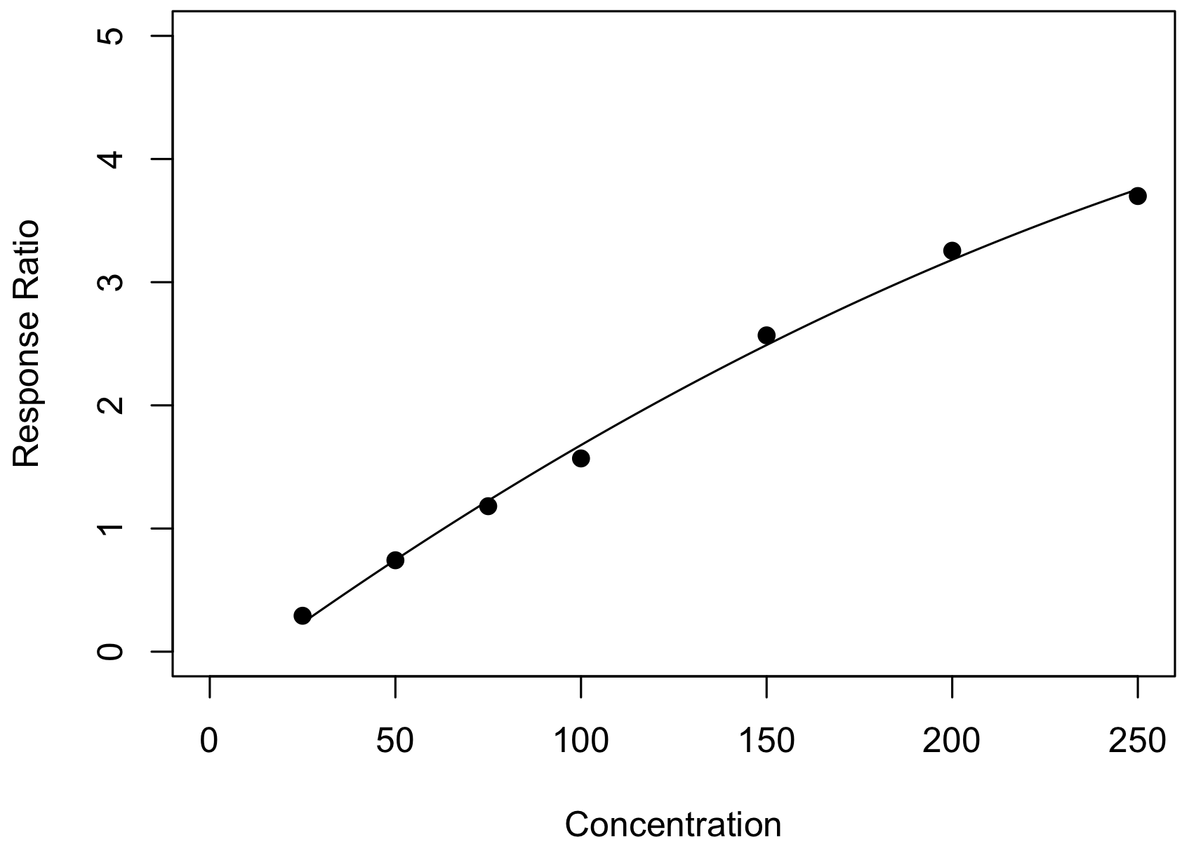
y = (-2.4×10⁻⁵)x² + 0.022x – 0.31
R² = 0.997
Figure S3.1 Methyltestosterone calibration curve from 22/09/2023

Table S3.2 Methyltestosterone Quality Assurance Data for 22/09/2023
Check Standard Concentration (µg/mL) | Methyltestosterone Peak Area | Internal Standard Peak Area | Peak Area Ratio | Calculated Concentration (µg/mL) | Bias  (%)
40 | 24744364 | 42171713 | 0.59 | 42.12 | 5.29
40 | 26415058 | 46624721 | 0.57 | 41.12 | 2.80
125 | 102708244 | 47692615 | 2.15 | 128.40 | 2.72
125 | 106184469 | 50338210 | 2.11 | 125.67 | 0.53

3.2 Limit of Detection (LOD)
To determine the limit of detection, methyltestosterone solutions were prepared at 5, 10, 15 and 20 μg/mL. Each solution was analyzed in replicate five times and the signal to noise ratio calculated. For each replicate, the methyltestosterone peak was compared to the SWGDRUG mass spectral library (version 3.11, released 1 June 2022), and the (reverse) match factor was required to be greater than 850/1,000 for positive identification.

Table S3.3: Full analytical data for calculation of limit of detection
Concentration (µg/mL) | Injection | Max Peak Height | Max Noise Height | R Match | Signal to Noise Ratio
5 | 1 | 27851 | 18209 | 618 | 1.53
5 | 2 | 16977 | 9613 | 568 | 1.77
5 | 3 | 9569 | 7192 | 495 | 1.33
5 | 4 | 7469 | 4257 | 401 | 1.75
5 | 5 | - | - | - | -
10 | 1 | 47217 | 18600 | 799 | 2.54
10 | 2 | 31785 | 11348 | 715 | 2.80
10 | 3 | 18159 | 5556 | 691 | 3.27
10 | 4 | 13106 | 4674 | 597 | 2.80
10 | 5 | 9206 | 3292 | 504 | 2.80
15 | 1 | 94718 | 16721 | 822 | 5.66
15 | 2 | 61838 | 9122 | 813 | 6.78
15 | 3 | 38108 | 6063 | 786 | 6.29
15 | 4 | 28038 | 4579 | 742 | 6.12
15 | 5 | 22735 | 2901 | 696 | 7.84
20 | 1 | 140564 | 16720 | 863 | 8.41
20 | 2 | 86310 | 10288 | 852 | 8.39
20 | 3 | 64611 | 5920 | 829 | 10.91
20 | 4 | 42794 | 4064 | 792 | 10.53
20 | 5 | 36207 | 3399 | 763 | 10.65

Evaluation of the results demonstrated an acceptable signal to noise ratio above 10 μg/mL (>3.3), however these replicates did not meet the requirements specified for positive identification of methyltestosterone. Therefore, the LOD for this method was determined to be 20 μg/mL.

3.3 Lower Limit of Quantitation (LLOQ)

LLOQ was defined using the lowest non-zero calibrator. The 25 μg/mL calibration standard was analyzed across 5 separate runs and the bias was evaluated. As defined in Standard 036 (25), to be accepted, the bias of these replicates was required to fall below 20%.

Table S3.4 Analytical data for calculation of lower limit of quantitation.
Nominal Concentration (µg/mL) | Calculated Concentration (µg/mL)
25 | 26.81
25 | 29.47
25 | 27.78
25 | 25.75
25 | 28.43
Grand Mean | 27.65
Bias | 10.59

Equation 3.1: Calculation of Bias (%)
$$Bias \left(\%\right)=\left\{\frac{Grand Mean of Calculated Concentration-Nominal Concentration}{Nominal Concentration}\right\} × 100$$

The LLOQ was defined as the lowest non-zero calibrator at 25 μg/mL with bias within 10.59% of the nominal concentration.

3.4 Calculation of Bias
To evaluate bias, low, medium and high check standards for methyltestosterone were analyzed over five separate runs. Each run was carried out on a different day, with a new calibration curve. Each check standard was analyzed in triplicate within each run, giving a total of 15 replicates for each concentration. The maximum acceptable bias for each concentration was defined as ±20%. This method was determined to be accurate with bias within ±12% across all check standards.

Table S3.5 Methyltestosterone check standard data for bias calculations.
 | Low Check Standard (40 µg/mL) |  | Medium Check Standard (125 µg/mL) |  | High Check Standard (225 µg/mL)
 | Calculated Conc. | Bias | Calculated Conc. | Bias | Calculated Conc. | Bias
Run 1 | 42.02 | 5.06 | 125.63 | 0.51 | 239.88 | 6.61
Run 1 | 42.34 | 5.85 | 136.07 | 8.86 | 224.88 | 0.05
Run 1 | 42.01 | 5.03 | 136.04 | 8.83 | 243.54 | 8.24
Run 2 | 38.38 | 4.04 | 117.06 | 6.35 | 225.96 | 0.43
Run 2 | 39.66 | 0.86 | 115.53 | 7.57 | 228.02 | 1.34
Run 2 | 39.09 | 2.28 | 118.93 | 4.85 | 233.74 | 3.88
Run 3 | 42.12 | 5.29 | 128.40 | 2.72 | 234.56 | 4.25
Run 3 | 41.12 | 2.80 | 125.67 | 0.53 | 232.21 | 3.20
Run 3 | 39.72 | 0.70 | 125.93 | 0.74 | 250.06 | 11.14
Run 4 | 40.67 | 1.69 | 130.99 | 4.79 | 239.28 | 6.35
Run 4 | 39.50 | 1.24 | 137.12 | 9.69 | 245.91 | 9.29
Run 4 | 41.50 | 3.75 | 137.70 | 10.16 | 247.98 | 10.21
Run 5 | 42.79 | 6.97 | 130.52 | 4.42 | 252.99 | 12.44
Run 5 | 43.12 | 7.81 | 131.82 | 5.46 | 251.71 | 11.87
Run 5 | 43.99 | 9.98 | 131.20 | 4.96 | 244.22 | 8.54
Grand Mean | 41.20 | 4.22 | 128.57 | 5.36 | 239.66 | 6.52

3.5 Calculation of Precision
To evaluate precision, low, medium and high check standards were analyzed over five separate runs. Each run was carried out on a different day, with a new calibration curve. Each check standard was analyzed in triplicate within each run, giving a total of 15 replicates for each concentration. Within-run and between-run precision was calculated as CV% using a single factor ANOVA. The maximum acceptable CV% for each concentration was defined as 20%. This method was determined reproducible with precision determined as being within 3% for within-run and within 16% for between-run results.

Within-run precision was calculated for each concentration using Equation 3.2, where MS_{wg} is the mean square within groups obtained from the ANOVA table.

Equation 3.2: Calculation of Within-Group Precision.
$$Within-Run CV \left(\%\right)= \left[\frac{\sqrt{{MS}_{wg}}}{Grand Mean for each concentration}\right]× 100$$

Between-run precision was calculated for each concentration using Equation 3.3, where MS_{bg} is the mean square between groups obtained from the ANOVA table and n is the number of observations in each group.

Equation 3.3: Calculation of Between-Group Precision.
$$Between-Run CV \left(\%\right)= \left[\frac{\frac{\sqrt{{MS}_{bg}}+\left(n-1\right) × {MS}_{wg}}{n}}{Grand Mean for each concentration}\right]× 100$$

Table 3.6 Low check standard data for precision calculations (40 µg/mL)

Run 1  (µg/mL) | Run 2  (µg/mL) | Run 3  (µg/mL) | Run 4  (µg/mL) | Run 5  (µg/mL)
42.02 | 38.38 | 41.43 | 41.75 | 43.34
42.34 | 39.66 | 41.04 | 42.06 | 42.71
42.01 | 39.09 | 42.09 | 43.79 | 44.49

Anova: Single Factor

Groups | Count | Sum | Average | Variance
Run 1 | 3.00 | 126.37 | 42.12 | 0.04
Run 2 | 3.00 | 117.13 | 39.04 | 0.41
Run 3 | 3.00 | 124.56 | 41.52 | 0.28
Run 4 | 3.00 | 127.60 | 42.53 | 1.21
Run 5 | 3.00 | 130.54 | 43.51 | 0.81
Grand Mean (µg/mL) | 41.20
Within Run Precision | 1.97%
Between Run Precision | 3.32%

Source of Variation | SS | df | MS | F | P-value | F crit
Between Groups | 31.12 | 4.00 | 7.78 | 11.81 | 0.00 | 3.48
Within Groups | 6.59 | 10.00 | 0.66
Total | 37.71 | 14.00

Table 3.7 Medium check standard data for precision calculations (125 µg/mL)

Run 1  (µg/mL) | Run 2  (µg/mL) | Run 3  (µg/mL) | Run 4  (µg/mL) | Run 5  (µg/mL)
125.63 | 117.06 | 128.40 | 130.99 | 130.52
136.07 | 115.53 | 125.67 | 137.12 | 131.82
136.04 | 118.93 | 125.93 | 137.70 | 131.20

Anova: Single Factor

Groups | Count | Sum | Average | Variance
Run 1 | 3.00 | 397.74 | 132.58 | 36.23
Run 2 | 3.00 | 351.52 | 117.17 | 2.90
Run 3 | 3.00 | 380.00 | 126.67 | 2.27
Run 4 | 3.00 | 405.81 | 135.27 | 13.82
Run 5 | 3.00 | 393.54 | 131.18 | 0.42
Grand Mean (µg/mL) | 128.57
Within Run Precision | 2.59%
Between Run Precision | 8.96%

Source of Variation | SS | df | MS | F | P-value | F crit
Between Groups | 603.87 | 4.00 | 150.97 | 13.57 | 0.00 | 3.48
Within Groups | 111.29 | 10.00 | 11.13
Total | 715.15 | 14.00

Table 3.8 High check standard data for precision calculations (225 µg/mL)

Run 1  (µg/mL) | Run 2  (µg/mL) | Run 3  (µg/mL) | Run 4  (µg/mL) | Run 5  (µg/mL)
239.88 | 225.96 | 234.56 | 239.28 | 252.99
224.88 | 228.02 | 232.21 | 245.91 | 251.71
243.54 | 233.74 | 250.06 | 247.98 | 244.22

Anova: Single Factor

Groups | Count | Sum | Average | Variance
Run 1 | 3.00 | 708.30 | 236.10 | 97.77
Run 2 | 3.00 | 687.72 | 229.24 | 16.25
Run 3 | 3.00 | 716.83 | 238.94 | 94.07
Run 4 | 3.00 | 733.17 | 244.39 | 20.66
Run 5 | 3.00 | 748.92 | 249.64 | 22.44
Grand Mean (µg/mL) | 239.66
Within Run Precision | 2.96%
Between Run Precision | 15.85%

Source of Variation | SS | df | MS | F | P-value | F crit
Between Groups | 731.21 | 4.00 | 182.80 | 3.64 | 0.04 | 3.48
Within Groups | 502.35 | 10.00 | 50.24
Total | 1233.56 | 14.00

3.6 Carryover
To evaluate carryover, the highest methyltestosterone calibration standard (250 µg/mL) and subsequent methanol blank were analyzed over three separate runs. Each run was carried out on a different day, with a new calibration curve. This method was determined to produce no carryover.
A

B

C

Figure S3.2 Mestanolone and methyltestosterone 250 µg/mL calibration standard (left) and subsequent methanol blank (right) run on three different days: (A) on 22-09-2023, (B) on 30-08-2023, and (C) on 29-08-2023.

Section 4: Method validation data for metandienone quantitation method

4.1 Example Calibration Data

Table S4.1 Metandienone calibration curve data for 18/10/2023
Concentration (µg/mL) | Internal Standard Peak Area | Metandienone Peak Area | Peak Area Ratio
25 | 18643461 | 44260495 | 0.42
50 | 38421351 | 52511134 | 0.73
75 | 62067689 | 53177887 | 1.17
100 | 86966713 | 55607701 | 1.56
150 | 126863367 | 50860212 | 2.49
200 | 174361476 | 52631100 | 3.31
250 | 198828468 | 53726873 | 3.70

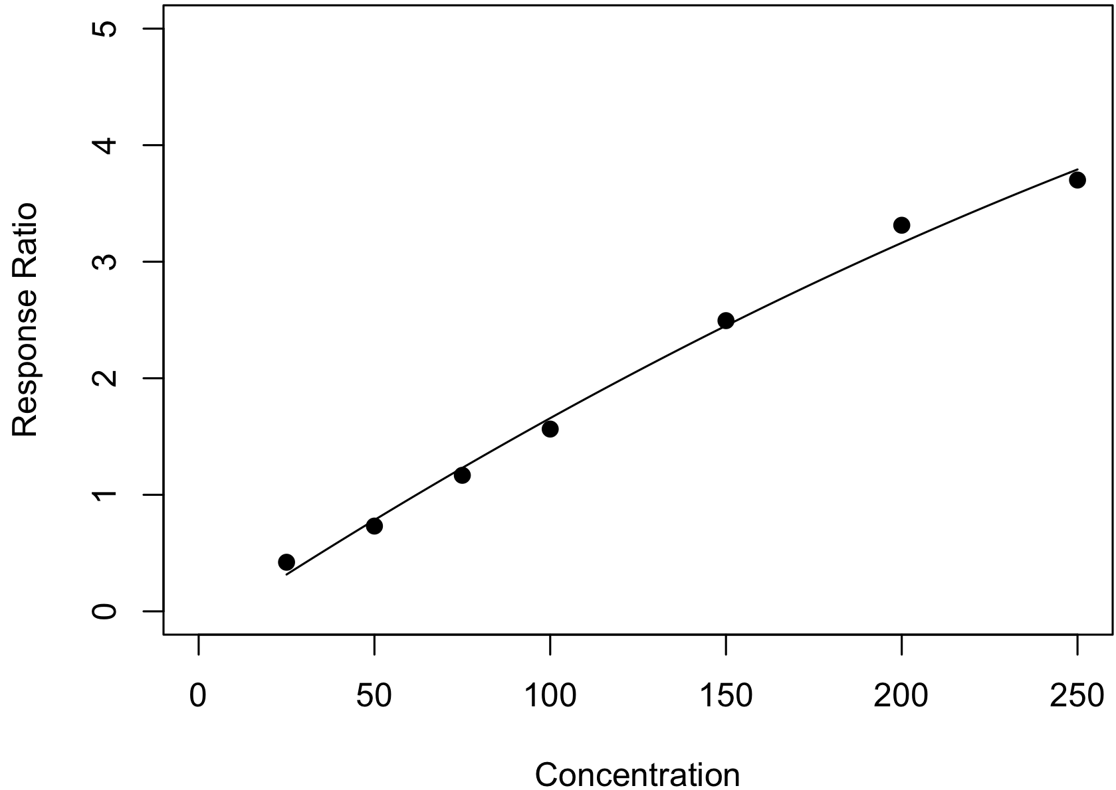
y = (-1.6×10⁻⁵)x² + 0.020x – 0.17
R² = 0.994
Figure S4.1 Metandienone calibration curve from 18/10/2023

Table S4.2 Metandienone Quality Assurance Data for 18/10/2023
Check Standard Concentration (µg/mL) | Metandienone Peak Area | Internal Standard Peak Area | Peak Area Ratio | Calculated Concentration (µg/mL) | Bias  (%)
40 | 26590570 | 50821344 | 0.52 | 35.94 | 10.15
40 | 23950287 | 47618809 | 0.50 | 34.86 | 12.85
125 | 98059699 | 46064323 | 2.13 | 129.09 | 3.27
125 | 104677631 | 52295719 | 2.00 | 121.07 | 3.15

4.2 Limit of Detection (LOD)
To determine the limit of detection, metandienone solutions were prepared at 5, 10, 15 and 20 μg/mL. Each solution was analyzed in replicate five times and the signal to noise ratio calculated. For each replicate, the metandienone peak was compared to the SWGDRUG mass spectral library (version 3.11, released 1 June 2022), and the (reverse) match factor was required to be greater than 850/1,000 for positive identification.

Table S4.3: Full analytical data for calculation of limit of detection
Concentration (µg/mL) | Injection | Max Peak Height | Max Noise Height | R Match | Signal to Noise Ratio
5 | 1 | 34278 | 18070 | 685 | 1.90
5 | 2 | 20329 | 11896 | 599 | 1.71
5 | 3 | 12725 | 8176 | 559 | 1.56
5 | 4 | - | - | - | -
5 | 5 | - | - | - | -
10 | 1 | 66977 | 18839 | 827 | 3.56
10 | 2 | 39849 | 12139 | 796 | 3.28
10 | 3 | 23261 | 6673 | 749 | 3.49
10 | 4 | 16448 | 4890 | 690 | 3.36
10 | 5 | 11719 | 3385 | 697 | 3.46
15 | 1 | 106059 | 18195 | 883 | 5.83
15 | 2 | 63192 | 11508 | 861 | 5.49
15 | 3 | 34307 | 6751 | 792 | 5.08
15 | 4 | 24514 | 4489 | 780 | 5.46
15 | 5 | 21273 | 3123 | 740 | 6.81
20 | 1 | 130518 | 18276 | 877 | 7.14
20 | 2 | 75594 | 11141 | 865 | 6.79
20 | 3 | 47718 | 6409 | 844 | 7.45
20 | 4 | 33585 | 4709 | 822 | 7.13
20 | 5 | 26054 | 3481 | 776 | 7.48

Evaluation of the results demonstrated an acceptable signal to noise ratio above 10 μg/mL (>3.3), however these replicates did not meet the requirements specified for positive identification of metandienone. Therefore, the LOD for this method was determined to be 20 μg/mL.

4.3 Lower Limit of Quantitation (LLOQ)

LLOQ was defined using the lowest non-zero calibrator. The 25 μg/mL calibration standard was analyzed across 5 separate runs and the bias was evaluated. As defined in Standard 036 (25), to be accepted, the bias of these replicates was required to fall below 20%.

Table S4.4 Analytical data for calculation of lower limit of quantitation.
Nominal Concentration (µg/mL) | Calculated Concentration (µg/mL)
25 | 29.18
25 | 30.29
25 | 28.62
25 | 30.26
25 | 30.03
Grand Mean | 29.68
Bias | 18.71%

Equation 4.1: Calculation of Bias (%)
$$Bias \left(\%\right)=\left\{\frac{Grand Mean of Calculated Concentration-Nominal Concentration}{Nominal Concentration}\right\} × 100$$

The LLOQ was defined as the lowest non-zero calibrator at 25 μg/mL with bias within 18.71% of the nominal concentration.

4.4 Calculation of Bias
To evaluate bias, low, medium and high check standards for metandienone were analyzed over five separate runs. Each run was carried out on a different day, with a new calibration curve. Each check standard was analyzed in triplicate within each run, giving a total of 15 replicates for each concentration. The maximum acceptable bias for each concentration was defined as ±20%. This method was determined to be accurate with bias within ±13% across all check standards.

Table 4.5 Metandienone check standard data for bias calculations.
 | Low Check Standard (40 µg/mL) |  | Medium Check Standard (125 µg/mL) |  | High Check Standard (225 µg/mL)
 | Calculated Conc. | Bias | Calculated Conc. | Bias | Calculated Conc. | Bias
Run 1 | 34.88 | 12.81 | 129.12 | 3.30 | 228.52 | 1.56
Run 1 | 35.31 | 11.73 | 131.32 | 5.05 | 216.63 | 3.72
Run 1 | 35.74 | 10.64 | 114.67 | 8.26 | 221.16 | 1.70
Run 2 | 35.82 | 10.45 | 127.63 | 2.10 | 229.58 | 2.03
Run 2 | 36.04 | 9.91 | 135.25 | 8.20 | 245.92 | 9.30
Run 2 | 35.97 | 10.08 | 124.25 | 0.60 | 243.71 | 8.31
Run 3 | 37.73 | 5.69 | 123.15 | 1.48 | 208.42 | 7.37
Run 3 | 37.24 | 6.89 | 127.43 | 1.94 | 217.62 | 3.28
Run 3 | 36.40 | 9.00 | 134.08 | 7.27 | 224.71 | 0.13
Run 4 | 35.23 | 11.93 | 120.66 | 3.47 | 225.66 | 0.29
Run 4 | 35.89 | 10.28 | 121.21 | 3.03 | 212.33 | 5.63
Run 4 | 35.43 | 11.43 | 118.22 | 5.43 | 218.37 | 2.95
Run 5 | 35.94 | 10.15 | 129.09 | 3.27 | 220.14 | 2.16
Run 5 | 34.86 | 12.85 | 121.07 | 3.15 | 224.20 | 0.35
Run 5 | 35.57 | 11.08 | 124.24 | 0.60 | 233.73 | 3.88
Grand Mean | 35.87 | 10.33 | 125.43 | 3.81 | 224.71 | 3.51

4.5 Calculation of Precision
To evaluate precision, low, medium and high check standards were analyzed over five separate runs. Each run was carried out on a different day, with a new calibration curve. Each check standard was analyzed in triplicate within each run, giving a total of 15 replicates for each concentration. Within-run and between-run precision was calculated as CV% using a single factor ANOVA. The maximum acceptable CV% for each concentration was defined as 20%. This method was determined reproducible with precision determined as being within 5% for within-run and within 19% for between-run results.

Within-run precision was calculated for each concentration using Equation 4.2, where MS_{wg} is the mean square within groups obtained from the ANOVA table.

Equation 4.2: Calculation of Within-Group Precision.
$$Within-Run CV \left(\%\right)= \left[\frac{\sqrt{{MS}_{wg}}}{Grand Mean for each concentration}\right]× 100$$

Between-run precision was calculated for each concentration using Equation 4.3, where MS_{bg} is the mean square between groups obtained from the ANOVA table and n is the number of observations in each group.

Equation 4.3: Calculation of Between-Group Precision.
$$Between-Run CV \left(\%\right)= \left[\frac{\frac{\sqrt{{MS}_{bg}}+\left(n-1\right) × {MS}_{wg}}{n}}{Grand Mean for each concentration}\right]× 100$$

Table 4.6 Low check standard data for precision calculations (40 µg/mL)

Run 1  (µg/mL) | Run 2  (µg/mL) | Run 3  (µg/mL) | Run 4  (µg/mL) | Run 5  (µg/mL)
34.88 | 35.82 | 37.73 | 35.23 | 35.94
35.31 | 36.04 | 37.24 | 35.89 | 34.86
35.74 | 35.97 | 36.4 | 35.43 | 35.57

Anova: Single Factor

Groups | Count | Sum | Average | Variance
Run 1 | 3.00 | 105.93 | 35.31 | 0.18
Run 2 | 3.00 | 107.83 | 35.94 | 0.01
Run 3 | 3.00 | 111.37 | 37.12 | 0.45
Run 4 | 3.00 | 106.55 | 35.52 | 0.11
Run 5 | 3.00 | 106.37 | 35.46 | 0.30
Grand Mean (µg/mL) | 35.87
Within Run Precision | 1.28%
Between Run Precision | 3.59%

Source of Variation | SS | df | MS | F | P-value | F crit
Between Groups | 6.56 | 4.00 | 1.64 | 7.69 | 0.00 | 3.48
Within Groups | 2.13 | 10.00 | 0.21
Total | 8.69 | 14.00

Table 4.7 Medium check standard data for precision calculations (125 µg/mL)

Run 1  (µg/mL) | Run 2  (µg/mL) | Run 3  (µg/mL) | Run 4  (µg/mL) | Run 5  (µg/mL)
129.12 | 127.63 | 123.15 | 120.66 | 129.09
131.32 | 135.25 | 127.43 | 121.21 | 121.07
114.67 | 124.25 | 134.08 | 118.22 | 124.24

Anova: Single Factor

Groups | Count | Sum | Average | Variance
Run 1 | 3.00 | 375.11 | 125.04 | 81.81
Run 2 | 3.00 | 387.13 | 129.04 | 31.75
Run 3 | 3.00 | 384.66 | 128.22 | 30.33
Run 4 | 3.00 | 360.09 | 120.03 | 2.53
Run 5 | 3.00 | 374.40 | 124.80 | 16.32
Grand Mean (µg/mL) | 125.43
Within Run Precision | 4.55%
Between Run Precision | 18.94%

Source of Variation | SS | df | MS | F | P-value | F crit
Between Groups | 151.66 | 4.00 | 37.91 | 1.16 | 0.38 | 3.48
Within Groups | 325.48 | 10.00 | 32.55
Total | 477.14 | 14.00

Table 4.8 High check standard data for precision calculations (225 µg/mL)

Run 1  (µg/mL) | Run 2  (µg/mL) | Run 3  (µg/mL) | Run 4  (µg/mL) | Run 5  (µg/mL)
228.52 | 229.58 | 208.42 | 225.66 | 220.14
216.63 | 245.92 | 217.62 | 212.33 | 224.2
221.16 | 243.71 | 224.71 | 218.37 | 233.73

Anova: Single Factor

Groups | Count | Sum | Average | Variance
Run 1 | 3.00 | 666.31 | 222.10 | 36.01
Run 2 | 3.00 | 719.21 | 239.74 | 78.59
Run 3 | 3.00 | 650.75 | 216.92 | 66.71
Run 4 | 3.00 | 656.36 | 218.79 | 44.55
Run 5 | 3.00 | 678.07 | 226.02 | 48.67
Grand Mean (µg/mL) | 224.71
Within Run Precision | 3.30%
Between Run Precision | 18.62%

Source of Variation | SS | df | MS | F | P-value | F crit
Between Groups | 990.43 | 4.00 | 247.61 | 4.51 | 0.02 | 3.48
Within Groups | 549.06 | 10.00 | 54.91
Total | 1539.49 | 14.00

4.6 Carryover
To evaluate carryover, the highest metandienone calibration standard (250 µg/mL) and subsequent methanol blank were analyzed over three separate runs. Each run was carried out on a different day, with a new calibration curve. This method was determined to produce no carryover.
A

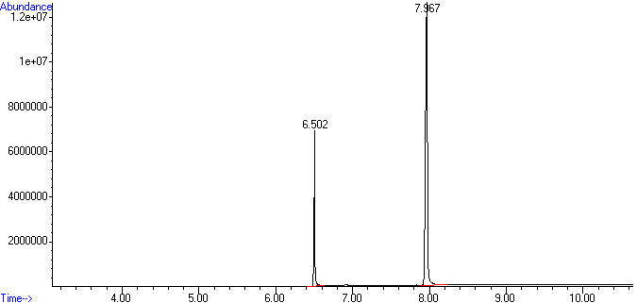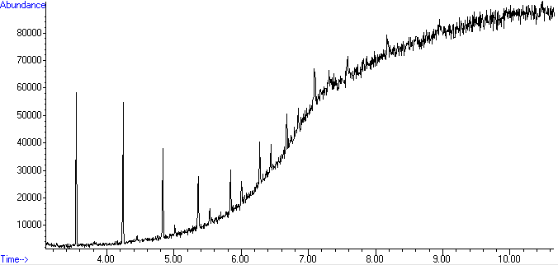
B

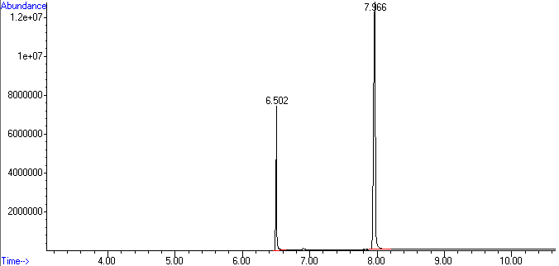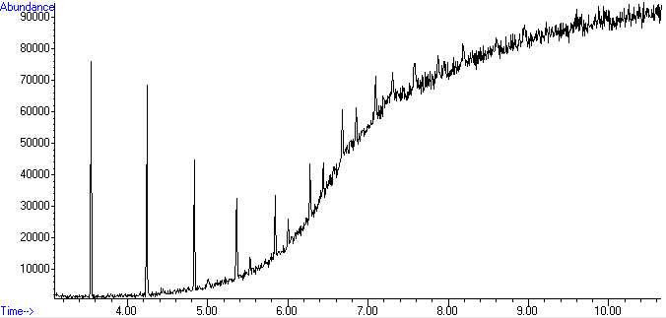
C

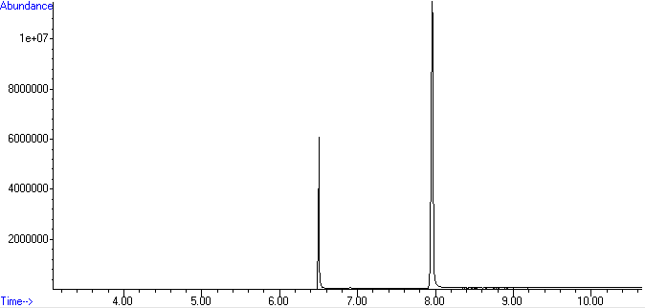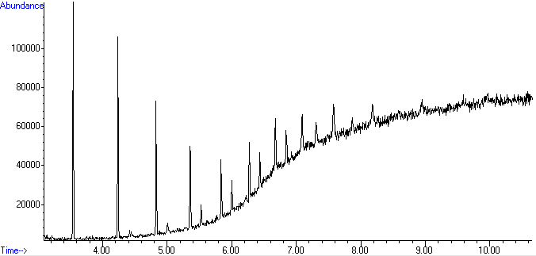

Figure S4.2 Metandienone 250 µg/mL calibration standard (left) and subsequent methanol blank (right) run on three different days: (A) on 10-10-2023, (B) on 11-10-2023, and (C) on 12-10-2023.

Section 5: Method validation data for stanozolol quantitation method

5.1 Example Calibration Data

Table S5.1 Stanozolol calibration curve data for 25/10/2023
Concentration (µg/mL) | Internal Standard Peak Area | Stanozolol Peak Area | Peak Area Ratio
50 | 794289 | 20210144 | 0.04
75 | 1960902 | 20188713 | 0.10
100 | 3867668 | 21659419 | 0.18
150 | 9853401 | 24216046 | 0.41
200 | 16215116 | 25063344 | 0.65
250 | 21898062 | 26968174 | 0.81
300 | 33271189 | 28060543 | 1.19

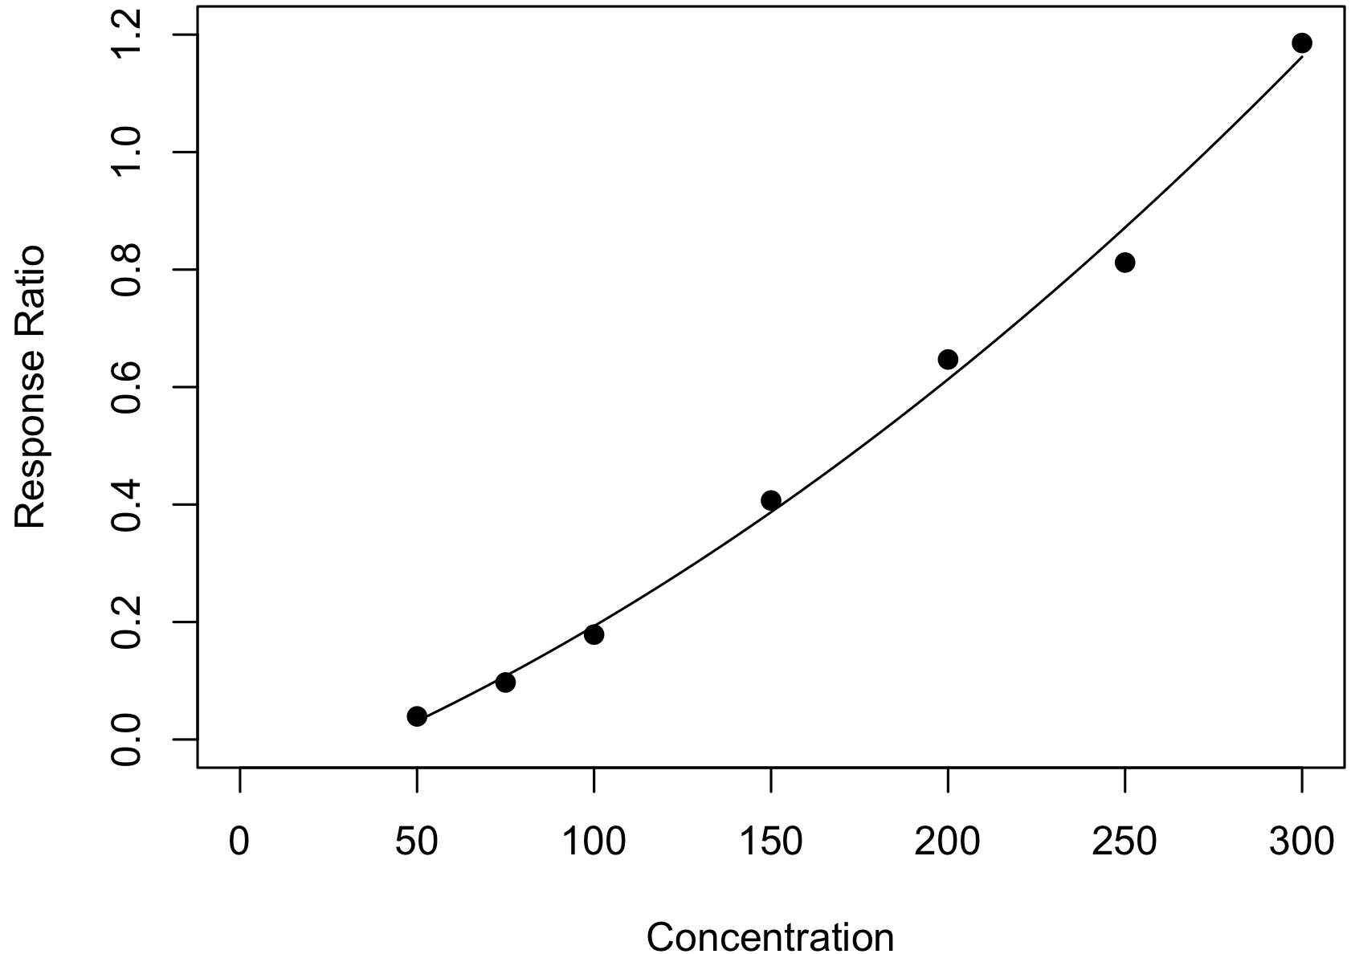
y = (6.4×10⁻⁶)x² + 0.002x – 0.098
R² = 0.994
Figure S5.1 Stanozolol calibration curve from 25/10/2023

Table S5.2 Stanozolol Quality Assurance Data for 25/10/2023
Check Standard Concentration (µg/mL) | Stanozolol Peak Area | Internal Standard Peak Area | Peak Area Ratio | Calculated Concentration (µg/mL) | Bias  (%)
60 | 2637042 | 28134908 | 0.09 | 70.51 | 17.51
60 | 2286534 | 27621269 | 0.08 | 67.04 | 11.73
175 | 14221603 | 26058691 | 0.55 | 185.80 | 6.17
175 | 14558008 | 26869282 | 0.54 | 184.96 | 5.69

5.2 Limit of Detection (LOD)
To determine the limit of detection, stanozolol solutions were prepared at 5, 10, 15 and 20 μg/mL. Each solution was analyzed in replicate five times and the signal to noise ratio calculated. Due to using a SIM method, each replicate of the stanozolol peak was not compared to the SWGDRUG mass spectral library as it was for the other reference standards.

Table S5.3: Full analytical data for calculation of limit of detection
Concentration (µg/mL) | Injection | Max Peak Height | Max Noise Height | Signal to Noise Ratio
10 | 1 | 5765 | 5327 | 1.08
10 | 2 | 5227 | 4489 | 1.16
10 | 3 | 5025 | 4280 | 1.17
10 | 4 | 5011 | 4203 | 1.19
10 | 5 | 4968 | 4331 | 1.15
25 | 1 | 7818 | 4273 | 1.83
25 | 2 | 7854 | 4448 | 1.77
25 | 3 | 8122 | 4701 | 1.73
25 | 4 | 8217 | 4726 | 1.74
25 | 5 | 7743 | 4740 | 1.63
50 | 1 | 12058 | 2828 | 4.26
50 | 2 | 15990 | 2838 | 5.63
50 | 3 | 17793 | 2938 | 6.06
50 | 4 | 19591 | 3015 | 6.50
50 | 5 | 15601 | 4763 | 3.28
75 | 1 | 34778 | 3279 | 10.61
75 | 2 | 43360 | 3412 | 12.71
75 | 3 | 43739 | 3508 | 12.47
75 | 4 | 42311 | 3549 | 11.92
75 | 5 | 30720 | 4916 | 6.25

Evaluation of the results demonstrated an acceptable signal to noise ratio above 50 μg/mL (>3.3); therefore, the LOD for this method was determined to be 50 μg/mL.

5.3 Lower Limit of Quantitation (LLOQ)

LLOQ was defined using the lowest non-zero calibrator. The 50 μg/mL calibration standard was analyzed across 5 separate runs and the bias was evaluated. As defined in Standard 036 (25), to be accepted, the bias of these replicates was required to fall below 20%.

Table S5.4 Analytical data for calculation of lower limit of quantitation.
Nominal Concentration (µg/mL) | Calculated Concentration (µg/mL)
50 | 52.80
50 | 46.83
50 | 55.75
50 | 55.08
50 | 52.75
Grand Mean | 52.64
Bias | 5.28%

Equation 4.1: Calculation of Bias (%)
$$Bias \left(\%\right)=\left\{\frac{Grand Mean of Calculated Concentration-Nominal Concentration}{Nominal Concentration}\right\} × 100$$

The LLOQ was defined as the lowest non-zero calibrator at 50 μg/mL with bias within 5.28% of the nominal concentration.

5.4 Calculation of Bias
To evaluate bias, low, medium and high check standards for stanozolol were analyzed over five separate runs. Each run was carried out on a different day, with a new calibration curve. Each check standard was analyzed in triplicate within each run, giving a total of 15 replicates for each concentration. The maximum acceptable bias for each concentration was defined as ±20%. This method was determined to be accurate with bias within ±18% across all check standards.

Table 5.5 Stanzolol check standard data for bias calculations.
 | Low Check Standard (60 µg/mL) |  | Medium Check Standard (175 µg/mL) |  | High Check Standard (275 µg/mL)
 | Calculated Conc. | Bias | Calculated Conc. | Bias | Calculated Conc. | Bias
Run 1 | 58.51 | 2.49 | 177.89 | 1.65 | 267.57 | 2.70
Run 1 | 62.08 | 3.46 | 178.04 | 1.74 | 269.46 | 2.02
Run 1 | 61.74 | 2.90 | 176.08 | 0.61 | 270.41 | 1.67
Run 2 | 64.44 | 7.41 | 188.89 | 7.94 | 272.44 | 0.93
Run 2 | 65.08 | 8.47 | 193.11 | 10.35 | 284.29 | 3.38
Run 2 | 63.39 | 5.66 | 192.30 | 9.89 | 283.70 | 3.16
Run 3 | 69.10 | 15.17 | 182.29 | 4.17 | 260.61 | 5.23
Run 3 | 65.97 | 9.94 | 176.17 | 0.67 | 261.96 | 4.74
Run 3 | 65.87 | 9.78 | 171.97 | 1.73 | 282.39 | 2.69
Run 4 | 67.40 | 12.33 | 179.99 | 2.85 | 287.13 | 4.41
Run 4 | 65.26 | 8.77 | 190.73 | 8.99 | 279.21 | 1.53
Run 4 | 65.83 | 9.71 | 183.43 | 4.82 | 273.86 | 0.42
Run 5 | 70.51 | 17.51 | 185.80 | 6.17 | 288.23 | 4.81
Run 5 | 67.04 | 11.73 | 184.96 | 5.69 | 271.85 | 1.15
Run 5 | 67.48 | 12.47 | 181.25 | 3.57 | 291.91 | 6.15
Grand Mean | 65.31 | 9.19 | 182.86 | 4.72 | 276.33 | 3.00

5.5 Calculation of Precision
To evaluate precision, low, medium and high check standards were analyzed over five separate runs. Each run was carried out on a different day, with a new calibration curve. Each check standard was analyzed in triplicate within each run, giving a total of 15 replicates for each concentration. Within-run and between-run precision was calculated as CV% using a single factor ANOVA. The maximum acceptable CV% for each concentration was defined as 20%. This method was determined reproducible with precision determined as being within 4% for within-run and within 20% for between-run results.

Within-run precision was calculated for each concentration using Equation 5.2, where MS_{wg} is the mean square within groups obtained from the ANOVA table.

Equation 5.2: Calculation of Within-Group Precision.
$$Within-Run CV \left(\%\right)= \left[\frac{\sqrt{{MS}_{wg}}}{Grand Mean for each concentration}\right]× 100$$

Between-run precision was calculated for each concentration using Equation 5.3, where MS_{bg} is the mean square between groups obtained from the ANOVA table and n is the number of observations in each group.

Equation 5.3: Calculation of Between-Group Precision.
$$Between-Run CV \left(\%\right)= \left[\frac{\frac{\sqrt{{MS}_{bg}}+\left(n-1\right) × {MS}_{wg}}{n}}{Grand Mean for each concentration}\right]× 100$$

Table 4.6 Low check standard data for precision calculations (40 µg/mL)

Run 1  (µg/mL) | Run 2  (µg/mL) | Run 3  (µg/mL) | Run 4  (µg/mL) | Run 5  (µg/mL)
58.51 | 64.44 | 69.10 | 67.40 | 70.51
62.08 | 65.08 | 65.97 | 65.26 | 67.04
61.74 | 63.39 | 65.87 | 65.83 | 67.48

Anova: Single Factor

Groups | Count | Sum | Average | Variance
Run 1 | 3.00 | 182.33 | 60.78 | 3.88
Run 2 | 3.00 | 192.91 | 64.30 | 0.73
Run 3 | 3.00 | 200.94 | 66.98 | 3.37
Run 4 | 3.00 | 198.49 | 66.16 | 1.23
Run 5 | 3.00 | 205.03 | 68.34 | 3.57
Grand Mean (µg/mL) | 65.31
Within Run Precision | 2.45%
Between Run Precision | 5.20%

Source of Variation | SS | df | MS | F | P-value | F crit
Between Groups | 102.85 | 4.00 | 25.71 | 10.06 | 0.00 | 3.48
Within Groups | 25.56 | 10.00 | 2.56
Total | 128.41 | 14.00

Table 4.7 Medium check standard data for precision calculations (125 µg/mL)

Run 1  (µg/mL) | Run 2  (µg/mL) | Run 3  (µg/mL) | Run 4  (µg/mL) | Run 5  (µg/mL)
177.89 | 188.89 | 182.29 | 179.99 | 185.80
178.04 | 193.11 | 176.17 | 190.73 | 184.96
176.08 | 192.30 | 171.97 | 183.43 | 181.25

Anova: Single Factor

Groups | Count | Sum | Average | Variance
Run 1 | 3.00 | 532.01 | 177.34 | 1.19
Run 2 | 3.00 | 574.30 | 191.43 | 5.02
Run 3 | 3.00 | 530.43 | 176.81 | 26.93
Run 4 | 3.00 | 554.15 | 184.72 | 30.08
Run 5 | 3.00 | 552.01 | 184.00 | 5.86
Grand Mean (µg/mL) | 182.86
Within Run Precision | 2.03%
Between Run Precision | 6.94%

Source of Variation | SS | df | MS | F | P-value | F crit
Between Groups | 436.10 | 4.00 | 109.02 | 7.89 | 0.00z | 3.48
Within Groups | 138.16 | 10.00 | 13.82
Total | 574.26 | 14.00

Table 4.8 High check standard data for precision calculations (225 µg/mL)

Run 1  (µg/mL) | Run 2  (µg/mL) | Run 3  (µg/mL) | Run 4  (µg/mL) | Run 5  (µg/mL)
267.57 | 272.44 | 260.61 | 287.13 | 288.23
269.46 | 284.29 | 261.96 | 279.21 | 271.85
270.41 | 283.7 | 282.39 | 273.86 | 291.91

Anova: Single Factor

Groups | Count | Sum | Average | Variance
Run 1 | 3.00 | 807.44 | 269.15 | 2.09
Run 2 | 3.00 | 840.43 | 280.14 | 44.59
Run 3 | 3.00 | 804.96 | 268.32 | 148.93
Run 4 | 3.00 | 832.84 | 277.61 | 68.95
Run 5 | 3.00 | 851.99 | 284.00 | 114.04
Grand Mean (µg/mL) | 276.33
Within Run Precision | 3.15%
Between Run Precision | 19.71%

Source of Variation | SS | df | MS | F | P-value | F crit
Between Groups | 583.97 | 4.00 | 145.99 | 1.29 | 0.34 | 3.48
Within Groups | 1135.94 | 10.00 | 113.59
Total | 1719.90 | 14.00

4.6 Carryover
To evaluate carryover, the highest stanozolol calibration standard (300 µg/mL) and subsequent methanol blank were analyzed over three separate runs. Each run was carried out on a different day, with a new calibration curve. This method was determined to produce some carryover, so a methanol blank.
A

B

C

Figure S4.2 Metandienone 250 µg/mL calibration standard (left) and subsequent methanol blank (right) run on three different days: (A) on 10-10-2023, (B) on 11-10-2023, and (C) on 12-10-2023.
Section 6: Method validation data for oxymetholone quantitation method

6.1 Example Calibration Data

Table S6.1 Oxymetholone calibration curve data for 07/11/2023
Concentration (µg/mL) | Internal Standard Peak Area | Oxymetholone Peak Area | Peak Area Ratio
50 | 4161793 | 36550670 | 0.11
75 | 13083537 | 39483453 | 0.33
100 | 22980584 | 39342463 | 0.58
150 | 47308437 | 40876844 | 1.16
175 | 63057299 | 42575114 | 1.48
200 | 81891155 | 45102542 | 1.82
250 | 110933116 | 45636442 | 2.43

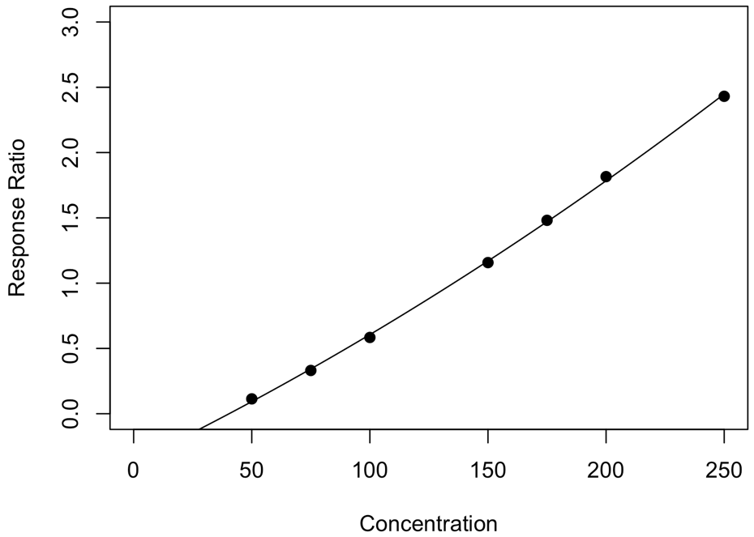
y = (1.0×10⁻⁵)x² + 0.009x – 0.37
R² = 0.999
Figure S6.1 Oxymetholone calibration curve from 07/11/2023

Table S6.2 Oxymetholone Quality Assurance Data for 07/11/2023
Check Standard Concentration (µg/mL) | Oxymetholone Peak Area | Internal Standard Peak Area | Peak Area Ratio | Calculated Concentration (µg/mL) | Bias  (%)
60 | 11957041 | 44018618 | 0.27 | 67.98 | 13.30
60 | 10792128 | 42902914 | 0.25 | 65.99 | 9.99
125 | 36211304 | 41485237 | 0.87 | 124.23 | 0.62
125 | 42988088 | 46221993 | 0.93 | 129.28 | 3.43

6.2 Limit of Detection (LOD)
To determine the limit of detection, oxymetholone solutions were prepared at 5, 10, 15 and 20 μg/mL. Each solution was analyzed in replicate five times and the signal to noise ratio calculated. For each replicate, the oxymetholone peak was compared to the SWGDRUG mass spectral library (version 3.11, released 1 June 2022), and the (reverse) match factor was required to be greater than 850/1,000 for positive identification.

Table S6.3: Full analytical data for calculation of limit of detection
Concentration (µg/mL) | Injection | Max Peak Height | Max Noise Height | R Match | Signal to Noise Ratio
20 | 1 | 68314 | 54931 | 561 | 1.24
20 | 2 | 93188 | 59987 | 637 | 1.55
20 | 3 | 105689 | 69104 | 641 | 1.53
20 | 4 | 112802 | 77294 | 648 | 1.46
20 | 5 | 118160 | 80219 | 648 | 1.47
50 | 1 | 357212 | 71348 | 871 | 5.01
50 | 2 | 398710 | 81026 | 877 | 4.92
50 | 3 | 384904 | 94247 | 867 | 4.08
50 | 4 | 457721 | 97794 | 902 | 4.68
50 | 5 | 397428 | 103621 | 873 | 3.84
100 | 1 | 1447655 | 137944 | 925 | 10.49
100 | 2 | 1708406 | 143890 | 935 | 11.87
100 | 3 | 1691457 | 158974 | 930 | 10.64
100 | 4 | 1698003 | 150386 | 938 | 11.29
100 | 5 | 1813182 | 155348 | 938 | 11.67
150 | 1 | 2873325 | 166561 | 943 | 17.25
150 | 2 | 3340950 | 181344 | 946 | 18.42
150 | 3 | 3459972 | 191806 | 945 | 18.04
150 | 4 | 3366542 | 193002 | 941 | 17.44
150 | 5 | 3549280 | 191929 | 950 | 18.49

Evaluation of the results demonstrated an acceptable signal to noise ratio above 50 μg/mL (>3.3) and these replicates met the requirements specified for positive identification of oxymetholone. Therefore, the LOD for this method was determined to be 50 μg/mL.

6.3 Lower Limit of Quantitation (LLOQ)

LLOQ was defined using the lowest non-zero calibrator. The 50 μg/mL calibration standard was analyzed across 5 separate runs and the bias was evaluated. As defined in Standard 036 (25), to be accepted, the bias of these replicates was required to fall below 20%.

Table S6.4 Analytical data for calculation of lower limit of quantitation.
Nominal Concentration (µg/mL) | Calculated Concentration (µg/mL)
50 | 51.11
50 | 54.56
50 | 50.76
50 | 52.49
50 | 52.14
Grand Mean | 52.21
Bias | 4.42%

Equation 4.1: Calculation of Bias (%)
$$Bias \left(\%\right)=\left\{\frac{Grand Mean of Calculated Concentration-Nominal Concentration}{Nominal Concentration}\right\} × 100$$

The LLOQ was defined as the lowest non-zero calibrator at 50 μg/mL with bias within 4.42% of the nominal concentration.

6.4 Calculation of Bias
To evaluate bias, low, medium and high check standards for oxymetholone were analyzed over five separate runs. Each run was carried out on a different day, with a new calibration curve. Each check standard was analyzed in triplicate within each run, giving a total of 15 replicates for each concentration. The maximum acceptable bias for each concentration was defined as ±20%. This method was determined to be accurate with bias within ±19% across all check standards.

Table 6.5 Oxymetholone check standard data for bias calculations.
 | Low Check Standard (60 µg/mL) |  | Medium Check Standard (125 µg/mL) |  | High Check Standard (225 µg/mL)
 | Calculated Conc. | Bias | Calculated Conc. | Bias | Calculated Conc. | Bias
Run 1 | 67.65 | 12.75 | 128.09 | 2.47 | 222.26 | 1.22
Run 1 | 69.78 | 16.30 | 128.04 | 2.44 | 226.67 | 0.74
Run 1 | 70.99 | 18.32 | 136.84 | 9.47 | 228.70 | 1.65
Run 2 | 66.41 | 10.68 | 113.27 | 9.38 | 225.86 | 0.38
Run 2 | 69.06 | 15.09 | 129.78 | 3.82 | 234.50 | 4.22
Run 2 | 69.41 | 15.68 | 122.25 | 2.20 | 238.45 | 5.98
Run 3 | 66.58 | 10.96 | 126.47 | 1.17 | 213.39 | 5.16
Run 3 | 68.95 | 14.92 | 132.46 | 5.97 | 222.19 | 1.25
Run 3 | 68.62 | 14.37 | 131.09 | 4.87 | 220.52 | 1.99
Run 4 | 66.93 | 11.56 | 120.33 | 3.73 | 217.52 | 3.33
Run 4 | 69.40 | 15.66 | 129.19 | 3.35 | 227.32 | 1.03
Run 4 | 71.27 | 18.78 | 126.34 | 1.07 | 222.47 | 1.12
Run 5 | 67.98 | 13.30 | 124.23 | 0.62 | 227.96 | 1.32
Run 5 | 65.99 | 9.99 | 129.28 | 3.43 | 233.92 | 3.96
Run 5 | 65.46 | 9.10 | 127.78 | 2.22 | 236.68 | 5.19
Grand Mean | 68.30 | 13.83 | 127.03 | 3.75 | 226.56 | 2.57

6.5 Calculation of Precision
To evaluate precision, low, medium and high check standards were analyzed over five separate runs. Each run was carried out on a different day, with a new calibration curve. Each check standard was analyzed in triplicate within each run, giving a total of 15 replicates for each concentration. Within-run and between-run precision was calculated as CV% using a single factor ANOVA. The maximum acceptable CV% for each concentration was defined as 20%. This method was determined reproducible with precision determined as being within 5% for within-run and within 16% for between-run results.

Within-run precision was calculated for each concentration using Equation 6.2, where MS_{wg} is the mean square within groups obtained from the ANOVA table.

Equation 6.2: Calculation of Within-Group Precision.
$$Within-Run CV \left(\%\right)= \left[\frac{\sqrt{{MS}_{wg}}}{Grand Mean for each concentration}\right]× 100$$

Between-run precision was calculated for each concentration using Equation 6.3, where MS_{bg} is the mean square between groups obtained from the ANOVA table and n is the number of observations in each group.

Equation 6.3: Calculation of Between-Group Precision.
$$Between-Run CV \left(\%\right)= \left[\frac{\frac{\sqrt{{MS}_{bg}}+\left(n-1\right) × {MS}_{wg}}{n}}{Grand Mean for each concentration}\right]× 100$$

Table 6.6 Low check standard data for precision calculations (60 µg/mL)

Run 1  (µg/mL) | Run 2  (µg/mL) | Run 3  (µg/mL) | Run 4  (µg/mL) | Run 5  (µg/mL)
67.65 | 66.41 | 66.58 | 66.93 | 67.98
69.78 | 69.06 | 68.95 | 69.4 | 65.99
70.99 | 69.41 | 68.62 | 71.27 | 65.46

Anova: Single Factor

Groups | Count | Sum | Average | Variance
Run 1 | 3.00 | 208.42 | 69.47 | 2.86
Run 2 | 3.00 | 204.88 | 68.29 | 2.69
Run 3 | 3.00 | 204.15 | 68.05 | 1.65
Run 4 | 3.00 | 207.60 | 69.20 | 4.74
Run 5 | 3.00 | 199.43 | 66.48 | 1.77
Grand Mean (µg/mL) | 68.30
Within Run Precision | 2.42%
Between Run Precision | 3.67%

Source of Variation | SS | df | MS | F | P-value | F crit
Between Groups | 16.72 | 4.00 | 4.18 | 1.53 | 0.27 | 3.48
Within Groups | 27.40 | 10.00 | 2.74
Total | 44.13 | 14.00

Table 6.7 Medium check standard data for precision calculations (125 µg/mL)

Run 1  (µg/mL) | Run 2  (µg/mL) | Run 3  (µg/mL) | Run 4  (µg/mL) | Run 5  (µg/mL)
128.09 | 113.27 | 126.47 | 120.33 | 124.23
128.04 | 129.78 | 132.46 | 129.19 | 129.28
136.84 | 122.25 | 131.09 | 126.34 | 127.78

Anova: Single Factor

Groups | Count | Sum | Average | Variance
Run 1 | 3.00 | 392.97 | 130.99 | 25.67
Run 2 | 3.00 | 365.30 | 121.77 | 68.32
Run 3 | 3.00 | 390.02 | 130.01 | 9.85
Run 4 | 3.00 | 375.86 | 125.29 | 20.46
Run 5 | 3.00 | 381.29 | 127.10 | 6.73
Grand Mean (µg/mL) | 127.03
Within Run Precision | 4.03%
Between Run Precision | 15.44%

Source of Variation | SS | df | MS | F | P-value | F crit
Between Groups | 165.87 | 4.00 | 41.47 | 1.58 | 0.25 | 3.48
Within Groups | 262.04 | 10.00 | 26.20
Total | 427.91 | 14.00

Table 6.8 High check standard data for precision calculations (225 µg/mL)

Run 1  (µg/mL) | Run 2  (µg/mL) | Run 3  (µg/mL) | Run 4  (µg/mL) | Run 5  (µg/mL)
222.26 | 225.86 | 213.39 | 217.52 | 227.96
226.67 | 234.5 | 222.19 | 227.32 | 233.92
228.7 | 238.45 | 220.52 | 222.47 | 236.68

Anova: Single Factor

Groups | Count | Sum | Average | Variance
Run 1 | 3.00 | 677.63 | 225.88 | 10.84
Run 2 | 3.00 | 698.81 | 232.94 | 41.46
Run 3 | 3.00 | 656.10 | 218.70 | 21.84
Run 4 | 3.00 | 667.31 | 222.44 | 24.01
Run 5 | 3.00 | 698.56 | 232.85 | 19.86
Grand Mean (µg/mL) | 226.56
Within Run Precision | 2.14%
Between Run Precision | 8.55%

Source of Variation | SS | df | MS | F | P-value | F crit
Between Groups | 478.55 | 4.00 | 119.64 | 5.07 | 0.02 | 3.48
Within Groups | 236.04 | 10.00 | 23.60
Total | 714.59 | 14.00

6.6 Carryover
To evaluate carryover, the highest oxymetholone calibration standard (250 µg/mL) and subsequent methanol blank were analyzed over three separate runs. Each run was carried out on a different day, with a new calibration curve. This method was determined to produce no carryover.
A

B

C

Figure S6.2 Oxymetholone 250 µg/mL calibration standard (left) and subsequent methanol blank (right) run on three different days: (A) on 26-10-2023, (B) on 27-10-2023, and (C) on 31-10-2023.

Section 7: Method validation data for oxandrolone quantitation method

7.1 Example Calibration Data

Table S7.1 Oxandrolone calibration curve data for 10/11/2023
Concentration (µg/mL) | Internal Standard Peak Area | Oxandrolone Peak Area | Peak Area Ratio
25 | 1297696 | 3515473 | 0.37
50 | 3083593 | 3658858 | 0.84
75 | 4737125 | 3507270 | 1.35
100 | 6363221 | 3557872 | 1.79
150 | 9905552 | 3695302 | 2.68
200 | 12812244 | 3447088 | 3.72
250 | 17091712 | 3430814 | 4.98

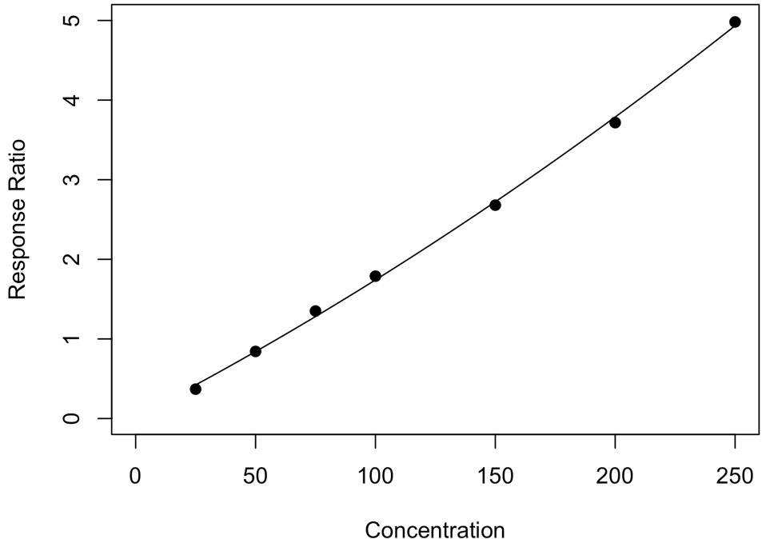
y = (1.7×10⁻⁵)x² + 0.016x + 0.02
R² = 0.999
Figure S7.1 Oxandrolone calibration curve from 10/11/2023

Table S7.2 Oxandrolone Quality Assurance Data for 10/11/2023
Check Standard Concentration (µg/mL) | Oxandrolone Peak Area | Internal Standard Peak Area | Peak Area Ratio | Calculated Concentration (µg/mL) | Bias  (%)
40 | 2080313 | 3204699 | 0.65 | 38.70 | 3.24
40 | 2055033 | 3149671 | 0.65 | 38.90 | 2.75
125 | 7850378 | 3396034 | 2.31 | 129.55 | 3.64
125 | 7635191 | 3175868 | 2.40 | 134.21 | 7.37

7.2 Limit of Detection (LOD)
To determine the limit of detection, oxandrolone solutions were prepared at 5, 10, 15 and 20 μg/mL. Each solution was analyzed in replicate five times and the signal to noise ratio calculated. For each replicate, the oxandrolone peak was compared to the SWGDRUG mass spectral library (version 3.11, released 1 June 2022), and the (reverse) match factor was required to be greater than 850/1,000 for positive identification.

Table S4.3: Full analytical data for calculation of limit of detection
Concentration (µg/mL) | Injection | Max Peak Height | Max Noise Height | R Match | Signal to Noise Ratio
5 | 1 | 205680 | 89782 | 899 | 2.29
5 | 2 | 196437 | 91475 | 873 | 2.15
5 | 3 | 187691 | 92286 | 890 | 2.03
5 | 4 | 176327 | 90352 | 876 | 1.95
5 | 5 | 171233 | 89867 | 882 | 1.91
10 | 1 | 306667 | 89551 | 925 | 3.42
10 | 2 | 313677 | 89570 | 919 | 3.50
10 | 3 | 301590 | 89868 | 925 | 3.36
10 | 4 | 305573 | 89078 | 929 | 3.43
10 | 5 | 317947 | 89573 | 892 | 3.55
15 | 1 | 408855 | 89583 | 933 | 4.56
15 | 2 | 425986 | 92690 | 937 | 4.60
15 | 3 | 427180 | 89167 | 935 | 4.79
15 | 4 | 420635 | 90225 | 933 | 4.66
15 | 5 | 412643 | 87208 | 938 | 4.73
20 | 1 | 566881 | 89578 | 943 | 6.33
20 | 2 | 586902 | 89629 | 943 | 6.55
20 | 3 | 572869 | 89021 | 948 | 6.44
20 | 4 | 560308 | 88315 | 944 | 6.34
20 | 5 | 565270 | 89789 | 947 | 6.30

Evaluation of the results demonstrated an acceptable signal to noise ratio above 10 μg/mL (>3.3) and these replicates met the requirements specified for positive identification of oxandrolone. Therefore, the LOD for this method was determined to be 10 μg/mL.

7.3 Lower Limit of Quantitation (LLOQ)

LLOQ was defined using the lowest non-zero calibrator. The 25 μg/mL calibration standard was analyzed across 5 separate runs and the bias was evaluated. As defined in Standard 036 (25), to be accepted, the bias of these replicates was required to fall below 20%.

Table S7.4 Analytical data for calculation of lower limit of quantitation.
Nominal Concentration (µg/mL) | Calculated Concentration (µg/mL)
25 | 25.07
25 | 22.90
25 | 22.13
25 | 24.77
25 | 21.75
Grand Mean | 23.33
Bias | 6.70%

Equation 4.1: Calculation of Bias (%)
$$Bias \left(\%\right)=\left\{\frac{Grand Mean of Calculated Concentration-Nominal Concentration}{Nominal Concentration}\right\} × 100$$

The LLOQ was defined as the lowest non-zero calibrator at 25 μg/mL with bias within 6.70% of the nominal concentration.

7.4 Calculation of Bias
To evaluate bias, low, medium and high check standards for oxandrolone were analyzed over five separate runs. Each run was carried out on a different day, with a new calibration curve. Each check standard was analyzed in triplicate within each run, giving a total of 15 replicates for each concentration. The maximum acceptable bias for each concentration was defined as ±20%. This method was determined to be accurate with bias within ±13% across all check standards.

Table 7.5 Oxandrolone check standard data for bias calculations.
 | Low Check Standard (40 µg/mL) |  | Medium Check Standard (125 µg/mL) |  | High Check Standard (225 µg/mL)
 | Calculated Conc. | Bias | Calculated Conc. | Bias | Calculated Conc. | Bias
Run 1 | 40.70 | 1.76 | 133.95 | 7.16 | 240.54 | 6.91
Run 1 | 39.91 | 0.22 | 136.70 | 9.36 | 238.11 | 5.82
Run 1 | 38.60 | 3.50 | 132.07 | 5.66 | 229.95 | 2.20
Run 2 | 39.50 | 1.26 | 131.71 | 5.37 | 235.47 | 4.66
Run 2 | 37.70 | 5.75 | 131.14 | 4.91 | 230.99 | 2.66
Run 2 | 38.19 | 4.53 | 130.14 | 4.11 | 224.74 | 0.11
Run 3 | 39.17 | 2.08 | 139.53 | 11.62 | 247.72 | 10.10
Run 3 | 36.11 | 9.72 | 138.00 | 10.40 | 240.53 | 6.90
Run 3 | 36.91 | 7.72 | 133.81 | 7.05 | 239.89 | 6.62
Run 4 | 41.01 | 2.54 | 137.86 | 10.29 | 250.36 | 11.27
Run 4 | 41.36 | 3.41 | 139.85 | 11.88 | 242.67 | 7.85
Run 4 | 41.37 | 3.44 | 132.14 | 5.71 | 232.20 | 3.20
Run 5 | 38.70 | 3.24 | 129.55 | 3.64 | 238.12 | 5.83
Run 5 | 38.90 | 2.75 | 134.21 | 7.37 | 231.12 | 2.72
Run 5 | 37.40 | 6.50 | 128.92 | 3.13 | 223.50 | 0.67
Grand Mean | 39.04 | 3.89 | 133.97 | 7.18 | 236.39 | 5.17

7.5 Calculation of Precision
To evaluate precision, low, medium and high check standards were analyzed over five separate runs. Each run was carried out on a different day, with a new calibration curve. Each check standard was analyzed in triplicate within each run, giving a total of 15 replicates for each concentration. Within-run and between-run precision was calculated as CV% using a single factor ANOVA. The maximum acceptable CV% for each concentration was defined as 20%. This method was determined reproducible with precision determined as being within 3% for within-run and within 14% for between-run results.

Within-run precision was calculated for each concentration using Equation 7.2, where MS_{wg} is the mean square within groups obtained from the ANOVA table.

Equation 7.2: Calculation of Within-Group Precision.
$$Within-Run CV \left(\%\right)= \left[\frac{\sqrt{{MS}_{wg}}}{Grand Mean for each concentration}\right]× 100$$

Between-run precision was calculated for each concentration using Equation 7.3, where MS_{bg} is the mean square between groups obtained from the ANOVA table and n is the number of observations in each group.

Equation 7.3: Calculation of Between-Group Precision.
$$Between-Run CV \left(\%\right)= \left[\frac{\frac{\sqrt{{MS}_{bg}}+\left(n-1\right) × {MS}_{wg}}{n}}{Grand Mean for each concentration}\right]× 100$$

Table 7.6 Low check standard data for precision calculations (40 µg/mL)

Run 1  (µg/mL) | Run 2  (µg/mL) | Run 3  (µg/mL) | Run 4  (µg/mL) | Run 5  (µg/mL)
40.70 | 39.50 | 39.17 | 41.01 | 38.70
39.91 | 37.70 | 36.11 | 41.36 | 38.90
38.60 | 38.19 | 36.91 | 41.37 | 37.40

Anova: Single Factor

Groups | Count | Sum | Average | Variance
Run 1 | 3.00 | 119.21 | 39.74 | 1.13
Run 2 | 3.00 | 115.39 | 38.46 | 0.87
Run 3 | 3.00 | 112.19 | 37.40 | 2.52
Run 4 | 3.00 | 123.74 | 41.25 | 0.04
Run 5 | 3.00 | 115.00 | 38.33 | 0.66
Grand Mean (µg/mL) | 39.04
Within Run Precision | 2.62%
Between Run Precision | 3.99%

Source of Variation | SS | df | MS | F | P-value | F crit
Between Groups | 26.66 | 4.00 | 6.67 | 6.39 | 0.01 | 3.48
Within Groups | 10.43 | 10.00 | 1.04
Total | 37.09 | 14.00

Table 7.7 Medium check standard data for precision calculations (125 µg/mL)

Run 1  (µg/mL) | Run 2  (µg/mL) | Run 3  (µg/mL) | Run 4  (µg/mL) | Run 5  (µg/mL)
133.95 | 131.71 | 139.53 | 137.86 | 129.55
136.70 | 131.14 | 138.00 | 139.85 | 134.21
132.07 | 130.14 | 133.81 | 132.14 | 128.92

Anova: Single Factor

Groups | Count | Sum | Average | Variance
Run 1 | 3.00 | 402.72 | 134.24 | 5.42
Run 2 | 3.00 | 392.99 | 131.00 | 0.63
Run 3 | 3.00 | 411.34 | 137.11 | 8.77
Run 4 | 3.00 | 409.85 | 136.62 | 16.02
Run 5 | 3.00 | 392.68 | 130.89 | 8.35
Grand Mean (µg/mL) | 133.97
Within Run Precision | 2.09%
Between Run Precision | 5.18%

Source of Variation | SS | df | MS | F | P-value | F crit
Between Groups | 105.79 | 4.00 | 26.45 | 3.37 | 0.05 | 3.48
Within Groups | 78.39 | 10.00 | 7.84
Total | 184.18 | 14.00

Table 7.8 High check standard data for precision calculations (225 µg/mL)

Run 1  (µg/mL) | Run 2  (µg/mL) | Run 3  (µg/mL) | Run 4  (µg/mL) | Run 5  (µg/mL)
240.54 | 235.47 | 247.72 | 250.36 | 238.12
238.11 | 230.99 | 240.53 | 242.67 | 231.12
229.95 | 224.74 | 239.89 | 232.20 | 223.50

Anova: Single Factor

Groups | Count | Sum | Average | Variance
Run 1 | 3.00 | 708.60 | 236.20 | 30.77
Run 2 | 3.00 | 691.20 | 230.40 | 29.04
Run 3 | 3.00 | 728.14 | 242.71 | 18.90
Run 4 | 3.00 | 725.23 | 241.74 | 83.09
Run 5 | 3.00 | 692.74 | 230.91 | 53.47
Grand Mean (µg/mL) | 236.39
Within Run Precision | 2.78%
Between Run Precision | 13.56%

Source of Variation | SS | df | MS | F | P-value | F crit
Between Groups | 403.66 | 4.00 | 100.91 | 2.34 | 0.13 | 3.48
Within Groups | 430.56 | 10.00 | 43.06
Total | 834.21 | 14.00

7.6 Carryover
To evaluate carryover, the highest oxandrolone calibration standard (250 µg/mL) and subsequent methanol blank were analyzed over three separate runs. Each run was carried out on a different day, with a new calibration curve. This method was determined to produce no carryover.
A

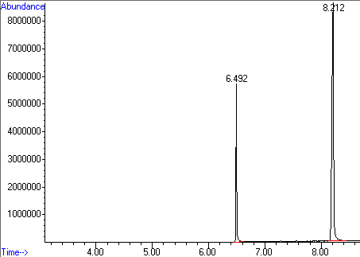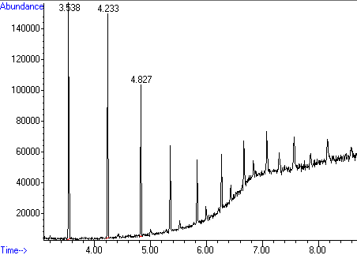
B

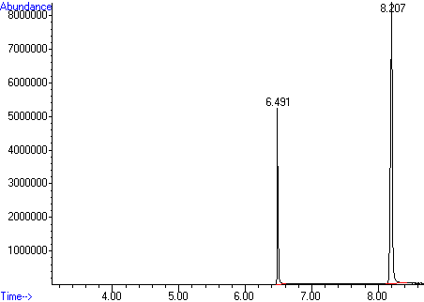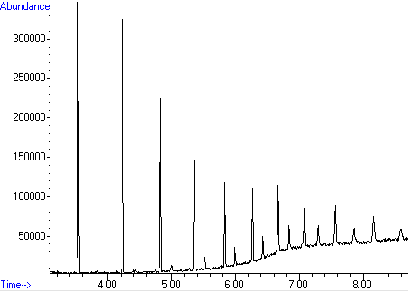
C

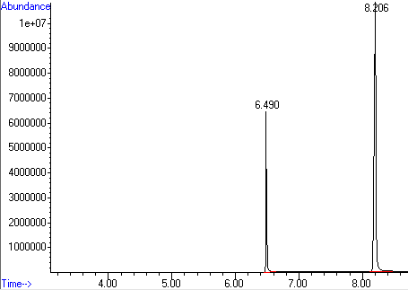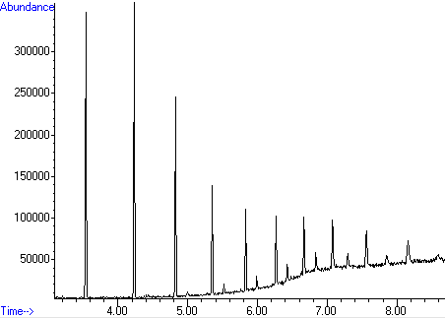

Figure S7.2 Oxandrolone 250 µg/mL calibration standard (left) and subsequent methanol blank (right) run on three different days: (A) on 19-10-2023, (B) on 23-10-2023, and (C) on 25-10-2023.
Section 8: Full qualitative data for samples found to contain AASs seized in Scottish prisons.

Table 8.1. Full AAS qualitative data for seized samples from GC-MS analysis, including retention time (RT), RT of reference (ref) standard, MS library R-Match, and mass-to-charge ratio (m/z). Due to security concerns, the prison establishment is provided as a number.
Sample ID | Prison ID | Date | Initial visual description | Compound Identified | RT (mins) | Ref Standard  RT (mins) | R-Match (x/1000) | m/z (a.m.u)
FL22/0706-1 | 3 | 15/07/2022 | 17x Orange tablets | Stanozolol | 10.144 | 10.165 | 912 | 328
FL22/0706-2 | 3 | 15/07/2022 | 1x Pink tablet | Methyltestosterone | 8.138 | 7.812 | 946 | 302
FL22/0741 | 1 | 22/08/2022 | 1x White tablet fragment | Methyltestosterone | 7.810 | 7.812 | 960 | 302
 |  |  |  | Metandienone | 7.950 | 7.928 | 986 | 300
FL22/0773 | 1 | 18/07/2022 | 1x Round white tablet | Methyltestosterone | 7.809 | 7.812 | 947 | 302
 |  |  |  | Metandienone | 7.947 | 7.928 | 970 | 300
FL22/0815 | 3 | 25/09/2022 | 38x White round tablets | Oxandrolone | 8.125 | 8.105 | 965 | 306
 |  |  |  | Methyltestosterone | 7.809 | 7.812 | 950 | 302
 |  |  |  | Metandienone | 7.967 | 7.928 | 927 | 300
FL22/0957 | 1 | 10/10/2022 | 1x Sample tube containing white powder | Oxandrolone | 8.020 | NA | 930 | 306
 |  |  |  | Etizolam | 9.887 | 9.955 | 923 | 342
FL22/0958 | 1 | 10/10/2022 | 1x Sample tube containing yellow powder | Oxandrolone | 8.101 | 8.105 | 965 | 306
 |  |  |  | Stanozolol | 10.142 | 10.165 | 942 | 328
FL22/0979 | 1 | 27/10/2022 | 1x Sample tube containing white powder | Oxandrolone | 8.077 | 8.105 | 967 | 306
FL22/0982 | 1 | 23/11/2022 | 1x Round white tablet | Metandienone | 7.946 | 7.928 | 968 | 300
 |  |  |  | Methyltestosterone | 7.812 | 7.812 | 949 | 302
FL22/0993-1 | 11 | 04/06/2022 | 1x Round white tablet | Methyltestosterone | 7.815 | 7.812 | 973 | 302
 |  |  |  | Metandienone | 7.948 | 7.928 | 965 | 300
FL22/0993-2 | 11 | 04/06/2022 | 1x Round light blue tablet | Oxandrolone | 8.101 | 8.105 | 969 | 306
 |  |  |  | Methyltestosterone | 7.809 | 7.812 | 897 | 302
 |  |  |  | Metandienone | 7.955 | 7.928 | 930 | 300
FL22/0993-3 | 11 | 04/06/2022 | 1x Round pink tablet | Oxandrolone | 8.099 | 8.105 | 966 | 306
FL22/0993-4 | 11 | 04/06/2022 | 3x White tablets | Oxymetholone | 8.254 | 8.251 | 958 | 332
FL23/0055 | 5 | 10/10/2022 | 2x Fragments of green tablet | Methyltestosterone | 7.810 | 7.812 | 967 | 302
 |  |  |  | Oxymetholone | 8.343 | 8.339 | 937 | 332
 |  |  |  | Androstenedione | 7.829 | NA | 935 | 286
FL23/0081 | 9 | 29/08/2022 | 49x White round tablets | Mestanolone | 7.510 | 7.517 | 963 | 304
 |  |  |  | Oxymetholone | 8.253 | 8.251 | 957 | 332
FL23/0095 | 4 | 09/02/2023 | 5x Round yellow tablets | Oxandrolone | 8.117 | 8.105 | 969 | 306
FL23/0097-1 | 4 | 14/03/2023 | 57x Pink tablets | Oxymetholone | 8.272 | 8.251 | 960 | 332
FL23/0097-2 | 4 | 14/03/2023 | 1.5x white tablets | Oxymetholone | 8.215 | 8.251 | 949 | 332
 |  |  |  | Zopiclone | 10.475 | NA | 963 | 388
FL23/0099 | 4 | 06/03/2023 | 3x Round yellow tablets | Oxandrolone | 8.123 | 8.105 | 969 | 306
FL23/0102 | 1 | 11/04/2023 | 1x Round white tablet | Metandienone | 7.947 | 7.928 | 964 | 300
 |  |  |  | Methyltestosterone | 7.807 | 7.812 | 942 | 302
FL23/0124 | 11 | 08/02/2023 | Loose blue powder in bag | Oxandrolone | 8.119 | 8.105 | 957 | 306
FL23/0133 | 11 | 03/04/2023 | 1x Clear wrap blue powder | Oxandrolone | 8.112 | 8.105 | 953 | 306
FL23/0180-2 | 3 | 03/01/2023 | 50x White round tablets | Stanozolol | 10.141 | 10.165 | 926 | 328
 |  |  |  | Oxymetholone | 8.346 | 8.339 | 956 | 332
 |  |  |  | Metandienone | 7.956 | 7.928 | 971 | 300
 |  |  |  | Methyltestosterone | 7.822 | 7.812 | 935 | 302
FL23/0189 | 1 | 15/05/2023 | 1x Round green tablet | Oxymetholone | 8.345 | 8.339 | 944 | 332
FL23/0203 | 3 | 24/04/2023 | 2x Whole yellow tablets | Oxandrolone | 8.097 | 8.105 | 966 | 306
FL23/0205-1 | 6 | 14/03/2023 | 1x White tablet fragment | Metandienone | 7.958 | 7.928 | 968 | 300
 |  |  |  | Methyltestosterone | 7.808 | 7.812 | 919 | 302
FL23/0205-2 | 6 | 14/03/2023 | 12x Round white tablets | Metandienone | 7.958 | 7.928 | 968 | 300
 |  |  |  | Methyltestosterone | 7.809 | 7.812 | 924 | 302
FL23/0205-3 | 6 | 14/03/2023 | Clingfilm wrap with trace amount of pink powder | Metandienone | 7.937 | 7.928 | 970 | 300
 |  |  |  | Methyltestosterone | 7.955 | NA | 913 | 302
FL23/0210 | 6 | 24/03/2023 | 20x Red tablets | Metandienone | 7.937 | 7.928 | 966 | 300
 |  |  |  | Methyltestosterone | 7.807 | 7.812 | 927 | 302
FL23/0227 | 3 | 20/03/2023 | Red tablets | Metandienone | 7.944 | 7.928 | 964 | 300
 |  |  |  | Methyltestosterone | 7.804 | 7.812 | 925 | 302
FL23/0251 | 3 | 03/06/2023 | 1x paper wrap with green powder, crushed tablets, and whole tablet with score | Oxymetholone | 8.256 | 8.251 | 955 | 332
FL23/0269 | 4 | 27/03/2023 | 20x Broken yellow tablets | Oxandrolone | 8.131 | 8.105 | 966 | 306
FL23/0270-1 | 4 | 03/03/2023 | 2x Round light pink tablets | Oxymetholone | 8.333 | 8.345 | 948 | 332
FL23/0270-2 | 4 | 03/03/2023 | 3x Round reddish pink tablets | Oxymetholone | 8.337 | 8.345 | 957 | 332
FL23/0271 | 4 | 13/05/2023 | Approx. 20x round white tablets | Oxymetholone | 8.346 | 8.345 | 949 | 332
FL23/0272 | 4 | 13/05/2023 | 1x Blue oblong shaped tablet | Oxymetholone | 8.346 | 8.345 | 951 | 332
FL23/0274 | 4 | 13/05/2023 | 1x Round white tablet | Oxymetholone | 8.256 | 8.251 | 892 | 332
 |  |  |  | Zopiclone | 10.991 | NA | 925 | 388
 |  |  |  | Sildenafil | 9.114 | NA | 855 | 474
FL23/0275-1 | 4 | 20/04/2023 | 1x Round yellow tablet | Oxandrolone | 8.127 | 8.105 | 959 | 306
FL23/0276-1 | 4 | 17/03/2023 | 7x Round pink tablets | Oxymetholone | 8.343 | 8.345 | 957 | 332
FL23/0277 | 4 | 07/04/2023 | 6x Whole & 1 half tablet | Oxymetholone | 8.318 | 8.345 | 943 | 332
 |  |  |  | Mirtazapine | 6.501 | NA | 971 | 265
FL23/0278 | 4 | 28/04/2023 | 1x White hexagonal shaped tablet | Oxymetholone | 8.334 | 8.345 | 951 | 332
FL23/0280 | 4 | 13/05/2023 | Large amount of round white tablets | Oxymetholone | 8.255 | 8.251 | 955 | 332
FL23/0292 | 3 | 23/05/2023 | 2x Round white tablet | Metandienone | 7.935 | 7.928 | 964 | 300
 |  |  |  | Oxymetholone | 8.248 | 8.251 | 945 | 332
 |  |  |  | Stanozolol | 10.134 | 10.165 | 888 | 328
FL23/0308 | 12 | 15/11/2022 | 1x white tablet | Oxymetholone | 8.385 | 8.345 | 889 | 332
 |  |  |  | Sertraline | 6.792 | NA | 970 | 305
FL23/0316 | 5 | 27/02/2023 | 50x round white tablets | MDMB-INACA | 7.004 | 7.019 | 885 | 289
 |  |  |  | Oxymetholone | 8.374 | 8.389 | 927 | 332
FL23/0317 | 5 | Jul-23 | Large amount of green tablet fragments | Methyltestosterone | 7.857 | 7.811 | 964 | 302
 |  |  |  | Mestanolone | 7.500 | 7.509 | 947 | 304
FL23/0320 | 5 | 11/03/2023 | 4x whole purple tablets | Oxymetholone | 8.257 | 8.251 | 949 | 332
 |  |  |  | Metandienone | 7.933 | 7.928 | 966 | 300
FL23/0323 | 5 | 11/03/2023 | Loose herbal material | Metandienone | 9.245 | NA | 928 | 300
 |  |  |  | Δ⁹-THC | 8.640 | NA | 970 | 314
FL23/0328-1 | 6 | 14/07/2023 | 1x Round blue tablet | Oxymetholone | 8.351 | 8.345 | 930 | 332
 |  |  |  | Amitriptyline | 6.267 | NA | 960 | 277
FL23/0341 | 7 | 25/07/2023 | 1x Round white tablet | Oxymetholone | 8.370 | 8.389 | 931 | 332
FL23/0344 | 7 | 08/07/2023 | Small amount of orange substance | Etizolam | 10.468 | 10.267 | 945 | 342
 |  |  |  | Oxymetholone | 8.372 | 8.389 | 950 | 332
 |  |  |  | Mestanolone | 7.500 | 7.518 | 950 | 304
FL23/0346 | 7 | 22/06/2023 | 23x round yellow tablets | Oxymetholone | 8.374 | 8.389 | 946 | 332
FL23/0352 | 10 | 15/02/2023 | 1x bag crushed soap-like material | Mestanolone | 7.500 | 7.518 | 948 | 304
FL23/0358 | 10 | 15/03/2023 | Approx. 20x round pink tablets | Oxymetholone | 8.271 | 8.251 | 944 | 332
 |  |  |  | Metandienone | 7.945 | 7.928 | 886 | 304
FL23/0359 | 10 | 05/04/2023 | 4x Round green tablets + 2x fragments | Oxymetholone | 8.347 | 8.345 | 947 | 332
FL23/0360 | 10 | 02/05/2023 | 10x Round blue tablets | Oxymetholone | 8.351 | 8.345 | 905 | 332
 |  |  |  | Amitriptyline | 6.264 | NA | 967 | 277

Section 9: Example photographs of other samples types seized from the Scottish prisons found positive for AASs.

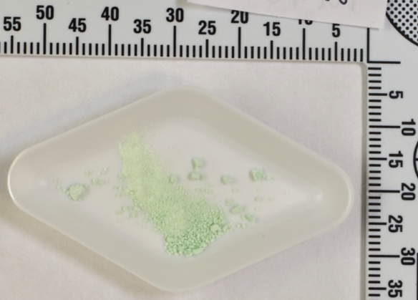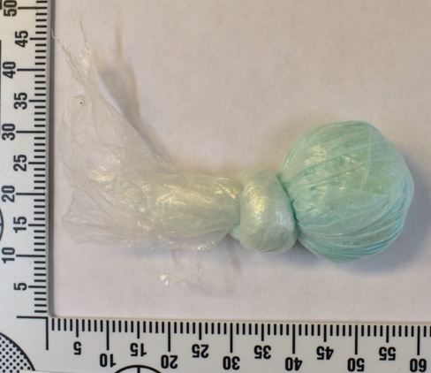
(b)
(a)
(c)
(d)
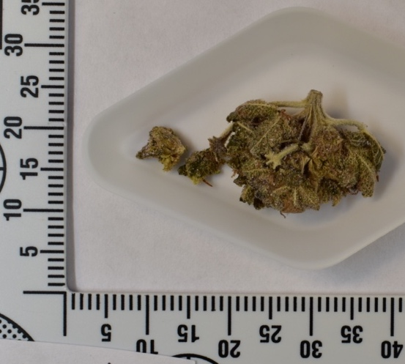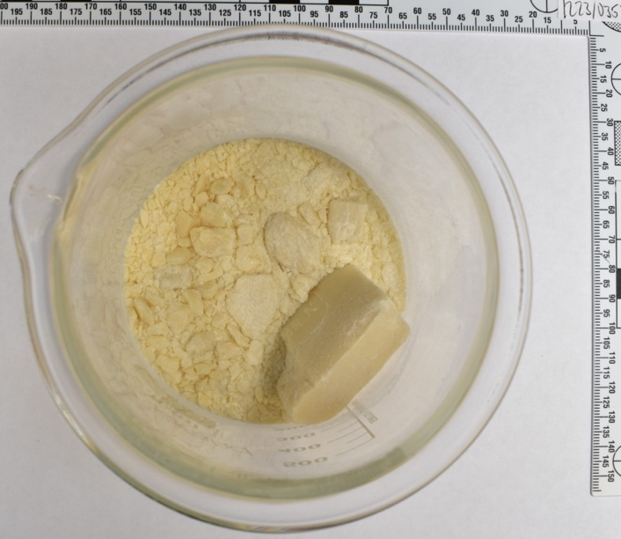
Figure 9.1. Examples of other sample types seized from the Scottish prisons found positive for AASs: (a) green powder seized 7th February 2022 found positive for oxymetholone and mestanolone; (b) blue powder seized 3rd April 2023 found positive for oxandrolone; (c) herbal material seized 11th March 2023 found positive for metandienone and Δ⁹-THC; and (d) pieces of crushed soap bar-like material seized 15th February 2023 found positive for mestanolone.

Section 10: Full tablet markings data for samples of tablets found to contain AASs seized in Scottish prisons.

Table 10.1. Full tablet markings data for samples of tablets found to contain AASs seized in Scottish prisons. For samples that only contained fragments, so the shape and markings of the tablets could not be determined, “NA” is written in the table. “opp” indicates marking on opposite side of the tablet.

Sample ID | Prison ID | Date | Steroid Identified | Colour | Shape | Markings
FL22/0706-1 | 3 | 15/07/2022 | Stanozolol | Peach | Round | Score
FL22/0706-2 | 3 | 15/07/2022 | Methyltestosterone | Pink | Round | Unknown
FL22/0741 | 1 | 22/08/2022 | Methyltestosterone | White | Round | Score
FL22/0741 | 1 | 22/08/2022 | Metandienone | White | Round | Score
FL22/0773 | 1 | 18/07/2022 | Methyltestosterone | White | Round | Score
FL22/0773 | 1 | 18/07/2022 | Metandienone | White | Round | Score
FL22/0815 | 3 | 25/09/2022 | Oxandrolone | White | Round | Score
FL22/0815 | 3 | 25/09/2022 | Methyltestosterone | White | Round | Score
FL22/0815 | 3 | 25/09/2022 | Metandienone | White | Round | Score
FL22/0982 | 1 | 23/11/2022 | Metandienone | White | Round | Score
FL22/0982 | 1 | 23/11/2022 | Methyltestosterone | White | Round | Score
FL22/0993-1 | 11 | 04/06/2022 | Methyltestosterone | White | Round | Score
FL22/0993-1 | 11 | 04/06/2022 | Metandienone | White | Round | Score
FL22/0993-2 | 11 | 04/06/2022 | Oxandrolone | Light blue | Round | Score
FL22/0993-2 | 11 | 04/06/2022 | Methyltestosterone | Light blue | Round | Score
FL22/0993-2 | 11 | 04/06/2022 | Metandienone | Light blue | Round | Score
FL22/0993-3 | 11 | 04/06/2022 | Oxandrolone | Light pink | Round | Score
FL22/0993-4 | 11 | 04/06/2022 | Oxymetholone | White | Round | Score
FL23/0055 | 5 | 10/10/2022 | Methyltestosterone | Green | NA | NA
FL23/0055 | 5 | 10/10/2022 | Oxymetholone | Green | NA | NA
FL23/0055 | 5 | 10/10/2022 | Androstenedione | Green | NA | NA
FL23/0081 | 9 | 29/08/2022 | Mestanolone | White | Round | Score
FL23/0081 | 9 | 29/08/2022 | Oxymetholone | White | Round | Score
FL23/0095 | 4 | 09/02/2023 | Oxandrolone | Yellow | Round | Score
FL23/0097-1 | 4 | 14/03/2023 | Oxymetholone | Pink | Round | Score
FL23/0097-2 | 4 | 14/03/2023 | Oxymetholone | White | Oval | E/L
FL23/0097-2 | 4 | 14/03/2023 | Zopiclone | White | Oval | E/L
FL23/0099 | 4 | 06/03/2023 | Oxandrolone | Yellow | Round | Score
FL23/0102 | 1 | 11/04/2023 | Metandienone | White | Round | Score
FL23/0102 | 1 | 11/04/2023 | Methyltestosterone | White | Round | Score
FL23/0180-2 | 3 | 03/01/2023 | Stanozolol | White | Round | Score
FL23/0180-2 | 3 | 03/01/2023 | Oxymetholone | White | Round | Score
FL23/0180-2 | 3 | 03/01/2023 | Metandienone | White | Round | Score
FL23/0180-2 | 3 | 03/01/2023 | Methyltestosterone | White | Round | Score
FL23/0189 | 1 | 15/05/2023 | Oxymetholone | Green | Round | SHREE opp Score
FL23/0203 | 3 | 24/04/2023 | Oxandrolone | Yellow | Round | C/R
FL23/0205-1 | 6 | 14/03/2023 | Metandienone | White | NA | NA
FL23/0205-1 | 6 | 14/03/2023 | Methyltestosterone | White | NA | NA
FL23/0205-2 | 6 | 14/03/2023 | Metandienone | White | Round | None
FL23/0205-2 | 6 | 14/03/2023 | Methyltestosterone | White | Round | None
FL23/0210 | 6 | 24/03/2023 | Metandienone | Red | Round | Score
FL23/0210 | 6 | 24/03/2023 | Methyltestosterone | Red | Round | Score
FL23/0227 | 3 | 20/03/2023 | Metandienone | Red | Round | Score
FL23/0227 | 3 | 20/03/2023 | Methyltestosterone | Red | Round | Score
FL23/0251 | 3 | 03/06/2023 | Oxymetholone | Green | Round | Score
FL23/0269 | 4 | 27/03/2023 | Oxandrolone | Yellow | Round | Score
FL23/0270-1 | 4 | 03/03/2023 | Oxymetholone | Light pink | Round | None
FL23/0270-2 | 4 | 03/03/2023 | Oxymetholone | Red | Round | Score
FL23/0271 | 4 | 13/05/2023 | Oxymetholone | White | Round | Score
FL23/0271 | 4 | 13/05/2023 | Metandienone | White | Round | Score
FL23/0272 | 4 | 13/05/2023 | Oxymetholone | Blue coated | Egg | 100
FL23/0274 | 4 | 13/05/2023 | Oxymetholone | White | Round | Score
FL23/0274 | 4 | 13/05/2023 | Zopiclone | White | Round | Score
FL23/0274 | 4 | 13/05/2023 | Sildenafil | White | Round | Score
FL23/0275-1 | 4 | 20/04/2023 | Oxandrolone | Yellow | Round | Score
FL23/0276-1 | 4 | 17/03/2023 | Oxymetholone | Red | Round | Score
FL23/0277 | 4 | 07/04/2023 | Oxymetholone | Orange-red coated | Oval | I/ opp score
FL23/0277 | 4 | 07/04/2023 | Mirtazapine | Orange-red coated | Oval | I/ opp score
FL23/0278 | 4 | 28/04/2023 | Oxymetholone | White | Hexagonal | None
FL23/0280 | 4 | 13/05/2023 | Oxymetholone | White | Round | None
FL23/0292 | 3 | 23/05/2023 | Metandienone | White | Round | Score
FL23/0292 | 3 | 23/05/2023 | Oxymetholone | White | Round | Score
FL23/0292 | 3 | 23/05/2023 | Stanozolol | White | Round | Score
FL23/0308 | 12 | 15/11/2022 | Oxymetholone | White | Oblong | 100 opp score
FL23/0308 | 12 | 15/11/2022 | Sertraline | White | Oblong | 100 opp score
FL23/0316 | 5 | 27/02/2023 | MDMB-INACA | White | Round | T 50 opp score
FL23/0316 | 5 | 27/02/2023 | Oxymetholone | White | Round | T 50 opp score
FL23/0317 | 5 | Jul-23 | Methyltestosterone | Green | NA | NA
FL23/0320 | 5 | 11/03/2023 | Oxymetholone | Purple | Round | Score
FL23/0320 | 5 | 11/03/2023 | Metandienone | Purple | Round | Score
FL23/0328-1 | 6 | 14/07/2023 | Oxymetholone | Blue | Round | C opp AA
FL23/0328-1 | 6 | 14/07/2023 | Amitriptyline | Blue | Round | C opp AA
FL23/0341 | 7 | 25/07/2023 | Oxymetholone | White | Round | None
FL23/0346 | 7 | 22/06/2023 | Oxymetholone | Yellow | Round | None
FL23/0358 | 10 | 15/03/2023 | Oxymetholone | Pink | Round | Score
FL23/0358 | 10 | 15/03/2023 | Metandienone | Pink | Round | Score
FL23/0359 | 10 | 05/04/2023 | Oxymetholone | Green | Round | SHREE opp Score
FL23/0360 | 10 | 02/05/2023 | Oxymetholone | Blue | Round | D
FL23/0360 | 10 | 02/05/2023 | Amitriptyline | Blue | Round | D

Section 11: Full quantitative data for samples found to contain AASs seized in Scottish Prisons.

Table 11.1. Full AAS quantitation data for seized samples.
Sample ID | Compound Identified | Sample Format | Mass of single tablet or powder (mg) | Response | IS Response | Response Ratio | Conc. (ug/mL) | Mass of powder sampled (mg) | Dilution | Conc. (ug/mg) | % AAS in sample | AAS per tablet (mg)
FL22/0706-1 | Stanozolol | Tablet | 369.6 | 3727367 | 29657727 | 0.13 | 80.36 | 10.0 | 10 | 40.18 | 4.02% | 14.85
FL22/0706-2 | Methyltestosterone | Tablet | 218.3 | <LOQ
FL22/0741 | Methyltestosterone | Tablet | 174.8 | <LOQ
FL22/0741 | Metandienone | Tablet | 174.8 | 136097318 | 52395888 | 2.60 | 162.92 | 10.0 | 20 | 162.92 | 16.29%
FL22/0773 | Methyltestosterone | Tablet | 265.7 | <LOQ
FL22/0773 | Metandienone | Tablet | 265.7 | 98945280 | 56034109 | 1.77 | 111.48 | 10.0 | 20 | 111.48 | 11.15% | 29.62
FL22/0815 | Oxandrolone | Tablet | 155.3 | 10334498 | 2972682 | 3.48 | 173.57 | 10.0 | 20 | 173.57 | 17.36% | 26.96
FL22/0815 | Methyltestosterone | Tablet | 155.3 | 13826444 | 55801565 | 0.25 | 25.93 | 10.0 | 2 | 2.59 | 0.26% | 0.40
FL22/0815 | Metandienone | Tablet | 155.3 | <LOQ
FL22/0957 | Oxandrolone | Powder | 485.7 | <LOQ
FL22/0958 | Oxandrolone | Powder | 324.8 | 11579682 | 3227088 | 3.59 | 190.92 | 10.1 | 10 | 95.46 | 9.55% | -
FL22/0958 | Stanozolol | Powder | 324.8 | 8565250 | 28229300 | 0.30 | 129.44 | 10.1 | 10 | 64.08 | 6.41% | -
FL22/0979 | Oxandrolone | Powder | 197.9 | 7663091 | 3276234 | 2.34 | 130.93 | 10.0 | 10 | 65.47 | 6.55% | -
FL22/0982 | Metandienone | Tablet | 253 | 160904788 | 55998620 | 2.87 | 172.34 | 10.0 | 40 | 344.69 | 34.47% | 87.21
FL22/0982 | Methyltestosterone | Tablet | 253 | 15493329 | 60189004 | 0.26 | 26.41 | 10.0 | 2 | 2.64 | 0.26% | 0.67
FL22/0993-1 | Methyltestosterone | Tablet | 106.6 | 119227308 | 43276992 | 2.75 | 160.16 | 10.0 | 10 | 80.08 | 8.01% | 8.54
FL22/0993-1 | Metandienone | Tablet | 106.6 | 126514787 | 48578489 | 2.60 | 160.35 | 10.0 | 30 | 240.53 | 24.05% | 25.64
FL22/0993-2 | Oxandrolone | Tablet | 197.5 | 4878136 | 3090370 | 1.58 | 91.30 | 10.0 | 10 | 45.65 | 4.56% | 9.02
FL22/0993-2 | Methyltestosterone | Tablet | 197.5 | <LOQ
FL22/0993-2 | Metandienone | Tablet | 197.5 | <LOQ
FL22/0993-3 | Oxandrolone | Tablet | 207.3 | 4892111 | 3135738 | 1.56 | 90.31 | 10.0 | 10 | 45.15 | 4.52% | 9.36
FL22/0993-4 | Oxymetholone | Tablet | 123.3 | 4351221 | 3584098 | 1.21 | 156.20 | 10.0 | 30 | 234.31 | 23.43% | 28.89
FL23/0055 | Methyltestosterone | Tablet | 147.1 | 78061549 | 44015263 | 1.77 | 103.52 | 10.0 | 10 | 51.76 | 5.18% | 7.61
FL23/0055 | Oxymetholone | Tablet | 147.1 | 8593726 | 50216311 | 0.17 | 57.95 | 10.0 | 2 | 5.80 | 0.58% | 0.85
FL23/0055 | Androstenedione | Tablet | 147.1 | NA
FL23/0081 | Mestanolone | Tablet | 114.7 | 36309112 | 57278663 | 0.63 | 40.86 | 10.0 | 2 | 4.09 | 0.41% | 0.47
FL23/0081 | Oxymetholone | Tablet | 114.7 | 1546516 | 3475962 | 0.44 | 91.03 | 10.1 | 30 | 135.19 | 13.52% | 15.51
FL23/0095 | Oxandrolone | Tablet | 188.8 | 13583352 | 2979031 | 4.56 | 219.34 | 10.0 | 20 | 219.34 | 21.93% | 41.41
FL23/0097-1 | Oxymetholone | Tablet | 183.4 | 6768608 | 3632270 | 1.86 | 190.63 | 10.0 | 20 | 190.63 | 19.06% | 34.96
FL23/0097-2 | Oxymetholone | Tablet | 143.2 | <LOQ
FL23/0099 | Oxandrolone | Tablet | 185.5 | 10134169 | 2953614 | 3.43 | 171.59 | 10.0 | 20 | 171.59 | 17.16% | 31.83
FL23/0102 | Metandienone | Tablet | 217.6 | 107847503 | 54931965 | 1.96 | 123.56 | 10.0 | 10 | 61.78 | 6.18% | 13.44
FL23/0102 | Methyltestosterone | Tablet | 217.6 | <LOQ
FL23/0124 | Oxandrolone | Powder | 840.7 | 13346767 | 2795196 | 4.77 | 228.14 | 10.0 | 20 | 228.14 | 22.81% | -
FL23/0133 | Oxandrolone | Powder | 1017.8 | 9919017 | 3303592 | 3.00 | 152.69 | 10.0 | 20 | 152.69 | 15.27% | -
FL23/0180-2 | Stanozolol | Tablet | 124.5 | 15185472 | 30843627 | 0.49 | 174.16 | 10.0 | 10 | 87.08 | 8.71% | 10.84
FL23/0180-2 | Oxymetholone | Tablet | 124.5 | 93246976 | 47168086 | 1.98 | 214.93 | 9.9 | 10 | 108.55 | 10.86% | 13.51
FL23/0180-2 | Metandienone | Tablet | 124.5 | 180869581 | 57022841 | 3.17 | 199.36 | 10.0 | 10 | 99.68 | 9.97% | 12.41
FL23/0180-2 | Methyltestosterone | Tablet | 124.5 | <LOQ
FL23/0189 | Oxymetholone | Tablet | 153.9 | 90567330 | 48005932 | 1.89 | 207.99 | 10.0 | 20 | 207.99 | 20.80% | 32.01
FL23/0203 | Oxandrolone | Tablet | 196 | 3502614 | 3081443 | 1.14 | 66.94 | 10.0 | 10 | 33.47 | 3.35% | 6.56
FL23/0205-1 | Metandienone | Tablet | 22.4 | 207360837 | 62816118 | 3.30 | 207.66 | 10.0 | 10 | 103.83 | 10.38% | 2.33
FL23/0205-1 | Methyltestosterone | Tablet | 22.4 | <LOQ
FL23/0205-2 | Metandienone | Tablet | 122 | 190777996 | 60096167 | 3.17 | 199.53 | 10.0 | 10 | 99.77 | 9.98% | 12.17
FL23/0205-2 | Methyltestosterone | Tablet | 122 | <LOQ
FL23/0205-3 | Metandienone | Powder | 2.5 | NA
FL23/0205-3 | Methyltestosterone | Powder | 2.5
FL23/0210 | Metandienone | Tablet | 212.4 | 32318254 | 55835113 | 0.58 | 40.52 | 10.0 | 10 | 20.26 | 2.03% | 4.30
FL23/0210 | Methyltestosterone | Tablet | 212.4 | <LOQ
FL23/0227 | Metandienone | Tablet | 204.1 | 79233679 | 54103372 | 1.46 | 93.20 | 10.0 | 10 | 46.60 | 4.66% | 9.51
FL23/0227 | Methyltestosterone | Tablet | 204.1 | <LOQ
FL23/0251 | Oxymetholone | Tablet | 235.3 | 3968540 | 3367315 | 1.18 | 153.45 | 10.0 | 20 | 153.45 | 15.35% | 36.11
FL23/0269 | Oxandrolone | Tablet | 195.2 | 12062589 | 2876576 | 4.19 | 204.15 | 10.0 | 20 | 204.15 | 20.41% | 39.85
FL23/0270-1 | Oxymetholone | Tablet | 181.5 | 16456963 | 43808774 | 0.38 | 78.16 | 10.1 | 20 | 77.38 | 7.74% | 14.04
FL23/0270-2 | Oxymetholone | Tablet | 197.3 | 19192641 | 43450426 | 0.44 | 84.51 | 10.1 | 20 | 83.68 | 8.37% | 16.51
FL23/0271 | Oxymetholone | Tablet | 116.6 | 93438923 | 42106880 | 2.22 | 233.18 | 10.0 | 30 | 349.77 | 34.98% | 40.78
FL23/0272 | Oxymetholone | Tablet | 611.4 | <LOQ
FL23/0274 | Oxymetholone | Tablet | 172.7 | <LOQ
FL23/0275-1 | Oxandrolone | Tablet | 185.2 | 10169314 | 2751390 | 3.70 | 183.06 | 10.0 | 20 | 183.06 | 18.31% | 33.90
FL23/0276-1 | Oxymetholone | Tablet | 201.1 | 62089770 | 41709779 | 1.49 | 176.48 | 10.2 | 20 | 173.02 | 17.30% | 34.79
FL23/0277 | Oxymetholone | Tablet | 302.1 | <LOQ
FL23/0278 | Oxymetholone | Tablet | 209.8 | 17721847 | 48859997 | 0.36 | 76.90 | 10.1 | 20 | 76.14 | 7.61% | 15.97
FL23/0280 | Oxymetholone | Tablet | 307.7 | 3517858 | 3497024 | 1.01 | 139.77 | 10.0 | 20 | 139.77 | 13.98% | 43.01
FL23/0292 | Metandienone | Tablet | 126.4 | 77455758 | 59932457 | 1.29 | 76.53 | 10.0 | 10 | 38.26 | 3.83% | 4.84
FL23/0292 | Oxymetholone | Tablet | 126.4 | 1302951 | 3420942 | 0.38 | 84.96 | 10.0 | 20 | 84.96 | 8.50% | 10.74
FL23/0292 | Stanozolol | Tablet | 126.4 | 7507079 | 32273422 | 0.23 | 110.90 | 10.0 | 10 | 55.45 | 5.54% | 7.01
FL23/0308 | Oxymetholone | Tablet | 313.9 | 14336873 | 66008513 | 0.22 | 82.40 | 9.9 | 1 | 4.16 | 0.42% | 1.31
FL23/0316 | Oxymetholone | Tablet | 205.1 | <LOQ
FL23/0317 | Methyltestosterone | Tablet | 94.8 | 137754398 | 56619777 | 2.43 | 140.72 | 10.0 | 5 | 35.18 | 3.52% | -
FL23/0317 | Mestanolone | Tablet | 94.8 | 12235345 | 56619777 | 0.22 | 24.34 | 10.0 | 5 | 6.09 | 0.61% | -
FL23/0320 | Oxymetholone | Tablet | 183.9 | 125716 | 3513612 | 0.04 | 49.79 | 10.1 | 20 | 49.30 | 4.93% | 9.07
FL23/0320 | Metandienone | Tablet | 183.9 | <LOQ
FL23/0328-1 | Oxymetholone | Tablet | 103.7 | <LOQ
FL23/0341 | Oxymetholone | Tablet | 1523.5 | <LOQ
FL23/0344 | Oxymetholone | Powder | 10.1 | NA
FL23/0344 | Mestanolone | Powder | 10.1
FL23/0346 | Oxymetholone | Tablet | 761.2 | <LOQ
FL23/0358 | Oxymetholone | Tablet | 185.2 | 6792607 | 3225965 | 2.11 | 204.74 | 9.9 | 20 | 206.81 | 20.68% | 38.30
FL23/0358 | Metandienone | Tablet | 185.2 | 184450485 | 59369682 | 3.11 | 189.18 | 10.0 | 10 | 94.59 | 9.46% | 17.52
FL23/0359 | Oxymetholone | Tablet | 152.6 | 100154176 | 40648790 | 2.46 | 251.13 | 10.0 | 20 | 251.13 | 25.11% | 38.32
FL23/0360 | Oxymetholone | Tablet | 128.1 | <LOQ

Section 12: R Script for quantitation
#========================
# CALIBRATION CURVE
#========================
library(readxl)
library(writexl)

#Import the Responses of the Calibration Standards (With Columns of Sample, Response, ISResponse)
CalibData <- read_xlsx("AASQuant_13112023_Oxymetholone.xlsx",1) ; is.numeric(CalibData$Sample[1:11]) ; CalibData

#Calculate the Response Ratios for the three data sets
CalibData[4] <- CalibData[2] / CalibData[3] ; names(CalibData)[4] <- "ResponseRatio" ; CalibData

#Calculate a Quadratic Regression for the Calibration Curve
QuadRegression <- function(x,y){
xi4 <- 0
xi3 <- 0
xi2 <- 0
for(i in 1:length(x)) {
xi4 <- c(xi4, ((x[i])^4))
xi3 <- c(xi3, ((x[i])^3))
xi2 <- c(xi2, ((x[i])^2))
}
sxi4 <- sum(xi4)
sxi3 <- sum(xi3)
sxi2 <- sum(xi2)
sxi <- sum(x)
xi2y <- xi2[-1] * y
sxi2y <- sum(xi2y)
xiy <- x*y
sxiy <- sum(xiy)
syi <- sum(y)
Matrix1 <- matrix(c(sxi4, sxi3, sxi2, sxi3, sxi2, sxi, sxi2, sxi, length(x)), nrow=3)
Matrix2 <- solve(Matrix1)
Matrix3 <- matrix(c(sxi2y, sxiy, syi), nrow=1)
Matrix4 <- Matrix3 %*% Matrix2
return(Matrix4)
}

QR <- QuadRegression(as.numeric(CalibData$Sample[1:6]) , CalibData$ResponseRatio[1:6]) ; QR

#Plot the Calibration Curve
png(filename="Oxymetholone_AASCalibrationCurve_13112023.png",units="in",width=6,height=5,res=300)
plot(as.numeric(CalibData$Sample[1:6]),CalibData$ResponseRatio[1:6], type = "p", pch=19, xlim=c(0,250), ylim=c(0,3),xlab="Concentration",ylab="Response Ratio")
curve(QR[1,1]*x^2 + QR[1,2]*x + QR[1,3], from = 50, to = 250, n=101, add = TRUE)
dev.off()

#Calculate the Coefficient of Determination
R2 <- function(x,y) {
pred <- 0
m <- sum(y)/length(y)
for(i in 1:length(x)) {
pred <- c(pred, (QR[1,1]*x[i]^2 + QR[1,2]*x[i] + QR[1,3]))
}
SE <- (pred[-1] - y)^2
SSE <- sum(SE)
STO <- (y - m)^2
SSTO <- sum(STO)
Rsq <- 1 - (SSE/SSTO)
return(Rsq)
}

Rsquared <- R2(as.numeric(CalibData$Sample[1:6]) , CalibData$ResponseRatio[1:6]) ; Rsquared

#Export Regression Data
RegressionData <- data.frame(QR[1],QR[2],QR[3],Rsquared) ; names(RegressionData) <- c("a","b","c","R^2") ; RegressionData
write_xlsx(RegressionData, "Oxymetholone_CalibRegressionData_13112023.xlsx")

#=========================
# QUANTITATION VALIDATION
#=========================

#Calculation of the Concentration Ratio
CalcConc <- function(x){
Conc <- 0
for(i in 1:length(x)) {
Conc <- c(Conc, (-QR[1,2] + sqrt(((QR[1,2])^2) - 4*(QR[1,1])*(QR[1,3]-x[i])))/(2*QR[1,1]))
}
return(Conc[-1])
}

CalibData[5] <- c(50, 75, 100, 150, 200, 250, CalcConc(CalibData$ResponseRatio[-(1:6)])) ; names(CalibData)[5] <- "Calculated Concentration"

# % Bias
CalibData[6] <- c(rep("NA",6),((abs(CalibData$`Calculated Concentration`[7:10]-as.numeric(CalibData$Sample[7:10])))/as.numeric(CalibData$Sample[7:10]))*100,rep("NA", NROW(as.vector(CalibData$Response[-(1:10)])))) ; names(CalibData)[6] <-"% Bias"

write_xlsx(CalibData,"/Users/CYNorman/Documents/Papers/Anabolic Steroids/Quant/Oxymetholone_SampleData_13112023.xlsx")

