Supplementary Material

Supplementary Figures
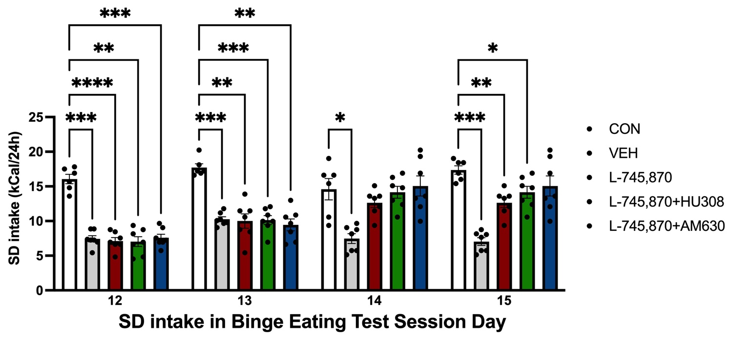
Supplementary Figure. Standard diet (SD) 24h kilocaloric (kcal) intake. Data express the mean ± SEM. Bar graph shows bar plot of SD intake in days when binge tests sessions 12 to 15 were conducted. Two-way ANOVA analysis (group × BET) with Sidak’s multiple comparisons test. ****p<0.0001; ***p<0.001; **p<0.01; **p<0.05.

